Fertilizer Timing -- Apply N as sidedress  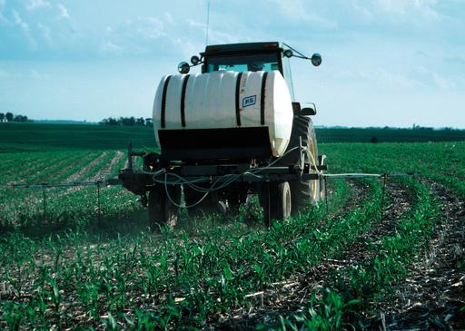  Photo USDA NRCS | Fertilizer Rate – Apply at Maximum Return to Nitrogen rate (MRTN)  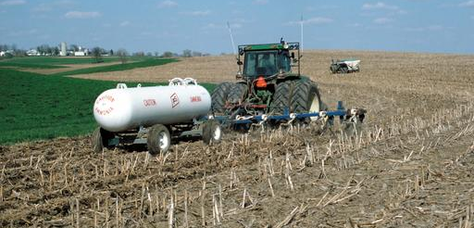  Photo USDA NRCS | No-Till  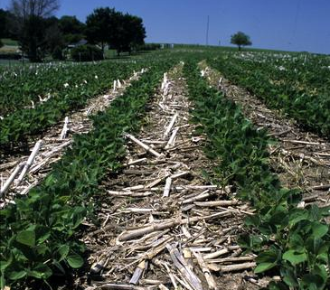  Photo USDA NRCS
Cover Crops  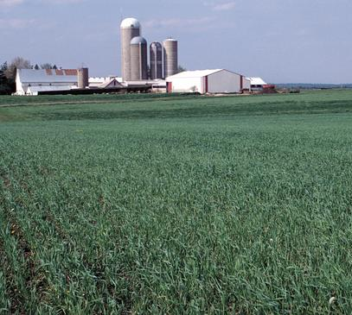  Photo USDA NRCS | Convert to Perennial Bioenergy Crop  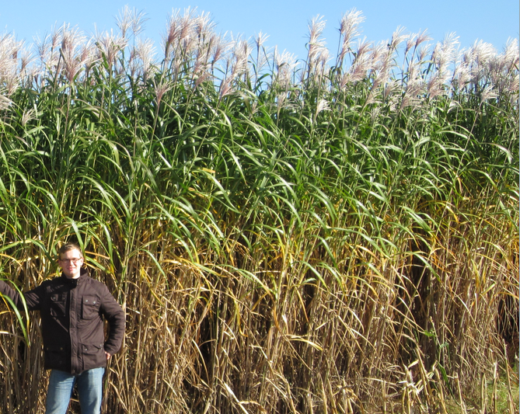 | Convert to Pasture  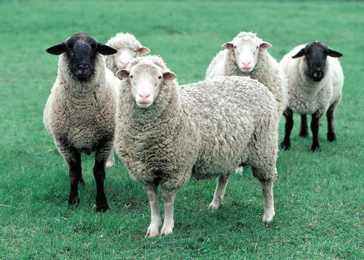  Photo USDA NRCS
Controlled Drainage  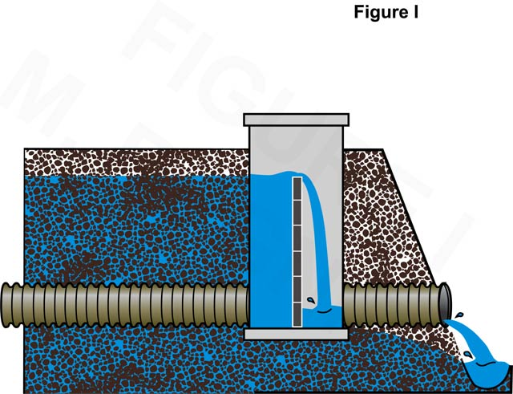 | Denitrifying Bioreactor  Creative Commons Hamsterdancer  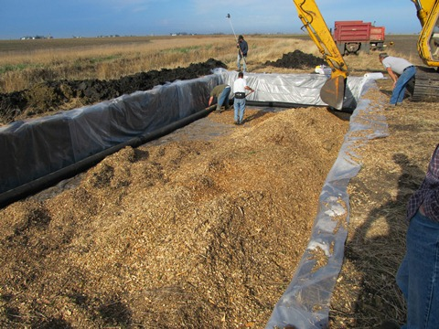  Photo courtesy L. Gentry, U of I | Drain to a Constructed Wetland  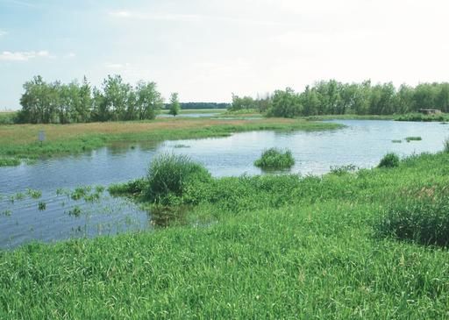  Photo USDA NRCS
Riparian Buffer Strip  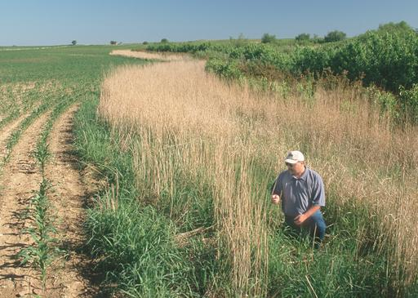  Photo USDA NRCS | Saturated Buffer  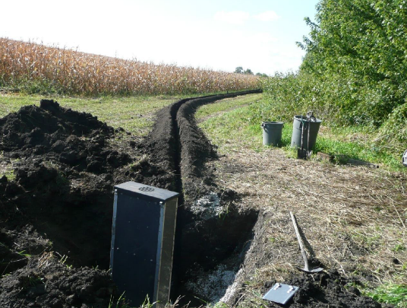  Photo courtesy D. Jaynes, ARS | Terraces  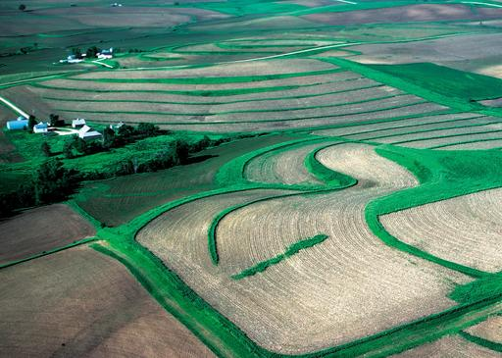  Photo USDA NRCS
Fertilizer Timing -- Apply N as sidedress  Photo USDA NRCS | Fertilizer Rate – Apply at Maximum Return to Nitrogen rate (MRTN)  Photo USDA NRCS
Fertilizer Timing -- Apply N as sidedress  Photo USDA NRCS | Fertilizer Rate – Apply at Maximum Return to Nitrogen rate (MRTN)  Photo USDA NRCS | Fertilizer Timing -- Apply N as sidedress  Photo USDA NRCS
Fertilizer Timing -- Apply N as sidedress  Photo USDA NRCS | Fertilizer Rate – Apply at Maximum Return to Nitrogen rate (MRTN)  Photo USDA NRCS | Fertilizer Timing -- Apply N as sidedress  Photo USDA NRCS
Fertilizer Timing -- Apply N as sidedress  Photo USDA NRCS | Fertilizer Rate – Apply at Maximum Return to Nitrogen rate (MRTN)  Photo USDA NRCS | Fertilizer Timing -- Apply N as sidedress  Photo USDA NRCS
 |  | Photo USDA NRCS

