Nutrient Reduction Game Introduction/Instructions
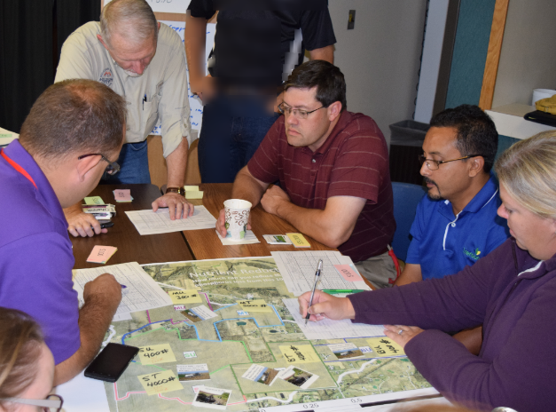
The Green Ditch Watershed is 1000 acres. It is a real watershed that has been monitored for about 10 years, but for this purpose many of the numbers and all the owners are invented. It is very small, but works for this exercise. Indiana has about 23,000 watersheds that are this size.
The average annual loss of nitrogen is 8,000 pounds and the annual loss of phosphorus is 1,000 pounds. Those numbers are fairly low for a 1,000 acre agricultural watershed. The monitoring has also shown that about 90% of the nitrogen, which is our focus today, is from the tile drains. (For phosphorus, the number is less but may be up to 50%.)
The Green Ditch Watershed Agriculture Council has been awarded a grant of $20,000 to reduce the nutrient loss from this small watershed. They want to show that voluntary incentives can work to reduce nutrient loss.
You will play the role of one producer who owns or rents two 100-acre fields in the watershed (sharing the role with one or two other people to encourage discussion). You have a little information about the farmer you represent; please feel free to make up any additional information! You should act as you think this farmer would be likely to act.
Nutrients can be reduced by implementing conservation practices. There are 12 available practices that can be applied to suitable fields. The nitrogen load reduction for the 100-acre field, as well as the cost of that practice, are shown in the worksheet. The grant will fund 75% of the costs of any practice that the farmer selects, while the producer needs to provide about 25%. This is similar to Farm Bill programs such as EQIP administered by USDA NRCS (actual percentage varies by state and by practice).
The effectiveness of each practice at reducing nitrogen losses from the field, the costs paid by the grant, and the cost to you are shown in the table for your farm. These numbers are based on the Iowa Nutrient Reduction Strategy, and of course are not exact but are a reasonable guess at effectiveness. It is up to you to decide which, if any, conservation practices you are willing to apply on your fields.
The Watershed Agriculture Council’s goal is to reduce as much nitrogen from the watershed as possible. To solve hypoxia in the Gulf of Mexico, nutrients need to be reduced by about 45%, so the 45% reduction numbers are provided as a guide. If the Council is successful at reducing nitrogen, it will be able to apply for additional grant funds. The watershed coordinator will manage the grant funds, and also try to encourage all farmers to adopt conservation practices so the Council can show the success of voluntary conservation.
In each round, each “producer” (2 or 3 people) can place one practice on one field if he/she wishes. As in real life, conservation practices are on a first-come, first-served basis, so whoever is ready first can implement a practice. However no one can implement a second practice until all have had a chance to do one. Go around the table as many times as you can until the grant funds run out, or 10 minutes is up.
To implement a practice,
- lay a practice card down on that field,
- pay your share of the implementation costs to the banker, and
- subtract the reduction in nitrogen loss for your field, and write the new total for the field.
The watershed coordinator pays the watershed’s share to the banker, and updates the nitrogen loss at the outlet.

Discussion
- How did you as a producer or landlord make your decision to implement or not implement conservation practices? What factors did you consider?

- Do you think your decision making is typical of producers in your state? Does this give you any insight into the role of Extension Educators in working on your state’s water quality issues?

- Were you aware of the difference between nitrogen (in the form of nitrate) losses between tile-drained and undrained fields? What does it suggest? What would be different if the game were played for phosphorus instead?

- What did you learn about the number of practices needed to reduce nitrogen? If we target the worst areas of a watershed only, or only a few “bad actors” are we likely to achieve the goal?

- What else did you learn? (discuss)

Note: Materials for this exercise is available at https://engineering.purdue.edu/~frankenb/NRG/. Contact Jane Frankenberger, Professor of Agricultural and Biological Engineering at Purdue (frankenb@purdue.edu) if you are interested in discussing further use or development.
Your thoughts for us
- What is the most important thing you learned from this exercise?

- Did anything surprise you?

- Who else could benefit from an exercise like this?

- What suggestions do you have for making it more effective in the future?

- Any other comments?

