Nutrient Reduction Game - Instructions for Leaders
Jane Frankenberger, Purdue University.

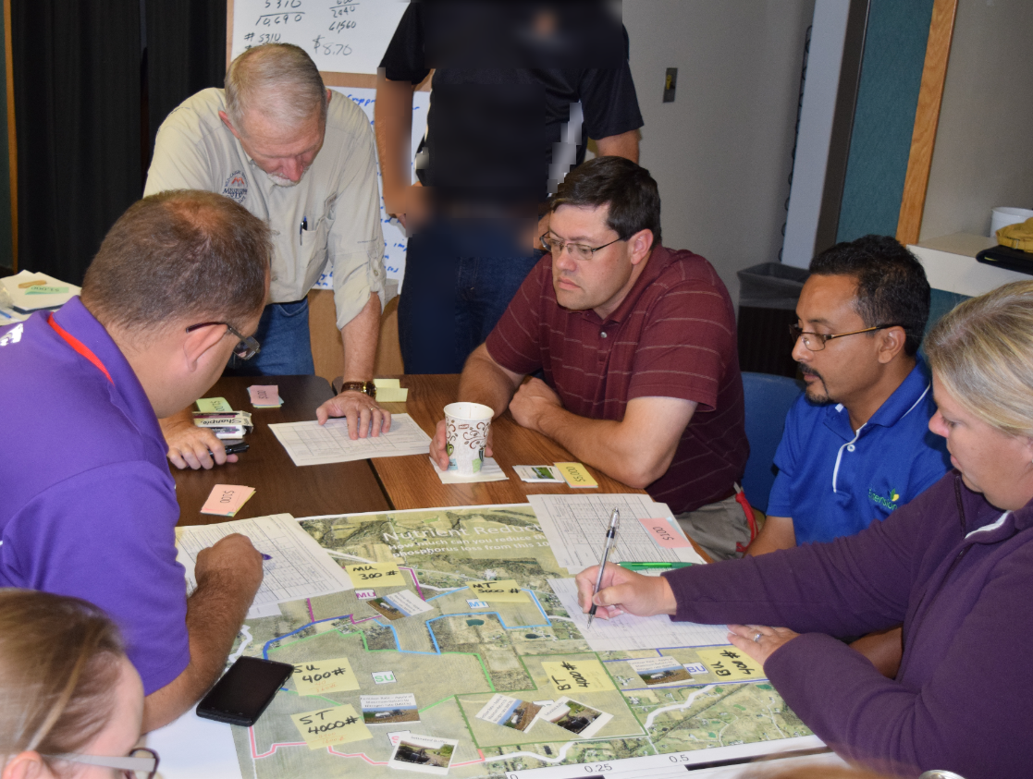
Learning Objectives:
I originally developed the game with the following learning objectives.
Objectives: After playing the game, people will understand the following:
- In order to achieve the load reduction goal, many practices need to be implemented (not just a few per watershed) and this implies that every field or at least every farmer needs to have one or more practices.
- Nitrogen behaves differently than phosphorus. The biggest nitrogen losses are from tile-drained land, while phosphorus losses occur on both drained and undrained land.
- Farmers do not have clear incentives for adopting conservation practices (if the costs are correct.) Therefore an objective is that the game will help people who work closely with farmer better think through what might go through a farmer’s mind in deciding what practices, if any, to implement. This will perhaps lead to greater insights on outreach.
- Conservation practices can work by changing nutrient management, trapping nutrients at the edge of field, or changing the cropping system (land use). These have very different estimated load reductions and costs. (Note: The worksheets are not currently laid out to emphasize this goal.)
In playing it, others have suggested the following additional objectives.
- Better results can be achieved by planning together, rather than just a first-come, first-served approach. (Cooperating and targeting are beneficial.) I think this is a reasonable learning objective, but should not overshadow the others, as I believe it gives a false sense of how easy it is to reduce nutrients together.
- Some have stressed the competition between “Farmers”, on the basis of who can reduce the most at the least cost. Again, I think this is a reasonable goal for “playing the game”, but I don’t think it quite captures the learning objectives that are most important.

Preparing for Playing the Game
One “Watershed”, which is an independent set of players playing around one map poster, is needed for every 8 to 11 people.
- Each watershed needs a Watershed Coordinator, who should be trained ahead of time if possible.
- Each watershed needs a Banker
- There are three farms per watershed, and each should have 2 or 3 people playing the role of the farmer (and landlord in the case of the rented farm).
Items needed for each Watershed:
- Watershed map, printed on poster-sized paper
- Original Loss sheet for each field (total of 6). These need to be printed out each time the game is played, as they will be written on.
- Conservation Practice game piece set for each farm (12 pieces * 3 farms/watershed)
- Watershed N or P Loss (two sheets)
- Money. I’m not sure how much you need but maybe 30 of each of the following: $5000, $1000, $500, $100

Introduction - Background
Background: Players need to understand the following. How much introduction is needed depends on the audience.
- Players need to understand something about nutrient load reduction and probably about State Nutrient Reduction Strategies (or Nutrient Loss Reduction Strategy as Illinois calls it) which form the basis for the game. The game would work well following a presentation on the strategy for that state.
- Players also need to understand the importance of tile drainage and the fact that tile drained lands lose much more nitrate.
- Players would benefit from having some understanding about the practices. I have had one powerpoint slide per practice; I don’t know if that is the most helpful. The game may pique their interest to learn more later.
- Costs used were from the Iowa Nutrient Reduction Strategy, based on Equal Annualized Cost at (50 year life and 4% discount rate), which “factors in the cost of any corn yield impact as well as the cost of physically implementing the practice. For the capital costs, a design life of 50 years and a discount rate of 4% were used. The price of corn was assumed to be $5/bushel and the cost of nitrogen was assumed to be $0.50/lb N”
- It might be helpful to explain how this tiny watershed fits in the larger watershed. It might be fun to use “Streamer”, Use Streamer (http://nationalmap.gov/streamer/webApp/streamer.html#)

Playing the game
Before starting, the rules and objectives need to be explained. I think this would work with the group as a whole, perhaps with powerpoint or rules posted at each table. I originally thought each facilitator (watershed coordinator) would explain at the table, but I think with a large group it would be rare to have enough trained facilitators. The script on the following page should be read or made into a presentation.

Introduction – Playing the Game
Here is a script you might read, or explain in your own words:
The Green Ditch Watershed is 1000 acres. It is a real watershed that has been monitored for about 10 years, but for this purpose many of the numbers and all the owners are invented. It is very small, but works for this exercise. The state of Indiana has about 23,000 watersheds that are this size.
The average annual loss of nitrogen is 15,000 pounds and the annual loss of phosphorus is 1,500 pounds. Those numbers are fairly typical for a 1,000 acre agricultural watershed. The monitoring has also shown that about 90% of the nitrogen is from the tile drains, and about 50% of the phosphorus.
The Green Ditch Watershed Agriculture Association has been awarded a grant of $20,000 to reduce the nutrient loss from the watershed. They want to show that voluntary incentives can work to reduce nutrient loss.
You will play the role of one farmer who owns or farms two fields in the watershed (sharing the role with one or two other people to encourage discussion). You have a little information about the farmer you represent; please feel free to make up any additional information! You should act as you think this farmer would be likely to act.
Nutrients will be reduced by implementing conservation practices. There are 12 available practices that can be applied to suitable fields. The nitrogen load reduction for the 200-acre field, as well as the cost of that practice, are shown in the worksheet. The grant will fund 75% of the costs of any practice that the farmer selects, while the farmer needs to provide about 25%. This is similar to Farm Bill programs such as EQIP administered by USDA NRCS (actual percentage varies by state and by practice).
The effectiveness of each practice at reducing N or P, the costs paid by the grant, and the cost to you are shown in the table. It is up to you to decide which, if any, conservation practices you are willing to apply. These numbers are based on the Iowa Nutrient Reduction Strategy, and of course are not exact but are a reasonable guess at effectiveness.
The Watershed Association’s goal is to reduce as much nitrogen from the watershed as possible. To solve hypoxia in the Gulf of Mexico, nutrients need to be reduced by about 45%, so these numbers are provided as a guide. If the Association is successful at reducing nitrogen, it can apply for additional grant funds. The watershed coordinator will manage the grant funds, and also try to encourage all farmers to adopt conservation practices to reduce nitrogen.
In each round, each farmer can place one practice on one field if he/she wishes. Go around the table, and one farmer at a time will decide whether to implement a practice on a field, what to implement, and where to place it. You implement a practice by laying a practice card down on that field, paying your share of the implementation costs to the banker, while the watershed coordinator pays the watershed’s share. Once implemented, subtract the reduction in nutrient loss, and write the new value on the field’s nutrient loss sheet. We will then update the loss at the outlet. Go around the table as many times as you can until the grant funds run out, or 10 minutes is up.
Watershed coordinators, please begin by asking the farmers on your left if they want to implement a practice in one field.

Discussion
- How did you as a farmer make your decision to implement or not implement? Do you think your decision making is typical of farmers in your state?

- What do you think of the difference between tile-drained and undrained fields? Does this seem realistic? What does it suggest? What would be different if the game were played for phosphorus instead?

- What did you learn about the number of practices needed to reduce nitrogen? If we target the worst areas of a watershed only, are we likely to achieve the goal?

- Do you agree with the following quote? Did anything from playing this game change your opinion?
“It is important that individual farmers or localized groups of farmers, such as a watershed or drainage district, be allowed the flexibility to choose the combination of practices that will achieve water quality goals at the most effective costs. Given the best available information, farmers, alone or in groups, are able to find the lower cost and lower risk strategies more effectively than a mandate directed from the state or national level.” Section 2.4 of Iowa Nutrient Reduction Strategy. (p.187 in complete document)

Acknowledgements:
The general concept of this game is based on Minnesota Sea Grant’s “Watershed Game”, http://www.northlandnemo.org/watershedgame.html. Thanks to the Extension professionals, watershed leaders, and Purdue students who have played it and contributed to its improvement over the years.

Photo Credits:
Watershed N&P: Tile drained photo: Dan Jaynes, Iowa State University
Sloping corn field: Flickr Creative Commons https://flic.kr/p/8jKfSg

Appendix
This is the table from the Iowa Nutrient Reduction Strategy. The “State Average EAC” column was the basis for assigning costs. Other states may have different values, and it is a good idea to use those.
