Sunshine Small Farm
Tile-Drained Field ST
Original Nitrogen Load
(20 lbs/acre/year): 2000 lbs/year
Reduction 1 -
New Total:
Reduction 2 -
New Total:
Reduction 3 -
New Total:
Goal: 1100 lbs/year

McDonald Rented Farm
Tile-Drained Field MT
Original Nitrogen Load
(20 lbs/acre/year): 2000 lbs/year
Reduction 1 -
New Total:
Reduction 2 -
New Total:
Reduction 3 -
New Total:
Goal: 1100 lbs/year

Blue Creek Big Farm
Tile-Drained Field BT
Original Nitrogen Load
(20 lbs/acre/year): 2000 lbs/year
Reduction 1 -
New Total:
Reduction 2 -
New Total:
Reduction 3 -
New Total:
Goal: 2200 lbs/year

Sunshine Small Farm
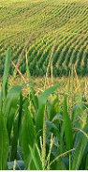
Undrained Field SU
Original Nitrogen Load
(20 lbs/acre/year): 200 lbs/year
Reduction 1 -
New Total:
Reduction 2 -
New Total:
Reduction 3 -
New Total:
Goal: 110 lbs/year

McDonald Rented Farm
Undrained Field MU
Original Nitrogen Load
(20 lbs/acre/year): 200 lbs/year
Reduction 1 -
New Total:
Reduction 2 -
New Total:
Reduction 3 -
New Total:
Goal: 110 lbs/year

Blue Creek Big Farm
Undrained Field BU
Original Nitrogen Load
(20 lbs/acre/year): 200 lbs/year
Reduction 1 -
New Total:
Reduction 2 -
New Total:
Reduction 3 -
New Total:
Goal: 110 lbs/year

Nitrogen Load at the Watershed Outlet
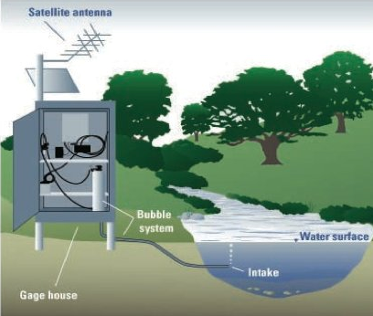
Original: 8,000 lbs/year
Reduction 1 -
New Total:
Reduction 2 -
New Total:
Reduction 3 -
New Total:
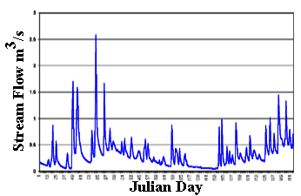
Reduction 4 -
New Total:
Reduction 5 -
New Total:
Reduction 6 -
New Total:
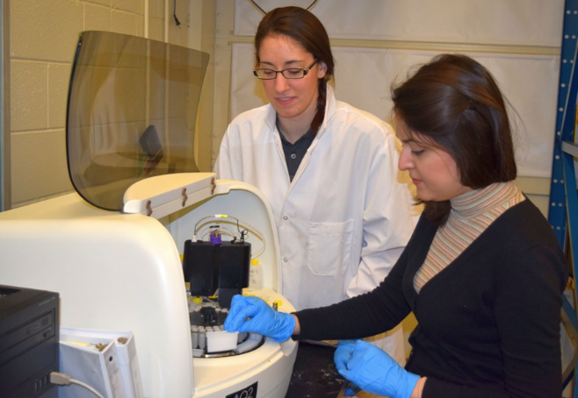
Reduction 7 -
New Total:
Reduction 8 -
New Total:
Reduction 9 -
New Total:
Goal: 4,400 lbs/year

