# ECE 638 Exam No. 1 Fall 2021

This is a take-home exam. You may use whatever resources you have at your disposal. However you may **not** consult **anyone** else about any aspect of the exam. You have 48 hours to work the following **four** problems that are worth a total of 145 pts. (Please see the last page of the exam for a summary of the point assignment.) To obtain maximum partial credit, be sure to show the complete derivation of your answers. Also, please be sure to include any code that you use to solve any problem. Please e-mail your solution to Runzhe Zhang ([zhan3052@purdue.edu](mailto:zhan3052@purdue.edu" \t "_blank)) by 9p EDT on Friday 15 October. If you have questions about any aspect of the exam, please send an e-mail to me Professor Allebach ([jpallebach@gmail.com](mailto:jpallebach@gmail.com)). I will endeavor to reply to all e-mails as promptly as possible. If necessary, I will schedule a one-on-one Zoom meeting with you address your questions.

1. (40 pts.) Consider a three-channel sensor with the response functions  shown below.

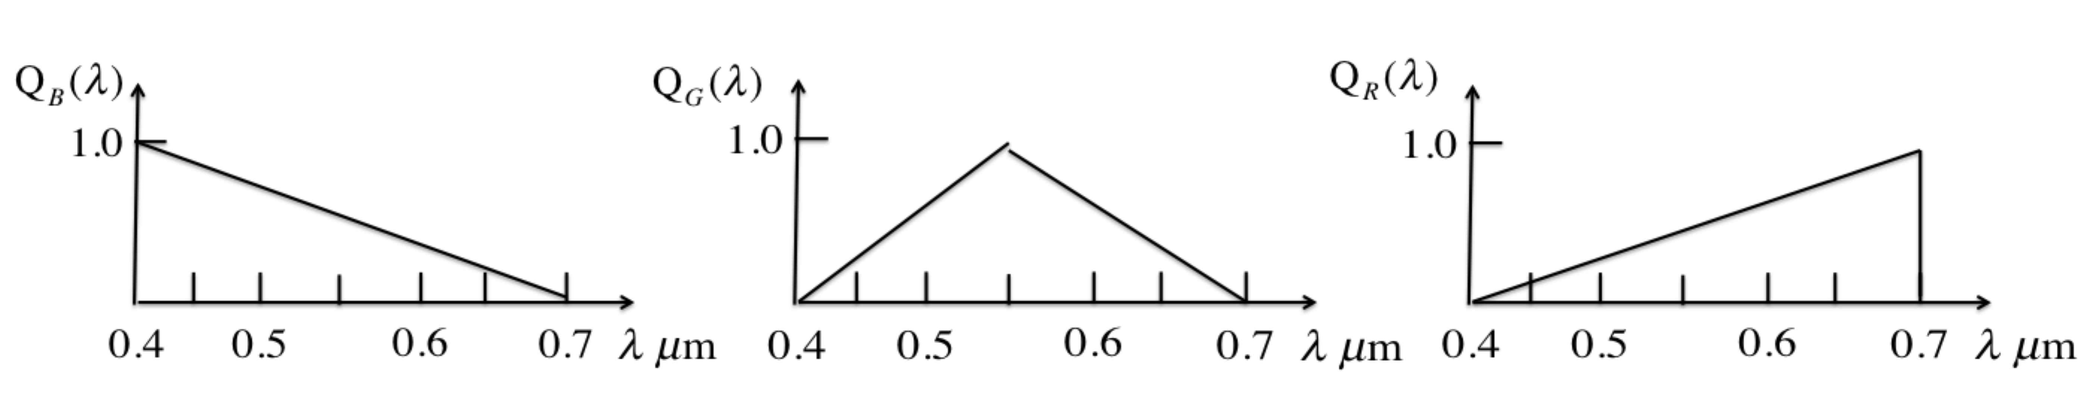

1. (8) Find the response of this sensor to the stimulus  with the spectral power distribution shown below:

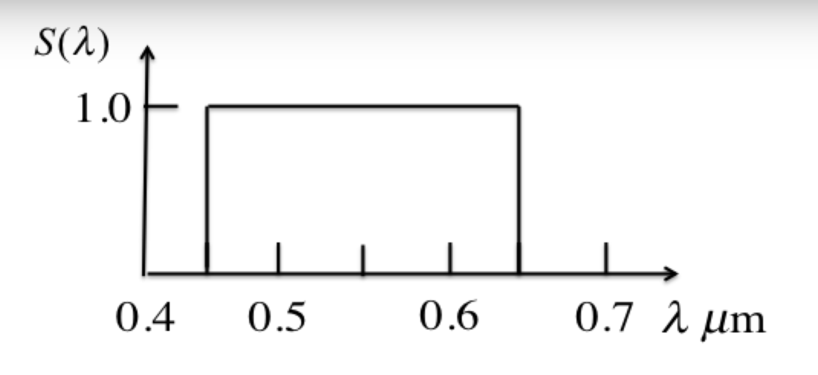

1. (8) Carefully sketch the spectral locus in the sensor chromaticity diagram for this sensor, using an equilateral triangle where each chromaticity coordinate is given by the distance from one of the vertices along the direction that is normal to the opposite edge.

Consider the primary set  with power spectral distribution shown below:

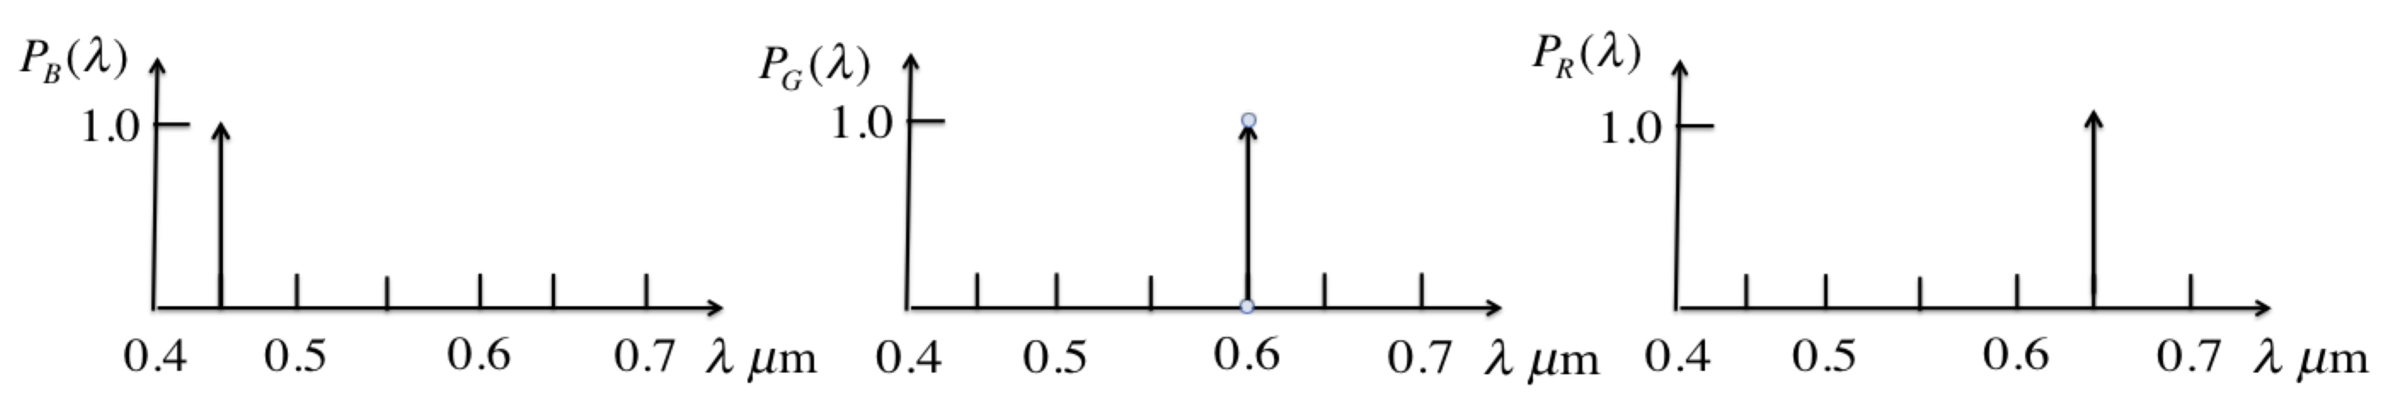

1. (8) Find the amounts of each of the three primaries that will yield a match to the stimulus  from part a), as viewed by the sensor with response functions shown above.
2. (8) Find the color matching functions  for this primary set.
3. (8) Use the color matching functions as an alternate solution to finding the amounts of the primaries that will match the stimulus  shown above.

2. (30 pts.) Consider a finite dimensional model for a linear, bichromatic (2-channel) vision system. Assume that we sample at  wavelengths. Suppose that the sensor response matrix is given by



1. (5) Find the response of this sensor to the stimulus .
2. (10) Find the projection operator  for this sensor.

c. (5) Find the fundamental component  for this stimulus.

d. (5) Find the black-space component  for the stimulus.

1. (5) Find a metamer  to  such that .
2. (25) This is a continuation of Problem 2 from HW No. 3.

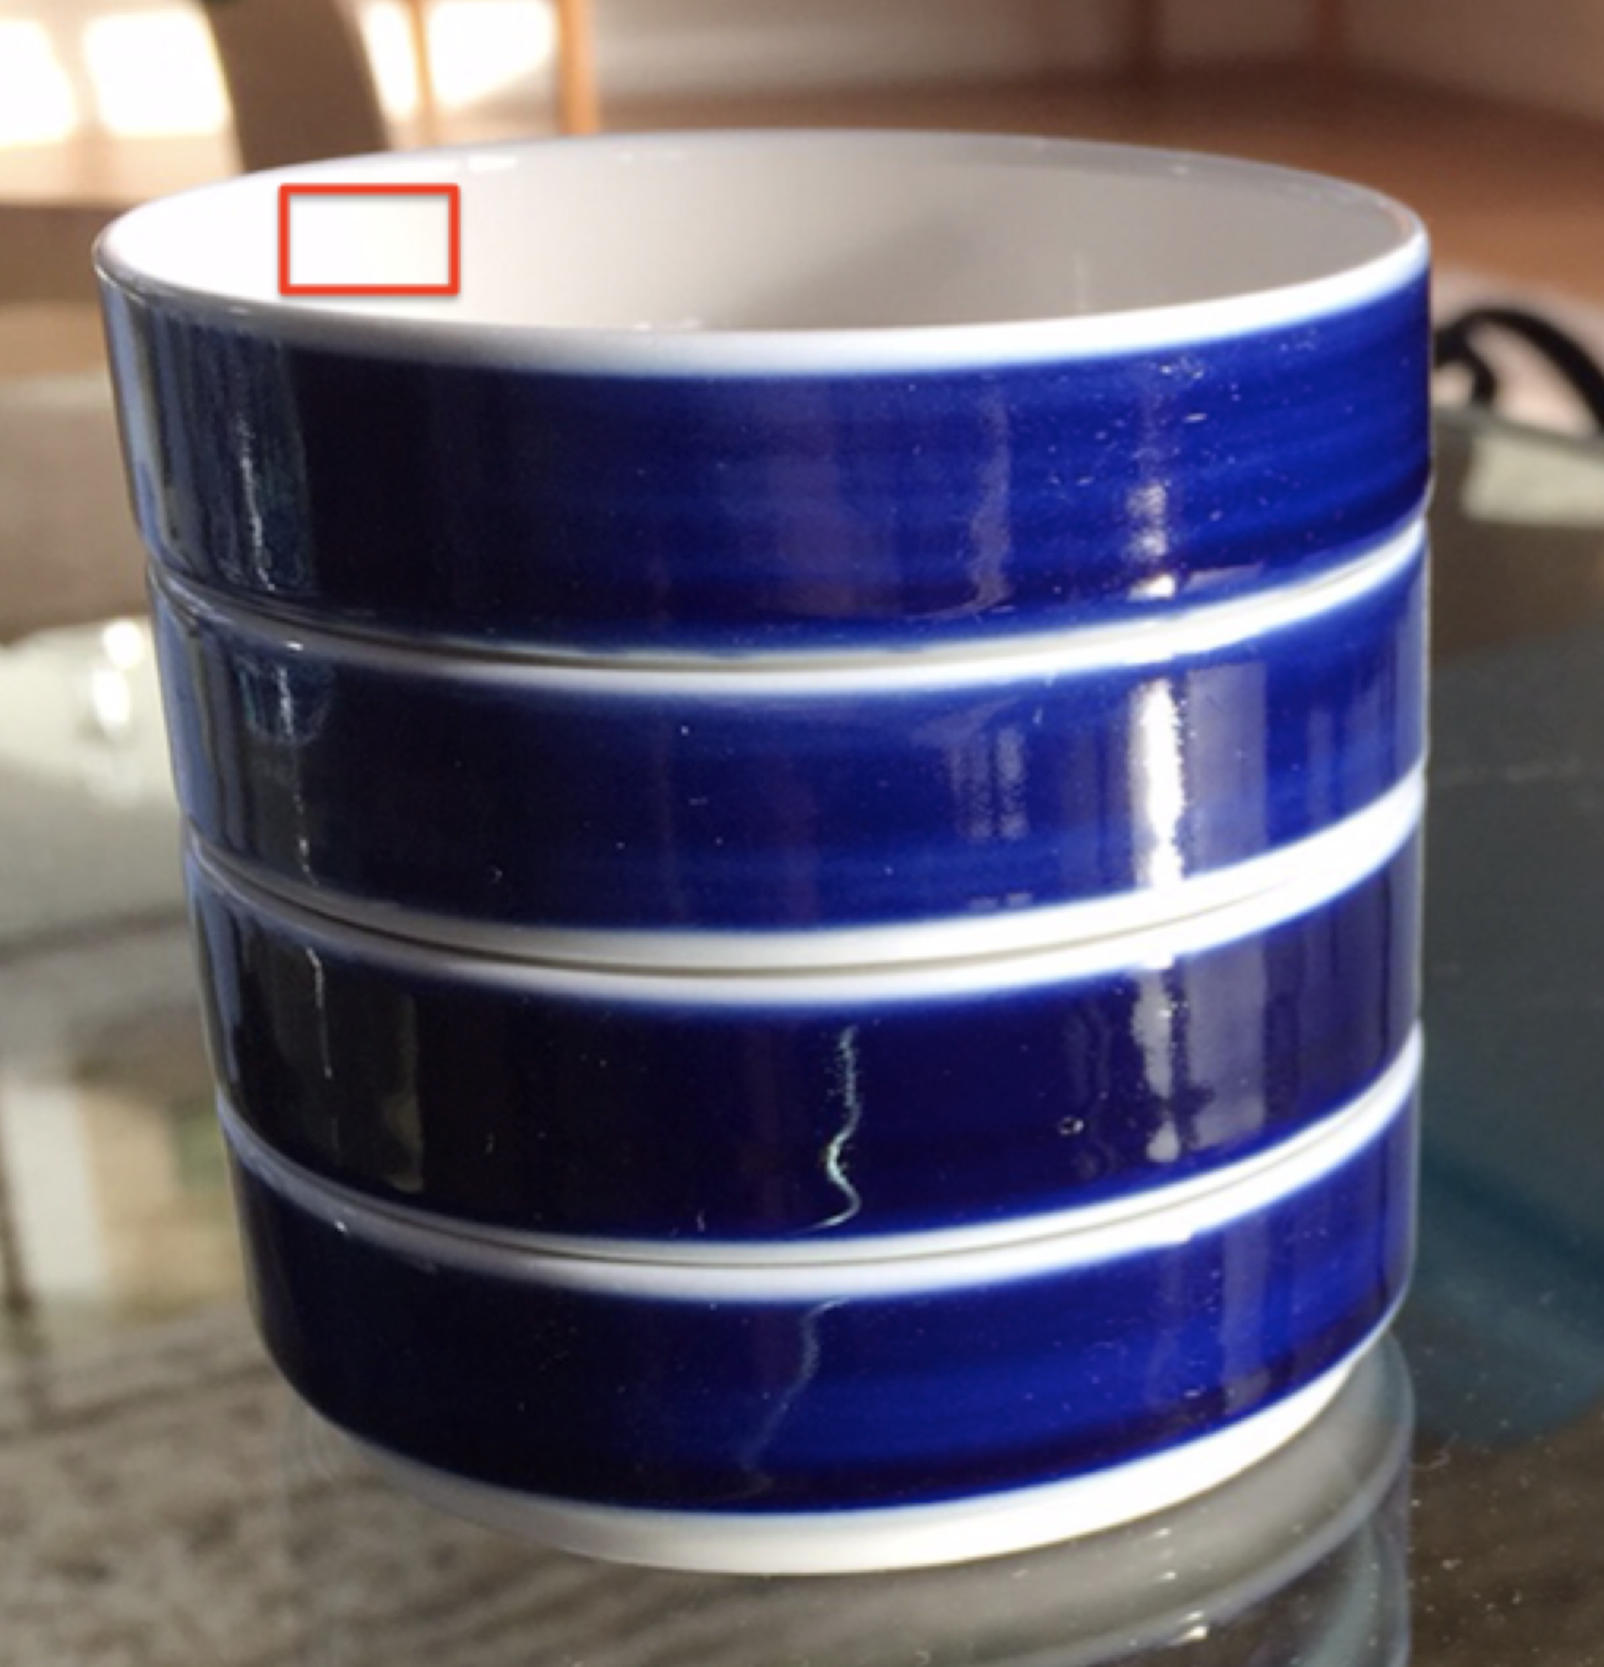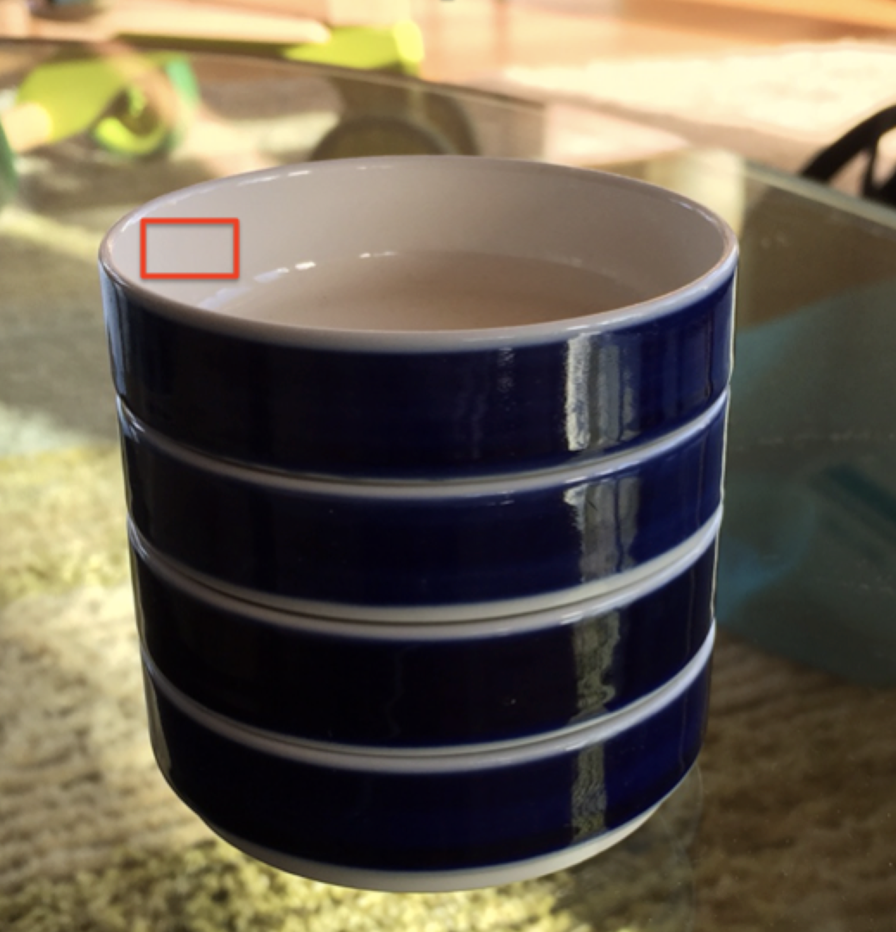

(a) (b)

Fig. 1: Images for Problem 3.

a. (5) Using the two images of the blue dishes, as illustrated in Fig. 1 above, calculate and report the average RGB values within each red square.

b. (5) Using the transformation that you developed in your solution to Problem 2 from HW No. 3, or the posted solution to that problem (be sure to document which you are using), compute the CIE XYZ values for these two patches.

c. (5) Compute the CIE XYZ xy chromaticity coordinates for these two patches.

d. (5) On Fig. 1(3.11) from Problem 3 of HW No. 2, plot the xy chromaticity points for these two patches.

e. (5) From Fig. 1(3.11), estimate the correlated color temperature of each patch.

1. (50) This problem deals with characterization and calibration of a color image capture device – namely an iPhone. The image below is that of a version of the Macbeth/X-Rite Color Checker that was captured with an iPhone camera. It can be downloaded from the course website at the link “Data Files”. The file is called “Color-checker-from-iPhone.jpg”. Using this image, and the CIE XYZ coordinates of each patch, which has been measured with an X-Rite instrument, and which can be found in the file called “ColorChecker\_DigitalSG\_XYZ\_D50\_M2.xlsx” in the same folder, the task for this problem is to determine a mapping from iPhone RGB to CIE L\*a\*b\*.

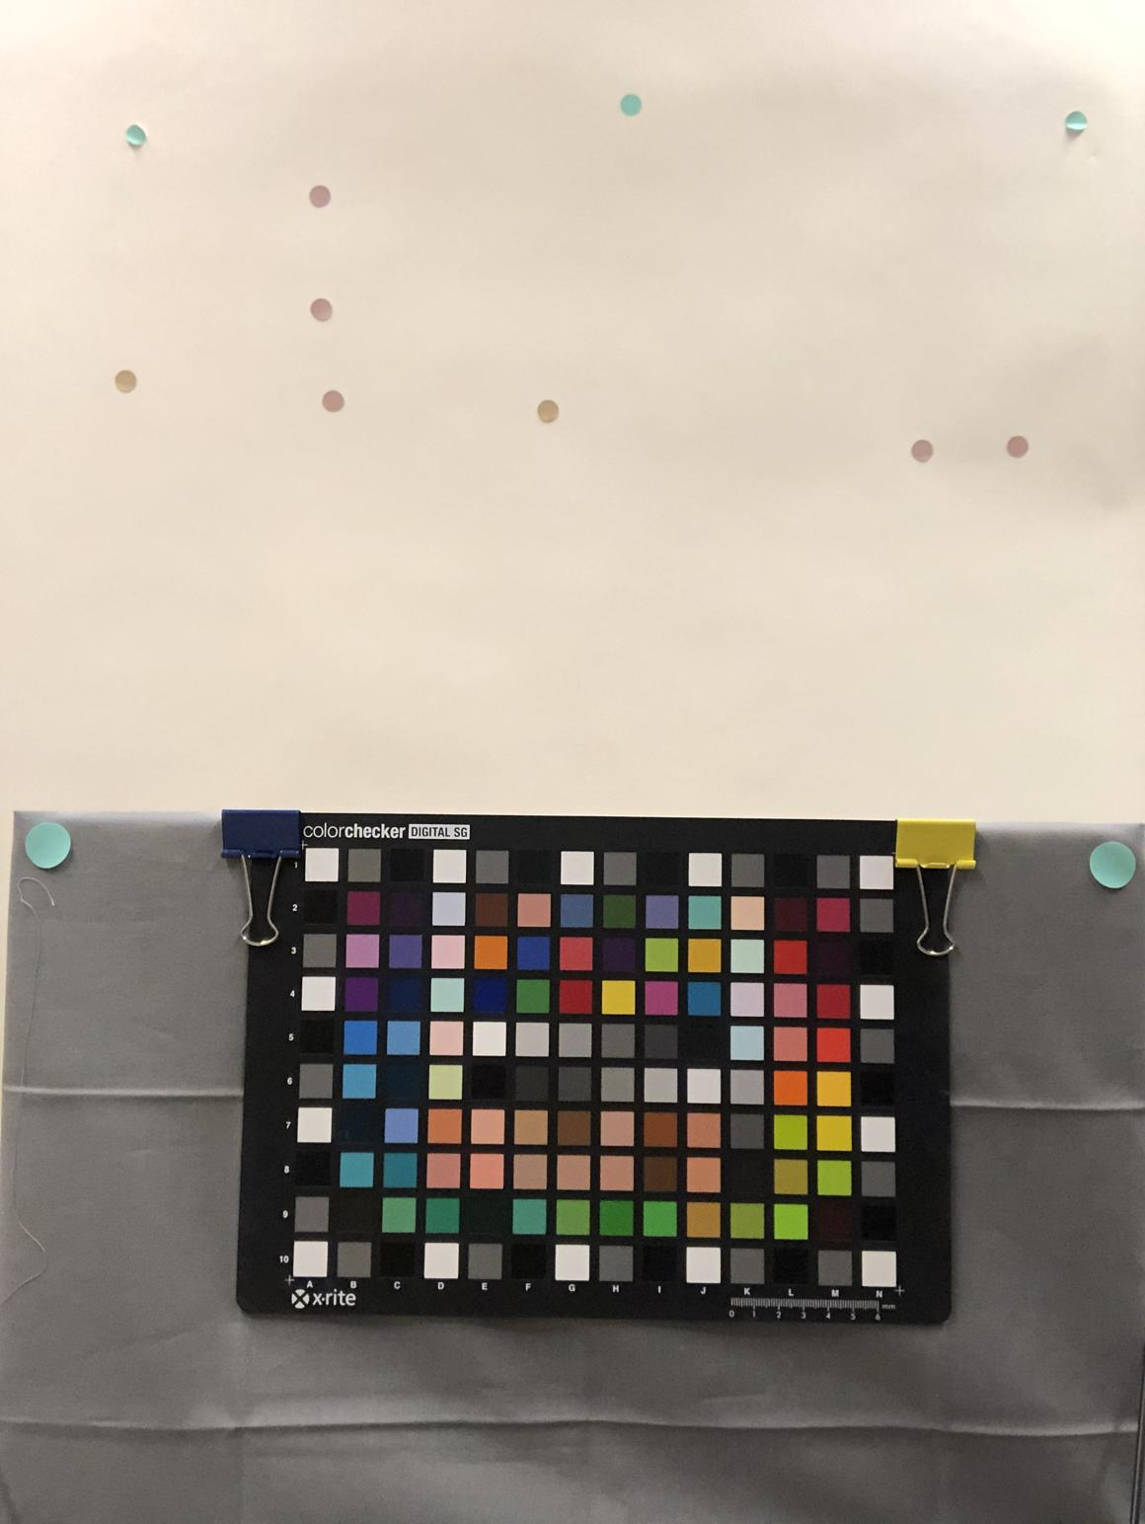

Specifically, you should perform the following steps:

1. (15) Write some code to extract average RGB values from each patch in “Color-checker-from-iPhone.jpg”. You will need to average the RGB values over a region centered in each patch to eliminate the JPEG noise. Turn in an excel file containing the RGB values from each patch.
2. (10) Use the neutral patches to determine the gray balance curves for each of the R, G, and B channels of the camera. Turn in the parameters for each curve, as well as a plot of each curve.
3. (10) Using the data in “ColorChecker\_DigitalSG\_XYZ\_D50\_M2.xlsx”, determine the entries of a 3x3 matrix that gives a least squares fit in the transformation from camera linear RGB to CIE XYZ. Turn in the entries of your matrix, as well as a detailed description of how you obtained them.
4. (5) Provide the equations to transform from CIE XYZ to CIE L\*a\*b\* assuming a D50 white point.
5. (10) Using the patches from “Color-checker-from-iPhone.jpg” and the data in the file “ColorChecker\_DigitalSG\_XYZ\_D50\_M2.xlsx”, determine the goodness of fit for your camera model. Calculate the average error and the standard deviation of the error in units of DELTA E\_76. Plot a histogram of the DELTA E\_76 errors.

**1. \_\_\_\_\_\_\_** (out of 40 pts.)

**2. \_\_\_\_\_\_\_** (out of 30 pts.)

**3. \_\_\_\_\_\_\_** (out of 25 pts.)

**4. \_\_\_\_\_\_\_** (out of 50 pts.)

**Total \_\_\_\_\_\_\_** (out of 145 pts.)