ECE 438 Essential Definitions and Relations (Exam 1)

CT Metrics
1. Energy 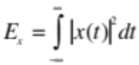
2. Power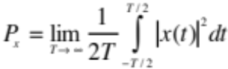
3. root mean squared value 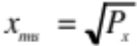
4. Area 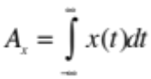
5. Average value 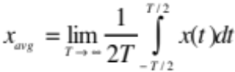
6. Magnitude 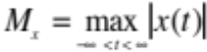
DT Metrics
1. Energy 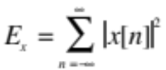
2. Power 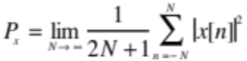
3. root mean squared value
4. Area 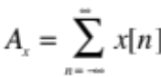
5. Average 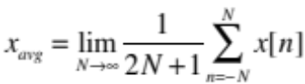
6. Magnitude 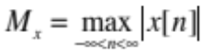
CT Signals and Operators
1. 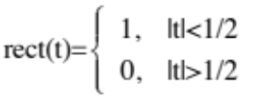
2. 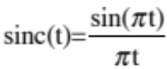
3. 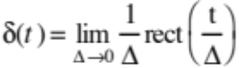
4. 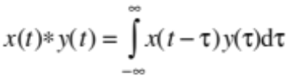
5. 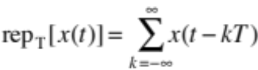
6. 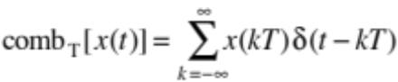
Properties of the CT Impulse
1. 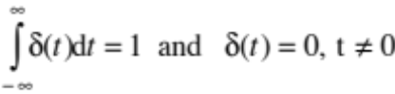
2. 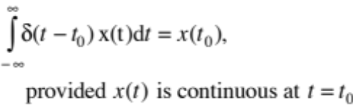
3. 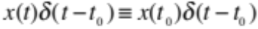
4. 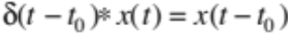
5. 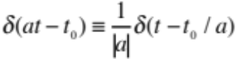
CTFT
Sufficient conditions for existence
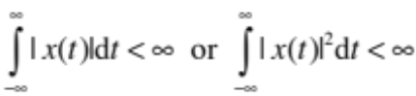
Forward transform
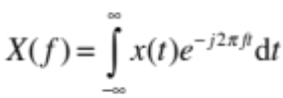
Inverse transform
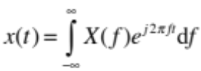
Transform Relations
1. Linearity
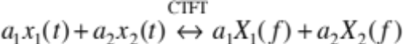
2. Scaling and shifting
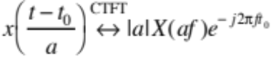
3. Modulation
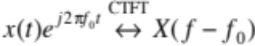
4. Reciprocity
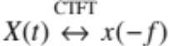
5. Parseval
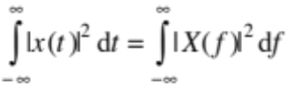
6. Initial Value
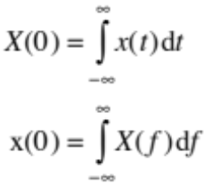
7. Convolution
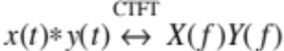
8. Product
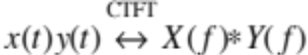
9. Transform of periodic signal
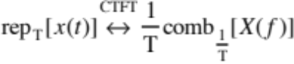
10. Transform of sampled signal
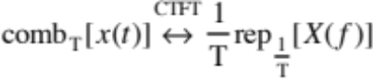
Transform Pairs
1. 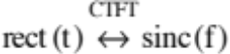
2. 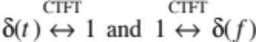
3. 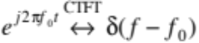
4. 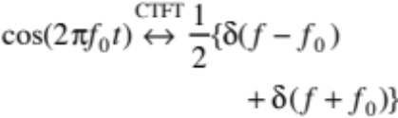
DT Signals and Operators
1. 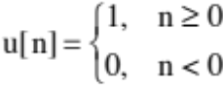
2. 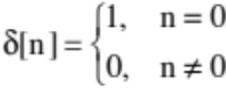
3. 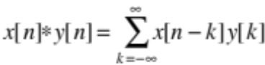
Properties of the DT Impulse
1. 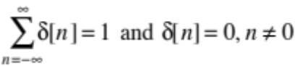
2. 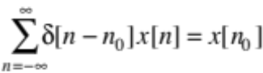
3. 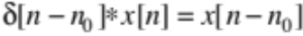
DTFT
Sufficient conditions for existence
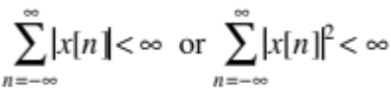
Forward transform
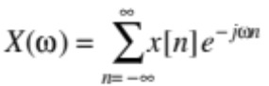
Inverse transform
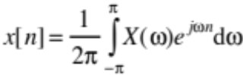
Transform Relations
1. Linearity
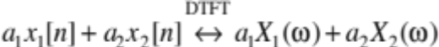
2. Shifting
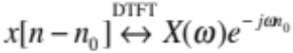
3. Modulation
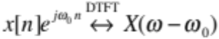
4. Parseval
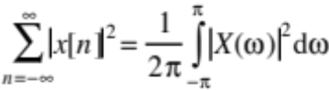
5. Initial Value
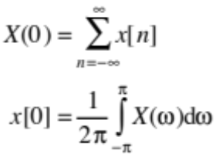
6. Convolution
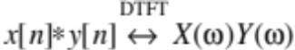
7. Product
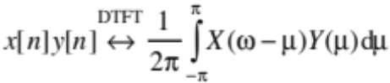
Transform Pairs
1. 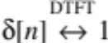
2. 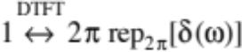
3. 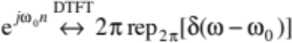
4. 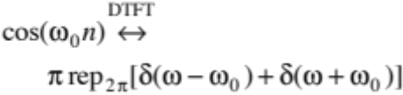
5. 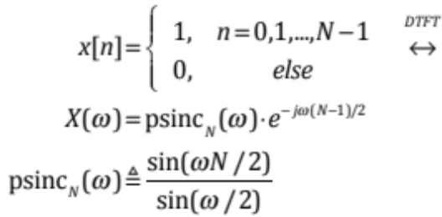
Here, “psinc” means periodic sinc function.
Relation between CT and DT
1. Time Domain
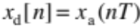
2. Frequency Domain
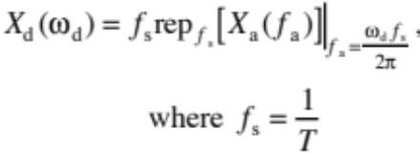
Miscellaneous
1. Geometric Series
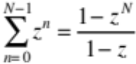
2. roots 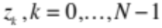, of a complex constant , i.e. solutions to
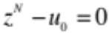
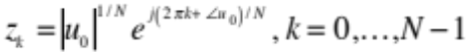
3. Trigonometric Identities


