ECE 438 Assignment No. 8 Spring 2023

1. The digital synthesizer for voiced speech shown below operates at a 12 kHz sampling rate.
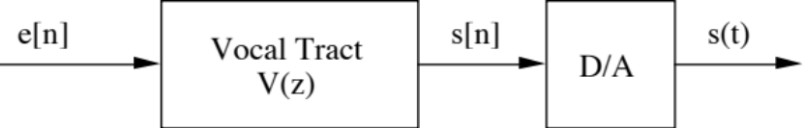
The excitation is given by
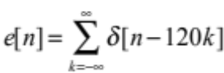.
The vocal tract transfer function 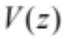 has poles and zeros at the locations shown below:
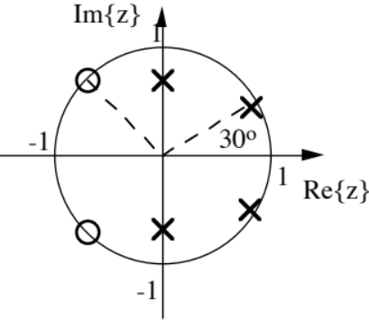
a. What is the pitch period in seconds and the pitch frequency in Hz?
b. Find the formant frequencies in Hz, and rank them according to their strength, i.e. how peaked the vocal tract response is at the corresponding frequency. Explain the reasoning underlying your ranking.
c. Sketch what the speech waveform 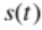 might look like.
2. Consider the spectrogram shown below for the utterance “Every salt breeze comes from the sea.”
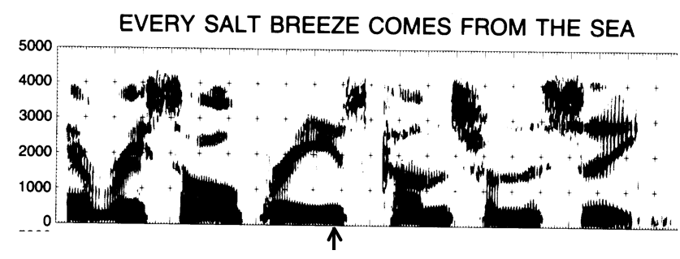
a. Assuming the entire utterance lasted 2 sec, very roughly estimate the pitch period.
b. Is this a wideband or narrowband spectrogram?
c. If your answer to part a, was “wideband”, sketch what a narrowband spectrogram for this same signal would look like. On the other hand, if your answer to part a, was “narrowband”, sketch what a wideband spectrogram for this same signal would look like.
d. Identify the formant frequencies at the time marked by the arrow.
e. What phoneme do you think is being uttered at this point? Support your answer by comparison with the formant frequencies in the table below:
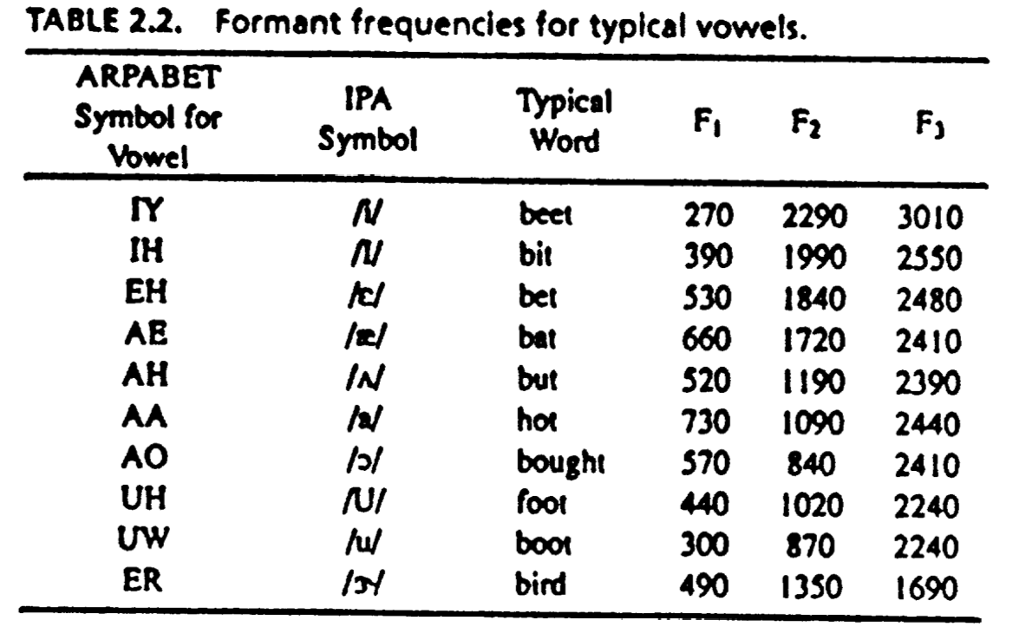
3. Consider the signal
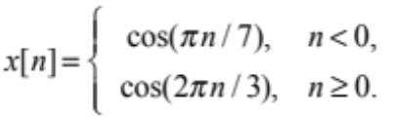
a. Carefully sketch 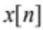.

Assume a rectangular window
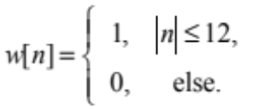
b. Compute the STDTFT as defined below
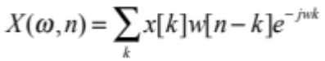
for the following cases (Be sure to express your answer in terms of the function 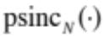 for appropriate values of ):
i. 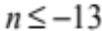
ii. 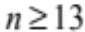
iii. 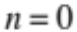
c. Sketch 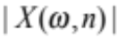 for all n. Be sure to label important dimensions. (You may ignore the contributions of the phase terms when preparing your sketch.)
- In class, we derived conditions for perfect reconstruction using an -channel modulated filter bank in which the -th channel has unit sample response 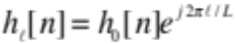, where 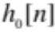 is the unit sample response of the 0-th channel. Thus the frequency response of each channel is just a shifted version of the frequency response of the 0-th channel. Consider a system with unit sample response for the 0-th channel given by
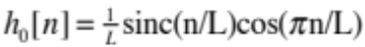.
  - Sketch the unit sample response 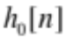 for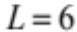.
  - Derive the frequency response 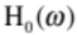 corresponding to the unit sample response . Note that it may be easiest to do this by considering what frequency response will yield the correct inverse DTFT from 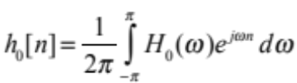, for the given , while also keeping in mind Euler’s identity.
  - Sketch for.
  - Show that satisfies the time-domain condition derived in class for perfect reconstruction with a modulated filter bank.
  - Show that satisfies the frequency-domain condition derived in class for perfect reconstruction with a modulated filter bank.
  - Comment on the frequency selectivity of the filter bank with base unit sample response given above, compared with a filter bank having base unit sample response 

