Flat Earth Equations of Motion
Useful for Studying Flight Dynamics and Control

Professor Dominick Andrisani
School of Aeronautics and Astronautics
Purdue University

Reference: Brian L. Stevens and Frank L. Lewis, Aircraft Control and Simulation, John Wiley and Sons, 1992.
Aerodynamic Model for Flight Dynamics and Control Software

- Nonlinear Aerodynamic Model
A.1. Body Axis System has unit vectors $(\hat{i},\hat{j},\hat{k})$ (not stability axis system). Let ${\hat{i}}_{w},{\hat{j}}_{w},{\hat{k}}_{w}$ be wind axis system unit vectors with ${\hat{i}}_{w}$ directed into the wind, ${\hat{k}}_{w}$ in the plane of symmetry but perpendicular to ${\hat{i}}_{w}$, ${\hat{j}}_{w}$ perpendicular to ${\hat{i}}_{w},{\hat{k}}_{w}$ in a right hand rule sense (generally out the right wing)
A.2. Definitions of Angle of Attack and Sideslip
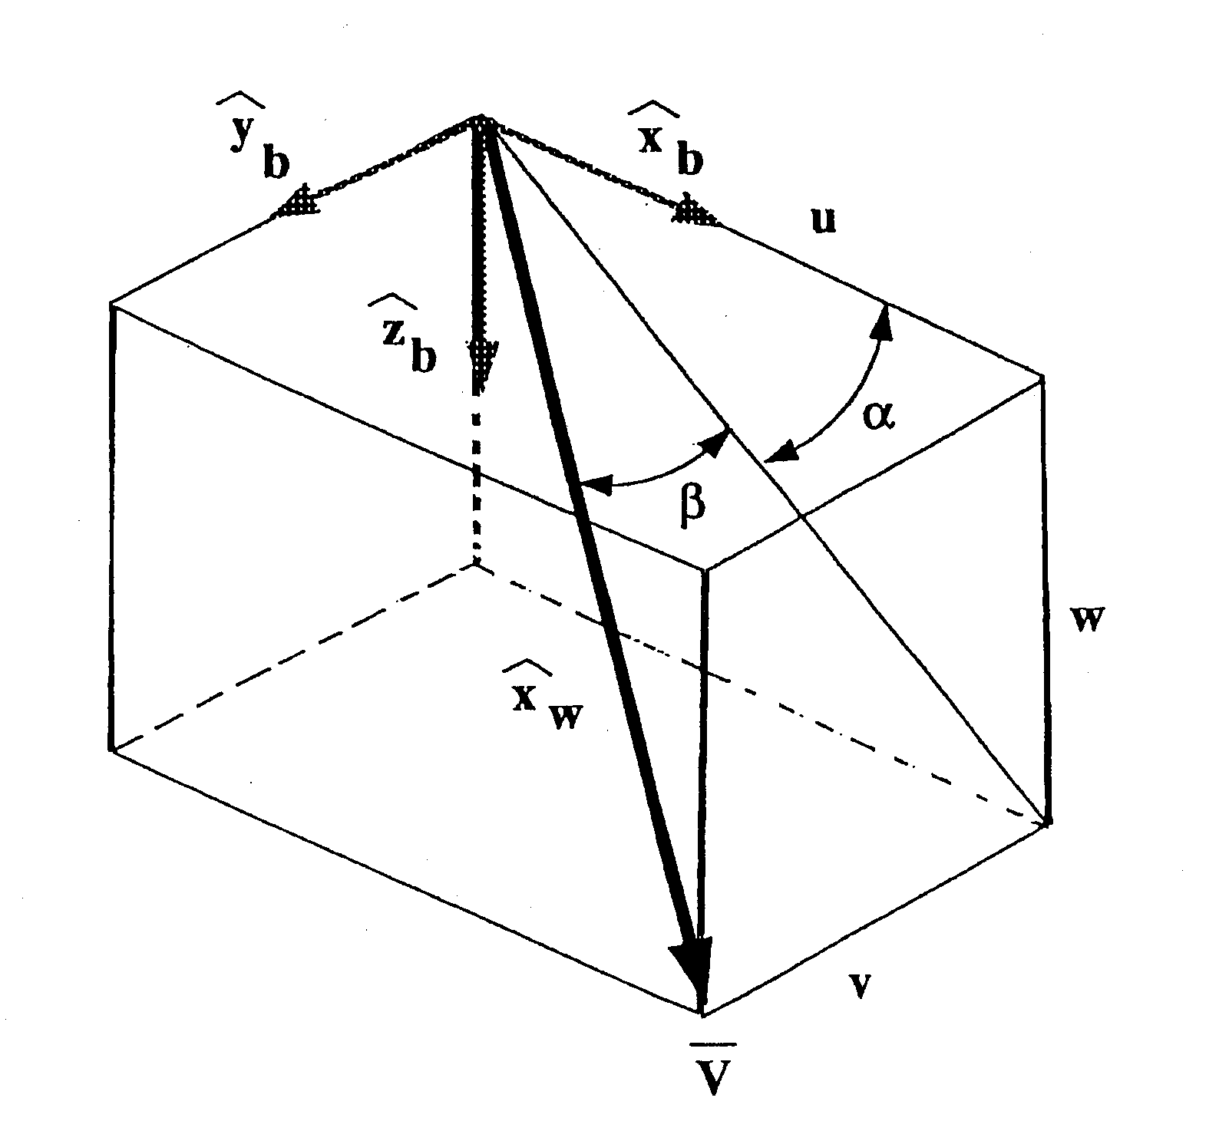
$$\bar{v}=\left|\bar{v}\right|{\hat{x}}_{w}=u{\hat{x}}_{b}+v{\hat{y}}_{b}+w{\hat{z}}_{b}$$
$$\text{sin}β=\frac{v}{\sqrt{u^{2}+v^{2}+w^{2}}}$$
$$\text{tan}α=\frac{w}{u}$$
Assume still air.
Roskam notation is $\bar{V}=U\hat{i}+V\hat{j}+W\hat{k}$
A.3. Force Analysis
$${\bar{F}}_{A}=\underset{D}{\underbrace{−\text{Drag}}} {\hat{i}}_{w}−\underset{L}{\underbrace{\text{Lift}}} {\hat{k}}_{w}+\underset{Y}{\underbrace{\text{Side} \text{Force}}} {\hat{j}}_{w}$$
$$\frac{{\bar{F}}_{A}}{\bar{q}s}=−C_{D}i_{w}−C_{L}{\hat{k}}_{w}+C_{y_{w}}{\hat{j}}_{w}$$
We will use the transform between wind axis system and body axis system. This involves wind angles and $β$.
See Stevens and Lewis page 63, equations 2.3-2
$$\begin{aligned}\bar{Q}=Q_{x_{B}}\hat{i}+Q_{y_{B}}\hat{j}+Q_{z_{B}}\hat{}k \\ =Q_{x_{w}}{\hat{i}}_{w}+Q_{y_{w}}{\hat{}j}_{w}+Q_{z_{w}}{\hat{}k}_{w}\end{aligned}$$
$↓ T^{B \text{to} w}$
$\left[\begin{matrix}Q_{x_{w}} \\ Q_{y_{w}} \\ Q_{z_{w}}\end{matrix}\right]=\left[\begin{matrix}\text{cos}α\text{cos}β \\ −\text{cos}α\text{sin}β \\ −\text{sin}α\end{matrix}\left|\begin{matrix} \text{sin}β \\ \text{cos}β \\ 0\end{matrix}\right|\begin{matrix}\text{sin}α\text{cos}β \\ −\text{sin}α\text{sin}β \\ \text{cos}α\end{matrix}\right] \left[\begin{matrix}Q_{x_{B}} \\ Q_{y_{B}} \\ Q_{z_{B}}\end{matrix}\right]$
$\left[\begin{matrix}Q_{x_{B}} \\ Q_{y_{B}} \\ Q_{z_{B}}\end{matrix}\right]=\left[\begin{matrix}\text{cos}α\text{cos}β \\ \text{sin}β \\ \text{sin}α\text{cos}β\end{matrix}\left|\begin{matrix}−\text{cos}α\text{sin}β \\ \text{cos}β \\ −\text{sin}α\text{sin}β\end{matrix}\right|\begin{matrix}−\text{sin}α \\ 0 \\ \text{cos}α\end{matrix}\right] \left[\begin{matrix}Q_{x_{w}} \\ Q_{y_{w}} \\ Q_{z_{w}}\end{matrix}\right]$
$↑ T^{w \text{to} B}$
where
$\begin{aligned}\text{tan}α=w/u \\ \text{sin}β=v/{\left|\bar{v}\right|} \\ \left|\bar{v}=(u^{2}+v^{2}+w^{2)^{1/2}}\right|\end{aligned}$
A.4. Examples of Using the Transformation Between Wind and Body Axis System
$\bar{v}=u\hat{i}+v\hat{j}+w\hat{k}=\left|\bar{v}\right|{\hat{i}}_{w}$
$\left[\begin{matrix}u \\ v \\ w\end{matrix}\right]=$
$\begin{aligned}\frac{{\bar{F}}_{A}}{{\bar{q}}^{s}}=−C_{D}{\hat{i}}_{w}+C_{y}{\hat{j}}_{w}−C_{L}{\hat{k}}_{w} \\ =C_{x}\hat{i}+C_{y}\hat{j}+C_{z}\hat{k}\end{aligned}$
$$\left[\begin{matrix}C_{x} \\ C_{y} \\ C_{z}\end{matrix}\right]=\begin{matrix}T^{w \text{to} B} \\ \\ \left[\begin{matrix}−C_{D} \\ C_{y_{w}} \\ −C_{L}\end{matrix}\right]\end{matrix}$$
A.5. Moment Analyses
$M_{A}=M_{A_{x}}\hat{i}+M_{A_{y}}\hat{j}+M_{A_{z}}\hat{}k$
$=\bar{q}s\left[\underset{\underset{↑}{}}{b}\underset{}{C_{ℓ}}\hat{i}+\underset{\underset{↑}{}}{\bar{c}}C_{M}\hat{}j+{\text{bC}}_{N}\hat{}k\right]$
wing span mean aerodynamic chord
A.6. Aerodynamic Force Coefficient Model (Wind Axis System)
lift for minimum drag coeff minimum drag coeff
$C_{D}=k{\left(C_{L_{\text{static}}}−\overset{\overset{¯}{}}{C_{L_{\text{DM}}}}\right)}^{2}+\overset{\overset{¯}{}}{C_{\text{DM}}}$
often $k,C_{L_{\text{DM}}}$ and $C_{\text{DM}}$ are functions of Mach number.
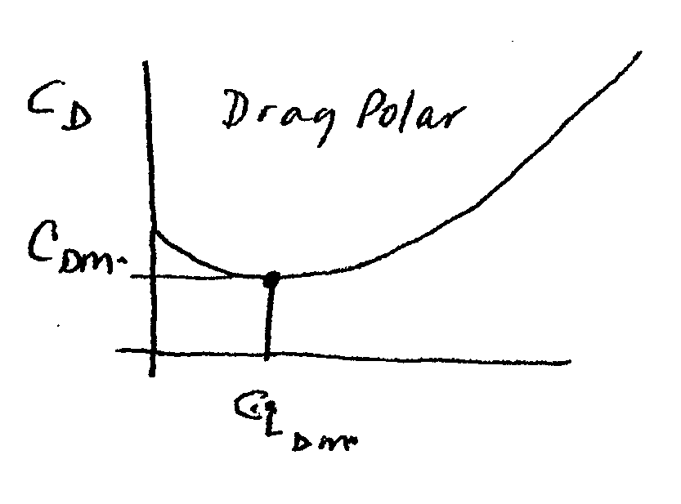
$C_{L_{\text{static}}}=C_{L_{0}}+C_{L_{α}}α+C_{L_{de}}d_{e}$
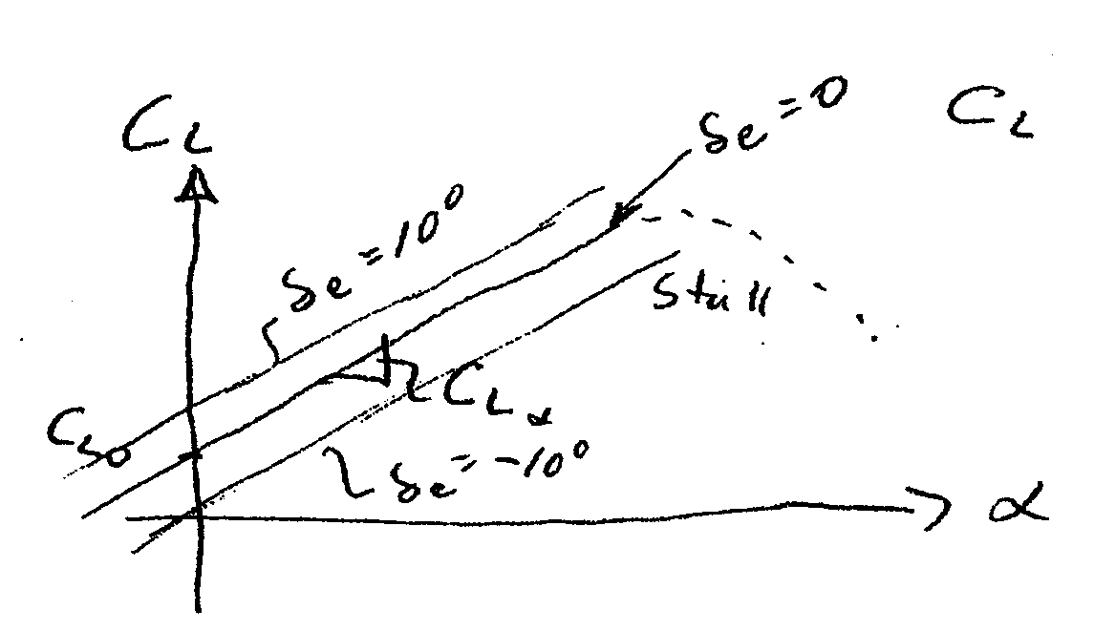
We will use only the linear form for lift. Although to model still we need to use a different form
$C_{L}=C_{L_{\text{static}}}+\underset{C_{L_{\text{dynamic}}}}{\underbrace{C_{L\overset{˙}{α}}\frac{\overset{˙}{α}\bar{c}}{z\left|\bar{v}\right|}+C_{L_{Q}}\frac{Q\bar{c}}{z\left|\bar{v}\right|}}}$
$C_{y_{w}}=C_{y_{0}}+C_{y_{β}}β+\underset{\underset{\underset{C_{y_{\text{static}}}}{¯}}{}}{C_{y_{dr}}dr}+C_{y_{da}}da+\underset{C_{y_{\text{dynamic}}}}{\underbrace{C_{y_{p}}\frac{\text{pb}}{z\left|\bar{v}\right|}+C_{y_{R}}\frac{\text{Rb}}{z\left|\bar{v}\right|}}}$
A.7. Aerodynamic Moment Model about cg (body axis system)
Rolling Moment
$C_{l}=\underset{C_{l_{\text{static}}}}{\underbrace{C_{l_{0}}+C_{l_{β}}β+C_{l_{da}}da+C_{l_{dr}}dr}}\underset{C_{l_{\text{dynamic}}}}{\underbrace{+\frac{b}{z\left|\bar{v}\right|}\left[C_{l_{P}}P+C_{l_{R}}R\right]}}$
Pitching Moment about cg

about cg $C_{M}=C_{M}^{\text{ref}{}^{}}+C_{Z}\left(\frac{x_{\text{ref}}}{\bar{c}}−\frac{x_{\text{cg}}}{\bar{c}}\right)$
about arb. ref. point. $→ C_{M}^{\text{ref}}=\overset{C_{M_{\text{static}}}}{\overbrace{C_{M_{0}}+C_{M_{α}}α+C_{M_{δe}}δe}}$
$\underset{C_{M_{\text{dynamic}}}}{\underbrace{\frac{α\bar{c}}{z\left|\bar{v}\right|}C_{M_{\overset{˙}{α}}} +\frac{Q\bar{c}}{z\left|\bar{v}\right|}}} C_{M_{Q}}$
often $C_{M_{0}} C_{M_{α}} C_{M_{δe}}$ are functions of Mach number. We will ignore this.

Yawing moment
about arbitrary reference point
$$C_{N}^{\overset{↑}{\text{ref}}}=\underset{C_{N_{\text{static}}}}{\underbrace{C_{N_{0}}+C_{N_{β}}β+C_{N_{δa}}δa+C_{N_{δr}}δr}}\underset{C_{N_{\text{dynamic}}}}{\underbrace{+\frac{b}{z\left|\bar{v}\right|}\left(C_{N_{P}}P+C_{N_{R}}R\right)}}$$
about cg
$$C_{N}^{↑}=C_{N}^{\text{ref}}−\frac{\bar{c}}{b}C_{Y}\left(\frac{x_{\text{ref}}}{\bar{c}}−\frac{x_{\text{cg}}}{\bar{c}}\right)$$
A.8. C. G. Different from Moment Reference Point
Assume there is a moment reference point located behind the cg
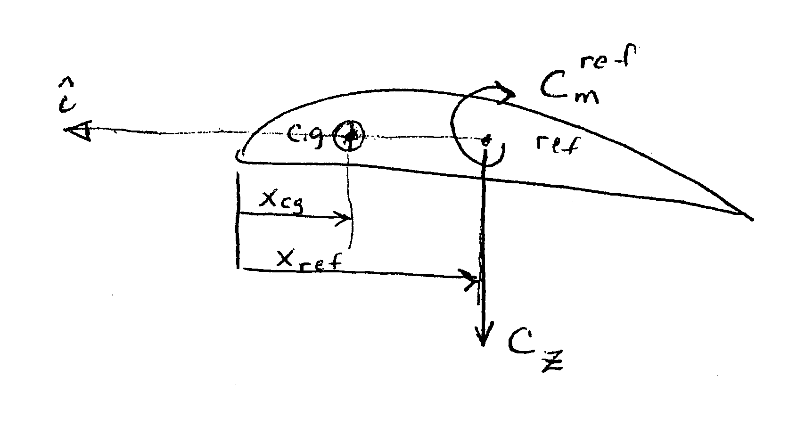
Ignore pitching moments due to drag and y-force
about cg $→ C_{M}=C_{M}^{\text{ref}}+C_{Z}\left(\frac{x_{\text{ref}}}{z}−\frac{x_{\text{cg}}}{\bar{c}}\right)$
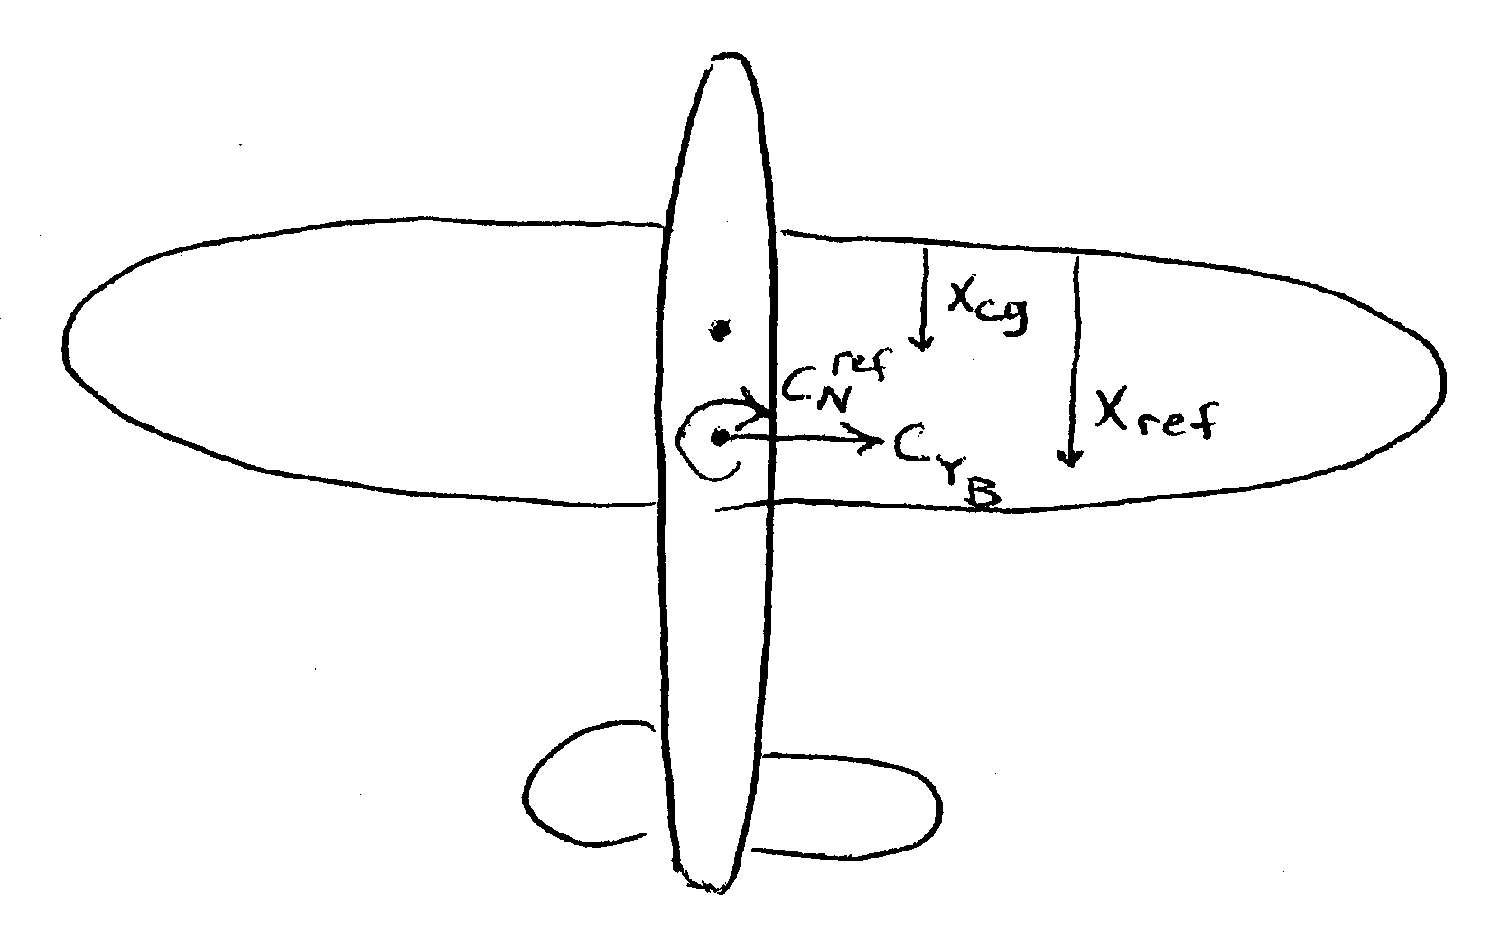
Ignore yawing moments due to lift and drag forces
Body axis component of aero force in Y direction
$C_{N}=C_{N}^{\text{ref}}−C_{Y}^{↓}\left(\frac{x_{\text{ref}}}{b}−\frac{x_{\text{cg}}}{b}\right)$
$=C_{N}^{\text{ref}}−\frac{\bar{c}}{b}C_{Y}\left(\frac{x_{\text{ref}}}{\bar{c}}−\frac{x_{\text{cg}}}{\bar{c}}\right)$

Summary of Unknown Aerodynamic Parameters
Drag | $$\begin{aligned}k \\ C_{L_{\text{DM}}} \\ C_{\text{DM}}\end{aligned}$$ | Lift at minimum drag  Minimum drag coef. | big, medium, small  Importance  big
Lift | $$\begin{aligned}C_{L_{0}} \\ C_{L_{α}} \\ C_{L_{δe}} \\ C_{L_{\overset{˙}{α}}} \\ C_{L_{Q}}\end{aligned}$$ | Lift coef at zero $α$  Lift curve slope  Lift due to elevator  Lift due to $\overset{˙}{α}$  Lift due to pitch rate | big  big  big  medium size  medium size
Side Force | $$\begin{aligned}C_{y_{0}} \\ C_{y_{β}} \\ C_{y_{δr}} \\ C_{y_{δa}} \\ C_{y_{P}} \\ C_{y_{R}}\end{aligned}$$ | Side force when $β=δr=δa=P=R=0, \text{usually}=0$  Side force due to slideslip , big  Side force due to rudder , big  Side force due to aileron , small  Side force due to roll rate , small  Side force due to yaw rate , medium
Cg location | $$\begin{aligned}{x_{\text{cg}}}/{\bar{c}} \\ {x_{\text{ref}}}/{\bar{c}}\end{aligned}$$
Roll Mom. | $$\begin{aligned}C_{ℓ_{0}} \\ C_{ℓ_{β}} \\ C_{ℓ_{δa}} \\ C_{ℓ_{δR}} \\ C_{ℓ_{P}} \\ C_{ℓ_{R}}\end{aligned}$$ | Roll moment when $β=δr=δa=P=R=0 , \text{usually}=0$  Rolling mom. due to slideslip, dihedral effect , big  Rolling mom. due to aileron, aileron effectiveness, big  Rolling mom. due to rudder, medium  Rolling mom. due to rollrate, damping in roll, big  Rolling mom. due to yaw rate, small
Pitch Mom. | $$\begin{aligned}C_{M_{0}} \\ C_{M_{α}} \\ C_{M_{δe}} \\ C_{M_{\overset{˙}{α}}} \\ C_{M_{Q}}\end{aligned}$$ | Pitch mom. when $α=δe=\overset{˙}{α}=Q=0$, big  Pitch mom. due to $α$ , big  Pitch mom. due to $de$, elevator effectiveness , big  Pitch mom. due to $\overset{˙}{α}$ , lag of downwash denv. , big  Pitch mom. due to $Q$, damping in pitch , big
Yawing Mom. | $$\begin{aligned}C_{N_{0}} \\ C_{N_{B}} \\ C_{N_{da}} \\ C_{N_{dr}} \\ C_{N_{P}} \\ C_{N_{R}}\end{aligned}$$ | Yaw mom. when $β=da=dr=P=R=0,\text{usually}=0$  Yaw mom. due to sideslip, weathercock stab. , big  Yaw mom. due to aileron, medium  Yaw mom. due to rudder, rudder effectiveness , big  Yaw mom. due to rollrate, small  Yaw mom. due to yaw rate, damping in yaw, big

- A Minor Problem with $\overset{˙}{α}$
B.1. Definition
since
$\text{tan}α=\frac{W}{U}$
$\overset{˙}{α}=\frac{U\overset{˙}{W}−W\overset{˙}{U}}{U^{2}+W^{2}}$
An approximation to this equation is sometimes used. Since $U\text{>>}W$ and $U\text{>>}V$
$U^{2}+W^{2} ≈ U^{2}$
i.e.
$V^{\text{and} W \text{are}} \text{typically} \text{small} \text{compared} \text{to} U$
also $U\text{>>}W$ so
$U\overset{˙}{W}\text{>>}W\overset{˙}{U}$
Therefore
$\overset{˙}{α}≈\frac{\overset{˙}{W}}{U}$
B.2. The Problem
Notice that $C_{L^{\text{and} C_{M} \text{are}}}$ a function of $\overset{˙}{α}$ or equivalently $\overset{˙}{W}$. This makes $F_{A_{x}} F_{A_{y}}$ and $F_{A_{z}}$ functions of $\overset{˙}{W}$, i.e. $F_{A_{z}}(\overset{˙}{W}, …)$. The equations of motion for body axis force have $\overset{˙}{W}$ on the left hand side and on the right hand side, i.e.
$\overset{˙}{W}=\text{QU}−\text{PV}+g_{0}^{'}\text{cos}φ\text{cos}+\frac{F_{\text{Az}}}{m}(\overset{˙}{W}, …)$
We would like to solve for the $\overset{˙}{W}$ term on the right hand side, move it to the left hand side, combine terms on the LHS and divide through by the multiplier of $\overset{˙}{W}$.
Suppose
$F_{A_{z}}(\overset{˙}{W}, α, δ_{e}, Q)=F_{1}(\overset{˙}{W})+F_{A_{z}}^{'}(α, δe, Q)$
where
$F_{1}(\overset{˙}{W})=a\overset{˙}{W}$
$↑$ some multipliers of $\overset{˙}{W}$
Then
$\overset{˙}{W}\left(1−\frac{a}{m}\right)=\text{QU}−\text{PV}+g_{0}^{'}\text{cos}φ\text{cos}θ+\frac{F_{z}^{'}}{m}(α, δ_{e}, Q)$
and
$\overset{˙}{W}=\frac{1}{1−\frac{a}{m}}\left[\text{QU}−\text{PV}+g_{0}^{'}\text{cos}φ\text{cos}θ+\frac{F_{z}^{'}}{m}(α, δ_{e}, Q)\right]$
Now we have a diff. eqn. where $\overset{˙}{W}$ only appears on the LHS.
When we go to solve the moment equation we have the following problem
$\overset{˙}{Q}=C_{s}\text{PR}−C_{6}(P^{2}−R^{2})+C_{7}M(\overset{˙}{W}, α, δe, Q)$
But this problem is simpler because we have an explicit equation for $\overset{˙}{W}$ above that we can use on the RHS of the $\overset{˙}{Q}$ equation. Therefore we can determine $\overset{˙}{Q}$.
It turns out that $a=−\bar{q}S\frac{\text{cos}α}{m}C_{L_{\overset{˙}{α}}}\frac{\bar{c}}{z\left|\bar{v}\right|}\frac{1}{U}$

Recall
$\overset{˙}{W}=\text{QU}−\text{PV}+g_{0}^{'}\text{cos}φ\text{cos}θ+\frac{F_{z}}{m}$
but a portion of $F_{z}$ is a function of $\overset{˙}{α}$ and therefore $\overset{˙}{W}$. Let’s examine this term separately. Use the approximation that $\overset{˙}{α}=\frac{\overset{˙}{W}}{U}$
$$\begin{aligned}\left[F_{A_{x}} | \right]\left[F_{A_{y}} | \right] \\ \end{aligned}$$
but $C_{L}=f_{1}(\overset{˙}{α})+f_{2}(α, δ_{e}, Q)$
$f_{1}(\overset{˙}{α})=C_{L_{\overset{˙}{α}}}\frac{\overset{˙}{α}\bar{c}}{z\left|\bar{v}\right|}$
$f_{1}(\overset{˙}{w})=C_{L_{\overset{˙}{α}}}\frac{\bar{c}}{z\left|\bar{v}\right|}\frac{\overset{˙}{w}}{U}$
$f_{2}=C_{L_{0}}+C_{L_{α}}α+C_{L_{δe}}δe+C_{L_{Q}}\frac{Q\bar{c}}{z\left|\bar{v}\right|}$
$$\begin{aligned}\left[F_{A_{x}} | \right]\left[F_{A_{y}} | \right] \\ \end{aligned}$$
$=\bar{q}s\left[\begin{matrix}+\text{sin}α f_{1}(\overset{˙}{w}) \\ 0 \\ −\text{cos}α f_{1}(\overset{˙}{w})\end{matrix}\right]+\bar{q}s T^{w \text{to} B}\left[\begin{matrix}−C_{D} \\ +C_{y} \\ −f_{2}\end{matrix}\right]$
$↑$ ignore this term since it is small.
$$\left[\begin{matrix}F_{A_{x}} \\ F_{A_{y}} \\ F_{A_{z}}\end{matrix}\right]=\left[\begin{matrix}0 \\ 0 \\ −\bar{q}s\text{cos}{αC}_{L_{\overset{˙}{α}}}\frac{\bar{c}}{z\left|\bar{v}\right|}\frac{\overset{˙}{w}}{U}\end{matrix}\right]\underset{\left[\begin{matrix}F_{A_{x}} \\ F_{A_{y}} \\ F_{A_{z}^{'}}\end{matrix}\right]}{\underbrace{+\bar{q}s T^{w \text{to} B}\left[\begin{matrix}−C_{D} \\ +C_{y} \\ −f_{2}\end{matrix}\right]}}$$
$$∴ \overset{˙}{w}=\text{QU}−\text{PV}+g_{0}^{'}\text{cos}φ\text{cos}θ+\frac{F_{A_{z}^{'}}}{m}−\bar{q}\frac{s\text{cos}}{m}{αC}_{L_{\overset{˙}{α}}}\frac{\bar{c}}{z\left|\bar{v}\right|}\frac{\overset{˙}{w}}{U}$$
$\overset{˙}{w}\left(1−\frac{a}{m}\right)=\text{QU}−\text{PV}+g_{0}^{'}\text{cos}φ\text{cos}θ+\frac{F_{A_{z}^{'}}}{m}$
$$\overset{˙}{w}=\left(\frac{1}{1−\frac{a}{m}}\right)=\left[\text{QU}−\text{PV}+g_{0}^{'}\text{cos}φ\text{cos}θ+\frac{F_{A_{z}^{'}}}{m}\right]$$
and then $\overset{˙}{α}≃\frac{\overset{˙}{w}}{U}$
$\overset{˙}{α}=\frac{1}{U}\left(\frac{1}{1−\frac{a}{m}}\right)\left[\text{QU}−\text{PV}+g_{0}^{'}\text{cos}φ\text{cos}θ+\frac{F_{A_{z}^{'}}}{m}\right]$
and we can substitute this into the pitching moment equation at the $C_{m_{\overset{˙}{α}}}$ term.
- Propeller Thrust Model
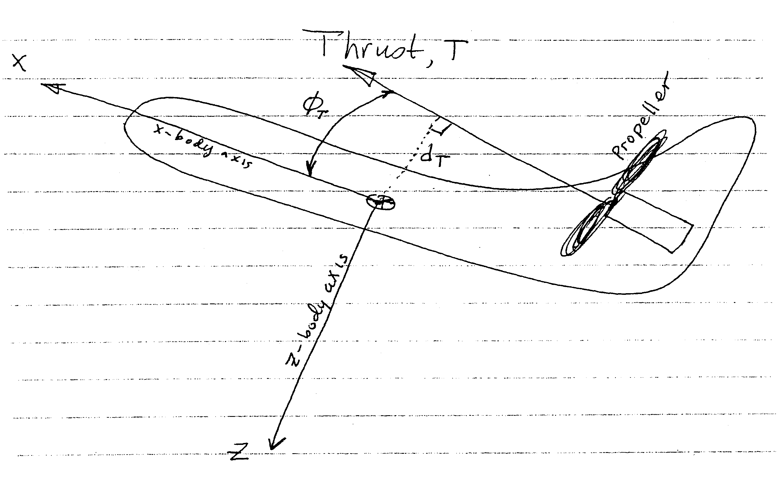
$d_{T}$ is the thrust offset distance
$φ_{T}$ is the thrust offset angle
T is the magnitude of the thrust

$T=\text{550} \text{Bhp} {N_{p}}/{V_{t}}$ (lbf)
Bhp is the brake horsepower of the engine (hp)
$N_{p}$ is the propeller efficiency (non-dimensional)
$V_{t}$ is the aircraft speed (ft/sec)

Thrust is assumed to act in the x-z plane.

