**Aircraft Spin Testing**

Read chapter 34 of your text.

Definition: A Spin is an out-of-control maneuver in a stalled condition during which the aircraft rotates while descending at high rates of descent. Spins can be either upright or inverted.

**Video of an Extra 300**

Upright flat spin (opposite aileron and power-on (left spin entry) to cause, recover power off aileron neutral, opposite rudder)

<http://www.youtube.com/watch?v=EJp6WAEVlwY>

Inverted flat spin (entered from inverted flight right spin add full power and right aileron; recover with power off neutral aileron, full opposite rudder)

<http://www.youtube.com/watch?v=klI40PzlQAM&NR=1>

**PA-28-161 Warrior III Spin Recovery**

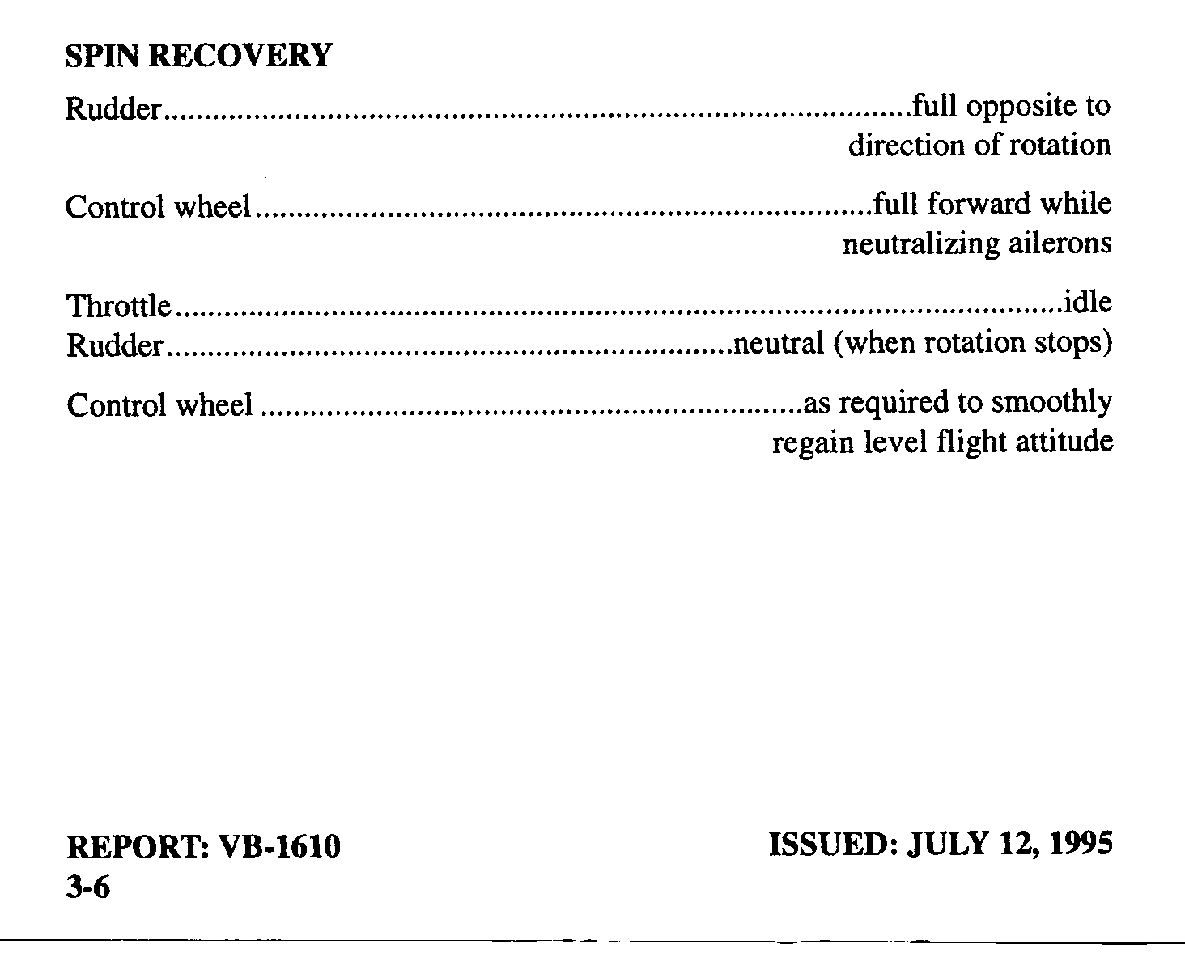

**Other Spin Videos**

Aeronca http://www.youtube.com/watch?v=S49vL4NAt9k

[Republic Seabee **Spin** Test](http://www.youtube.com/watch?v=8-T0zuV3pg0) http://www.youtube.com/watch?v=8-T0zuV3pg0

Spin video

http://www.youtube.com/watch?v=OiKcG7NOdUk&feature=PlayList&p=5FC16457C735833C&playnext_from=PL&playnext=1&index=47

Light Aircraft outside view

http://www.youtube.com/watch?v=XCfLZ054yc8&feature=PlayList&p=89083BEE5D40027F&playnext_from=PL&playnext=2&index=33

NASA GA testing using free flying model aircraft

http://www.youtube.com/watch?v=KfLuyyK5BAQ

T-45 wiyh difficult recovery

http://www.youtube.com/watch?v=NpGwst3VQiM&NR=1

F-22

http://www.youtube.com/watch?v=ML6pQ_6Lgf4