Executive Summary
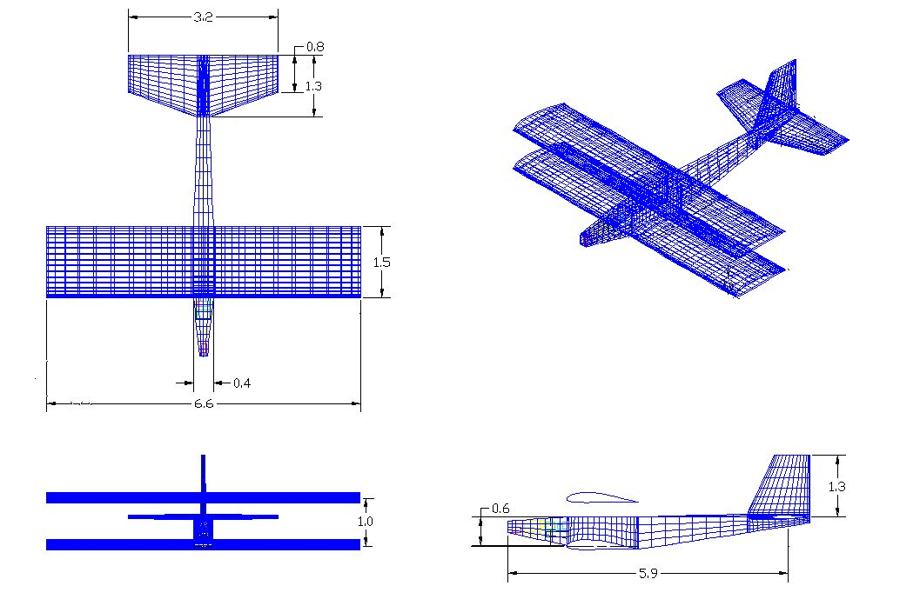

The mission specification calls for the design of a remotely piloted model aircraft. This aircraft must be able to carry a rate gyroscope for augmenting vehicle stability. The vehicle must meet a minimum endurance flight time of 12 minutes. It must be easily transportable, fitting in a compact car. The vehicle must have the capability to carry 1 lb of data logging equipment. The aircraft structure was to be built for less than $200 US dollars within a two week time period. The vehicle must be robust to crashes, taking into account the flight facility conditions. The mission must be completed within Mollenkopf Athletic Center, the indoor football training facility at Purdue University.
To complete the mission indoors, it was determined that the vehicle must fly at a slow speed with 30 ft/s being the maximum cruise speed. The vehicle must have a climb angle of at least 5.5 degrees. The vehicle must take off in a maximum distance of 120 feet. To complete a turn within the football field the vehicle must have a turn radius less than 37.5 feet.
Taking into account all the desired specifications a large wing area would be necessary to complete the mission. To avoid producing a multiple piece wing and remain within the compact guides a biplane plane was chosen. This design not only shortened the overall span, but also increased the maneuverability of the aircraft. Orion Aerospace’s aircraft, SID-5, was constructed mostly of a balsa truss configuration reinforced by a MonoKote skin. This resulted in a sturdy and light aircraft.
The overall design and fabrication took place within 13 weeks. Analyzing the overall cost of the prototype it was determined that man-hours were the most expensive part of SID-5’s design. The aircraft met and surpasses all desired expectations proving to be more maneuverable than originally designed.
Design Summary

Figure I: Three Dimensional View of SID-5 with internal components

Table I. Aircraft Parameters
Wing span (b) | 6.6 ft | Span v-tail | 1.3 ft
Chord | 1.5 ft | Root chord V-tail | 1.3 ft
Fuselage length | 5.9 ft | Tip chord V-tail | 0.8 ft
Span h-tail | 3.2 ft | L.E. sweep V-tail | 21.0°
Root chord h-tail | 1.3 ft | ¼ chord sweep v-tail (degrees) | 10.9°
Tip chord h-tail | 0.8 ft | Vertical tail area | 1.3 ft²
L.E. sweep h-tail  (degrees) | 18.4° | Total wetted area | 61.2 ft²
Horizontal tail area | 3.3 ft² | Incidence wing  (degrees) | 3°°
¼ chord sweep h-tail (degrees) | 14.0° | Incidence h-tail | 0°

Introduction

The mission specification calls for the design of a remotely piloted model aircraft. This aircraft must be able to carry a rate gyroscope for augmenting vehicle stability. The vehicle must meet a minimum endurance flight time of 12 minutes. It must be easily transportable, fitting in a compact car. The vehicle must have the capability to carry 1 lb of data logging equipment. The aircraft structure was to be built for less than $200 US dollars within a two week time period. The vehicle must be robust to crashes, taking into account the flight facility conditions. The mission must be completed within Mollenkopf Athletic Center, the indoor football training facility at Purdue University.
To complete the mission indoors, it was determined that the vehicle must fly at a slow speed with 30 ft/s being maximum. The vehicle must have a climb angle of at least 5.5 degrees. The vehicle must take off in a maximum distance of 120 feet. To complete a turn within the football field the vehicle must have a turn radius less than 37.5 feet.
The overall design by Orion Aerospace employs a biplane to reduce the wingspan and increase maneuverability. With a shorter wingspan it was easier to meet the indoor turn radius constraint. A biplane configuration also reduced the need for additional high lift devices, aiding in the construction efforts. A square fuselage and rectangular wings were chosen to save in construction complexity and project cost. A conventional tail was chosen based on historical model aircraft. The tail dragging landing gear utilized simplified construction and allowed for more accurate fabrication. To begin design a constraint diagram was constructed to determine target wing and power loading. The preliminary numbers served as guidelines in the initial phases of design.

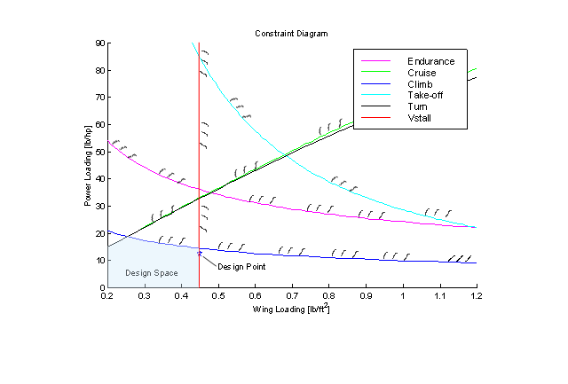

Figure II. Constraint Diagram

Design Process

I. Aerodynamics

Aerodynamic analysis began shortly after Orion’s concept was determined with the selection of the wing airfoil. The complexity of the aerodynamic analysis was increased due to the biplane configuration. The motivation behind aerodynamic design was to provide a low drag airfoil for the wings, horizontal and vertical tail while producing enough lift for each phase of the mission.
To begin the aerodynamic analysis first the airfoil for the wings, vertical tail, and horizontal surfaces were determined. The two dimensional coefficients were computed from both experimental and theoretical data. A biplane is an atypical aircraft design to implement. This made calculations for coefficient of lift and drag quite complex. Warner’s method was first utilized to obtain the aerodynamic coefficients (Ref 1.1). This method was verified using Roskam’s aerodynamic method (Ref 1.2) The coefficient of moment about the center of gravity for several elevator deflections was then determined (Equation A.30). The Endurance parameter for best velocity was determined (Equation A.26) CMARC, a computation fluid dynamics code, was utilized to verify aerodynamic results.
The additional wing of the biplane shortened the overall span of the aircraft. The second wing both reduced the need for additional high lift devices and resulted in the adverse effect of an increase in interference drag

1.1 Airfoil Selection

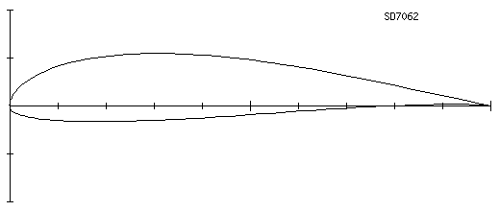
Orion Aerospace chose the Selig-Donovan 7062 for as the airfoil for the wing (See Figure 1.1).

Figure1.1: SD 7062 Airfoil
To determine which airfoil would be best for the design, a database of low Reynolds number, slow speed airfoils was compiled. From this database the geometry of the airfoil was then considered. Taking into account the limits placed upon time and the experience with model construction airfoils that were highly cambered or employed cusped trailing edges were avoided. Placing this constraint on the wing resulted in a handful of airfoils. Experimental data for the two-dimensional coefficient of lift, coefficient of drag, and coefficient of moment were obtained for these airfoils. (www.nasg.com) This data was then compared to two-dimensional data obtained from running Xfoil (See Appendix A). The two-dimensional coefficients were then compared results can be seen in Figure A.3 and Figure A.5. The horizontal and vertical tails were modeled as flat plates.
Most of the time during flight will be spent in a cruise phase. As found in the constructed matlab design sizing code the coefficient of lift will be 0.7 at cruise. (See Appendix G for code) Choosing an airfoil that provided minimal drag at this point is beneficial to design. Of all the airfoils chosen the SD 7062 provided the greatest lift with the least amount of drag at the cruise design point.

1.2 Three Dimensional Coefficients
Once the airfoil was selected the three dimensional coefficients were determined. The aerodynamics became complicated when the biplane was concerned. There was not one way to accurately determine specific aerodynamic coefficients for a biplane. Warner’s paper on biplane aerodynamics outlines a method in which three-dimensional coefficients can be determined. Warner’s method was verified using the Roskam series of aircraft design. Analysis was completed using an Oswald efficiency factor for biplanes. (See Appendix A). Utilizing Warner’s method a CL-max of 1.25 was determined. Roskam’s method determines a CL-max of 1.48. It is noted that both of these methods provided a three dimensional CLmax less than the two dimensional 1.53 CLmax.

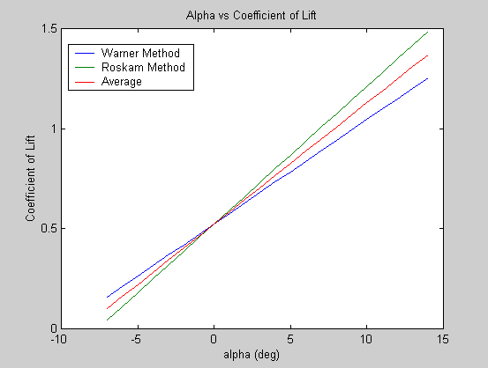
CLmax
Method
1.25
Warner
1.53
2-D
1.3773
Average
1.48
Roskam

Figure 1.2: Three-Dimensional Coefficient of Lift vs. Angle of attack
Plotting the three-dimensional drag polar for the SD7062 allowed for the coefficient of drag at each phase of the mission to be calculated.
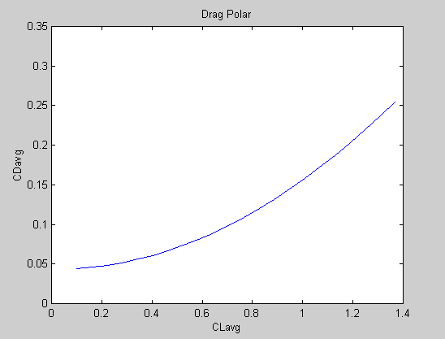

1
9.0°
Stall
.84
5.2°
Turn
.70
3.0°
Cruise
.75
4.0°
Climb
CL
Angle of Attack
Phase

Figure 1.3: Three-Dimensional Drag Polar at Cruise Reynolds Number
Graphing the lift over drag vs. angle of attack allowed for the angle where the max L/D occurs to be determined. (See Figure A.10) It can be seen in Figure A.10 that the max L/D occurs around the cruise angle of attack. This is an important observation because most of the mission will be spent in the cruise phase

1.3 Endurance Parameter
The endurance parameter for the aircraft allows for the best endurance velocity and the best endurance angle of attack to be determined (see Figure 1.4). The calculations for this value can be found in Equation A.26 in Appendix A.
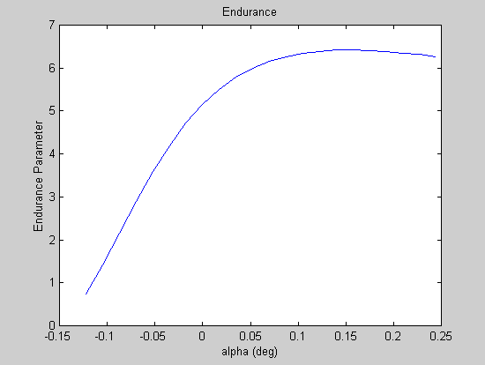

Figure 1.4: Endurance Parameter
It was found that the best endurance velocity is 20.5 ft/s, and the best endurance angle is 8.4 degrees. The proximity of the best endurance values to stall values lead Orion Aerospace to determine that the aircraft would not fly at the best endurance velocity.
The coefficient of moment about the center of gravity can be seen in Figure 1.5. This graph shows that the aircraft can be trimmed at flight conditions. A greater analysis of the coefficient of moment can be found in the stability and controls section
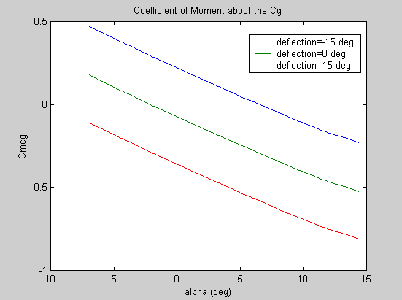

Figure 1.5: Coefficient of moment about the Center of Gravity
1.4 CMARC Analysis
To verify calculated coefficients CMARC and PMARC codes were utilized. (See Appendix A for explanation) An isometric view of the coefficient of pressure of the aircraft can be seen in Figure A.9.
CMARC data can be utilized to verify calculated aerodynamic coefficients. CMARC provided accurate values for the cruise coefficient of lift, but did not accurately predict the coefficient of drag.

ii. Dynamics and Control

The dynamics and control analysis of the SID-5 was accomplished through several steps. First, the horizontal tail, vertical tail, and the control surfaces were sized. Then a suitable static margin was determined. Following these initial choices, a static stability analysis was performed on the design to help ensure longitudinal and lateral-directional stability of the chosen configuration. Although it would have been advantageous to do a complete dynamic stability analysis on the configuration, this was deemed infeasible due to a lack of sufficient time. It turned out that the static stability criterion were sufficient to ensure stability. Next, a trim analysis was performed on the chosen design to verify that the aircraft could trim for all flight conditions and possible static margins. Finally, a major aspect of this project was to incorporate rate feedback to the pitch axis of motion. Through open loop analysis, a gain was calculated that could be implemented in a feedback loop in order to augment the stability of the SID-5 in the pitch axis.

2.1 Sizing of the Empennage
The horizontal and vertical tails were sized using the tail volume coefficient method [Ref. 2.1]. The tail volume coefficient is a parameter that incorporates the tail surface area, tail moment arm, wing area, and a characteristic wing length. If all the other parameters are known, the tail surface area can be obtained. At this point in the design, the wing dimensions had already been defined and the fuselage length constrained to 5.9 ft, so the only parameters that remained to be found were the horizontal and vertical tail volume coefficients. Past AAE 451 designs were referenced in order to obtain suitable values for these coefficients [Ref. 2.2, 2.3, 2.4]. Choosing values in the range of those used on these past designs, the horizontal and vertical tail volume coefficients for the SID-5 were determined to be 0.45 and 0.04, respectively. For simplicity and ease of construction, both tails were designed as flat plates, as is common on model aircraft. The aspect and taper ratios were selected based on guidelines set forth by Raymer [Ref. 2.1]. These guidelines are intended to result in a tail that stalls before the main wing in order to avoid aircraft stall. The results of this tail sizing are shown in Table 2.1.

Table 2.1: Tail Sizing Results
3.3
1.3
Planform Area (ft²)
0.0
0.0
Dihedral (deg)
18.4
21.0
LE Sweep (deg)
0.6
0.6
Taper Ratio
3.00
1.30
Aspect Ratio
1.1
1.0
AvgChord(ft)
3.2
1.3
Span(ft)
H-tail
V-tail

2.2 Control Surface Sizing
The sizes of the control surfaces were also determined according to historical guidelines set forth by Raymer [Ref. 2.1]. Picking control surface sizes in the ranges declared suitable in the said reference yielded ailerons that are 15% of the wing chord and 90% of the wing span, elevators that are 40% of the horizontal tail chord and 95% of the horizontal tail span, and a rudder that is 40% of the vertical tail chord and runs along the full span of the vertical tail.

2.3 Static Margin, Center of Gravity, and Aerodynamic Center
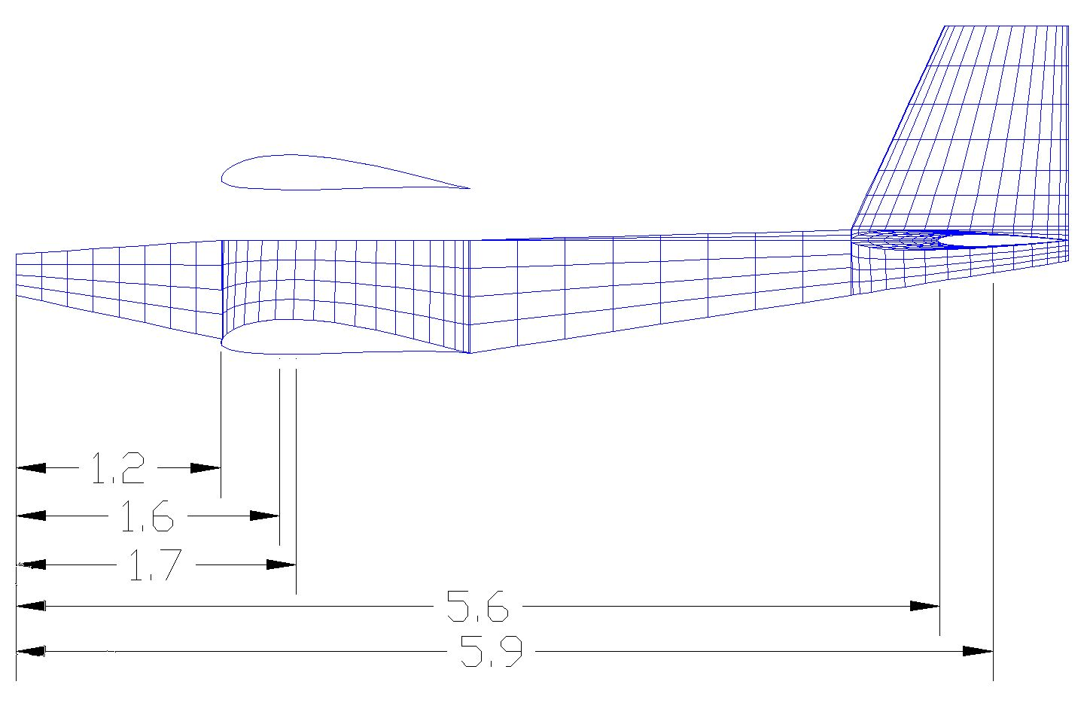
The SID-5 was designed to fly at a static margin of 10%, which, according to the aerodynamic center location calculated in the aerodynamic analysis, yielded a center of gravity location that was just past the quarter chord of the wing, at around 27% of the chord. This static margin was picked mainly on the basis of modeling experience. Patrick Dempsey, the Orion Aerospace team leader, and Dave Henady, one of the test pilots, having many years of modeling experience between them, advised that model aircraft with exceptional flying qualities tend to have the center of gravity located at the wing quarter chord or slightly behind it. Therefore, the 10% static margin was chosen because it placed the center of gravity at this recommended location. Sufficient room was made available in the fuselage to allow for appropriate placing of internal components to achieve this desired static margin. It should be noted that the SID-5 flew extraordinarily well with this static margin. Figure 2.1 shows the location of the center of gravity and aerodynamic center in relation to other parts of the aircraft. Note that in the figure, LE stands for leading edge, CG stands for center of gravity, AC stands for aerodynamic center, and HT stands for horizontal tail.
X_{LE}
X_{CG}
X_{AC}
X_{ACHT}
X_{total}

.

Figure 2.1: Center of Gravity and Aircraft Aerodynamic Center Locations

2.4 Static Stability Analysis
To help ensure that SID-5 would be stable in flight, a few pertinent static stability derivatives were calculated and a comparison was made against the values of two other aircraft. These values were calculated using the methods of Roskam [Ref. 2.5, 2.6] (see Appendix B for code used for these calculations). Table 2.2 shows this comparison. The derivatives listed in the table are, from top to bottom, airplane pitching moment due to change in angle of attack (α), airplane yawing moment due to change in sideslip angle (β), airplane pitching moment due to elevator deflection (δ_{e}), and airplane yawing moment due to rudder deflection (δ_{r}). Note that the derivatives for the Cessna 172 are given by Roskam [Ref. 1.2] and that the MPX5 is a small RC model aircraft designed by Mark Peters for the purposes of his thesis [Ref. 2.6].

Table 2.2: Pertinent Static Stability Derivative Comparison
-1.15
-1.28
-0.81
C_{mδe}
-0.11
-0.07
-0.08
C_{nδ r}
0.16
0.07
0.12
C_{nβ}
-1.13
-0.89
-0.40
C_{mα}
MPX5
Cessna
172
SID-5
All units are
rad⁻¹

As can be seen from the values listed in the table, the SID-5 has static stability derivatives that are roughly of the same magnitude as those listed for the other two airplanes. The pitching moment due to angle of attack and the pitching moment due to elevator deflection derivatives for the SID-5 are both relatively low, but still on the same order of magnitude as the values associated with the Cessna and MPX5. Since these derivatives govern the aircraft’s static response to perturbations of the flight conditions, this comparison provided a reasonable degree of assurance that the SID-5 would fly as desired. The results of flight-testing confirmed this prediction. It should also be noted that the yawing moment due to sideslip derivative exceeds the constraint suggested by Roskam [Ref. 1.2]. Roskam recommends that for sufficient directional stability the yawing moment due to sideslip derivative should be greater than or equal to approximately 0.057 per radian. This particular derivative is a function of the vertical tail area so the fact that this constraint was exceeded verified that SID-5’s vertical tail was large enough to ensure directional stability (see Appendix B for a graphical depiction). It probably would have been possible to reduce the size of the vertical tail, according to this result, but it was decided that the extra yaw authority provided by the larger vertical stabilizer was preferred over the minor drag and weight penalties associated with the larger tail area.

2.5 Trim Analysis
Using the linearized lift and pitching moment data provided by the aerodynamic analysis, trim diagrams were constructed to verify that SID-5 would be trimmable for all flight conditions with an appropriate amount of elevator deflection. These diagrams were constructed using the method described by Roskam [Ref. 2.5] (see Appendix B for code used in this analysis). It was decided to set both the top and bottom wings at 3 degrees of positive incidence in order to achieve the cruise lift coefficient of 0.7 at zero angle of attack. This would allow the aircraft to fly with the fuselage level during cruise, thus reducing drag. The horizontal tail was set at 0 degrees incidence to reduce drag during cruise. Figure 2.2 and 2.3 are the trim diagrams for SID.
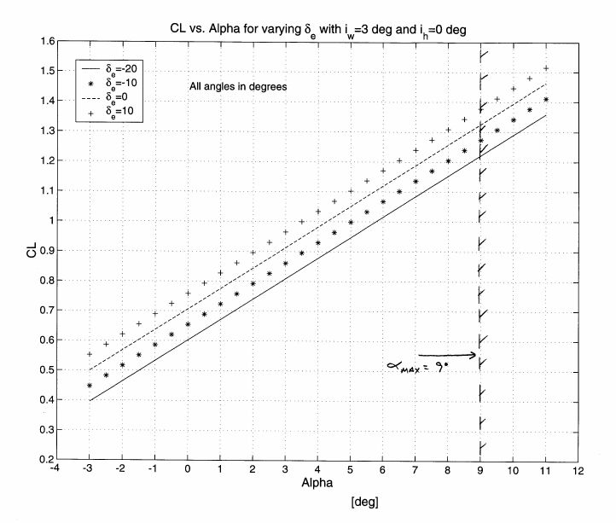

Figure 2.2: Lift Coefficient vs. Angle of Attack for Varying Elevator Deflection

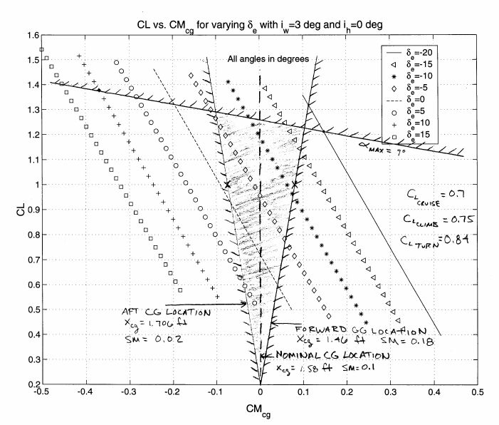

Figure 2.3: Trim Triangle

Figure 2.2 shows the entire range of lift coefficients achievable by SID-5 for a range of elevator deflections and that the cruise lift coefficient of 0.7 is achievable at 0 degrees angle of attack with no elevator deflection. Figure 2.3, the trim triangle, shows the entire flight envelope at which the aircraft can trim. The shaded portion of the triangle shows this envelope. The triangle is bounded on the top by the stall angle of attack of the aircraft and on the sides by the forward and aft center of gravity lines. These center of gravity lines account for shifts in the center of gravity or static margin from the desired value. Since the SID-5 is electric powered, these shifts will not occur due to changing fuel levels as in internal combustion powered aircraft. However, shifting payload could cause the center of gravity to shift, and it was also likely that in loading the internal equipment the exact desired center of gravity or static margin would not always be achieved. The trim triangle shows that the aircraft is trimmable for static margins between 2-18% for the entire range of lift coefficients it would see during the mission, these being for the cruise, climb, and turn phases. As can be seen from the figure, the amount of elevator deflection required for trim ranges from about +6 to –17 degrees. Based on modeling experience this was deemed an acceptable level of deflection that would not cause the tail surface to stall. Note for trimmed flight at the cruise lift coefficient that only 2-3 degrees of down elevator is required. This was confirmed during flight-testing, as the pilot remarked that he had to add a touch of down elevator to trim the aircraft while cruising.

2.6 Feedback Implementation
A major part of the mission for this design was to incorporate rate feedback to one of the axes of motion using a mechanical rate gyro. It was decided that the SID-5 would incorporate feedback to the pitch axis. A diagram of this loop closure is shown in Figure 2.4. Note that q denotes pitch rate, q_{m} denotes measured pitch rate, and k_{r} is the rate gyro gain that is implemented.

TX
RX
Servo
Aircraft

Pilot
q(s)
δ_{e}(s)
Pitch Rate Gyro

q_{m}
k_{r}
q_{m}(s)
q(s)
q
δ_{e}
+
+/-
k_{r}

Figure 2.4: Block Diagram of Feedback Loop

From this diagram, it can be seen that the pilot enters an elevator command to the transmitter, which passes the signal through the air to the receiver located in the aircraft. This signal then travels to the servo, which deflects the elevator. The deflected elevator then acts to produce a pitch rate through the aircraft transfer function. This pitch rate is measured by the rate gyro, and then fed back to the control loop after being amplified by the gain. The sign of the gain could be adjusted to either stabilize or destabilize the dynamic pitch response of the aircraft. Note that the short period mode approximation was used to approximate the aircraft transfer function determining the aircraft’s response to elevator deflection [Ref. 2.5]. The models used for approximating the servo and pitch rate gyro transfer functions are given in Appendix B.
The rate gyro gain that was implemented in the design was calculated using open loop transfer function analysis. A code provided by Prof. Andrisani was used to accomplish this analysis (see Appendix B). Originally the intention was to pick a gain that could be implemented at first to make the aircraft more stable in the pitch axis. The sign of the gain would then be switched to make the pitch response less stable. It should be noted that the numerical value of the gain could not be changed without excessive calibration of the gyro, so a gain had to be chosen that would not make the aircraft unstable when its sign was changed from the stabilizing to destabilizing sign. In other words, the destabilizing gain would make the response less stable, not unstable. To ensure that the closed loop poles of the system did not move into the right half plane, the region of instability, the implemented gain had to conform to gain and phase margin requirements. The gain that was chosen and the associated gain and phase margins as compared to the requirements are shown in Table 2.3.

Table 2.3: Implemented Gain Margin Characteristics and Requirements
>/= 10
>/= 45
Required Phase Margin (deg)
>/= 1
>/= 6
Required Gain Margin (dB)
Infinite
1.11
0.33
(destabilizing)
Infinite
25.8
-0.33
(stabilizing)
Phase Margin
(deg)
Gain Margin (dB)
Gain Implemented

As shown in the table, the implemented gains adhered to the established requirements. Nyquist plots were also produced to verify the calculated gain and phase margins. These plots are shown in Appendix B.
The stabilizing gain was implemented during flight-testing and was found to behave as expected. The pilot remarked that with the stabilizing gain activated the plane seemed “sluggish”. This makes sense, because stabilizing feedback acts to oppose perturbations and return the aircraft to its original state. He also remarked that when he gave exaggerated elevator inputs to the aircraft, creating large pitch perturbations, the aircraft’s oscillatory response was damped significantly relative to the response when the gain was not implemented. The destabilizing gain was never implemented during the test flights because there was insufficient opportunity to test it outdoors. Since the destabilizing gain was not tested outdoors, it was deemed too risky to attempt to implement it during the later indoor flights.

III. Structures

3.1Introduction
As with many aspects of aircraft design the structural makeup of the aircraft was highly crucial to its success. The aircraft must perform the requirements set forth by the mission while remaining durable, lightweight, and within the budget presented. The design was motivated mainly by historical knowledge of model aircraft. The construction process and time factor were also kept in mind. SID-5 was constructed in a traditional manner. Its wing was made up of a spar and rib configuration, while the rest of the structure, the fuselage and tail, were made up of joined balsa truss layouts. The aircraft sizing and layout were planned using extensive sizing and force model codes given in appendix C. With the parameters mentioned above and a high amount of effort set forth by the team, the structure of the aircraft was designed.

3.2 Material Properties
In beginning the design of the structure, the materials to be used were considered. The material properties of the aircraft are of great importance. SID-5 needed to be made of a strong yet lightweight material sturdy enough to withstand forces due to taking off, landing, turning and other possibly unforeseen impacts. The material must have been easily workable in the manufacturing process, and relatively inexpensive. The material properties of balsa, plywood, and spruce, which are shown below in Table 3.1, were considered.

Table 3.1: Properties of the materials used and considered for use in SID-5.

The majority of SID-5’s structure is balsa wood. Balsa wood is widely used in model aircraft for many reasons. Balsa is one of the lightest and softest woods in the world, while also being one of the strongest for its weight. This type of wood is durable, absorbing shock and vibration well. Every structural component of SID-5 is made from balsa except the spar caps in the wing and horizontal tail. The spar caps carry the majority of the bending load. For this reason, the spar caps were made out of spruce. Even though spruce is a heavier wood then balsa, it has a much higher yield stress. This is why spruce was considered a useful material for this part of the design.

3.3 Analysis
Once the basic design and the materials were chosen, analysis could be done on the load capabilities of the aircraft. Forces, such as wing loading, shear forces, moments, and normal forces, seen by the aircraft were calculated using a matlab code. The forces were modeled at a load factor of 3.75. This value for the load factor is well above anything that the aircraft would actually see, but in this way the aircraft would be designed using conservative values and would have a built-in margin for safety. Once the values for the anticipated loads seen by the aircraft were figured, they were compared with the values that the materials were capable of withstanding. Adjustments were made to the size of the wing spar using the above analysis.

3.4 Design
The overall plan of the structure was designed with the use of as little material necessary. This philosophy helped in limiting the weight by disposing of any ineffective material. The geometry of the wing consisted of 1/16in balsa ribs set chordwise every 3 inches from the wing tips. The wing integrated the use of a single spar placed at the quarter chord. The spar caps had dimensions of 1/8in by 3/8in while the shearweb had a thickness of 1/16in. Strips of balsa were added at the leading edge and trailing edge of the wing to align the ribs and also act as reinforcement. A typical rib layout along with a top internal view of the wing is shown below in Figure 3.1.

Figure 3.1: View of a typical rib section along with a top internal view of the wing.

The fuselage was made up of a truss structure with a sheet of balsa for the floor as to accommodate the equipment stored internally. The center of gravity is located 1.6 feet behind the nose of the aircraft. SID-5 was found to have moments, which were calculated using a matlab code, of Iz = 1.1463 and Iy = 1.2185 (feet⁴). The equipment was placed inside the fuselage as to accommodate the designated center of gravity. Space was left for packing around each piece of equipment to prevent damage. The equipment layout is shown along with a table showing the size and weight of each component in Appendix C. Finally the aircraft was covered with a monokote skin. Monokote is relatively lightweight and effective in increasing the torsional rigidity of the aircraft.

3.5 Landing Gear
The landing gear arrangement chosen for SID-5 was that of a conventional “taildragger” system. Taildragger landing gear was the most widely used landing gear arrangement during the first 40 years of aviation. With this type of arrangement, two main wheels were set forward of the center of gravity and an auxiliary wheel was set at the tail. This type of landing gear allows for sufficient propeller clearance, while at the same time proving to be light in weight when compared to other types of landing gear arrangements. On the other hand, the taildragger landing gear was naturally unstable. To counteract this instability, the requirements for sizing and placing of the landing gear laid out in Raymer’s Aircraft Design book were followed. SID-5’s main wheels were located 1.2ft back from the nose, which is 0.6in in front of the leading edge of the wing. The main wheels have a lateral separation angle of 37.7 degrees
. This placement is within the recommendation of Raymer [Ref. 2.1] and proved to be sufficient in stabilizing the aircraft on the ground. A more detailed account of the landing gear requirements can be found in Appendix C.
Once all of the parts are completed and sized, a weight breakdown could be calculated. SID-5’s total estimated weight was 10.2lbs. Table C.2 of Appendix C shows a weight breakdown of SID-5.

IV. Propulsion

From the mission specification, the propulsion system is restricted to the propeller driven electric motor using battery as fuel source due to the indoor flight. Therefore, the components of the propulsion system for the SID-5 aircraft are an electric motor, a propeller, a speed controller, a gearbox, and battery pack. The combined components of the propulsion system must satisfy the thrust, 3.35lbf, endurance requirements, 12 minutes, and ability to take off in 40 yards (120 ft.) set by the mission specification. Furthermore, to achieve the main purpose of the project, which is to minimize the aircraft size, the propulsion system must have the most efficient components and the battery pack as small as possible to complete the mission.
Initial propulsion sizing is determined by the preliminary sizing code [App. G.1], which is focused on sizing the aircraft to the lightest weight possible. Therefore, the initial propulsion sizing is based on the number of batteries to complete the mission. The battery data used in the preliminary sizing code is the Sanyo 2000SCRC Ni-Cad cells.

4.1 Motor Selection

The characteristics of electric motors are determined by the following constants given by manufacturers [App. D-4 Table 4.1.]:
-Io: No load current. It is the lowest current to spin the motor.
-Rm: Terminal resistance: It is the resistance drawn by the motor structure.
-Kv: Voltage constant: It is a constant describing the relationship between RPM and voltage.
-Kt: Torque constant: It is a constant describing the relationship between torque and current drawn from the battery pack.
For a given battery size and the current drawn by the battery pack, these constants affect motor speed, power, torque and efficiency [Ref. 4.1]. Using the motor code [App. D-5, D-6], it is found that low no load current drives motors to the most efficient stage at lower current. Terminal resistance and no load current dictate the maximum power produced by motors. For large Rm, the maximum power at high current is smaller than those motors that have low Rm, even though at low current, it has little effect on the power output. The no load current also reduces the power output of motors. Therefore, motors with large value of Io and Rm are eliminated from the selection due the above results. The voltage constant determines motor speed, which is trivial factor to select a motor, although Kv will be the factor for the propeller and gearbox selection. Due to the wide range of availability for both gearbox and propeller, the Kv value plays very little role in selecting any components of propulsion system. The torque constant determines torque output by motors. As current increases the torque output increases linearly, then the slope is the value of Kt [App. D-1 Figure1.1 to 1.6].
There are two variables that can change the efficiency and the power output of motor. First, the input current decides the power output of motor and the efficiency. Figure 4.1 shows the efficiencies of five major candidate motors at different input current. From this Figure, the only motor that has the highest efficiency at low current is Maxcim N32-13Y. Furthermore, Figure 4.2 shows the proportional relationship between power output and the current drawn to motors. It is not necessary to select the motor that produces the highest power output, but to select the adequate motor that can deliver enough power to produce enough thrust to fly the mission.

Another variable that can affect the efficiency and power output is the voltage going into the motor. However, since the voltage going into the motor is rather based on the number of the battery pack, which is decided by the energy requirement, it is not set by the motor efficiency or power output. Therefore, choosing the voltage setting is based on how many cells would be needed to meet the energy requirement. Figure 4.3 shows, nevertheless, the proportional relationship between the voltage and power output of the motor. Furthermore, the increase of the motor efficiency is shown in Figure 4.4.
The Maxcim N32-13Y is selected mainly for its low no load current, high efficiency and high power output at low current. Also, the price for Maxcim N32-13Y is the lowest among the evaluated motors [App. D-3. Table 3.1].

4.2 Speed Controller Selection
Once the motor is selected, the speed controller is narrowed down to the two types that are compatible to the selected motor. The method used to determine the most efficient speed controller is to analyze the power dissipated by the speed controller. This fact is directly related to the resistance that carries in the speed controller. The resistance and the power dissipated are related proportionally. Furthermore, low power dissipated translates to the high efficiency of the component. The Maxμ35B-21 is chosen due to its low resistance, thus, low power dissipated [App. D-1 Table1.1].

4.3 Propeller and Gearbox Selection
The method used to analyze the performance of the propeller is Goldstein method code supplied to the students [Ref. 4.4, App. D-7]. However, due to the complicated matter of the aerodynamics of the propeller, it is assumed to be constant throughout the analysis. The code is run for various diameters and pitches of propeller with the constant RPM of the propeller and cruise speed of 25 ft/s. The goal is to match the thrust required from the sizing code [App. G.1.], and the power used by the propeller should not exceed the power output from the gearbox. Figure 4.5 shows two trends of the performance of the propellers. As the diameter of the propeller increases, the power used by the propeller to run is increased proportionally. Furthermore, as the gear ratio increases, the power used to run decreases. Therefore, it is desirable to run the propeller at lower RPM setting. Then, it is not feasible to run larger than18 inch diameter propeller due to the power usage of the propeller, which leads to large battery pack, more weight to the aircraft, to maintain 12 minutes flight time.

The other requirement for the complete flight is to produce enough thrust such that the aircraft actually can fly for 12-minute period. Figure 4.6 shows thrust produced by the propeller. As diameter of the propeller increases, the thrust increases proportionally. To meet the thrust requirement of 3.35lbf, it is not possible to use small propeller such as 13-inch propeller. Although small propellers do not use lots of power, which means they do not drain the battery energy relatively, they cannot produce enough thrust to fly the aircraft. Therefore, large propeller such as 14-inch propeller is selected to use for the aircraft. Furthermore, low RPM shows decrease of the thrust, which leads to use 3.53 gear ratio box.
The efficiency of the propeller is somewhat uncertain part of analysis. From the Goldstein Method, the efficiency is very low ranging from 30% to 50%. In addition to this uncertainty, the efficiency decreases as the diameter of the propeller increases [Figure 4.7].

Comparing with similar size of the aircrafts [Ref. 4.5, Ref. 4.8], the Goldstein Method is believed to under predict the power and thrust due to the low estimation of the efficiency. Therefore, if the performance of the selected propeller, 14-inch diameter and 8-inch pitch, meets the requirements using the Goldstein Method, it is safe to assume it will meet in the actual flight test. As for the pitch variation, it has shown fairly similar relationship as diameter variation [App. D-2. Table 2.1].

4.4 Battery Selection and Energy Balance
The endurance requirement drives the battery pack selection. The battery pack must maintain a current and voltage to the motor to keep the plane aloft during all phase of the flight test. Furthermore, The battery pack comprises about 1/3 of the total weight of the aircraft. The number of cells must be minimized to keep the weight of the aircraft down.
The initial battery pack is based on 2000mAh Sanyo Ni-Cad cells since these cells were available in stock. The weight of 18 cells is 3.38lb. However, the lower weight with higher capacity battery is sought to ensure the completion of the endurance time. Panasonic 3000mAh Ni-MH is considered as an alternative battery pack. The weight of 18 cells is 2.17lb. Therefore, it is beneficial to use Ni-MH cells although these cells tend to be very sensitive to heat, which means high internal resistance. Furthermore, Ni-MH cells have not been used previously, creating a doubt of the performance.
The throttle settings of each phase are based on the ratio between thrust of each phase and the maximum thrust. However, the throttle settings were higher than usual setting, therefore, the settings are slighted modified to lower setting [App. D-3 Table3.2.].
Once throttle settings are decided along with estimated time spent in each phase, the minimum energy required from battery pack can be decided [Ref. 4.3]. The value is about 2500 Watt-Min. The iteration procedure then followed to match the number of the battery cells. The assumption is that energy available from the battery pack is based on Ni-Cad. Thus, the use of Ni-MH does not affect the outcome of the endurance requirement. The available energy from different battery packs is shown in Table 3.3 of App. D-3. It is clear that with 18 cells of battery for both Ni-Cad and Ni-MH are able to complete the endurance mission.

4.5 Propulsion Tests
Once propulsion system has been selected, it was necessary to test the actual performance to insure that the system would meet its requirements. The testing determines whether there are deficiencies in the propulsion system and what components may have to change to meet its requirements.
The first test carried out was to test whether all components were working properly or not. Baseline test performed to confirm the correct operation. The batteries were fully charged and radio was set up with the system.
Due to the late shipping of the motor from the manufacturer, it was impossible to perform wind tunnel test to verify the thrust produced by the propulsion system. However, a few static run-time tests were carried out to verify the endurance mission. The motor mount was built to perform the tests. The mount was secured by the clamps to avoid any unsafe condition. Approximately one minute of full throttle was run, then rest of time was run at 60% throttle setting [App.D-3 Table3.4.]. The results showed that with Ni-Cad, the endurance time could be met if only the full throttle setting does last no more than one minute. With Ni-MH, it showed that the endurance requirement was easily met.

4.6 Summary
The final propulsion system for SID-5 consists of Maxcim N32-13Y motor, Maxμ35B-21 speed controller, 3.53:1 gearbox and 14X8 Airscrew Electric Wood propeller. The battery pack is made of 18 cells of both 2000mAh Ni-Cad and 3000mAh Ni-MH connected in serial. The performance in the actual flight test was very satisfactory, completing every requirement set by mission specification.

V. Construction

At the beginning of the design process a construction method for SID-5 was agreed upon by Orion Aerospace. SID-5 was constructed using conventional model airplane building techniques. SID-5’s wing was built with balsa ribs, both spruce and balsa spars, and MonoKote covering. The fuselage and tails built utilized a balsa truss structure covered with MonoKote similar to aircraft built before World War II such as the Piper Cub.
Plans for SID-5 were drawn with patterns for each part. Airframe sizes calculated by the aircraft sizing code in Appendix G were used to construct a CMARC model for computational fluid dynamics analysis. That model was imported into AutoCAD and individual component plans, such as wings and fuselage, were drawn in 2-D and plotted full size. The plans were used to cut out and assemble the parts as components.
Final aircraft weight breakdown is shown in Appendix E, Table E.1. Final aircraft weights were measured after all flights were complete. SID-5 suffered major damage on test flight 3 (See Appendix E for details). Repairs added to the final weight. The Ni-CD battery pack was heavier than predicted by approximately one-quarter pound and the fuselage was slightly heavier than predicted because it was constructed with wood that was larger than used in the sizing code. The wings and tail did come out lighter than predicted due to careful construction.
Before flight-testing SID-5 weighed 10.2 pounds with the Ni-CD battery pack and 9.0 pounds with the Ni-MH battery pack. In the end SID-5 was slightly over weight with the Ni-CD battery pack, 11.3 pounds, and slightly under weight with the Ni-MH battery pack, 10.0 pounds. Different scales were also used contributing to differences between the initial and final aircraft weights. The over weight was due to the repairs performed, but was still reasonably close to the predicted weight of 10.2 pounds.

VI. Performance

Aircraft performance plays a vital part in aircraft design. Minimum performance requirements are stated in the RFP and are the baseline values used during the design process. Orion Aerospace imposed SID-5 performance values that were used in the aircraft sizing code in Appendix G. Imposed values were obtained from equations in Appendix E. Actual performance values were measured during flight-testing. Table 1 shows SID-5 performance values.

Table 5.1: SID-5 performance.
 | Constraint | Sizing Code | Actual
Parameter | Values | Values | Values
Maximum Takeoff Distance (ft) | 120 | 35.5 | 24
Minimum Climb Angle (degrees) | 5.5 | 12 | 20
Minimum Endurance (minutes) | 12 | 13 | 12
Maximum Stall Speed (ft/s) | 20 | 20 | 20
Maximum Cruise Speed (ft/sec) | 30 | 25 | 27
Maximum Allowable Turn Radius (ft) | 37.5 | 20 | 12

SID-5 had better performance than predicted in parameters affected by the propulsion system. Propulsion system performance was discussed in Chapter 4.3. Overall SID-5 performance closely resembled Orion Aerospace imposed values.
During flight testing SID-5 successfully completed the mission specified in the RFP. SID-5 was very stable in flight. The aircraft flew with no control input in excess of thirty seconds while in Mollenkopf Athletic Center. SID-5 was also able to perform loops, barrel rolls, knife-edges, and various other aerobatic maneuvers. Flight cards describing SID-5’s flights can be found in Appendix E. SID-5 met and exceeded all expectations.

VII. Economic Analysis

Aircraft cost plays a major role in every design. If an aircraft is over budget the number of customers who purchase the aircraft is reduced. The budget intended for this semester was 200.00 US Dollars per aircraft. Components to be included into the budget were materials for the airframe. Specifically excluded from the budget were radio equipment (transmitter, receiver, servos) and propulsion system (motor, electronic speed control, batteries). Table F.1 in Appendix F shows SID-5 price breakdown. A “kit price” of $122.83 was obtained while a total of materials used in the completed aircraft was $1384.95. SID-5 met the budget constraint.
Labor was also totaled and Professor Andrisani and the class agreed upon a value of $75/hour. Orion Aerospace expended approximately 2600 man-hours during the course of the semester with a value of $195,000.00. When summing the total materials used and labor expended a total aircraft value of approximately $196,385.00 is obtained. If SID-5 were to be marketed the kit price would have to be inflated to recover the cost of development. A sale price of around $175 would be comparable to prices of commercially available kits for aircraft of SID-5’s size making the sale of approximately 4000 SID-5 kits necessary to turn a profit.

Conclusion

The purpose of this design effort was to build and test a Remotely Controlled aircraft that meets the requirements set forth by the Request For Proposal. Furthermore, this RC aircraft targets its market to those customers who want to enjoy high quality large RC aircraft. The designed aircraft successfully achieved all mission objectives required by the mission specifications. In addition, the RC aircraft carried a pitch rate gyro that gave the pilot control over stability of the aircraft. The conventional balsa wood wing construction along with biplane configuration, yielded an aircraft that could be carried inside of a compact size car. Also, the simplicity of manufacturing process, compared to a composite wing design, brings greater marketing appeal to model aircraft enthusiasts. Biplane configuration gives unique ability for low speed flight, especially indoor flight, and reduced size of the aircraft. The ability to carry the large battery packs, of up to 25 cells, attracts customers striving for longer endurance times. Even though the SID-5 is the first prototype, this RC aircraft design exhibits exceptional flight qualities preventing any sudden stalls or unpredictable flight characteristics. Perhaps, the most noticeable point of this RC aircraft is the maneuverability, making it marketable to any RC aircraft modeler who wants to enjoy high performance flight qualities.
References

  - Warner, Biplane Aerodynamics.

  - Roskam, Jan. Airplane Design: Parts I-VI, 1985, Roskam Aviation and Engineering Corporation, Ottawa, Kansas.

  - Raymer, Daniel P. Aircraft Design: A Conceptual Approach. 1989, American Institute of Aeronautics and Astronautics, Inc., Washington, D.C.

  - Strzyz, J., Lee, B.C., Okutsu, M., Meyer, E., Matlik, J., Braeckel, K., and Miller, D., 1999. AAE 451 Thiokol Design Report.

  - Awan, K., Grobe, S., Martin, J., McDaniel, Z., Rennells, M., Sharp, B., Derby, L.,
Mutchler, B., Ramierez, A., Schlomer, R., Shafer, B., Snell, S., 1998. AAE 451 Thiokol Design Report.

  - Bockmiller, D., Dressel, K., Sablotny, T., Weinstock, V., Cano, H., Pomart, C., Schenk, P., 1999. AAE 451 Thiokol Design Report.

  - Roskam, Jan. Airplane Flight Dynamics and Controls. 1995, Design, Analysis and Research Corporation, Lawrence Kansas.

  - Peters, Mark. E. Development of a Light Unmanned Aircraft for the Determination of Flying Qualities. Master’s Thesis, 1996, Purdue University, W. Lafayette, IN.

+
4.1 Boucher, Robert. Electric Motor Handbook, Astro Flight, Inc., 1995.

4.2 Andrisani, D. Propeller Data for Radio Controlled Aircraft, AAE 451 Class Notes,
W. Lafayette, IN.

4.3 Andrisani, D. Analysis and Design of Electrically Powered Propeller Driven Aircraft,

AAE 451 Class Notes, W. Lafayette, IN.

4.4 Goldstein Method Class Handout.

4.5 Maxcim Motor Homepage- http://www.maxcim.com

4.6 Astro Flight Homepage- http://www.astroflight.com

4.7 Aveox Motor Homepage- http://www.aveox.com

4.8 ElectriCalc Motor Database- http://www.slkelectronics.com/ecalc/motors.htm

4.9 AAE 451 Red Team, Thiokol Design Report, W. Lafayette, IN, 1999.

  - Brandt, S.A., Stiles, R.J., Bertin, J.J., and Whitford, R., Introduction to Aeronautics: A Design Perspective, American Institute of Aeronautics and Astronautics, Inc., Reston, Virginia, 1997

