Appendix A: Aerodynamics

A.1 Speeds used in Calculations

Stall Speed: 20 ft/s
Cruise Speed: 25 ft/s
Max Speed: 30 ft/s

A.2 Reynolds Number Calculations

Re=$\frac{ρ\text{Uc}}{μ}$
Where ρ is the density, U is the velocity, c is the chord, and μ is the kinematic viscosity.

Reynolds numbers calculated ranged from 186279-279419

A.3 Warner’s method of determining three-dimensional Coefficients

${\frac{\text{dCl}}{dα}}_{b}=\frac{1}{\frac{1}{{\text{dCl}}/{dα}}+\frac{n}{π\text{AR}}+\frac{β}{2}}$Equation A.1
Lift Curve Slope:
Where $\frac{\text{dCl}}{dα}$ is the lift curve slope and AR is the aspect ratio

A.4 Zero Angle Lift Coefficient
Equation A.2
Zero Lift Coefficient:
$\text{CLo}=\text{CLowf}+\text{CL}{αhη}_{h}\frac{\text{Sh}}{S}(i_{h}−ε_{\text{oh}})$Where CLo is the zero angle lift coefficient, CLowf is the zero angle lift coefficient of the wing fuselage, CLoh is the zero angle lift coefficient of the horizontal tail, ηh is the, Sh is the area of the horizontal tail, S is the area of the wing, ih is the incidence of the horizontal tail, and εoh is the downwash angle due to the horizontal tail.

Equation A.3
$\text{CL}={\text{CL}}_{α}(α−α_{\text{ol}})+\text{CLo}+{\text{CL}}_{δe}δe$Three Dimensional Coefficient of Lift

Where Clα is the lift curve slope, alpha is the angle of attack, αol if the zero lift angle of attack, CLo is the previously calculated zero lift coefficient of lift, Clδe is the coefficient of lift due to elevator deflection, and delta e is the deflection of the elevator.

A.5 Zero Angle Coefficient of Drag
Equation A.4
Zero Angle Coefficient of Drag
$\text{CDo}=\text{Cdwing}+\text{Cdfuselage}+\text{Cdvtail}+\text{Cdhtail}+\text{Cd}\text{lg}+\text{Cdstrut}$
Where Cdwing is the coefficient of drag of the wing, Cdfuselage is the coefficient of drag for the fuselage, Cdvtail is the coefficient of drag due to the vertical tail, Cdhtail is the coefficient of drag due to horizontal tail, Cdlg is the coefficient of drag due to the landing gear, Cdstrut is the coefficient of drag due to the struts.

A.6 Induced Drag
Equation A.5
Induced Drag
$\text{CDi}=\frac{{\text{CL}}^{2}}{eπ\text{AR}}$
Where CL is the coefficient of lift, e is Oswald’s efficiency factor, and AR is the aspect ratio.

A.7 Oswald’s efficiency factor for biplanes
Equation A.6
Oswald’s efficiency factor

$$e=\frac{μ^{2}(1+r^{2})}{μ^{2}+2\text{σμ}r+r^{2}}$$
Where μ is kinematic viscosity

A.8 Three-Dimensional Coefficient of Drag
Equation A.7
Coefficient of Drag

$\text{CD}=\text{CDo}+\text{CDi}$
Where CD is the total coefficient of drag, Cdo is the zero lift coefficient of drag, and Cdi is the induced drag.

A.9 Roskam’s Method of determining three-dimensional coefficients
Equation A.8
Coefficient of Lift

$$CL=C\text{Lo}+C_{L_{α}}α$$

Equation A.9
Lift Curve Slope
$$CLα=C{Lα}_{\text{wf}}+C{Lα}_{h}η_{η}\left(\frac{S_{\text{ht}}}{S}\right)\left(1−\frac{dε}{dα}\right)$$

Equation A.10
Lift Curve Slope-wing fuselage
$$C_{{Lα}_{\text{wf}}}=K_{\text{wf}}C_{{Lα}_{w}}$$

Equation A.11
Downwash on the wing due to the horizontal tail
$\begin{aligned}\frac{dε}{dα}=4\text{.}\text{44}\left[{\left\{K_{A}K_{λ}K_{h}\sqrt{(\text{cos}Λ_{c/4})}\right\}}^{1\text{.}\text{19}}\right] \\ \end{aligned}$Where $\frac{dε}{dα}$is the downwash on the wing due to the horizontal tail $Λ_{c/4}$ is the quarter chord sweep of the horizontal tail, CLαw is the lift curve slope of the wing, and CLαwf is the lift curve slope of the wing-fuselage combination.

Equation A.12
Form Factor Utilized in downwash equation

$$K_{A}=\left(\frac{1}{\text{AR}}\right)−\frac{1}{(1+{\text{AR}}^{1\text{.}7})}$$

Equation A.13
Form Factor Utilized in downwash equation

$$K_{λ}=\frac{1}{7}\left(\text{10}−3λ\right)$$

Equation A.14
Form Factor Utilized in downwash equation

$$K_{h}=\frac{\left(1−\frac{h_{h}}{b}\right)}{{\left(\frac{2l_{h}}{b}\right)}^{(1/3)}}$$

$\begin{aligned} \\ C_{\text{Lo}}=(0\text{.}5(i_{w_{u}}+i_{w_{l}})−α_{{\text{oL}}_{w}})C_{{Lα}_{\text{wf}}} \\ \end{aligned}$Equation A.15
Lift Coefficient Zero Angle of Attack

A.10 Three-Dimensional Lift Curve Slope
Equation A.16
Lift Curve Slope
$\begin{aligned}C_{Lα}=\frac{C_{lα}}{1+\left(\frac{\text{57}\text{.}3C_{lα}}{π\text{AR}e}\right)} \\ \end{aligned}$

A.11 Three-Dimensional Coefficient of Drag
Equation A.17
Induced Drag

$$\text{CDi}=\frac{{\text{CL}}^{2}}{eπ\text{AR}}$$

Equation A.18
Oswald’s Efficiency Factor
$$e=\frac{μ^{2}(1+r^{2})}{μ^{2}+2\text{σμ}r+r^{2}}$$

Equation A.19
Drag Coefficient at Zero Angle of Attack
$\begin{aligned} \\ \text{Cdo}=({\text{Cd}}_{\text{fuselage}}+{\text{Cd}}_{\text{wing}}+{\text{Cd}}_{\text{horizontaltail}}+{\text{Cd}}_{\text{verticaltail}}+{\text{Cd}}_{\text{strut}})1\text{.}\text{18}\end{aligned}$
Equation A.20
Coefficient of Drag

$\text{CD}=\text{CDo}+\text{CDi}$

A.12 Endurance Parameter
To solve for the best endurance speed the following equations were used

Equation A.21
Coefficient of Lift-Coefficient of Drag Relationship

$$\frac{{\text{CL}}^{\frac{3}{2}}}{\text{CD}}=\text{number}$$

This number was calculated and placed into the coefficient of drag equation.

Equation A.22
Coefficient of Drag

$$\text{CD}=\text{CDo}+{\text{kCL}}^{2}$$

The coefficient of drag equation was manipulated to take the following form

Equation A.23
Manipulated Coefficient of Drag Equation

$$\frac{{\text{CL}}^{\frac{3}{2}}}{\text{CDo}+{\text{kCL}}^{2}}=\text{number}$$

Equation A.24
Lift Equation

$$L=W=\text{.}5ρ{\text{SCLV}}^{2}$$

This equation was manipulated to solve for velocity

Equation A.25
Lift Equation Manipulated

$$V^{2}=\frac{2W}{ρ\text{SCL}}$$

Equation A.26
Equation for Best Endurance Velocity

$V=\sqrt{\frac{2(\frac{W}{S})}{ρ\text{CL}}}$

Where V is the velocity, W is the weight, rho is the density, CL is the coefficient of lift, Cdo is the zero angle coefficient of drag, k 1/(piARe), where AR is the aspect ratio, and e is Oswald’s efficiency factor.

A.13 Coefficient of Moment Calculations
Equation A.27
Zero Angle of Attack Coefficient of Moment

$$\begin{aligned}{\text{Cm}}_{o}={\text{Cm}}_{w}+\frac{c_{h}S_{h}}{c_{w}S_{w}}{\text{Cm}}_{h}+\frac{x}{c_{w}}{\text{CL}}_{αw}−\frac{l_{h}S_{h}}{c_{w}S_{w}}({\text{CL}}_{\text{oh}}+{\text{CL}}_{αh}(i_{h}−ε_{o})) \\ \end{aligned}$$

Equation A.28
Moment Coefficient due to Angle of Attack
${\text{Cm}}_{α}=\frac{x}{c_{w}}{\text{CL}}_{αw}−\frac{l_{h}S_{h}}{c_{w}S_{w}}{\text{CL}}_{αh}(1−\frac{dε}{dα})$

Equation A.29
Coefficient of Moment Equation

$\text{Cm}=\text{Cmo}+{\text{Cm}}_{α}α+{\text{Cm}}_{δe}δ_{e}$

Where Cm is the coefficient of moment, Cmw is the coefficient of moment of the wing, ch is the chord of the horizontal tail, Sh is the area of the horizontal tail, cw is the chord of the wing, Sw is the area of the wing, Cmh is the coefficient of moment of the horizontal tail, x is the neutral point, Clalphaw is the lift slope curve of wing, lh is the length of the horizontal tail, xacwingbody is the aerodynamic center of the wing body combination, Cmo is the zero lift coefficient of moment, Cmdeltae is the coefficient of moment due to deflection.

A.14 Locating the Center of Gravity
Equation A.30
Center of gravity location
$\begin{aligned} \\ x=x_{{\text{acwing}}/{\text{body}}}+\frac{{\text{CL}}_{αh}}{{\text{CL}}_{αw}}η_{h}\frac{S_{h}}{S_{w}}x_{\text{ach}}(1−\frac{dε}{dα})\begin{aligned}\frac{1+\frac{{\text{CL}}_{αh}}{{\text{CL}}_{αw}}η_{h}\frac{S_{h}}{S_{w}}(1−\frac{dε}{dα})}{}\end{aligned}\end{aligned}$$\begin{aligned}x_{\text{cg}}=x−\text{SM} \\ \end{aligned}$Equation A.31
Neutral Point location
Where xcg is the location of the center of gravity, x is the location of the neutral point, and SM is the static margin.

A.15 Aerodynamic figures
Plots utilized in Airfoil Selection

Figure A.1: Coefficient of Lift vs. Angle of Attack at RE=102600
Figure A.2: Coefficient of Lift vs. Angle of Attack at RE=203800
Figure A.3: Coefficient of Lift vs. Angle of Attack at RE=301200

Figure A.4: Two Dimensional Drag Polar at RE=102600

Figure A.5: Two Dimensional Drag Polar at RE=203800

Figure A.6: Two Dimensional Drag Polar at RE=301299

The following website was referenced when searching for airfoils: www.nasg.com

Sigma and Beta curve Fits

Figure A.7: Sigma vs. Gap/span curve fit

Figure A.8: Beta vs. Gap/chord curve fit
CMARC and Xfoil limitations and explanation

Two aerodynamics panel codes used by Orion Aerospace were XFoil and CMARC. A panel code takes a full model and cuts it into pieces, or panels, and solves equations for the airflow over each panel. Accurate model analysis can be accomplished more easily with a panel code than creating a model for wind tunnel analysis. XFOIL is a program for the design and analysis of subsonic isolated 2-D airfoils. CMARC is a panel code for evaluating full 3-D models.
XFoil was used to compare the 2-D aerodynamics of candidate airfoils. The lift and drag values were calculated by XFoil and compared. XFoil is inaccurate at low Reynolds numbers. This is because laminar separation bubbles occur on the airfoil at low Reynolds numbers and XFoil is unable to handle them. Thus XFoil is not the appropriate tool for analyzing most radio-controlled aircraft because of their low Reynolds number flight regimes.
A CMARC model of SID-5 was also constructed. CMARC is not an easy program to use and it takes months to get a full aircraft modeled and working properly. Without prior knowledge of CMARC the task was virtually impossible to accomplish during the course of the semester while designing the aircraft to be modeled and taking several other courses. The model was made to work at cruise angle of attack and velocity. Lift and drag were calculated to be the same as the sizing code calculated. There were several errors still in the file causing inaccurate results at any other angle of attack.
Without taking a course on CMARC before taking senior design it is not wise to attempt a CMARC model. Many hours were put into the CMARC with few worthwhile results. The hours would have been better utilized in other ways.
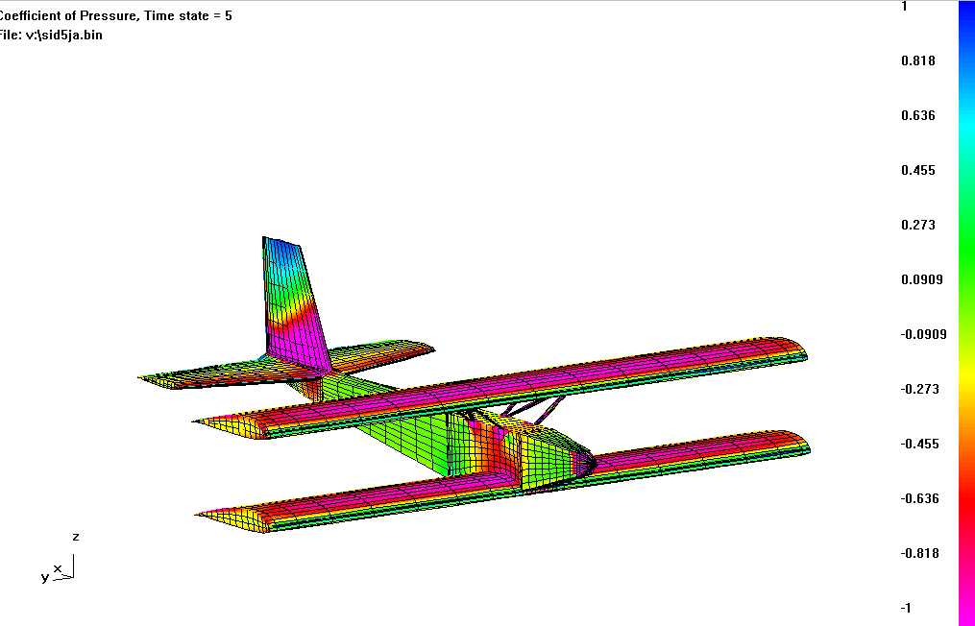

Figure A.9: Coefficient of Pressure calculated in CMARC

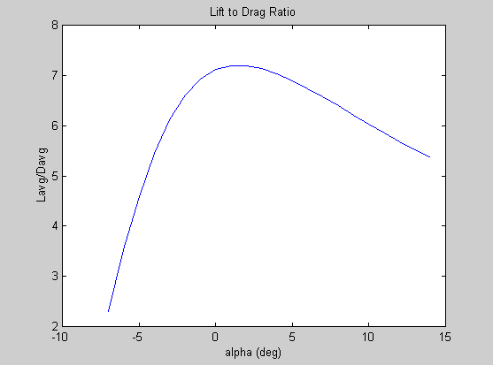

Figure A.10: Three-Dimensional L/D vs. angle of attack

B here

Appendix C: Structures
Structures code:
To find the forces and loads on the aircraft and to be able to get an idea of the affects of these forces, a matlab code was written. The code first finds the wing loading on the aircraft taking into account a load factor of 3.75. The wing loading was calculated using Schrenk’s approximation.
Schrenk’s approximation takes into account the trapezoidal method (equation C.1 & C.2) and the elliptical method (equation C.3) for wing loading.

$\text{EquationC}\text{.}1:q(y)=q(0)\left[1−\frac{2y}{b}\left(1−λ\right)\right]$$\text{EquationC}\text{.}2:q(0)=\frac{w∗3\text{.}\text{75}}{b}$$\text{EquationC}\text{.}3:q(y)=\frac{4S}{b∗\text{pi}}\sqrt{1−\left(\frac{2y}{b}\right)\hat{2}}$The result is shown below in Figure C.1.

Figure C.1: Wing loading along the wingspan
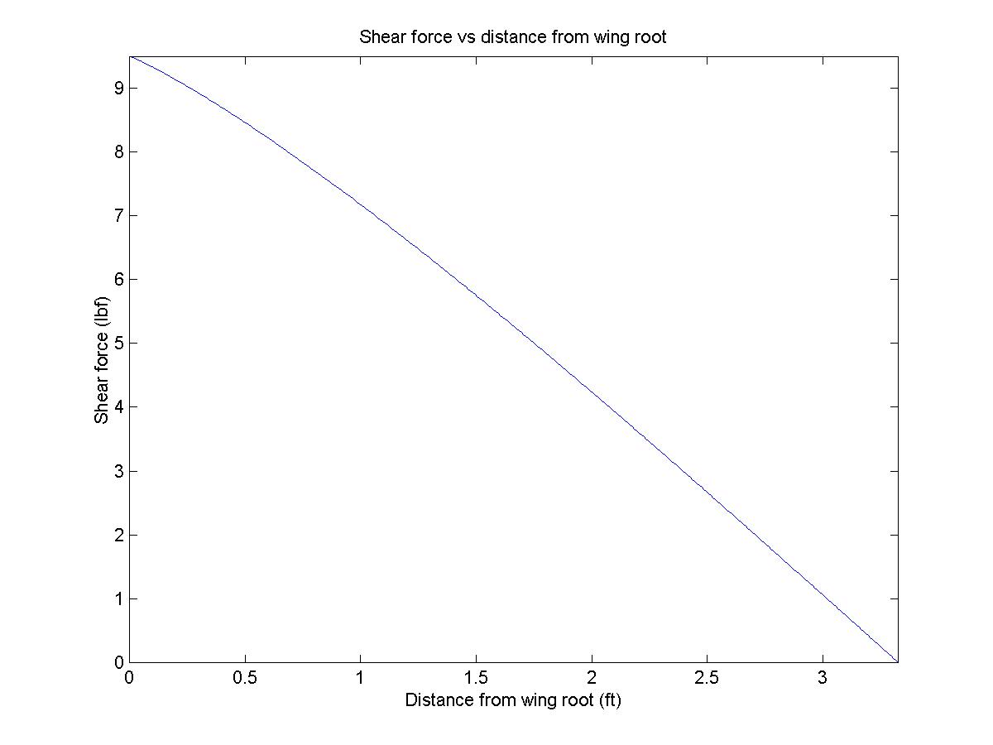Once the wing loading was found, the shear forces could be found. The shear forces were calculated by integrating the wing loading. The result is shown below in Figure C.2.

Figure C.2: Shear Force along wingspan calculated by matlab code.

Once the shear force along the wing was found, it could be integrated to find the moment felt along by the wing. The moment along the wingspan can be seen below in Figure C.3.

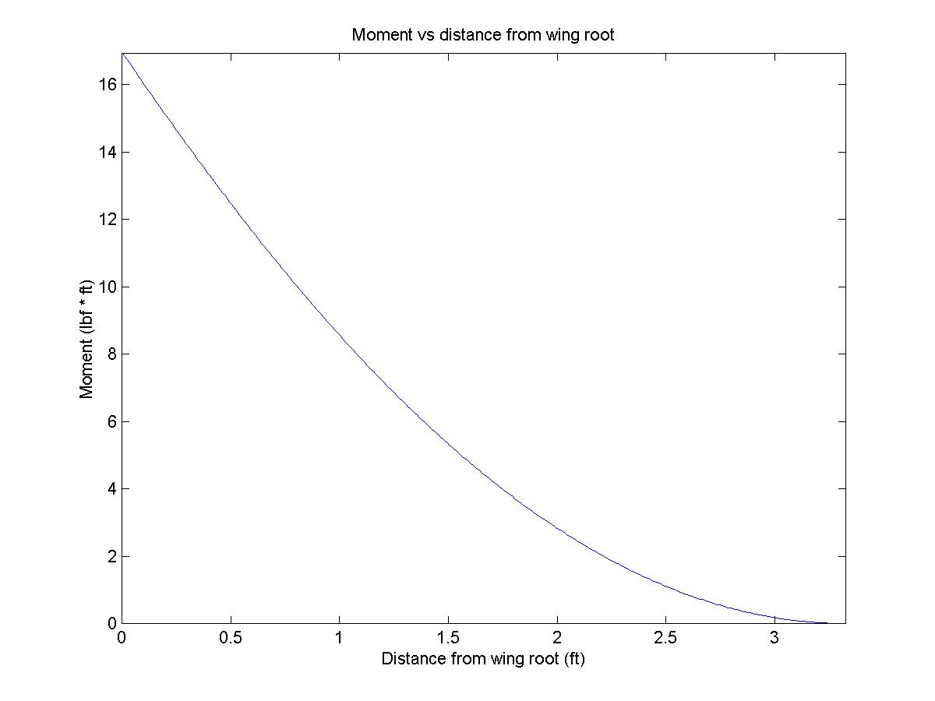

Figure C-3: Moment along the span of the wing.

$\text{EquationC}\text{.}4:σ_{\text{xx}}=\left(\frac{\text{My}}{I_{z}}\right)$After calculating the moment on the wing, the normal force felt by the wing could be calculated using equation C.4.

As seen by the graph in Figure C.4, the highest magnitude of normal force, approximately 2750 psi, is felt at the sparcaps.

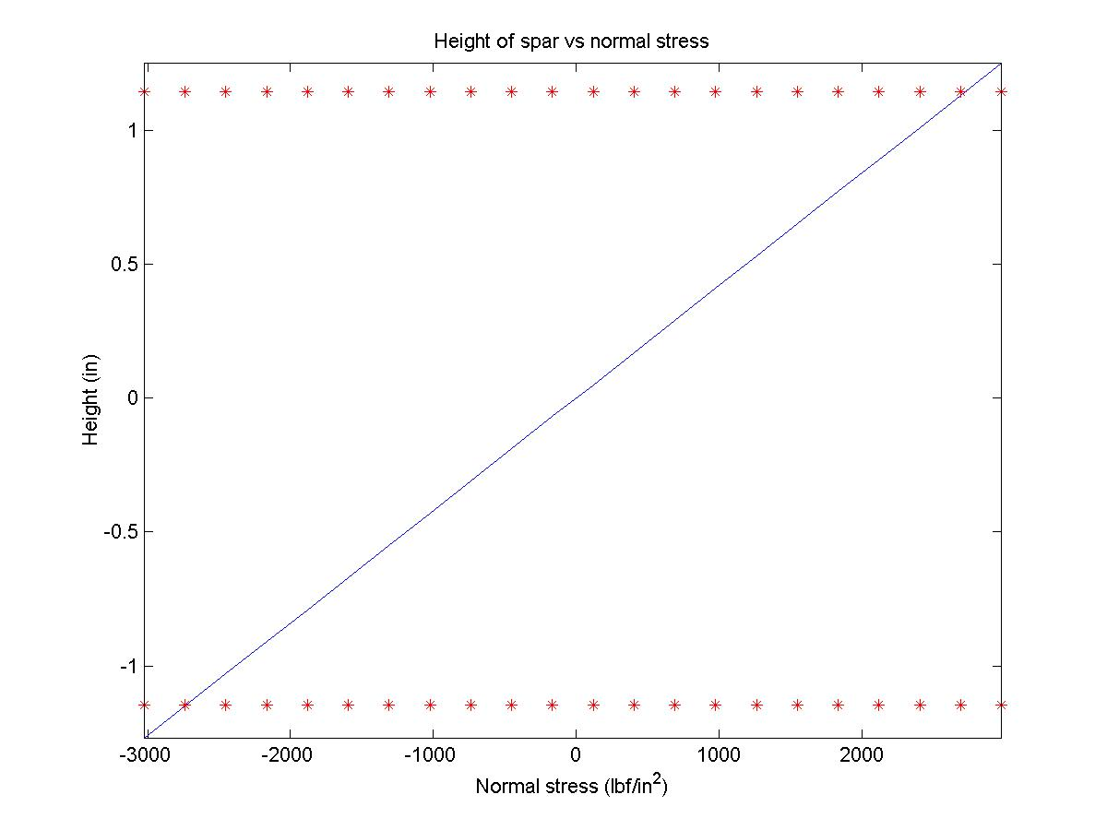

Figure C.4: Normal Stress vs. Height of spar cap.
Comparing this amount of force with the yield stress of spruce (8600psi), it can be seen that the structure of the wing is capable of withstanding the loads felt by it.

Landing Gear
Correct sizing and placement of the landing gear is essential to the stability of the aircraft on the ground. Guidelines for the layout of the conventional taildragger landing gear arrangement followed the steps given in Raymer’s Aircraft Design book. With the aircraft stationary on the ground at the takeoff gross weight, the taildown angle would be about 10-15 deg. Also, the center of gravity should fall between 16-25 deg back from the main wheel location. Placement and sizing of the landing gear is essential to the stability of the aircraft on the ground. Figure C.5 shows the method described above in placing and sizing the landing gear.

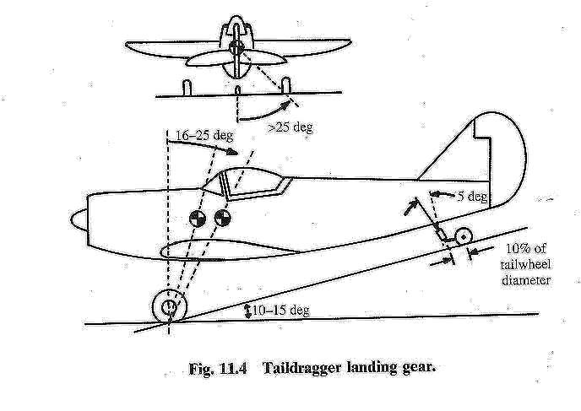
Figure C.5: Figure 11.4 from Raymer’s Aircraft Design shows placement and sizing method for landing gear.

Equipment Layout
The equipment was placed inside the fuselage to accommodate the designated center of gravity. Space was left for packing around each piece of equipment to prevent damage. The equipment layout is shown along with a table showing the size and weight of each component below in Figure C.6 and Table C.1.

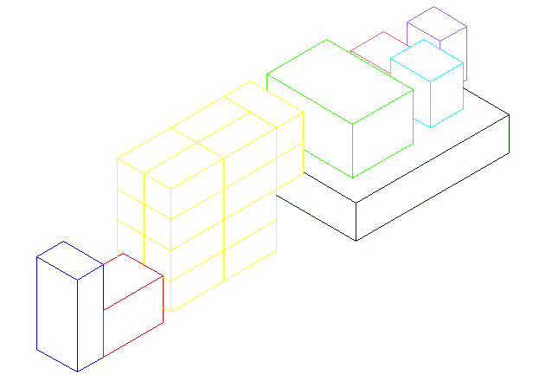
Figure C.6: A color-coded representation of the layout of the equipment

.
Table C.1: Size and weight of each piece of equipment used in SID-5.
Equipment Volume (in3) Weight (oz)
Gear box 3 x 1.5 x 1 1.5
Motor 2.25 x 1.5 7.5
Speed Controller 1.5 x 1.25 x 1 3.0
Receiver 1.75 x 1.25 x 0.75 1.0
Gyro 1.5 x 1.25 x 1.25 3.5
Data Recorder 1.75 x 2.25 x 3.25 8.0
Battery (18) 2 x 1 x 1 2.8
Servo (4) 1.5 x 1.25 x 0.75 2.0
Interface 1.25 x 3.5 x 5.75 7.0

Table C.2: Estimated weight breakdown of SID-5.
11.0 (oz)
Fuselage
9.8 (oz)
Misc
9.5 (oz)
Tail
42.0 (oz)
Wing
2.0(oz)
Servo (4)
2.8(oz)
Cell weight (18)
1.0(oz)
Propeller
1.5(oz)
Gearbox
7.5(oz)
Motor
15.0(oz)
Tattletail8
3.5(oz)
Gyro
3.0(oz)
Speed controller
1.0(oz)
Receiver

D here
Appendix E: Performance

This appendix contains information on aircraft performance. The following equations can be found in [Ref 5.1]. Turn radius and cruise speed were constraint values rather than calculated. Actual performance data was calculated using yard markers on the football field and a stopwatch.

W = weight (lbs)
S = wing area (sqft)
rho = air density (slugs per cubic foot)
g = gravitational constant (feet per second squared)
T = thrust (lbf)
Tave = average thrust for all mission segments calculated by sizing code [App. G]
D = drag (lbf)
Gamma = climb angle (degrees)
Vmax = velocity (ft per second)

1) Takeoff Distance = (1.44*(W @ Takeoff)^2)/(rho*S*g*T)
2) Gamma = asin((T-D)/W)
3) Endurance = Battery Capacity/(Tave * Vcruise)
4) Stall speed = sqrt(W/(1/2*rho*S*C_{L}))

Flight Card 1

A/C NAME: | SID-5
FLIGHT NUMBER | 1
CREW CHIEF: | Pat Dempsey
GROUND CREW: | Keith Hout | Bridget Fitzpatrick | Heather Garber | JS Mok
PILOT | Dave Henady
DATE: | Saturday 18 NOV
TX FREQUENCY: | Channel 36 | ATM. PRESS. | 30.22 mm Hg | TEMP: | 30 F
FLIGHT ACTIVITY | First Flight
Location | Delphi Airport
Mission | Attempted First Flight
Comments | ~extremely windy
 | ~had problem keeping airplane from blowing away
 | ~sustained minor damage from being blown into parked car
 | ~need to add down trim to plane-Pilot
 | ~initially was too cold for motor to function, had to be brought in and warmed up
 | ~plane was predictable and handled well-Pilot
Duration | 3 minutes
Take off Distance | ~plane basically hopped into the air
Landing | ~no major problems
Battery Utilized | Ni-Cd
Damage Report | ~cracked rib
Repair Time | ~minor

Flight Card 2

A/C NAME: | SID 5 |  | DATE: | 19-Nov
FLIGHT NUMBER(S) | 2
CREW CHIEF: | Pat Dempsey |  | PILOTs: | Pat Dempsey
 |  |  |  | Dave Henady
GROUND CREW: | Keith Hout, Bridget Fitzpatrick, Heather Garber, J.S. Mok
TX FREQUENCY: | 36 | ATM. PRESS. | 30.30 mmHg | TEMP:46F
FLIGHT ACTIVITY | Second Flight
Location | Mollenkopf
Mission | Short hop | (P.D.) | A
 | Short hop and turn | (P.D.) | B
 | Endurance Mission | (D.H.) | C
Comments | A
 | Fine take off and landing needed some power.
 | B
 | Fine take off, very stable turn and hard landing due to not
 | adding enough power.
 | C
 | Very smooth take off,tunred and flew very nicely.
 | Very predictable flying and stable.
 | Very Maneuverable.
 | A lot of power.
Duration | A | B | C
 | less than 15 sec. | About 20 sec. | Appr. 14 min. 30 sec.
Flight Speed | A | B | C
 | 25 ft/s. | 25 ft/s. | 27~30 ft/s.
Take Off Distance | A | B | C
 | 15 yards. | 15 yards. | 20 yards.
Landing Distance | A | B | C
 | 10 yards. | 2 yards | 40~50 yards.
Battery | Ni-MH
Damage Report | A | No damage.
 | B | Separated firewall of motor.
 | C | No damage.
Repair Time | A | N/A
 | B | 5 min.
 | C | N/A |  | Card#

Flight Card 3

A/C NAME: | SID-5
FLIGHT NUMBER | 3
PILOT: | Dave Henady
DATE: | Sunday 19 NOV
TX FREQUENCY | Channel 36 | ATM PRESSURE | 30.30 mm Hg | TEMP | 46 F
FLIGHT ACTIVITY | Flap Test
Location | Mollenkopf
Mission | Use of flaps for indoor flight
Comments | ~Flight started out well
 | ~Adding flaps on landing is not the best idea
 | ~Plane was stopped by student to keep from hitting wall
 | ~adding flaps pitched plane up, and had to add more down elevator
 | ~Group heart attack occurred shortly after crash
 | ~it was demonstrated that feedback gain can be used
Duration | 5 minutes
Take Off Distance | 20 yards
Landing | ~Plane was caught in ground effect. Would not land.
 | ~Touched down late and then hit student
Battery Utilized | Ni-Cd
Damage Report | ~crushed leading edge on left side of bottom wing
 | ~crushed leading edge on majority of upper wing
 | ~about 15 broken ribs
 | ~broken elevator
 | ~major damage to group morale
Repair Time | ~substantial, about 90 man hours

Flight Card 4

A/C NAME: | SID-5
FLIGHT NUMBER | 4
PILOT | Dave Henady
CREW CHIEF: | Pat Dempsey
GROUND CREW: | Keith Hout | Bridget Fitzpatrick | Heather Garber | JS Mok
DATE: | Tuesday 21 NOV
TX FREQUENCY: | Channel 36 | ATM. PRESS. | 30.33 mm Hg | TEMP: | 46 F
FLIGHT ACTIVITY | W and W/O Feedback Gain
Location | Mollenkopf
Mission | demonstrate a/c flight both w and w/o feedback gain
Comments | ~Very predictable
 | ~gyro dampened out oscillations
 | ~made the controls more sluggish
Duration | 5 minutes
Take off Distance | 15 yards
Landing | 30 yards. No problems
Battery Utilized | Ni-Cd
Damage Report | Happily None to Report
Repair Time | Nonexistent

Flight Card 5

A/C NAME: | SID-5
FLIGHT NUMBER | 5
PILOT | Sean Henady
DATE: | Tuesday 21 NOV
TX FREQUENCY: | Channel 36 | ATM. PRESS. | 30.33 mm Hg | TEMP: | 46 F
FLIGHT ACTIVITY | Endurance+Manuevers
Location | Mollenkopf
Mission | perform the a/c mission of 12 minutes
Comments | ~did not make 12 minutes because performed a lot of maneuvers
 | ~flew nicely
 | ~did four circles hands off
 | ~pilot enjoyed flying this plane
Duration | 10:58 minutes
Take off Distance | 20 yards
Landing | 30 yards. No problems
Battery Utilized | Ni-MH
Damage Report | Happily None to Report
Repair Time | Nonexistent

Flight Card 6

A/C NAME: |  |  | DATE: | 21-Nov
FLIGHT NUMBER(S) | 6
PILOT: | Sean Henady
TX FREQUENCY: | 36 | ATM. PRESS. | 30.33 mmHg | TEMP:46F
FLIGHT ACTIVITY | Sixth Flight
Location | Mollenkopf
Mission | High Performance Test
Comments | Short take off with full throttle setting.
 | Tight turn with 6 yard radius.
 | Demonstrated nice roll rate.
 | Successful stall turns.
 | Tested the minimal stall speed with power on and off.
 | With power off stall speed was less than appr. 20 ft/s.
 | With power on stall speed was less than appr.15 ft/s.
 | Achieved maximum speed in Mollenkopf was appr.100 ft/s.
Duration | Appr. 8 min.
Flight Speed | Between 10 and 68 mph.
Take Off Distance | 8 yards ( 24 ft.)
Landing Distance | 10 yards
Battery | Ni-Cd.
Damage Report | No Damage.
Repair Time | N/A.

Appendix F: Cost Analysis

This appendix contains information on cost analysis. All pricing information was accurate as of 31 October 2000. A detailed price breakdown of SID-5 is shown in Table F.1. The total of all parts used on SID-5 at the time of flight is denoted as “used parts” while “kit price” denotes the cost of materials normally included in a commercial radio controlled airplane kit. Standard kits include wood, hardware (screws, control horns, etc.), plans, and building instructions. Kits do not include control systems, propulsion systems, glue or covering material (MonoKote). Since SID-5 is a scratch built airplane there are no building instructions, thus no instructions will be furnished with the kit leaving the exact construction method up to the builder.

Table F.1: Price breakdown of SID-5.

Appendix G: Design Codes

1. Matlab sizing code
2. Matlab aerodynamics code
3. Matlab structures code
Size
Aero
Struct

