Thiokol Design Report



A&AE451 Aircraft Design Class
Fall 2000

Team DR2

Purdue University
School of Aeronautics and Astronautics
1282 Grissom Hall
West Lafayette, Indiana 47907-1282
Thiokol Design Report

A&AE451 Aircraft Design Class

Fall 2000
Team DR2

December 7, 2000

Code of Ethics

Taken from the Purdue University Handbook, Section II: Student Code of Honor:

“The purpose of the Purdue University academic community is to search for the truth and to endeavor to communicate with our fellowman. Self-discipline and a sense of social obligation within each individual are necessary for the fulfillment of these goals. It is the responsibility of all Purdue students to live by this code, not out of gear of the consequences of its violation, but out of self-respect.

As human beings we are obligated to conduct ourselves in accordance with moral law. As members of the civil community we have to conduct ourselves as responsible citizens in accordance with the rules and regulations governing all residents of the state of Indiana and of the local community. As members of the Purdue University community, we have the responsibly to observe all University regulations. As members of the academic community, our foremost interest should be toward our education and our foremost responsibility is to maintain academic honesty. A student who assists in any form of dishonesty is equally as guilty as the student who accepts such assistance.”

The members of Team DR2 subscribe to the above Code of Ethics and maintain that the information contained within this report is original unless otherwise referenced.

Team DR2

Mark Blanton Team Historian, Propulsion and Cost

Chris Curtis Construction Method and Structures

Loren Garrison Aerodynamics, Stability&Control, and Performance

Chris Peters Team Leader, Aerodynamics, Stability&Control, and Performance

Jeff Rodrian Team Co-Leader, Construction Method, and Structures
Table of Contents

Section Page
- Executive Summary 1
- Request For Proposal 2
  - Design Objectives 2
  - Design Requirements 2
- Concept Evaluation and Selection 4
- Aircraft Description 5
- Aerodynamics 7
  - Introduction 7
  - Two-Dimensional Aerodynamics 7
  - Three-Dimensional Aerodynamics 8
  - The Warner Three-Dimensional Lift Calculations for Biplanes 8
  - Computational Fluid Dynamics Analysis 9
  - Parameter Selection 10
- Stability and Control and Dynamic Modeling 11
  - Introduction 11
  - Dynamic Model 11
  - The Dynamic Modeling Design Approach 12
  - Stability and Control 14
    - Static Margin, Neutral Point, and Center of Gravity 14
    - Horizontal Tail Sizing 14
    - Control Surface Sizing 14
    - Trimibility 15
- Structure Design and Construction Method 16
  - Introduction 16
  - Weight, Center of Gravity Location, and Inertias 16
  - Design 16
  - Composite Wing Manufacturing 17
- Propulsion and Power System 20
  - Introduction 20
  - Design Methodology 20
  - Component Selection 21
- Economic Plan 23
- Conclusion 24
- References 25

Appendix
- Contact Information
- Concept Selection
- Aerodynamics
- Dynamic Modeling
- Stability and Control
- Structure Design and Construction Method
- Propulsion and Power System
- Economic Plan
- Flight Test Results

List of Tables

Section Page
- Executive Summary
- Request For Proposal
- Concept Evaluation and Selection
  - Weighted Objectives Criteria Selection and Design Aircraft Selection 4
- Aircraft Description
  - Brief Aircraft Description 5
- Aerodynamics
- Stability and Control and Dynamic Modeling
  - Stability Derivatives for Dutch Roll Approximation 13
- Structure Design and Construction Method
- Propulsion and Power System
  - Astroflight 640G Motor Characteristics 21
  - Master Airscrew Propeller Characteristics 21
  - Astroflight 204D Speed Controller Characteristics 22
  - Sanyo 3000SCR Battery Characteristics 22
  - Aircraft Endurance Time Calculation 22
- Economic Plan
  - Total Cost of DR2 23
- Conclusion
- References
List of Figures

Section Page
- Executive Summary
- Request For Proposal
  - Sketch of Mission Profile 2
- Concept Evaluation and Selection
  - Initial Design Concept 4
- Aircraft Description
  - Aircraft 3-View 5
  - Initial Constraint Diagram 6
- Aerodynamics
- Stability and Control and Dynamic Modeling
  - Overall Aircraft Model 12
- Structure Design and Construction Method
  - Fuselage Structure 16
  - Checking Upper Surface of Finished Mold 17
  - Checking Lower Surface of Finished Mold 17
  - Vacuum Bag Setup 18
  - Lower Skin, Outer Layer of Fiberglass As Foam Is Placed Into Mold 18
  - Breather and Bleeder Cloth Applied to Lower Skin Mold 19
  - Final Vacuum Bag Setup for Wing Skins 20
- Propulsion and Power System
- Economic Plan
- Conclusion
- References
List of Symbols

AOC Angle of Climb
AR Aspect Ratio
T/W Thrust-to-Weight Ratio
b_{u} Span of the Upper Wing Surface
b_{l} Span of the Lower Wing Surface
C_{D} Coefficient of Drag
C_{Do} Zero-lift Drag Coefficient
C_{L} Coefficient of Lift
CG Center of Gravity
D Drag
FS Flight Station
g Acceleration due to Gravity
G/b Gap-to-Span Ratio
G/c Gap-to-Chord Ratio
L Lift
NP Neutral Point
q Dynamic Pressure
r_{max} Maximum Turning Radius
S_{ref} Reference Area
S_{TO} Takeoff Distance
SM Static Margin
t/c Thickness-to-Chord Ratio
V_{loiter} Loiter Velocity
V_{stall} Stall Velocity
W/P Power Loading

α Angle of Attack
β Warner Biplane Parameter
γ Flight path angle
Γ Dihedral
ηp Propulsion Efficiency
λ Taper Ratio
Λ Sweep Angle
Κ Induced Drag Factor
μ Viscosity
ρ Air Density
σ Warner Biplane Parameter
- Executive Summary

The objective for the Fall 2000 A&AE451 Aircraft Design Project was to design a small remotely piloted variable stability aircraft using feedback control. Feedback control is often employed to modify, or improve, the dynamic response of the aircraft in flight. Using a feedback sensor, in the yaw axis, an analytical prediction of the dynamic motion of the aircraft was made.

Several constraints, defined in the Request for Proposal, name the challenges that must be overcome. The design must be flown inside the Mollenkopf Athletic Center at the Purdue University campus. The aircraft’s propulsion system must be an electric motor for indoor use. The aircraft’s dimensions must also not be excessive as to be able to fly indoors. The aircraft must be robust to crash yet stable in all flight regimes, exemplifying exceptional flying qualities. The aircraft must also display a conventional takeoff and maintain powered flight for twelve minutes.

The design selected by Team DR2 is a bi-wing, tail-dragger aircraft design. The design incorporates and electric propulsion and power design, a small sized aircraft, as well as the use of advanced composites for the aircraft wing structures. The feedback control of the yaw axis is controlled by a rate gyro and servo. The system is easily transportable in a compact car and has an appealing design for both engineers and pilots. The versatility of this design allows for easy internal modifications as well as displaying advanced composite construction, which will appeal to the customer.

This variable stability aircraft will be marketed to existing companies who sell and manufacture model aircraft. The aircraft will also be made available, as a teaching aid, to courses at the university level, especially Purdue University.

Completion of flight tests revealed that the remote controlled aircraft flew for nine minutes and eight seconds and demonstrated exceptional flying qualities. The aircraft demonstrated these qualities, both with and without the feedback gain implemented, indoors and outdoors. The robust aircraft design met the strength and crash test, withstanding heavy loads and rough landings. The overall evaluation of the aircraft design by Team DR2 and the pilots was an outstanding design.

Request For Proposal
  - Design Objectives

The reusable design vehicle must loiter for at least 12 minutes within the Mollenkopf Athletic Facility. It must carry an easily accessible payload consisting of a gyroscope, gain control box, Tattletale 8 data logger in a shielded box, and an interface module. Feedback control will modify the dynamic response of the yaw axis during flight and have two feedback gains (off and nominal) that are selectable by the pilot during flight. The data logger must record in-flight the yaw rate and rudder deflection as well as the airspeed. This data will be compared to the analytical predictions made for the vehicle.

The vehicle will be propelled by a single electric motor running off a battery and must exhibit exceptional handling qualities because of the requirements for confined, indoor flight. It will, therefore, have a minimum of two axes flight control system.

  - Design Requirements

No disassembled aircraft component will exceed 6.0 feet in length so that the aircraft can be transported in a compact car. For safe indoor flight operations, a margin of 30 feet from each wall will be maintained throughout the airborne part of the mission. Two missions must be achievable within the Mollenkopf Athletic Facility. The first is an abort mission in which the aircraft must land if an altitude of 6.0 feet is not attained by the time the aircraft is 212.0 feet from the take-off wall as shown in Figure 2.1. The abort mission consists of a take-off, short climb to ‘abort-height’, landing and full stop safely using less than the length of Mollenkopf.
6’
Point of No Return
with Observer
65’
Lowest Obstruction
AOC > 5.5°
42’
125’
30’
South Wall
North Wall
Safe Airspace
30’
30’
< 120’
r_{turn}< 50’
Abort

Figure 2.1: Sketch of Mission Profile

The second, primary mission’s goal is to loiter for 12.0 minutes after a rolling take-off and climb. The aircraft maximum stall speed was chosen at 20.0 feet per second based on previous A&AE 451 and UAV designs, which had stall speeds ranging from 9.0 to 22.0 feet per second. A low stall speed will be needed for good aircraft handling qualities inside Mollenkopf.

The minimum climb angle of the design vehicle was set at AOC = 5.5°. The climb angle must be met to prevent the need for an aborted take-off due to insufficient altitude before the first turn. Vehicle altitude must remain between 6.0 feet and 30.0 feet during loiter. The minimum altitude was set at 6.0 feet to allow approximately 1.0 wingspan margin between the aircraft and the ground. The maximum loitering height was set at 30.0 feet to allow 12.0 feet separation from the lowest obstacle within Mollenkopf.

The turn rate was calculated based on making a 180+ degree continuous turn with a radius of 50 feet (66% of the maximum turn radius) and a loiter speed of 22 feet per second.

Figure 2.1 details the primary mission flight profile. The aircraft launches 30.0 feet from the south wall and must lift off in less than 120 feet. The aircraft will then climb at an angle greater than 5.5° until it at least reaches the minimum cruise altitude of 6.0 feet. It will then turn and begin a loitering circuit around Mollenkopf. During this 12-minute loiter, the pilot will be required to remotely switch the feedback control gain to increase the stability of the vehicle. The loiter speed must be greater than 1.2V_{stall} and provide 10 seconds of straight and level flight. After the 12 minute loiter phase, the aircraft will safely descend, land, and come to a complete stop within the length of Mollenkopf.

Structural considerations set the limit load factor at 2.5 and net safety factor at 1.5, subsequently the ultimate load factor for the aircraft is 3.75 (safety factor × limit load factor). Impact loads during a crash should not result in catastrophic failure of any portion of the vehicle.

Concept Evaluation and Selection

  - Concept Criteria and Weighted Objectives Selection

The weighted objectives method was used to determine which of three aircraft concepts shown in Figure 3.1 will be best suited to meet the mission requirements. These concepts from left to right are a traditional hi-wing aircraft, a biplane, and twin-boom design.

Figure 3.1: Initial Design Concepts

Concept evaluation began by team members brainstorming criteria that should be used to choose a design. These criteria listed below in Table 3.1 were then ranked using weighted values and the three lowest ranked criteria were dropped and the remaining criteria were re-ranked.

The next step was evaluating each of the three design concepts based on these aspects. Each group member voted on each concept rating the excellent to bad. A corresponding number was assigned to the quality and the numbers totaled for the concept. This vote was a group evaluation; hence the group vote was discussed if the values for the individual votes differed. These numbers were then multiplied by the whole number percentage to determine the number of votes that each concept earned. These votes can be seen in Table 3.1. Since the votes for the biplane and high wing concepts were close, a group discussion resolved the design concept using sound engineering judgment and desirability. The biplane concept was chosen based on these characteristics.

 |  |  | Criteria Evaluation |  |  | Concept Evaluation
 |  |  |  | Re-evaluated
Rank | Criteria | Votes | Percentage | Percentage | Biplane |  | High Wing | Twin Boom
1 | Turn rate | 71 | 14.2 | 16.7 | 5 |  | 0 | 0
2 | Ease of Analysis | 55 | 11.0 | 12.9 | -3 |  | 5 | 3
3 | Ease of Construction | 53 | 10.6 | 12.8 | 0 |  | 3 | -3
4 | Stability | 48 | 9.6 | 11.3 | 3 |  | 5 | 3
t-5 | Wing Length | 45 | 9.0 | 10.6 | 5 |  | 0 | 0
t-5 | Takeoff | 45 | 9.0 | 10.6 | 5 |  | 3 | 0
6 | Accessibility | 39 | 7.9 | 9.2 | 3 |  | 3 | 3
7 | Fuselage, Internal | 34 | 6.8 | 8.0 | 3 |  | 3 | 0
8 | Drag | 32 | 6.4 | 7.5 | 0 |  | 3 | 3
- | Ease of Assembly | 29 | 5.8 | Total Votes | 236.3 |  | 264.4 | 85.2
- | Simplicity | 24 | 4.8
- | Propulsion | 22 | 4.4

Table 3.1: Weighted Objectives Criteria Selection and Design Aircraft Selection

Aircraft Description

  - The System Configuration

The biplane concept, as shown in Figure 4.1 is a puller prop, tail-dragger, conventional tail, bi-wing design. Table 4.1 gives major attributes of the design aircraft. The fuselage is designed to hold all the required payload and flight instruments listed in the design mission specification. The aircraft fuselage and wings will be built using fiberglass and foam construction techniques. Selig S 1210 airfoils will be used on both untapered, unswept wings.

A three-axis flight control will be used in the biplane, hence four servos located in the wings, with two additional servos responsible for rudder and elevator control. For radio control, a single six channel receiver and receiver battery are needed. For this mission, a Tattletale 8 data recorder and one gyro, intended for yaw rate measurements, will be installed. An Astro 640G electric motor, powered by a 14-cell Nickel-Metal-Hydride (NiMH) battery, will be used to propel the biplane during the 12 minute flight. The propeller is a Master Airscrew 14-inch diameter and 10-degree pitch propeller.
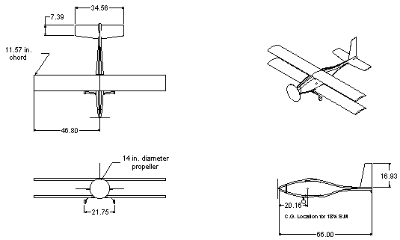

Figure 4.1 Aircraft Three-View

Aerodynamics |  |  | Weight |  |  | Propulsion
Fuselage Length [ft] | 5.10 |  | Payload [oz] | 18.5 |  | Propeller |  |  | 14x10
Wing Span [ft] | 7.84 |  | Fixed [oz] | 59.57 |  | Motor Type |  |  | Astro 640G
Wing Chord [ft] | 0.97 |  | Fuselage [oz] | 37.08 |  | Cell Type |  |  | NiMH
Wing Area [ft^2] | 15.20 |  | Wing [oz] | 93.12 |  | Number Cells |  |  | 14
Aspect Ratio | 8.1 |  | Horizontal Tail [oz] | 4.00 |  | Horsepower |  |  | 0.94
Gap [in] | 8 |  | Vertical Tail [oz] | 3.50
Span Ratio | 1 |  | Misc. [oz] | 5.49 |  | Dynamics and Control
Stagger [in] | 0 |  | Total [lb] | 221.2488 |  | # Axes of Control |  |  | 3
Declage [in] | 0 |  |  |  |  | Feedback Axis |  |  | Yaw
 |  |  |  |  |  | Gear Type |  |  | Tail-dragger
 | Table 4.1: Brief Aircraft Description

Constraint Diagram

The wing loading (W/S) and power loading (W/P) for the aircraft design were chosen from the constraint diagram shown below in Figure 4.2. The initial weight estimate was made using historical data gathered from past AAE 451 designs (specifically the tow plane) and fixed weights such as the servos, the speed controller, the payload and the receiver. The initial weight estimate was 10.2 lbs gross takeoff weight. Below Equations 4.1 through 4.5 are the constraints used to determine the appropriate wing loading and power loading. Derivations of these constraints can be found in Appendix F.
$\frac{T}{W}=2ρ(V_{\text{Loiter}}^{2}){\left(WS_{\text{ref}}\right)}^{−1}⋅C_{D_{Ο}}$ ${\left(WP\right)}^{−1}=\left(\text{sin}γ+\frac{1\text{.}2C_{D}}{C_{L_{\text{MAX}}}}\right)⋅\left(\frac{1\text{.}2V_{\text{stall}}}{\text{550}η_{p}}\right)$

Equation 4.1: Loiter Velocity Equation 4.2: Climb Angle Constraint

$$\frac{T}{W}=\left[{\left(\frac{V_{\text{loiter}}}{{gπr}_{\text{max}}}\right)}^{2}+\frac{1}{V_{{\text{loiter}}^{2}}}\right]\frac{2K}{ρ}\left(\frac{W}{S_{\text{ref}}}\right)+\frac{{\text{qC}}_{\text{Do}}}{\frac{W}{S_{\text{ref}}}}$$

Equation 4.3: Sustained Turn Rate Constraint
$\frac{T}{W}=\frac{1\text{.}\text{44}\left(\frac{W}{S}\right)}{{ρC}_{L_{\text{max}}}{\text{gS}}_{\text{TO}}}+\frac{D}{W}+μ\left[1−\frac{L}{W}\right]$
$\frac{W}{S}=12{ρV}_{\text{stall}}^{2}C_{L_{\text{max}}}$

Equation 4.4: Ground Roll Constraint Equation 4.5: Stall Speed Constraint
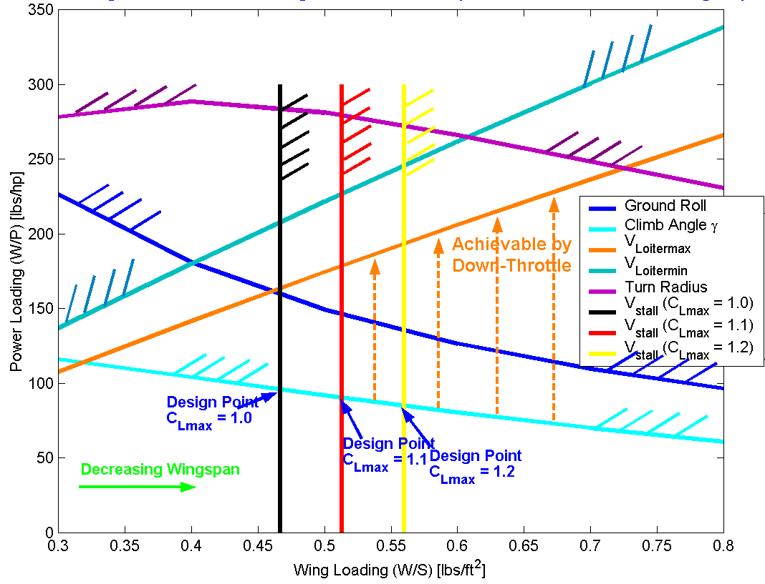

Figure 4.2: Initial Constraint Diagram

The best design point from the constraint diagram will have both large W/P and W/S values. Large power loading will allow lighter, less powerful engines to be used and large wing loading will decrease the overall wing area and wing span of the aircraft. A conservative value of C_{Lmax}=1.1 was set for the stall speed constraint, thus the design point at W/S = 0.52 and W/P =0.173 was chosen. An insignificantly larger power loading value could have been attained, but it would have required a lesser wing loading.
- Aerodynamics

  - Introduction

The objective of the aerodynamic analysis is to obtain an adequate lift and drag model for the DR2. Mission specific considerations are the main driver in the selection process of the airfoil, wing and empennage parameters, lift analysis and drag model. The results of the aerodynamic analysis are a crucial part in the analysis of stability and control, structures, and the dynamic modeling of the aircraft. The unique characteristics of the indoor mission calls for a rather unconventional approach to the aerodynamic analysis. The low Reynolds number flight regime, mission airspace, payload considerations, and exceptional flying qualities resulted in the selection of the biplane concept. Consequently a couple of biplane analytical methods are described and compared to determine an appropriate model for the DR2.

  - Two-Dimensional Aerodynamics

The first step in the aerodynamic analysis was to determine the Reynolds number range in which the aircraft would most likely fly. To determine this, the flight altitude, the range of cruise velocities and the approximate range of wing chords were determined. From these parameters, it was determined that the Reynolds number would range from 100,000 to 150,000. These values would later be used in determining an airfoil section for the main wing.

The two-dimensional analysis began by compiling a database of airfoils. The airfoils in this database were selected from the NASG website (Reference 12). The data from this website was primarly compiled from experimental data collected by Michael Selig at the University of Illinois at Urbana-Champaign. Since the NASG website contained over a thousand airfoils, only airfoils with a C_{lmax} of more than 1.35 at the predicted takeoff Reynolds number (approximately 100,000) were chosen. This process yielded a database of about 30 airfoils; the lift curves and drag polars of these airfoils were then plotted for comparison, Appendix C Figures C-1.1, C-1.2. Two key characteristics of the airfoils were evaluated in this comparison process. First, a high C_{lmax} was desired so that the aircraft could obtain stall speed requirement with a minimum wing area. Second, the airfoil should have a wide drag bucket with low overall drag to minimize the number of batteries required to meet the endurance requirement.

Evaluating the airfoils with these two criteria resulted in the selection of three airfoils, the Wortmann FX 63-137, Selig S 1210, and Selig S 1223. These three airfoils were evaluated again for the two previous criteria and also for the additional endurance criteria. To evaluate the endurance of the airfoil, the endurance parameter, C_{l}^{3/2}/C_{d}, of the airfoils were compared. It was desirable to have a high endurance parameter in order to maximize the endurance of the aircraft. From these three criteria, the Selig S 1210 was selected as the airfoil for the wings. The two- dimensional lift and drag polars of this airfoil are included in Appendix C Figures C-1.7 and C-1.8, along with the airfoil geometry, Figure C-1.5.

It should be noted that the shape of the airfoil was not a consideration in the airfoil selection process due to the fact that the wings were to be made from molds using composite materials. In addition, analysis of the airfoils was not performed using the Drela’s Xfoil airfoil analysis program for two reasons. First, there was a sufficient amount of experimental data, which was available. Second, the Xfoil program often has problems converging when airfoils are tested at low Reynolds numbers due to the occurrence of laminar separation bubbles.

  - Three-Dimensional Aerodynamics

The two major factors of the three-dimensional aerodynamics were the size and the geometry of the wing. The wing area was determined from the sizing code and form the predicted performance of the wing, particularly the maximum lift coefficient. In addition the maximum span was limited by the forecasted construction technique. The length of the wood that the molds for the wings were to be made from limited the length of a single wing section to four feet. To avoid complexity in the attachment of the wing sections it was determined that the wings should be made of, at most, two sections. Therefore, the total span of each wing was limited to a maximum of eight feet. These two factors determined the wing area, aspect ratio, and the chord length for the wings. To lower the construction costs its was necessary to have an untwisted, untapered, unswept wing so that the same mold could be used to make both the left and right wing sections.

Once these wing characteristics were determined, the three-dimensional lift, drag, and moment coefficients could be calculated. Since the chosen configuration of the aircraft was a biplane, the typical three-dimensional lift calculations could not be used. After some research a method for calculating the three-dimensional lift coefficients for biplanes was discovered. This method was formulated by Warner in his book Airplane Design: Performance (Reference 1). The Warner method uses the two dimensional lift curve slope, the gap to span ratio and the gap to chord ratio to calculate the three-dimensional lift curve slope. Using this method the three-dimensional lift, drag coefficients were calculated. The three-dimensional moment coefficient was calculated using the Roskam method (Reference 2) and then corrected with factors from Mark Peters Master’s thesis from the Fall of 1996 (Reference 3). Refer to Appendix C for the complete procedure for calculating the three dimensional lift drag and moment coefficients.

  - The Warner Three-Dimensional Lift Calculation for Biplanes

First, it is useful to define the proper characteristics of the aircraft. These properties include: span of each wing, chord of each wing, total wing area, and aspect ratio of each wing. In addition, it is important to determine the gap, or the vertical distance between the upper and lower wings, the stagger, or the horizontal distance between the upper and lower wings, and the overhang, or the difference between the span of the upper and lower wings.

Once the aforementioned quantities are determined the gap-to-span ratio, G/b, and the gap-to-chord ratio, G/c can be calculated. These values are then used to calculate σ and β using either linear interpolation with the data tables provided by Warner (Figure A-1 and Figure A-2), or by using the Equations 5.1a and 5.1b, which were determined by curve fitting the data.

(a) $β=0\text{.}\text{0072}{\left(\frac{G}{c}\right)}^{2}−0\text{.}\text{226}\left(\frac{G}{c}\right)+0\text{.}\text{208}$
(b) $σ=\text{63}\text{.}\text{112}{\left(\frac{G}{b}\right)}^{4}−\text{62}\text{.}\text{595}{\left(\frac{G}{b}\right)}^{3}+\text{23}\text{.}\text{759}{\left(\frac{G}{b}\right)}^{2}−5\text{.}\text{2979}\left(\frac{G}{b}\right)+0\text{.}\text{9984}$
Equation 5.1: Warner Curve Fits for the Determination of Coefficients a) β and b) σ

Where G/c and G/b are as defined above. Once the value for σ has been determined, the Warner Biplane efficiency factor, n, can be calculated using Equation 5.2.

$$n=1+σ$$
Equation 5.2: Warner Span Efficiency Coefficient for Equal Upper and Lower Spans
Where b_{u} is the span of the upper wing, b_{l} is the span of the lower wing, and σ is as defined above. The values for n and β are then used with the two-dimensional lift curve slope, C_{lα}, to determine the three-dimensional lift curve slope, C_{lα}, in Equation 5.3.

$$C_{Lα}=\frac{1}{\frac{1}{C_{lα}}+\frac{n}{π\text{AR}}+\frac{β}{2}}$$
Equation 5.3: Warner Lift Curve Slope Equation
Where AR is the aspect ratio and C_{lα}, β, and n are as defined above. The three-dimensional lift coefficient can then be calculated using Equation5.4.

$$C_{L}=C_{\text{Lo}}+C_{Lα}α$$
Equation 5.4: Three-Dimensional Lift Curve Equation

  - Computational Fluid Dynamics Analysis:

Since the configuration of the aircraft warranted the need for unconventional three-dimensional analysis techniques, the aircraft was modeled in a computational fluid dynamics (CFD) program. The Digital Wind Tunnel, CMARC, and POSTMARC programs were used to model the three-dimensional characteristics of the aircraft. In particular, the three-dimensional lift curve slope was determined through the CMARC/POSTMARC analysis.

Due to complexity of the configuration, the DR2 aircraft was modeled in the following four stages: single wing, biplane wings, biplane wings with a horizontal stabilizer, and the full aircraft. The analysis of the lift curve slope was performed on the model containing just the lifting surfaces. The primary reason for the use of the lifting surface model is that modeling the intersections of the fuselage with the wings and empennage is extremely complicated and must be exact to obtain the correct pressure distribution on the aircraft. As a result, the entire aircraft was modeled, however it was not used for verification of the Warner method for calculating the lift curve slope of a biplane. The Warner method resulted in lift curve slope (C_{Lα}) of 3.99 rad⁻¹, likewise the CMARC results yielded a lift curve slope of 3.92 rad⁻¹. Consequently, the theoretical method and the computational model are only 1.8% different and are, therefore, in agreement. Furthermore, the pressure distribution for both the entire aircraft model and the lifting surface model are included in Figure C-3.1 and Figure C-3.2 of Appendix C.

  - Parameter Selection

A couple of factors were driving the design as far as the parameter selection was concerned. First the limited time to complete the design, second the construction method, and third the mission requirements. The limited time restricted the team to few design iterations. The approach taken was to select parameters early in the design phase based on empirical data and to freeze as many parameters as possible. The design was built up on these parameters and other parts were designed to fit the frozen parameters. From the constraint diagram analysis, the Wing-Loading (W/S) and the Power Loading (W/P) were fixed. From experience in similar aircraft construction the Aspect Ratio (AR), Taper Ratio (λ), Sweep (Λ), Thickness-to-Chord-Ratio (t/c), Stagger (β), Gap (G), Decalage, Dihedral (Γ), and Overhang (b_{u}/b_{l}) were fixed, their values for all aerodynamic surfaces are listed in Table A-2, where appropriate. The reason that these values had to be fixed was partially due to the selected construction technique. A key to success for the construction of the DR2 was the construction of the composite wings. This construction technique requires extensive and expensive preparation as cutting wing-molds. These Molds were to be used in the construction for the final wings also. Therefore the aforementioned parameters were frozen very early in the design when usually they would be subject to change as the design process iterates.

Stability and Control and Dynamic Modeling

Introduction

The dynamic modeling of the DR2 is of particular interest, as one of the mission requirements is to carry a datalogger to log the response of a rate gyro. As described in the RFP and in the mission outline, the rate gyro is supposed to be mounted in one of the three major axes of flight. For the DR2 the yaw-axis was selected. Variable gains in the rate gyro, namely ‘nominal’ (to be designed) and ‘off’, need to be remotely selectable to perform in-flight experiments. The datalogger ideally records the control surface input, the airspeed, and the response of the aircraft. The goal of the dynamic modeling analysis is to predict the behavior of the DR2 in an ‘a priori’ model using the parameters determined in the aerodynamic analysis. During the run of the flight test program the ‘a priori’ model should then be verified by comparing the datalogger output to the predicted response. Due to the limited spectrum of this project a simplified analysis is used to achieve this goal. For the DR2 yaw analysis a simplified Dutch-Roll approximation model is used as outlined in Roskam, Reference 2.

The stability and control analysis for the DR2 needs to verify and ensure acceptable flight dynamics for all sections of the mission. The goal of this analysis is to obtain an aircraft that meets the requirements for exceptional flying qualities as specified in the RFP and is stable in all possible scenarios. Control parameters like center of gravity (CG), neutral point (NP), and static margin (SM) are described, analyzed and justified in this section. Furthermore the empennage sizing is iterated and the surface sizes are determined to meet all stability and flight control requirements using Class II surface sizing.

Dynamic Model

The dynamic model for the DR2 is extensively analyzed in the yaw axis. The diagram in Figure 6.1 shows the basic setup of the dynamic model. Ideally each component is analyzed individually and eventually combined to obtain the overall model. This approach is needed to obtain the gain desired for the nominal gain selection in the rate gyro. A couple of fundamental issues have to be clarified before the analysis is done. What is the desired goal? The RFP calls for a variable stability aircraft in one axis. Generally the stability of an aircraft with similar design intentions is driven to be more stable, rate gyros are used to stabilize aircraft. For the purpose of this project, and in light of the possible future use as demonstration material for Stability and Control classes at Purdue University, the option of actually destabilizing the aircraft is also to be considered in this case. For the DR2 it is decided to analyze the model and find a gain that destabilizes the aircraft, but still keeps it stable in yaw. The idea is to be able to select positive or negative feedback in the rate gyro and remain stable for both conditions. Selecting one stabilizes the aircraft, moving the poles of the aircraft dutch-roll approximation further into the left-half-plane, selecting the other destabilizes the aircraft moving the poles closer to being purely imaginary. Making this decision carries fundamental risks with itself. How accurate are the aerodynamic parameters needed to analyze the dynamic model? Every error that is introduced contributes to an uncertainty when the gain is determined. Using a gain close to a marginally stable aircraft could result in an unstable aircraft due to the errors in the analysis, which needs to be avoided. Particularly flying in an indoor facility operating the DR2 unstable can have fatal results for the aircraft or even for people and property.
Receiver
Servo
Aircraft
Model
Dutch
Roll Approx.
Washout
Filter
Rate Gyro
Pilot Rudder
Input δ_{rc}(Volts)
Transmitter
r
δ_{r}
+
-
+
k_{r}
Gain Selector and Feedback sign implementation
Figure 6. 1: Overall Aircraft Model

The Dynamic Modeling Design Approach

For the dynamic modeling each of the components in Figure 6.1 is analyzed individually, as mentioned before. Three major components are of interest for the analysis and gain determination, the rate gyro, the servo, and the aircraft model. A fourth component that might be of further interest is the washout filter – for simplicity the washout filter is neglected. To obtain the dynamic model for the servo and the rate gyro a simple parameter ID test is conducted. For the actual servo used, a Futaba FD-S132H, the transfer function is not evaluated. The transfer function for the rate gyro turns out to be a single constant ‘k’.

In Appendix B an extensive method description for the dutch-roll approximation is given, the derivation of this method can be found in Reference 2. The values obtained in the analysis are compared to the values of existing aircraft, namely the C172 and the MPX-5, a model aircraft designed for a similar mission by Mark Peters (Reference 3), this is listed in Table 6.1 (DR2 S_{vt}I). From this comparison it can be found that the values obtained for the DR2 are generally lower than the values for the other aircraft. It turns out that the main reason for that discrepancy is the Class II vertical tail (VT) sizing. The volume coefficient for the VT is selected based on the Weathercock criterion described in Appendix D. This Criterion is originally given for handling quality characteristics of manned flight and might not be applicable for model aircraft. The Tail is eventually constructed and analyzed to the specifications given in the aircraft parameters in Appendix B. The corresponding stability derivative coefficients are listed in Table 6.1.

Table 6.1: Stability Derivatives for Dutch Roll Approximation

The design process continues finding the natural frequency and the damping ratio of the open loop dutch roll transfer function, as shown in Equations 6-1. As these are resulting in a stable aircraft feedback is applied to the yaw rate p and a gain is selected for the aircraft model itself. The root locus for both the positive and negative feedback gains are shown in Appendix D. Eventually all models are combined to obtain the overall transfer function including the servo and the rate gyro, this determines the final gain k_{y} used in the rate gyro. The gain should be selected for the mode to become unstable, which is determined to be a rather small number, k_{y} = 0.0067, two orders of magnitude smaller than the Airtronics rate gyro can handle as an input. The small magnitude gain can be explained from the nature of the dutch roll mode. The open loop poles are close to the imaginary axis and therefore only a small gain is needed to move the poles onto the imaginary axis. To make use of the rate gyro for stabilizing gain it has to be tweaked to a much larger value, which is randomly selected but works amazingly well. For destabilizing purposes, the Airtronics rate gyro is not applicable and the destabilizing mode has not been tested for the DR2.
$$\begin{aligned}\frac{r(s)}{δ(s)}=\frac{\left\{N_{δ}\left({\text{sV}}_{\text{loi}}−Y_{β}\right)+N_{β}Y_{δ}\right\}}{s^{2}−s\left(N_{r}+\frac{Y_{β}}{V_{\text{loi}}}\right)+\left\{N_{β}+\frac{1}{V_{\text{loi}}}\left(Y_{β}N_{r}−N_{β}Y_{r}\right)\right\}}=\frac{−\text{185}\text{.}\text{45}s−5\text{.}\text{194}}{s^{2}+1\text{.}\text{240}s+8\text{.}\text{3081}} \\ ω_{{\text{nd}}_{r}}≈\sqrt{N_{β}}=2\text{.}\text{88}\text{rad} \\ ζ_{d_{r}}\frac{−\left(N_{r}+\frac{Y_{β}}{V_{\text{loi}}}\right)}{2ω_{{\text{nd}}_{r}}}=\text{ 0}\text{.}\text{215}\end{aligned}$$
Equation 6.5: Dutch Roll Transfer Function and Damping Ratio and Frequency Calculation
Similar to the dutch-roll approximation approach, the short period approximation is used for pitch analysis. The short period approximation is used to determine natural frequency and damping ratio in the pitch axis. This method is shown in detail in Appendix D. From the pole determination of the short period approximation it can be shown that the dynamic behavior is stable. Equations 6.2 list the transfer function, frequency and damping ratio of the short period mode.
$$\begin{aligned}\frac{q(s)}{δ_{e}(s)}=\frac{\left[\left(U_{1}M_{δ_{e}}+Z_{δ_{e}}M_{\overset{˙}{α}}\right)s+\left(M_{α}Z_{δ_{e}}−Z_{α}M_{δ_{e}}\right)\right]}{U_{1}\left[s^{2}−\left(M_{q}+\frac{Z_{α}}{U_{1}}+M_{\overset{˙}{α}}\right)s+\left(\frac{Z_{α}M_{q}}{U_{1}}−M_{α}\right)\right]}=\frac{−\text{25}\text{.}\text{45}s−\text{101}\text{.}\text{93}}{s^{2}+\text{12}\text{.}\text{35}s+\text{73}\text{.}\text{77}} \\ ω_{{\text{nd}}_{\text{SP}}}=8\text{.}\text{59}\text{rad} \\ ζ_{d_{\text{SP}}}=\text{ 0}\text{.}\text{719}\end{aligned}$$
Equation 6.2: Short Period Approximation Transfer Function, Damping Ratio, and Frequency

Stability and Control

    - Static Margin, Neutral Point, and Center of Gravity

Due to the indoor flight constraint, it is required that an electrical power plant must power the aircraft. Consequently, the mass of the aircraft will not generally change during flight. Therefore, it is determined that the position of the center of gravity (CG), of the aircraft, can be placed by arranging the internal components to meet a desired static margin, SM. From previous designs, the static margin ranges from 10% to 25% or higher. For the DR2 a designed static margin (nominal) of 18% is picked and stability is evaluated for a range from 10% to 24%. It is the goal of the stability and control analysis to size the elevator and the horizontal tail to meet stability requirements for the entire range of static margins. A potential static margin shift can occur as equipment shifts during flight or varies between missions. Furthermore, analyzing the static margin in a wider range also accounts for possible errors from the aerodynamic analysis that are reflected in the neutral point (NP) calculation. After the construction and test flight phase it is determined that the CG-location uniquely varies as the mission is flown with or without payload. Generally the CG location is kept right at the quarter chord of the wing, FS 1.77, resulting in a SM of 10.26%. The maximum shift experienced in any of the missions is a CG location at FS 1.73 resulting in a SM of 13.78%. For both cases the aircraft shows exceptional flying qualities. The stability analysis shown in Section 6.4.4 is the approach used to size the aircraft and does not reflect the actual outcome after the construction. Nevertheless it is left in this report to show the approach used to demonstrate the trim conditions for the DR2 in pre-production.

    - Horizontal Tail Sizing

A modified Class II sizing of the horizontal stabilizer is used as described in Appendix E. Here it is assumed that the center of gravity is fixed to obtain a static margin of 18% and the surface is varied to ensure stability with a horizontal tail moment arm that is geometrically achievable. This method results in a horizontal tail area, S_{HT}=2.25 ft², at an Aspect Ratio of 2.5, and the moment arm, l_{HT} =3.171 ft. After the construction a horizontal tail area of 2.16 ft² is achieved with a moment arm of l_{HT} = 3.18. As mentioned before, the SM is reduced to 10.26%.

    - Control Surface Sizing

The control surfaces of the aircraft are sized using empirical methods described in Reference 2. No more detailed analyses can be done within the scope of this project. However, it must be ensured that the servos powering the control surfaces are able to provide enough torque. To accommodate this constraint, approximations are used that are based on historical data. For the elevator, a flap-to-chord ratio of 0.41-0.53 is used with a full span design, the rudder has flap-to-chord ratio of 0.52-0.59 over the full span, and the ailerons have a flap-to-chord ratio of 0.26 over 55% of the span. For the biplane design, ailerons are used on both the upper and lower wings. Each aileron is powered by a micro servo mounted directly at the aileron root. A more detailed description is listed in the aircraft parameter list in Appendix B.

    - Theoretical Trimability

The trimability of the aircraft is evaluated for elevator deflections ranging from -10˚ to 10˚. The incidence angle of both wings and the horizontal stabilizer are designed to achieve the trim conditions for the previous range of static margins and full elevator range. From the analysis, it is determined that the DR2 is trimable for cruise aircraft angles of attack ranging from 0˚ to 9˚ and for cruise velocities ranging from 23 ft/s to 34 ft/s. These trim conditions were evaluated with an upper wing incidence of 0˚, lower wing incidence of –2˚ and a horizontal stabilizer incidence of –2˚.

The analysis of the trim conditions is performed using a non-linear lift model, similar to the approach of Mark Peters in Reference 3. The non-linear model is used in this case due to the extreme non-linearity of the two-dimensional lift curve near the zero lift angle of attack. This occurrence is most likely due to a lower airfoil surface stall at low lift coefficient values. The non-linearity in this case is due to the specific airfoil (Selig S-1210), which is designed for high lift applications resulting in an effective shift in the two-dimensional lift curve. The non-linear model was essential because the zero lift angle of attack is the only point on the lift curve which translates from 2-D to 3-D analysis. Therefore, a linear lift curve slope could not be applied through the zero lift angle of attack, resulting in the application of a non-linear lift model. The complete method for the calculations in this section is described in Appendix E.

Structure Design and Construction Method

Introduction

The structural design of DR2 was driven by several key mission requirements and to expand students’ composite manufacturing experience. To meet the mission requirements a large, robust, and light aircraft was needed. With the use of a composite wing and fuselage team DR2 was able to produce a very robust aircraft. The approach to handle the complex methods of determining the structural behavior of the composite parts was handled with the use of designer knowledge and a proof of concept wing. With the use of composite materials team members of DR2 gained manufacturing experience not obtained with balsa wood construction or in other engineering classes. To verify the successful integration of all required payload and to visually check the aircraft geometry a full 3-D model was created in Ironcad (Reference 4).

Weights, Center of Gravity Location, and Inertias

A summary, of the calculated weights for the major components of DR2 compared to the final weight of constructed components, is provided by Table F-2 in Appendix F.1. The calculated weights were found using historical data (see Appendix F.1). The predicted weights and final weights were in close agreement except for the wing weights (Figure F-2, Appendix F.1). The C.G. location was set to meet a static margin of 18% and then equipment was placed to meet the requirement (see Appendix F). The ample fuselage interior volume permits a range of static margins to be met (Table F-2, Appendix F.1).

Design

The benefits of a strong and robust composite structure heavily influenced the design of the aircraft structure. The wing was designed to use composite construction techniques commonly employed in full size aircraft construction. The wing is fabricated using a fiberglass sandwich foam core for the upper and lower wing surface (see Appendix F). A solid foam wing cross section was not used; instead the skins were fabricated using female molds and then bonded with a single main spar. The spar is used to join the two wing halves. A test model wing was fabricated and successfully verified the wing design.
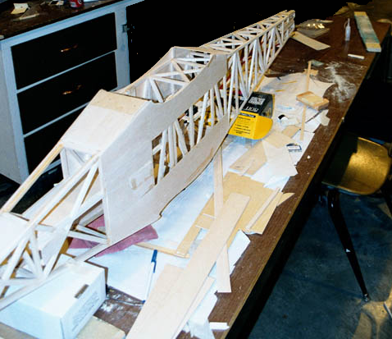
A balsa wood truss structure was used to fabricate the fuselage (Figure 7.1). The structural sizing of the fuselage was done using historical data of similar sized aircraft.

To meet the tip-over criteria a composite landing gear was fabricated. The landing gear was fabricated using carbon graphite fabric (see Appendix F).

The vertical and horizontal tails are constructed using balsa wood. A balsa wood truss structure was covered with 1/16” balsa wood sheeting and Monokote, providing a very strong tail structures.
Figure 7.1: Fuselage Structure

Composite Wing Manufacturing

The wing is fabricated using a technique similar to methods employed in full-scale aircraft construction. The wing is fabricated as an upper and lower skin that is joined to create the wing. To obtain the most accurate airfoil geometry and meet the aerodynamic parameters used to determine the aircraft performance female molds are used to shape the wing skins. For DR2 the female molds were fabricated using a 5-axis mill to machine poplar wood blanks (see Appendix F). The programs to run the 5-axis mill were created using Surfcam V7.1 (Reference 5). After the molds were machined they needed to be finished and sealed to obtain a very smooth surface. The molds were sealed with polyurethane varnish. The final shape of the molds was verified with checking templates (see Figure 7.2 and 7.3). The foam core used for fabrication was 1/8” Divinycell H45 sheet foam. To aid in the release of the fiberglass part from the mold a Mylar release film was used, ensuring proper release of the part from the mold. Vacuum bagging provided a proper resin to fiber ratio and increased the quality of the bond between the fiberglass and the foam core. The method used to vacuum bag the wings are shown is Figure 7.4.
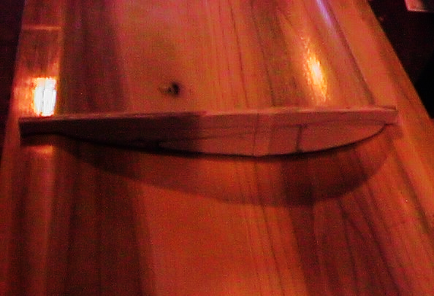

Figure 7.2: Checking Upper Surface of Finished Mold
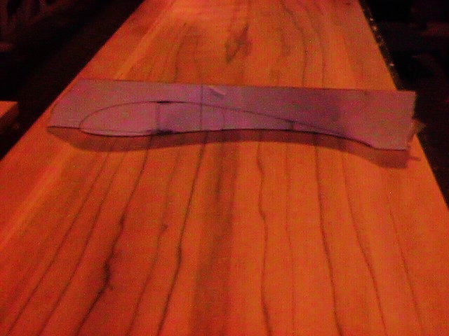

Figure 7.3: Checking Lower Surface of Finished Mold

Breather
Release Film
Teflon Film
Bleeder
Vacuum bag

Figure 7.4: Vacuum Bag Setup
The fiberglass and foam was wet-out on the table, a mixture of epoxy and microballoons, a lightweight filler, was used to wet-out the foam (Figure 7.5).
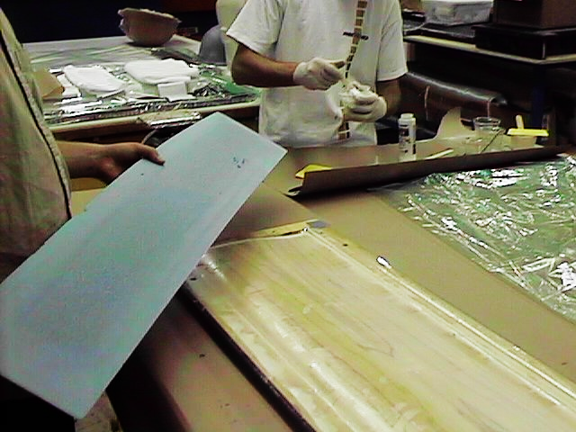

Figure 7.5: Lower Skin, Outer Layer of Fiberglass, and foam wet-out

After the foam and fiberglass was wet-out they were placed into the molds (Figure 7.5).
Once the fiberglass and foam were properly positioned in the mold the breather/bleeder cloth was applied to the lower skin mold and the vacuum bag system was applied (Figure 7.6 and 7.7).

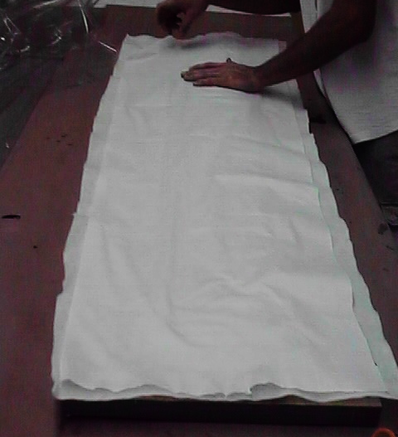

Figure 7.6: Breather and Bleeder Cloth Applied to Lower Skin Mold

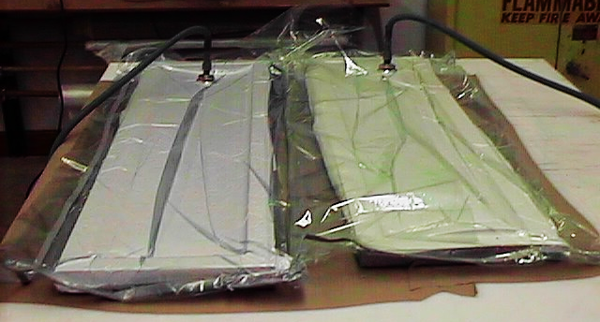

Figure 7.7: Final Vacuum Bag Setup for Wing Skins
- Propulsion and Power System

  - Introduction

The propulsion system, for this remote control aircraft, was based on the endurance parameter from the request for proposal. The remotely piloted aircraft was required to stay aloft for a 12-minute duration. The other constraint, placed on the aircraft engine, was the use of an electrically powered engine for the indoor flight.

To analyze the propulsion system, several aircraft parameters were required. These parameters included the aircraft’s power loading, total weight estimation, empty weight estimation, aircraft drag during takeoff and cruise, airfoil thickness, wing camber, and total wing area. A constraint code, developed for this design, yielded the initial design point for the propulsion analysis.

Selection for the electric power plant and the electrical power source were simplified based on the inventory of both. For the initial size estimation for the propulsion power system, a historical data point was selected as well as this aircraft’s size estimation. The design point selected was the Tow Plane Concept completed by the A&AE451 Green Team during the spring semester of 1998. The Tow Plane weight was approximately 8 pounds, similar in size to the 9.5 pounds estimation. This weight and the current inventory yielded the electric motor and power supply, the Astro40G electric motor and the Sanyo 3000SCR battery.

The Astro40G electric motor was selected over the Astro25G because of the larger engine size. Both motors, in the rough calculations, proved to be acceptable. With the increase of weight at the end of the build period, the Astro40G was the final selection to insure that enough power was available for the heavier plane. The manufacturer, Astroflight, installed the gearbox, with a gear ratio of 1.63:1. This eliminated the need to buy a separate gearbox for the engine. The speed controller for the Astroflight motor, the Astro 204D Speed Controller, was selected in order to maintain cohesion and reliability between the motor components. The 204D model also handles large current loads, which is important for the size of the battery pack. Using Astroflight products should eliminate any conflict or incompatibilities between different manufacturers.

The Sanyo 3000SCR battery packs were selected over the Sanyo1700SCR batteries in the inventory because of the higher energy density. Fourteen batteries, in series, were initially selected and became the final number to power the propulsion system.

Design Methodology

To analyze the propulsion system design, three distinct programs were used. The first program used was a scripted MatlabTM file, which determined the requirements of the propulsion system. This file calculated the power-train model of the propulsion system. The thrust required by the propeller was determined using the drag/thrust data for the aerodynamics section. This number was fed into a motor and gearbox to determine the amount of torque required to turn the propeller and the amount of electrical power required. The battery power was then calculated for the variable engine and the endurance time matched with a required number of cells.

The motor size and battery size were inputted into the constraint code and the refined aerodynamic data was calculated. Thrust available, by the airplane, was an output calculated by a propeller code Gold.m. This code, the FORTRAN 77/90 version was written by Professor Sulivan of the Aeronautical and Astronautical Engineering Department at Purdue University, solves for the propeller thrust depending on propeller revolutions per minute (RPM), propeller pitch, and propeller diameter. The output, of the Gold.m program, was the integrated thrust and power of the propeller sections. These values were then compared to the aerodynamic data to determine if the thrust was sufficient.

The calculations, performed above, would predict the theoretical values for the propulsion system. However, these values would require corroboration. Another computer program, Motocalc, was used to calculate the design parameters of the engine using the propeller calculations and the aerodynamic data. Using this input data, Motocalc would evaluate the flight conditions of the aircraft at differing throttle settings. Several of these parameters included motor RPM, propeller RPM, and endurance time at a give flight speed. The most important information gathered from the Motocalc program was the propeller RPM and endurance time. Using the propeller RPM data, an interative process began which evaluated the Gold.m thrust with the Motocalc propeller RPM and endurance time. Evaluation of the propeller size, the motor, and the battery size were inherent in each of these calculations and were solved for in a simultaneous manner. Hence at the end of the iterative process, the propulsion system was selected. Ultimately the decision for the propulsion system combination relied on the endurance time.

Component Selection

The most powerful motor in the inventory, the Astro40G, was selected as the motor for DR2. This selection was based on the inventory and historic data. Table 8.1 describes the Astro40G motor characteristics.

Table 8.1: Astroflight 640G Motor Characteristics

To propel the aircraft the propeller was picked based on thrust and ground clearance. The diameter of the propeller was fixed at 14 inches to clear the fuselage height of 12 inches. By selecting this propeller clearance requirement, the propeller pitch was limited to six, eight, and ten inches. Master Airscrew, the manufacturer, imposed the size restriction by its product line size. Analysis of the propeller pitch tradeoffs can be found in Appendix G. The result, of the pitch analysis, lead to the selection of the Master Airscrew propeller in Table 8.2.

Table 8.2: Master Airscrew Propeller Characteristics
The speed controller for this project was selected based on the inventory and the compatibility. The Astro204D speed controller matched perfectly in terms of both the component compatibility and the maximum current draw of the engine. The specifications for the speed controller are as follows:

Table 8.3: Astroflight 204D Speed Controller Characteristics

To power the propulsion system, the Sanyo 3000SCR battery was selected. This battery is in the current inventory and in its 14 cell configuration supports the mission. The battery specifications can be found below in Table 8.4.

Table 8.4: Sanyo 3000SDCR Battery Characteristics

The endurance and throttle setting was calculated using Motocalc. The values were based on Motocalc estimations and were evaluated by the team as values that were an optimum. Hence the values are accepted to be higher than what the team feels the system will perform at. Using engineering judgment and conservative analysis, the following values should meet the performance requirements set forth by the request for proposal:

Table 8.5: Aircraft Endurance Time Calculation

These values represent a system efficiency of 73.1%, however, it assumes that the Sanyo 3000SCR battery pack has a 100% charge. It is also assumed that the battery endurance is linear with charge percentage and that the flight will be made at a constant throttle setting. Therefore the endurance time is predicted to be approximately 15 minutes. Based on these assumptions, the propulsion and power system meets the endurance requirement.

The actual endurance of the aircraft was 9 minutes and 8 seconds. Analysis of this deviation resulted in several answers. The first is the Motocalc software, which did not give an accurate prediction. The second, the actual power draw of the motor was apparently higher than manufacturer printed and the calculations showed. Next, the charge absorbed by the battery system was inconsistent throughout the differing flights of the aircraft. Finally, the actual flight plan of the aircraft did not maintain the desired throttle settings. The higher throttle setting and maneuvers performed would diminish the battery life. A combination of these effects resulted in the lower endurance time.
- Economic Plan

To determine the full cost of DR2, the number of man-hours and a list of construction costs were made. Using timesheets for each individual tem member, a tally of man-hours was made for the entire semester was made. The total number of man-hours devoted to the design, build, and test of the aircraft came to 1805 hours. Each man-hour was determined to have the value of $75.00, which translates into $135,375.00 for the cost of the total man-hours. The breakdown and distribution of time, for the team and team members, is outlined in Appendix H.

The cost of the aircraft components was broken down into three categories. The first column, of Table 9.1, refers to the overall cost of the aircraft. This value includes the price of all purchased and donated materials. The second column represents the total cost for a consumer to by the kit for this airplane. This value does not represent the supplies that would be used by the consumer to build the aircraft. The third column represents the total cost incurred by the A&AE 451 Team to build the aircraft. A complete listing of the expenses can be found in Appendix H.

Table 9.1: Total Cost of DR2

- Conclusion

Many lessons were learned in designing, building, and testing the aircraft. Team DR2 spent over 1800 man-hours to complete this arduous task of building an airplane. Approximately ten weeks were spent learning about biplane airfoil analysis, using computational fluid mechanics codes (CMARC), evaluating rate gyro and servo models, electric motor propulsion, and composite construction techniques. At the end of these ten weeks, the aircraft design moved into the construction phase. Construction of the aircraft was completed within two weeks followed by several days of flight-testing.

The design of the aircraft was a culmination of the team’s education at Purdue University; and would be tested successfully in this design. Team members would use their knowledge, numerous resources, and computer modeling techniques to design the aircraft. The major innovation in this design, that no other previous design had incorporated, was the composite structures used in the biplane’s wings. The team learned how to build a wing, made of composite materials, from cutting the wooden molds to the assembling the final wing.

DR2 met all of the requirements, specified in the Request for Proposal, with the exception of the endurance time. However, and most importantly, the aircraft flew with outstanding flying characteristics with and without the feedback gains. The aircraft, flown by an experienced r/c modeler, marveled at the easy and stability of flight. The structural design of the aircraft was robust exemplified by its handling of many heavy landings on Astroturf, concrete, and hard ground. DR2 flew well under all flight regimes, from slow flight to aerobatic maneuvers.

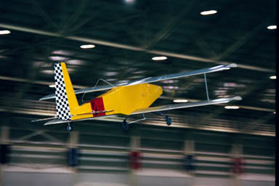
Each team member gained extensive knowledge in the designing and building of this aircraft. With this knowledge, this Team DR2 has learned how to use the design process, how to improve the work that was done, how to cut down on the building time, and how the process of flight-testing works. Team DR2 was successful in building the aircraft near the desired cost of $200, a cost set for smaller previous aircraft. With these goals accomplished, the bar has been raised for future class to look at this design and measure their own.

- References

- Warner, Airplane Design: Performance
- Roskam, Ian, Airplane Flight Dynamics and Automated Flight Controls, DARcorporation, Lawrence, KS, 1995
- Mark Peters Master’s Thesis
- Ironcad
- Surfcam
- Raymer, D.P., Aircraft Design: A Conceptual Approach, AIAA, Reston, VA, 1999
- White Team, The Fat Albert, A&AE 451 May, 1997
- Niu, M.C., Airframe Structural Design, Conmilit Press LTD., 1995
- Whiskey-Tango Aerospace, A&AE 451 Spring 1999
- Agarewal, B.D. & Broutman, L.J., Analysis and Performance of Fiber Composites, John Wiley & Sons, Inc. 1980
- Lardner, T.J. & Archer, R.R., Mechanics of Solids, McGraw-Hill, 1994
- Nirho University Aerodynamics Student Group website, www.NASG.com.
- Robert J. Boucher, Electric Motor Handbook
- Motocalc Program, www.motocalc.com

