CE 595: Finite Elements in Elasticity

HW#1 Solutions

Problem #1
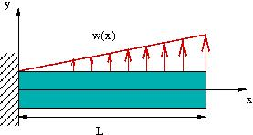

Given: A cantilevered beam has a length L, constant cross-sectional area A, constant moment of inertia , and a variable Young’s modulus . It is loaded by a vertically upward line load . Assume that there is no body force present and that bending strain energy is the only significant contributor to internal work.

Required: Using the Rayleigh-Ritz method on the Principle of Virtual Displacements, derive an approximate expression for the vertical deflection of the beam’s centerline using the approximating function , where , , and are unknown constants.

Hint: Bending strain is computed by , and bending stress is computed by . Be sure to write your volume integrals in the form and remember how is defined!

Solution: In the absence of body forces, the Principle of Virtual Displacements takes the following form:
In words, the virtual work done by the external forces must equal the virtual strain energy stored in the beam. Let’s start with the work done by external forces. Since both the applied load and the expected displacement are positive, the real work done is simply the product of and integrated over the beam. Hence, the virtual work is the product of and integrated over the beam, where the virtual displacement is simply , where , , and are arbitrary constants. Since is a line load (and thus is already integrated over the beam’s thickness), the integral over the surface becomes:

As for the bending strain energy, we follow the information given in the hint:
We recognize the integral over the area as the definition of , which is a constant in this problem. Pulling this out and performing the resulting x integral is done in the following Matlab session:

>> syms x L a2 a3 a4 da2 da3 da4 wo Eo Iz

>> strainenergy = Eo*Iz*expand( int( (1+x/L)*(2*a2 + 6*a3*x + 12*a4*x^2)*(2*da2 + 6*da3*x + 12*da4*x^2),x,0,L))

strainenergy =

Eo*Iz*(264/5*L^5*a4*da4+162/5*L^4*da4*a3+162/5*L^4*a4*da3+14*L^3*da4*a2+21*L^3*da3*a3+14*L^3*a4*da2+10*L^2*da3*a2+10*L^2*da2*a3+6*a2*da2*L)

This expression minus the external virtual work must equal zero, according to PVD:

>> extwork = wo/L*(da2*L^4/4 + da3*L^5/5 + da4*L^6/6)

extwork =

wo/L*(1/4*da2*L^4+1/5*da3*L^5+1/6*da4*L^6)

>> pvd = strainenergy - extwork;

According to the Rayleigh-Ritz method, we obtain equations to solve for , , and by taking partial derivatives of the PVD statement with respect to the corresponding virtual coeffcients; i.e.,
These calculations are shown below:

>> pvd = strainenergy - extwork;
>> eqn1 = diff(pvd,da2)

eqn1 =

Eo*Iz*(14*L^3*a4+10*L^2*a3+6*a2*L)-1/4*wo*L^3

>> eqn2 = diff(pvd,da3)

eqn2 =

Eo*Iz*(162/5*L^4*a4+21*L^3*a3+10*L^2*a2)-1/5*wo*L^4

>> eqn3 = diff(pvd,da4)

eqn3 =

Eo*Iz*(264/5*L^5*a4+162/5*L^4*a3+14*L^3*a2)-1/6*wo*L^5

>> consts = solve(eqn1,eqn2,eqn3,a2,a3,a4)

consts = *** consts is an example of a Matlab entity called
*** a structure. In this case, the solutions for the
a2: [1x1 sym] *** unknown constants are the components of this
a3: [1x1 sym] *** structure. The way to access the values of these
a4: [1x1 sym] *** components is shown in the subsequent commands.

>> consts.a2

ans =

61/378/Eo/Iz*wo*L^2

>> consts.a3

ans =

-263/2268/Eo/Iz*L*wo

>> consts.a4

ans =

143/4536/Eo/Iz*wo

Based on these results, we can write the approximate deflection curve:

(How good is this solution? Though not required for this problem, you can actually integrate the governing equation to get the exact solution – as you might guess, it’s a mess, but it’s not too bad in Matlab. You can then compare the exact and approximate solutions. Below, I show a plot of these two solutions in nondimensional form:
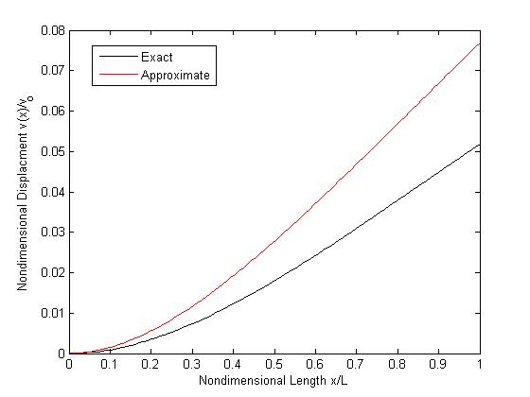
(The parameter simply relates the size of the load to the stiffness of the beam.) You can see that the approximate solution is an overestimate of the exact solution, and it’s really only close near x = 0. If you were really interested in getting a good approximation for this problem, this result suggests the need to look at a higher order approximation – say, adding in a term like to the given approximate solution.)

