Homework No.12
Due Date: Wednesday, April 26, 2017
Problem No. 1 (LRFD only)

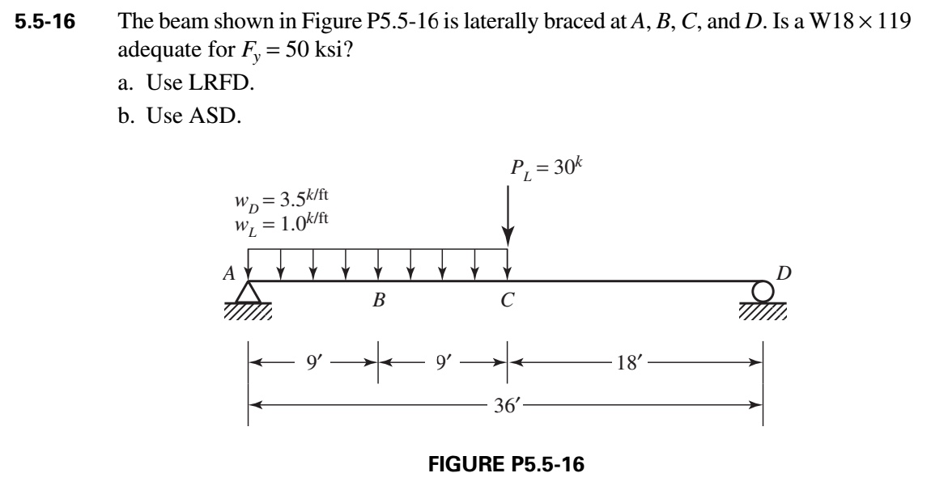

Problem No. 2 (LRFD Only).
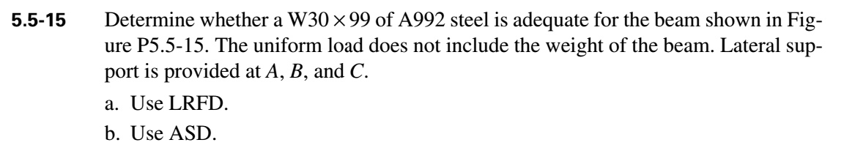
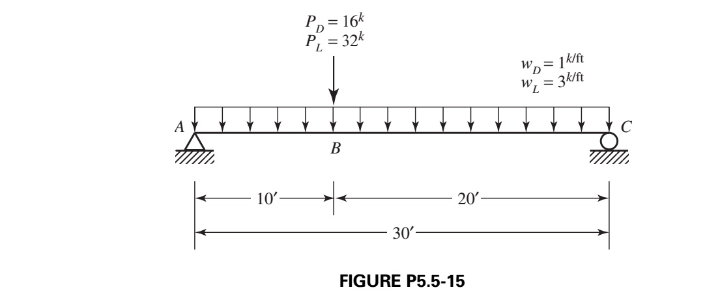

Problem No. 3 (LRFD only)

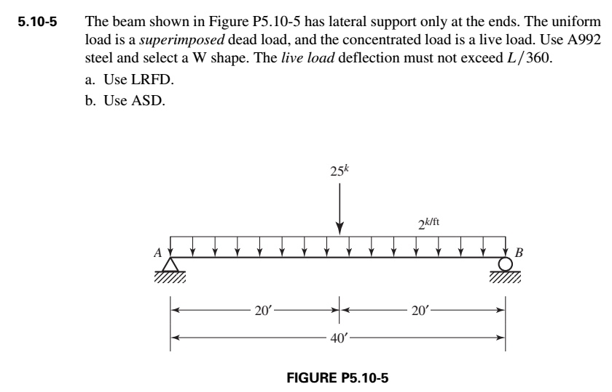

Problem No. 4 (LRFD only)
