Homework No.11
Due Date: Monday, April 10, 2017
Problem No. 1

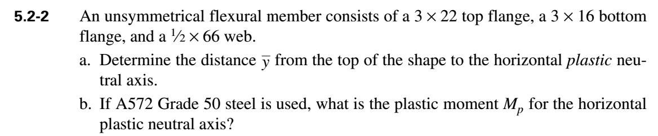
c. What is the plastic section moduls, Z ?
d. Compute the elastic neutral axis and moment of inertia.
e. Also compute section modulus S, and the yield moment of the cross-section

Problem No. 2
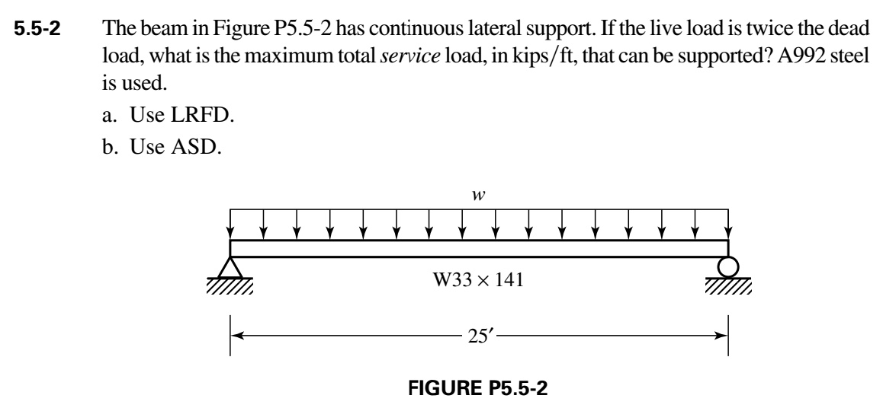
Use the Tables in the Manual to report the section plastic modulus, and design plastic moment capacity of the W33x141 section.

You can also use Tables to calculate the maximum moment for simply supported beam subjected to uniform distributed loading.

