# CHAPTER 3. BOLTED AND WELDED CONNECTIONS

## 3.1 INTRODUCTORY CONCEPTS

* There are different types of bolted connections. They can be categorized based on the type of loading.
* Tension member connection and splice. It subjects the bolts to forces that tend to shear the shank.
* Beam end simple connection. It subjects the bolts to forces that tend to shear the shank.
* Hanger connection. The hanger connection puts the bolts in tension

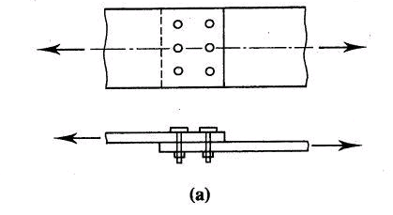

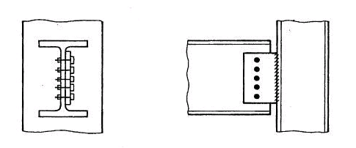

**(b) (c)**

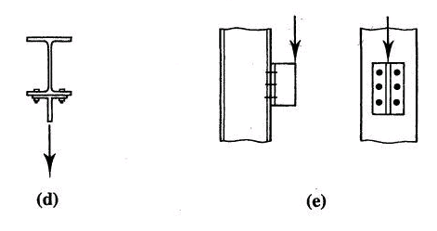

**Figure 1**

* The bolts are subjected to shear or tension loading.
* In most bolted connection, the bolts are subjected to shear.
* Bolts can fail in shear or in tension.
* You can calculate the shear strength or the tensile strength of a bolt
* Simple connection: If the line of action of the force acting on the connection passes through the center of gravity of the connection, then each bolt can be assumed to resist an equal share of the load.
* The strength of the simple connection will be equal to the sum of the strengths of the individual bolts in the connection.
* We will first concentrate on bolted shear connections.

**3.2 BOLTED SHEAR CONNECTIONS**

* We want to design the bolted shear connections so that the factored design strength (* *Rn­) is greater than or equal to the factored load.
* So, we need to examine the various possible failure modes and calculate the corresponding design strengths.
* Possible failure modes are:
* Shear failure of the bolts
* Failure of member being connected due to fracture or block shear or ….
* Edge tearing or fracture of the connected plate
* Tearing or fracture of the connected plate between two bolt holes
* Excessive bearing deformation at the bolt hole
* Shear failure of bolts
* Average shearing stress in the bolt = fv = P/A = P/( db2/4)
* P is the load acting on an individual bolt
* A is the area of the bolt and db is its diameter
* Strength of the bolt = P = fv x ( db2/4) where fv = shear yield stress = 0.6Fy
* Bolts can be in *single* shear or *double* shear as shown below.
* When the bolt is in double shear, two cross-sections are effective in resisting the load. The bolt in *double shear* will have the twice the shear strength of a bolt in single shear.

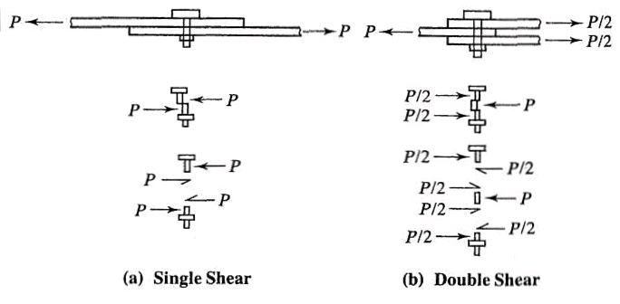

* Failure of connected member
* We have covered this in detail in Ch. 2 on tension members
* Member can fail due to tension fracture or block shear.
* Bearing failure of connected/connecting part due to bearing from bolt holes
* Hole is slightly larger than the fastener and the fastener is loosely placed in hole
* Contact between the fastener and the connected part over approximately half the circumference of the fastener
* As such the stress will be highest at the radial contact point (A in Figure 3). However, the average stress can be calculated as the applied force divided by the projected area of contact.
* Average bearing stress fp = P/ (db t), where P is the force applied to the fastener.
* The bearing stress state can be complicated by the presence of nearby bolt or edge. The bolt spacing and edge distance will have an effect on the bearing strength.
* Bearing stress effects are independent of the bolt type because the bearing stress acts on the connected plate not the bolt.
* A possible failure mode resulting from excessive bearing close to the edge of the connected element is shear tear-out as shown below (Figure 4). This type of shear tear-out can also occur between two holes in the direction of the bearing load.

Rn = 2 x 0.6 Fu Lc t = 1.2 Fu Lc t

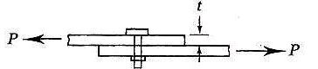

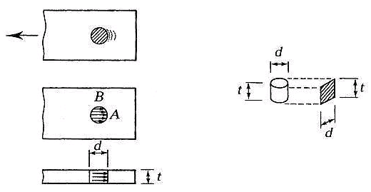

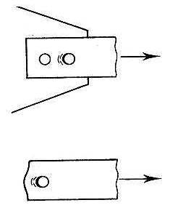

**Figure 3**

* To prevent excessive deformation of the hole, an upper limit is placed on the bearing load. This upper limit is proportional to the fracture stress times the projected bearing area

Rn = C x Fu x bearing area = C Fu db t

If deformation is not a concern then C = 3, If deformation is a concern then C=2.4

C = 2.4 corresponds to a deformation of 0.25 in.

* Finally, the equation for the bearing strength of a single bolts is **Rn

where,  = 0.75 and Rn = 1.2 Lc t Fu < 2.4 db t Fu

Lc is the clear distance in the load direction, from the edge of the bolt hole to the edge of the adjacent hole or to the edge of the material

* This relationship can be simplified as follows:

The upper limit will become effective when 1.2 Lc t Fu = 2.4 db t Fu

i.e., the upper limit will become effective when Lc = 2 db

If Lc < 2 db, Rn = 1.2 Lc t Fu

If Lc > 2 db, Rn = 2.4 db t Fu

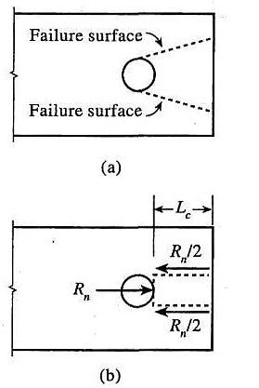**Figure 4**

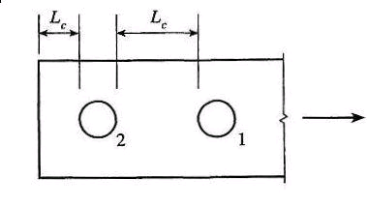

**3.3 DESIGN PROVISIONS FOR BOLTED SHEAR CONNECTIONS**

* In a simple connection, all bolts share the load equally.



* In a bolted shear connection, *the bolts are subjected to shear* and the connecting / connected plates are subjected to bearing stresses.



* The shear strength of all bolts = shear strength of one bolt x number of bolts
* The bearing strength of the connecting / connected plates can be calculated using equations given by AISC specifications.
* The tension strength of the connecting / connected plates can be calculated as discussed earlier in Chapter 2.

**3.3.1 AISC Design Provisions**

* Chapter J of the AISC Specifications focuses on connections.
* Section J3 focuses on bolts and threaded parts
* AISC Specification J3.3 indicates that the minimum distance (s) between the centers of bolt holes is 2**. A distance of 3db is preferred (db is the nominal dia. of the bolt).
* AISC Specification J3.4 indicates that the minimum edge distance (*L*e) from the center of the standard bolt hole to the edge of the connected part is given in Table J3.4 on page **16.1**-123.
* AISC Specification J3.5 indicates that the maximum edge distance for bolt holes (measured from center of hole) is 12 times the thickness of the connected part (but not more than 6 in.). The maximum spacing for bolts between painted members or unpainted members not subject to corrosion is 24 times the thickness of the thinner part (but not more than 12 in.). For bolts between unpainted members subject to atmospheric corrosion, the spacing is 14 times the thickness of thinner part (but not more than 7in.).
* Specification J3.6 indicates that the design tension or shear strength of bolts is ** FnAb
* * *is 0.75 (LRFD)
* Table J3.2 gives the values of Fn.
* Ab is the unthreaded area of bolt.
* In Table J3.2, there are different types of bolts A325 and A490 (Group A and Group B).
* The shear strength of the bolts depends on whether threads are included or excluded from the shear planes. If threads are included in the shear planes then the strength is lower.
* We will always assume that threads are included in the shear plane, therefore less strength to be conservative.
* We will look at specifications J3.7 – J3.9 later.
* AISC Specification J3.10 indicates the bearing strength of plates at bolt holes.
* The design bearing strength at bolt holes is **Rn (*=*0.75 (LRFD))
* Rn = 1.2 Lc t Fu ≤ 2.4 db t Fu - deformation at bolt holes is a design consideration
* Rn = 1.5 Lc t Fu ≤ 3.0 db t Fu - deformation at bolt holes not a consideration

* Where, Fu = specified tensile strength of the connected material
* Lc = clear distance, in the direction of the force, between the *edge* of the hole and the *edge* of the adjacent hole or edge of the material (in.).
* t = thickness of connected material

For connections, the bearing resistance shall be taken as the sum of the bearing resistances of the individual bolts.

**3.3.2 AISC Design Tables**

* Table 7-1 on page 7-22 of the AISC Manual gives the design shear strength of one bolt. Different bolt types (A325, A490, A307), thread condition (included or excluded), loading type (single shear or double shear), and bolt diameters (5/8 in. to 1 in.) are included in the Table.
* Table 7-2 on page 7-23 of the AISC Manual gives the design tensile strength of one bolt. It includes different types of bolts and diameters.
* Table 7-4 on pages 7-26 and 7-27 of the AISC manual gives the design bearing strength at bolt holes for various bolt spacings.
* These design bearing strengths are in kips/in. thickness of the connected part.
* The tabulated numbers must be multiplied by the plate thickness to calculate the design bearing strength of the connected part.
* The design bearing strengths are given for different bolt spacings (2.67db and 3db), different Fu (58 and 65 ksi), and different bolt diameters (5/8 – 1-1/2 in.)
* Table 7-4 also includes the spacing (sfull) required to develop the full bearing strength for different types of holes (standard, short-slotted, oversized, etc.) and bolt diameters
* Table 7-4 also includes the bearing strength when s > sfull
* Table 7-4 also includes the minimum spacing 2-2/3 db values for different bolt dia.
* Table 7-5 in the AISC manual on pages 7-28 and 7-29 is similar to Table 7-5. It gives the design bearing strength at bolt holes for various edge distances.
* These design bearing strengths are in *kips/in. thickness* of the connected part.
* The tabulated numbers must be multiplied by the plate thickness to calculate the design bearing strength of the connected part
* The design bearing strengths are given for different edge distances (1.25 in. and 2 in.), different Fu (58 and 65 ksi), and different bolt diameters (5/8 – 1-1/2 in.)
* Table 7-5 also includes the edge distance (Le full) required to develop the full bearing strength for different types of holes (standard, short-slotted, oversized, etc.) ­ and bolt diameters
* Table 7-5 also includes the bearing strength when Le > Le full for different bolt diameters.

**Example 3.1** Calculate and check the design strength of the connection shown below. Is the connection adequate for carrying the factored load of 60 kips? Assume A325 bolts.

Solution

**Step I.** Shear strength of bolts

* The design shear strength of one bolt in shear = ** Fn Ab = 0.75 x 54 x  x 0.752/4
*  Fn Ab = 17.9 kips per bolt (See Table J3.2 and Table 7-1)
* Shear strength of connection = 4 x 17.9 = 71.6 kips

**Step II.** Minimum edge distance and spacing requirements

* See Table J3.4, minimum edge distance = 1 in. for rolled edges of plates
* The given edge distances (1.25 in.) > 1 in. Therefore, minimum edge distance requirements are satisfied.
* Minimum spacing = 2.67 db = 2.67 x 0.75 = 2.0 in.
* Preferred spacing = 3.0 db = 3.0 x 0.75 = 2.25 in.
* The given spacing (2.5 in.) > 2.25 in. Therefore, spacing requirements are satisfied.

**Step III.** Bearing strength at bolt holes.

* Bearing strength at bolt holes in connected part (5 x ½ in. plate)
* At edges, Lc = 1.25 – hole diameter/2 = 1.25 – (3/4 + 1/16)/2 = 0.844 in.
* **Rn­ = 0.75 x (1.2 Lc t Fu) = 0.75 x (1.2 x 0.844 x 0.5 x 58) = 22.03 kips
* But, **Rn ≤ 0.75 (2.4 db t Fu) = 0.75 x (2.4 x 0.75 x 0.5 x 58) = 39.15 kips
* Therefore, **Rn = 22.03 kips at edge holes
* *Compare with value in Table 7-5. Rn = 44.0 x 0.5 = 22.0 kips*
* At other holes, s = 2.5 in, Lc = 2.5 – (3/4 +1/16) = 1.688 in.
* Rn = 0.75 x (1.2 Lc t Fu) = 0.75 x (1.2 x 1.688 x 0.5 x 58) = 44.06 kips
* But, **Rn ≤ 0.75 (2.4 db t Fu) = 39.15 kips. Therefore **Rn = 39.15 kips
* Therefore, **Rn = 39.15 kips at other holes
* *Compare with value in Table 7-4. Rn = 78.3 x 0.5 =39.15 kips*
* Therefore, bearing strength at holes = 2 x 22.03 + 2 x 39.15 = 122.36 kips
* Bearing strength at bolt holes in gusset plate (3/8 in. plate)
* At edges, Lc = 1.25 – hole diameter/2 = 1.25 – (3/4 + 1/16)/2 = 0.844 in.
* **Rn­ = 0.75 x (1.2 Lc t Fu) = 0.75 x (1.2 x 0.844 x 0.375 x 58) = 16.52 k
* But, **Rn ≤ 0.75 (2.4 db t Fu) = 0.75 x (2.4 x 0.75 x 0.375 x 58) = 29.36 kips
* Therefore, **Rn = 16.52 kips at edge holes
* *Compare with value in Table 7-6*. *Rn = 44.0 x 3/8 = 16.5 kips*
* At other holes, s = 2.5 in, Lc = 2.5 – (3/4 +1/16) = 1.688 in.
* Rn = 0.75 x (1.2 Lc t Fu) = 0.75 x (1.2 x 1.688 x 0.375 x 58) = 33.04 kips
* But, **Rn ≤ 0.75 (2.4 db t Fu) = 29.36 kips
* Therefore, **Rn = 29.36 kips at other holes
* *Compare with value in Table 7-5. Rn = 78.3 x 0.375 = 29.36 kips*
* Therefore, bearing strength at holes = 2 x 16.52 + 2 x 29.36 = 91.76 kips
* Bearing strength of the connection is the smaller of the bearing strengths = 91.76 kips

|  |
| --- |
| **Connection Strength** |
| Shear strength = 71.6 kips |
| Bearing strength (plate) = 122.34 kips |
| Bearing strength (gusset) = 91.76 kips |

*Connection strength (Rn) > applied factored loads (Q). Therefore ok.*

**Example 3.2** Design a double angle tension member and a gusset plated bolted connection system to carry a factored load of 100 kips. Assume A36 (36 ksi yield stress) material for the double angles and the gusset plate. Assume A325 bolts. Note that you have to design the double angle member sizes, the gusset plate thickness, the bolt diameter, numbers, and spacing.

#### Solution

**Step I.** Design and select a trial tension member

* See **Table 5-8** on page 5-49 of the AISC manual.
* Select 2*L* 3 x 2 x 3/8 with **Pn = 112 kips (yielding) and 113 kips (fracture)
* While selecting a trial tension member check the fracture strength with the load.

**Step II.** Select size and number of bolts

The bolts are in double shear for this design (may not be so for other designs)

* See **Table 7-1** on page 7-22 in the AISC manual

Use four 3/4 in. A325 bolts in double shear

**Rn = 35.8 x 4 =143.2 kips - shear strength of bolts from Table 7-1

**Step III.** Design edge distance and bolt spacing

* **See Table J3.4**
  + The minimum edge distance = 1 in. for 3/4 in. diameter bolts in rolled edges.
* Select edge distance = 1.25 in.
* **See specification J3.5**
  + Minimum spacing = 2.67 db = 2.0 in.
  + Preferred spacing = 3.0 db = 2.25 in.
  + Select spacing = 3.0 in., which is greater than preferred or minimum spacing

**Step IV.** Check the bearing strength at bolt holes in angles

* Bearing strength at bolt holes in angles
  + Angle thickness = 3/8 in.
  + See **Table 7-5** for the bearing strength per in. thickness at the edge holes
  + Bearing strength at the edge holes (Le = 1.25 in.) = **Rn = 44.0 x 3/8 = 16.5 k
  + See **Table 7-4** for the bearing strength per in. thickness based on bolt spacing
  + Bearing strength at non-edge holes (s = 3 in.) = **Rn = 78.3 x 3/8 = 29.4 k
  + *Bearing strength at bolt holes in each angle = 16.5 + 3 x29.4 = 104.7 kips*
  + *Bearing strength of double angles = 2 x 104.7 kips = 209.4 kips*

**Step V.** Check the fracture and block shear strength of the tension member

* *This has been covered in the chapter on tension members and is left to the students.*

**Step VI. Design the gusset plate**

* See **specification J4.1** for designing gusset plates. These plates must be designed for the limit states of yielding and rupture
* Limit state of yielding
  + **Rn = 0.9 Ag Fy > 100 kips
  + Therefore, Ag = L x t > 3.09 in2
  + Assume t = ½ in; Therefore L > 6.18 in.
  + Design gusset plate = 6.5 x ½ in.
  + Yield strength = **Rn = 0.9 x 6.5 x 0.5 x 36 = 105.3 kips
* Limit state for fracture
  + An = Ag – (db+1/8) x t
  + An = 6.5 x 0.5 – (3/4 + 1/8) x 0.5 = 2.81 in2
  + **But, An ≤ 0.85 Ag = 0.85 x 3.25 = 2.76 in2**
  + **Rn = 0.75 x An x Fu = 0.75 x **2.76** x 58 = 120 kips
* Design gusset plate = 6.5 x 0.5 in.
* **Step VII.** Bearing strength at bolt holes in gusset plates

Assume Le = 1.25 in. (same as double angles)

* + Plate thickness = 1/2 in.
  + Bearing strength at the edge holes = **Rn = 44.0 x 1/2 = 22.0 k
  + Bearing strength at non-edge holes = **Rn = 78.3 x 1/2 = 39.15 k
  + *Bearing strength at bolt holes in gusset plate = 22.0 + 3 x 39.15 = 139.5 kips*

**Summary of Member and Connection Strength**

|  |  |  |
| --- | --- | --- |
| Connection | Member | Gusset Plate |
| Shear strength = 143.2 kips | Yielding = 112 kips | Yielding = 105.3 kips |
| Bearing strength = 209.4 kips (angles) | Fracture =? | Fracture = 120 kips |
| Bearing Strength = 139.5 (gusset) | Block Shear =? |  |

* Overall Strength is the smallest of all these numbers = 105.3 kips
* Gusset plate yielding controls
* Resistance > Factored Load (100 kips).
* Design is acceptable

**­3.4 SLIP-CRITICAL BOLTED CONNECTIONS**

* High strength (A325 and A490) bolts can be installed with such a degree of tightness that they are subject to large tensile forces.
* These large tensile forces in the bolt clamp the connected plates together. The shear force applied to such a tightened connection will be resisted by friction as shown in the Figure below.





* Thus, *slip-critical bolted connections* can be designed to resist the applied shear forces using friction. If the applied shear force is less than the friction that develops between the two surfaces, then no slip will occur between them.
* However, slip will occur when the friction force is less than the applied shear force. After slip occurs, the connection will behave similar to the bearing-type bolted connections designed earlier.
* Table J3.1 summarizes the minimum bolt tension that must be applied to develop a slip-critical connection.
* Slip-critical connections shall be designed to prevent slip and for the limit states of bearing-type connections.
* When bolts pass through fillers, all surfaces subject to slip shall achieve design slip resistance.
* The design slip resistance shall be determined for the limit state of slip as follows:

Slip resistance = Rn = ** *Du hf Tb ns*

where,  = 1.0 for standard size and short-slotted holes perpendicular to the direction of load

 = 0.85 for oversized and short-slotted holes parallel to the direction of load

 = 0.70 for long-slotted holes

** = mean slip coefficient for Class A or B surfaces

*      ** *0.30 for Class A surfaces (unpainted clean mill scale)

= 0.50 for Class B surfaces *(unpainted blast cleaned surfaces)*

*Du = 1.13*, a multiplier that reflects the ratio of the mean installed bolt pretension to the specified minimum bolt pretension.

*hf* = factor for fillers

*=* 1 when no fillers or bolts have been added to distribute load in fillers

*=* 1 when bolts have not been added but there is only one filler between connected parts

*=* 0.85 when bolts have not been added and there are two or more fillers between the connected parts

*Tb* = minimum bolt tension given in Table J3.1

*ns* = number of slip planes required to permit connection to slip

* See Table 7-3 on pages 7-24 and 7-25 of the AISC manual. This Table gives the shear resistance of fully tensioned bolts. It assumes Class A faying surfaces with =0.30.
* For example, the shear resistance of Group A 1-1/8 in. bolt in single shear fully tensioned to 56 kips (Table J3.1) for standard hole is equal to 19 kips (Class A faying surface).
* When the applied shear force exceeds the **Rn value stated above, slip will occur in the connection.
* The final strength of the connection will depend on slip resistance of the bolt (Table 7-3), the shear/tensile strength of the bolts calculated using the values in Table 7-1, 7-2 and on the bearing strength of the bolts calculated using the values in Table 7-4, 7-5.

**Example 3.3** Design a slip-critical splice for a tension member subjected to 300 kips of tension loading. The tension member is a W8 x 28 section made from A992 (50 ksi) material. The unfactored dead load is equal to 50 kips and the unfactored live load is equal to 150 kips. Use A325 bolts.

#### Solution

**Step I.** Factored loads

* Factored design load = 1.2 D + 1.6 L = 300 kips
* Tension member is W8 x 28 section made from A992 (50 ksi) steel. The tension splice must be slip critical (i.e., it must not slip).

**Step II.** Slip-critical splice connection

Rn of one fully-tensioned slip-critical bolt =  ** *Du hf Tb ns*

Considering standard holes ( Class A Surface (** No Fillers (hf=1), Bolts will be in single shear

* If db = 3/4 in.

Rn of one bolt = 1.0 x 0.3 x 1.13 x 1.00 x 28 x 1 = 9.49 kips

**Rn of n bolts = 11.1 x n > 300 kips (splice must be slip-critical)

Therefore, n > 32

* If db = 1 in.

Rn of one bolt = 17.3kips -from **Table 7-3**

Rn of n bolts = 17.3 x n > 300 kips (splice must be slip-critical)

Therefore, n > 18 bolts

**Step III.** Layout of splice connection

* Flange-plate splice connection



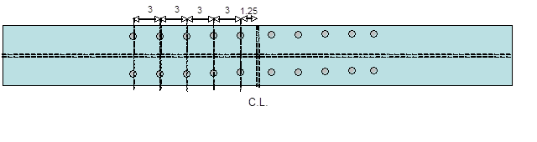

* Therefore, choose 20 fully tensioned 1 in. A325 bolts (Group A) on either side of the splice connection with layout as shown above.
* Note, that the minimum bolt tension = 51 kips from **Table J3.1**
* Minimum edge distance (Le) = 1-1/4in. from **Table J3.4**
* Design edge distance Le = 1.25 in.
* Minimum spacing = s = 2-2/3 db = 2.67 x 1 = 2.67 in. **(Spec. J3.3)**
* Preferred spacing = s = 3.0 db = 3.0 x 1 = 3 in. **(Spec. J3.3)**
* sfull = 3-1/16 in. **(see Table 7-4)**
* Design s = 3.0 in.

**Step IV.** Connection strength as Bearing Connection

* The splice connection should also be designed as a normal shear/bearing connection for the factored load of 300 kips.
* The shear strength of bolts = 31.8 kips/bolt x 20 = 636 kips  **(see Table 7-1)**
* Bearing strength of 1 in. bolts at edge holes (Le = 1.25 in.) = 42.0 kips/in. thickness

(see **Table 7-5**)

* Bearing strength of 1 in. bolts at non-edge holes (s = 3.0”) = 113 kips/in. thickness

(see **Table 7-4**)

* Bearing strength of bolt holes in flanges of wide flange section

= 4 x 42 x 0.465 +16 x 91.3 x 0.465 = 918.84 kips

**Step V.** Design the splice plate (Using Grade A36 splice plate)

* Tension yielding: 0.9 Ag Fy > 300 kips; Therefore, Ag > 9.3 in2
* Tension fracture: 0.75 An Fu > 300 kips

Therefore, An =Ag - 4 x (1 +1/8) x t > 6.9 in.

* Beam flange thickness = 0.465 in. Beam flange width = 6.535 in.
* Assume 6.5 in. wide splice plates with thickness = 1 in.
* The strength of the splice plate = 421.2 kips (yielding) and 369.75 kips (fracture)
* Block shear - student should check. Develop path and check.

**Step VI.** Check member strength (yield, fracture and block shear)

* Student on his own.

# CHAPTER 3b. WELDED CONNECTIONS

## 3b.1 INTRODUCTORY CONCEPTS

* Structural welding is a process by which the parts that are to be connected are heated and fused, with supplementary molten metal at the joint.
* A relatively small depth of material will become molten, and upon cooling, the structural steel and weld metal will act as one continuous part where they are joined.

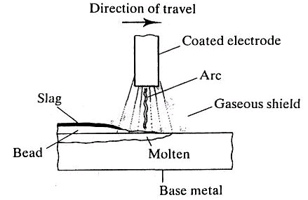

* The additional metal is deposited from a special electrode, which is part of the electric circuit that includes the connected part.
* In the shielded metal arc welding (SMAW) process, *current* arcs across a gap between the electrode and the base metal, heating the connected parts and depositing part of the electrode into the molten base metal.
* A special coating on the electrode vaporizes and forms a protective gaseous shield, preventing the molten weld metal from oxidizing before it solidifies.
* The electrode is moved across the joint, and a weld bead is deposited, its size depending on the rate of travel of the electrode.
* As the weld cools, impurities rise to the surface, forming a coating called *slag* that must be removed before the member is painted or another pass is made with the electrode.
* Shielded metal arc welding is usually done manually and is the process universally used for field welds.
* For shop welding, an automatic or semi-automatic process is usually used. Foremost among these is the submerged arc welding (SAW),
* In this process, the end of the electrode and the arc are submerged in a granular flux that melts and forms a gaseous shield. There is more penetration into the base metal than with shielded metal arc welding, and higher strength results.
* Other commonly used processes for shop welding are *gas shielded metal arc*, *flux cored arc*, and *electro-slag welding*.
* Quality control of welded connections is particularly difficult, because defects below the surface, or even minor flaws at the surface, will escape visual detection. Welders must be properly certified, and for critical work, special inspection techniques such as radiography or ultrasonic testing must be used.
* The two most common types of welds are the fillet weld and the groove weld. Fillet weld examples: lap joint – fillet welds placed in the corner formed by two plates

Tee joint – fillet welds placed at the intersection of two plates.

* Groove welds – deposited in a gap or groove between two parts to be connected

e.g., butt, tee, and corner joints with beveled (prepared) edges

* Partial penetration groove welds can be made from one or both sides with or without edge preparation.

# 

# 3b.2 Design of Welded Connections

* Fillet welds are most common and used in all structures.
* Weld sizes are specified in 1/16 in. increments
* A fillet weld can be loaded in any direction in shear, compression, or tension. However, it always **fails in *shear****.*
* The shear failure of the fillet weld occurs along a plane through the throat of the weld, as shown in the Figure below.

* Shear stress in fillet weld of length L subjected to load P = *fv* =
* If the ultimate shear strength of the weld = fw

Rn =

* *Rn = i.e., ** factor = 0.75

* fw = shear strength of the weld metal is a function of the electrode used in the SMAW process.
* The tensile strength of the weld electrode can be 60, 70, 80, 90, 100, 110, or 120 ksi.
* The corresponding electrodes are specified using the nomenclature E60XX, E70XX, E80XX, and so on. This is the standard terminology for weld electrodes.
* The strength of the electrode should match the strength of the *base metal.*
* If yield stress (y) of the base metal is ≤ 60 - 65 ksi, use E70XX electrode.
* If yield stress (y) of the base metal is ≥ 60 - 65 ksi, use E80XX electrode.
* E70XX is the most popular electrode used for fillet welds made by the SMAW method.
* **Table J2.5** in the AISC Specifications gives the weld design strength

fw = 0.60 FEXX

For E70XX, ** fw = 0.75 x 0.60 x 70 = 31.5 ksi

* Additionally, the shear strength of the base metal must also be considered. The fillet weld is connected to the base metal. The area of the base metal subjected to shear stresses by the fillet weld shall be equal to (tBM x Lw).
* This base metal area can fail by shear yielding or rupture. The smaller of the two strengths will govern. See AISC specification J4.2 on page 16.1-129 for the equations J4-3 and J4-4 that can be used to determine the shear strength of the base metal:

For shear yielding; ** Rn = 1.0 x 0.6 Fy x gross area of base metal subjected to shear

For shear rupture; ** Rn = 0.75 x 0.6 Fu x net area of base metal subjected to shear

where, Fy and Fu are the yield and tensile strength of the base metal.

* For example:

Strength of weld in shear Strength of base metal

= 0.75 x 0.707 x a x Lw x fw  = min {1.0 x 0.6 x Fy x t x Lw

0.75 x 0.6 x Fu x a x Lw}

Smaller governs the strength of the weld

* Always check weld metal and base metal strength. Smaller value governs. In most cases, the weld metal strength will govern.
* In weld design problems it is advantageous to work with strength per unit length of the weld or base metal.

**3b.2.1 Limitations on weld dimensions** (See AISC Spec. **J2.2b** on page **16.1-54** of manual)

* **Minimum size (amin)**

**-** function of the thickness of the thinnest connected plate

- given in Table J2.4 of the AISC specifications

* **Maximum size (amax)**

**-** function of the thickness of the thickest connected plate:

- Along edges of plates with thickness ≤ 0.25 in., amax­ = t

- Along edges of plates with thickness ≥ 0.25 in., amax = t - 1/16 in.

* **Minimum length (Lw)**

**-** length (Lw) ≥ 4 a otherwise, aeff = Lw / 4

- Read **J2.2 b**

- Intermittent fillet welds: Lw-min = 4 x a or 1.5 in., whichever is greater

* **Maximum effective length - read AISC J2.2b**
* If weld length Lw < 100 a, then effective weld length (Lw-eff) = Lw
* If Lw < 300 a, then effective weld length (Lw-eff) = Lw (1.2 – 0.002 Lw/a)
* If Lw > 300 a, the effective weld length (Lw-eff) = 180 x a
* **Weld Terminations - read AISC J2.2b**
* Lap joint – fillet welds terminate at a distance > a from edge.
* Weld returns around corners must be > 2 a (AISC does not require weld returns)

**Example 3b.1.** Determine the design strength of the tension member and connection system shown below. The tension member is a 4 in. x 3/8 in. thick rectangular bar. It is welded to a 1/2 in. thick gusset plate using E70XX electrode. Consider the yielding and fracture of the tension member. Consider the shear strength of the weld metal and the surrounding base metal.

Solution

**Step I.** Check for the limitations on the weld geometry

* tmin = 3/8 in. (member)

tmax = 0.5 in. (gusset)

Therefore, amin = 3/16 in. - AISC **Table J2.4**

amax = 3/8 - 1/16 = 5/16 in. - AISC **J2.2b**

Fillet weld size = a = 1/4 in. - *Therefore, OK!*

* Lw-min = 1.0 in. (4 x a) - OK.
* Lw-min for each length of the weld = 4.0 in. (*transverse distance between welds*, see **J2.2b**)
* Given length = 5.0 in., which is > Lmin. Therefore, *OK*!
* Length/weld size = 5/0.25 = 20 - *Therefore, maximum effective length* **J2.2 b** *satisfied.*
* End returns at the edge corner size - minimum = 2 a = 0.5 in. -*Therefore, OK!*

**Step II.** Design strength of the weld

* Weld strength = ** x 0.707 x a x 0.60 x FEXX x Lw

= 0.75 x 0.707 x 0.25 x 0.60 x 70 x 10 = 55.68 kips

* Base Metal strength = min {** x 0.6 x Fy x Lw x t ; ** x 0.6 x Fu x Lw x a}

= min {1.0 x 0.6 x 50 x 10 x 3/8 ; 0.75 x 0.6 x 65 x 10 x 1/4}

= min {112.5 ; 73.125 kips}

= 73.125 kips

**Step III.** Tension strength of the member

* * *Rn = 0.9 x 50 x 4 x 3/8 = 67.5 kips - tension yield
* ** Rn = 0.75 x Ae x 65 - tension fracture

Ae = U A

A = Ag = 4 x 3/8 = 1.5 in2 - See Table D3.1

U = 0.75 , since connection length (Lconn) < 1.5 w - See Table D3.1

Therefore, ** Rn = 54.8 kips

The design strength of the member-connection system = 54.8 kips. Tension fracture of the member governs. The end returns at the corners were not included in the calculations.

**Example 3b.2** Design a double angle tension member and connection system to carry a factored load of 250 kips.

*Solution*

**Step I.** Assume material properties

* Assume 36 ksi steel for designing the member and the gusset plates.
* Assume E70XX electrode for the fillet welds.

**Step II.** Design the tension member

* From Table 5-8 on page 5-47 of the AISC manual, select 2*L* 5 x 3½ x 1/2 made from 36 ksi steel with yield strength = 259 kips and fracture strength = 261 kips.

**Step III.** Design the welded connection

* amin = 3/16 in. - **Table J2.4**

amax = 1/2 - 1/16 in. = 7/16 in. - **J2.2b**

*Design*, a = 3/8 in. = 0.375 in.

* Shear strength of weld metal = ** Rn  = 0.75 x 0.60 x FEXX x 0.707 x a x Lw

= 8.35 Lw kips

* Strength of the base metal in shear = min {1.0 x 0.6 x Fy x t x Lw ; 0.75 x 0.6 x Fu x a x Lw}

= min {10.8 Lw ; 9.7875 Lw} kips

* Shear strength of weld metal governs,  Rn = 8.35 Lw kips
*  Rn > 250 kips

8.35 Lw > 250 kips

Lw > 29.94 in.

Design, length of 1/2 in. E70XX fillet weld = 30.0 in.

* *Shear strength of fillet weld = 250.5 kips*

**Step IV.** Layout of Connection

* Length of weld required = 30 in.

Since there are two angles to be welded to the gusset plate, assume that total weld length for

each angle will be 15.0 in.

* As shown in the Figure above, 15 in. of 1/2 in. E70XX fillet weld can be placed in three ways (a), (b), and (c).
* For option (a), the AISC Spec. **J2.2b** requires that the fillet weld terminate at a distance greater than the size (1/2 in.) of the weld. For this option, L1 will be equal to 7.5 in.
* For option (b), the fillet weld can be returned continuously around the corner for a distance of at least 2 a (1 in.). For this option, L2 can be either 6.5 in. or 7.5 in. However, the value of 7.5 in. is preferred. The end returns are provided to ensure that the weld size is maintained over the full length of the weld. These are not required by AISC Specs.
* For option (c), L3 will be equal to 5.75 in.

**Step V.** Fracture strength of the member

* Ae = U Ag

For the double angle section, use the value of x from Table 1-7 on page 1-37 of manual.

|  |  |
| --- | --- |
| Option | U = |
| (a) | 1-0.901/7.5 = 0.88 ≤ 0.9 |
| (b) | 1-0.901/6.5 =0.86 ≤ 0.9 |
| (c) | 1-0.901/5.75 = 0.84 ≤ 0.9 |

Assume case (a). Therefore, U =0.88

** Rn = 0.75 x 0.88 x 8.00 x 58 = 306.24 kips > 250 kips - fracture limit state is *ok!*

**Step VI.** Design the gusset plate

**Rn > Tu  - tension yielding limit state

Therefore, 0.9 x Ag x 36 > 250 kips

Ag > 7.72 in2

**Rn > Tu - tension fracture limit state

Therefore, 0.75 x An x Fu > 250 kips

An ≤ 0.85 Ag - Spec. **J4.1**

An > 5.747 in2 Therefore, Ag > 6.76 in2

Design gusset plate thickness = 1.0 in. and width = 8.0 in.

