# Chapter 2. TENSION MEMBER DESIGN

## 2.1 INTRODUCTORY CONCEPTS

* Stress: The stress in an axially loaded tension member is given by Equation (2.1)

 (2.1)

where P is the magnitude of load, and

A is the cross-sectional area normal to the load

* The stress in a tension member is uniform throughout the cross-section except:
  + near the point of application of load, and
  + at the cross-section with holes for bolts or other discontinuities, etc.
* For example, consider an 8 x ½ in. bar connected to a gusset plate and loaded in tension as shown below in Figure 2.1



**Figure 2.1** Example of tension member.

* Area of bar at section *a – a* = 8 x ½ = 4 in2
* Area of bar at section *b – b* = (8 – 2 x 7/8 ) x ½ = 3.12 in2
* Therefore, by definition (Equation 2.1) the reduced area of section *b – b* will be subjected to higher stresses
* However, the reduced area and therefore the higher stresses will be localized around section b – b.
* The unreduced area of the member is called its gross area = Ag
* The reduced area of the member is called its net area = An

**2.2 STEEL STRESS-STRAIN BEHAVIOR**

* The stress-strain behavior of steel is shown below in Figure 2.2



**Figure 2.2** Stress-strain behavior of steel

* In Figure 2.2, E is the elastic modulus = 29000 ksi.

Fy­ is the yield stress and Fu is the ultimate stress

y­ is the yield strain and u­ is the ultimate strain

* Deformations are caused by the strain . Figure 2.2 indicates that the structural deflections will be small as long as the material is elastic (*f* < Fy)
* Deformations due to the strain  will be large after the steel reaches its yield stress Fy­.

**2.3 DESIGN STRENGTH**

* A tension member can fail by reaching one of two limit states:

(1) excessive deformation; or (2) fracture

* Excessive deformation can occur due to the yielding of the gross section (for example section a-a from Figure 2.1) along the length of the member
* Fracture of the net section can occur if the stress at the net section (for example section b-b in Figure 2.1) reaches the ultimate stress Fu.
* The objective of design is to prevent these failure before reaching the ultimate loads on the structure (*Obvious*).
* This is also the load and resistance factor design approach recommended by AISC for designing steel structures

**2.3.1 Load and Resistance Factor Design**

The load and resistance factor design approach is recommended by AISC for designing steel structures. It can be understood as follows:

Step I. Determine the factored loads acting on the structure

* The values of D, L, W, etc. given by ASCE/SEI 7-10 are nominal loads (not maximum or ultimate)
* During its design life, a structure can be subjected to some maximum or ultimate loads caused by combinations of D, L, or W loading.
* The ultimate load on the structure can be calculated using factored load combinations, which are given by ASCE and AISC (see pages 2-10 and 2-11 of AISC manual). The most relevant of these load combinations are given below:

1.4 D (2.2 – 1)

1.2 D + 1.6 L + 0.5 (Lr or S) (2.2 – 2)

1.2 D + 1.6 (Lr or S) + (0.5 L or 0.5 W) (2.2 – 3)

1.2 D + 1.0 W + 0.5 L + 0.5 (Lr or S) (2.2 – 4)

0.9 D + 1.0 W (2.2 – 5)

Step II. Conduct linear elastic structural analysis

* Determine the required strengths (Pr­, Vr, and Mr) for each structural member

Step III. Design the members

* The failure (design) strength of the designed member must be greater than the corresponding design forces calculated in Step II. See Equation (2.3) below:

** Rn >  (2.3)

* Where, Rn is the calculated failure strength of the member
* ** is the resistance factor used to account for the reliability of the material behavior and equations for Rn
* Qi is the nominal load
* i is the load factor used to account for the variability in loading and to estimate the ultimate loading condition.

**2.3.2 Design Strength of Tension Members**

* Yielding of the gross section will occur when the stress *f* reaches Fy.



Therefore, nominal yield strength = Pn = Ag Fy  (2.4)

Factored yield strength = *t* Pn (2.5)

where, *t* = 0.9 for tension yielding limit state

* See the AISC manual, section on specifications, Chapter D (page 16.1 –26)
* Facture of the net section will occur after the stress on the net section area reaches the ultimate stress Fu



Therefore, nominal fracture strength = Pn = Ae Fu

Where, Ae is the effective net area, which may be equal to the net area or smaller.

The topic of Ae will be addressed later.

Factored fracture strength = t Ae Fu (2.6)

Where, *t* = 0.75 for tension fracture limit state (See page 16.1-27 of AISC manual)

**2.3.3 Important notes**

* Note 1. Why is fracture (& not yielding) the relevant limit state at the net section?

Yielding will occur first in the net section. However, the deformations induced by yielding will be localized around the net section. These localized deformations will *not* cause excessive deformations in the complete tension member. Hence, yielding at the net section will *not* be a failure limit state.

* Note 2. Why is the resistance factor (*t*) smaller for fracture than for yielding?

The smaller resistance factor for fracture (*t* = 0.75 as compared to *t* = 0.90 for yielding) reflects the more serious nature and consequences of reaching the fracture limit state.

* Note 3. What is the design strength of the tension member?

The design strength of the tension member will be the lesser value of the strength for the two limit states (gross section yielding and net section fracture).

* Note 4. Where are the Fy and Fu values for different steel materials?

The yield and ultimate stress values for different steel materials are noted in Tables 2-4, 2-5 and 2-6 in the *AISC* manual on pages *2-*48, 2-49and *2-50*.

* Note 5. What are the most common steels for structural members?

See Table 2-4 in the *AISC* manual on page *2-*48.The preferred materials for applicable shape series are highlighted in black, the remaining acceptable ones are highlighted in grey. According to this Table: the preferred material for *W* shapes is *A992* (Fy = 50 ksi; Fu = 65 ksi); the preferred material for *C*, *L*, *M* and *S* shapes is *A36* (Fy = 36 ksi; Fu = 58-80 ksi). All these shapes are also available in *A572* *Gr. 50* (Fy = 50 ksi; Fu = 65 ksi).

* Note 6. What is the amount of area to be deducted from the gross area to account for the presence of bolt-holes?
* The *nominal* diameter of the hole (dh) is equal to the bolt diameter (db­) + 1/16 in.
* However, the bolt-hole fabrication process damages additional material around the hole diameter.
* Assume that the material damage extends 1/16 *in*. around the hole diameter.
* Therefore, for calculating the net section area, assume that the gross area is *reduced by a hole diameter* equal to the nominal hole-diameter + 1/16 in.

Example 2.1 A 5 x ½ bar of A572 Gr. 50 steel is used as a tension member. It is connected to a gusset plate with six 7/8 in. diameter bolts as shown in below. Assume that the effective net area Ae equals the actual net area An and compute the tensile design strength of the member.



Solution

* Gross section area = Ag = 5 x ½ = 2.5 in2
* Net section area (An)
* Bolt diameter = db = 7/8 in.
* Nominal hole diameter = dh = 7/8 + 1/16 in. = 15/16 in.
* Hole diameter for calculating net area = 15/16 + 1/16 in. = 1 in.
* Net section area = An­  = (5 – 2 x (1)) x ½ = 1.5 in2
* Gross yielding design strength = *t* Pn = *t* Fy Ag
* Gross yielding design strength = 0.9 x 50 ksi x 2.5 in2 = 112.5 kips
* Fracture design strength = *t* Pn = t Fu Ae
* Assume Ae = An (only for this problem)
* Fracture design strength = 0.75 x 65 ksi x 1.5 in2 = 73.125 kips
* Design strength of the member in tension = smaller of 73.125 kips and 112.5 kips
  + Therefore, design strength = 73.125 kips (*net section fracture controls*).

Example 2.2 A single angle tension member, *L* 4 x 4 x 3/8 in. made from A36 steel is connected to a gusset plate with 5/8 in. diameter bolts, as shown in Figure below. The service loads are 35 kips dead load and 15 kips live load. Determine the adequacy of this member using AISC specification. Assume that the effective net area is 85% of the computed net area. (*Calculating the effective net area will be taught in the next section*).

* Gross area of angle = Ag = 2.86 in2 (*from Table 1-7 on page 1-44 of AISC*)



* Net section area = An
  + Bolt diameter = 5/8 in.
  + Nominal hole diameter = 5/8 + 1/16 = 11/16 in.
  + Hole diameter for calculating net area = 11/16 + 1/16 = 3/4 in.
  + Net section area = Ag – (3/4) x 3/8 = 2.86 – 3/4 x 3/8 = 2.579 in2
* Effective net area = Ae = 0.85 x 2.579 in2 = 2.192 in2
* Gross yielding design strength = *t* Ag Fy = 0.9 x 2.86 in2 x 36 ksi = 92.664 kips
* Net section fracture = *t* Ae Fu = 0.75 x 2.192 in2 x 58 ksi = 95.352 kips
* Design strength = 92.664 kips (gross yielding governs)
* Ultimate (design) load acting for the tension member = Pu
  + The ultimate (design) load can be calculated using factored load combinations given on page *2-10* of the *AISC* manual, or Equations (*2.2-1 to 2.2-5*) of notes (see pg. 4)
  + According to these equations, two loading combinations are important for this problem. These are: (1) 1.4 *D*; and (2) 1.2 *D* + 1.6 *L*
  + The corresponding ultimate (design) loads are:

1.4 (PD) = 1.4 (35) = 49 kips

1.2 (PD) + 1.6 (PL) = 66 kips (controls)

* The ultimate design load for the member is 66 kips, where the *factored* dead + live loading condition controls.
* Compare the design strength with the ultimate design load
  + The design strength of the member (92.664 kips) is greater than the ultimate design load (66 kips).
  + *t* Pn (92.664 kips) > Pu­ (66 kips)
* The *L* 4 x 4 x 3/8 in. made from A36 steel is adequate for carrying the factored loads.

**2.4 EFFECTIVE NET AREA**

* The *connection* has a significant influence on the performance of a tension member. A connection almost always weakens the member, and a measure of its influence is called joint efficiency.
* Joint efficiency is a function of: (a) material ductility; (b) fastener spacing; (c) stress concentration at holes; (d) fabrication procedure; and (e) **shear lag**.
* All factors contribute to reducing the effectiveness but shear lag is the most important.
* Shear lag occurs when the tension force is not transferred *simultaneously* to all elements of the cross-section. This will occur when some elements of the cross-section are not connected.
* For example, see Figure 2.3 below, where only one leg of an angle is bolted to the gusset plate.



**Figure 2.3** Single angle with bolted connection to only one leg.

* A consequence of this partial connection is that the connected element becomes overloaded and the unconnected part is not fully stressed.
* Lengthening the connection region will reduce this effect
* Research indicates that shear lag can be accounted for by using a reduced or effective net area Ae
* Shear lag affects both bolted and welded connections. Therefore, the effective net area concept applied to both types of connections.
* For bolted connection, the effective net area is Ae = *U* An
* For welded connection, the effective net area is Ae = *U* Ag
* Where, the reduction factor *U* is determined as shown in Table D3.1 on page 16.1-28 of the AISC manual. In several cases shown in Table D3.1:

*U* = 1-  (2.7)

* Where,  is the distance from the centroid of the connected area to the plane of the connection, and L is the length of the connection.
  + - If the member has two symmetrically located planes of connection,  is measured from the centroid of the nearest one – half of the area.
    - Additional approaches for calculating  for different connection types are shown in the *AISC* manual on page ***16.1-283*** *(see Figures C-D3.1).*
* The distance L is defined as the length of the connection in the direction of load.
* For bolted connections, L is measured from the center of the bolt at one end to the center of the bolt at the other end.
* For welded connections, it is measured from one end of the connection to other.
* If there are weld segments of different length in the direction of load, L is the average length.
* Example pictures for calculating L are given on pages ***16.1-284 and 16.1-286*** of *AISC*.
* The AISC manual also gives values of *U* that can be used instead of calculating /L.
* They are based on average values of /L for various bolted connections.
* For W, M, S, or HP shapes and for Tee shapes cut from them,
  + if the connection is through the flanges with at least three fasteners per line in the direction of applied load
    - with width-to-depth ratio of at least 2/3 ………………………….*U* = 0.90
    - with width-to-depth ratio less than 2/3 ……………………..…….*U* = 0.85
  + if the connection is through the web with 4 or more fasteners in the direction of loading …………………………………………………………………………….……….U=0.70
* For single and double angles with four or more fasteners per line in direction of loading …………………………………………………………………………………..….U=0.80
* For single and double angles with three fasteners per line in direction of loading ……………………………………………………………………………………...U=0.60
* For better idea, see Figure 3.7-3.11 on pages 47-49 of the Segui text-book.
* These values are acceptable but not the best estimate of U. If U is calculated using Equations given in the Table D3.1, then the larger value is permitted for use.
* If used in the exam or homeworks, full points for calculating U will not be given, unless the corresponding Equations have also been used, and the larger value picked.

Example 2.3 Determine the effective net area and the corresponding design strength for the single angle tension member of *Example 2.2*. The tension member is an *L* 4 x 4 x 3/8 in. made from A36 steel. It is connected to a gusset plate with 5/8 in. diameter bolts, as shown in Figure below. The spacing between the bolts is 3 in. center-to-center.

* Compare your results with those obtained for *Example 2.2*.



* Gross area of angle = Ag = 2.86 in2 (*from Table 1-7 on page 1-44 of AISC*)
* Net section area = An
  + Bolt diameter = 5/8 in.
  + Hole diameter for calculating net area = 11/16 + 1/16 = 3/4 in.
  + Net section area = Ag – (3/4) x 3/8 = 2.86 – 3/4 x 3/8 = 2.579 in2
*  is the distance from the centroid of the area connected to the plane of connection
  + For this case  is equal to the distance of centroid of the angle from the edge.
  + This value is given in the *Table 1-7 on page 1-44 of* the *AISC* manual.
  +  = 1.13 in.
* L is the length of the connection, which for this case will be equal to 2 x 3.0 in.
  + L = 6.0 in.
* *U* = 1- = 1- = 0.8116 in.
* Alternately, *U = 0.60* as per Case 8 of Table D3.1. Larger value of 0.8116 and 0.60 is used.
* Effective net area = Ae = 0.8116 x 2.579 in2 = 2.093 in2
* Gross yielding design strength = *t* Ag Fy = 0.9 x 2.86 in2 x 36 ksi = 92.664 kips
* Net section fracture = *t* Ae Fu = 0.75 x 2.093 in2 x 58 ksi = 91.045 kips
* Design strength = 91.045 kips (net section fracture governs)
* In Example 2.2
  + Factored load = Pu = 66.0 kips
  + Design strength = *t*Pn = 92.66 kips (*gross section yielding governs*)
  + Net section fracture strength = *t* Pn = 95.352 kips (*assuming* Ae = 0.85)
* Comparing Examples 2.2 and 2.3
  + Calculated value of *U* (0.8166) is less than the assumed value (0.85)
  + The assumed value was unconservative.
  + It is preferred that the *U* value be specifically calculated for the section.
  + After including the calculated value of *U*, net section fracture governs the design strength, but the member is still adequate from a design standpoint.

Example 2.4 Determine the design strength of an ASTM A992 W8 x 24 with four lines of ¾ in. diameter bolts in standard holes, two per flange, as shown in the Figure below.

Assume the holes are located at the member end and the connection length is 9.0 in. Also calculate at what length this tension member would cease to satisfy the slenderness limitation in LRFD specification D1



Solution:

* For ASTM A992 material: Fy = 50 ksi; and Fu = 65 ksi
* For the W8 x 24 section:
* Ag = 7.08 in2 d = 7.93 in.
* tw = 0.245 in. bf = 6.5 in.
* tf = 0.4 in. ry = 1.61 in.
* Gross yielding design strength = *t* Pn = *t* Ag Fy = 0.90 x 7.08 in2 x 50 ksi = 319 kips
* Net section fracture strength = *t* Pn = *t* Ae Fu = 0.75 x Ae x 65 ksi
* Ae = *U* An - for bolted connection
* An = Ag – (no. of holes) x (diameter of hole) x (thickness of flange)

An = 7.08 – 4 x (diameter of bolt + 1/8 in.) x 0.4 in.

An = 5.68 in2

* *U*  = 1 - 
* What is  for this situation?

 *is the distance from the edge of the flange to the centroid of the half* (*T*) *section*



* can be obtained from the dimension tables for Tee section *WT 4 x 12*. See page ***1-66 and 1-67*** of the AISC manual:

 = 0.695 in.

* The calculated value varies slightly due to the deviations in the geometry
* *U =* 1- = 1- = 0.923
* Alternately, according to Case 7 of Table D3.1, *U* = 0.90.
* Use larger value, therefore, U =0.923
* Net section fracture strength = **t Ae Fu = 0.75 x 0.923 x 5.68 x 65 = 255.6 kips
* The design strength of the member is controlled by net section fracture = 255.6 kips
* According to LRFD specification D1, the maximum unsupported length of the member is limited to 300 ry = 300 x 1.61 in. = 543 in. = 40.3 ft.

**2.4.1 Special cases for welded connections**

* If some elements of the cross-section are not connected, then Ae will be less than An
* For a rectangular bar or plate Ae will be equal to An
* However, if the connection is by longitudinal welds at the ends as shown in the figure below, then Ae = *U*Ag

Where, *U* = 1.0 for L ≥ 2w

*U* = 0.87 for 1.5 w ≤ L < 2 w

*U* = 0.75 for w ≤ L < 1.5 w

L = length of the pair of welds ≥ w

w = distance between the welds or width of plate/bar

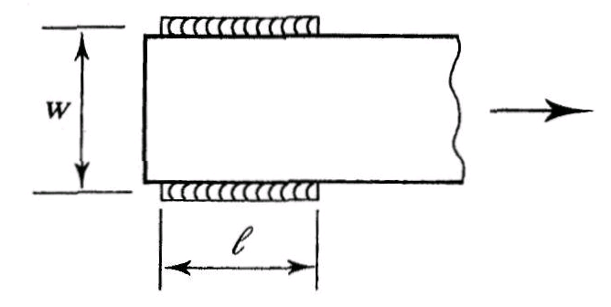

* AISC Table D3.1 Case 3, gives another special case for welded connections.

For any member connected by *transverse welds alone*,

Ae = area of the directly connected element of the cross-section

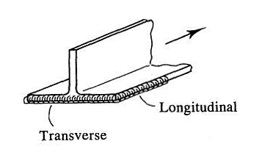

Example 2.5 Consider the welded single angle *L* 6x 6 x ½ tension member made from A36 steel shown below. Calculate the tension design strength.

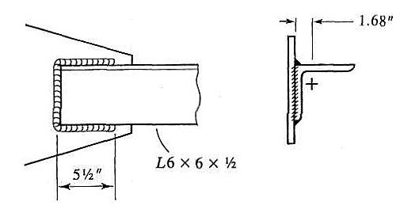

Solution

* Ag = 5.00 in2
* An = 5.00 in2 - because it is a welded connection
* Ae = *U* An - where, *U* = 1 - 
*  = 1.67 in. for this welded connection
* L = 5.5 in. for this welded connection
* *U* = 1-  = 0.70
* Gross yielding design strength = *t* Fy Ag = 0.9 x 36 x 5.00 = 162 kips
* Net section fracture strength = *t* Fu Ae = 0.75 x 58 x 0.70 x 5.00 = 152.25 kips
* Design strength = 152.25 kips (*net fracture governs*)

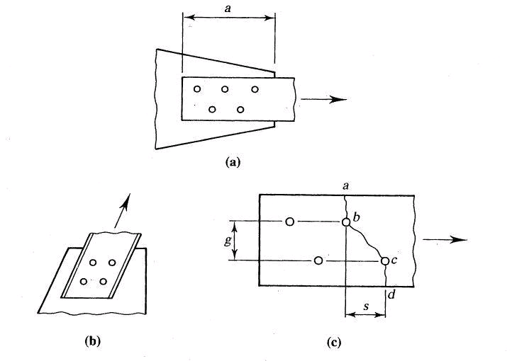

**2.5 STAGGERED BOLTS**

For a bolted tension member, the connecting bolts can be staggered for several reasons:

(1) To get more capacity by increasing the effective net area

(2) To achieve a smaller connection length

(3) To fit the geometry of the tension connection itself.

* For a tension member with staggered bolt holes (see example figure above), the relationship *f* = P/A does not apply directly, and the stresses are a combination of tensile and shearing stresses on the inclined portion *b-c*.
* Net section fracture can occur along any zig-zag or straight line. For example, fracture can occur along the inclined path *a-b-c-d* in the figure above. However, all possibilities must be examined.
* Empirical methods have been developed to calculate the net section fracture strength

According to AISC Specification B4.3

* net width = gross width -
* where, d is the diameter of hole to be deducted (*dh* + 1/16, or *db* + 1/8)
* s2/4g is added for each gage space in the chain being considered
* *s* is the longitudinal spacing (pitch) of the bolt holes in the direction of loading
* *g* is the transverse spacing (gage) of the bolt holes perpendicular to loading dir.
* net area (An) = net width x plate thickness
* effective net area (Ae) = *U* An where U = 1- /L
* net fracture design strength = *t* Ae Fu (*t* = 0.75)

**Example 2.6** Compute the smallest net area for the plate shown below: The holes are for 1 in. diameter bolts.



* The effective hole diameter is 1 + 1/8 = 1.125 in.
* For line *a-b-d-e*

wn = 16.0 – 2 (1.125) = 13.75 in.

* For line *a-b-c-d-e*

wn = 16.0 – 3 (1.125) + 2 x 32/ (4 x 5) = 13.52 in.

* The line *a-b-c-d-e* governs:
* An = t wn = 0.75 (13.52) = 10.14 in2

Note

* Each fastener resists an equal share of the load
* Therefore different potential failure lines may be subjected to different loads.
* For example, line *a-b-c-d-e* must resist the full load, whereas *i-j-f-h* will be subjected to 8/11 of the applied load. The reason is that 3/11 of the load is transferred from the member before *i-j-f-h* received any load.
* **Staggered bolts in angles.** If staggered lines of bolts are present in both legs of an angle, then the net area is found by first unfolding the angle to obtain an equivalent plate. This plate is then analyzed like shown above.
* The unfolding is done at the middle surface to obtain a plate with gross width equal to the sum of the leg lengths minus the angle thickness.
* AISC Specification B4.3 says that any gage line crossing the heel of the angle should be reduced by an amount equal to the angle thickness.
* See Figure below. For this situation, the distance g will be = 3 + 2 – ½ in.

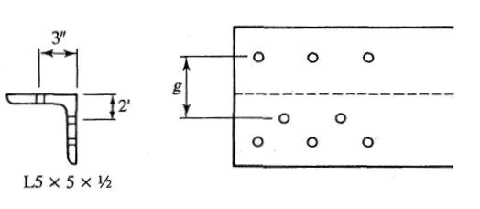

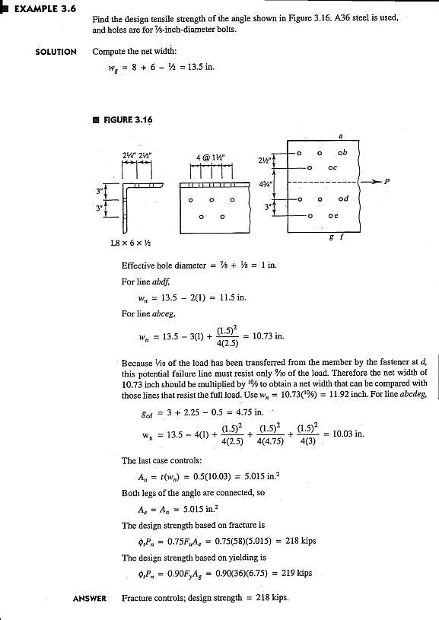 **2.6 BLOCK SHEAR**

* For some connection configurations, the tension member can fail due to ‘tear-out’ of material at the connected end. This is called *block shear*.
* For example, the single angle tension member connected as shown in the Figure below is susceptible to the phenomenon of *block shear*.



**Figure 2.4** Block shear failure of single angle tension member

* For the case shown above, shear failure will occur along the longitudinal section a-b and tension failure will occur along the transverse section b-c
* AISC Specification (SPEC) Chapter D on tension members does not cover block shear failure explicitly. But, it directs the engineer to the Specification Section J4.3

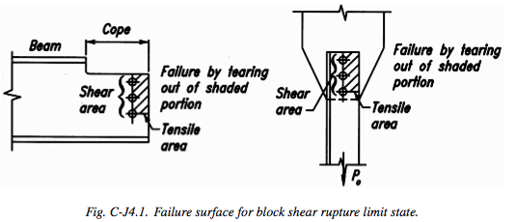

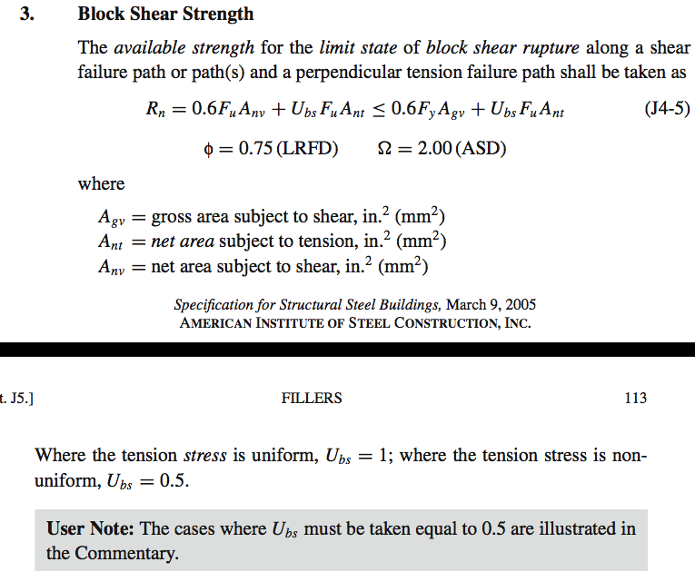

Basically, equation J4-5 above limits the shear strength to the smaller of 0.6 Fu Anv and 0.6 Fy Agv. That is the smaller of the shear yield and ultimate strength.

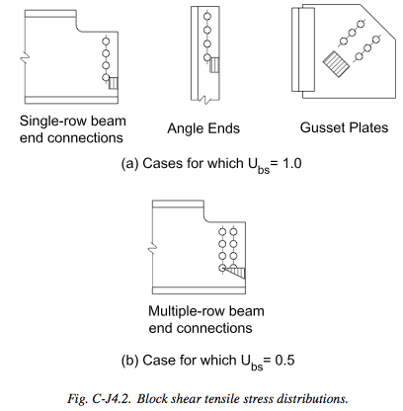

**Example 2.8** Calculate the block shear strength of the single angle tension member considered in Examples 2.2 and 2.3. The single angle *L 4 x 4 x 3/8* made from A36 steel is connected to the gusset plate with 5/8 in. diameter bolts as shown below. The bolt spacing is 3 in. center-to-center and the edge distances are 1.5 in and 2.0 in as shown in the Figure below.

Compare your results with those obtained in *Example 2.2 and 2.3*



* Step I. Assume a block shear path and calculate the required areas



* + Agt = gross tension area = 2.0 x 3/8 = 0.75 in2
  + Ant = net tension area = 0.75 – **0.5** x (5/8 + 1/8) x 3/8 = 0.609 in2
  + Agv = gross shear area = (3.0 + 3.0 +1.5) x 3/8 = 2.813 in2
  + Anv = net shear area = 2.813 – **2.5** x (5/8 + 1/8) x 3/8 = 2.109 in2
* Step II. Calculate which equation governs
  + 0.6 Fu Anv = 0.6 x 58 x 2.109 = 73.393 kips
  + 0.6 Fy Agv = 0.6 x 36 x 2.813 = 60.76 kips
  + 0.6 Fy Agv < 0.6 Fu Anv
  + Therefore, equation with gross yielding of the shear path governs
* Step III. Calculate block shear strength
  + *t* Rn = 0.75 (0.6 Fy Agv + Fu Ant)
  + t Rn = 0.75 (60.76 + 58 x 0.609) = **72.06 kips**
* Compare with results from previous examples

Example 2.2:

Ultimate factored load = Pu = 66 kips

Gross yielding design strength = *t* Pn = 92.664 kips

Assume Ae = 0.85 An

Net section fracture strength = 95.352 kips

Design strength = 92.664 kips (gross yielding governs)

Example 2.3

Calculate Ae = 0.8166 An

Net section fracture strength = 91.045 kips

Design strength = 91.045 kips (net section fracture governs)

Member is still adequate to carry the factored load (Pu) = 66 kips

Example 2.8

Block shear fracture strength = 72.06 kips

Design strength = 72.06 kips (block shear fracture governs)

Member is still adequate to carry the factored load (Pu) = 66 kips

* *Bottom line*:
  + Any of the three limit states (gross yielding, net section fracture, or block shear failure) can govern.
  + The design strength for all three limit states has to be calculated.
  + The member design strength will be the smallest of the three calculated values
  + The member design strength must be greater than the ultimate factored design load in tension.

**Practice Example** Determine the design tension strength for a single channel C15 x 50 connected to a 0.5 in. thick gusset plate as shown in Figure. Assume that the holes are for 3/4 in. diameter bolts and that the plate is made from structural steel with yield stress (F­y­) equal to 50 ksi and ultimate stress (Fu) equal to 65 ksi.

1.5”

3”

3”

3 @ 3” = 9”

center-to-center

**T**

**T**

gusset plate

**C15 x 50**

* **Limit state of yielding due to tension:**



* **Limit state of fracture due to tension:**





**Note**: The connection eccentricity, x, for a C15X50 can be found in the AISC manual.



* **Limit state of block shear rupture:**

**Compute **

**Compute **

**Calculations indicate: **

**Compute: **



Block shear rupture is the critical limit state and the design tension strength is 445 kips.

## 2.7 Design of tension members

* The design of a tension member involves finding the lightest steel section (angle, wide-flange, or channel section) with design strength (**Pn) greater than or equal to the maximum factored design tension load (Pu) acting on it.
* ** Pn ≥ Pu
* Pu is determined by structural analysis for factored load combinations
* ** Pn is the design strength based on the *gross section yielding*, *net section fracture*, and *block shear rupture* limit states.
* For gross yielding limit state, **Pn = 0.9 x Ag x Fy
* Therefore, 0.9 x Ag x Fy ≥ Pu
* Therefore, Ag ≥ 
* For net section fracture limit state, **Pn = 0.75 x Ae x Fu
* Therefore, 0.75 x Ae x Fu ≥ Pu
* Therefore, Ae ≥ 
* But, Ae = *U* An
* Where, *U* and An depend on the end connection.
* Thus, designing the tension member goes hand-in-hand with designing the end connection, which we have not covered so far.
* Therefore, for this chapter of the course, the end connection details will be given in the examples and problems.
* The AISC manual tabulates the tension design strength of standard steel sections (Tables 5-1 to 5-8)
* Include: wide flange shapes, angles, tee sections, and double angle sections.
  + The gross yielding design strength and the net section fracture strength of each section is tabulated.
  + This provides a great *starting point* for selecting a section.
* **There is one serious limitation**
  + The net section fracture strength is tabulated for an assumed value of *U* = 0.75, obviously because the precise connection details are not known
  + For all W, Tee, angle and double-angle sections, Ae is assumed to be = 0.75 Ag
  + The engineer can **first** select the tension member based on the tabulated gross yielding and net section fracture strengths, and then check the net section fracture strength and the block shear strength using the actual connection details.
* Additionally for each shape the manual tells the value of Ae below which net section fracture will control:
  + Thus, for W shapes net section fracture will control if Ae < 0.923 Ag
  + For single angles, net section fracture will control if Ae < 0.745 Ag
  + For Tee shapes, net section fracture will control if Ae < 0.923
  + For double angle shapes, net section fracture will control if Ae < 0.745 Ag
* **Slenderness limits**
  + Tension member slenderness l/r must preferably be limited to 300 as per LRFD specification D1

**Example 2.10** Design a member to carry a factored maximum tension load of 100 kips.

1. Assume that the member is a wide flange connected through the flanges using eight ¾ in. diameter bolts in two rows of four each as shown in the figure below. The center-to-center distance of the bolts in the direction of loading is 4 in. The edge distances are 1.5 in. and 2.0 in. as shown in the figure below. Steel material is A992



**SOLUTION**

* **Step I. Select a section from the Tables**
* Go to the **TEN. Section** (Section 5) of the AISC manual. See Table 5-1 on pages 5-5 to 5-13.
* From this table, select W8x10 with Ag = 2.96 in2, Ae = 2.22 in2.
* Gross yielding strength = 133 kips, and net section fracture strength=108 kips
* This is the lightest section in the table.
* Assumed *U* = 0.75. And, net section fracture will govern if Ae < 0.923 Ag
* **Step II. Calculate the net section fracture strength for the actual connection**
* According to the Figure above, An = Ag - 4 (db + 1/8) x tf
* An = 2.96 - 4 (3/4 + 1/8) x 0.205 = 2.24 in2
* The connection is only through the flanges. Therefore, the shear lag factor *U* will be the distance from the top of the flange to the centroid of a WT 4 x 5.
* See **DIM.**section of the AISC manual. See Table 1-8, on pages 1-68, 1-69
*  = 0.953
* *U* = 1- /L = 1 - 0.953 / 4 = 0.76
* Ae = 0.76 An = 0.76 x 2.24 = 1.70 in2
* **tPn = 0.75 x Fu x Ae = 0.75 x 65 x 1.70 = 82.9 kips
* Unacceptable because Pu = 100 kips; **REDESIGN** required
* **Step III. Redesign**

Many ways to redesign. One way is shown here:

* Assume *t* Pn > 100 kips
* Therefore, 0.75 x 65 x Ae > 100 kips
* Therefore, Ae > 2.051 in2
* Assume, Ae = 0.76 An (based on previous calculations, step II)
* Therefore An > 2.7 in2
* But, Ag = An + 4 (db + 1/8) x tf (based on previous calculations, step II)
* Therefore Ag > 2.7 + 3.5 x tf
* Go to the section dimension Table 1-1 on page 1-28 of the AISC manual. Select next highest section.
  + - For W 8 x 13, tf = 0.255 in.
    - Therefore, Ag > 2.7 + 3.5 x 0.255 = 3.59 in2
    - From Table 1-1, W8 x 13 has Ag = 3.84 in2 > 3.59 in2
    - Therefore, W8 x 13 is acceptable and is chosen.
* **Step IV. Check selected section for net section fracture**
  + Ag = 3.84 in2
  + An = 3.84 - 3.5 x 0.255 = 2.95 in2
  + From dimensions of WT4 x 6.5,  = 1.03 in.
  + Therefore, *U* = 1- /L = 1-1.03/4 = 0.74
  + Therefore, Ae = *U* An = 0.74 x 2.95 = 2.18 in2
  + Therefore, net section fracture strength = 0.75 x 65 x 2.18 = 106.3 kips
  + Which is greater than 100 kips (design load). Therefore, W 8 x 13 is acceptable.
* **Step V. Check the block shear rupture strength**
* Identify the block shear path



* + The block shear path is show above. **Four blocks** will separate from the tension member (two from each flange) as shown in the figure above.
  + Agv = [(4+2) x tf ] x 4 = 6 x 0.255 x 4 = 6.12 in2 - for four tabs
  + Anv = {4+2 - 1.5 x (db+1/8)} x tf x 4 = 4.78 in2
  + Agt = 1.5 x tf x 4 = 1.53 in2
  + Ant = {1.5 - 0.5 x (db+1/8)}x tf x 4 = 1.084 in2
* Identify the governing equation:
* 0.6FyAgv = 0.6 x 50 x 6.12 = 183.6 kips
* 0.6FuA­nv = 0.6 x 65 x 4.78 = 186.42 kips , which is > 0.6 FyAgv
* Calculate block shear strength
* *t*Rn = 0.75 (0.6FyAgv + FuAnt) = 0.75 (183.6 + 65 x 1.084) = 190.545 kips
* Which is greater than Pu = 100 kips. Therefore W8 x 13 is still acceptable
* **Summary of solution**

|  |  |  |  |  |  |  |  |  |
| --- | --- | --- | --- | --- | --- | --- | --- | --- |
| **Mem.** | **Design load** | **Ag** | **An** | **U** | **Ae** | **Yield strength** | **Fracture strength** | **Block-shear strength** |
| W8x13 | 100 kips | 3.84 | 2.95 | 0.74 | 2.18 | 173 kips | 106.3 kips | 190.545 kips |
|  |  | Design strength = 106.3 kips (net section fracture governs)  W8 x 13 is adequate for Pu = 100 kips and the given connection | | | | | | |

**Example 2.11** Design a member to carry a factored maximum tension load of 100 kips.

1. The member is a single angle section connected through one leg using four 1 in. diameter bolts. The center-to-center distance of the bolts is 3 in. The edge distances are 2 in. Steel material is A36



* **Step I. Select a section from the Tables**
* Go to the **TEN.** Section (Section 5) of the AISC manual. See Table 5-2 on pages 5-14 to 5-17.
* From this table, select *L*4x3x1/2 with Ag = 3.25 in2, Ae = 2.44 in2.
* Gross yielding strength = 105 kips, and net section fracture strength=106 kips
* Assumed *U* = 0.75. And, net section fracture will govern if Ae < 0.745 Ag
* **Step II. Calculate the net section fracture strength for the actual connection**
* According to the Figure above, An = Ag - 1 (db + 1/8) x t
* An = 3.25 - 1(1 + 1/8) x 0.5 = 2.6875 in2
* The connection is only through the **long leg**. Therefore, the shear lag factor *U* will be the distance from the back of the long leg to the centroid of the angle.
* See **DIM.**Section (Section 1) of the AISC manual. See Table 1-7, on pages 1-46, 1-47
*  = 0.822 in.
* *U* = 1- /L = 1 - 0.822 /9 = 0.909
* Ae = 0.909 An = 0.909 x 2.6875 = 2.443 in2
* **tPn = 0.75 x Fu x Ae = 0.75 x 58 x 2.443 = 106.3 kips
* Acceptable because Pu = 100 kips.
* **Step V. Check the block shear rupture strength**
* Identify the block shear path



* + Agv = (9+2) x 0.5 = 5.5 in2
  + Anv = [11 - 3.5 x (1+1/8)] x 0.5 = 3.53 in2
  + Agt = 2.0 x 0.5 = 1.0 in2
  + Ant = [2.0 - 0.5 x (1 + 1/8)] x 0.5 = 0.72 in2
* Identify the governing equation:
* 0.6 FuAnv = 0.6 x 58 x 3.53 = 122.84 kips
* 0.6FyA­gv = 0.6 x 36 x 5.5 = 118.8 kips, which is < 0.6 Fu Anv
* Calculate block shear strength
* *t*Rn = 0.75 (0.6FyAgv + FuAnt) = 0.75 (118.8 + 58*0.72) = 120.42 kips
* Which is greater than Pu = 100 kips. Therefore *L*4x3x1/2 is still acceptable
* **Summary of solution**

|  |  |  |  |  |  |  |  |  |
| --- | --- | --- | --- | --- | --- | --- | --- | --- |
| **Mem.** | **Design load** | **Ag** | **An** | **U** | **Ae** | **Yield strength** | **Fracture strength** | **Block-shear strength** |
| *L*4x3x1/2 | 100 kips | 3.25 | 2.69 | 0.909 | 2.443 | 105 kips | 106.3 kips | 120.42 kips |
|  |  | Design strength = 105 kips (gross section yield governs)  *L*4x3x1/2 is adequate for Pu = 100 kips and the given connection | | | | | | |

* Note: For this problem Ae/Ag = 2.41/3.25 = 0.752, which is > 0.745. As predicted by the AISC manual, when Ae /Ag > 0.745, gross section yield governs.