CE 270: Exam No. 1 Fall 2016 October 4, 2016, from 8:00 – 9:30 pm

NOTES:
- No crib sheets, equations sheets etc.
- No text book, notes, or any other materials
- Use of calculator is permitted
- No cell phones
- Submit the question paper back with your answer sheets
- You can use your own engineering pad paper, or white sheets that we provide
- Please write your name clearly on the question paper to submit
- Please show all your work, and attach your rough work sheet as well
- Write neatly, clearly, and specify units as needed
- Maintain academic integrity

Name:
PUID:
Question 1
Question 2
Question 3
Question 4
Total

Question No. 1. Calculate all the reactions for the beam shown below. (25 Points)

Question No. 2. Calculate all the internal forces at points A and B, and indicate their signs and directions (15 points)

Question 3. Calculate the total vertical deflection, the axial forces and axial stresses in all the columns supporting the rigid beam. (35 points)

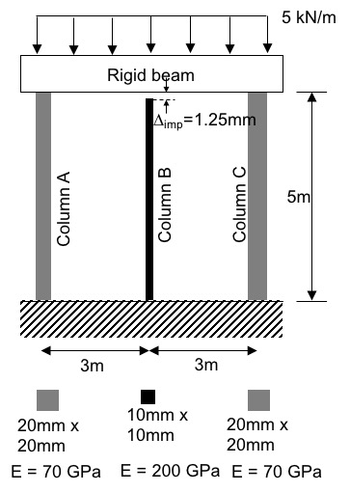

(25 points)
Question 4. Consider the tension member and hanger detail shown below. The tension member has a rectangular cross-section (5 x 0.5 in.), and is made from A992 steel.

The member is bolted to two angles using four shear bolts with diameter equal to 0.5 in., and made from A325 steel.

The two angles are anchored to the concrete ceiling using four anchor bolts with diameter equal to 0.75 in., and made from A108 steel.

Check the design to carry 100 kips of tension force: The allowable tension stress for A992 steel is 50 ksi; the allowable shear stress for A325 steel is 67.5 ksi; and the allowable tension stress for A108 steel is 65 ksi

Assume that the force is shared equally by the bolts.

