Minutes
Indiana Rural Safety & Health Council
April 12, 2011

The Council was called to order at 1:00 pm by President Amy Kraft at the Indiana Farm Bureau Insurance Building, East Street in Indianapolis. Those present were as follows:
Bill Field – Purdue University
Amy Kraft – Indiana Farm Bureau Insurance
Jim Rink – Indiana Farm Bureau Insurance
Ernie Sheldon – Indiana State University
Gayvin Strantz – Indiana REMC Statewide
Roger Tormoehlen – Purdue University
Steve Wettschurack – Purdue University
The minutes were changed to correct “Mary” Addison to “Merry” Addison. The minutes were approved as edited. Roger Tormoehlen noted that minute approval is not required.
The treasurer’s report was accepted subject to audit.
Amy Kraft summarized the progress being made in preparing safety ads for the FFA Magazine. There will be an ad on texting while driving in the next issue. She is looking for ideas for future half page ads. Steve Wettschurack suggested that an ad be done on the role FFA has had in conducting local grain rescue training events. Another topic would be the FFA involvement in the Bridging Horizons Program to enhance the accessibility of rural communities.
A discussion was held on lifetime memberships. Ernie Sheldon moved that we offer an individual lifetime membership for $250.00. Seconded by Roger Tormoehlen. Motion was carried. Bill Field will send out a note to every announcing the new membership option.
Ernie Sheldon noted that his address was incorrect on the membership form. His correct address is:
Ernie Sheldon
Indiana State University
TC 301M Myers Technology Building
Terre Haute, IN 47809
Jim Rink of Indiana Farm Bureau Insurance demonstrated the Farm Hazard Hunt Exhibit. It consists of a model farm with numerous hazards to be identified. Jim has been taking the display to FFA and 4-H programs, Farm Bureau meetings, grower/producer events and any place where he can get an audience. In addition, he demonstrates the speed at which a grain suffocation or PTO entanglement can occur. Jim is planning to have the display at the Indiana State Fair in the Farm Bureau Building.
A discussion took place on how the Council can support Farm Bureau’s safety effort. Ideas include promotion on the Council website and listing in safety resources.
Steve Wettschurack discussed the lack of basic farm safety knowledge he has seen in the classes he is teaching for emergency first responders.
Bill Field proposed that the Council support the grain rescue classes to the amount of $500.00. Motion passed.
Ernie Sheldon moved that the Council support the National AgrAbility Training Workshop in November 2011 in the amount of $750.00. Motion passed.
Ernie Sheldon moved that the Council support the ISU ASSE Student Chapter in the amount of $200.00. Motion passed.
The next meeting was scheduled for July 7, 2011 at 10:00 a.m. at Farm Bureau Insurance in Indianapolis. Everyone is welcome.

Submitted by:
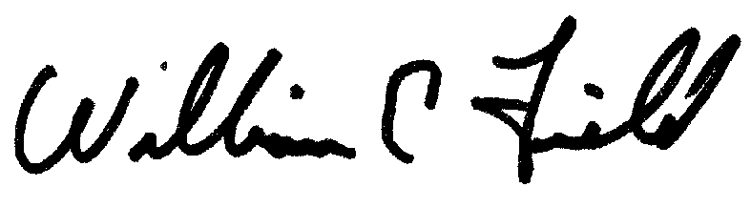
W.E. Field
Secretary

