Minutes
Indiana Rural Safety & Health Council
January 19, 2010

Lisa Chaudion opened the meeting at 3:00 p.m. with the following individuals present:
Rick Ainsworth – Farm Bureau Insurance
Anna Ariens – Indiana FFA
Lisa Chaudion – Indiana Young Farmers
Bill Field – Purdue University
Cress Hizer – Indiana Feed & Grain Association
Amy Kraft – Indiana Farm Bureau
Dan McNeil – Indiana Feed & Grain Association
Wayne Newhart – REMC, retired
Ernie Sheldon – Indiana State University
Steve Wettschurack – Purdue University
Minutes of the November 16, 2009 meeting were approved without changes.
Ernie Sheldon presented the treasurer’s report including a profit and loss statement for 2009. A summary is attached. The treasurer’s report was approved subject to annual audit.
Lisa raised the issue of payment for the six safety ads in the FFA magazine. No record of payment existed. Each issue of the magazine is sent to over 10,000 individuals across the state.
Lisa reported that the FFA organization would potentially be absorbed into the Indiana State Department of Agriculture. While this transition is taking place, Lisa and Anna cannot serve as officers on the Council.
The need to affirm new officers for 2010 was addressed due to the concern for changes in the current employment status of two of the officers.
The following individuals were affirmed by acclamation as officers for 2010:
Amy Kraft – President/Vice President
Ernie Sheldon – Treasurer
Bill Field – Secretary
Ernie reported that the ISU Credit Union will no longer honor the signatures of non-credit union members. Therefore, Ernie is the only person who can currently access Council funds. He was charged to pursue alternatives to ensure at least two currently elected officers can access funds. He will report back at the next meeting.
It was decided to hold the 2010 Ag Safety and Health Forum on Thursday, September 16 at the Beck Center north of Lafayette on U.S. 52. Bill Field confirmed this date with the Beck Center. Program topics include the following suggestions:
- Having more hands on demonstrations
- Utilize grain rescue training facilities at the Center
- Provide support for FFA Chapters to attend
- Explore a high profile speaker
- Provide complimentary lunch – explore possible sponsor
A discussion was held with Cress Hizer and Dan McNeil on their plans to conduct a campaign on grain bin safety. They will kick off the program next Wednesday, January 27, 2010 at the IFGA Annual Meeting in Indianapolis. Components they are trying to put together include a printed mailer on grain handling safety to send out to farmers, a short PowerPoint presentation to have available online for rural educators and IFGA members to conduct safety presentations and media.
The Council agreed to assist where possible and it was noted that the most recent safety ad focused on the topic of out-of-condition grain and how it contributes to engulfment.
The next meeting was scheduled for Wednesday, March 3, 2010 at 3:00 p.m. at the Farm Bureau Insurance Building in Indianapolis.

Submitted by:
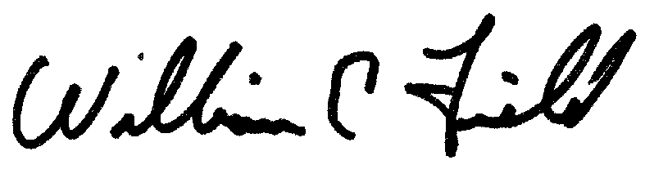
W.E. Field
Secretary
