https://marketing.purdue.edu/Toolkit
Colors:
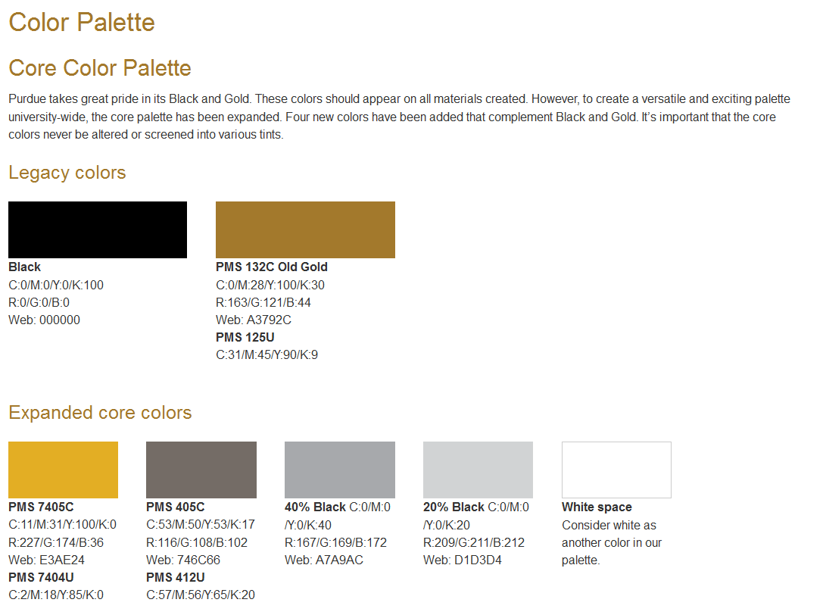
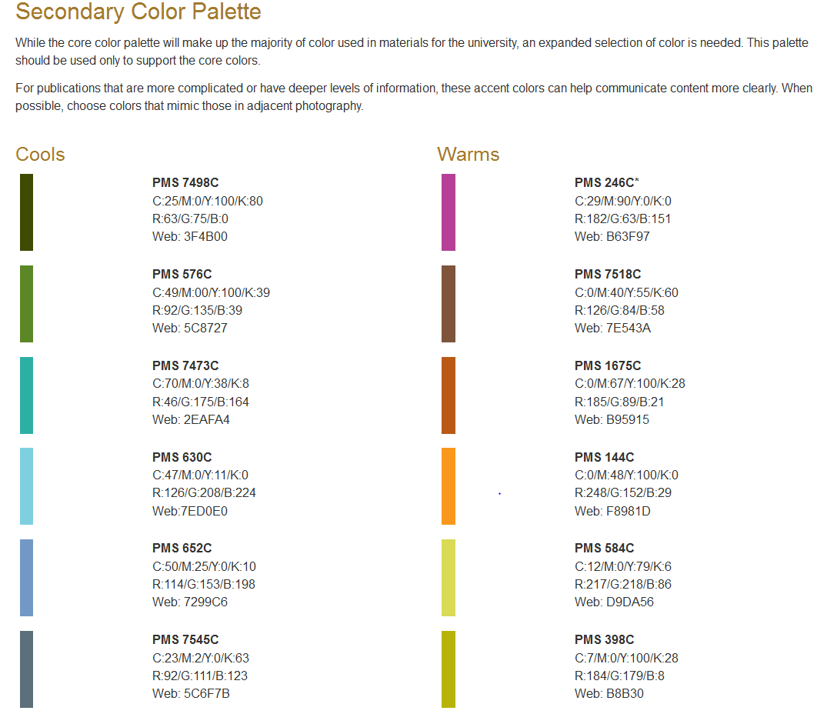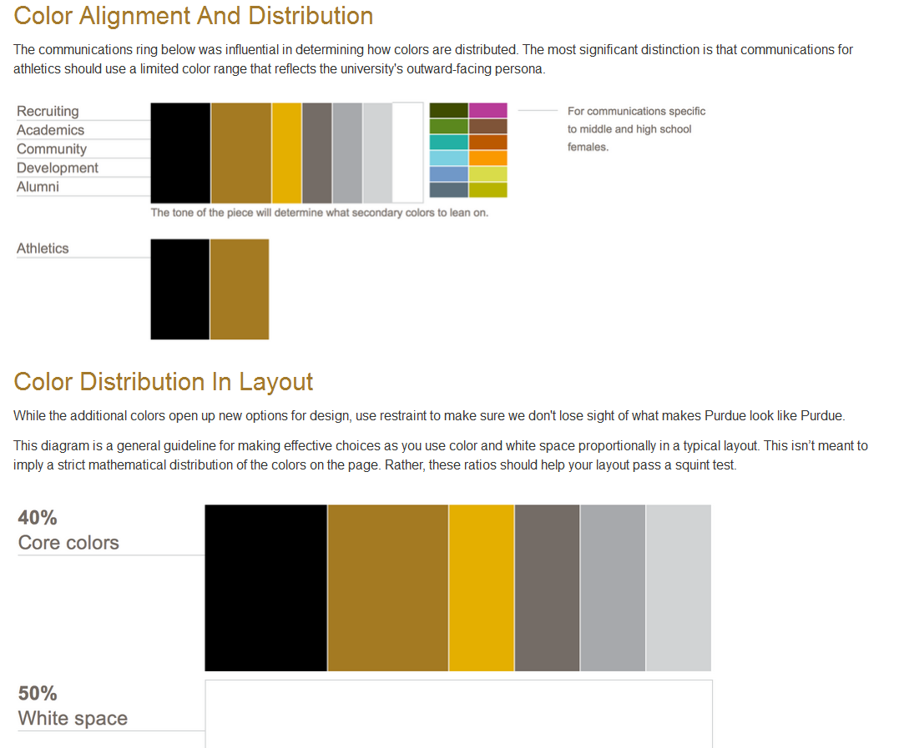






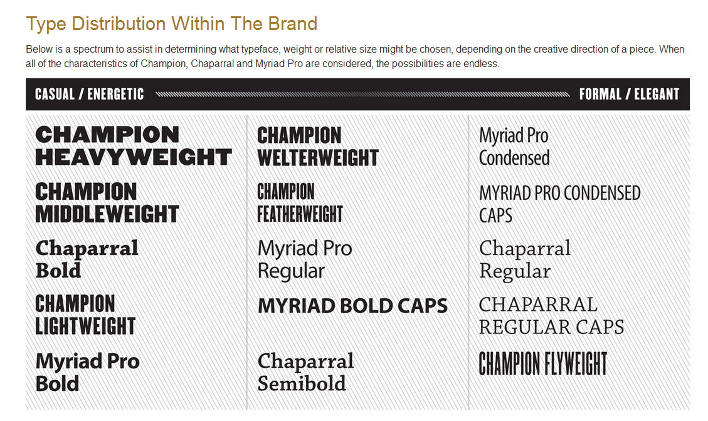

Wayne,
This is the information that I received from the past president when I took over. I did not change the password or server name on this account. I have set up a gmail account for the club that I would like to see the files get transferred onto in case something goes wrong with the server.
The login information is as follows:
ispls.purdue@gmail.com
purdue1869
If you need to get a hold of me, you have my cell number and my personal email address is gpeterson14@gmail.com. I would be more than happy to help you out.
Thanks,
Glenn

Hey Glenn,
Here is a bunch of info on president stuff for ISPLS:
1) to access the ACSM server you have to be on an ECN computer.
to set up the drive click My Computer > Tools > Map Network Drive
then
Drive: choose any arbitrary letter that is free
Folder: type \\cobweb\ACSM then select browse
User Name: ACSM
Password: ISPLS1115
This gives you access to all the ISPLS files and records
2) In the Geomatics Lab, all of the merchandise is in the cabinet
under the microwave
you open it by using the flat head screw driver on the counter
There is also information from last year's convention in it
3) If you are planning on spending money for a meeting or say the
convention
forms need to be filled out 2 weeks in advance and you get them at
BOSO in Schleman on the 2nd floor
4) In the spring, there is usually a banquet (aka the people from the
club plus johnson, van gelder and some of the grad geo profs)
you go to a restaurant in the area and ISPLS pays
5) currently there is around $1,500 in the account
but include the rooms for the convention
If you have any other questions, feel free to email me. I would try to
make sure the convention stuff is done as soon as you can when you get
back to campus.
Hope this helps and good luck!!!
Erika Donaubauer
School of Civil Engineering, Purdue University
edonauba@purdue.edu

