AAE 490/590 Motorcycle Aerodynamics

The objective is the aerodynamic design of an electric powered motorcycle to set land speed records at the Bonneville Salt Flats. The bike is intended for the small motorcycle class (<150 kg) with partial streaming. This is an applied aerodynamics exercise using CFD and wind tunnel testing.

Contact Professor Sullivan for more information.

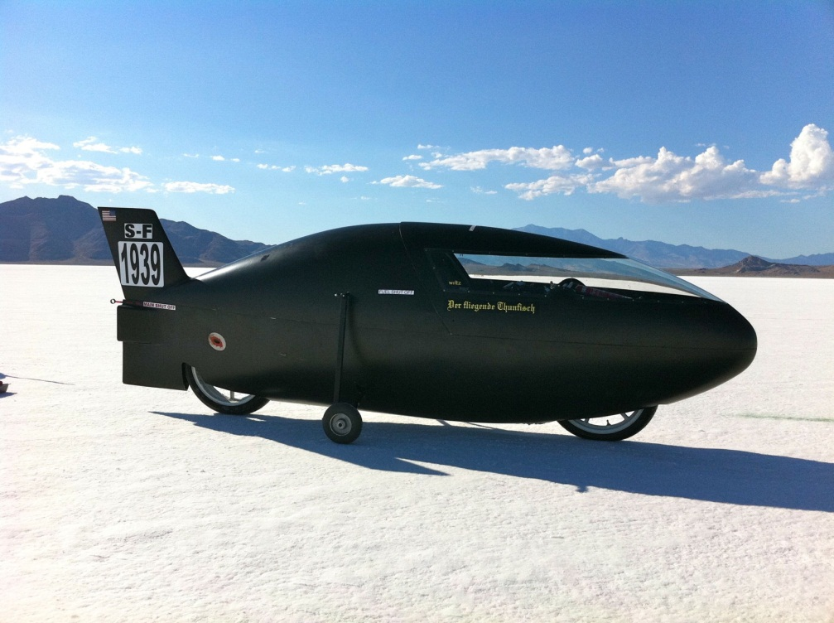

Streamlined Motorcycle at Bonneville Salt Flats this year

Aerodynamic Design by AAE students some years ago