SEMICONDUCTOR EDUCATION AND TRAINING

Summer Training, Awareness, and Readiness for Semiconductors (STARS)
Program Description: Purdue University has developed STARS, an intensive eight-week semiconductor training program offered annually on the Purdue campus. This program helps students develop deep-tech skills. The STARS 2024 program will have several tracks focused on chip design, semiconductor manufacturing, advanced packaging and heterogeneous integration, and supply chain optimization. Students will participate in hands-on experiential learning activities in the Scifres Nanotechnology Cleanroom and other labs at Purdue, May 20 to July 12, 2024.
Target Students: STARS is designed to be the academic equivalent of a summer internship for Purdue rising sophomores in engineering and science disciplines, and a few participants from Ivy Tech Community College. After completion of STARS, students are encouraged to pursue other relevant courses at Purdue towards earning a semiconductor concentration or certificate. Preference will be given to students who participate in the Changing the World with Chips - Introduction to Semiconductors course offered in spring 2024.
Cost of the Program: The full cost of the program per participant is $15,000, ($10,000 to cover a competitive student stipend and $5,000 program management costs such as materials, design kits, access to the clean room, and instructors.)
Industry Request for Support: We aim to train 100 students in summer 2024 and seek industry support at $15,000 per student to reach our goal. If you’d like to sponsor STARS, please contact Cristina Farmus, Vice President for Special Programs, cfarmus@purdue.edu, 765-430-6067. Purdue will provide invoices if needed. We are confident that the Purdue programs will be foundational to address our national need for more semiconductor professionals in the coming decades. To follow our progress on STARS, visit our Student Opportunities page.
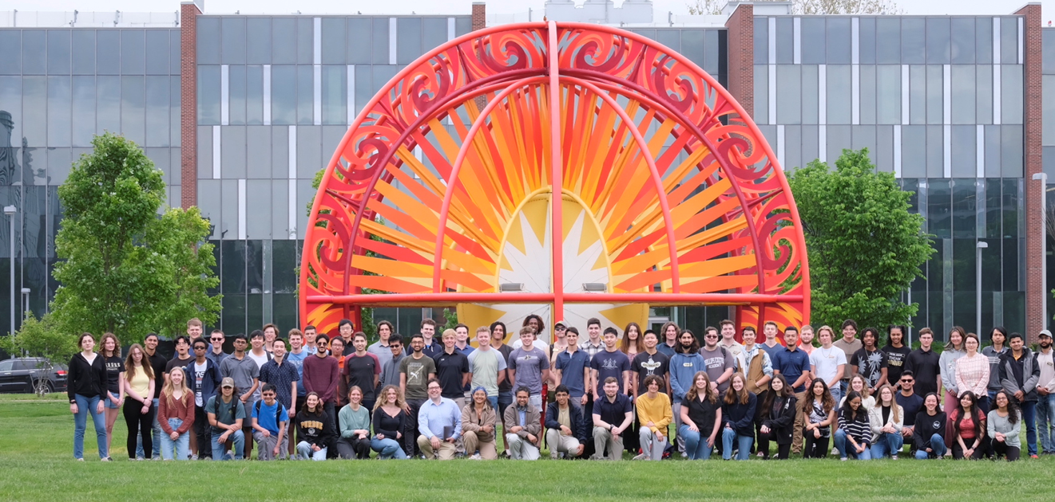
For details on STARS 2023, please see the following page.
Purdue students on the first day of STARS 2023 program.
PURDUE – “THE BEST HUMAN FAB”

https://engineering.purdue.edu/semiconductors

Summer 2023 STARS Highlights
During Summer 2023, Purdue engaged 76 students in the Summer Training, Awareness, and Readiness for Semiconductors (STARS) Program, either as students or as teaching assistants.
Student testimonies are available here https://stories.purdue.edu/seeing-stars-purdue-trains-next-generation-of-semiconductor-engineers/
76 students
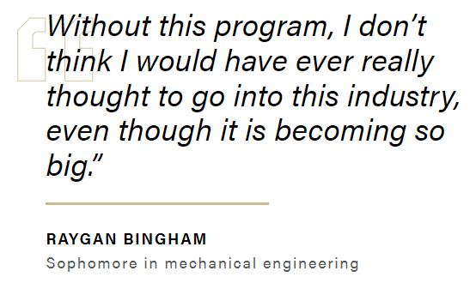
- 24 women (33%)
- 14 URM (4 black, 10 Hispanic / Latino)
- 8 first generation college
- 10 international

Majors include
- 32 First Year Engineering
- 12 Computer Engineering
- 10 Electrical Engineering
- 4 Purdue Polytechnic Institute
- 4 Materials Engineering
- 4 Mechanical Engineering
- 2 Chemical Engineering
- 4 IVY Tech Community College
Purdue University thanks the 2023 corporate partners who made the program possible: Cisco, GlobalFoundries, Intel, L3Harris, MediaTek, Synopsys, SK hynix, SkyWater, TSMC, Texas Instruments, and Western Digital.
Industry Benefits
STARS is a one-of-a-kind program that will attract students early towards a semiconductor career. Purdue provides quality, intensive training for students who may not yet have sufficient skills or knowledge to find an internship in semiconductors and might steer to other industries with lower barriers to entry. Companies that sponsor STARS will have input in the activities planned and privileged access to the student cohort. $15,000 per student is a good investment for a summer intern, with no overhead or liability, and minimum time investment from the company. Students who complete STARS will be prepared for Co-Op opportunities or internships as early as fall 2024.
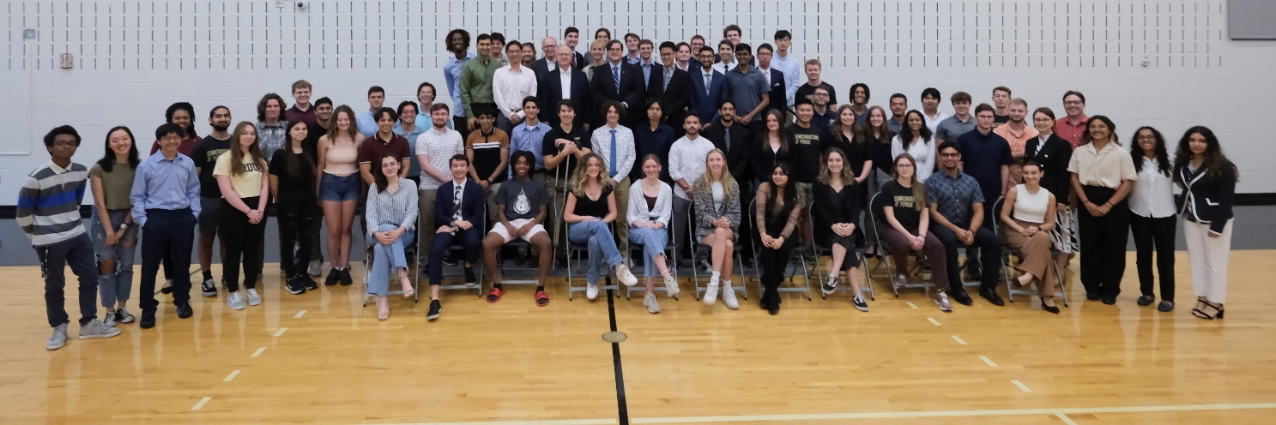
STARS students on the final day of the program - 100 % of the participants completed the training.

https://engineering.purdue.edu/semiconductors

