Team Information
- Section: ___________________________
- Date: ___________________________

Team Members (write full names):

- ____________________________________________

- ____________________________________________

- ____________________________________________

- ____________________________________________

(Optional) Team Name: ___________________________________________

Instructions
This in-class activity guides you through programming buzzer on the MSP430-Grove board pack and
Includes five (5) deliverables..
- Insert diagrams, pseudocode, and code directly into this Word file.
- Conduct your calculations in Excel, record the results in this Word file.
- Submit ONLY your Word file through the designated Brightspace In-Class Activity Drop Box.
File naming convention:
- Word file → ENGR131_ICA_LastNames.docx

Relevant Course Resources:
Pre-Class Videos | - None
Course Resources | - Getting Started with Energia and the TI Kits  - Sketchbook in Activity

Submission Instructions:
- Re-name your answer sheet as:
  - Word file → ENGR131_ICA_TaumSauk_TeamNumer.docx
- Submit your work through the designated Brightspace In-Class Activity Drop Box at https://purdue.brightspace.com/.

Task 1: Block Diagram
Guide:
- Connect the Grove Starter Kit Ultrasonic Range Sensor. The code indicates that the signal (sig) pin of the Range Sensor connects to pin 38. This means that the Range Sensor must connect to J15 of the Grove Board using the four-prong connector cable.

- Connect the Grove Starter Kit 4 Digit Digital Display. This sensor has two signals, meaning we need to connect to two pins. The code indicates that clk connects to pin 40, and dio connects to pin 39. This means that the 4-Digit Display should connect to J13 of the Grove Board using the four-prong connector cable.

- Connect the Grove Starter Kit Buzzer. The code indicates that the signal (sig) pin of the Buzzer connects to pin 36. This means that the Range Sensor must connect to J17 of the Grove Board using the four-prong connector cable.

- Connect the Grove Board to MSP 430. Remember to align the pin numbers.

- Connect MSP 430 to your laptop.

Draw (by hand or via a computer) a block diagram of the microcontroller set up shown in the picture.
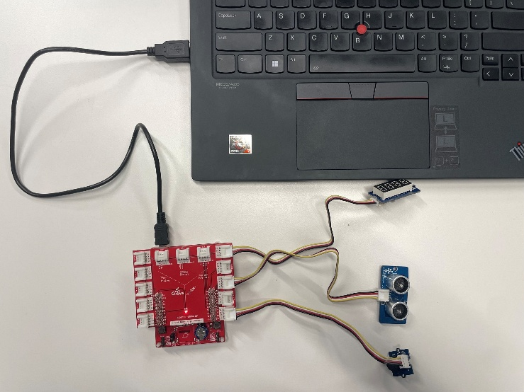
Task 2: Pseudocode
Draft a pseudocode that represents the early warning system’s logics. That is, alerts if the distance measured by the ultrasonic ranger gets too close. You also need to define a reasonable threshold for this system, for example, 15 cm.

Task 3: Code Modification
Download Taum Sauk Part2 Sketchbook and modify on warning_system file. If you are not able to see the provided code, please copy paste the reference code into a blank sketch.
Task 4: Data Collection and Error Analysis
Up to this point in the course, we have assumed that the measurements we have taken using our sensors and microprocessors have been absolutely correct. This is unfortunately not the case because two types of error exist any time measurements are made: Systemic and Random errors. In this problem, you will be investigating the random error inherit to the Ultrasonic Range Sensor. It is important to know the limits of the equipment that we are going to use for our warning system that we are considering using at the Taum Sauk Reservoir.
Record your measurements and calculate the required statistics using the formula below.
- Calculate the percent error for each measurement using the following formula:

$$\% Error= \frac{Measured Value-Theoretical Value}{Theoretical Value}$$

- Calculate the Sum of Square Error (SSE) using the following formula:

$$SSE=\sum_{i=1}^{n}{{(Theoretical Value-Measured Value)}^{2}}$$
Cycle [Count] | Measured Distance [cm] | Percent Error [%] | (Theoretical - Measured)² [cm²]
1
2
3
4
5
6
7
8
9
10

Mean Percent Error: ________________ SSE: ________________

Task 5: Brief Comment on Your Error Analyses

Reference Code: warning_system
#include "TM1637.h"
#include "Ultrasonic.h"

/* Macro Define */
#define CLK 40 /* 4-Digit Display clock pin */
#define DIO 39
#define BLINK_LED RED_LED /* 4-Digit Display data pin */
#define ULTRASONIC_PIN 38 /* Ultrasonic Ranger pin */
/****** DEFINE BUZZER PIN HERE *******/

/* Global Variables */
TM1637 tm1637(CLK, DIO); /* 4-Digit Display object */
Ultrasonic ultrasonic(ULTRASONIC_PIN); /* Ultrasonic Ranger object */
int distance = 0; /*obstacles in front */
int blink_internal = 0; /*variable to store the distance to obstacles in front */
int8_t bits[4] = {0}; /* array to store the single bits of the value */

/* the setup() method runs once, when the sketch starts */
void setup()
{
/* Initialize 4-Digit Display */
tm1637.init();
tm1637.set(BRIGHT_TYPICAL);
pinMode(RED_LED, OUTPUT);
/****** ADD PIN MODE FOR BUZZER HERE *******/
}

/* the loop() method runs over and over again */
void loop()
{
distance = ultrasonic.MeasureInCentimeters(); /* read the value from the sensor */
/*****************************************/
/* ADD YOUR SELECTION STRUCTURE HERE */
/*****************************************/
memset(bits, 0, 4); /* reset array before we use it */
for(int i = 3; i >= 0; i--)
{
/* Convert the value to individual decimal digits for display */
bits[i] = distance % 10;
distance = distance / 10;
tm1637.display(i, bits[i]); /* display on 4-Digit Display */
}
delay(100);
}

Communication Errors between the TI Kits and Your Computer:
- Make sure that your TI Kit is plugged in correctly using the provided Micro USB to USB A cable. There should be a green power LED lit up when this occurs.
- The COM port selected in Energia is not the correct port. While it is generally the highest port number available. This is not always the case. All COM Ports should be tried if there are communication issues.
- Ensure all drivers have been installed. For instructions on how to install, please see Step 2 in Getting Started.
- Restart Energia IDE.
- Restart your computer (Should not be required, but can help depending on your computer’s settings).

