Team Information
- Section: ___________________________
- Date: ___________________________

Team Members (write full names):

- ____________________________________________

- ____________________________________________

- ____________________________________________

- ____________________________________________

(Optional) Team Name: ___________________________________________

Instructions
This in-class activity guides you through programming buzzer on the MSP430-Grove board pack and
Includes three (3) deliverables..
- Insert diagrams, pseudocode, code, and figures directly into this Word file.
- Submit both your Word file through the designated Brightspace In-Class Activity Drop Box.

Relevant Course Resources:
Pre-Class Videos | - None
Course Resources | - Getting Started with Energia and the TI Kits  - Sketchbook in activity

Submission Instructions:
- Re-name your answer sheet as:
  - Word file → ENGR131_ICA_TaumSauk_TeamNumber.docx
- Submit your work through the designated Brightspace In-Class Activity Drop Box at https://purdue.brightspace.com/.

Task 1: Block Diagram
Draw (by hand or via a computer) a block diagram of the microcontroller set up shown in the picture
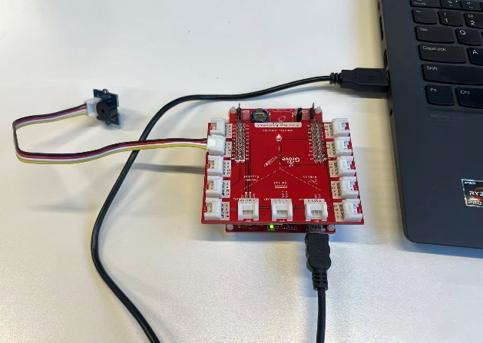

Task 2: Flowchart
Draw a flowchart (by hand or on a computer) that represents the selection structure described in the lecture slide scenario:
Imagine you are an engineer working at a hydroelectric dam. The dam holds back a huge reservoir of water. If the water level rises too high, it can overflow or even damage the dam structure, leading to a dangerous accident. Therefore, you want to have a warning system (buzzer) that alerts (beeps) people when the water level reaches a threshold.

Task 3: Code Modification
Download Taum Sauk Sketchbook and modify on selection_structure file. If you are not able to see the provided code, please copy paste the reference code #2 into a blank sketch.

Task 4: Upload Image of Prototype

Reference Code #1: buzzer_basic_control
int buzzerPin = 37; // digital pin 37

void setup() {
pinMode(buzzerPin, OUTPUT); // set pin as output
digitalWrite(buzzerPin, LOW);
}

void loop() {
digitalWrite(buzzerPin, HIGH); // buzzer ON
delay(2000); // wait 2 seconds
digitalWrite(buzzerPin, LOW); // buzzer OFF
while(true); // stop here (no repeat)
}

Reference Code #2: selection_structure
int buzzerPin = 37; // Buzzer pin (37)

int threshold = 10; // distance threshold [unit]

int distance = 5; // change this value to test your selection structure

void setup() {
pinMode(buzzerPin, OUTPUT);
digitalWrite(buzzerPin, LOW); // start silent
}

void loop() {
// --- selection structure: beep or stay silent ---
if (distance < threshold) {
// *************************************************************
// write or paste a code that make the buzzer beep for 2 seconds
// *************************************************************
} else {
// *************************************************
// write or paste a code that keep the buzzer silent
// *************************************************
}
while(true); // KEEP THIS HERE TO STOP THE LOOP
}

Communication Errors between the TI Kits and Your Computer:
- Make sure that your TI Kit is plugged in correctly using the provided Micro USB to USB A cable. There should be a green power LED lit up when this occurs.
- The COM port selected in Energia is not the correct port. While it is generally the highest port number available. This is not always the case. All COM Ports should be tried if there are communication issues.
- Ensure all drivers have been installed. For instructions on how to install, please see Step 2 in Getting Started.
- Restart Energia IDE.
- Restart your computer (Should not be required, but can help depending on your computer’s settings).

