Senior Design Project Ideas
Introduction:
The project can make or break senior design. If a project is novel and exciting to you, you can be inspired to work well beyond the call of duty and produce something you can be truly proud of at the end of the semester. If you find the project trivial and dull, it can be difficult to motivate yourself to work on the project and it becomes a burden, even if graduation hinges on successful completion of this course.
Sometimes teams come up with great projects all on their own and work hard at them. Other times, a team suffers “inventor’s block” and needs nudging or suggestions for good project ideas. With that in mind, the ECE477 course staff have done the unthinkable. We offer the following ideas for you to consider for your project. The projects listed here are made freely available for your use for the purposes of ECE477 senior design. Feel free to investigate them and do (or don’t do) them as you wish.
All ideas listed here were submitted voluntarily from the persons credited in this document. To the best of the ECE477 course staff’s abilities, projects listed here are some combination of innovative, novel, useful, and original. It should be noted that these projects are generally not easy (if you’re looking for the easiest possible project to graduate senior design, you’ve come to the wrong place), but they are all believed to be feasible projects. Enjoy!

- Next Generation 3D-Printing Electronics
Author: George Hadley Date Submitted: July 15th, 2011

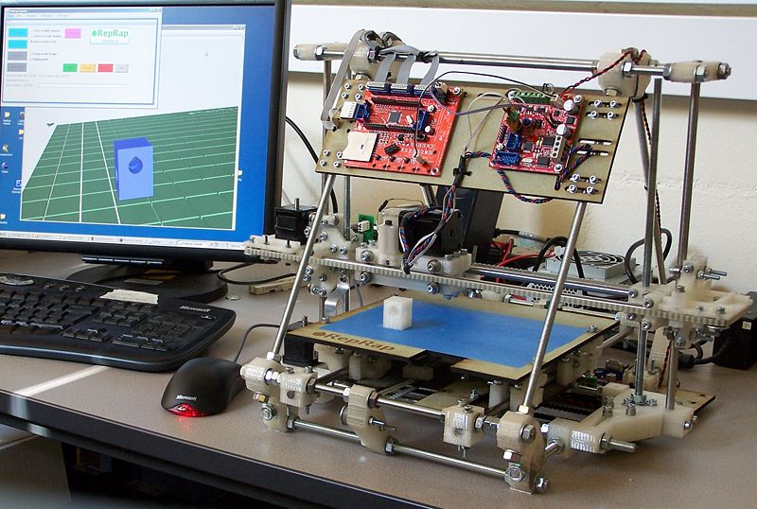

Introduction:
3D printing is a computer-assisted printing process by which 3D physical objects are constructed layer by layer out of a material, such as plastic, glass, metal, or ceramics. 3D printing is a relatively new technology, developed in the late 1980’s with early commercialization attempts beginning in the 1990s.
3D printing has recently seen much more widespread adoption and development with the introduction of open source 3D printers such as the RepRap, Makerbot Industries Cupcake and Thing-O-Matic printers, and MIT’s Fab-in-a-Box project. With these, 3D printing has the potential to become a distributed household manufacturing technique, doing away with the need for some large overseas factories and expensive international shipping lines.

Problem Description:
In order to function properly, a 3D printer needs a working set of electronics controlling the motion of the 3 (or in some advanced cases, 5) axes of motion. There are a number of open source 3D electronics systems out there available for use. A fairly exhaustive list of such electronics systems can be found here.
As good as contemporary 3D printing electronics systems are, there is room for improvement as they say.

Project Description:
Create a set of 3D printer electronics (either from scratch or modified from an existing open source project – VERIFY THAT IN THE LICENSE!) to support features conducive to next generation 3D printing. Some example features include:
- USB Interface: Currently, many sets of 3D-printer electronics rely on serial/parallel interfaces or USB-to-serial IC’s. These interfaces require special cables, adapters, and drivers that aren’t necessarily readily available on contemporary computer systems, increasing cost. Implementing a standard Mini-USB or Micro-USB interface would allow the board to operate more compatibly with contemporary computer systems.
- Feedback: In current open source 3D printing systems, some printer models and their associated electronics exhibit “open loop” control. There’s no feedback telling the electronics whether or not they’ve actually arrived at the desired coordinates, the electronics just “guess”. Adding in support for feedback devices may be useful in new 3D printing electronics.
- Multiple Toolheads: A “toolhead” is the tool portion of the 3D printer. Once you have a calibrated, correct, moving platform, you can replace the standard tool with many possible tools, including:
  - Extruder: Pushes plastic through a heated nozzle, building up plastic models layer-by-layer.
  - Plotter: Toolhead for holding a pen (or other writing utensil), allowing the 3D printer to draw pictures.
  - Laser: Sufficiently powerful lasers are capable of marking, etching, or precsion-cutting materials.
  - Vaccuum Nozzle: A toolhead commonly used by pick-and-place machines, for precision placement of PCB components in professional assembly.
  - Rotary Tool: For CNC milling capabilities
  - Camera: Captures images, which can then be stiched together to create high resolution 3-dimensional scans of physical objects
Current-generation electronics largely support only one type of toolhead for the given printer. For next generation electronics one might attempt to make toolheads “hot-swappable”, giving a given toolhead a unique toolhead ID that can be recognized by the motherboard. This could potentially vastly increase the utility of contemporary 3D printers.

- VGA Capture Device
Author: George Hadley Date Submitted: July 15th, 2011
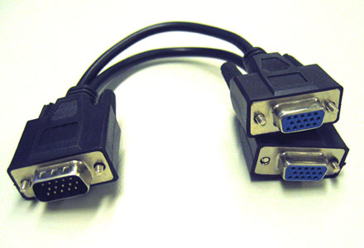

Introduction:
When diagnosing computer problems or writing tutorials, the ability to take screenshots can be an invaluable tool. For Windows users, this is easily accomplished using the ‘print screen’ key.

Problem Description:
In order to successfully take screenshots of a computer system, an operating system that supports the print-screen capability must be running. There are certain situations where this may not be the case, such as before the operating system starts up (when setting BIOS options), when running an operating system that does not support screenshot capabilities, or when one wishes to take screenshot from the output of a simple device, such as a video game system, etc. that does not run a traditional operating system.

Project Description:
Develop custom hardware (rather than software) for taking screenshots. The hardware would act as a “through” device for a standard video interface (such as VGA). Video data would pass through the device, but when a button is pressed or a computer command sent to the hardware, an onboard processor would capture a copy of the VGA stream. This data could then be converted to a standard image format (jpeg, tiff, png, etc.) onboard, and saved to an onboard SD card/flash drive. Alternatively, the device could feature a USB interface, allowing it to show up as a mass-storage device class device on a separate computer. In this way, technical problems with video projects could be diagnosed more easily, even in situations where screenshot functionality is not available or supported.

- Parking Ticket Detector
Author: George Hadley Date Submitted: July 15th, 2011
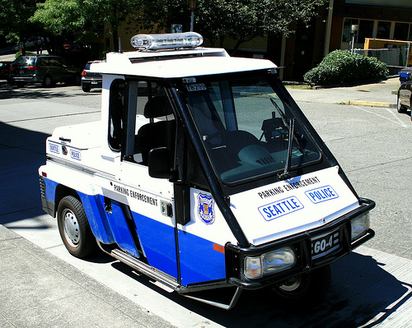
Introduction:
Parking can be a major hassle in urban environments, and it is only exacerbated by parking tickets and municipal parking corps. Lacking knowledge about whether or not one’s car has been “marked” by the parking police, students are often forced to trek long distances to their cars every few hours on a busy school day.

Problem Description:
In cities and other crowded areas, the standard, efficient way that parking police use to mark whether or not a car has been somewhere is to mark the tire with a brightly-colored, water soluble substance (usually chalk). For busy students and employees, it would be very valuable to be able to know whether one’s car has been marked and needs to be moved without having to walk half an hour to go find out.

Project Description:
The parking ticket detector consists of a set of electronics for determining whether or not one’s car has been marked by the parking police and must therefore be moved to avoid a parking ticket. The detector would consist of a network of cameras capable of being installed in the wheel wells of a car. In the event that one of the car tires had been marked, the electronics would raise an alert, sending an email or text to the user. The user could then potentially access the given camera feed directly using a web app or other such service, allowing him or her to determine whether or not moving their car is necessary.

- Pedestrian Panorama Camera
Author: George Hadley Date Submitted: July 15th, 2011
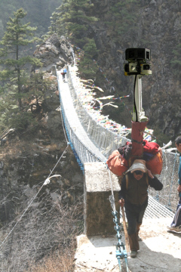
Introduction:
With the advent of Google’s StreetView technology, it is now possible to “drive” down virtual streets as though you were in real physical locations. Unfortunately, laws of men and physics sometimes prevent the Google StreetView van from going to places where users would really like to have imagery from.

Project Description:
The Pedestrian Panorama Camera consists of a harness, multiple cameras and other electronics (GPS, etc.). Using this technology, users could capture imagery of trail hikes and scenic nature areas, adding a Google “TrailView” capability to Google Earth.
The project would consist of a hardware component, as well as a software suite for associating image data with GPS coordinates in the Google Earth API.

- Piezoelectric Spy Shoes
Author: George Hadley Date Submitted: July 18th, 2011
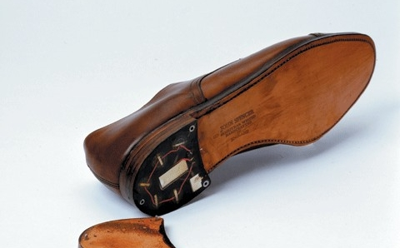
Introduction:
During the height of the Cold War, espionage was an invaluable tool for both the United States and Soviet Union. One particularly effective espionage device developed by the KGB was the “spy shoe”, in which a microphone was inserted in the heel of a shoe, along with a small transmitter for transmitting the microphone data. More details on this spy shoe can be found at http://www.gizmag.com/go/1576/.

Project Description:
Develop a modern version of this spy shoe using contemporary technology. For example, microphone elements could be replaced with a piezoelectric membrane. Data could be saved to an SD card for later use, signal processing could be use to remove the large impulse noises resulting from footstep operation, and two shoes could be used for stereo sound recordings.

- Reflow Soldering Controller (Support for Multiple Heating Profiles)
Author: George Hadley Date Submitted: July 18th, 2011
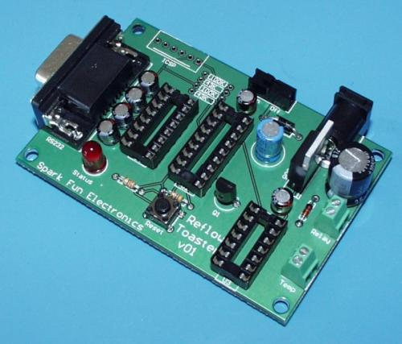
An Example Reflow Controller Built by Sparkfun Electronics
Introduction:
Contemporary electronics often feature small, surface mount components. Some of these, such as SOIC, SSOP, and QFP packages, can be soldered by hand. Other packages, such as surface mount packages containing exposed thermal pads and BGA packages, feature under-chip pads that cannot be accessed by soldering iron, and, as such, are extremely difficult or impossible to solder. Industrial equipment for soldering contemporary circuit boards relies on processes such as wave soldering, and professional equipment for these more advanced soldering techniques is often expensive and far too bulky to be tractable to electronics hobbyists.

Problem Description:
Advanced electronics hobbyists have developed methods to solder complex circuit boards using a technique known as reflow soldering. Under these methods, a stencil or a board is obtained (either created or ordered from a professional company). Using this stencil, a substance known as solder paste (a mixture of powderized solder and an adhesive substance is applied to the board). Parts are then carefully placed on the board, either by hand or using an SMD placement machine. The boards are then placed in an environment run by a common industrial heating source, such as a toaster oven or electric skillet. In this way, the heat heats up the solder paste, evaporating the adhesive and causing the powderized solder to reflow, simultaneously soldering every electrical connection on the board at the same time. Using these methods, very advanced circuit boards have been constructed, and they have also been successfully used in the repair of defective motherboards and other professional-grade circuits.
To successfully reflow solder a board, the board needs to be heated in a particular way: the board needs to be heated above the melting point of the solder for long enough that the solder is able to reflow and complete electrical connections. At the same time, heating the board too quickly or for too long can cause thermal damage to the components on the board, rendering the board useless. To control the heating of the boards, a heating element such as a toaster oven or electric skillet must be modified to accept computerized control. The control circuitry that accomplishes this task is commonly referred to as a Reflow Soldering Controller.
To help OEMs reflow solder circuits while not damaging sensitive components, component manufacturers publish reflow soldering temperature profiles for their parts. These are commonly found in datasheets in the form of time-temperature graphs, showing what heat levels should be applied at various stages of the reflow soldering process.

Project Description:
Develop a reflow soldering controller for soldering of advanced electronic circuits. The controller should be able to interface to a computer over a standard interface (USB, Ethernet, etc.) and/or load and store data from an attached flash drive or SD card. The controller should detect the temperature of an attached heating element through some sort of sensor (thermistor, thermocouple, etc.). Then, the controller should be able to control power to the heating element using a closed-loop control method (such as PID control). In this way, the controller can accurately heat a circuit board using an included temperature profile. As a possible addition, a PC-side application could be developed that accepts multiple temperature profiles as input and outputs to the controller a composite heating profile that ensures no parts on the board are damaged by the reflow soldering process.

- Submit Your Ideas!
The senior design staff generously submitted the ideas contained in this document so that you might have fun and rewarding project options for ECE477. If you have a cool project idea, but lack the time or resources to do it, consider submitting your idea to ECE477 so that a future engineering team might bring it into reality! Email your 477 project ideas to ece477@ecn.purdue.edu. Be sure to include your name (for credit), the date of submission, an introduction, problem description, and project description.

