EAGLE PCB Submissions
- Your last step as pcb finalization should be to draw a border around your board and make a note of the X_Y dimensions for the production submission. This border should be on the silk screen layer.
- After the layout has been finalized, select the CAM processor button, , go to File > Open > Job and select gerb274x.cam. This file sets the layers and processing parameters for the pcb. Note that each layer is represented by a tab.

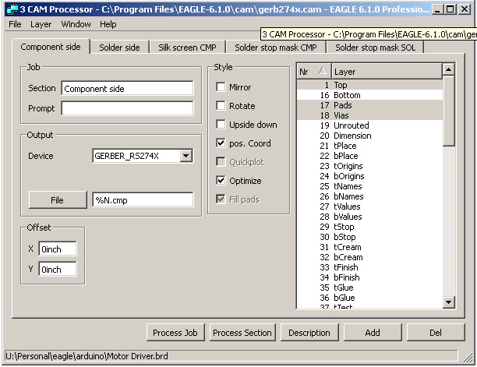

- Click the File button in the Output section and select the directory where you want the pcb files stored. It is suggested that this be a subdirectory of your layout files for clarity. Check this for all pcb layers.
- Click the Process Job button. This will create the pcb files and place them in the assigned directory.
- Select the CAM processor button and go to File > Open > Job and select excellon.cam. This file is used to create the drill file.
- Click the File button in the Output section and select the pcb file subdirectory created above.
- Click the Process Job button. The drill file will be created.
- Go to the pcb directory. Six files should be present:

*.drd drill file
*.cmp top side copper
*.plc top side silkscreen
*.sol bottom side copper
*.stc top side solder mask
*.sts bottom side solder mask
8. Zip these files. The name of the zip file should have the team number and board number, such as “Team3_pcb1.zip”. Go to www.4pcb.com and submit them to FreeDFM for checking. When the report comes back indicating “NO SHOWSTOPPERS” submit the identical ZIP file to staff as the pcb submission.
9. This file should be sent to ___________________
cc. ALL team members
Subject: Team __ submission pcb _ of _
(NOTE: ONLY 1 pcb per email. Teams submitting more than 1 pcb need to indicate which pcb is being submitted, as in pcb 2 of 4.)
Attach the zip file to the email.
In the body of the email give the dimensions, in inches, as well as quantity of pcbs required, the email and phone number of the primary contact for any questions that might arise. Verify that you have submitted the file to FreeDFM and that your file has come back with no showstoppers by typing “No Showstoppers”

