User Manual

Year: 2014 Semester: Fall Team: 4 Project: Aerial Distress Beacon

Creation Date: October 7, 2015 Last Modified: October 7, 2015

Author: <redacted> Email: rdacted@pudue.edu

Assignment Evaluation:

Item | Score (0-5) | Weight | Points | Notes
Assignment-Specific Items
Product Description
Product Illustration
Setup Instructions
Usage Instructions
Troubleshooting Instructions
Writing-Specific Items
Spelling and Grammar
Formatting and Citations
Figures and Graphs
Technical Writing Style
Total Score

5: Excellent 4: Good 3: Acceptable 2: Poor 1: Very Poor 0: Not attempted

Comments:

Product Description

Any time we venture away from civilization, there is a risk of encountering an injury or emergency that requires modern emergency services. However, there is a chance that in remote areas, you may not be able to call 911 on your phone and may become stranded without a means of rescue. To mitigate this risk, the Areal Distress Beacon (or ADB) provides a system to give you the best possible chance of rescue. By taking advantage of altitude, the ADB offers enhanced range and operating conditions over conventional radios. Just carry it with you on your next adventure and it will track your GPS coordinates. If you should require emergency services, simply speak into the ADB to record your voice, giving a brief description of your situation. Then, inflate the balloon with hydrogen and release your message into the air. It will broadcast from a high altitude and drift over a large area.

Product Illustrations

Complete System:

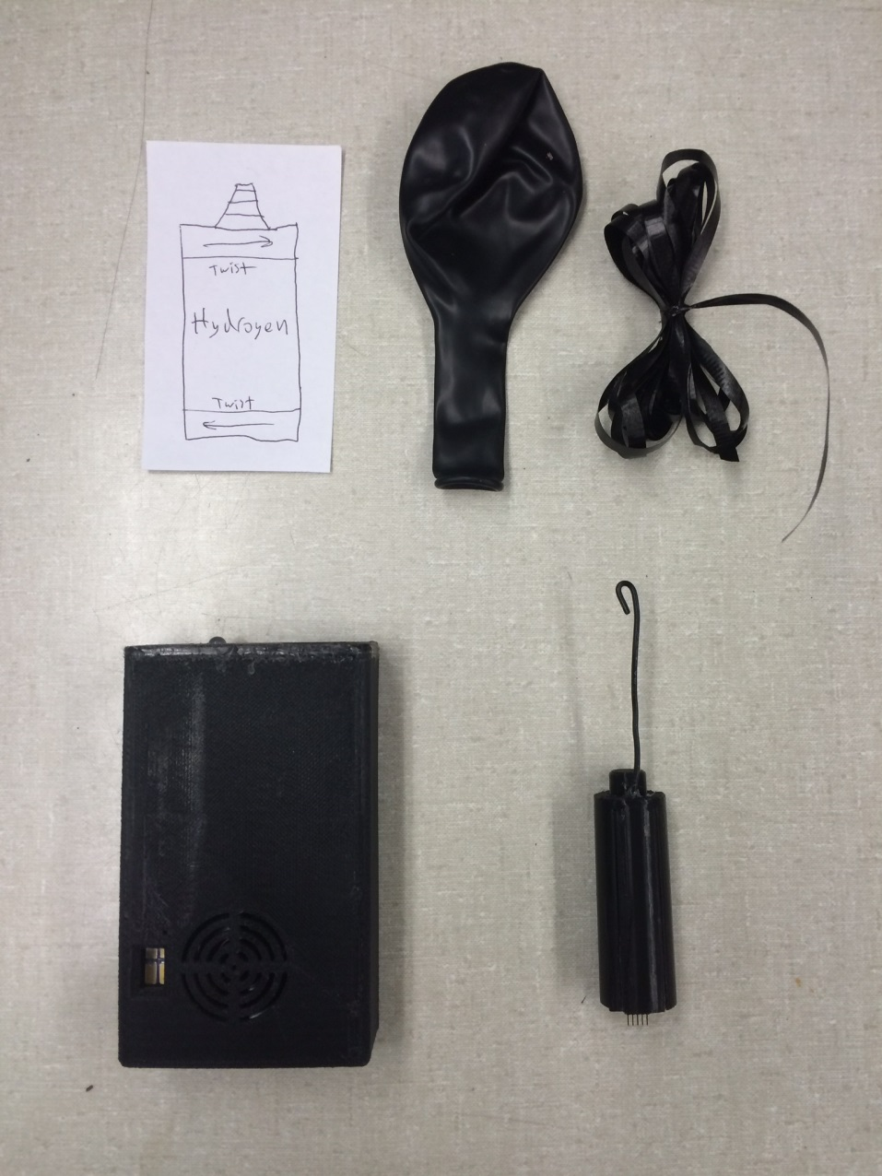

Features:

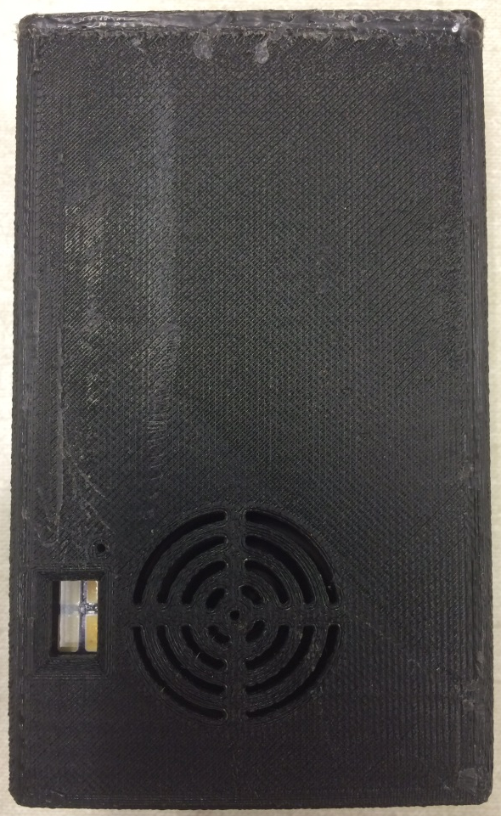
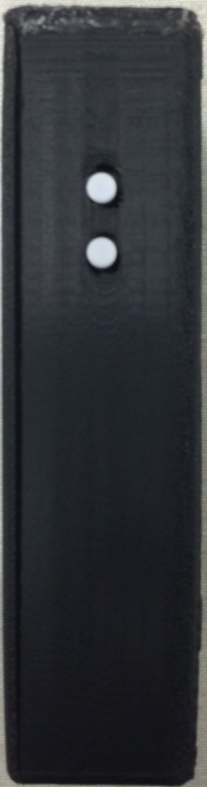
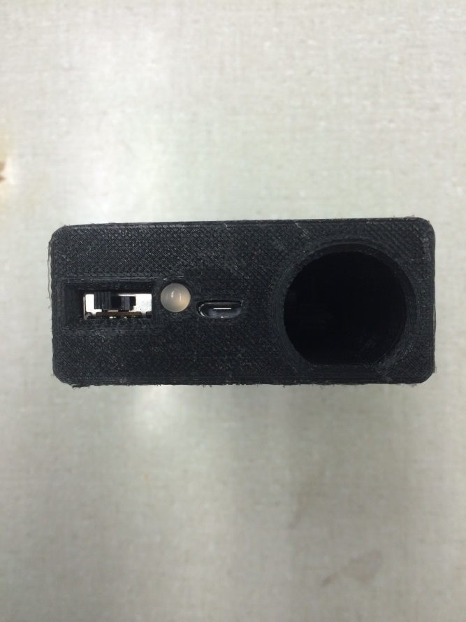
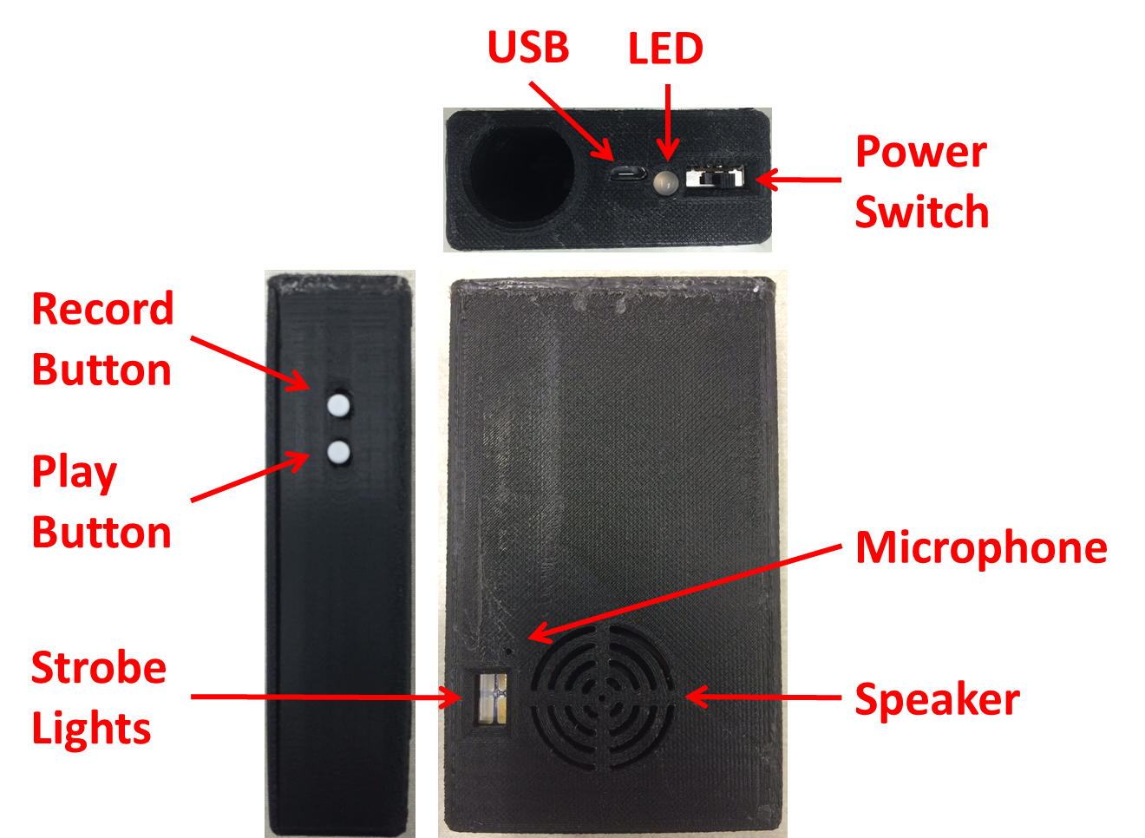
Record
Button
Play
Button
USB
LED
Power
Switch
Speaker
Microphone
Strobe Lights

Setup Instructions

Charging the Launcher:

Insert the Beacon into the Launcher.

Plug the small end of the USB Cable into the Launcher.

Plug the other end the USB Cable into the Power Supply or any available USB power source.

Allow the device to charge overnight.

The above should be repeated before each trip you take with your ADB.

Usage Instructions

Monitoring:

Turn on the Launcher when you start your trip by sliding the Power Switch to the center position.

Carry the ADB with you and it will keep your GPS coordinates up to date.

If you will remain in the same location for more than an hour, slide the Power Switch to the left-most position while you are stationary to conserve power, and then turn it back on when you begin moving again.

Deployment:

CONTACT 911 BY CONVENTIONAL MEANS IF POSSIBLE. The ADB is intended for use as a last resort only and does not replace contacting emergency services by phone where possible.

If the Launcher is off, turn on it on by sliding the Power Switch to the center position.

Place the Microphone near your mouth and press the Record Button. The LED will illuminate red to indicate that you may begin recording.

Provide a brief voice description of your emergency. You have up to 12 seconds.

Press the Playback Button and listen to what was recorded. Your GPS coordinates will be automatically appended. Repeat steps 3-6 until the recording is what you want to transmit.

Insert the nozzle of the Hydrogen Generator into the Balloon.

Twist the two ends of the Hydrogen Generator firmly and shake to activate. Wait until the Balloon ceases to expand then tie the end to seal it.

Tie one end of the String to the Balloon and the other end to the loop at the end of the Antenna on the Beacon.

Remove the Beacon from the Launcher and release the assembly into the air.

Strobe Mode:

As you await emergency services, you may increase your visibility by activating strobe mode.

Slide the Power Switch to the right-most position.

The Strobe Lights will flash periodically.

Troubleshooting Instructions

Problem | Potential Solutions
Launcher will not turn on. | The Launcher may need to be charged. See setup instructions.  If none of the above solves the issue, please contact the ADB support team at the number below.
I do not hear my message when I press the playback button. | Is the launcher on? Check the power switch.  Did the LED blink green when you turned on the device? If not, it may need to be charged. See setup instructions.  Is the Beacon in the Launcher? If not, insert the Beacon into the Launcher  Verify that the Beacon is fully inserted into the launcher by pressing down on it.  If none of the above solves the issue, please contact the ADB support team at the number below.

We are sorry you are experiencing trouble with your ADB!

24/7 Customer Support: 1-800-123-4567.

