Software Overview

Year: 2014 Semester: Fall Team: 7 Project: Digital Knockout

Creation Date: Sept 9, 2014 Last Modified: September 12, 2014

Author: <redacted> Email: rdacted@purdue.edu

Assignment Evaluation:

Item | Score (0-5) | Weight | Points | Notes
Assignment-Specific Items
Software Overview
Description of Algorithms
Description of Data Structures
Program Flowcharts
State Machine Diagrams
Writing-Specific Items
Spelling and Grammar
Formatting and Citations
Figures and Graphs
Technical Writing Style
Total Score

5: Excellent 4: Good 3: Acceptable 2: Poor 1: Very Poor 0: Not attempted

General Comments:

1.0 Software Overview

Digital Knockout will utilize a 3-axis accelerometer breakout board in each boxing glove to provide an estimate of the force of the punch. This firmware can measure dynamic acceleration resulting from motion or vibration. It measures acceleration on the range of +/-3g. The output signals are analog voltages that are proportional to acceleration [1], with 0g output being 1.65V for a 3.3V power supply.

The Xbee S1 RF Module on the glove supports both analog and digital inputs. In terms of software, the Xbee pins will need to be configured as analog-to-digital converter channels, so that they can be directly connected to the analog outputs of the accelerometer. To transmit this accelerometer data to the Xbee on the main console, a Zigbee network mesh will need to be set up using API commands. The receiving Xbee will be able to output the acceleration data to the UART, ready to be read by the microcontroller.

On the microcontroller side, the software functionality that it will be responsible for will include the ability to take in the accelerometer data and use it to calculate force of the punch. The microcontroller is expected to receive data from both players’ gloves, and use certain algorithms to determine Health Points for each player. These are explained in further detail in the next section.

Furthermore, the microcontroller will need to provide the functionality of checking the accuracy of the punch. This will be done using IR receivers and emitters. The receivers will send out binary data over the Xbee module on a player’s vest, to the Xbee on the main console. The microcontroller will incorporate an algorithm to check whether or not an accurate punch was made, and if so, then it will decide where exactly on the vest the punch was registered.

The PIC microcontroller has a built-in timer module. It will be used to count up to one-second intervals in order to generate and display a countdown timer on the LCD interface.

The life of the batteries used in each of the components will be measured using micropower comparators in voltage detection circuits [2]. The firmware allows the ability to set a low battery threshold voltage. These comparators will output analog voltage readings, and transfer them over the Xbee modules. The final functionality that the microcontroller will provide will be to use the voltage readings to display an appropriate warning message on the LCD interface in case of low battery in any of the components.

2.0 Description of Algorithms

The success or accuracy of a punch will be determined based on whether or not the IR receivers detect a transmission from the IR emitters on the boxing gloves. This will be simple binary data, and basic algorithms like conditional statements will be utilized to determine a successful punch.
The position of the set bit will indicate the portion of the vest at which the punch was detected.

Once the accelerometer readings have been obtained, a simple formula, F=ma (using a constant mass), will be used to determine the force of the punch. In single player mode, no further calculations will be performed with the force. However, in multi-player mode, Health Points (HP) for each player will need to be updated based on the punch. Ideally, if one player makes a successful punch, the decrease in HP of the opponent will be proportional to the force of the punch. On the other hand, if both players punch at the same time, a different algorithm will be used to calculate HP: the microcontroller will compare the force of both punches, and whichever player has the weaker punch will lose a certain amount of Health Points, based on the difference between the two forces.

For battery life monitoring, references and data sheets for either the AA form or Lithium-ion batteries (whichever we intend to use) will be utilized to determine a threshold voltage. Below that voltage, the LCD display will reflect a warning message to the player, indicating that the batteries need to be changed.

3.0 Description of Data Structures

The accelerometers will output analog voltage readings on three of its output pins, one for each of x-, y- and z-axes. Since these are directly interfaced to ADC pins on the Xbee, the data structure that needs to be considered in this case is the one used by the Xbee to transmit data to other Xbees on the network. The receiver Xbee will output data to a UART interface, and it will be of the form displayed in Figure 3.1 below. I/O data begins with a header. The first byte of the header defines the number of samples forthcoming. The remaining two bytes of the header indicate which channels or inputs are active. Each bit represents either a digital IO line, or an ADC channel [3].

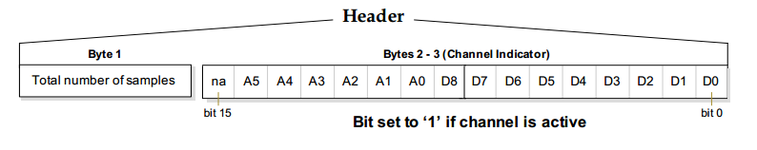
Figure 3.1 - source: Digi International

Sample data then follows the header, and can be read using the channel indicator (last two bytes of the header). If any of the digital IO are enabled, the first two bytes are the IO sample. The ADC then follows, and it is represented as an unsigned 10-bit value, right justified on a 16-bit boundary [3]. This is displayed below in Figure 3.2.

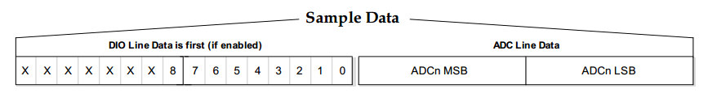

Figure 3.2 - source: Digi International

The IR sensor data will also be transferred over Xbee modules, and the microcontroller will receive it as a 9-bit packet, where each bit represents the Boolean value of one of the 9 IR receivers on the vest. The location of the punch on the vest will be determined based on which bit in this packet has been set. This 9-bit packet can be stored as a queue or a simple array.

Apart from the data structures described above, the microcontroller in the main console will use various variables to store information such as the punch force that is computed for each player, the current Health Points of each player, and the time remaining in the boxing round.

4.0 Sources Cited:

[1] Analog Devices (2009) ADXL335 Datasheet [online]. Available: https://www.sparkfun.com/datasheets/Components/SMD/adxl335.pdf

[2] Linear Technology Corporation. (n.d) SOT-23 Comparator and Voltage
Reference for Battery Monitoring. Available: http://cds.linear.com/docs/en/datasheet/1998fb.pdf

[3] Digi International Inc (2014). Xbee/Xbee Pro RF Modules Product Manual. Available ftp://ftp1.digi.com/support/documentation/90000982_P.pdf

Appendix 1: Program Flowcharts

MAIN PROGRAM MODE SELECT

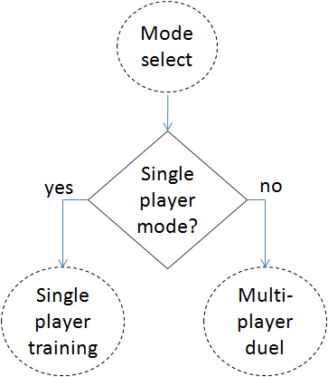
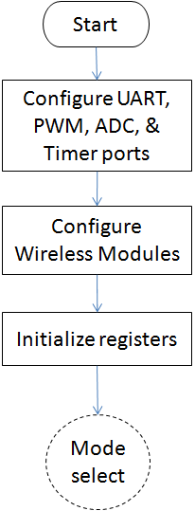

SINGLE PLAYER TRAINING

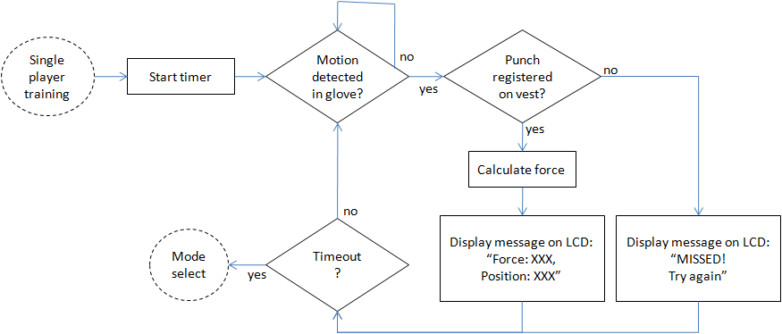

MULTI-PLAYER DUEL
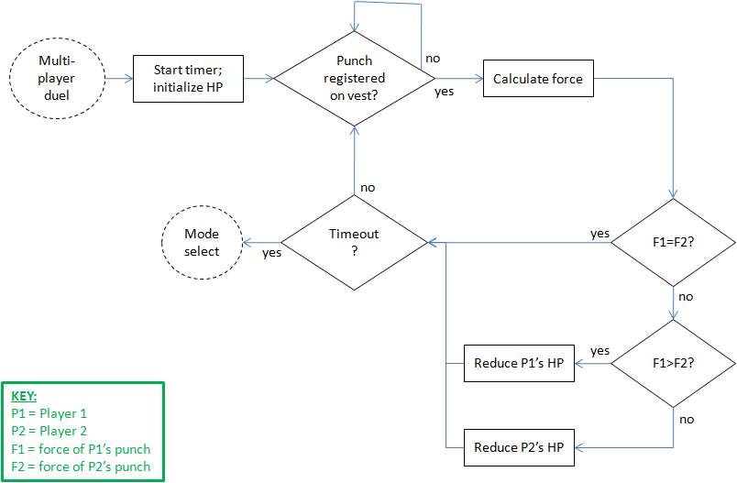

Appendix 2: State Machine Diagrams

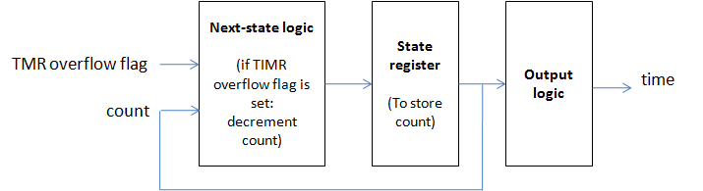
Moore state machine for determining time remaining in boxing round.

Moore state machine for determining player Health Points.

