Software Overview

Year: 2014 Semester: Fall Team: 6 Project: HexApod

Creation Date: September 9, 2014 Last Modified: October 7, 2015

Author: <rdacted> Email: rdacted@purdue.edu

Assignment Evaluation:

Item | Score (0-5) | Weight | Points | Notes
Assignment-Specific Items
Software Overview
Description of Algorithms
Description of Data Structures
Program Flowcharts
State Machine Diagrams
Writing-Specific Items
Spelling and Grammar
Formatting and Citations
Figures and Graphs
Technical Writing Style
Total Score

5: Excellent 4: Good 3: Acceptable 2: Poor 1: Very Poor 0: Not attempted

General Comments:

1.0 Software Overview

The hexapod project requires two different firmware components. One component is the user’s controller device, which can wirelessly control the movement of the hexapod robot, display live video received from the robot, request the hexapod robot to send back the current location information and to command the robot to climb over obstacles. The other component is the hexapod robot itself. The robot should be able to walk, overcome obstacles and send back current locations based on the user instructions.

The software implemented in the microcontroller can be described as a state machine. After startup, the robot will first configure its wireless connection between user’s controller device and the hexapod. After that, the microcontroller waits for instructions from the user’s controller device. These instructions can be robot’s movements, user requesting video feedback or a GPS location. Once such instruction becomes available, the software programmed in the robot will interpret the instruction it receives and recognize whether the user commanded a walking instruction or simply just needs a current location report. Each function command will trigger the corresponding function flag in the software and cause different actions to be done. If the command received is a walking instruction, the corresponding PWM signals will be sent to the servo controller and move the robot in the right walking sequence. If the command is to climb over obstacles, the Infrared Proximity Sensor will first be used to measure distance between the robot and the obstacles. Based on such information, the robot will be programmed to find a position where the distance between the robot and the obstacle is in a reasonable range. Then the pre-programmed walking sequences will lead the robot getting over the obstacles (Detailed explanation will be in Description of Algorithms section). If the command received is to send back the current location information, the microcontroller will first read the current geo-information from the GPS receiver module, and then send back the GPS location. After executing the command sent from the user, the robot will be in idle state and wait for the next users’ commands.

2.0 Description of Algorithms

There are two main algorithms needed to be either designed or implemented on the hexapod robot. One part is to implement the combined Insect-Wave^{[1]} and Mammal-Kick^{[1]} tripod gait on the robot so that it can easily walk forward, backward, left and right.
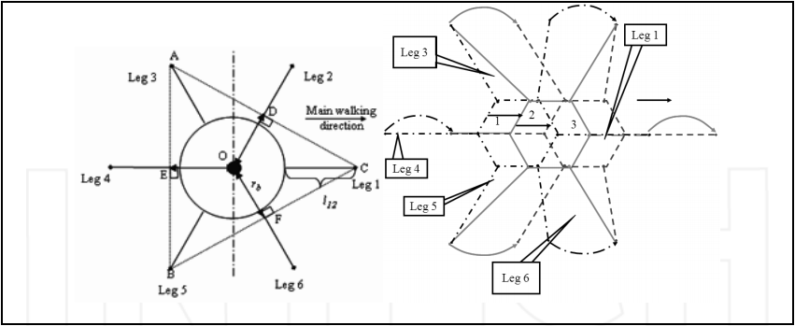
Fig.1 Insect-Mammal combined tripod gait ^{[1]}

The robot legs and body will be built and placed as depicted in the Figure 1 on the left. The figure is a top view of the robot. When the robot has received any walking instructions, the microcontroller will send the pre-programmed PWM signals to the servo controllers. These pre-programmed PWM signals are derived from the walking sequences of the Insect-Mammal combined tripod gait.

In the first step of a forward walking sequence, leg 1, leg 3 and leg 5 stands on the ground and push the body forward while leg 2, leg 4, and leg 6 swings ahead. In the second step, leg 2, leg 4, and leg 6 stands on the ground, pushing the body forward while leg 1, leg 3, and leg 5 change to a swing phase. After this, the procedure returns to the first step of sequence and proceeds. The whole cycle will include two steps so that the body is moved twice. The moving direction and sequences have been shown in Figure 1. The turning sequences is very similar as the walking sequences. In the first step of the turning sequence, leg 1, leg 3 and leg 5 stands on the ground, and leg 2, leg 4, and leg 6 swings around the body and lands on the ground. In the second step, leg 2, leg 4, and leg 6 stands on the ground, and leg 1, leg 3, and leg 5 will be swinging the same angle to complete the turn. The two steps will be repeated until the robot has turned to the designated angles. The exact turning angles for each servo will be determined later when testing and experimenting with the hexapod robot.

The other part is to design the algorithm for the robot to get over obstacles autonomously. In order to accomplish this autonomous task, the climbing leg steps and sequences need to be pre-programmed in the microcontroller. Since the climbing sequences is fixed for every obstacle, the distance between the robot and the obstacle has to be fixed as well. Also, there will be limitations on the maximum height of the obstacle that the robot can tackle. When the robot meets an obstacle, the user needs to make sure that the distance between the robot and the obstacle is within the detection range of the Infrared Proximity Sensor. There will be indicator signals on the user’s controller device. Once the distance is within a reasonable range, the user can send the command to begin climbing over obstacles autonomously. The software programmed in the robot will first detect its distance between the obstacles, and if the distance is not within the pre-programmed fixed distance, the microcontroller will send additional command to the servo controllers to adjust the distances to the obstacles. The robot will repeat checking and adjusting until it is at the pre-programmed fixed distance. Once the fixed distance is achieved, the hexapod’s body will be lift upward in order to detect the height of the obstacles. The body is lifted until there is nothing that can be detected from the infrared proximity sensor, as this indicates the obstacles’ height. Based on the data collected, it can then determine whether the obstacle can be climbed over or not. If the obstacle can be climbed over, the robot body will lift up to a certain height and perform the pre-programmed climbing sequences. The details of the climbing sequences will be determined later when testing and experimenting with the hexapod robot.

3.0 Description of Data Structures

There are two different data structures needed for the hexapod project. The first data structure used is to interpret the format of the command sending from wireless module through UART interface to the microcontroller. This command includes moving forward, moving backward, turning left, turning right, climbing over the obstacle, and sending back the current geo-location information. Since the UART packet is 8 bit long, the first command moving forward will be encoded as 8’b00000001, the second command moving backward will be encoded as 8’b00000010. The remaining commands will be encoded in the sequence mentioned above the as binary number of the previous command increased by one. The maximum possible number of commands is 2⁸ based on the number of bits of the UART packet. If there are new commands needed, they will follow the same formatting method discussed before.

The second data structure used is to interpret the command send to the servo controller for performing walking or climbing sequences. According to the data sheet ^{[2]} of the servo controller, the data format is as the following #<ch>P<pw>S<spd>…. #<ch>P<pw>S<spd>T<time><cr>. (Symbols of servo controller’s data format is further detailed in Electrical Overview document) Thus, one possible command for moving one leg is #1P1500#2P1500#3P1500. For the first step of the forward moving sequence, the command is 6 times larger than the example of moving one leg. It is possibly 36 times larger for finishing one walking sequence. All such command needs to be pre-programmed into the microcontroller, and it will take a large amount of memory. Therefore, the data structure of the command for walking sequences is definitely memory-intensive, and it will affect the decision of choosing the microcontroller.

4.0 Sources Cited:

[1] D. Xilun (2010, March 01), Locomotion analysis of hexapod robot, Available: http://cdn.intechopen.com/pdfs-wm/10075.pdf
[2] SSC-32 Datasheet
http://www.swarthmore.edu/NatSci/ceverba1/Class/e5/E5Lab2/ssc-32%20lynxmotion%20manual.pdf

Appendix 1: Program Flowcharts
Initial Configuration

Wait For Command

Command Received?

No

Yes

Decode Command

Send Back Location
Climb Over Obstacle
Walk Instruction

Appendix 2: State Machine Diagrams

State Transition Diagram of the Autonomously Climbing Sequences

