Reliability and Safety Analysis

Year: 2015 Semester: Spring Team: 13 Project: CoDDeLo

Creation Date: 04/03/2015 Last Modified: October 7, 2015

Author: <redacted> Email: rdacted@purdue.edu

Assignment Evaluation:

Item | Score (0-5) | Weight | Points | Notes
Assignment-Specific Items
Reliability Analysis
MTTF Tables
FMECA Analysis
Schematic of Functional Blocks (Appendix A)
FMECA Worksheet (Appendix B)
Writing-Specific Items
Spelling and Grammar
Formatting and Citations
Figures and Graphs
Technical Writing Style
Total Score

5: Excellent 4: Good 3: Acceptable 2: Poor 1: Very Poor 0: Not attempted

Comments:

Reliability Analysis

dsPIC33FJ256GP710A

The dsPIC33FJ256GP710A [1] is used to control the entire system. It was chosen for reliability analysis because of its complexity. The failure per 10^6 hours ($λ_{P}$) and mean time to failure (MTTF) was calculated based on the formulas outlined in MIL-HDBK-217F [2]. I used the model of digital CMOS IC microprocessor model for this microcontroller. $λ_{P}$ = (C₁ · π_{t} + C₂· π_{e}) · π_{l} · π_{q}. The MTTF and $λ_{P}$ is in the expected range. A failure of this microcontroller would not directly cause harm to the users.

Table 1, microcontroller analysis.
Parameter name | Description | Value | Comments
C1 | Die complexity | 0.14 | PIC controller
π_{t} | Temperature coeff. | 1.5 | PIC controller
C₂ | Pin/Package Constant | 0.052 | Nonhermetic SMT with 100 pins
π_{e} | Environmental Constant | 0.5 | $$G_{B}$$
π_{l} | Learning Factor | 1 | The IC is more than two years in production.
π_{q} | Quality Factor | 10 | Commercial components

Entire design:
$$λ_{P}$$ |  | 2.36
MTTF |  | 0.424

MCP1700

The MCP1700 [3] voltage regulator is used to provide power to the digital circuits. If this voltage regulator fails to operate normally, there will be insufficient or excessive amount of power deliver to other digital components in our system, which would cause mistakes in logic computations. Incorrect logic computation would make some component, such as keypad, LCD, Xbee and motor, operate in an unexpected way, which would damage the entire system and users.
The failure per 10^6 hours is calculated by $λ_{P}$ = (C₁ · π_{t} + C₂· π_{e}) · π_{l} · π_{q.} The model of CMOS Switch-Mode Regulator is used. The MTTF and $λ_{P}$ is in the expected range. A failure of this microcontroller would not directly cause harm to the users.

Table 2, voltage regulator analysis.
Parameter name | Description | Value | Comments
C1 | Die complexity | 0.01 | 1 to 100 bipolar transistors is used
π_{t} | Temperature coeff. | 0.1 | CMOS, $T_{j}$= 25 ° C
C₂ | Pin/Package Constant | 0.0012 | 3 pin SMT
π_{e} | Environmental Constant | 0.5 | $$G_{B}$$
π_{l} | Learning Factor | 1 | The IC is more than two years in production.
π_{q} | Quality Factor | 10 | Commercial components

Entire design:
$$λ_{P}$$ |  | 0.016
MTTF |  | 62.5

Xbee Module

The Xbee S1 wifi module contains MC 13213 HS08 microcontroller which dominate the complexity of this module. Also, the Xbee module is a key component to let our system to communicate with a database and quadcopters. Given this, it is important to analyze the reliability of the Xbee. The following data is obtained from the MIL_HDBK_217F [2] and the MC13213 datasheet[4]. The failure per 10^6 hours is calculated by $λ_{P}$ = (C1 · πt + C2· πe) · πl · πq. The model of digital CMOS IC microprocessor is used. The MTTF and $λ_{P}$ is in the expected range. A failure of this microcontroller would not directly cause harm to the users.

Table 3, Xbee module analysis.
Parameter name | Description | Value | Comments
C1 | Die complexity | 0.14 | 8-bit microcontroller
π_{t} | Temperature coeff. | 0.98 | maximum operating temperature is 85° C
C₂ | Pin/Package Constant | 0.036 | Nonhermetic SMT with 71 pins
π_{e} | Environmental Constant | 0.5 | $$G_{B}$$
π_{l} | Learning Factor | 1 | The IC is more than two years in production.
π_{q} | Quality Factor | 10 | Commercial components

Entire design:
$$λ_{P}$$ |  | 1.552
MTTF |  | 0.64

SUMMARY

The MTTF of all three components all more than half million hours which are long enough for our machine. The possible methods to improve the reliability of our design is to use microcontroller and other ICs as simple as possible. We can also design a cooling system to reduce the temperature coefficient.

Failure Mode, Effects, and Criticality Analysis (FMECA)

There were three criticality levels for this project, low medium and high. High refers to failures which cause injury to users in a catastrophic way, such as burning and toxic gas releasing. Medium refers to failures which has a small probability to cause injury to users by mechanical collision. Low refers to negligible failure which only cause the system to shut down and does not do any damage to users. The acceptable failure rate for high level failure is ${10}^{-10}$. For medium and low level failure, the failure rate is ${10}^{-6}$. I assume the users read the user manual thoroughly before using our machine. We also assume the electrical system of our design will not be exposed in raining, snowing or other catastrophic weather.

3.0 Sources Cited:

dsPIC33FJXXXGPX06A/X08A/X10A Data Sheet, Microchip Technology Inc., 2011.

“Military Handbook Reliability Prediction of Electronic Equipment” Department of Defense. Washington DC. MIL-HDBK-217F, Dec. 2, 1991.

MCP1700 Low Quiescent Current LDO, Microchip Technology Inc., 2013

MC13211/212/213 ZigBee™- Compliant Platform - 2.4 GHz Low Power Transceiver for the IEEE® 802.15.4 Standard plus Microcontroller, Rev 1.8, Freescale Semiconductor, 20

Appendix A: Schematic Functional Blocks

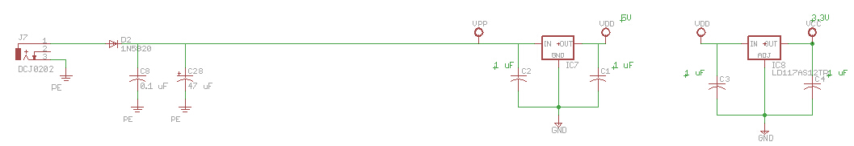
Figure 1, power supply circuit.

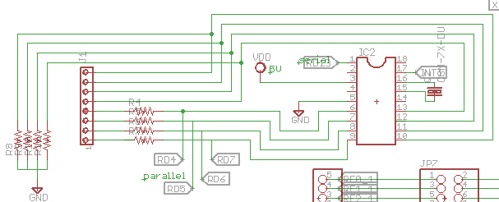
Figure 2, keypad circuit.

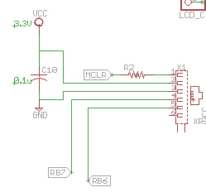
Figure 3, in-circuit programmer circuit.

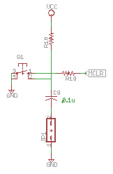
Figure 4, reset circuit.

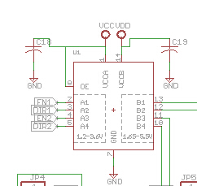
Figure 5, logic level converter circuit.

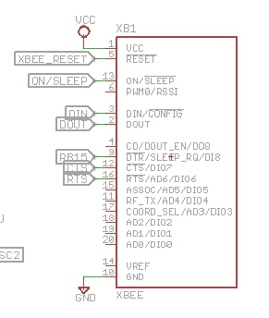
Figure 6, Xbee module circuit.

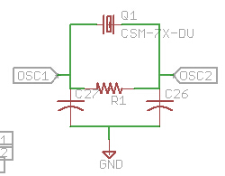
Figure 7, crystal oscillator circuit.

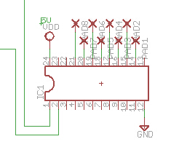
Figure 8, shift register circuit.

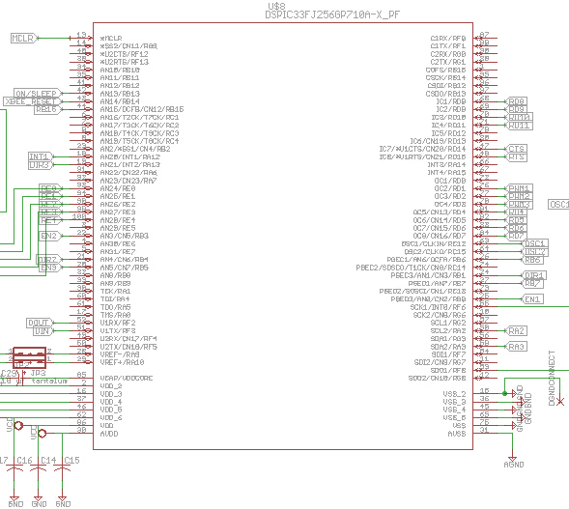
Figure 9, microcontroller circuit.

Appendix B: FMECA Worksheet

Table 4, power supply circuit FEMCA.
Failure No. | Failure Mode | Possible Causes | Failure Effects | Method of Detection | Criticality | Remarks
1 | Voltage drop | C8, C28, C1, C2, C3, C4 | Errors appear in logic computation. Some components may turns off. | Observation,  Display and transmitting errors on LCD and Xbee. | Low
2 | Voltage regulator fails short | 2 voltage regulators | Damage all ICs and overheat the system. | Observation,  smoke/burning, excessive heat | High | The overheat on the electrical components would cause burning and toxic gas releasing from PCB

Table 5, keypad circuit FEMCA.
Failure No. | Failure Mode | Possible Causes | Failure Effects | Method of Detection | Criticality | Remarks
3 | No input received from keypad | EDE 1144 encoder (IC2), Crystal oscillator | User cannot enter their username and password | Observation,  Measure the output voltage from the keypad encoder | Low | Assuming the resistors are not open-circuited and supply voltage is normal.

Table 6, in-circuit programmer circuit FEMCA.
Failure No. | Failure Mode | Possible Causes | Failure Effects | Method of Detection | Criticality | Remarks
4 | No voltage supply to in-circuit programmer | C10 | Cannot program the microcontroller | Observation, errors appear when program the microcontroller | Low | Assuming supply voltage is normal.
5 | No data received from in-circuit programmer | Damaged programming cable, damaged RJ11 connector | Cannot program the microcontroller | Observation, errors appear when program the microcontroller | Low | Assuming supply voltage is normal.
6 | Large noise appears on the output of the in-circuit programmer | Opened bypass capacitor | Unpredictable | Observation, wrong software program might be performed | Low

Table 7, reset circuit FEMCA.
Failure No. | Failure Mode | Possible Causes | Failure Effects | Method of Detection | Criticality | Remarks
7 | Reset signal is always high | Damaged pushbutton | Cannot reset the system | Observation | Low
8 | Reset signal is always low | Shorted bypass capacitor C9 | The system is always resetting. The system cannot function. | Observation | Low | Assuming pushbutton is in good status.

Table 8, logic level converter circuit FEMCA.
Failure No. | Failure Mode | Possible Causes | Failure Effects | Method of Detection | Criticality | Remarks
9 | Output cannot reach 5V | Damaged logic converter IC | Cannot control the component that connect to the logic converters (LCD and motor drivers). | Observation,  Measure the output voltage from logic converter. | Medium | Assuming supply voltage is normal.
10 | Large noise appears on the output of the logic converter | Opened bypass capacitor | Unpredictable | Malfunction may appears on some components | Medium

Table 9, Xbee module circuit FEMCA.
Failure No. | Failure Mode | Possible Causes | Failure Effects | Method of Detection | Criticality | Remarks
11 | Failure to send data | IC on Xbee module, | No communication between our system and a database | Observation | Low | Assuming supply voltage is normal.

Table 10, crystal oscillator circuit FEMCA.
Failure No. | Failure Mode | Possible Causes | Failure Effects | Method of Detection | Criticality | Remarks
12 | No signal received from OSC1 & OSC2 of the microcontroller | Damaged crystal (Q1) | Real time application will not accurate | Observation | Low

Table 11, shift register circuit FEMCA.
Failure No. | Failure Mode | Possible Causes | Failure Effects | Method of Detection | Criticality | Remarks
13 | Wrong parallel data output from the shift register | Microcontroller SPI data output and clock,  Damaged shift register IC | Errors appear on LCD | Observation | Low
14 | No parallel data output from the shift register | Damaged shift register IC | No display on LCD | Observation | Low | Assuming supply voltage is normal.

Table 12, microcontroller circuit FEMCA.
Failure No. | Failure Mode | Possible Causes | Failure Effects | Method of Detection | Criticality | Remarks
15 | No signal come out of the microcontroller | Damaged capacitor on VDD/VCORE pin | Unpredictable | Every component does not function. | Low | Assuming supply voltage is normal.
16 | No supply voltage goes into VCC pin | Shorted bypass capacitors | Unpredictable | Every component does not function | Low | Assuming supply voltage is normal.
17 | Large noise appears on the output of the microcontroller | Opened bypass capacitor | Unpredictable | Malfunction may appears on some components | Medium

