Mechanical Overview

Year: 2014 Semester: Fall Team: 3 Project: Real-Time Vehicle Telemetry (RTVT)

Creation Date: September 2014 Last Modified: October 7, 2015

Author: <redacted> Email: rdacted@purdue.edu

Assignment Evaluation:

Item | Score (0-5) | Weight | Points | Notes
Assignment-Specific Items
Commercial Packaging Analysis 1
Commercial Packaging Analysis 2
Project Packaging Specifications
CAD Model Illustrations
PCB Footprint Layout
Writing-Specific Items
Spelling and Grammar
Formatting and Citations
Figures and Graphs
Technical Writing Style
Total Score

5: Excellent 4: Good 3: Acceptable 2: Poor 1: Very Poor 0: Not attempted

Comments:

Commercial Product Packaging

Product #1

A commercial product similar to our device comes in the form of an Android app, Torque Pro [1], that can be found on the Google Play store. It contains features similar to our system, making use of Bluetooth to read information from the OBDII port, as well as making use of GPS information. That information displayed on the phone screen in the form of a customizable dashboard, and settings can be modified using the touchscreen interface.

This design has some positive features in its packaging. By using a smartphone, the developers can make use of an existing environment familiar to the user. The user will hence not need to purchase or mount a different device in their vehicles. In addition, by using a smartphone, the user will have a plethora of after-marketing mounting options for positioning the device on the dashboard for easy reference.

However, there are some drawbacks to this as well. Since the application exists on the smartphone, it is not a device that the user will want to leave in the vehicle during his absence. The user will have to keep removing the device from the car, and mounting it again. In addition, the most common way to mount the device for safe and easy reference during driving is to make use of a windshield mount. This is in fact illegal in most states [2].

For our device, we plan to make use of a display for the information as well, as opposed to only storing the data. Similarly, the user interface will make use of a touchscreen, making it easier for the user to interface with the device. In contrast to the smartphone, our device will also appear as a separate, non-descript box, allowing the user to mount it permanently without fear of having the device stolen. We also benefit from having wireless connections by using a Bluetooth connection to get the OBDII data from the vehicle.

Product #2

Another commercial product similar to our device is the Kiwi Drive Green [3], an OBDII scanner. It accomplishes some of the same tasks as our system, such as reading data from the OBDII port. This device is similar to a smartphone, except that it is dedicated to this function and does not have a touchscreen.

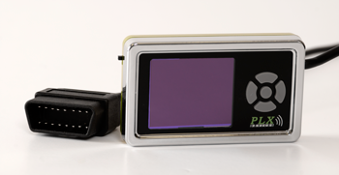

Fig 1. Kiwi Drive Green device by PLX devices

The advantages of this packaging is the small size of the device, allowing it to be portable and mounted without taking much space or blocking the driver's view of the road. This packaging also comes with a built in mount, allowing the user to choose to mount it on the dashboard or on the windshield.

However, there are certain disadvantages with this product as well. With this size, the user may not be willing to leave this device in the vehicle, lest it be stolen. Also, its small size limits the availability of certain features, such as a wireless OBDII connection and a GPS antenna for location tracking. As mentioned previously, there is also the issue of windshield mounting being illegal in most states.

In our design, we choose a relatively bigger design so that we can incorporate more features, yet keep it small enough that it is not too bulky to mount. In addition we chose to forgo the wired connection to the OBDII port, using a Bluetooth connection instead.

Project Packaging Specifications

As can be seen from the diagrams in Appendix 1, the packaging design will resemble a simple box. It will be mounted on the dashboard of the vehicle by the use of suction cups, and will have a clear LCD on the front of it. On the back, there will be an SD card slot as well as the power cable.

The reason for the simple design is to keep the device non-descript and cheap, so that it will be less likely to be targeted by thieves. We make use of an on-board GPS module for location tracking, and an on-board Bluetooth module for connecting to the OBDII port wirelessly. We make use of suction cups to mount the system on the dashboard to prevent violation of any windshield mounting laws.

Sources Cited

[1] Google Play. Torque Pro (OBD 2 & Car) [Online]. Available: https://play.google.com/store/apps/details?id=org.prowl.torque&hl=en

[2] ProClipUSA. (June 17, 2013). Are Suction Cup Windshield Mounts Legal In Your State? [Online]. Available:http://blog.proclipusa.com/are-suction-cup-windshield-mounts-legal-in-your-state/

[3] PLX Devices. Kiwi Drive Green [Online]. Available: http://www.plxdevices.com/product_info.php?id=SCANKIWI

Appendix 1: Project Packaging Illustrations

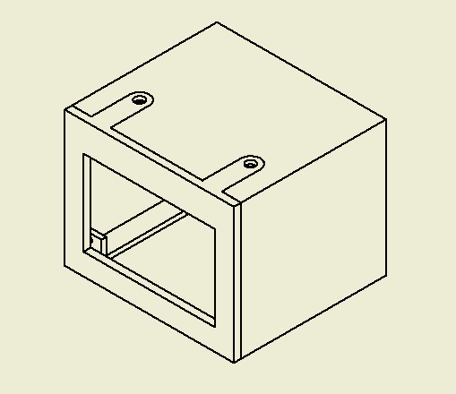

Major Dimensions: Height = 3.50 in, Length = 4.38 in, Width = 3.94 in

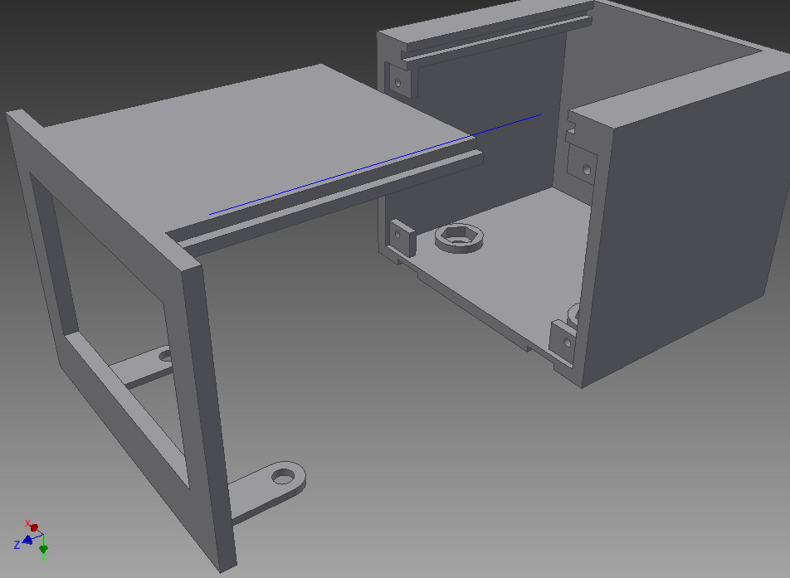

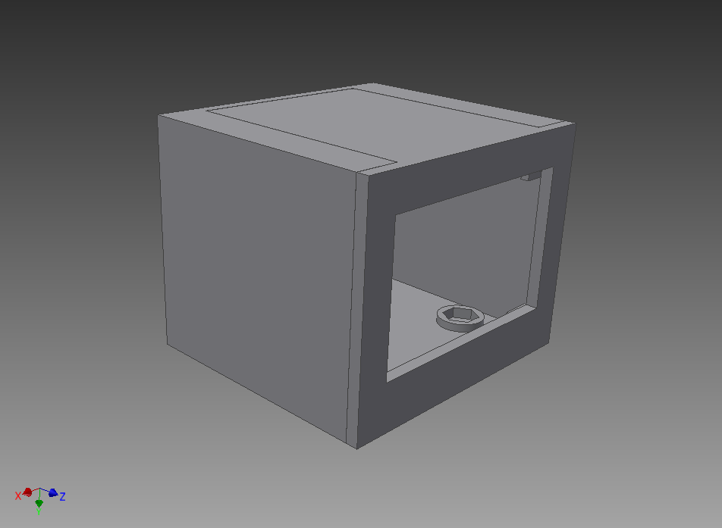

Appendix 2: Project Packaging Specifications

Materials List:
Material | Quantity | Weight | Cost
Model Resin (FullCure 720 Transparent) | 20 in³ | 357.9 g | $71.58
Support Resin (FullCure 705 Support) | 10 in³ | 179 g | $17.90
Suction Cups | 4 | 113.4 g | $10.00
Bolts, 1/4"-20, 3/4" length | 2 | 12.7 g | $0.30
Screws, 1/4"-20, .5" length | 10 | 45.35g | $2.00
Lock Nuts, 1/4"-20 | 6 | 21.77g | $0.51
TOTAL |  | 730.12 g | $102.29

Tooling Requirements:
Tooling | Estimated Cost
3D-printing | Free with Artisan Fabrication Lab (AFL)
Drill Press | N/A
Taps | N/A
File | N/A

Estimated packaging weight: 730.12 g

Estimated packaging costs: $ 102.29

Appendix 3: PCB Footprint Layout

