Mechanical Overview

Year: 2015 Semester: Spring Team: 2 Project: R.I.S.K.

Creation Date: February 9, 2015 Last Modified: February 13, 2015

Author: <redacted> Email: young149@purdue.edu

Assignment Evaluation:

Item | Score (0-5) | Weight | Points | Notes
Assignment-Specific Items
Commercial Packaging Analysis 1
Commercial Packaging Analysis 2
CAD Model Illustrations
Project Packaging Specifications
PCB Footprint Layout
Writing-Specific Items
Spelling and Grammar
Formatting and Citations
Figures and Graphs
Technical Writing Style
Total Score

5: Excellent 4: Good 3: Acceptable 2: Poor 1: Very Poor 0: Not attempted

Comments:

Commercial Product Packaging
We analyzed two commercial products that are electronic board games, similar to our electronic adaptation of Risk. These products are “Intercept: The Electronic Search and Destroy Game” [1] and “Deal or No Deal: Electronic Game” [2].

Product #1

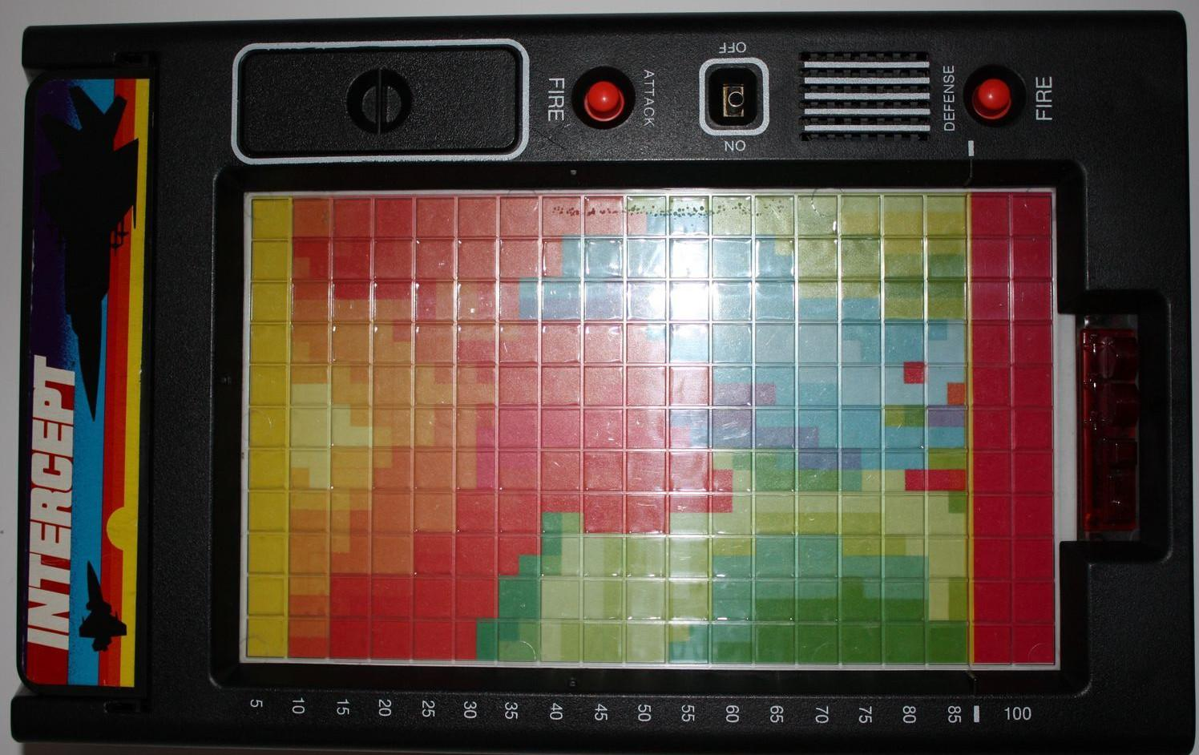
Figure 1: Packaging for Product #1
“Intercept: The Electronic Search and Destroy Game” is packaged within a rectangular plastic package. The top of the board has a power switch, two “fire” buttons, a speaker, pieces to be placed and moved on the game board, and lights. The two short sides of the board have sliders for the players to move their pieces.

The plastic packaging allows the game to have a unique shape that is not perfectly a rectangular prism. It also allows the game to be produced and sold at a lower cost. However, the freely moving pieces that go on top of the board are small and could easily be lost.

Our project will have a power switch, two buttons, and be shaped like a rectangle just like this game. We will not have freely moving pieces because we do not want them to be lost. Parts that would have normally been free include our troops and cards. The troops have been replaced by seven segment displays and the cards have been replaced by a web application.

Product #2

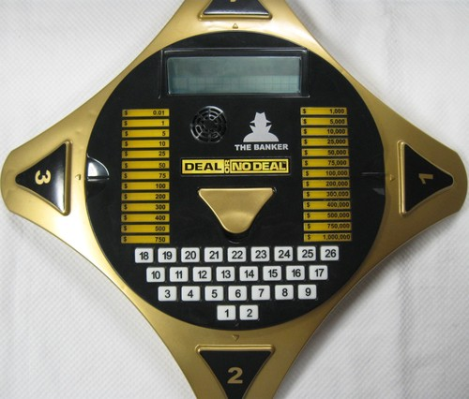
Figure 2: Packaging for Product #2

The “Deal or No Deal: Electronic Game” is packaged within a diamond-shaped plastic packaging with curved edges. Within the top surface are embedded an LCD screen to display game information, twenty-six buttons used for gameplay purposes, and backlit cut-outs used to represent which dollar amounts within the game are still active.

The use of plastic as a packaging material causes the game to be lightweight; this, combined with the compact arrangement of components, allows for the game to be easily portable. The one downside to this is that it is somewhat fragile as a result, and will not be able to withstand significant drops or extreme forces.

Our project will also have an LCD screen and buttons that will be mounted within the upper surface of the packaging. Additionally, we plan on using some form of plastic to build the frame of the game, as it is easy to work with and can be made translucent. Unlike this game, however, our game will not be designed so as to be portable, and it will be shaped in the form of a simple rectangle.

2.0 Sources Cited

[1] (1978). Intercept: The Electronic Search and Destroy Game. [Online]. Available: http://boardgamegeek.com/boardgame/6630/intercept-electronic-search-and-destroy-game
[2] (2006). Deal or No Deal: Electronic Game. [Online]. Available: http://boardgamegeek.com/boardgame/26137/deal-or-no-deal-electronic-game

Appendix 1: CAD Model Illustrations

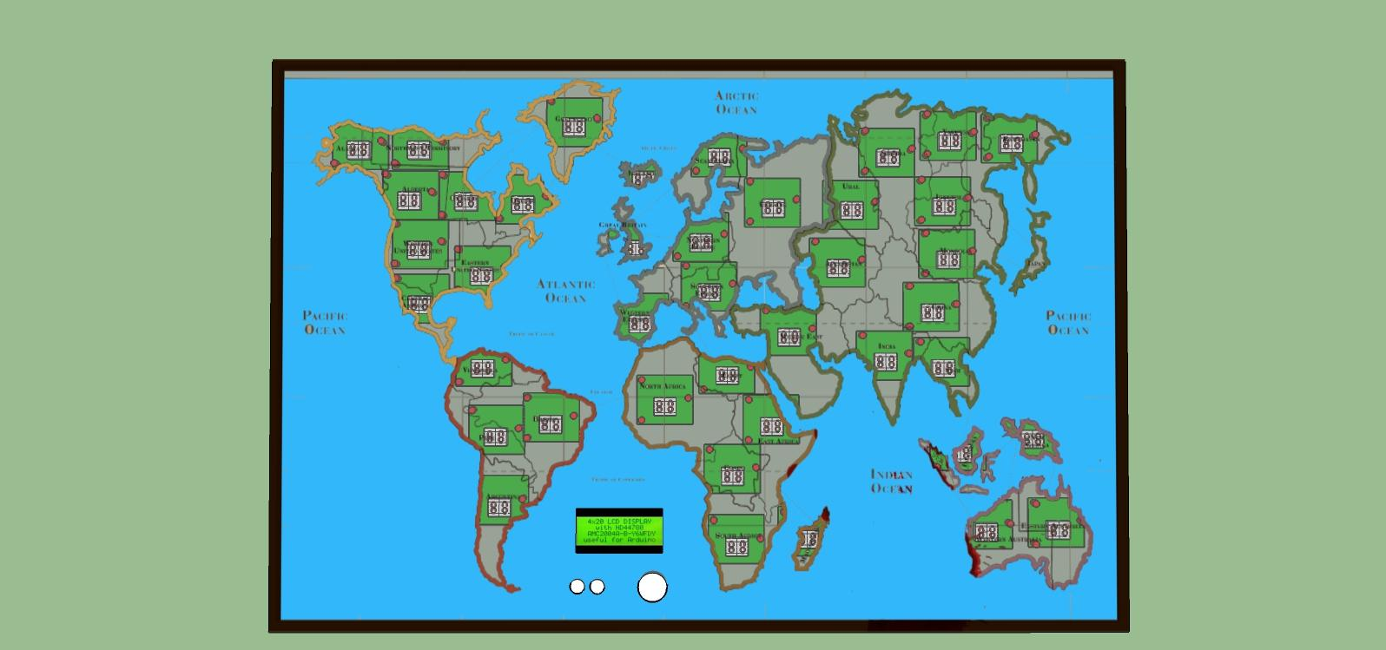
Figure 3: Top view of game board
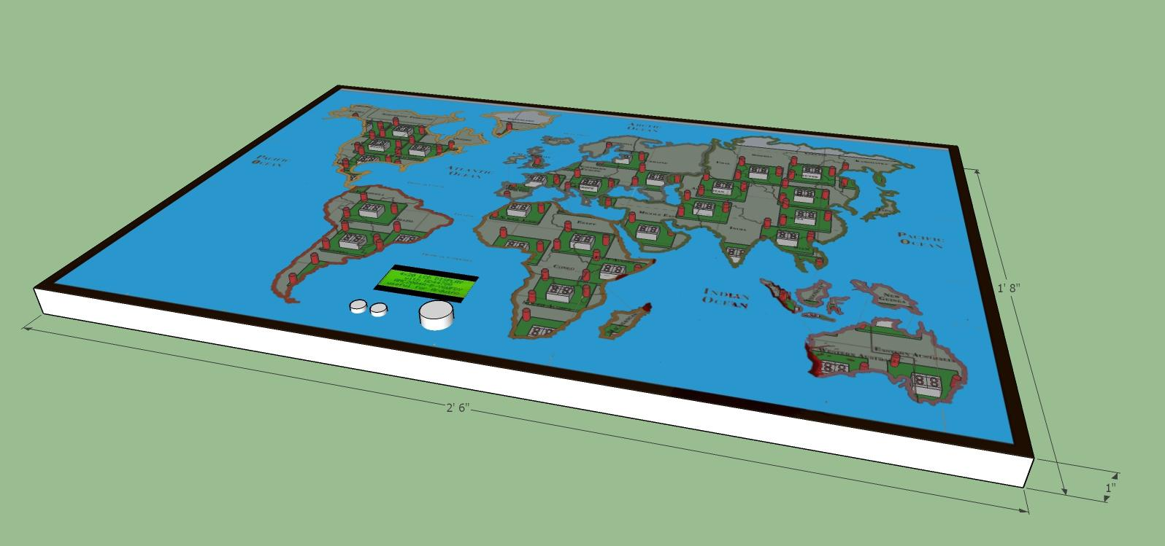
Figure 4: Game board dimensions
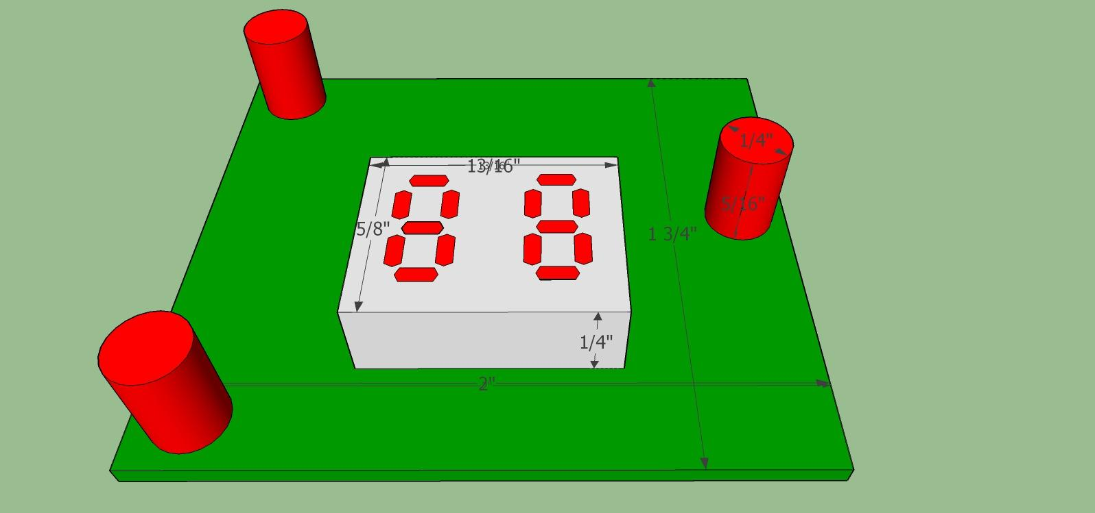
Figure 5: Country circuit board
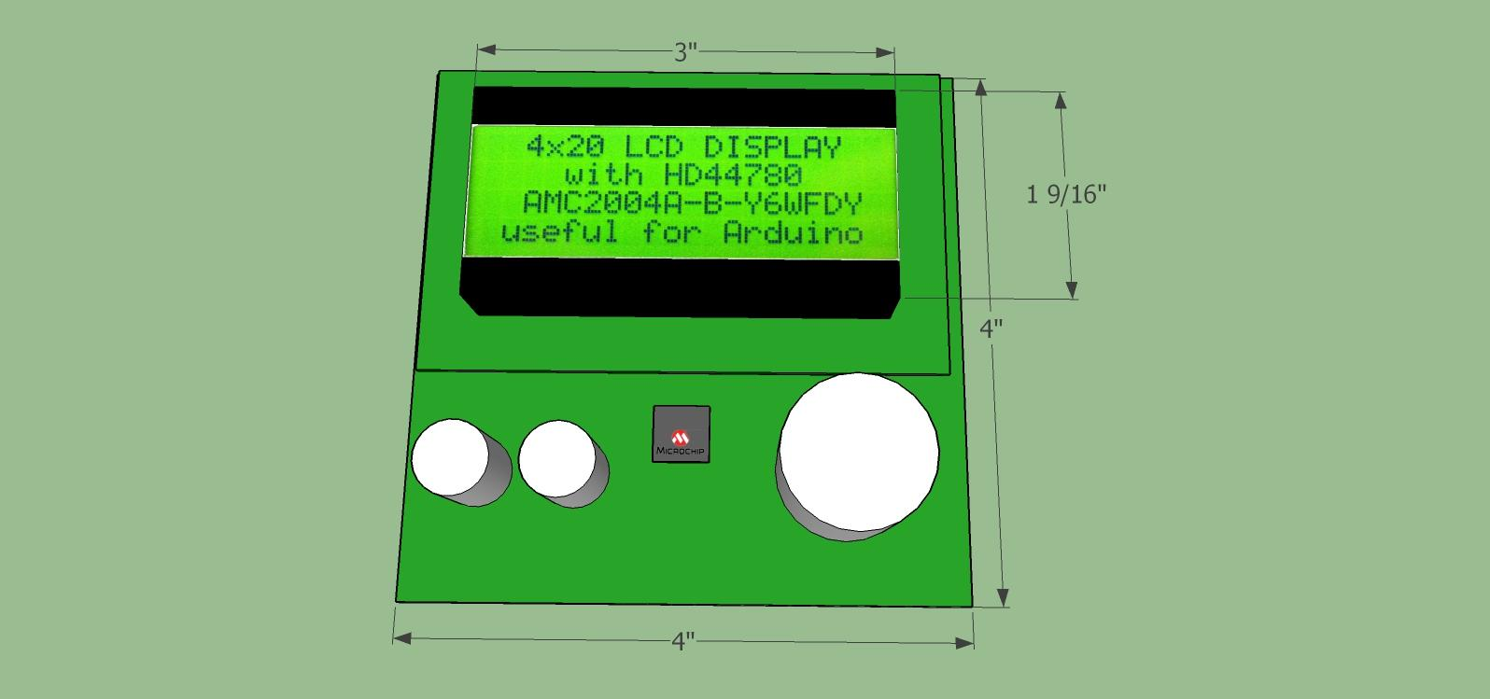
Figure 6: Main control circuit board
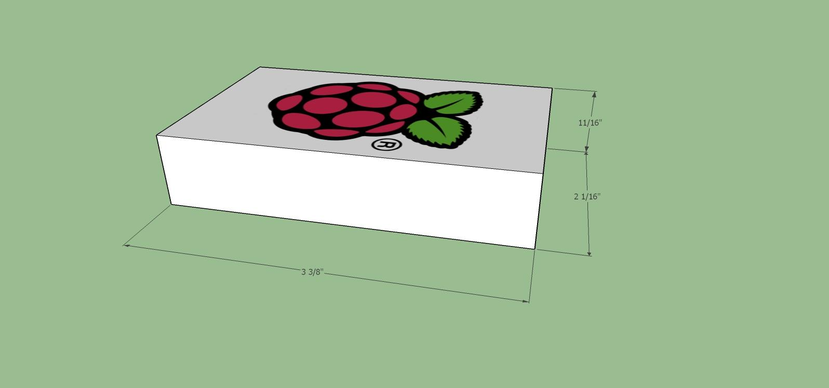
Figure 7: Raspberry Pi Dimensions
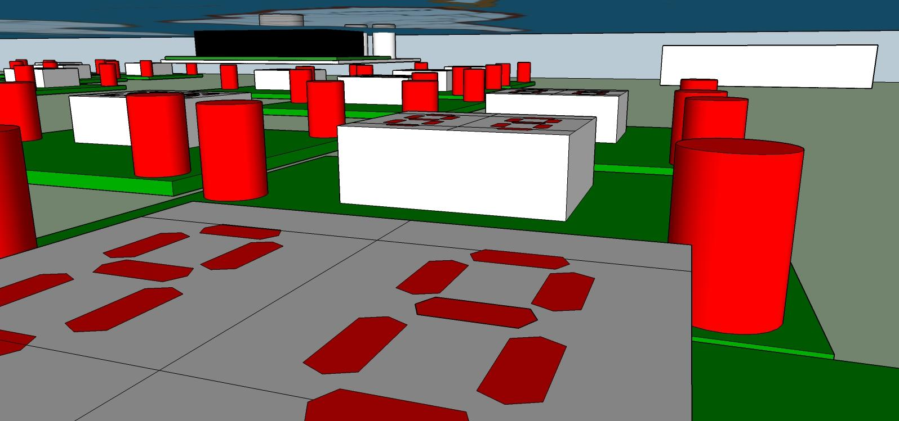
Figure 8: Interior view

Figure 9: Relative size of board (man for scale)

Appendix 2: Project Packaging Specifications
Material | Tools Required | Weight | Cost
Frosted Acrylic | Table Saw, Drill/Drill Press, Adhesive, Buffer | 1.5 lb | $15.00
Opaque Acrylic | Table Saw, Drill/Drill Press, Adhesive, Buffer | 3.5 lb | $45.00
Screws | Screwdriver | 1.2 lb | $16.00
Stand-offs | Screwdriver | 0.423 lb | $27.60
Aluminum Foil (or other material for reflecting light) | N/A | ~0 lb | $4
Table 1: Materials, tools, weight, and cost

Appendix 3: PCB Footprint Layout

Country PCB: 43 copies (42 countries, 1 for card display)
Dimensions: 2” x 1.75” (3.5 in² area)

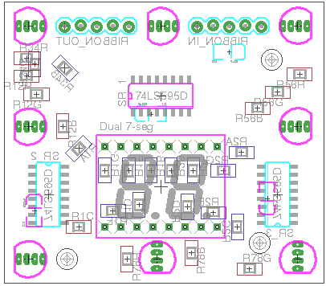
Figure 10: Country PCB

Main PCB: 1 copy
Dimensions: 4” x 5” (20 in² area)

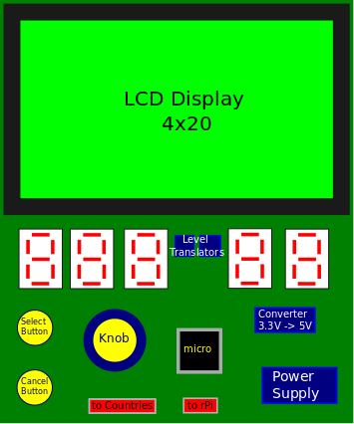
Figure 11: Main PCB

