Functional Specification

Year: 2014 Semester: Fall 2014 Team: 7 Project: Digital Knockout

Creation Date: September 2, 2014 Last Modified: September 5, 2014
Member 1: Elliot D Zak____________________ Email: zake@purdue.edu_____________
Member 2: Mariam Zaim___________________ Email: mzaim@purdue.edu___________
Member 3: Xin Tze (Joyce) Tee______________ Email: xtee@purdue.edu_____________
Member 4: Aparajita Dutta__________________ Email: dutta3@purdue.edu___________

Assignment Evaluation:

Item | Score (0-5) | Weight | Points | Notes
Assignment-Specific Items
Functional Description
Expected Usage Case
Theory of Operation
Design Constraints
Functional Block Diagram
Writing-Specific Items
Spelling and Grammar
Formatting and Citations
Figures and Graphs
Technical Writing Style
Total Score

5: Excellent 4: Good 3: Acceptable 2: Poor 1: Very Poor 0: Not attempted

General Comments:

1.0 Functional Description

Video gaming has become a popular form of entertainment for people of all ages. To that end, video games such as Nintendo Wii and Xbox Kinect have been developed with the objective that people can carry out daily exercise while also entertaining themselves. However, the controller for such games can easily slip out of a player’s hand, ending up with broken TVs and windows [1], and possibly even injuries to other people.

“Digital Knockout” is an electronic boxing game that uses wireless technology to provide a safe gaming environment for single players or multi-players. It is comprised of two gaming vests, two pairs of gloves, and a main console [Appendix 2]. The wireless functionality allows players to throw “air punches”, thus reducing any chances of injuries or broken items.

The goal of the game is to aim at the opposing vest, and throw a punch as accurately and forcefully as possible. The main console allows the ability to select between one or two players. Multiplayer mode allows two players to compete against each other, while single player mode allows a person to go through rounds of “training”, with punch statistics displayed on the main console.
2.0 Expected Usage Case
Digital Knockout is a training game targeted for people who wish to either practice their boxing skills, or simply have fun with friends. Although there is no particular age constraint on who can play this game, the boxing gloves and vest, included in the game, are of a universal size. To be able to get accurate scores for the punches during the game, it is necessary for the vest and gloves to fit the player well. The wireless feature of this game allows it to be portable and it can be played both indoors as well as outdoors, as long as a power outlet is available to start up the main console.

The game allows two players to have a simulated, non-contact boxing match which makes it important for both players to have enough room to move about during the match. Therefore it is recommended that there is at least 4 square feet of free space around each individual player. The game also has a single player mode that can be used as a boxing trainer. This feature requires the player to hang one vest on a wall, at his/her shoulder level and practice throwing punches while pointed at this vest. There is no requirement for prior expertise in boxing to play this game; it is a fun experience for both novice and expert boxers.

3.0 Theory of Operation

The purpose of Digital Knockout is to allow players to practice boxing without the risk of injury. The goal of the game is to emulate a real boxing match to the highest extent possible, with the absence of any physical contact between the two players.

The IR emitters on the gloves, along with the receivers on the opponent’s vest help to check whether or not the punch has hit the player. The location of the punch on the vest is determined based on the specific sensors that are able to detect the IR emission. Thus, to be in “defend” mode, a player would need to raise up his/her hands to block the IR receivers on his/her vest.

Accelerometers in the boxing gloves help to determine the movement and orientation of the punch thrown, by measuring acceleration forces in the three axes. By Newton’s Second Law of Motion, F = ma, the measure of acceleration is directly proportional to force [2], given that the player’s mass is constant. By coupling the “force” of the punch and the data from the IR sensors for each player, a standardized formula can be used to calculate Health Points for each player, based on whoever hit more accurately and/or forcefully.

In the single player version, however, the player is simply given feedback on the accuracy and acceleration of his/her punches by providing raw data from the sensors and accelerometers. This is aimed to help the player practice punching technique individually.

4.0 Design Constraints

4.1 Computational Constraints

Primarily, the computational functions for Digital Knockout will be:

- accumulation and communication of data from an accelerometer,

- comparison of accelerometer data between two players,

- accumulation of IR sensor data,

- communication of the IR sensors to the main console,

- interfacing the LCD display in order to display relevant information.

If time permits, sampling and the utilization of the FFT may be attempted to add sound effects and music to the game.

With regards to memory, we would like to be able to track the amount of punches thrown and registered in specific areas of the vest. Rather than using an external memory card, we may be able to simplify this by doing a simple count of how many times each IR sensor sends a high signal to the console (which would mean that a punch has been registered) with a threshold acceleration value being applied. The tentative microcontroller to be used for this project has a memory capacity of 2MB for Flash and 512KB for SRAM, which is adequate for storing the program [3]. At the end, we would like to display the number of punches registered in each specific area of both vests. As a result, Digital Knockout should be able to store data for one round (of a minute’s length) on the processor. Additionally, while playing the game, a minimum timing gap must be taken into account between two consecutive punches so that each punch can be accurately detected.

4.2 Electronics Constraints

The main electrical components of Digital Knockout will include: a microprocessor, a number of IR sensors, a number of accelerometers, an LCD screen, and a handful of wireless modules [4] (most probably Xbee S1). The wireless modules will need to communicate with the microcontroller on the main console through either SPI or I2C. At this moment it is undecided which will be the more suitable option. The IR receivers will be sending high or low signals to their respective wireless modules on the vests, which will then proceed to communicate that data to the main console. Likewise, the accelerometers will be sending the x-, y-, and z-axis acceleration data to the wireless modules on the gloves. Again, they will then take care of transmitting the data to the main console to be compared and then displayed. If time permits, we would like to use the PWM on the microcontroller to allow us to add some sort of music and sound effects to the game. The PWM would need to retrieve information from the sensors as soon as a punch is registered, so as to produce sound at appropriate times.

The microcontroller will require inputs for the IR sensors and for the accelerometers of each of the player. It should not be necessary to have inputs for each individual IR sensor. That would be impossible to do on a single microcontroller. We should be able to consolidate the IR signals of player one into one input and the IR sensor signals of player two into another input. Likewise, one input each should be necessary for each player’s accelerometer data. Then based on these four inputs, the health points will be calculated as the output and subsequently displayed on the LCD screen.

The sensors, wireless modules, and accelerometers will need to be mounted on the gloves and the vests of the players. This will mean that they will need adequate, secure packaging on these parts in order to perform their respective operations. As a result, in order to sufficiently match the usage case, batteries will be required for both the gloves and the vests. A voltage divider circuit may also be necessary depending on what type of voltage tolerances the parts have which are mounted on the vests and gloves.

4.3 Thermal/Power Constraints

Given the wireless nature of parts of this project, the gloves and vests will no doubt need to be battery-powered. Power consumption and dissipation are important considerations in this game, since too much power dissipation can cause the gloves and vests to get hot and uncomfortable for the player. The project will be aimed to keep power dissipation under 5W TDP, because anything above that would probably require external cooling devices like fans; this would be quite illogical to fit on a boxing glove. Although most microcontrollers, sensors and accelerometers can operate in up to fairly high temperatures, the target maximum operating temperature for this project is aimed to be 35 ᵒC (95 ᵒF).

The longer the battery life, the more satisfied that players will generally be. After looking at similar gaming consoles for Nintendo Wii and Xbox Kinect, it is intended that the parts in Digital Knockout have a target battery life of at least 10 hours. When running low on batteries, the main console will show a warning message on the screen, indicating that the batteries need to be replaced.
4.4 Mechanical Constraints

Digital Knockout comprises of portable boxing gloves and gaming vests, both of which are meant to be worn by the players during gameplay. The boxing gloves are of a standard adult size, which should easily fit teens and above, but are not suitable for toddlers or younger, as the glove might slip out of a young child’s hand. The vests are of a universal size, which should be able to fit children and adults of all ages.

The boxing gloves are designed to encourage “air boxing”, which means that using them to hit people or hard surfaces is not recommended. Depending on how much we are able to accomplish with the packaging of the vest, it might be fragile because of all the sensors scattered on it. Moreover, because these sensors will be on the outside of the gloves and vests, they are not waterproof, and would need to be kept out of contact of water.

Some additional mechanical constraints while designing the parts of this project are to make sure that the gloves and vests remain under 2 lb and 5 lb respectively, so as not to be uncomfortably heavy upon wearing.

4.5 Economic Constraints

As stated in the preliminary competitor analysis, there are no commercial products, which are explicitly identical to Digital Knockout but there are certain gaming consoles that allow similar boxing games such as Kinect for Xbox 360 and Nintendo Wii Fit. Open source projects like the Power Glove, KeyGlove and AcceleGlove [5], which also employ accelerometers and sensors, are potential competitors to the Digital Knockout. With this in mind, the product will experience certain economic pressure from other competitors. Since the Digital Knockout is targeted for a wide range of customers, the price setting is crucial in order to compete with others. The team proposed an initial cost target of $400 USD for the complete set of the product (which includes 2 pairs of boxing gloves and 2 vests).

4.6 Other Constraints

In order to emulate a real boxing match to the highest extent possible, sensors are attached to different parts of the vest, allowing players to perform various punches like the jab, cross, and hook, while also providing the ability to block punches.

Space is also another constraint for the Digital Knockout since it is a non-contact, portable, wireless game. As mentioned in Section 2.0, at least 6 square feet of free space around each individual player is required for a safe and conductive gaming environment. To ensure both players maintain a safe distance from each other, sensors that can successfully recognize punches even from a relatively long distance are aimed to be utilized to ensure maximum safety.

5.0 Sources Cited:

[1] BBC News (2006). Nintendo respond to Wii breakages [online].
Available: http://news.bbc.co.uk/2/hi/6182013.stm

[2] Woodford, Chris. (2009) Accelerometers. [Online]. Available: http://www.explainthatstuff.com/accelerometers.html

[3] Microchip Microcontroller [Online]. Available: http://www.microchip.com/pagehandler/en-us/family/32bit/

[4] Sarafan, Randy. (2012). Arduino Wireless SD Shield Tutorial. [Online]. Available: http://www.instructables.com/id/Arduino-Wireless-SD-Shield-Tutorial/

[5] MIT Technology Review (2014). Open-Source Data Glove. [Online] Available:
http://www.technologyreview.com/article/414021/open-source-data-glove/

Appendix 1: Functional Block Diagram

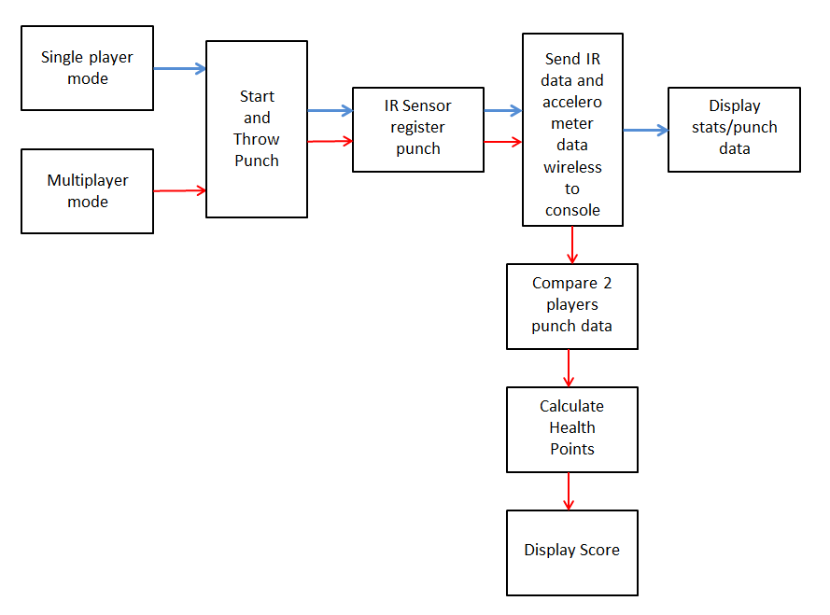
APPENDIX 2: SKETCH OF PROJECT PROTOTYPE