Initial Project Proposal

Year: 2022 Semester: Fall Project Name: Split USB Keyboard

Creation Date: April 13, 2022 Last Modified: August 17, 2022

Team Members (#1 is Team Leader):

Member 1: Logan Stapleton Email: stapletl@purdue.edu

Member 2: Justin Selbo Email: selboj@purdue.edu

Member 3: Andrew Smolensky Email: smolensk@purdue.edu

Member 4: Joe Zobel Email: zobelj@purdue.edu

1.0 Description of Problem (Andrew):

It is obvious to any observer that every facet of our society either already has or will have a digital component, especially if the pandemic-era trends of distance learning and work-from-home continue. Increased emphasis on digital work, play, and life means more people now than ever have access to a computer. In 2016, 77% of households reported owning a laptop or desktop computer [1]. Increased ownership of these devices means more people are affected by the dangers and pitfalls of long-term computer usage. Although computer usage can be the cause behind many common ailments, such as eye strain and poor posture, we are focusing on the keyboard to limit the scope of this project. Traditional keyboards fail because they are designed for everyone: key layout is expected and standardized, keys are sized so that the largest hands can press them, and the keyboards themselves are frequently designed to reduce costs by cutting functionality. These factors cause computer-related overuse issues like Carpal Tunnel Syndrome and other repeated stress injuries (RSIs) [2], which can lead to quality-of-life issues, lost wages, and chronic pain. Therefore, our project proposal involves a keyboard which aims to increase ergonomics by affecting the keyboard’s layout and seeks to increase efficiency by adding some useful functionality.

2.0 Proposed Solution (Andrew):

Our keyboard’s purpose is to demonstrate a more ergonomic and efficient keyboard design. To increase ergonomics, the keyboard’s layout is switched to a “stacked” configuration, where the keys are arranged in columns rather than rows. Stacked keyboards reduce RSI risk by decreasing the distance required to move your fingers while touch-typing. The keyboard will incorporate a split design, which reduces RSI risk by allowing your wrists to naturally align with your forearm while typing. The layout will have additional thumb buttons, which will reduce strain on the rest of the hand as the thumb is the strongest and most dexterous digit. Our proposed design also has some other features which indirectly reduce RSI risk by increasing overall keyboard functionality and efficiency. A dedicated volume knob and a USB pass-through hub would be useful features for computer users who use USB peripherals/storage or enjoy listening to music or watching video on their machines. A small integrated display could be programmed to show media information or computer statistics, which may reduce extra keyboard input. Our design will come with a software application which will permit the user to modify the keyboard’s layout and share their layout over the Internet. Modifying keyboard layouts, with the options of multiple layout “layers” and custom application hotkeys, has enormous potential to reduce RSI risk as this functionality would allow the user to replace a sequence of keys or a complicated keyboard/mouse interaction with a single press. Please see Appendix 1 for our initial proposal sketches.

3.0 ECE477 Course Requirements Satisfaction (Joe)

The proposed keyboard plans to incorporate a matrix of keys, USB passthrough ports, LED displays, and a rotary knob. We plan to divide these features into two halves of a keyboard connected with a single USB-C cable, with another USB-C cable connecting the main keyboard to the host computer.

3.1 Expected Microcontroller Responsibilities (Joe)

ECE477 is an embedded systems course which requires the use of a student-programmed microcontroller. For the project proposed, a microcontroller will be used for the purposes of interfacing with the host computer through the USB interface, interfacing with the matrix of keys, communicating with the secondary keyboard through a USB-C cable, controlling the LED display(s), calculating words per minute, and calculating the rotary knobs’ levels. Future functionality may be added to accommodate for the planned features.

3.2 Expected Printed Circuit Responsibilities (Joe)

ECE477 is an embedded systems course which requires the use of a student-designed and built printed circuit board (PCB). For the proposed project, the PCB is expected to incorporate a microcontroller, a matrix of keys, an LED display, a rotary knob, two USB interfaces to connect to the host computer and secondary keyboard, USB ports for passthrough, and a power supply. Our design will require two separate PCBs that will communicate through a USB-C cable. Future functionality may be added to accommodate for the planned features.

4.0 Market Analysis: (Justin)

The keyboard market size is massive. According to Statista, in 2022 the revenue size totals up to $4.77 billion dollars with a volume size of 266.86 million pieces [3]. These numbers are projected to grow from 2022-2026. More specifically, a market analysis done on ergonomic keyboards predicted the market size to be at about 2.00 billion dollars and growing [4]. This shows a massive market and submarket space that continues to grow. This ergonomic keyboard design clearly has a demand, as there is a plethora of people who spend all day typing. Software engineers, secretaries, journalists, really anyone who spends most of their work week typing runs an increased risk of carpal tunnel and other ergonomic related problems [5]. With ergonomic keyboards, it is expected that office suppliers/managers are going to be the main people purchasing our keyboards, which will then be distributed to employees. There is an expected smaller market on the commercial side, but ergonomic keyboards are mainly targeted towards professionals typing all day.

5.0 Competitive Analysis: (Justin)

Our overarching design and idea for an ergonomic keyboard is not new. However, the features of our project still differentiate us from other players in the market. Some keyboards have some of our features, but there was no keyboard found with all the features implemented together which are planned for our design, volume knob, mini-screen display, custom keyboard mapping, and a USB hub. We are hoping to corner out a section in the market. The availability of open-source projects with regards to keyboards will be beneficial and provide a great opportunity to make sections of the project easier. We will have to work around some established and patented project designs that could be similar to what we want to do. However, if we achieve our end goal, we should have a keyboard with more functionality while providing at least the same ergonomic benefit that some established split keyboards currently have.

5.1 Preliminary Patent Analysis: (Logan)

While there are not many patents similar to the split USB keyboard from a technical standpoint, there are a few patents regarding different aspects of a split or ergonomic keyboard that could impact the design. The patents in question can be found in additional detail below

5.1.1 US Patent Application US8946535 B2:

Patent Title: “Split keyboard for pc data and music output”

Patent Holder: James H. Bowen

Patent Filing Date: December 13th, 2012

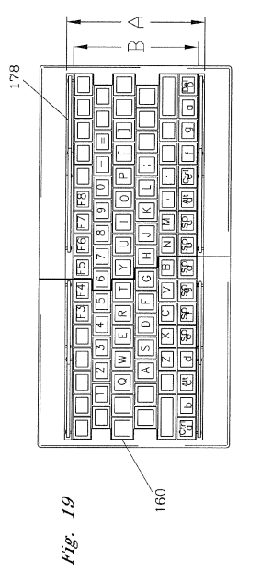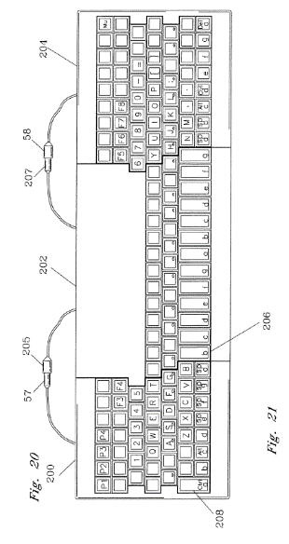

Figure 1. Split Musical Keyboard Folded Up and Unfolded

This patent [6] details a traditional computer keyboard which unfolds to reveal a musical keyboard underneath. This unfolding leaves the traditional keyboard in a split manner on the sides of the musical focused keys. This allows for the simultaneous use of traditional keyboard inputs while offering a more native musical keyboard input for music creation. This doesn’t focus on the same market that the Split USB Keyboard will target but does show some interesting approaches for the connection of different parts of the keyboard, as well as the mechanism for separating the keyboard. This has some design similarities to BAROCCO MD770 which is a current commercial product that will be explored in section 5.2.3.

5.1.2 US Patent Application US10025391 B2:

Patent Title: “Ergonomic Keyboard”

Patent Holder: Reuben Firmin

Patent Filing Date: December 29th, 2016

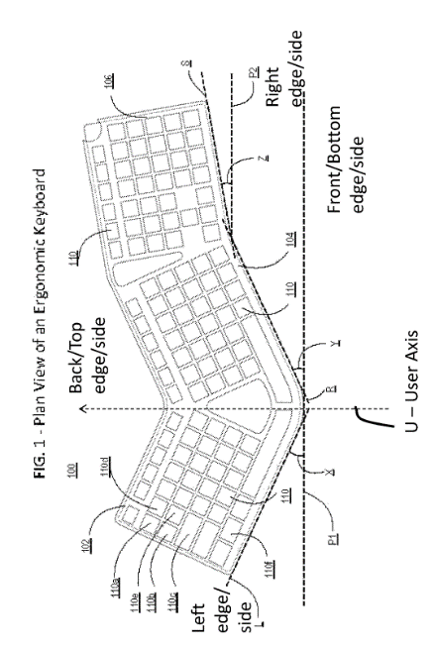

Figure 2. Ergonomic Keyboard Design

This patent [7]details a keyboard designed primarily for ergonomics. The ergonomics of this keyboard are improved by allowing the hands to rest in a more natural position while typing. This alleviates stress on the wrists and shoulders. This keyboard has non-staggered rows similar to the ErgoDox style keyboards explored in the commercial and open-source sections of this document. One downside of this design is the size of the keyboard, and by that notion, the price. PCB manufacturing costs increase considerably with price. An ergonomic keyboard that has two relatively smaller halves has a manufacturing edge in that regard.

5.1.3 US Patent Application US8894305 B2:

Patent Title: “Support accessory for split keyboard”

Patent Holder: Kinesis Corporation

Patent Filing Date: June 3rd, 2013

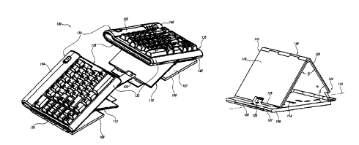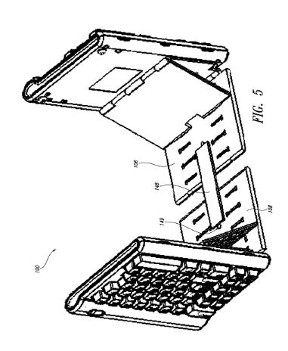Fig. 3. Support Accessory Configurations

This patent [8], assigned to Kinesis, is a kit to accompany a pre-existing split keyboard produced by Kinesis. This kit aims to increase the versatility of the keyboard by allowing the keyboard to be used in a variety of configurations such as at elevated angles, completely vertical, or even attached to a surface such as an office chair. This design shows the versatility that is possible out of a simple design and can be drawn from for inspiration for increasing the ergonomics of the split USB keyboard. One downside of this accessory is that it doesn’t come standard with the keyboard. A product that is hoping to maximize ergonomics should include accessories that help increase the product’s ergonomics.

5.2 Commercial Product Analysis: (Logan)

Over the past decade ergonomic keyboards have been increasing in popularity as the world has become more aware of the damage that can be caused by typing on traditional keyboards over an extended period. Although not abundant, there is some diversity in ergonomic keyboards. The products below are examples of split keyboards with interesting features that may be implemented or improved upon in the project. One common theme that occurred while researching split keyboards was the high price, many of the higher quality options like the ones below are priced in excess of $200, which is very uncommon for a typical keyboard, although maybe not too far off enthusiast or high-end gaming keyboards. The cheapest option available was $90 on amazon for the KINESIS Freestyle2 Ergonomic Keyboard which had no special functionalities to speak of and looked as if someone had taken a $10 keyboard and split it into two parts. This product did however have over 1000 product reviews, and with a relatively small percentage of purchasers leaving a review, it is safe to say that a market for these split ergonomic keyboards exists.

5.2.1 ZSA Moonlander

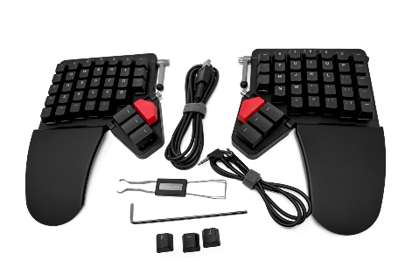
Price: $365
Fig. 4. Moonlander Keyboard

The Moonlander is a split keyboard made by a Canadian company called ZSA. This is the company’s second iteration of a split keyboard. The first keyboard they made was called the ErgoDox EZ [9]. Some of the notable ergonomic features of the moonlander include built in wrist wrests, tenting kit, and tiltable thumb clusters, and an ortholinear key layout where the keys are directly in line with each other and not staggered. These features can help alleviate of the strains on the wrist caused by more tradition keyboards. Other notable features include fully programmable functionality, multi-layer support, hot swappable mechanical key switches, USB-c connectivity, and an online hub for sharing keyboard layouts. This keyboard uses a TRRS cable more commonly known as an audio cable to connect the two halves. The moonlander connects to a pc through the left-hand side only.

5.2.2 Infinity ErgoDox

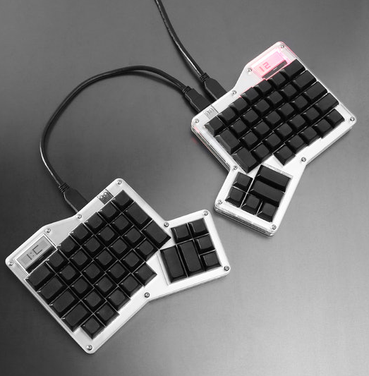
Price: $210
Fig. 5. Infinity ErgoDox

The Infinity ErgoDox is very similar to the moonlander in its design, and that is because they are both forks of the same open source ErgoDox design [9]. This keyboard differs from the other in its commercial offering as this is a DIY kit where customers would purchase the parts and assemble the board themselves. This keyboard also has an LCD display on each board. The Infinity version further distinguishes itself from other variants by comprising of two independently usable keyboards that can be daisy chained together. This means that either side of the keyboard can be the “master” that communicates with the PC, and either side can be used without the other.

5.2.3 Commercial Product #3: BAROCCO MD770 RGB BT

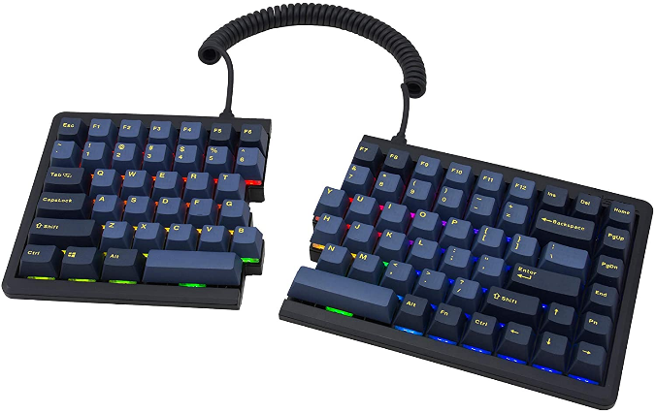
Price: $189
Fig. 6. BAROCCO MD770

The BAROCCO MD770 has a few interesting features that were worth exploring. Perhaps its most notable physical feature is the fact that they keys remain staggered and the keyboard actually has the ability to be pushed together to replicate a traditional keyboard. The other main feature of this board is Bluetooth capability. This keyboard can connect to a computer wirelessly just like a standard Bluetooth keyboard. However, the two halves are still tethered with a physical cable. Obviously with a wireless keyboard, it has to be charged and has a battery life, something to consider when purchasing, or designing, a keyboard. The keyboard can be operated in a wired mode in addition to its Bluetooth mode. There is a non-bluetooth version of this board available for $160 on amazon.

5.3 Open-Source Project Analysis: (Logan)

There is a considerably large community surrounding the designing and building of custom keyboards. While split and ergonomic keyboards are less common than more traditional keyboards, there still quite a few open-source projects that that can be drawn from to aid in the design of a custom keyboard.

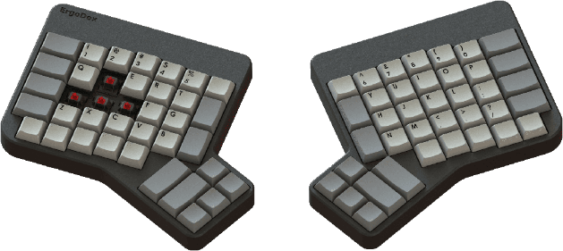
5.3.1 ErgoDox
Fig. 7. ErgoDox Original Design

The ErgoDox [9] is arguably the most important open-source ergonomic keyboard project as it inspired many of the split keyboards available for purchase today. It was a DIY keyboard project designed for ergonomics with easy to find components and is completely programmable. The entire project is open source allowing anyone to modify the project as they want. This project was the basis for the ZSA ErgoDox EZ, ZSA Moonlander, and the Infinity ErgoDox. The before mentioned commercial adaptations of the ErgoDox project added physical and or software improvements as well the ability to purchase either a kit or a complete keyboard. An interesting note about the open-source design plans are that the board is powered by a teensy microcontroller whose breakout pins are soldered directly into the ErgoDox PCB. The ErgoDox open-source project has a website detailing all of the parts needed, assembly instructions, a software/firmware guide, as well as the commercial variants that are available to purchase.

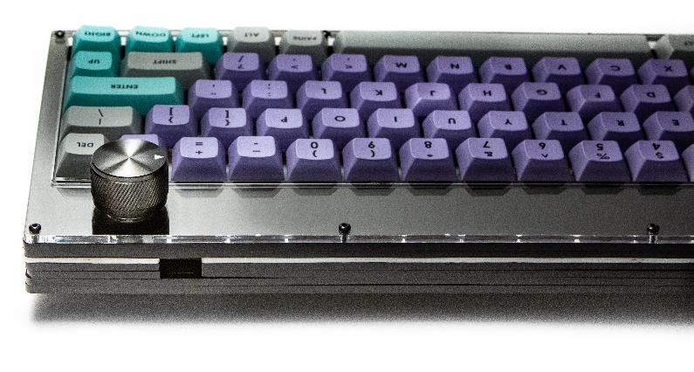
5.3.2 Grabert Keyboard
Fig. 8. Grabert Keyboard

The Grabert keyboard [10] is an open-source keyboard with quite a few hardware features that make it particularly interesting. The first and foremost is that uses a stm32f07 chip. Most open-source keyboards don’t use discrete chips that require surface mount soldering. The team has experience using an stm microcontroller, a design with an stm chip has the advantage of familiarity. Some other features present on this board include a rotary encoder, USB-c connectivity, and an OLED display. It is worth noting that this keyboard doesn’t have a split design, but the implementations of the lcd and encoder should be similar regardless of the traditional nature of this keyboard.

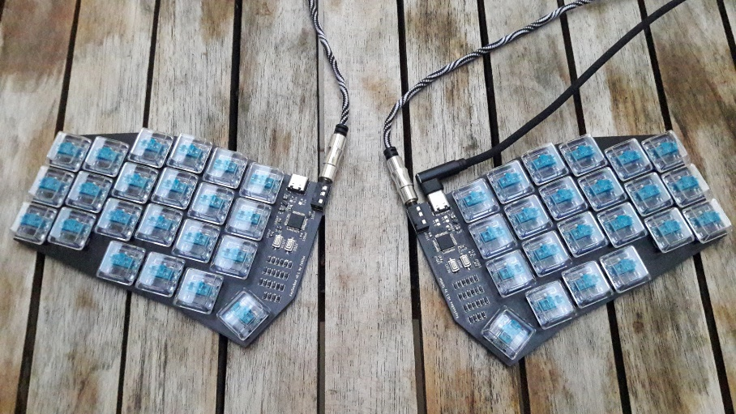
5.3.3 KeySeeBee
Fig. 9. KeySeeBee

The KeySeeBee’s [11] most notable feature is the lack of a case and plate above the pcb. Most keyboards have a plate where the switches sit, elevated above the pcb. This physical detail is not the focus of this board, however. This project is a good resource, as it is an example of a stm32 microcontroller driving a split keyboard. The project includes an estimated price per keyboard of about $13, which is very enticing considering the prices of some of the commercial options available. This price is only possible through a variety of design decisions made including smaller pcb footprints, less keys and therefore less components, as well as the $13 price point only applying if the materials for 5 keyboards are bought at the same time. One final thing to note is the face that this board, similar to the Infinity ErgoDox can have either half of the keyboard serve as the master board.

6.0 Sources Cited:

[1] Ryan, Camille (2016). Computer and Internet Use in the United States: 2016. Available: https://www.census.gov/content/dam/Census/library/publications/2018/acs/ACS-39.pdf

[2] Victoria Department of Health (2021). Computer-related injuries. Available: https://www.betterhealth.vic.gov.au/health/healthyliving/computer-related-injuries
[3] Statista (2022). Keyboards. Available: https://www.statista.com/outlook/cmo/consumer-
electronics/computing/keyboards/worldwide
[4] Dataintelo (2020). Ergonomic Keyboard Sales Market Research Report. Available:
https://dataintelo.com/report/global-ergonomic-keyboard-sales-market/

[5] Coastal Empire Orthopedics. Can Typing Cause Carpal Tunnel Syndrome?. Available: https://www.jonathanshultsmd.com/blog/can-typing-cause-carpal-tunnel-syndrome

[6] Bowen, James H (2012). Split keyboard for pc data and music output. Available: https://patents.google.com/patent/US8354580B2/

[7] Firmin, Reuben (2016). Ergonomic Keyboard. Available: https://patents.google.com/patent/US10025391B2/

[8] Hargreaves, William R. (2013). Support accessory for split keyboard. Available: https://patents.google.com/patent/US8894305B2

[9] robotmaxtron (2019). ErgoDox Mechanical Keyboard. Available: https://www.ergodox.io/

[10] KoBussLLC (2021). Grabert Hardware. Available: https://github.com/KoBussLLC/grabert-hardware
[11] TeXitoi (2022). KeySeeBee. Available: https://github.com/TeXitoi/keyseebee

Appendix 1: Concept Sketch

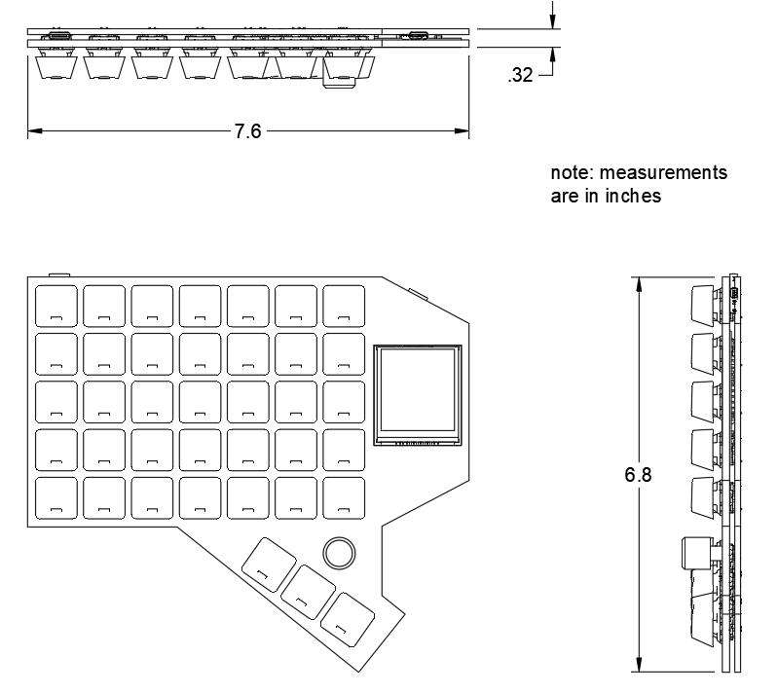
Fig. 10. Preliminary Drawing

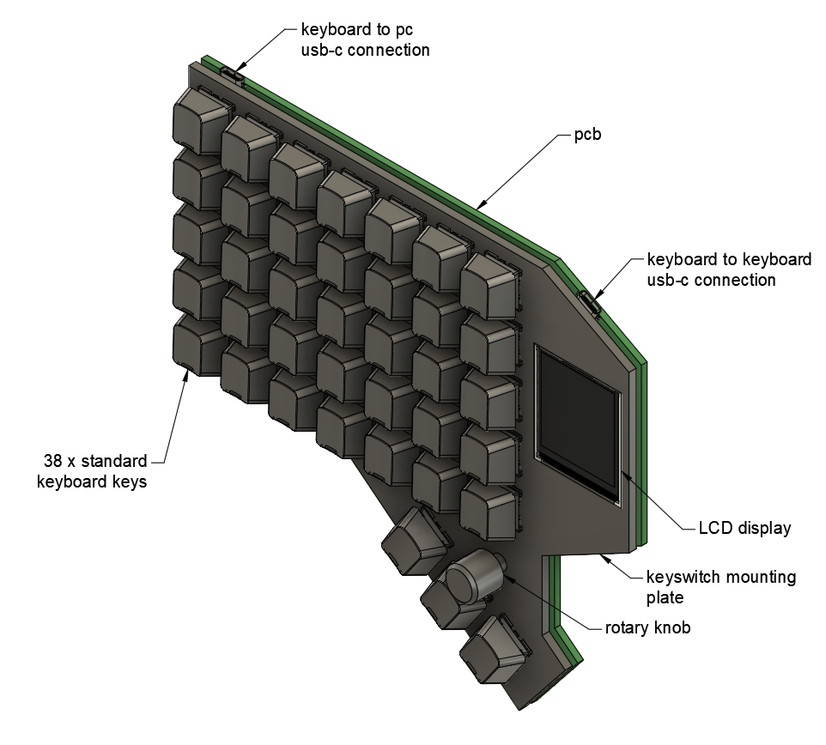
Fig. 11. Preliminary Design One Half Assembly

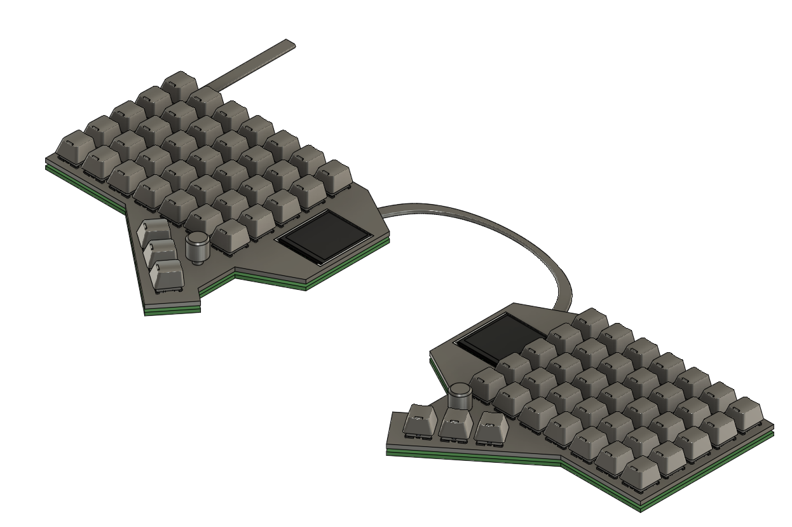
Fig. 12. Preliminary Design Full Assembly

