Initial Project Proposal

Year: 2016 Semester: Spring
Project Name: Ultimate Vending Machine
Creation Date: 9/13/2015 Last Modified: 2/29/2016

Team Members (#1 is Team Leader):
Member 1: Ruotong Ji Email: jiruotong1024@gmail.com
Member 2: Yaqin Huang Email: huang467@purdue.edu
Member 3: Renjun Zheng Email: zheng174@purdue.edu
Member 4: Xingyu Zhou Email: zhou326@purdue.edu

1.0 Description of Problem:

The payment process used by current vending machines could be significant improved, which is the focus of our proposed project. People will frequently encounter problems such as credit cards unable to be read, credit cards unable to be processed, cash unable to be identified, or no refunds when the user didn’t get anything. Also, customers will face problems when what they want to buy is out of stock, but they don’t find out until they are in front of the machine.

2.0 Proposed Solution:

Our proposed solution is to let people check the item availability and pay over the phone, which will increase both the speed of whole purchasing process and the customer’s level of satisfaction. Our mobile application will be first targeting on android platform, so basically all the people who use android phone will have chance to benefit from this project. In order to improve the paying system on the vending machine, our project will design a new vending machine, this machine will be equipped with two ways to pick up merchandise. People do not need to pay when they stand before the machine, they can order and pay for the vending machine item through an app on their android phone. After the payment is accessed, a number will be generated on their phone. To get their items people can either choose to scan the barcode or actually enter the number on the keyboard which we will provide on the vending machine.

3.0 ECE 477 Course Requirements Satisfaction

For our project, we will use microcontroller as the main control system of the vending machine and a printed circuit board as the part of the machine to generate our design. The microcontroller will manage delivery of merchandise and verify the confirmation number is valid. We will setup a server to process payments and create a mobile application to interface with server, and the server will handle communication with the microcontroller.

3.1 Expected Microcontroller Responsibilities

In order to satisfy ECE 477 course objective, our team plans on using a microcontroller in our design. First, the microcontroller will interface with pushbuttons, barcode scanner to get confirmation number. Second, microcontroller with display information on LCD. Third, microcontroller will communicate with server to verify user codes and change storage information. Fourth, microcontroller will interface with other device to output item.

3.2 Expected Printed Circuit Responsibilities

In order to meet ECE 477 course objective for a printed circuit board, our design will include a student designed PCB to house the microcontroller and other devices such as sensors, power, number pad and LCD screens. It has a USB port for barcode scanner and an internet interface.

4.0 Market Analysis:

Current vending machines don’t come equipped with the ability to process payments over the phone or check item availability remotely. We can expect large food and drink companies such as Coca-Cola and Pepsi can use this method on their next generation vending machine. Moreover, there are many companies other than the two soft drink company mentioned above can use this vending machine to sell snacks or other items.

5.0 Competitive Analysis:

There already exist many vending machines in the market. But most of them have their own shortcomings. For our project, because we do not accept any cash, our user does not need to bring any cash with them, which is a convenience. The second strength is that we use mobile phone payment instead of sliding cards on the vending machine. Sometimes the payment on the vending machine will not work. But on the mobile phone, it is much more stable. We also have the mobile app display the status of the machine and products, so the user does not have to actually go to the vending machine to check whether the machine is working or not, nor do they have to check if the product they want is sold out or not. One weakness is that if the payment in the app breaks down, there is no other way the user could make the payment, which means they cannot use the vending machine.

5.1 Preliminary Patent Analysis:

5.1.1 Patent #1 US20050102233A1:

Patent Title: “Use of cellular phones for payment of vending machines”
Patent Holder: Mackay George.
Patent Filing Date: October 17, 2002

This patent [2], assigned to Mackay George, describes a payment system that user make purchase via phone call to auto-attendant computer. The patent requires users follow instructions on how to make remote cellular payment on the vending machine in question. In detail, users will entering a sequence of challenges and responses between the remote auto-attendant computer and the vending machine to validate and confirm payment on the machine. This patent is similar to our design in using a validation method. Our methods simplified process and very intuitive so that user can simply scan the unique identification instead of answering questions. Besides, in this patent, user needs to identify the vending machines’ id in order to make purchase. Our system will let user pick which vending machine they would like to pick up.

5.2 Commercial Product Analysis:

5.2.1
Another commercial product that is similar to our project is the “Redbox” [2] , an automatic renting vending machine for latest games and movies. It contains some same features similar to our systems, such as mobile ordering. The Redbox is covered by a red metal paint and contains a LED touch screen as well as a card reader. It also contains an output port which allows uses to pick up DVDs or games.

One of the advantages of this packaging is that touchscreen is easy to use and there are no other buttons on the surface. It only accepts credit card and it can avoid taking fake coin. Users can also make orders online or via the mobile applications and pick up from any Redbox machines.

However, there are certain disadvantages with this product as well. The process of pick-up is quite complex and requires multiple steps. Its volume is big and heavy, which makes it hard to move and relocate.

Our project will not have a touchscreen but a keypad with a camera to make things much easier for users to take their items. Additionally, we plan to use wood to build the overall surface of our vending machine and some sort of plastic to cover the front. Our product will be much smaller but will be easier to move.

5.3 Open Source Project Analysis:
5.3.1 Zint Barcode Generator

A barcode encoding library supporting over 50 symbologies including Code 128, Data Matrix, USPS OneCode, EAN-128, UPC/EAN, ITF, QR Code, Code 16k, PDF417, MicroPDF417, LOGMARS, Maxicode, GS1 DataBar, Aztec, Composite Symbols and more.

After some time of inactivity this project is now back to life! This is the one and original ZINT barcode generator, the reference in open source barcodes.

ZINT is licensed under the terms of the GPL v3. Only the contained backend (aka ZINT shared library) is licensed under BSD 3.

Cons: For our project, it does not meet our specific requirements. Our design is quite different from this one.

6.0 Concept Sketch
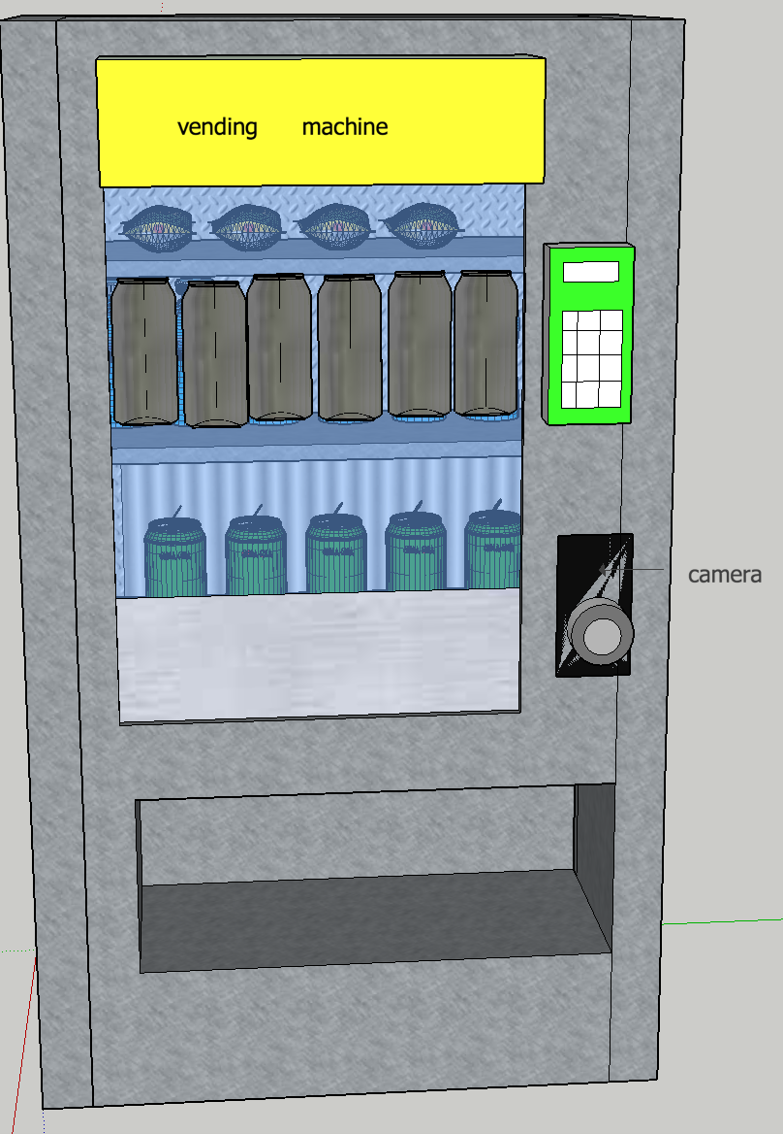
7.0 Sources Cited:
[1] Kenneth Park et. Al (2003, November 06). Associating mobile phone to vending machine via bar-code encoded data, CCD camera and internet connection [Patent]. Available at: https://patents.google.com/patent/US20050102233A1/

[2] Mackay George (2002, October 17). Use of cellular phones for payment of vending machines [Patent]. Available at:
https://patents.google.com/patent/US20030078895A1/en

