Homework 1: Design Project Proposal

Team Code Name: Text Message DJ Group No. 22

Team Members (#1 is Team Leader):

#1: Kyle Brown Areas of Expertise: Server-side software

#2: John Doherty Areas of Expertise: Microcontroller programming

#3: Chris McCabe Areas of Expertise: Power

#4: Garrett Strzelecki Areas of Expertise: Hardware and packaging

Project Abstract:

Every one wants to dance to their favorite songs at a party, but rarely do guests have much say in song selections and playlists. The Text Message DJ aims to make song selection at a party a more democratic process. The Text Message DJ is a standalone unit that creates and maintains a party playlist based on song requests sent from party guests via SMS. Guests can send text messages containing song names and the Text Message DJ will automatically parse messages, sort requests, and play the most popular. In addition to playing the song audio, the Text Message DJ will strobe lights in sync with the beat of the currently playing song.

Design/Functionality Overview:

The Text Message DJ is a party-in-a-box. The Text Message DJ simplifies song selection at a party and leaves the music decisions up to the guests. It gives anyone with a phone a say in what songs are played at the party. No need for anyone to be stuck managing playlists or trying to communicate song requests over loud music. Guests will simply send text messages with song names to the unit's designated phone number and Text Message DJ will handle the rest. As soon as the requests start coming in, music will start playing, accompanied by strobe lights that pulse with the beat of the song. The songs that get the most votes will take priority in the queue.

At the heart of the Text Message DJ is a SMS receiver unit with a SIM card to receive text messages. These messages are then parsed by the microcontroller and sent serially to a RasberryPi that manages requests and retrieves songs from Youtube. The audio data is then output to both an AUX jack and the microcontroller. The microcontroller, analog circuitry, and relays will then be used to pulse a strobe light to the beat of the song. Song data will also be displayed on an LCD on the box. Almost no setup will be required, and any options that need to be changed can be done through SMS.

The work load will be divided up by the major pieces of functionality. Kyle will work on the software side, developing internet scripts and communication protocols for the RasberryPi. John will work on the software and hardware for receiving and parsing SMS messages. Garrett will work on the software and circuitry for the strobe lights. Chris will design power supply circuitry and the packaging for the unit.

We estimate that the total cost for developing the prototype will be around $250. This is based on initial research into parts costs.

Project-Specific Success Criteria:

An ability to receive and parse text messages

An ability to strobe a light in sync with audio

An ability to display song names on LCD screen

An ability to maintain a list of song requests

An ability to play audio from the internet

Block Diagram:
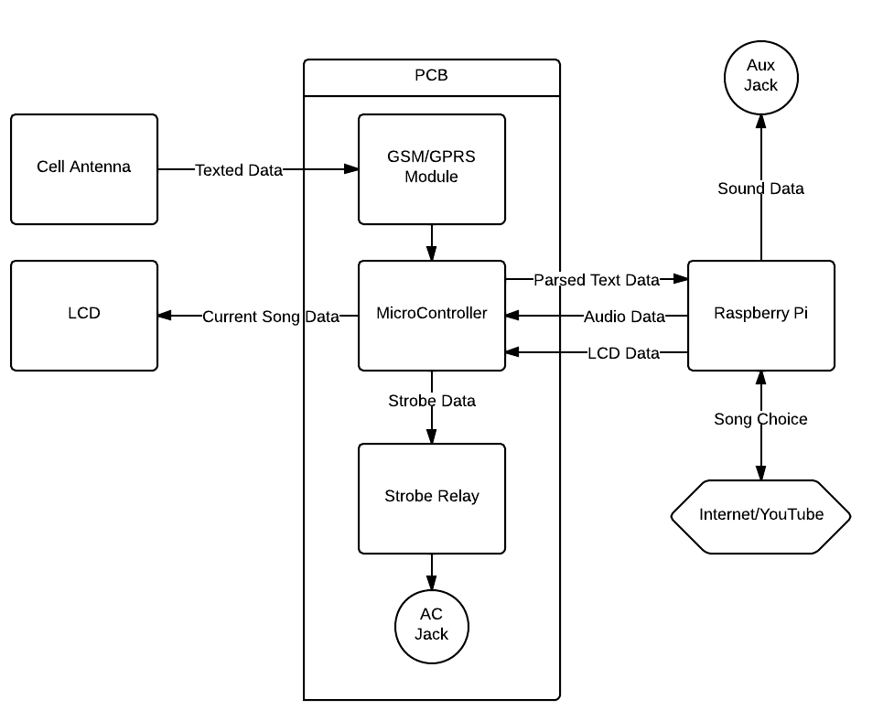

Division of Labor:

Design Component Homework |  | Professional Component Homework
4-Packaging Design and Specs | GS | 3-Design Constraint Analysis/Parts List | KB
5-Hardware Narrative and Prelim Schematic | CM | 10-Patent Liability Analysis | CM
6-PCB Narrative and Prelim Layout | JD | 11-Reliability and Safety Analysis | GS
9-Software Design Narrative | KB | 12-Social/Political/Environmental Analysis | JD

