Homework 4: Packaging Specifications and Design

Team Code Name: The Beancounters! Group No. 4

Team Member Completing This Homework: Shicheng Guo

E-mail Address of Team Member: guo7@purdue.edu
NOTE: This is the first in a series of four “design component” homework assignments, each of which is to be completed by one team member. The body of the report should be 3-5 pages, not including this cover page, references, attachments or appendices.

Evaluation:

SEC | DESCRIPTION | MAX | SCORE
1.0 | Introduction | 5
2.0 | Commercial Product Packaging | -
2.1 | <Product #1> | 10
2.2 | <Product #2> | 10
3.0 | Project Packaging Specifications | 20
4.0 | PCB Footprint Layout | 10
5.0 | Summary | 5
6.0 | List of References | 10
App A | Project Packaging Illustrations | 10
App B | Project Packaging Specifications | 10
App C | PCB Footprint Layout | 10
 | TOTAL | 100

Comments:

Comments from the grader will be inserted here.

Introduction

Our project is an automated coffee roaster. This product is designed to be operated in a kitchen countertop environment, so form follows function. However, due to the intended price range and audience, we have some difficult decisions to make. On the one hand, we want a machine that is simple. Our device is intended to do only one thing, but do it well. With the whole roasting process automated, user interaction is minimal, and our exterior packaging will want to reflect this. However, most people who care enough about coffee to roast their own beans will probably also appreciate a device that’s beautiful. So where do we draw the balance? Is it worth adding a small amount of form to compliment the function of the device, even if it goes against the simplicity we are striving for?

Another balance point we need to solve is the fight between sturdy and cheap. Our device needs to look durable and well designed. This disqualifies cheap, flimsy materials for the exterior, as these will not only reflect poorly on how the device looks but also add potential safety and operational risks. But these higher end materials come with an increased cost, and because we are trying make our device as absolutely cheap as possible, the tradeoffs can be difficult to swallow.

Commercial Product Packaging

We will now compare our product to two products we will be competing with. Coffee bean roasters can be divided into two categories, as with most countertop appliances: industrial and personal use. We will, of course, be comparing against personal use appliances, as the whole purpose of our product is to allow individuals to roast beans at home.

Product #1

Nesco CR-1010-PRR Coffee Bean Roaster, 800 watt. Price: $141.71^{[1]}.

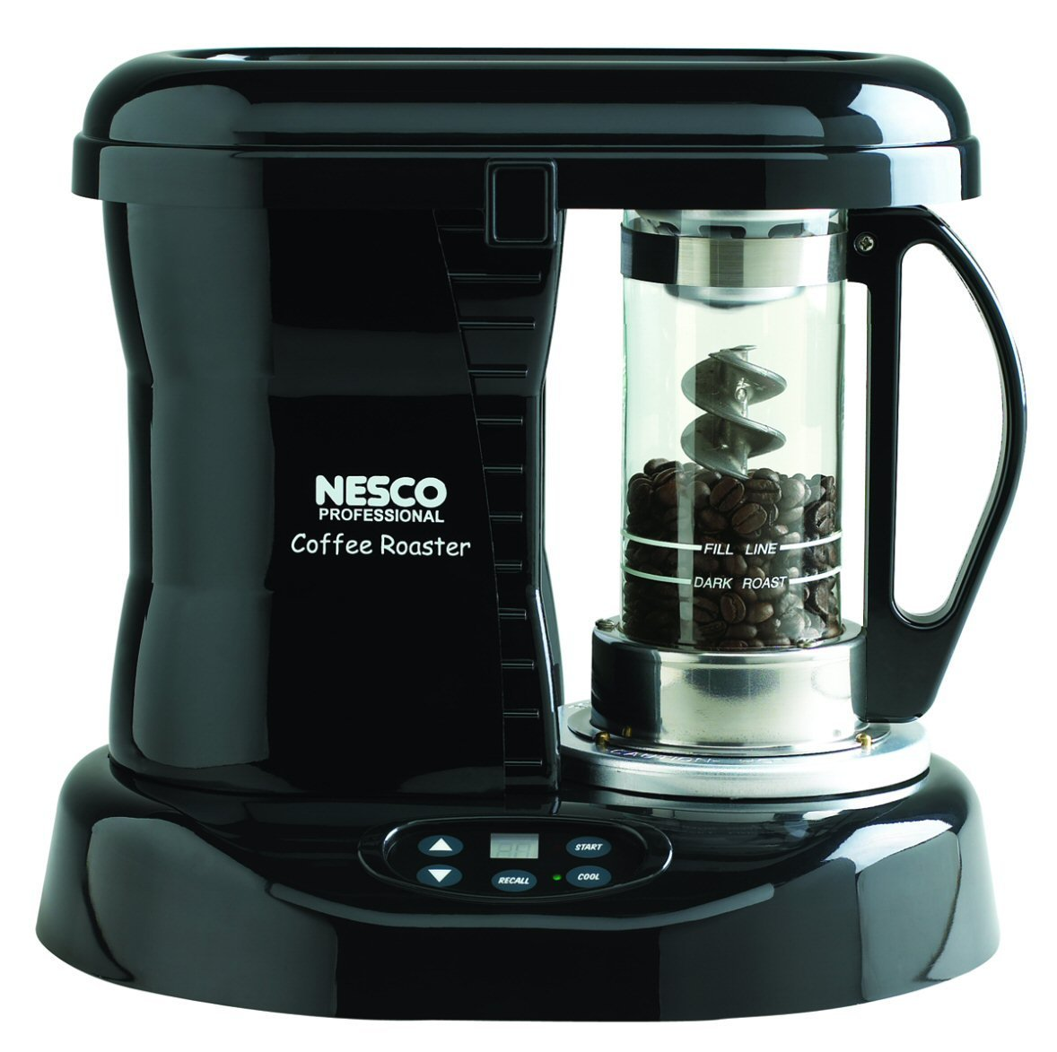

Our first product to compare to is the cheapest off-the-shelf roaster we could find. On the outside, it is quite nice looking and functional at the same time. There is a small LCD on the front, with only a few fair sized buttons. All of the electrical components are to the left, while the chamber where the beans are cooked is on the right. Because this device uses a physical mixer (the large helix in the middle of the cooking chamber), it does not need huge vents and is able to operate fairly quietly.

We definitely liked the overall design of this roaster. Despite being one of the cheapest roasters on the market, it looks solid and reliable, and definitely not out of place on a kitchen countertop. The clear roasting compartment allows the user to watch as the beans get roasted, which is something ours will not allow. Also, the helix in the cooking chamber definitely adds a cool factor, as it looks futuristic and formidable.

What we didn’t like is that for the price, the rest of the machine looks almost whimsical. The outside looks like plastic, and even though it looks solid, it does look a bit cheap at the same time. And again, people who care enough about coffee to roast their own beans at home would probably want a device to look classy or artistic. It doesn’t have to look expensive, but at least have some form of art or appeal in its design, and besides the cooking compartment, we felt like none of the rest of this device accomplished that. For a device that costs more than most coffee grinder and brewer combinations combined, we expected more, and we felt that some more handsome elements like a simple wood trim would have benefited this device greatly.

We also didn’t like the LCD on this device. Yes, simplicity is great and not much GUI is needed, but we would still prefer an LCD larger than the size of a thumbprint.

The design of our product will definitely take some of the good aspects of this one’s design. We cannot copy the clear roasting compartment with the helix mixer inside, as our device uses a different, automated process to heat the beans, but we will have the same solid build appeal. Our exterior will look professional and well made, but also nice, by way of either a low cost, two tone paint scheme or a material trim. A few dollars goes a long way here.

We will also add a larger LCD screen and a rotary/press selection knob for user interfacing, which will replace every other button on the device. The top of our device will have a large scoop/vent, while the sides may have smaller vents if needed, as our device uses air flow to both evenly cook the beans and cool the device. The top of our hood will also contain several sensors, which are not needed in this comparison device because it is not automated.

Product #2

Engadget custom made popcorn popper coffee roaster. Cost: $25 for base popper, plus $50 for other various components. Requires much assembly ^{[2]}.

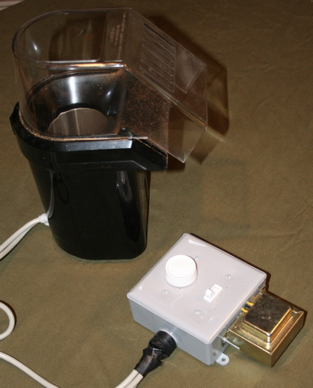

The second product we are comparing with is more similar to what we will be doing, albeit nowhere near as advanced. This is a custom, homemade device done by Engadget, and its build process is somewhat similar to ours. They take a base popcorn popper, and modify/interface it to become a coffee bean roaster.

One good thing about this popper is that it is definitely on the cheaper side to build. All of the components are relatively simple and off the shelf. The user interface is just a switch and a knob, and cannot get any simpler.

However, because it is a homemade device, it is far from beautiful. The wiring is messy and unprofessional. The controls are all on an external box connected to the device by a wire, and because of that the whole device looks like an unfinished, half-hearted attempt at an actual product. The transformer itself is actually outside the control box, where a user can actually touch it.

Our device will indeed have the same overall structure, but that’s about it. We will be using materials that cost the same or less than this product (minus the sensors, which this doesn’t even have), but we will have none of the messiness. Our electronics, especially the transformer, will be embedded in the actual popcorn popper, where it will be out of site and not prone to water contact. This device will be on a kitchen countertop, after all. And because our device will be using a digital automated process to cook the beans, we will have electronics and sensors on the hood scoop, adding cool factor to the design.

Project Packaging Specifications
Because our product requires taking an existing, off the shelf popcorn popper and greatly modifying it, much of our packaging is based on the base popper. As of now, we are using the Toastess TCP-713 Hot-Air Popcorn Popper^{[3]}, and because all of our modifications will be made internally, the size of this popper will be roughly the size of our device.
Our device will be consisted of two main parts: a base and a top. The base of our device will originally be an all-white, plastic rectangular prism. The bottom half will contain a motor, fan, heating elements, and all of the circuitry, while the top half will be the roasting compartment. The front of the prism will have a section drilled out for our LCD and rotary knob, and will be the only true exterior modification we will be making to the base popper.
The top is an acrylic lid scoop which funnels the air out of the device. The top of this lid will contain all of our electronic sensors (thermometer, microphone, camera). Because all of these sensors are directional, they will all be pointing straight down into the base. We will be designing a cover for these sensors as well.
We will be painting the exterior of the base a light brown, to match the coffee environment it will be in. If budget allows, we will also adorn it with a wood trim, as this will add class without much extra risk of over flamboyancy.
A detailed CAD drawing is in Appendix A, and a materials list, tooling requirements, estimated weight and cost, and other specifications are listed in Appendix B.

PCB Footprint Layout

We had four major parts for our initial PCB layout: The Atmega 168 microcontroller, two 16 pin headers, and the LM 7805 power regulator. We do have some other electrical components, but they are connected to the microcontroller directly.

For the Atmega 168, we are using the TQFP32 footprint because that is the package of the controller we have. For the LM 7805, there was a vast variety of footprints to choose from, varying in all shapes and sizes. We chose the TO220H because it was one of the only through hole packages for this voltage regulator. For the 16 pin headers, we used the standard 1x16 footprint.

We are estimating out PCB dimensions to be 1” by 1.5”. A preliminary schematic is in Appendix C.

Summary

This report begins with an introduction of our product, as well as the overall direction we took in designing the packaging of the device. We had to find a balance between simplicity and elegance, sturdiness and low cost. To help us with this, we studied two competing products, both relatively cheap, home-use coffee roasters: the Nesco CR-1010-PRR Coffee Bean Roaster, and the Engadget custom homemade roaster. The Nesco roaster is an actual, manufactured product. Although it is the cheapest off the shelf coffee bean roaster we could find, we found it to be well built and with simple styling. However, even though we liked the overall packaging; we felt that for the price the exterior could have been much better.

The custom roaster by Engadget had the exact opposite qualities of the Nesco one, except it also had a poor exterior. Cheap, flimsy looking, dirty. But it did its job, and it did it using the same air-flow method as ours will, albeit not automated.

Our device will have much increased functionality over both of these roasters, and will look as good as an off the shelf roaster while still costing around the same. We will have the overall form of the Engadget roaster but the fit and finish will be more similar to the Nesco roaster, if not better. A detailed explanation of how we plan on doing so follows the product comparisons. We finish with technical specifications and drawings, as well as a PCB preliminary layout.
6.0 List of References

Amazon Staff. 2012. Nesco CR-1010-PRR Coffee Bean Roaster, 800 Watt.

http://www.amazon.com/Nesco-CR-1010-PRR-Coffee-Bean-Roaster/dp/B000UCRYYS/ref=sr_1_1?ie=UTF8&qid=1348182763&sr=8-1&keywords=home+coffee+roaster

Will O'Brien. February 28th, 2006. How-To: Make a popcorn popper coffee roaster.

http://www.engadget.com/2006/02/28/how-to-make-a-popcorn-popper-coffee-roaster/

Newegg Staff, 2012. Toastess TCP-713 Hot-Air Popcorn Popper. http://www.newegg.com/Product/Product.aspx?Item=N82E16896201050

Appendix A: Project Packaging Illustrations

Frontal View Side View

Note: all elements besides the rotary switch are internal.

Appendix B: Project Packaging Specifications

Bill of Materials:
Vendor | Manufacturer | Part No. | Description | Unit Cost | Qty | Total Cost
Digi-Key | Atmel | ATMEGA8A-AU | Main microcontroller | 3.21 | 1 | 3.21
Digi-Key | CUI Inc | CMI-5247TF-K | Electet Microphone | 2.21 | 1 | 2.21
Digi-Key | Melexis Technologies NV | MLX90614ESF-ACF-000-TU-ND | IR Thermometer | 23.84 | 1 | 23.84
Hacromatic | Hacromatic | HacroCam | Camera with processor | 21.00 | 1 | 21.00
Newegg | Tostess | TCP713 | Hot-air Popcorn Popper | 15.00 | 1 | 15.00
Radioshack | Radioshack | 273-1512 Transformer | Transformer | 13.00 | 1 | 13.00
Digi-Key | IXYS | LCA717S | 2A 30V DC Relay | 5.77 | 1 | 5.77
Mouser | Teledyne Relays | ST24D12 | 12A AC Relay | 25.28 | 1 | 25.28
Newhaven Display | Newhaven Display | NHD-0216K3Z-NSW-BBW-V3 | 2x20 LCD Display | 20.75 | 1 | 20.75
Sparkfun | Alpha | COM-09117 | Rotary Encoder | 2.95 | 1 | 2.95
Digi-Key | Fairchild Semiconductor | LM 7805CT | 5V Power Regulator | 0.67 | 1 | 0.67
Sparkfun | China Yunsun | YSL-R1042WC-D15 | High Power white LED | 1.50 | 1 | 1.50
 |  |  |  | TOTAL |  | $135.18

Tooling Requirements | No specialized tools needed.
Estimated Dimensions | 8" W x 13" H x 5.8" D
Estimated Weight | ~5 lbs
Estimated Cost | $135.18

Appendix C: PCB Footprint Layout

