Homework 5: Theory of Operation and Hardware Design Narrative

Team Code Name: The Incredible HUD Group No. __3___

Team Member Completing This Homework: Aditya Balasubramanian

E-mail Address of Team Member: abalasub@ purdue.edu

Evaluation:

|  |  |
| --- | --- |
| **SCORE** | DESCRIPTION |
| 10 | **Excellent** – among the best papers submitted for this assignment. Very few corrections needed for version submitted in Final Report. |
| 9 | **Very good** – all requirements aptly met. Minor additions/corrections needed for version submitted in Final Report. |
| 8 | **Good** – all requirements considered and addressed. Several noteworthy additions/corrections needed for version submitted in Final Report. |
| 7 | **Average** – all requirements basically met, but some revisions in content should be made for the version submitted in the Final Report. |
| 6 | **Marginal** – all requirements met at a nominal level. Significant revisions in content should be made for the version submitted in the Final Report. |
| * | **Below the passing threshold** – major revisions required to meet report requirements at a nominal level. **Revise and resubmit.** |

* *Resubmissions are due within one week of the date of return, and will be awarded a score of “6” provided all report requirements have been met at a nominal level.*

Comments:

1. Introduction

The Incredible HUD is a helmet-based heads-up display with the capability to record GPS data and the associated telemetry data. It will also display images from the rear-view camera to the user, like a ‘virtual rear view mirror’. An accelerometer, GPS module and thermometer will be used to generate the telemetry data. The user will be able to select what data is displayed, and have quick access to view the rear-view camera, and turn off the display. In the interest of comfort, safety, and packaging concerns, the battery pack, motherboard and primary PCB will be located off-helmet in a secondary enclosure.

1. Theory of Operation

The system will be turned on by a switch connected to the battery pack on the secondary enclosure. The battery pack used is a 7.4V 5000mAh Li-Po battery, which will be sufficient for approximately 3 hours of runtime. The battery pack has a discharge current limit of 40A, which is more than sufficient for our expected current draw of 3A. The motherboard is expected to draw 2A, the projector 0.5A, leaving 0.5A for the microcontroller, sensors, camera, and a safety margin.

The battery is charged using a 9V unregulated wall-wart, which is fed into an advanced dual-cell lithium-polymer battery charge management controller, the MCP73842 [1]. A 9V source was chosen because it is easy to find, and falls well within the operating voltage of the charge controller. The MCP73842 charges the 2-cell lithium-polymer battery pack and also contains logic I/O pins that will be connected to the microcontroller via GPIO port pins. The battery pack is also connected to a DS2782 stand-alone fuel gauge [2] that monitors the state of the battery in terms of milliamp-hours left, and the temperature. This information is communicated to the microcontroller via I2C, where it is ultimately included in the data packet sent to the motherboard. The unregulated voltage output from the battery pack is passed to a LM2576 [3] switching regulator, which outputs 5.0V with up to a 3A load. This 5V is used to drive the motherboard, projector and rear-view camera. The secondary enclosure contains a PCB that will handle the power circuitry, a MAX3232 RS-232 level translator [4] between the microcontroller and motherboard, as well as coalesce the various connectors from the motherboard into a single DB-25 connector that will feed into the helmet. The secondary PCB will also contain the microcontroller, GPS module [5] (Trimble Copernicus GPS DIP), accelerometer [6] (MMA7361), and debugging headers for the microcontroller.

The DB-25 connector will be used in a custom pin-out form. The objective of this is to bring together the multiple ports used on the motherboard, the regulated power line, and the ground line into a single harness which feeds into the helmet. The motherboard ports passed through the DB-25 cable include VGA (for the projector) and USB (for webcam-motherboard communication), as well as a pass-through for the temperature sensor.

On the helmet itself, the projector is powered through the 5V line brought over by the DB-25 cable. The projector will be mounted at the very top of the helmet (where it is the flattest) along with the convex lens necessary for collimating the image (parallelizing the light rays to make it ‘float’ in the distance). The image will then be projected onto combiner glass mounted on the visor. The combiner glass ‘stops’ specific frequencies of light, allowing it to be displayed on the surface of the glass. Specifically, it stops light at 550nm, which is green (this is the same reason military aircraft HUDs are green in color). The rear-view camera (a standard USB webcam) also runs at 5V. There will be a second PCB on the helmet, but its sole purpose is to act as a breakout for the DB-25 cable into the various connectors needed.

The microcontroller will generate periodic packets of data based on telemetry data from the sensors that has been parsed into a custom format. This packet is then sent to the motherboard, where it is further parsed into a GUI format, sent back over VGA to the projector and displayed on the helmet.

1. Hardware Design Narrative

The main peripheral subsystems utilized in the microcontroller [7] are the Serial Communication Interface (SCI), Inter-integrated Circuit (I2C), Analog-To-Digital (ATD) converters, and the Timer (TIM).

Four ATD channels will be used. Three channels will be used to sample the 3-axis accelerometer at 1Hz. The accelerometer outputs 3 analog voltage signals that vary according to the acceleration in the x, y and z planes. The fourth channel will be used to sample the temperature sensor at 1Hz. The ports used for the accelerometer are AN12-AN14, and the port used for the temperature sensor is AN9. The abundance of ATD ports on the microcontroller makes the port choice fairly arbitrary.

The SCI subsystem on the microcontroller used has two SCI (or UART) ports that will be used. One SCI port (UART2) will be used to communicate with the Copernicus GPS module which sends GPS information packet to the microcontroller at 1Hz. This data is parsed along with the accelerometer and temperature sensor. The second SCI port (UART1) will be used to send packets of this parsed telemetry data from the microcontroller to the motherboard via the RS-232 protocol. The pins utilized for UART1 are U1RX and U1TX ($P49 and $P50), and UART2 utilizes U2RX and U2TX ($P52 and $P53).

The I2C subsystem will be used to interface with the battery ‘fuel-gauge’. The microcontroller will poll the fuel-gauge integrated circuit periodically, and receive packets containing the milliamp-hours remaining and the voltage-level of the battery. Additional features such as temperature monitoring may be implemented on an as-needed basis.

The timer will be used in the implementation of interrupts in the code. The interrupt-based system will monitor the pushbuttons for toggles, and change the display mode accordingly. The buttons and status LEDs will be connected to the microcontroller by general purpose input-output pins (GPIO). Additional GPIO port pins will be used to interface with the battery charge management controller. The charge status output pin will indicate to the microcontroller the current charge status (charge in progress, charge complete, and fault). The charge enable input pin is used by the microcontroller to set the charging mode, or to override a charge cycle.

All of the port pin assignments can be summarized in the table below.

|  |  |  |  |
| --- | --- | --- | --- |
| Pin Number | Pin Name | Input/Output | Use in Design |
| 23 | AN12 | Input | Accelerometer (x-axis) |
| 22 | AN13 | Input | Accelerometer (y-axis) |
| 21 | AN14 | Input | Accelerometer (z-axis) |
| 49 | U2RX | Input | Data from GPS module |
| 50 | U2TX | Output | Data to GPS module |
| 52 | U1RX | Input | Data from motherboard |
| 53 | U1TX | Output | Data to motherboard |
| 66 | SCL1 | Output | Clock for I2C |
| 67 | SDA1 | Input/Output | Data from I2C |
| 76-84 | RD1-RD7, RD12,RD13 | Input/Output | GPIO pins |

Table 3. 1 – Port Pin Assignments

1. Summary

In summary, all of main components and their functions have been outlined, including their placement within the device. Additionally, the various peripheral subsystems utilized by the microcontroller have been summarized, with details of their function, location and names provided.

List of References

1. MCP73842 - Advanced Single or Dual Cell Lithium-Ion/Lithium-Polymer Charge Management Controllers, Microchip. [Web] <http://ww1.microchip.com/downloads/en/DeviceDoc/21823c.pdf>
2. DS2782 Stand-Along Fuel Guage, Dallas Semiconductor, Maxim. [Web] <http://datasheets.maxim-ic.com/en/ds/DS2782.pdf>
3. LM2596 - SIMPLE SWITCHER® Power Converter 150 kHz 3A Step-Down Voltage Regulator. National Semiconductor. [Web]   
   <http://www.national.com/ds/LM/LM2596.pdf>
4. MAX3232 - 3.0V to 5.5V True RS-232 Transceivers, Maxim. [Web] <http://datasheets.maxim-ic.com/en/ds/MAX3222-MAX3241.pdf>
5. Copernicus GPS Module, Trimble. [Web] <http://www.sparkfun.com/datasheets/GPS/Copernicus_Manual.pdf>
6. MMA7361 - ±1.5g, ±6g Three Axis Low-g Micromachined Accelerometer, Freescale. [Web]   
   <http://www.freescale.com/files/sensors/doc/data_sheet/MMA7361L.pdf>
7. PIC32MX5XX/6XX/7XXFamily Data Sheet, Microchip. [Web] <http://ww1.microchip.com/downloads/en/DeviceDoc/61156G.pdf>

Appendix A: System Block Diagram

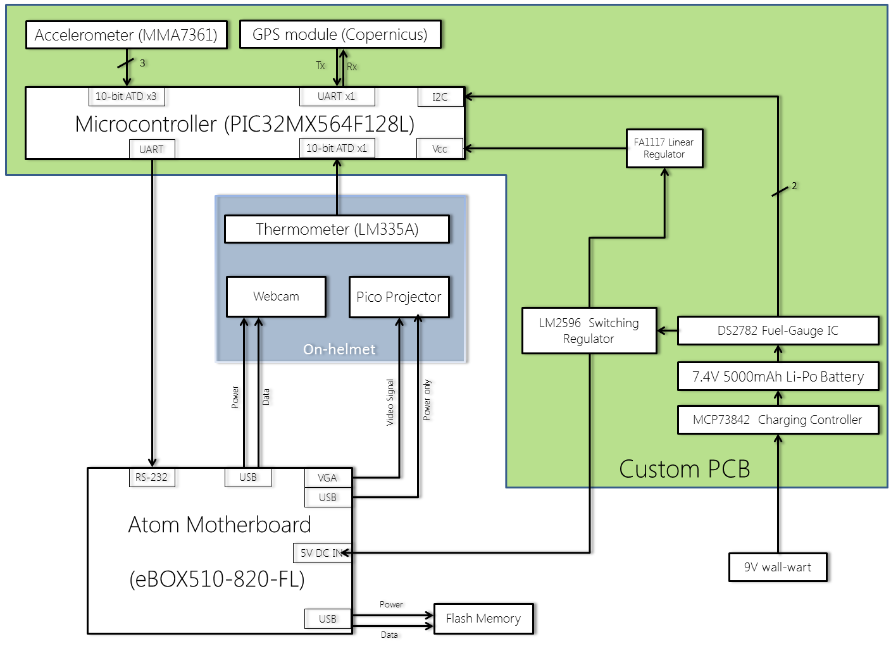

Appendix B: System Schematics

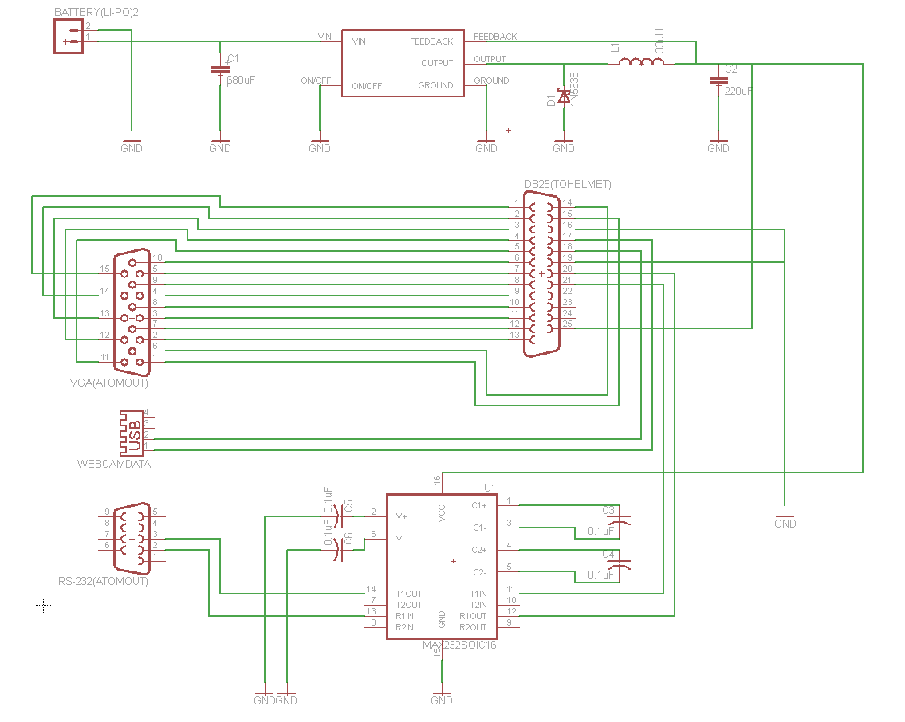

Figure 1 - Backpack Unit PCB*

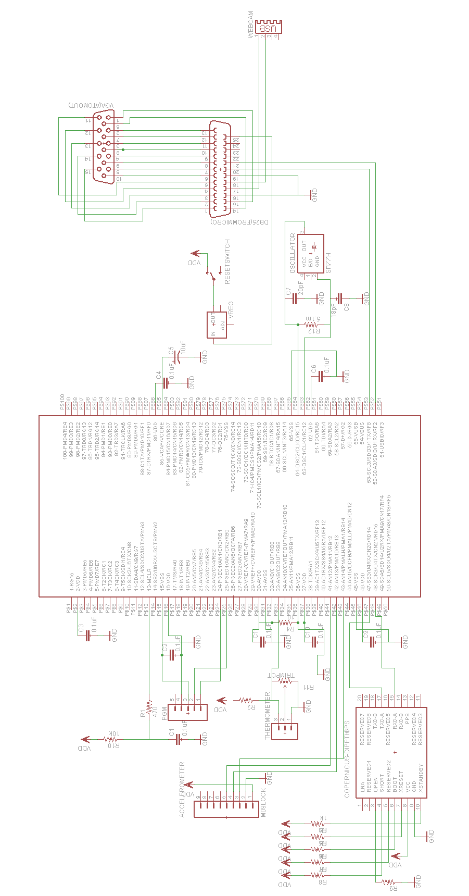

Figure 2 – Microcontroller and Sensors PCB*

*the two PCBs have been merged in the latest design