Homework 4: Packaging Specifications and Design

Team Code Name: The Incredible HUD Group No. 03
Team Member Completing This Homework: Marcelo Leone
E-mail Address of Team Member: mleone@purdue.edu

Evaluation:

SCORE | DESCRIPTION
10 | Excellent – among the best papers submitted for this assignment. Very few corrections needed for version submitted in Final Report.
9 | Very good – all requirements aptly met. Minor additions/corrections needed for version submitted in Final Report.
8 | Good – all requirements considered and addressed. Several noteworthy additions/corrections needed for version submitted in Final Report.
7 | Average – all requirements basically met, but some revisions in content should be made for the version submitted in the Final Report.
6 | Marginal – all requirements met at a nominal level. Significant revisions in content should be made for the version submitted in the Final Report.
* | Below the passing threshold – major revisions required to meet report requirements at a nominal level. Revise and resubmit.
* Resubmissions are due within one week of the date of return, and will be awarded a score of “6” provided all report requirements have been met at a nominal level.

Comments:

- Introduction
The Incredible HUD is a heads-up-display designed for a full-faced helmet, commonly used for motorcycles or off-road dirt bikes. When the topic of packaging arises for this device, one might find it difficult to imagine having all of the necessary components as part of the helmet itself. Due to the sleek and smooth nature of its surface, mounting the hardware on the helmet while keeping the attachments protected and relatively aerodynamic is very important. In reality, doing so will be the most challenging part of packaging our design. We have to face many issues, including those related to weather and impact resistance, display intensity and positioning, and also weight management. If our device is created and it impedes the user in any way, then the whole point of the heads-up-display will be wasted in a product that is inefficient and overburdening.

- Commercial Product Packaging
There are currently two commercial products that are really similar to the Incredible HUD; the Android Ski Goggles by Recon Instruments [1] and the SportVue by Motion Research Corporation [2]. These products have display technology that is portable and can relate to our project’s design. In the next section each of these products will be described and analyzed individually, pointing out both positive and negative aspects of their packaging. The differences that set our product apart from these commercial products are also mentioned, as our design needs to be unique and innovative.

  - Product #1
The first of the two commercial products, the Android Ski Goggles, is a great comparison to the Incredible HUD for a handful of reasons. The device in itself is a completely mobile entity; everything is packaged on the goggles and is contained so as to not impede the user’s sight or mobility. To control the format of the information it displays there are three buttons on the side of the goggles that are large and easily accessible. Also on the side is a USB port for transferring telemetry data collected during the product’s use and for recharging the internal battery that powers its parts. The display component sits in the bottom of the right eye of the goggles, placed so the user can gaze down to the right in order to read the information that the system outputs.

The great things about this product are the button interface, the rechargeable battery, the retrievable telemetry data, and the overall concept of portability. Seeing these aspects has influenced our design considerations and we will be incorporating these features as part of the Incredible HUD. We will have two or three control buttons on the side of the helmet, intuitive in nature so that a user can easily switch between display modes if desired. Like mentioned before, the hardware components will be integrated into the helmet (except for maybe the battery and motherboard if they are too unwieldy, in which case will be packaged to sit in a backpack) to promote mobility and portability of the device as a whole. In addition, telemetry data collected during operation will be available in a SD card that a user will be able to remove and insert to a computer for reviewing and manipulation purposes.

What sets our design apart from these goggles is the obvious fact that they are only goggles and not a full-faced helmet. More importantly, the display technology is such that the user needs to focus their attention to the small screen in the bottom right of their view. We feel that doing so is very undesirable because when skiing, or in our case, driving, the user needs to be able to pay full attention to what is in front of them. The projection display of our design will allow the user to do both since it will be focused out in the distance of the user’s view. However, this does add some complexity to our packaging because the projector and associated optical pieces (mirrors and lenses) need to be secured to the helmet in a precise way for optimal imaging. If the information that is displayed on the helmet’s visor ends up being distorted or hard to see then convenience of our product is ruined.

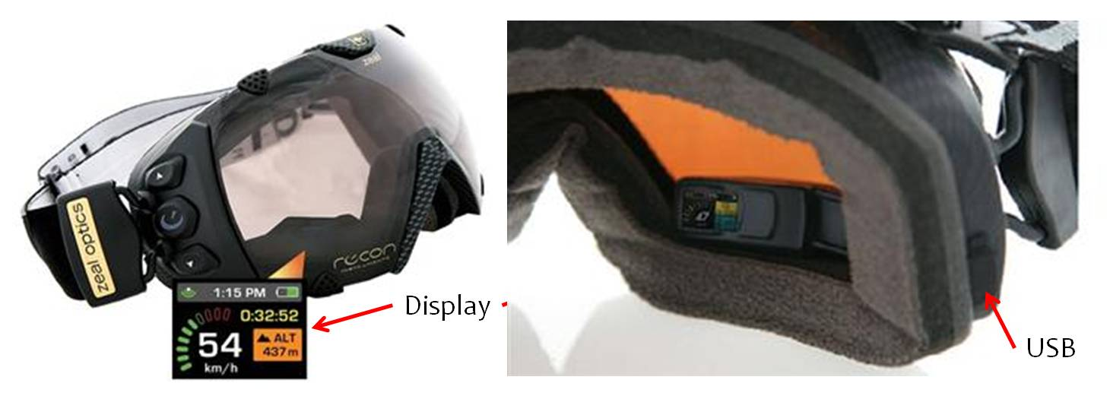
  - Product #2
The second of the two commercial products, the SportVue, is a valuable product to compare our design with. The SportVue can be purchased and applied to a variety of helmets ranging from bicycle helmets, to motorcycle helmets, to motocross helmets. It is a slim and sleek device that can be attached to any sort of visor or helmet via an adhesive connector/attachment. This then enables the small, transparent display pane to hang just along the top of the user’s view. Something very apparent with this product is that the display is relatively small and is therefore limited to what it can display at any given time. Whether its speed, lap time, or elevation, it can only display one or two data items at once.

The aspect of this product that we will mimic in our design is the idea of a transparent display that lies directly in the view of the user. However, the Incredible HUD will be different in that it will be a bigger display and the focus of such will not be at the point of the visor but instead ahead in the distance to permit the sensation of an “augmented sense of reality”. On the other hand, there are some negative things about this product, and they are pretty substantial. The adhesive connection that allows the SportVue to be applied to a variety of helmets is known to be faulty and falls off with any sort of quick, jerking movements. Also, the body of the device is not very rugged because it sticks out in the front of the helmet and in that position it is vulnerable to damages that it isn’t protected from. We definitely want our components to be well secured to the helmet and we will construct the mounting hardware so that it can withstand many environmental stresses and continue to function properly. If dust or water come in contact with our parts and damage them, not only will that be a waste of money but a failure in our design.

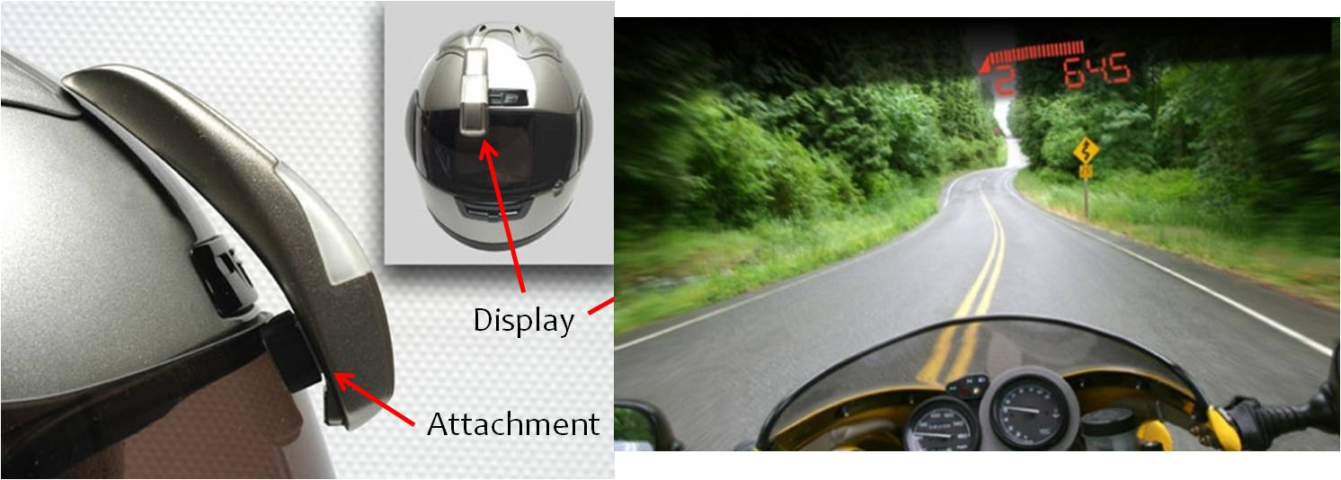
- Project Packaging Specifications
Since the Incredible HUD is designed for a full-faced helmet, one of the main aspects of the design is that all of the components need to be integrated with the helmet so as to promote mobility and portability to the user. This means that all or most of the components will need to be packaged on and/or in the helmet itself. If everything is incorporated into the helmet, all the user will have to do to enable the display is put the helmet on, and power up the device. When a person is going to use our device they won’t want to waste time assembling parts onto the helmet beforehand, they will want something that can simply be put on just like a regular helmet. The desired effects of having a heads-up-display in a helmet will be greatly hindered if having such a device is a burden or inconvenience to use.

Another concern is that if our components are attached to the helmet itself, then they have to be done so in a way that doesn’t impede the user’s movement, posture, or sight. To avoid those things, the weight of the components will need to be managed, along with the bulkiness of the attachments. It would be very unwieldy to have an imbalanced helmet with weird blocks protruding out of it, or even from the inside, poking into the user’s head. That is why in our design the hardware parts will be mounted flat against the surface of the helmet, and positioned in the centerline so no side is heavier than the other. This will help maintain a streamlined look and feel to our product, in addition to keeping the hardware components organized and optimally positioned for successful operation and ventilation. Since the casings for the parts are going to have slits in them designed to allow airflow from the wind going over the helmet, those slits will have to be positioned for maximum cooling without allowing anything else inside.

Last, but not least, is the consideration for weather and impact resistance. As this device will be used primarily outdoors, it will be subject to varying weather and conditions. We don’t want the performance of the components to decrease due to any water, humidity, dust, or projectiles such as bugs or small stones getting into the hardware and damaging the electronics. In order to assure this protection we will need to cover all the parts in a collection of plastic liner, mesh (wire or fabric), and aluminum casings. The placement of the wires associated with the components’ inter-connections will also need to be carefully planned so that everything is neat and streamlined. Any wires that will be able to be snaked into the helmet will be placed under the padding so that they can be protected and out of the way of the parts on the outside.

- PCB Footprint Layout
As described in the third homework, the major components of our design are the microcontroller, GPS, accelerometer, thermometer, and voltage regulator. These components will all be attached to our PCB in various ways because they differ in nature. The PCB itself will be attached in the “beak” of the helmet because that spot will offer protection and we will be able to easily route connections to the other components from there. The microcontroller is a quad-flat-thin package and it was chosen to make a custom footprint for it. A custom footprint was also made for the voltage regulator because in itself, it is a unique package. However, we will need to connect an inductor and two capacitors to it on the PCB, and for those we will use the standard surface mount (12 mil x 6 mil) footprints. Now as for the GPS and accelerometer, the parts that we purchased came on breakout boards so all we need on our PCB are places to connect them, using through-holes. The last component is the thermometer which is unique because for our design we need it to be on the outside of the helmet in order to record accurate temperatures. This will require us to simply wire it onto our PCB without the need for a footprint.

- Summary
In conclusion, the packaging for the Incredible HUD will be no easy task. Since we want it to be completely portable, we end up having many constraints for how we can put all of our components together onto the helmet. The mounting of the parts will be carefully planned so as to make our overall device compact and streamlined, yet efficient and rugged. Obviously many environmental variables will come into play when this device is fully operational because it is intended for outdoor use. All the components will require weather-proofing and protection from any sort of impact. And it can’t be forgotten that the “fully loaded” helmet can’t impede the user’s mobility or sight, i.e. the weight of the parts needs to be evenly distributed away from the visor so parts aren’t clustered in inconvenient places. We have to keep in mind that the user will generally be wearing this device for long periods of time!
List of References

[1] “The World’s First GPS Goggles with Head-Mounted Display Available Now” 2010 [Online] Available:
http://www.reconinstruments.com/media-room/world’s-first-gps-goggles-head-mounted-display-available-now
[Accessed: 9/21/2011]
[2] “Retro-fit heads-up display system for motorcycle and bicycle helmets” 2009 [Online] Available:
http://www.gizmag.com/go/2430/
[Accessed: 9/21/2011]

Appendix A: Project Packaging Illustrations

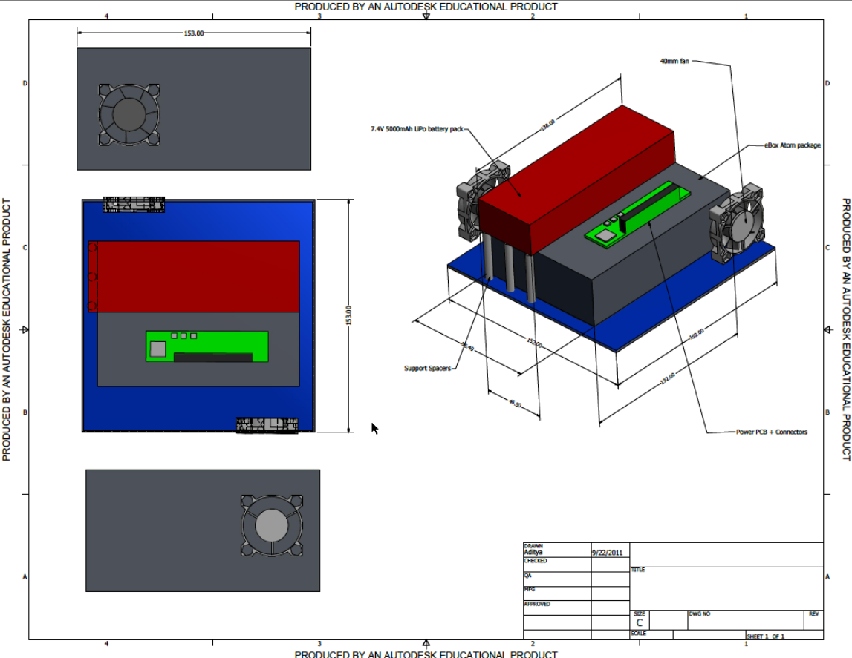

This is the backpack unit that could be constructed if we decide the battery is too unwieldy to mount on the helmet contains the motherboard, battery, voltage regulator, and two cooling fans.

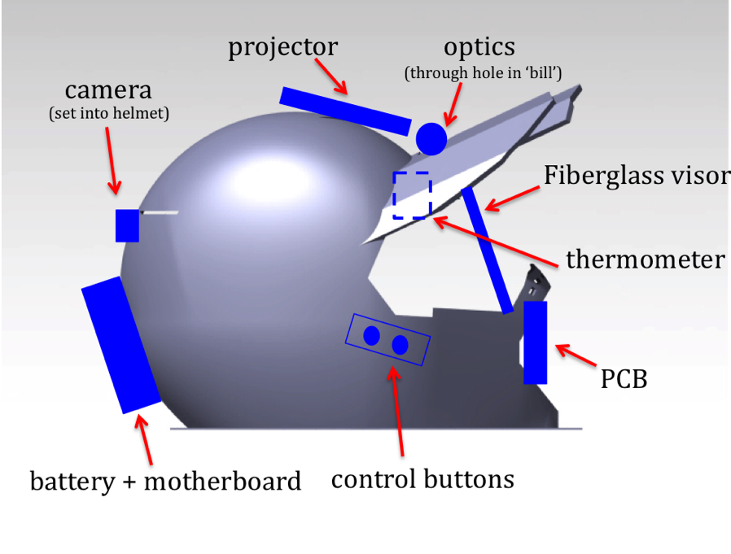
These are different angles of the mock up of where the hardware components will be placed.

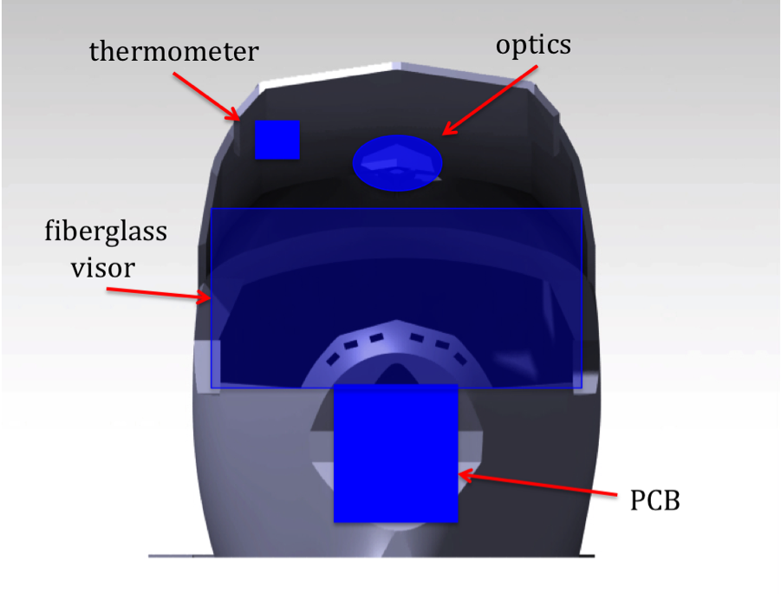

Appendix B: Project Packaging Specifications
Materials List:
- XXL motocross helmet w/ visor
- Fiberglass
- Reflective window tint
- Darkening window tint
- Silicon adhesive
- Plastic liner
- Wire/cloth mesh
- Screws & washers
- Aluminum casings

Tooling Requirements:
- No special tools will be required

Estimated Weight (helmet): 5 lbs
- Helmet = 3 lbs
- *Battery = 1 lb (at most)
- All other parts on the helmet are very lightweight = up to 1 lb (at most)

*If the battery is too unwieldy to attach to helmet directly, it will go into a backpack and its weight will no longer have an effect

Estimated Cost: $100-$110
- Helmet = $40
- Fiberglass = $10
- Tint = $10
- All other materials aren’t expected to cost more than $50

Appendix C: PCB Footprint Layout

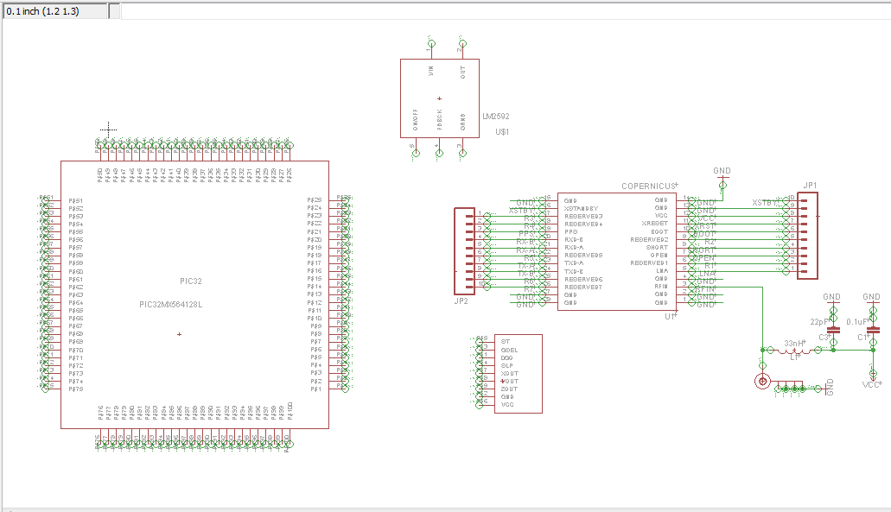
Schematic Layout

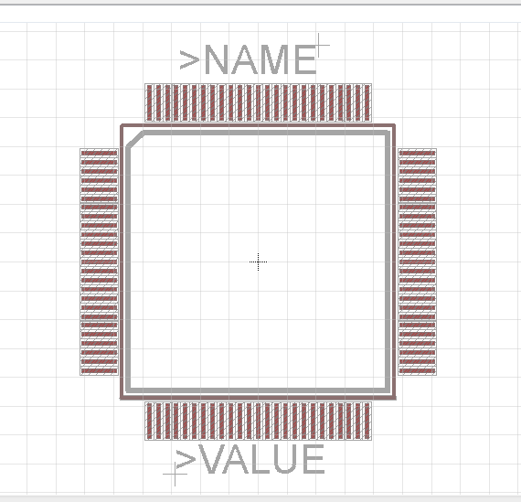
Microcontroller Footprint

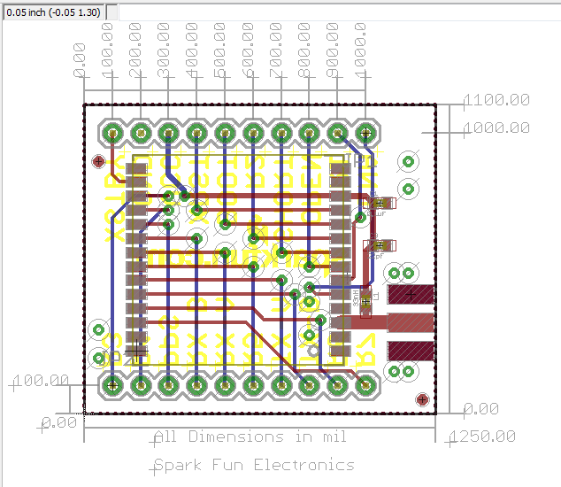
GPS Footprint

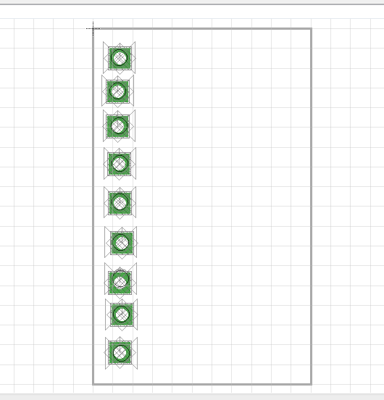
Accelerometer Footprint

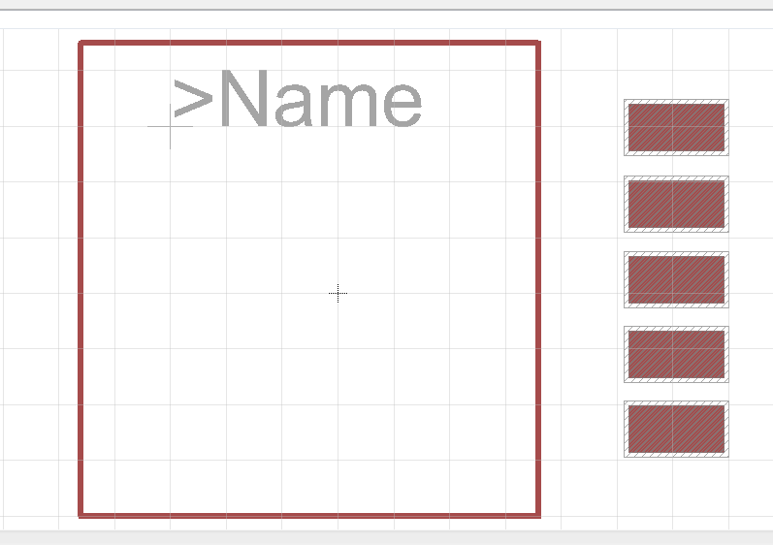
Voltage Regulator Footprint

