ECE 477 Final Report − Spring 2010
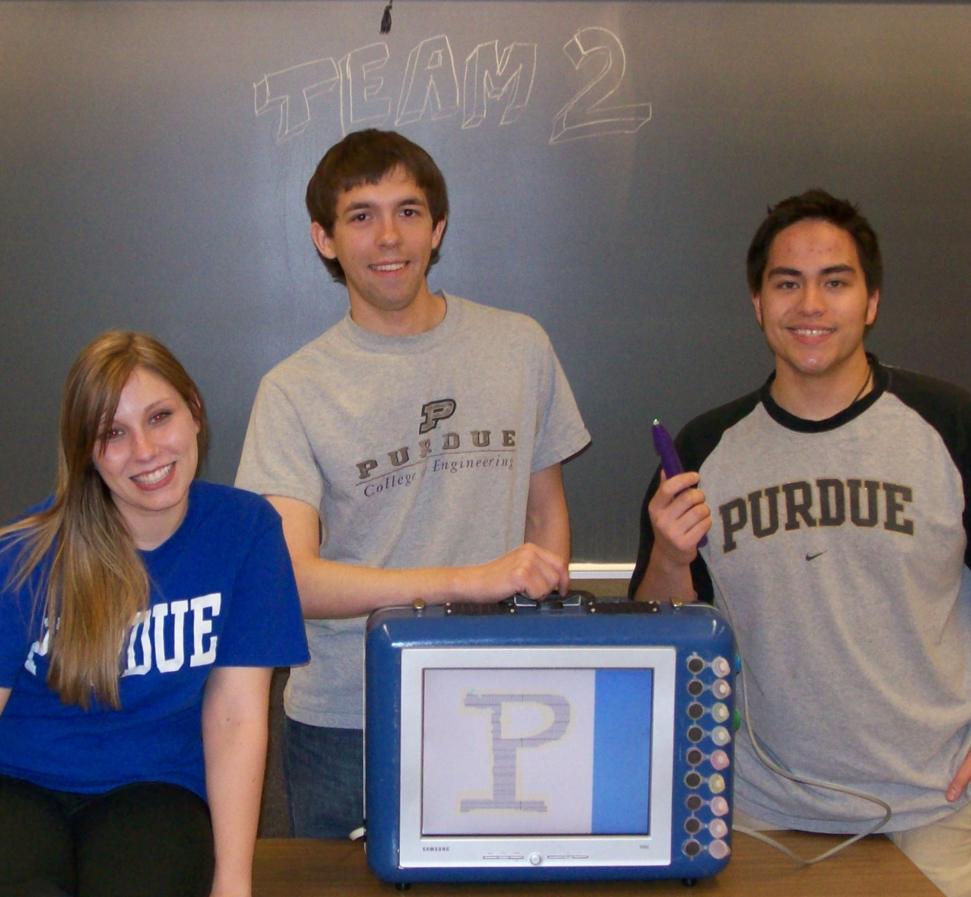
Team 2 − Digi-Brush
Josh Long
Katie Schremser
Caleb Ayew-ew

Team Members:

#1: _Caleb Ayew-ew_____________ Signature: ____________________ Date: _________

#2: _Joshua Long________________ Signature: ____________________ Date: _________

#3: _Kathleen Schremser__________ Signature: ____________________ Date: _________

CRITERION | SCORE | MPY | PTS
Technical content | 0 1 2 3 4 5 6 7 8 9 10 | 3
Design documentation | 0 1 2 3 4 5 6 7 8 9 10 | 3
Technical writing style | 0 1 2 3 4 5 6 7 8 9 10 | 2
Contributions | 0 1 2 3 4 5 6 7 8 9 10 | 1
Editing | 0 1 2 3 4 5 6 7 8 9 10 | 1
Comments: |  | TOTAL

TABLE OF CONTENTS

Abstract | 1
1.0 Project Overview and Block Diagram | 1
2.0 Team Success Criteria and Fulfillment | 3
3.0 Constraint Analysis and Component Selection | 4
4.0 Patent Liability Analysis | 8
5.0 Reliability and Safety Analysis | 11
6.0 Ethical and Environmental Impact Analysis | 14
7.0 Packaging Design Considerations | 17
8.0 Schematic Design Considerations | 21
9.0 PCB Layout Design Considerations | 26
10.0 Software Design Considerations | 29
11.0 Version 2 Changes | 34
12.0 Summary and Conclusions | 35
13.0 References | 36
Appendix A: Individual Contributions | A-1
Appendix B: Packaging | B-1
Appendix C: Schematic | C-1
Appendix D: PCB Layout Top and Bottom Copper | D-1
Appendix E: Parts List Spreadsheet | E-1
Appendix F: FMECA Worksheet | F-1

Abstract

The Digi-Brush is a child’s and parent’s dream of being able to paint without making a mess. The Digi-Brush allows a user to select from eight different colors, by dipping a “paintbrush” in the color pot. The user then just touches the paintbrush to the display and pushes the force resistor and their paint is displayed on the display. To distinguish the Digi-Brush from simple painting software, paintbrush characteristics are used such as different paintbrush sizes, and running out of paint.

- Project Overview and Block Diagram

The Digi-Brush allows a user to digitally paint on a LCD monitor display. The user can select a color by dipping the “paintbrush” into a color pot. When the color is selected a RGB LED on the tip of the brush is illuminated with the color that they had just selected. While the user has the brush in a color pot they can tap the force resistor to change the thickness of the brush stroke they will paint with. Once there is paint on the brush the user can touch any where they would like to paint on the display and the paint will be displayed. However, there is not an infinite amount of paint on the brush, like a real brush, and the user will run out of paint, when this happens the LED will turn off indicating the user has run out of paint. An additional indicator that the user is running out of paint is that the brush strokes will become thinner. The user can also clear the screen with the push of a button. The Digi-Brush was also intended to be able to save the image the user painted but, due to software issues and vendor support this functionality was never completed.

Figure 1: Digi-Brush Block Diagram

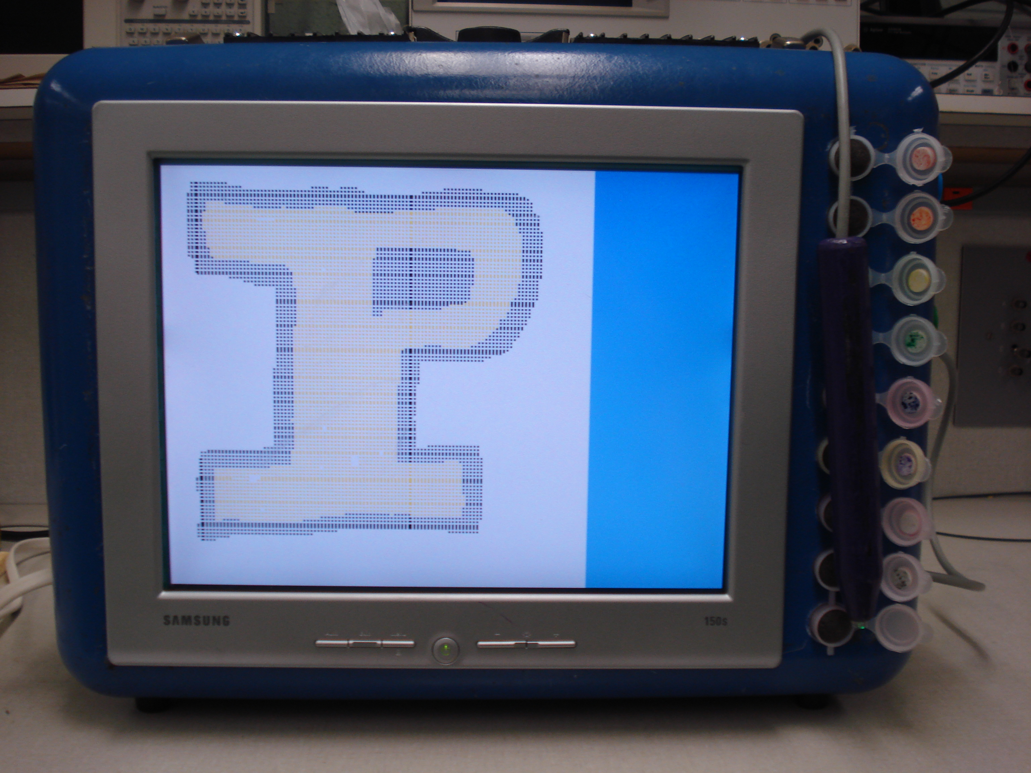
Figure 2: Finished Digi-Brush

- Team Success Criteria and Fulfillment

2.1 An ability to display images on the display board.

This success criterion was fulfilled. The user’s input was reflected on the display when they were painting, thus each time the user painted, a new image was displayed on the board.

2.2 An ability to track the digital brush on the display board.

This success criterion was fulfilled. When the user touched the display with a paintbrush full of paint the paint showed up at the location where the user touched on the display.

2.3 An ability to mimic paintbrush stroke characteristics on the display board.

This success criterion was fulfilled. A paintbrush can not hold an infinite amount of paint, so the Digi-Brush’s paintbrush had a limited amount of paint also. The amount of paint was determined by how long the user kept the paintbrush in a color pot. A user could also select to use different paintbrush stroke sizes. If the user chose a large paintbrush stroke size the stroke size would decrease in size as the amount of paint on the brush decreased.

2.4 An ability to save the painted image on an SD card.

This success criterion was not fulfilled. The necessary hardware was created but, the necessary software was unable to be created. Custom logic was created but timing issues arouse that could not be fixed in the amount of time left in the semester. Altera was contacted to acquire an IP Core but they never responded.

2.5 An ability to distinguish user’s color selection and display selected color before being painted.

This success criterion was fulfilled. When a user dipped the paintbrush in a paint pot the correct color was displayed on the RGB LED at the end of the paintbrush. Also the correct color was displayed on the display when the user painted.

Constraint Analysis and Component Selection

3.1 Introduction
The Digi-Brush will be able to simulate the characteristics of painting, but instead of painting on paper will use a touch panel and a display monitor to display the paint strokes. The touch panel will track the user’s strokes across the panel made with the digital paintbrush and the appropriate stroke and color will be displayed underneath the touch panel on an LCD monitor. The experience will emulate the experience of painting with other visual characteristics, but without the worry of creating a colored mess with paint. The user will also be able to save the digital paintings created to an external SD card. The following are the Project Specific Success Criteria for this project:
- An ability to display images on the display board
- An ability to track the digital brush on the display board
- An ability to mimic paintbrush stroke characteristics on the display board
- An ability to save the painted image on a SD card
- An ability to distinguish user’s color selection and display selected color before being painted

  - Design Constraint Analysis
The most important design constraint will be the actual interfacing of the monitor and touch panel. This will involve the transferring of images to the monitor using VGA protocol. The images will be based on user input from the touch panel and the user’s interaction with the brush. If and where the touch panel has been touched will need to be polled and updated at a frequent, constant rate using ATD values returned from the touch panel. Since it is very difficult to have a microcontroller natively use VGA another constraint will be getting an FPGA that will interface with the microcontroller and be able to output a VGA signal. Being able to support all the additional peripherals connected to the microcontroller is another constraint. These peripherals are located in various places, namely inside the brush, the SD card, the VGA controller, and the color selectors. The microcontroller will be need to be able to support SPI, I²C, and ATD peripherals, and in most cases multiples of each standard.

    - Computation Requirements
To determine where the user is touching the touch panel, the ATD values from the touch panel will need to be converted into a pixel location at a rate that will prevent the user from experiencing any latency. To mimic paint characteristics will take computational power, especially if user is not to experience any latency. The FPGA will need to be able to convert the image on the panel into a lossless image format and store it onto the SD card. This requirement can be a little more relaxed in the timing aspect as long as it doesn't interfere with the user's interaction.

    - Interface Requirements
To be able to display the images on the monitor a VGA protocol will be generated by the FPGA and sent to the monitor. For the microcontroller to be able to communicate with the FPGA regarding what to display an SPI protocol will be used. The touch panel that the user will interact with will be a 5-wire resistive touch panel, and will send an analog voltage to the microcontroller which will be read with a 10-bit ATD converter due to the accuracy a 10-bit converter can provide over an 8-bit converter. The microcontroller will be able to control the direction by switching 4 GPIO pins from high to low, depending on which direction is being polled. A force resistor will be used in the paint brush to measure how hard the user holds it. This will also require an ATD converter. The user will be able to select colors from "color pots" in which the user dips the paint brush. In the bottom of each “pot” will be a pushbutton covered by foam. The color will be determined by the microcontroller after polling the color pots using GPIO to see if any are being pressed. GPIO will also be used for pushbuttons for saving and clearing the image. The color the user is painting with will always be displayed by an LED within the paint brush, and therefore an LED driver will be used to power the LED. The microcontroller will give the commands to the driver over I²C.

    - On-Chip Peripheral Requirements
The microcontroller for the Digi-Brush will need 1 SPI module, 2 ATD converters with at least 10 bits of resolution, an I²C module, and at least 15 GPIO pins. The SPI module will be used for communication between the microcontroller and the FPGA. The ATD converters will be used to read the touch panel voltage, and force resistor. The I²C module will be used for interfacing with the LED Driver, and the GPIO pins will be used to read the color pots, pushbuttons, and control the outputs to the touch panel.

    - Off-Chip Peripheral Requirements
An LED driver will have to be used to illuminate an LED indicating the selected color. The LED Driver receives inputs from an I²C connection, with an optimum frequency of 1 MHz and a normal operating frequency of 24 kHz[1]. The LED Driver operates at 5V and a maximum output current of 120 mA. A VDAC will be required to correctly output a VGA signal to the monitor. The VDAC will operate at 3.3V with an operating frequency of 50, 140, 240, or 330 MHz [2].

    - Power Constraints
The Digi-Brush will be powered by a connection to an electrical socket. Therefore, low power consumption is not a major constraint. A proper wall wart will need to be selected to convert the 120 Vac to a 9V dc source. This digital voltage will then need to be scaled down to the voltages that the individual components will require. It will be important to choose a wall wart and power supply circuitry such that heat generation due to power dissipation is at a minimum.

    - Packaging Constraints
The packaging for the Digi-Brush will need to be very durable, as it will house an LCD monitor and a glass touch panel. Both items will need to be completely secured on the chassis so there’s very little chance of either one cracking and/or breaking. As the display is 15.1” diagonally, there will be no limitation on the size of the PCB other than the 60 sq. in. maximum size it is allowed to be. The brush of the Digi-Brush should be able to fit comfortably in a child’s hand and be made of a light-weight material. In order to meet these constraints, the brush should be no longer than 9 inches in length and 1.5 inches in diameter.

    - Cost Constraints
Due to that fact that there are many portable devices out in the market today that can do some kind of graphic touch technology, our product has direct competition and therefore should be as cheap as possible. Preferably the product would be cheaper than a netbook with a touch panel attachment, which can easily cost $400.

  - Component Selection Rationale
There are many different touch displays out on the market. There are also many ways to create one’s own touch display, the most common way being taking an LCD display and attaching a touch panel to it. Both were considered for the project. Due to the nature of combined touch panel/monitor systems and their use with computers, a separate touch panel and monitor were selected in order to allow the microcontroller to have more control over the input signals.
Originally a Freescale S12NE microcontroller was going to be used due to the fact that a development board was available for use. However, the Digi-Brush’s peripheral requirements are too great for the S12NE to meet as it only has two SCI, one SPI, and one I²C. The Freescale S12D has 3 SPI, 2 SCI, and 1 I²C, and is therefore more compatible with our needs. Freescale was the only microcontroller manufacturer considered due to the experience that all members of the team have with programming on Freescale architecture.

  - Summary
The design’s main constraints are being able to receive input from a touch panel, determining where on the touch panel the input corresponds to, and being able to convert this information into a proper output in a timely manner. A major constraint is that microcontrollers do not natively support VGA protocol and thus a VGA controller needs to be present. The microcontroller will get touch positions from the touch panel through an analog signal connection that will be connected via ATD converters and send outputs to a monitor using VGA protocol. All additional functionality of SD card saving, color selection, color indication, and grip and gesture recognition will be sent directly the microcontroller by SPI, I²C, or ATD converters. Most of the component selection was mainly guided by familiarity of parts and ease of integration with the microcontroller. Also taken into account was power dissipation in hopes to keep the device from becoming hot.

- Patent Liability Analysis

  - Introduction
The DigiBrush is a digital painting set that utilizes a stylus-like input device to represent a paintbrush. The paintbrush interacts directly with the touch-screen to create brushstrokes on an LCD. There will be focus on three similar devices that have patents issued. All patents in this document are not in violation of the Doctrine of Equivalence or infringe literally.

  - Results of Patent and Product Search
Utilizing Google Patent search patents were found based on the following keywords: digital paintbrush, digital painting apparatus, painting simulation, and input capturing. Three major patents were found to be similar to our product.
The first patent is for a Digital Mark-Making Method that claims it will create a 2D image on a computer that simulates an artist’s tool. It was filed by MetaCreations Corporation on December 7th, 1995. The user’s brushstroke is captured by the use of a mouse. The Digital Mark-Making Method utilizes a computer, or other hardware, to provide a digital representation of multiple-image elements to simulate various artists’ tools and smooth and continuous brush stroke without visible artifacts. The method allows for isolating a plurality of image elements, masking the image elements, creating a grid of image elements to function as an index of an array of the image elements, creating a file of such image elements for the purpose of accurately simulating brushes and other donor-receptor articulations common to natural media, and for rendering a brush stroke in multiple-images to accurately simulate digitally paint brushes and other implements [3].
The second patent is for a Method and Apparatus for Digital Painting which claims to display an image on a video display through a series of steps which include, but not limited to, receiving a series of painting strokes, recording said series as an ordered series, partitioning image into different regions, aging visible portion based on sequence iteration, updating age and image in said visible region. This patent was filed by Microsoft Corporation on November 26th, 1997. The user’s input is also captured by a “pointing device”. Once inputs are received the device records them from first to last and will update display on when a particular portion is to be displayed. The digital picture being painted is partitioned into a plurality of individual regions, and each region is assigned an age which indicates a painting step in the ordered sequence that is last applied to that region. When a region, or area of video display, becomes visible the age of the region is checked, and all of the painting steps in the ordered sequence that are after the step indicated by the age of the region are then applied to the region so that it becomes up-to-date. The age of that region is updated accordingly [4].
The third patent is for Digital Painting. This patent was filed on April 26th, 1999 by Adobe Systems Incorporated. Digital Painting functionality, under this patent, is as follows. A user identifies an area of digital canvas. Color gradients are determined based on a corresponding area on a reference. Brush strokes are applied in the area of the digital canvas, the brush strokes having trajectories based on the color gradients [5]. This is how the product emulates brush strokes.

  - Analysis of Patent Liability
The biggest similarity for all of these products is the fact that they all capture input from a pointing device to determine the location of the current area to be modified. Then that location on the image is modified based on a color. However, one major thing that separates the DigiBrush from all of these products is the fact that the DigiBrush specifically utilizes a touch-screen accompanied with a stylus-like paint brush and force resistor to capture input.
Modification of the image occurs in a different way as well. The MetaCreations method updates the image based on a pre-saved image to represent artist tool. Then the image is applied in various ways along the input string to simulate a brush stroke. The Microsoft device updates only regions that they deem “visible” within their grid layout of an image. These grids can all be visible based on age and user input. The Adobe design takes the current image and modifies based on a color reference and color gradients. The DigiBrush simply calculates a circle, whose radius depends on age of paint on brush and force applied, and writes the location of the circle’s pixels into external RAM then pulled out of Ram to be put onto the video device.

  - Action Recommended
As outlined above there doesn’t appear to be any infringement happening based on the sheer difference of modification and input capture. If, however, there is a patent in existence similar to our design then the only course of action would be to change our software to process data in a different way. To rectify the infringement one would just need to select a different software implementation.

  - Summary
In this report three patents were discussed they came from MetaCreations, Microsoft and Adobe. The devices were similar in the fact they all processed input as a brushstroke and displayed a digitally painted image based on the brushstroke and color. However, it was determined by analyzing their patents that there was no infringement, literal or within the realm of the Doctrine of Equivalence, on their patents.

- Reliability and Safety Analysis

  - Introduction
Digi-Brush allows a user to "paint" a picture by using a "brush" on a touch panel. The user's touch will be displayed on an LCD monitor that is mounted behind the touch panel. The user can paint with a variety of colors by dipping the brush into different color pots. The user can also save their paintings to a SD card to view later on a computer. All the user inputs are read from analog signals that the microcontroller will measure. Because of this, the microcontroller is critical in the design of the Digi-Brush. An FPGA interfaces with the LCD monitor to display the user’s input. The FPGA also stores all the pixel values being displayed for future use of saving the picture to an SD card and for use by a VDAC that generates VGA signals. Due the limited internal memory the FPGA has it must interface to an external SDRAM to store all the user input.
From the description above it can be deduced that the most critical components are the Freescale 9S12DP512DGV1 microcontroller [6], Altera Cyclone II EP2C20 [7], and Micrel LM2576 Buck Regulator [8]. To analyze any possible failures that occur, the schematic for the Digi-Brush are broken into functional blocks. While most of the potential failures that can occur for the Digi-Brush are not dangerous there is a possibility the power supply could fail and cause a fire.
  - Reliability Analysis

The three components that will most likely fail are the FPGA, microcontroller, and the three voltage regulators. The FPGA and microcontroller were chosen as critical components due to them being the most complex components in the design of the product. The voltage regulators were chosen due to them operating above room temperature and being the hottest operating components in the design.
These components failures per 10⁶ hours and mean time to failure (MTTF) are calculated using the following model from page 25 of the Military Handbook – Reliability Prediction of Electronic Equipment [9]: $λ_{P}=\left(C_{1}π_{T}+C_{2}π_{E}\right)π_{Q}π_{L}$ and $\text{MTTF}={\left(λ_{P}\right)}^{−1}$.
Table 5-1: FPGA (Altera Cyclone II)
Parameter name | Description | Value | Comments
C₁ | Die complexity | .29 | 30,001 to 60,000 Digital MOS gates
π_{T} | Temperature coeff. | .71 | Linear, temp of 50°C
C₂ | Package Failure Rate | .133946 | 240 Functional Pins, Nonhermatic
π_{E} | Environment Factor | 2 | Ground Fixed
π_{Q} | Quality Factor | 10 | Commercially manufactured component
π_{L} | Learning Factor | 1 | More than 2 years in production
λ_{P} | Part Failure Rate | 4.73792 | Failures/10⁶ hours
MTTF | 211063 Hours = 24.0802 Years

Table 5-2: Microprocessor (Freescale MC9S12D)
Parameter name | Description | Value | Comments.
C₁ | Die complexity | .28 | 16 bit MOS gates
π_{T} | Temperature coeff. | .71 | Linear, temp of 50°C
C₂ | Package Failure Rate | .058811 | 112 Functional Pins, Nonhermatic
π_{E} | Environment Factor | 2 | Ground Fixed
π_{Q} | Quality Factor | 10 | Commercially manufactured component
π_{L} | Learning Factor | 1 | More than 2 years in production
λ_{P} | Part Failure Rate | 3.16422 | Failures/10⁶ hours
MTTF | 316034 Hours = 36.0563 Years

Table 5-3: Switch Regulator (Micrel LM2576)
Parameter name | Description | Value | Comments
C₁ | Die complexity | .01 | 1 to 100 Linear MOS gates
π_{T} | Temperature coeff. | 3.8 | Linear, temp of 70°C
C₂ | Package Failure Rate | .002047 | 5 Functional Pins, Nonhermetic
π_{E} | Environment Factor | 2 | Ground Fixed
π_{Q} | Quality Factor | 10 | Commercially manufactured component
π_{L} | Learning Factor | 1 | More than 2 years in production
λ_{P} | Part Failure Rate | 3.84094 | Failures/10⁶ hours
MTTF | 260352 Hours = 29.7037 Years

The reliability of all the components listed above was too low for the recommended reliability. The temperature coefficient used for all the calculations led to lower ratings, and in reality all of them would most likely be operating at a lower temperature. An FPGA and a microcontroller with fewer functional pins could be used for the design which would improve the reliability for those components.

  - Failure Mode, Effects, and Criticality Analysis (FMECA)

There are three criticality levels for the types of failures for the Digi-Brush design. A high failure is a product failure that would result in injury to the user. There is only one high failure component for the Digi-Brush, and that is the power supply. The reasoning behind this is that the power supply can potentially start a fire. The acceptable failure rate for high failure is λ < 10⁻⁹. A medium failure will result in multiple components being damaged along with the offending component or a component that would be very difficult to repair or replace. The acceptable failure rate for medium failure is λ < 10⁻⁷. The third criticality level is the low failure. A low failure will result in only that component being damaged or not operating properly. Many of the low failure components will be able to be replaced easily or reconnected. The acceptable failure rate for low failure is λ < 10⁻⁶.
The Digi-Brush Schematic is split into several functional blocks. There are multiple blocks that indicate peripherals that interface to the FPGA and microcontroller. The blocks can be found in Appendix C. The FEMCA worksheet that shows failure modes can be found in Appendix F. Some of the failures listed in the FEMCA worksheet can be avoided if relays or fuses were incorporated into the design to prevent damage to additional components. Also the FPGA could use the microcontroller as a clock signal source for operating in a limp home mode.

  - Summary

The reliability of the Digi-Brush design is pretty good. However, there is room for improvement by using simpler components and having the components operate at a lower temperature. The safety of the Digi-Brush is good also, although there is possibility of fire due to the voltage regulators. However, fuses or relays could be incorporated into the design to make the Digi-Brush safer.

- Ethical and Environmental Impact Analysis

  - Introduction

The Digi-Brush is a toy intended for younger children (ages 5-10) that will allow them to paint in a new, fun way without creating a mess. The user will paint with a “brush” containing an RGB LED and a force resistor on a touch panel. The touch panel will be mounted above a monitor that will display the paint strokes created by the user, providing immediate feedback. The user will select a color by dipping the brush into different colored “pots,” each of which has a current flowing through it. At any point during the product’s use, the user will also be able to press a button to save the current image onto an SD card.
Due to the nature of the intended operation of the Digi-Brush, it is very unlikely that use of the product will result in unethical practices. Of course, this does not mean that the production of the Digi-Brush is free of unethical engineering practices. As this toy is intended for children, unusual but necessary scenarios must be test measures must be taken before the product is released to the public to ensure its safety. If any of these tests are neglected or improperly conducted, the production of this product could be deemed unethical. This product could also be further developed after being released and while unlikely, ethical concerns may be introduced by companies not licensing the product or any relevant patents correctly, and/or giving credit where credit is due.
As with any project or product that requires the use of a printed circuit board, the Digi-Brush will cause some environmental concern. Measures should be taken in all stages of its life cycle to ensure that the Digi-Brush has a minimal effect on the environment.

  - Ethical Impact Analysis

In the process of bringing the Digi-Brush to market, various tests would need to be performed on the product to verify its safety and reliability. Because this product is targeted to children between the ages of four and ten, it is not unreasonable that a young user would treat the Digi-Brush in unexpected and potentially dangerous ways. Examples include shaking the product, dropping the product, getting the product wet, placing fingers in ill-advised places, putting pieces in mouths, and getting the product dirty, to name a few. A prototype for the product should be tested for each scenario to verify that the user will not be harmed if he or she plays in a sandbox before using the Digi-Brush, uses it with damp or wet fingers, or places their finger inside a color pot while a current is flowing through it. If any of these tests cause harm to the user the product should be redesigned. While warning labels could also be a solution, intended users are too young to be expected to read or understand the product literature which is why the product should be redesigned.
There is also a chance that even with normal use a short could occur in the power supply circuitry, resulting in a fire or the product becoming extremely hot. Although this was determined to have a failure rate of greater than 1000 years, it is still a possibility. In order to avoid causing harm, warning labels should be placed on the box or the product that indicates children should not use the product without adult supervision. This warning label would also be necessary because power cords and electrical sockets can cause fires if they are damaged, overloaded, or improperly wired [10]. While it would be unreasonable for the Digi-Brush to be held responsible for improper wiring of electrical circuitry in the user’s home or if the user damages the power cord through improper use, electric devices in homes caused an annual average of approximately 4,600 fires and 31 deaths between 1994 and 1998 [11] and the user should be aware that improper use of the Digi-Brush could potentially cause a fire.
The Digi-Brush is a product that could continue to be further designed and improved upon in the future. Improvements could include things such as interchangeable brush tips that would allow for different types of paint strokes, better clarity of images, or improvements to the speed of the product. In order for these additional designs to be ethical, proper licensing of any patents that would apply and proper citing and compensation should be handled accordingly. While not all electrical engineers are members of IEEE, the IEEE code of ethics [12] states that each member will agree to seek, accept, and offer honest criticism of technical work, to acknowledge and correct errors, and to credit properly the contributions of others. Each engineer should hold him or herself to a code of ethics, but the Digi-Brush should be responsible for ensuring that all its patents, files, and any relevant data is properly recorded and stored in the event that another company claims to have invented or produced an algorithm or design that is owned by the Digi-Brush, or vice versa.

  - Environmental Impact Analysis

Just as ethics should be a major concern to today’s engineer, so too should be the impact of the engineer’s work on the environment. It can even be argued that environmental responsibilities are just as important as ethical and professional responsibilities [13]. The Digi-Brush should take all necessary measures to keep its environmental impact to a minimum. In order to achieve this, various actions can be taken at different stages in product’s life cycle.
The prototype for the Digi-Brush contains lead, which is not only dangerous to the environment but is also dangerous to children because their brains and nervous systems are more sensitive to its damaging effects [14]. Lead is contained in the soldering and traces of the Digi-Brush’s PCB. The environmental impact of the Digi-Brush can, therefore, be reduced during its manufacture by reducing the amount of lead used on the PCB. The production of the PCB would likely be licensed out to a manufacturing company, and efforts could be made to select a company that uses lead-free solder and assembly [15]. The overall effect of using lead-free materials is not expected to be extremely detrimental to the operation of the Digi-Brush [16], but the cost of the product could be increased. Manufacturing of other components contained in the Digi-Brush are not expected to cause harm to the environment.
The Digi-Brush is not expected to cause many environmental concerns during normal operation. The major environmental concern would be that the Digi-Brush does run on an AC power supply, and if the device was left plugged into a wall socket while not in use, it would continue to draw electricity. In order to promote environmental awareness, the user manual should encourage the user to unplug the device while not being used to conserve power consumption because the Digi-Brush does not include a sleep mode.
As with all PCBs and items that contain lead, proper disposal of the Digi-Brush should be carefully controlled. There are many companies that make an effort to dispose of PCBs correctly [17]. It is understood that most users would be unwilling to take the time to find a proper recycling center to deliver the Digi-Brush after they are done with the product. Therefore, the Digi-Brush will be willing to implement a program where they return a portion of the money spent on the initial purchase price of the product if the users send their Digi-Brush back to the company when they want to dispose of it. The Digi-Brush could offer users the option to print a pre-paid packing slip from the Digi-Brush’s website for this purpose to encourage recycling. The consumer gets a rebate, and the Digi-Brush will then send the device to the proper recycling facility. Further study would be required, but it is believed that the cost of this program will be funded by using working parts from the returned Digi-Brush in future products. It is hoped that the additional monetary incentive would encourage users to send back their Digi-Brushes so that it can be properly recycled.

  - Summary

Before the Digi-Brush can be released to the consumer market, careful consideration must be taken into account regarding its ethical and environmental impact. Because the design is intended for young children, rigorous testing should be conducted to ensure the safety of the product. In addition, while the Digi-Brush cannot control the actions of others, it should provide proper documentation in the event that the product or its parts are licensed to other companies for further development. Because this product contains a printed circuit board, the Digi-Brush will also contain lead, and should thus be handled properly during all stages of its life cycle. With consideration for these factors, the Digi-Brush can be brought to market with confidence as a safe, reliable, environmentally-friendly toy from an ethical manufacturer.

- Packaging Design Considerations

  - Introduction
Our project is based around the idea of a device that will allow children to paint without making any messes for their parents to clean up. The project will consist of two major pieces, a digital paintbrush and a base for the touch screen, monitor, and color selectors. The two will be connected using a cable. The base module will consist of a 19” x 15” metal containment and will contain a 60 sq. in. printed circuit board. The user will see a 15” monitor mounted under a 15” touch panel and 9 different colored pots along one edge of the monitor on the base. The brush module is an 8” long by 1” diameter shell made of prototyping material with an RGB LED on the end of it.

  - Commercial Product Packaging
There are many different commercial products available that feature touch screen technology. Any number of these products could be considered similar to our project when coupled with a software program such as Corel Painter 11 that allows the user to make images that appear in a way that indicates they were painted on the screen. For the purposes of providing a specific commercial product similar to our project, the Apple iPad [18] was chosen as it provides the user with a precise MultiTouch screen and can be coupled with a number of different apps [19] that allow the user to create images on the screen.
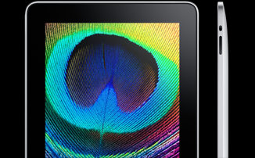
Figure7- 1 Apple iPad
A second product that would be similar to our project in terms of the packaging is the Crayola® Color Wonder Magic Light Brush [20]. This product is intended for children and allows them to paint in a way that the color only appears on the special paper.
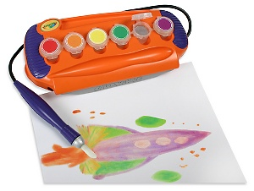
Figure 7-2 Crayola Color Wonder Magic Light Brush
    - Product #1
Although the Apple iPad has many other features besides painting-like applications, for the purpose of this assignment the focus will be on the packaging combined with the Brushes application. The Brushes application is an application for iPad, iTouch, and the iPhone that allows the user to paint an image [21]. While painting, the user has the ability to select between various types of brushes, choose any color, and undo or redo strokes. These images are automatically saved onto the device, and the user can later view the image or even replay each stroke to see how the image came about. The iPad is packaged in a 9.56” x 7.47”, 1.5 lb frame [22]. The screen has a resolution of 1024 x 768 on a 9.7” diagonal display [22]. The benefit of the packaging of the Apple iPad is its very thin frame that still manages to contain the touch screen monitor and all the internal components. This allows the iPad to be very lightweight and portable, which are both goals that we would like to accomplish with the Digi-Brush as well. However, users interact with the iPad by touching the screen with their finger whereas the intention of our project is to only allow users to interact with the screen through the digital paintbrush. The use of fingers with the Brushes application makes it more difficult for the user to paint effectively. The iPad is also designed for adult users, while the Digi-Brush is designed for users ages 5 – 10 who do not have the ability to detect color change as accurately as those ages 15 and above [23]. Because of this, the Digi-Brush would be much more suited for children ages 5 – 10 because the additional colors and brush techniques of the Brushes application on the iPad would be largely inapplicable. The Apple iPad costs $499, which will be much more comparable to our project than the Crayola® Color Wonder Magic Light Brush.

    - Product #2
The Crayola® Color Wonder Magic Light Brush was the original inspiration for this project. The packaging of the product consists of a plastic container that holds six different colors of paint, although each paint pot is actually filled with a clear gel. The product also comes with Color Wonder Paper, which is the only material on which the gel will display a color. A paintbrush that displays the color being painted through fiber optic LED bristles is attached to the plastic base. Our intention is to make our project look similar to this product, such that there will be a row of paint colors around the display monitor, the digital paint-brush will be attached to the base, and the entire product will be aesthetically pleasing to children with the use of bright, bold colors. We plan to adopt the look of the paintbrush as well, by using an RGB LED to display the selected color. The Crayola® Color Wonder Magic Light Brush costs $20, which will be significantly cheaper than our product’s final cost. However, Crayola’s product still contains paint that, though clear, can make sticky messes. Our project will have the benefit of not needing paint that little children can make messes with at all. In addition, the gel is thicker than paint the thick bristles of the paintbrush make it much harder to manipulate than watercolor paint. The Digi-Brush will allow the user to be more precise with their strokes.

  - Project Packaging Specifications
The Digi-Brush will be composed of two different components connected by a cable. The first module will be the base that contains the display and the color pots and the second module will be the paintbrush. The two modules will be connected by a cable, and the PCB will be housed in the base module. The Digi-Brush will be powered by a wall adapter, and will therefore have no power constraints such as conserving battery life.
The base module will contain a 15” display monitor that will have a 15” touch screen panel mounted on top of it. The reasoning behind a 15” display is that it is similar in size to an 8.5” x 11” piece of paper and the 15” monitor was less expensive than a similar 12” monitor. Along the edge of the display monitor will be an array of color pots similar to packaged paint sets for children. There will be 8 color pots, and each color pot will consist of a small plastic cup less than 1” in diameter. Attached to each pot will be a lid indicating the color that would be selected by inserting the brush into that particular pot. There will also be a clear color pot, to simulate a cup of water that one would use while painting. Along one of the sides of the monitor will be a slot for the SD card reader. Two buttons that can be pressed when the user would like to save or clear the painted image will be located along the edge of the base. The base module will also contain a PCB that will contain the microcontroller, FPGA, SDRAM, LED Drivers, and other necessary parts to determine when the touch screen has been touched and what should be displayed on the monitor and the brush. The base module will be made of a metal material as metal is durable, and easy to acquire. While metal may get warm, the components on the PCB do not create a significant amount of heat dissipation and therefore should not cause the packaging to become warm.
Connected to the base will be the brush module. It will be cylindrical in shape and connected to the base module through a cable coming out of one of its two ends. The cable will allow the RGB LED and force resistor to connect to the microcontroller and provide the necessary voltage to power the two components. The other end will contain an RGB LED that will indicate the color contained on the brush that would be displayed on the monitor if the user made a paint stroke. The brush will also contain a 0.5” diameter force resistor that will be used as an enable, with the theory that if the user is holding the brush and a touch is recognized on the touch screen, the user is most likely using the brush to make a paint stroke. The diameter of the brush will be 1”, which is the minimum diameter allowed in order for the brush to be able to support a flat surface for the 0.5” diameter force resistor. The length of the brush handle will be no less than 8”. Even with the large diameter, the brush should still be able to fit in a small user’s hand comfortably.
Drawings of the two modules can be found in Appendix B.

  - PCB Footprint Layout
The Digi-Brush will require a PCB footprint that will be able to have an overall size of 60 sq. in. The PCB will be housed in the base module underneath the LCD monitor. Because of this, the PCB footprint for the base module has little-to-no area restrictions as the display on the base will be greater than 15” diagonally and the footprint will be located underneath the display. The PCB will therefore be as large as it can be in order to separate the analog and digital components properly. The layout for the PCB footprint is provided in Appendix D.

  - Summary
This project will consist of two separate modules connected by a cable. The first module will be the base module that will house a touch panel, monitor, SD Card Reader, color pots, and a PCB. The second module will be the brush module that will resemble the brush that comes in Crayola’s® Color Wonder Magic Light Brush in that an RGB LED will display color. The overall size of the brush will be about 1” diameter and 8” in length while the size of the base will be much larger and constricted by the size of the display monitor.

- Schematic Design Considerations

  - Introduction
The Digi-Brush is designed to be a device that children can use to digitally create images that resemble watercolor-painted images using a digital paintbrush and a touch screen display. The brush module will send information from a force resistor to a Freescale microcontroller on the base module. The microcontroller and an Altera Cyclone II FPGA will be responsible for interpreting data from the touch screen panel as to where the panel has been touched and displaying the appropriate images on the screen. The microcontroller will also be responsible for determining color selection based on the voltage level of conductive foam in different color pots and displaying the color on the bristles of the paint brush through an LED driver on the brush.

  - Theory of Operation
The operation of the Digi-Brush is divided into two separate sections. The first section is the brush and the second is the base. The microcontroller and the power supply will be located on the base while the brush will contain a force resistor to determine gestures made by the user and LEDs to display the color being painted.

8.2.1 Brush
The brush will contain a force resistor that will be used to interpret when the user is touching the brush. The microcontroller on the base module will then determine the thickness of the stroke based on how many times the user squeezes the brush. The brush module will be connected to the base module by a cable.

Power Supply
The force resistor will operate at 5V in order to observe optimal characteristics after the ATD conversion [24]. Both power supply and ground will be provided from the base module through the cable connecting the base to the pen.
Force Resistor
The Interlink Electronics force resistor will be used with the touch panel, as an enable, to determine when the user is attempting to use the brush to paint on the screen. This will be done to prevent an image from being displayed when the user is pressing on the screen with his or her fingers or with objects that are not the digital brush. The force resistor will be connected to the microcontroller through an ATD connection.
LED Driver
A RGB LED at the end of the brush will display the color that would be painted should the user touch the brush to the touch panel. The RGB LED will be driven by two 5V LED Driver [25] located on the base module. The LED drivers will connect to the LED through a cable connecting the brush and the base modules. An I²C connection will connect the LED Driver to the microcontroller. The reason a LED Driver capable of an I²C connection was chosen was that all three SPI modules on the microcontroller were being used by other components; however these components were later deemed unnecessary and removed.

8.2.2 Base
Power Supply
The 15.1” monitor requires power from a wall outlet [26]. Due to wall outlet being an AC voltage and the rest of the components operating on DC voltage the power supply for the monitor will be separate from the power supply for the rest of the components. The power supply for the components will come from switching voltage regulators. This product is designed to run with a connection to an electrical socket due to the high power supply required by the monitor and the extra weight a battery would add.
Freescale 9SD12DP512 Microcontroller
The Freescale microcontroller will require a supply voltage of 5V [27]. The internal oscillator will be used for the clock signal, which operates at 25 MHz [27]. The microcontroller will be connected to several different components on the product that will use several different peripherals.
Altera Cyclone II FPGA
The Altera Cyclone II will be controlling the graphics for the product. It will receive information from the microcontroller regarding where the display has been touched and the current color being painted. It will then control the VGA outputs to the monitor with the VDAC and the SDRAM, using two parallel busses. The FPGA will also store the current image with the SD Card Reader when signaled to do so by the microcontroller, using a SPI. The FPGA runs on a power supply of 3.3V, although the internal circuitry runs on 1.25V [28]. The FPGA can operate on four different frequencies simultaneously. In order to interface with the SDRAM, SD card, VDAC and the microprocessor at the same time the FPGA will operate at 100 MHz and have the FPGA’s PLL generate a 25 MHz signal for the SDRAM and VDAC.
SDRAM
The data for the display will be stored on a Micron Synchronous DRAM MT48LC128M4A2. This SDRAM has a maximum clock frequency of 133 MHz [29]. The clock will be driven by an external oscillator that will provide a frequency of 100 MHz [30]. The SDRAM will operate best at 3.3V [29].
15.1” Monitor
The painted image will be displayed using a 15.1” monitor. The monitor receives input through a VGA connection and runs on a power supply of 90 - 264 VAC rms [26]. The monitor will be able to support a maximum of 16,194,277 colors, but due to programming constraints we will only use eight colors. The monitor has an optimum resolution of 1024 x 768 at 60 Hz, and has a horizontal synchronization of 30 – 60 kHz and a vertical synchronization of 56 – 75 Hz. The maximum pixel clock of the monitor is 80 MHz.
15.1” Touch Panel
The 15.1” touch panel will be mounted on top of the monitor and be used to recognize the location of the brush. The touch panel will operate on a 5V power supply, since this is the best resolution voltage for the internal A/D [31]. The touch panel will have one output that will be connected to the microcontroller with an ATD connection [32]. The microcontroller will use the voltage value to calculate the location of the brush.

SD Card Reader
The user will have the option of saving the current image to a Secure Digital Disk inserted into a slot on the side of the base. A 4UCON Technology SD Card Reader [33] will be used to write to an SD card. The SD Card Reader runs on 3.3V and will use SPI protocols to interact with the FPGA.
Color Pots
On the base module will be nine different color pots, eight of which will indicate a different color that the brush can be dipped into and a ninth will be clear, similar to the idea of using water to wash the bristles of a paintbrush. Each pot will contain a piece of conducting foam in the bottom connected to a 5V power supply. When the user presses the foam with the brush, the resistance of the foam will increase and the output voltage will decrease. Each color pot will be connected to the microcontroller through an ATD connection and the microcontroller will use the output voltages to detect when the brush has been dipped into a pot and which pot it was dipped into.

  - Hardware Design Narrative
Between all the various components that will be connected to the microcontroller, a total of eleven ATD lines, 1 I²C lines, and two GPIO lines will be used.

ATD
The touch panel, force resistor, and various color pots will all require a conversion from an analog signal to a digital signal that can be read by the microcontroller. The differential reference voltage for the ATD module on the microcontroller is 5V [27]. In total eleven ATD ports are necessary; one for the touch panel, one for the resistor, and nine for the color pots. Port pin AN0 will be reserved for the four inputs from the touch panel. Port pins AN5 – AN15 will be used for the eight pots that will represent the different colors of paint (red, orange, yellow, green, blue, purple, white, and black). The last ATD port pin used, AN4, will be the input from the force resistor.
TIM
The timer module on board the microcontroller will be used as a time-out for the paint strokes. Because paint cannot stay on a real paintbrush for an infinite amount of time, the Digi-Brush will mimic this functionality by having the timer module keep track of how long the brush has been allowed to create a stroke, and after a certain amount of time the display will stop displaying additional color. The TIM module is being used instead of an interrupt procedure because the amount of time the paint stays on the brush does not need to be exact and therefore does not need to interrupt any other functionality. No port pins will be necessary for the usage of this module.
I²C
The microcontroller contains one Inter-Integrated Circuit [27]. The component that will require an I²C is the LED Driver. Port pin PG6 will be used for SDA and port pin PG7 will be used for SCLK.
GPIO
The product will require two pushbuttons, one for saving images and another for clearing the image displayed on the monitor. Both buttons will be momentary contacts to ground when pressed and a 5V GPIO input when not. Both buttons will be connected with a 10 kΩ pull-up resistor and will be “debounced” internally on the microcontroller. The buttons will be connected to PP4 and PP5. The FPGA will interface with the microcontroller via SPI using pins PK0-PK3.

  - Summary
The main peripheral being used on the microcontroller is the ATD peripheral. The microcontroller will also use GPIO to interface with the FPGA and I²C to interface with the LED Driver. The FPGA will use two parallel busses to communicate the components that will display images on the monitor, and SPI to send data to the SD card. Due to the number of different components in the system, a total of four different voltages will be necessary to run this product.

- PCB Layout Design Considerations

  - Introduction
Digi-Brush is a touch screen monitor tethered, via a cable, with a “brush” that will enable users to paint digitally on a screen by touching the brush to the monitor. The user will be able to select colors by dipping the brush into foam that will change a LED color inside the brush indicating what color has been chosen/mixed. The user will also be able to save their creations onto an SD card to transfer to computer to view and print.
To display images on the monitor a FPGA with additional peripheral chips will be used. A microcontroller will also be used to interface with other peripheral chips and analog signals. Due to the amount of signals that will be used most of the components will be placed on the top PCB board allowing plenty of space on the bottom board to route signals that do not fit on the top, resulting in only needing a two layer board. The analog signals that will be used will be for the touch panel, pressure resistor in the brush, and color selectors. SDRAM, external oscillators, and a VDAC chip will be used in the project and will need to be placed close to their respective master chips. All other chips can be placed farther out for routing.

  - PCB Layout Design Considerations - Overall
The FPGA and microcontroller are the main components of the Digi-Brush and thus they will be placed in the center of the board. All input devices for the Digi-Brush are analog devices, which are: one signal for the touch panel, eight signals for the color selector, two for push buttons, and one signal for the force resistor. All the analog signals will be kept isolated on one side of the board to reduce EMI from affecting the rest of the digital signals [34]. Due to the microcontroller being the device that reads the analog devices, the microcontroller will be placed on the same side as the analog side and the FPGA will be placed on the opposite side. The microcontroller also connects to two LED drivers that will drive off board LEDs. The LED drivers will interface via headers to the LEDs, these headers will be on the same side of the board to reduce trace traffic.
The microcontroller must send the FPGA user input when the monitor is touched. However, the microcontroller operates at 5V [27] while the FPGA has a maximum operating voltage of 3.3V [28]. An 8-bit dual supply translating transceiver will be used to allow the two devices to communicate. The transceiver will be placed between the FPGA and microcontroller to allow direct trace connection.
The VDAC and SDRAM components are very sensitive and require consideration when placing on the PCB. The VDAC operates at 50 MHz while the SDRAM operates at 133 MHz and both will be using large parallel busses to communicate with the FPGA. With large amount of operation signals, skewing can become a problem. Both components will be placed close to the FPGA and I/O pins will be individually selected on the FPGA to allow for the closest connections to the given chips. The VDAC is especially noise sensitive and will have eight decoupling capacitors connected to it on bottom side of the board, which will allow the VGA signals to be on the top side [2]. The VDAC also has to interface to an external VGA connection so the chip will also be placed relatively close to an edge to connect to headers. Resistors will be connected to the traces connecting to the VGA headers to create the appropriate impedance for VGA protocol.
Since the FPGA does not store program data after power down a boot chip will be needed to program the FPGA on power up. Since the boot chip is not demanding on noise constraints and timing compared to the VDAC and SDRAM it will be placed farther away from the FPGA. However, it cannot be avoided that the traces of the boot chip will create some routing difficulties due to the fact that half the pins to program the FPGA are on one side of the chip and the other half are on another side of the chip. Luckily non power and ground traces will be seven mils wide which will be as small as possible to alleviate spacing issues when routing.

  - PCB Layout Design Considerations - Microcontroller
There are a few considerations to be taken for the microcontroller, given that it operates at a standard 5V and has fairly direct access to all the peripherals that it will be interfacing to. The microcontroller will be operating its native operating frequency of 25 MHz. However, an external resonator will have to be used to amplify the microcontroller’s internal clock. As recommended on the microcontroller’s data sheet [27] 0.1 µF bypass capacitors will be used.
As stated, the FPGA will be connected to a VDAC, SDRAM, boot chip, and the microcontroller. The FPGA will be operating at 100 MHz. The SDRAM is rated for a maximum operating frequency of 133 MHz, but also has a recommended operating frequency of 100 MHz. The FPGA’s PLL will be able to break the 100 MHz clock down to 25 MHz to operate the VDAC. The microcontroller will be generating a clock signal for the SPI that the FPGA and microcontroller will be communicating over. The boot chip supplies its own clock signal to the FPGA on power on to synchronize data transfer [35]. The FPGA will not generate the 100 MHz clock signal, an external 100 MHz oscillator will be used to generate operating frequency. The oscillator will be placed as close as possible to the FPGA to reduce the effect of the frequency noise from the oscillators, and also to preserve the clock signals from external noise.
The FGPA requires two different voltages of 3.3V and 1.2V to operate as intended. The PLL’s of the FPGA also have analog grounds that will need to connect to the analog ground. Analog ground will be connected to digital ground through the copper pour that will be used as a common ground for the whole PCB. The FPGA’s PLL’s also require decoupling capacitors for the voltage input pins. Due to the vast amount of passive components around the FPGA and the sheer amount of traces used to connect the FPGA to other components there is a high probability that many of the traces will be routed to the lower plane at one point or another.
For both the FPGA and microcontroller there will be three LEDs for operation status purposes. Each half of the FPGA will have its own set of LEDs. The LEDs will be in series with a 10k ohm resistor that is connected to the respective pins. For debugging purposes and possible backup expansion, almost all the unused pins of the microcontroller will be connected to headers. The headers will be far enough away from the microcontroller to not interfere with placement of any vital passive and active components.

  - PCB Layout Design Considerations - Power Supply
As noted the FPGA will be operating at 3.3V and 1.2V and the microcontroller at 5V. This will require the use of three voltage regulators, one for each required operating voltage. The input voltage for the regulators will be 9V, and then it will be regulated down to the proper voltage with the help of voltage division as suggested in the voltage regulators data sheet [36].
Each voltage trace will be 50 mils from the voltage regulators to nearby voltage input pins. Though the current PADs file does not reflect it the 3.3V and 1.2V rail will be routed along the outside of the FPGA half of the PCB board, and partially in the middle, due to all the different voltage input pins around the FPGA. The 5V rail will be routed along the outside of the other half of the PCB board. 50 mil ground rails will most likely also be used. Due to the FPGA’s PLL analog ground a digital and analog ground rail will have to be routed around the FPGA.

  - Summary
The printed circuit board layout for the Digi-Brush will have the FPGA and microcontroller in the center of the layout. A transceiver will be between the FPGA and microcontroller to enable proper communication voltage for each device. The microcontroller will interface with an LED driver, twelve analog signals, and have multiple headers for debugging and expansion. The FPGA will interface with an SDRAM, a VDAC, and a boot chip. The SDRAM and VDAC will be located as close as possible to the FPGA to prevent signal skew. Bypass/decoupling capacitors for all components that use them will be placed as close as possible to provide steady power. The board will be only two layers. There will be three main operating voltages of 1.2V, 2.2V and 5V.

- Software Design Considerations

10.1 Introduction
The DigiBrush is a children's painting set that simulates painting with on a 15” LCD touchscreen. The device is made up of three major components: the touchscreen display, color selectors, and the brush. The touchscreen will receive its input from the brush. When the screen is touched the current color will be displayed in that location on the screen. When dragged across the touchscreen it will simulate a brush-stroke. The color will change when the brush presses into a color selector pot. The color selected will mix with the color already on the brush and the LED in the brush will display that change.
  - Software Design Considerations
Since the device consists of two different programmable devices there will be two separate programming styles. The two major considerations for the microcontroller will be the inputs and the communication with the FPGA. The inputs for the microcontroller will consist of eight color selectors, a clear brush selector, the touch-panel, the force resistor, and the save and clear buttons. All inputs are essentially GPIO pins, with the exception of the touchpanel and force resistor. The touchpanel and force resistor will use ATD since they operate on voltage switching. The GPIO are used since most of the inputs will be used as switches. The inputs will be polled in a sequential continuous loop to ensure validity of an action. Polling was chosen to handle user input since our operating frequency is faster than what the user would recognize and thus it is not timing critical.
The three considerations for the FPGA are the generation of the VGA signal, the interfacing with internal RAM, and the SPI communication with microcontroller. The FPGA will use internal RAM since there were no useable open cores for SDR SDRAM. The SD card interfacing will also not be discussed due to the same issue external RAM had. The FPGA will utilize two open cores with modifications that handle SPI input and VGA synchronization.
Program space on the microcontroller will begin at 0x4000, which is the beginning of Flash array addresses [37] in the Flash EEPROM this space extends up to 0xFFFF. RAM uses 0x0800 and extends to 0x3FFF.

Module | Address | Description
PLL | 0x0034 - 0x003F | Phase Lock Loop for external oscillator
Timer | 0x0040 - 0x007F | Timer to simulate paint soak on brush
ATD | 0x0080,0x0088 | Registers for touch panel and force resistor
Digital I/O | 0x0081 - 0x0087,  0x0088 - 0x0089 | Color Selector Pots
SPI 1 | 0x00F0 - 0x00F7 | Interfacing with FPGA
IIC | 0x00E0 - 0x00E7 | LED Drivers (one for red one for green & blue)
RAM | 0x0800 - 0x3FFF | RAM Space
Fixed EEPROM | 0x4000 - 0xFFFF | Program Space
Table 10-1 Microcontroller Memory Mapping [27]

The PLL will use the same frequency of the external oscillator, which is 25MHz. ATD channels are set to return 8-bit, left-justified ATD values and will be converted to 10 bit. The IIC will operate in non-interrupt mode at approximately 70 KHz. The SPI block operates in Master Mode with no interrupts and will manually control the SS line for SPI transmissions to extend the amount of data sent to the FPGA. SPI will transmit at a rate of 1.56MHz. Most pins have been routed to headers on the PCB for to debug easily, these pins include the BDM port for in-system programming.
Program space on the FPGA is a little more complicated. Since the Cyclone II's memory is volatile the configuration device will be the one programming the FPGA on start-up. This device will configure the FPGA in the most efficient manner [38]. Almost all of the FPGA pins can be configured to be either input or output [28]. The FPGA will have two SPI ports, one SPI for the SD card and one for microcontroller packets. The other pins will be used to communicate with a 512 Mb external RAM and the VDAC. The VDAC will supply the VGA signal to the monitor. The SPI block for the FPGA will operate at whatever frequency SCK is set to by the microcontroller. The maximum SCK will be 100 MHz, due to the external oscillator of the FPGA. This will never be reached because the maximum rate the SPI form the microcontroller can operate at is 25MHz. The asynchronous data coming from the microcontroller will be synchronized using 3 internal registers for all data lines.

  - Software Design Narrative
The microcontroller will process all inputs, drive the LEDs on the brush and will be programmed in embedded C. The FPGA will handle the VGA signal, memory management, and microcontroller requests. The FPGA will be programmed in Verilog HDL. The FPGA will be programmed via the configuration device. No input will be reflected on the display until the FPGA is completely initialized.
10.3.1 Microcontroller
The microcontroller, after initialization will begin polling the analog inputs starting with the touch-panel. Thereafter, it updates the display by transmitting a 3 byte packet to the FPGA via SPI, continues on to the color pots, followed by the save and clear buttons and finally repeats.
To have a touch or color change recognized there needs to be force on the force resistor to ensure the brush is being held. If the user is holding the brush lightly it will not reflect the input of the user. The force resistor capture function first writes to the fifth ATD control register. This write signals an unsigned right-justified single conversion on the force resistor channel. It waits until the conversion is complete and compares the value to 0xFF. This value is the maximum pressure the force resistor can handle and since the resistor is very sensitive this value is easily achieved.
If a color change is detected it will call the update brush LED function. The brush LED function utilizes the IIC protocol to communicate with the LED driver [1]. The function firsts checks the busy signal it will wait until it is free. It then sets the IIC block to master. For each transmission over IIC the function waits for an acknowledge, sends data, clears the interrupt, then waits for a received acknowledge. The function first sends the address over the data bus, sets the LED driver modes, then writes to the internal data registers of the LED driver. The first three registers represent RGB values for the color selected respectively. The subsequent registers are written to with blank values for proper alignment. The function then signals the LED driver to turn on all of the LEDs.
To detect a touch the touchpanel's analog input is first averaged over five samples, then the standard deviation is found. The first STD is used to see if there was a touch on the X coordinate. If the STD for X is above 10 then it is not a touch. If it is below 10 then it repeats the average and STD for the Y coordinate and the STD is again compared to 10. The STD is necessary to eliminate the random values on the touch-panel lines from registering a false positive. The STD is used per datasheet suggestion. After a successful touch the update display function will be called. This function will form a packet consisting of the coordinates just received and current color on the brush. This packet will be sent to the FPGA via SPI.
Finally when there is a save or clear request, a packet is formed to inform the FPGA as such. The save request will form an almost null packet that contains a single bit that represents a save. Had an IP core been found the save bit would have saved the image on screen into the SD card. If no SD card is present it will do nothing. The clear request will also send an almost null packet. This will contain only 1 but as well that represents a clear. This simulates a fresh sheet of paper to begin painting anew.
The microcontroller code is working for determining a change on any ATD channels (touchpanel and force resistor), driving the LEDs, and capturing the color selectors. The packet transmitted to the FPGA will consist of 3 bytes, since the microcontroller can send one byte at a time. The first byte will contain the X coordinate, the 2nd will contain the Y coordinate, and the 3rd will contain the color and save clear update bits.
10.3.2 FPGA
The FPGA will constantly drive the VGA signal using standard 640x480 VGA protocol. The FPGA utilizes the PLL to generate a 100MHz clock the entire circuit and a 25MHz clock for VGA. Upon initialization the FPGA designates a 256x256 block of RAM to use for VGA storage. Each location in RAM has a depth of 3 bits to represent 8 colors. When an SPI transmission comes in it processes the request accordingly after it is complete. When a clear is requested it will write to all memory locations with white. When an update is requested it will write the color received to the coordinates received.
The VGA synchronization block counts 25MHz clock cycles. To generate the horizontal synchronization signal it counts 659 clock cycles then drives the H_SYNC signal low for 69 cycles. Then the signal goes back high. There are a total of 800 clock cycle counts for the horizontal synchronization signal. The vertical synchronization signal counts 493 clock cycles then drive the V_SYNC signal low for 2 clock cycles and then returns high. There are a total of 525 clock cycle counts for the vertical synchronization signal. These counts are used to meet the timing specifications of VGA [39]. When the horizontal count is less than 640 and the vertical count is less than 480 the VGA signal will output to the VDAC. At each clock cycle where the video is on the synchronization block will request one pixel from memory.
The SPI block will clock in the data signals to synchronize the inputs with the rest of the FPGA. Once the signals are synchronized on each SCK cycle from the microcontroller the SPI block will shift in the MOSI bit to a 24 bit shift register. When the SPI transmission is over the SPI block sets a flag to signal that data is ready to be processed.
The brain of the FPGA is the FPGA controller block. This will service all SPI request and VGA requests. This is essentially a 5-state state machine. Most of the time the controller will be in the idle stage. When an SPI transmission is received it will decode the packet and process accordingly. When an update signal is received it transfers into the write state. The write state will write the color in the SPI block to the coordinates from the SPI block. After a write the controller transfers to a SPI Clear state. This will clear the transmission complete flag. It will then transfer back to idle. When a clear request is given the FPGA controller transfers into a clear state. This will write “111” to all 65536 memory locations. Then it will clear the SPI transmission complete flag. While writing to internal Ram the VGA signal does not get serviced until it is completed writing. The idle state allows the RAM to be read by the VGA synchronization block.

  - Summary
Software design for the DigiBrush ultimately relies on the communication between the two major ICs. Those ICs are the Freescale microcontroller and the Altera FPGA. The information received in the microcontroller should be given to the FPGA in a timely manner to give the illusion of apparent motion. The microcontroller will operate in a continuous polling loop to ensure changes are responded to. If time allows other features not covered in the scope of this document may be implemented to increase user functionality and experience.

- Version 2 Changes

After finishing the Digi-Brush there is plenty of room for improvement and different ways to approach creating key functionality for the Digi-Brush in a simpliar fashion. Using an FPGA was a huge undertaking and seemed to add much more complexity to the project for the additional flexibility it provides. It was very hard to debug code that was running on the FPGA. However, once the project was complete a core staff membered mentioned there was debugging logic that could have been added to allow us to debug the FPGA while it was running. Adding debugging logic would be very helpful if the Digi-Brush was going to be revised.
An alternative to using an FPGA though would be much more attractive solution to creating the VGA signals for the display. Due to how complicated the timing is for SDRAM and SD cards it would be much more beneficial and simple using a beefy microcontroller with SDRAM and SD card library support. We also found out that interfacing to the VDAC is not that hard, the new microcontroller would just need to have a good number of pins and an additional PLL to generate the clock for the VDAC.
The touch panel for the Digi-Brush never produced a proper 0V-5V measurement probably due to the fact we had the microcontroller driver the voltages and grounds for the touch panel. Halfway through the semester it was discovered that Texas Instrument makes touch panel drivers, these drivers would most likely allow the touch panel produce a 0V-5V measurement.
The pressure sensor was also not as durable as we would have like it to be. Additional time could be spent to find a very durable pressure sensor that would last a much longer.

Summary and Conclusions

The Digi-Brush was challenging project from the start. With only three members in the team compared to the regular four everyone had to make sure they worked hard and efficiently. Along the way many milestones were accomplished and much was learned in the successful creation of the Digi-Brush.
Selecting components was difficult at times. Touch panel technology was new to everyone on the team and it was required of us to acquire the knowledge of how they worked if we were ever going to get the Digi-Brush working. VGA technology was something we all took for granted until we ourselves had to generate our own VGA signals to display user’s input. It took awhile but we eventually figured out how generate our own VGA signals and create the critical timing signals.
Seeing as no one on the team was an electrical engineer the creation and fabrication of the PCB was a tremendous learning experience. Once the PCB was in our hand the next challenge was soldering on surface mount components, which none of us had ever done. After a few fried components and a few solder bridges the hardware was completed. Though we all had experience in programming we did not know how to use IIC. IIC was required to communicate to the LED Driver.

References

- Texas Instruments 16-Channel Fm+ I2C-bus Constant-Current LED Sink Driver, [Online Document], 2008 Feb, [cited 2010 Mar], Available HTTP: http://www.ti.com/lit/gpn/tlc59116

- Analog Devies. CMOS, 330 Mhz Triple 10-Bit High Speed Video DAC. 2002. [Online]. Available: http://www.datasheetcatalog.org/datasheet2/f/0ckkuet47cit9uirrltkspr9e9fy.pdf . [Accessed: Feb. 2010]

- Mark Alan Zimmer, John Derry, “Digital Mark-Making Method,” U.S. Patent 5,767,680, December 7, 1995.

- John Bradstreet, Arthur F. Champernowne, “a Method and Apparatus for Digital Painting,” U.S. Patent 5,835,086, November 27, 1997.

- Michael D. Schuster, Gregg D. Wilensky, “Digital Painting,” U.S. Patent 6,870,550, April 26, 1999.

- Freescale. MC9S12DP512 Device Guide. 2005. [Online]. Available: http://www.freescale.com/files/microcontrollers/doc/data_sheet/9S12DP512DGV1.pdf?fsrch=1&WT_TYPE=Data%20Sheets&WT_VENDOR=FREESCALE&WT_FILE_FORMAT=pdf&WT_ASSET=Documentation. [Accessed Feb. 2010].

- Altera. Cyclone II Device Handbook. 2008. [Online]. Available: http://www.altera.com/literature/hb/cyc2/cyc2_cii5v1.pdf. [Accessed Feb. 2010].

- Micrel. LM2576 Datasheet. 2005. [Online]. Available: http://www.micrel.com/_PDF/lm2576.pdf. [Accessed March 2010].

- MIL-HDBK-217F Military Handbook - Reliability Prediction of Electronic Equipment. [Online]. Available: https://engineering.purdue.edu/ece477/Homework/CommonRefs/Mil-Hdbk-217F.pdf. [Accessed April 2010].

- “Safety,” Delta-M Electric, [Online]. Available: http://www.deltamelectric.com/safety.html. [Accessed: April 9, 2010].

- “Exposed Energized Wiring and Electrical Components,” February 2006. [Online]. Available: http://www.compliance.gov/forms-pubs/eresources/fastfacts_exposedwiring.pdf. [Accessed: April 9, 2010].

- “IEEE Code of Ethics,” IEEE, 2010. [Online]. Available: http://www.ieee.org/portal/pages/iportals/aboutus/ethics/code.html. [Accessed: April 9, 2010].

- Frank G. Splitt, “Engineering Education Reform: A Trilogy,” January 2003. [Online]. Available: https://engineering.purdue.edu/ece477/Homework/CommonRefs/enviro_refs.pdf. [Accessed: April 13, 2010].

- “Lead in Paint, Dust, and Soil: Basic Information,” U.S. Environmental Protection Agency, April 13, 2010. [Online]. Available: http://www.epa.gov/lead/pubs/leadinfo.htm#health. [Accessed: April 13, 2010].

- “Lead-Free and Proud,” 2008. [Online]. Available: http://www.screamingcircuits.com/services/lead-free.aspx. [Accessed: April 13, 2010].

- Bob McGrath, “The Effects of Lead-Free on PCB Fabrication,” February 2005. [Online]. Available: http://pcdandf.com/cms/images/stories/mag/0502/0502mcgrath.pdf. [Accessed: April 13, 2010].

- “Computer Recycling and Reuse”, 2010. [Online]. Available: http://earth911.com/recycling/electronics/computers/computer-recycling-and-reuse/. [Accessed: April 13, 2010].

- “iPad”, Jan. 2010. [Online]. Available: http://www.apple.com/ipad/. [Accessed: Feb. 8, 2010].

- “Rainbow Painter 3.1.2”, Feb. 9, 2010. [Online]. Available: http://www.apple.com/downloads/macosx/imaging_3d/rainbowpainter.html. [Accessed: Feb. 9, 2010].

- “Mess-Free Color Wonder Magic Light Brush”, [Online]. Available: http://www.crayola.com/products/splash/color_wonder/magic_light_brush/. [Accessed: Feb. 7, 2010].

- “Paint anywhere with Brushes on your iPhone”, 2009. [Online]. Available: http://brushesapp.com. [Accessed April 17, 2010].

- B. Chaffin, “Apple iPad Specs at a Glance”, January 27, 2010. [Online]. Available: http://www.macobserver.com/tmo/article/apple_ipad_specs_at_a_glance/. [Accessed: April 17, 2010].

- Vera J. Webber and C. W. Hunnicutt, “Children’s Ability to Perceive Color Change”, The Elementary School Journal, Vol. 48, No. 9, May 1948. [Online]. Available: The University of Chicago Press, http://www.jstor.org/stable/998993?seq=2. [Accessed: April 17, 2010].

- “FSR® Force Sensing Resistor® Integration Guide and Evaluation Parts Catalog,” [Online]. Available: http://www.sparkfun.com/datasheets/Sensors/Pressure/fsrguide.pdf. [Accessed: Feb. 17, 2010].

- “8-BIT Fm+ I2C-BUS CONSTANT-CURRENT LED SINK DRIVER,” 2009. [Online]. Available: http://focus.ti.com/lit/ds/symlink/tlc59108.pdf. [Accessed: Feb. 17, 2010].

- “SAMSUNG 150S/170S/190S,” 2002. [Online]. Available: http://downloadcenter.samsung.com/content/UM/200304/20030412151509656_BN59-00187P-02_En.pdf. [Accessed: Feb. 17, 2010].

- “MC9S12DP512 Device Guide V01.25,” Jul, 5, 2005. [Online]. Available: http://www.freescale.com/files/microcontrollers/doc/data_sheet/9S12DP512DGV1.pdf. [Accessed: Feb. 17, 2010].

- “Literature: Cyclone II Devices,” 2009. [Online]. Available: http://www.altera.com/literature/lit-cyc2.jsp. [Accessed: Feb. 18, 2010].

- “Synchronous DRAM,” 2000. [Online]. Available: http://download.micron.com/pdf/datasheets/dram/sdram/512MbSDRAM.pdf. [Accessed: Feb. 18, 2010].

- “LM1084 5A Low Dropout Positive Regulators,” June 2005. [Online]. Available: http://www.national.com/ds/LM/LM1084.pdf. [Accessed: Feb. 18, 2010].

- “5 Wire Resistive Touch Screen Specifications,” 2009. [Online]. Available: http://shop-on-line.tvielectronics.com/download/5-Wire_Resistive_TouchScreen_Specs.pdf. [Accessed: Feb. 17, 2010].

- “Various Resistive Touch Screen Technologies,” [Online]. Available: http://www.touchscreenguide.com/touchscreen/res.html. [Accessed: Feb. 17, 2010].

- “Breakout Board for SD-MMC Cards,” [Online]. Available: http://www.sparkfun.com/commerce/product_info.php?products_id=204. [Accessed: Feb. 18, 2010].

- Motorola. System Design and Layout Techniques for Noise Reduction in MCU-Based Systems. 1995. [Online]. Available: https://engineering.purdue.edu/ece477/Homework/CommonRefs/AN1259.pdf . [Accessed: Feb. 2010]

- Altera. Configuration Devices for SRAM-Based LUT Devices Data Sheet. 2005. [Online]. Available: http://datasheet.octopart.com/EPC2TC32-Altera-datasheet-11786.pdf . [Accessed: Feb. 2010]

- Micrel Inc. LM2576 52kHz Simple 3A Buck Regulator. 1998. [Online]. Available: http://www.micrel.com/_PDF/lm2576.pdf. [Accessed: Feb. 2010]

- Freescale FTS512K4 Block User Guide V01.06, [Online Document],
2001 Feb, [cited 2010 Mar],
Available HTTP:
http://www.freescale.com/files/microcontrollers/doc/ref_manual/S12FTS512K4V1.pdf

- Altera Configuration Handbook, Vol. 1, Sect. 1, Chp. 13: Configuring Cyclone II Devices, [Online Document], 2007 Feb, [cited 2010 Mar],
Available HTTP: www.altera.com/literature/hb/cfg/cyc_c51014.pdf

- VGA Output, [Webpage], 2007 Apr, [Cited 2010 Mar],
Available HTTP: http://www.johnloomis.org/altera/DE2/vga.html
Appendix A: Individual Contributions

A.1 Contributions of Caleb Ayew-ew:
All though all team members had multiple responsibilities; Caleb’s main focus was on the programming and implementation of the FPGA. The FPGA was quite a large portion of the project and thus it was designated a single programmer to expedite the process of using the FPGA. The responsibilities the FPGA would handle were SPI reception, VGA signal creation, and memory interfacing. Caleb decided it would be best to set these as separate blocks in the FPGA and then tie them together with a signal controller. Caleb thought it would be beneficial to learn Verilog HDL to program the FPGA.
Caleb started first on working on the VGA signal generation. VGA signal generation first required knowledge of VGA protocol and timing specifications for different resolutions. The DigiBrush was intended to operate at a 640x480 resolution. Caleb studied this timing specification the most. Once the timing requirements were understood Caleb began the layout for VGA generation. Caleb implemented a VGA synchronization block based on the code provided by John Loomis. The program originally displayed a simple test image onto a VGA monitor.
After the VGA signal was able to be generated Caleb worked on receiving SPI from the microcontroller. Caleb knew already how the SPI protocol worked so this was implemented and tested faster than the other blocks. The SPI block for FPGA was implemented using synchronization registers for the asynchronous inputs. Caleb then used shift registers to store the SPI information based off the synchronized input clock. Once the transmission was completed a flag needed to be a set.
Once SPI was written the main controller for the FPGA was written by Caleb to handle all process requested. These processes included the inputs from the VGA synchronization block, the requests from the microcontroller and the reading/writing to external RAM.
A majority of Caleb’s work was focused on getting the timing right for interfacing with the external SDR SDRAM. The timing proved to be a huge task. Caleb tried the simplest RAM configuration at first. The FPGA timing was always off and it never seemed to communicate correctly with external RAM. Caleb was never able to fully complete this task. Time now became an issue and in order to complete the project Caleb had to implement internal RAM blocks on the FPGA. This also required a change in the FPGA controller and SPI block. Once RAM was implemented on the FPGA Caleb completed the other blocks modifications. Once these were debugged and working Caleb worked with Katie to interface the microcontroller with the FPGA.
Once communication was working at a base level the transmission lines were probed by Caleb. Caleb discovered the SPI transmission was being interrupted by the slave select line. This is just how the microcontroller worked so Caleb modified the SPI reception block to handle this.
Caleb ultimately contributed the memory management and VGA signal generation to the DigiBrush product. Without the use of memory or a VGA signal the DigiBrush would not be able to have been completed.

A.2 Contributions of Kathleen Schremser:

While all members of the Digi-Brush had multiple tasks, the most significant contribution that Katie made to the team was the code that she wrote for the microcontroller. Smaller contributions that Katie made include research of I²C and the protocol for the LED Driver, testing and debugging software, and design and fabrication of the brush.
All of the code for the microcontroller was written by Katie. In order to program the Digi-Brush, Katie first had to find an IDE to allow her to write and compile code for the microcontroller. As the microcontroller was made by Freescale, she chose to use Freescale’s CodeWarrior Development Environment. Katie spent most of the initial weeks on the project learning how to use the development environment. Because the microcontroller used in the Digi-Brush was a 9S12 model made by Freescale and ECE 362 uses the same model, she was able to find working ATD and SPI initialization assembly code as well as functions written in assembly to capture ATD values and send data using SPI protocol from ECE 362 labs and adapt them for use by the Digi-Brush. By doing this, Katie was able to significantly decrease the amount of time spent debugging the peripherals this way. Before the microcontroller was soldered onto the PCB, Katie created testing modules for each peripheral and tested them with the M68DKIT912C32 development kit used in ECE 362, which contains a smaller 9S12 microcontroller than the one used in the final project. Once the microcontroller was soldered onto the board, Katie was able to merge all the different assembly modules into one combined C code. By creating the modules, Katie was able to speed up the programming and debugging of the algorithms used in the final project.
The largest function written for the microcontroller was a function to collect (x, y) coordinates from the touch panel and determine if it was because the touch panel was touched by the brush. Katie created multiple different algorithms to filter out unwanted values, as well as an averaging algorithm to give an average (x, y) coordinate as the values sent to the FPGA. Most of the debugging of the microcontroller involved finding better ways to filter out unwanted values.
Katie was unable to test the I²C needed for the LED Drivers as a module because the M68DKIT912C32 microcontroller does not support I²C. This protocol was also not taught in ECE 362, so in order to turn on the LED on the brush Katie had to learn the protocols of writing to registers in the LED Driver as well as learning I²C protocol. After testing multiple different ways to write to registers in the LED Driver, Josh suggested a protocol that had yet to be tried involving writing to all the registers in the LED Driver instead of one register at a time. Using this model, Katie was eventually able to find a way to turn on the LED using the LED Driver.
Katie was also able to contribute the brush to the project. She spent many hours creating a CAD model of the brush using Catia. This was especially difficult due the flat plane that the force resistor needed to sit on. Katie was then able to use her connections to the first-year engineering program at Purdue to turn this model into an actual brush with a prototyping machine located in Armstrong.

A.3 Contributions of Joshua Long:

Josh was the team leader of the team. At the beginning of the semester he met with the team to determine what they wanted to work on. Once the project was determined Josh looked into key hardware components, such as a touch display, microcontroller, and VGA protocol generator. As the team leader Josh determined what everyone would do.
Josh ordered most of the components that were used or secured them from Chuck. Josh created all the schematics that were used for the Digi-Brush. That required reading all the datasheets for all the components to determine how all the components should be connected. Josh had to create decals and pin outs for all the components used in the schematic that were not include in PADS libraries. Josh did all of the PADS tutorials so that he could do all the routing for the PCB. The PCB also required unique decal creations for some components. Josh did the Digi-Brush PCB layout five times. The last one was the final one that required him to drive to West Lafayette during spring break due to the fabrication house saying the PCB did not meet all fabrication requirements.
When the PCB arrived Josh had to make sure all the traces where connected properly. He discovered that all the traces were not connected properly and he had to do some fly-wiring once he had soldered on some of the components. Josh soldered on all components onto the PCB. Throughout the process of soldering on all the components he tested the functionality of each component after it had been soldered on.
Josh had to do some fly wiring and custom external component design when it was discovered that a different oscillator circuitry was required to generate a clock signal for the microcontroller. Later on there was some hardware failure that occurred that required Josh soldering on a new microcontroller twice. He also created an external PCB for an additional LED driver, due to the red diode in the RGB LED having different current requirement.
Throughout the development of the Digi-Brush Josh had to make hardware changes to how pins were connected. Once all most of the hardware and software was working Josh did all the wiring harnesses that connected the pushbuttons, color pots, paintbrush peripherals, SD card, and power. Josh fabricated base housing, which required cutting a fiberglass case. All the housing fabrication was done by hand, even the mounting of the touch panel onto the monitor.
Throughout the semester Josh helped Katie and Caleb debug their code. At one point Josh wrote out a detailed routine for which Katie could use to get the LED driver to work via IIC. Around the end of the semester Josh coded the SPI parser for the FPGA so that the proper data could be represented on the display.

Appendix B: Packaging

Figure B-1 Base Module

Figure B-2 Brush Module
Appendix C: Schematic

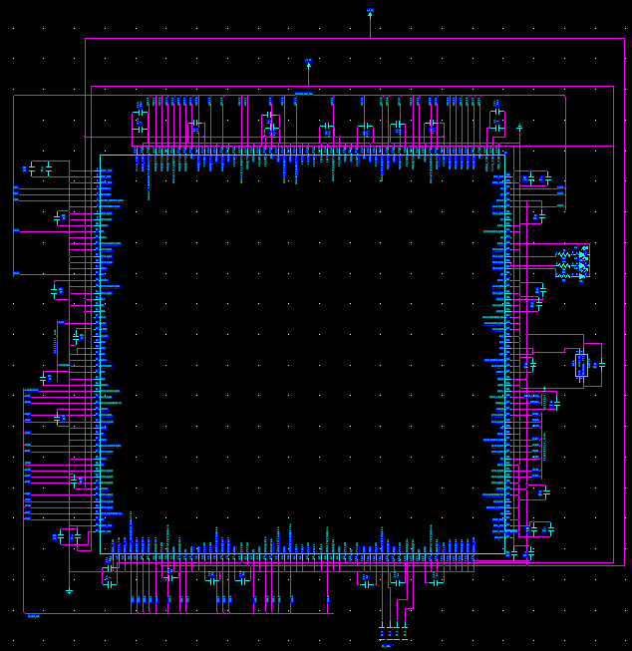
Figure C-1: FPGA Schematic

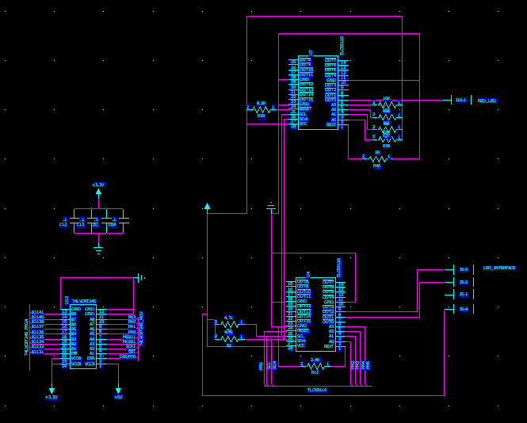
Figure C-2: LED Driver and Level Translator Schematic

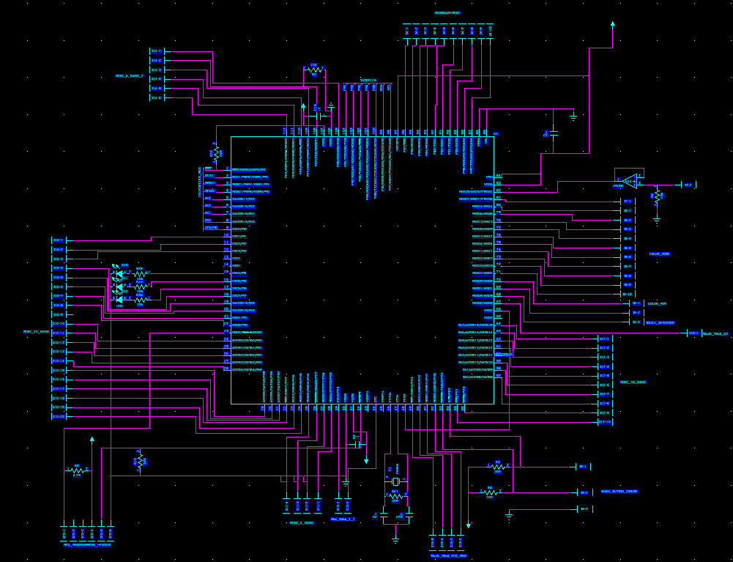
Figure C-3: Microcontroller Schematic

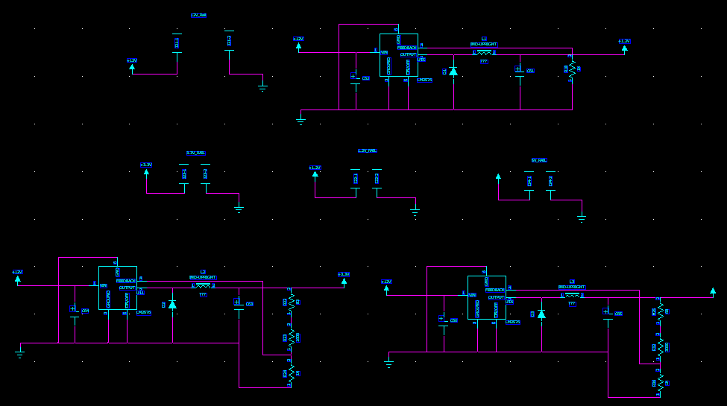
Figure C-4: Power Supply Schematic

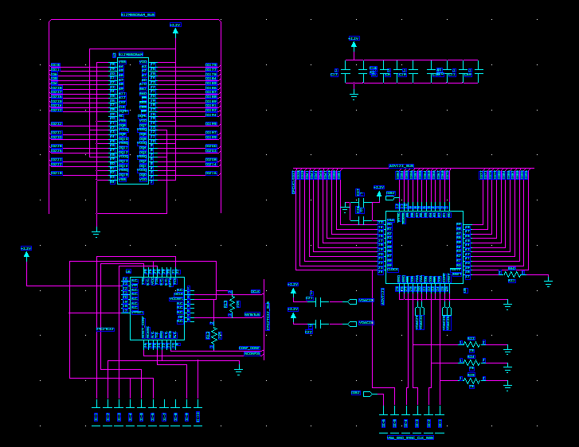
Figure C-5: SDRAM, FPGA bootchip, and VDAC Schematic
Appendix D: PCB Layout Top and Bottom Copper

Figure D-1: Top PCB Layer

Figure D-2: Bottom PCB Layer

Appendix E: Parts List Spreadsheet

Table E-1: Parts List Spreadsheet
Vendor | Manufacturer | Part No. | Description | Unit Cost | Qty | Total Cost
Arrow Electronics | Freescale | MC9S12CP512MPVE | 16-bit microctonroller | $23.78 | 1 | $23.78
Digi-Key | Analog Devices | ADV7123JSTZ240 | IC DAC Video | $12.45 | 1 | $12.45
Sparkfun | Freescale | MMA7260Q | Triple Axis Accelerometer Breakout | $19.95 | 1 | $19.95
Texas Instrument | Texas Instrument | TLC59116 | 24-Channel LED Driver | Sample | 2 | $0.00
TVI Electronics | NA | TSR-151-5W-SX | 15” 5-Wire Resistive Touch Panel | $96.00 | 1 | $96.00
Sparkfun | NA | SEN-09375 | Force Sensitive Resistor | $6.95 | 1 | $6.95
Sparkfun | NA | PRT-00136 | SD Card Socket | $3.95 | 1 | $3.95
Purdue | Altera | EP2C35F672C6N - K - CBC9Y0701A | FPGA | Donated | 1 | $0.00
Digi-Key | Altera | EPC2TC32 | FPGA boot chip | $37.50 | 1 | $37.50
Digi-Key | Micron | MT48LC32M16A2P-75 | SDRAM | $34.66 | 1 | $34.66
Amazon | Samsung | SyncMaster 150S | 15” LCD Monitor | $90.37 | 1 | $90.37
 |  |  |  | TOTAL |  | $325.61

Appendix F: FMECA Worksheet

Table F-1: Power Supply Functional Block
Failure No. | Failure Mode | Possible Causes | Failure Effects | Method of Detection | Criticality | Remarks
A1 | 5V output = 0V | Failure of U16, C66, D3, C65, L3, External Short | Device does not respond to user input | Observation | High | Could have a potential fire due to short
A2 | 5V output > 5V | Failure of U16, R36, R32, R25 | Possible damage to rest of circuitry | Observation | Medium | Could damage additional hardware
A3 | 5V output out of tolerance | Failure of C66, C65, R32, R36, U16 | Unpredictable operation | Observation | Medium | Could damage additional hardware
A4 | 3.3V output = 0V | Failure of U11, C64, D2, C63, L2, External Short | Device does produce the proper output | Observation | High | Could have a potential fire due to short
A5 | 3.3V output > 3V | Failure of U11, R24, R23, R22 | Possible damage to rest of circuitry | Observation | Medium | Could damage additional hardware
A6 | 3.3V output out of tolerance | Failure of C64, C63, R23, R24, U11 | Unpredictable operation | Observation | Medium | Could damage additional hardware
A7 | 1.25V output = 0V | Failure of U15, C62, C61, D1, L1, External Short | Device does not produce the proper output | Observation | High | Could have a potential fire due to short
A8 | 1.25V output > 1.25V | Failure of U15, R18 | Possible damage to rest of circuitry | Observation | Medium | Could damage additional hardware
A9 | 1.25V output out of tolerance | Failure of U15, C62, C61, R18 | Unpredictable operation | Observation | Medium | Could damage additional hardware

Table F-2: FPGA Circuitry Functional Block
Failure No. | Failure Mode | Possible Causes | Failure Effects | Method of Detection | Criticality | Remarks
B1 | No clock Signal | Failure of U10 or C14 | Device does not produce the proper output | Observation | Low | Will need to replace external oscillator
B2 | Corrupted Data Store | Software, Failure of U3 | Unpredictable graphical display | Observation | Medium | Could cause unpredictable behaviors on FPGA
B3 | No Video Output | Software, Failure of U5 | No display on LCD monitor, possible damage to monitor | Observation | Medium | Most likely would need to replace VDAC
B4 | Code does not load | Failure of U6 | Device does not produce the proper output | Observation | Low | Would need to replace boot chip
B5 | No file saved to SD card | Software, Short/Open circuit | No file on SD card | Observation | Low | Would probably just have to resolder connections

Table F-3: Microcontroller Circuitry Functional Block
Failure No. | Failure Mode | Possible Causes | Failure Effects | Method of Detection | Criticality | Remarks
C1 | Touch Panel does not work | Software, Short/Open circuit | User touch is no recorded, could damage microcontroller pins | Observation | Medium | User could not use product properly
C2 | Color pots do not work | Software, Short/Open circuit | User unable to select colors, could damage microcontroller pins | Observation | Medium | User could not use product properly
C3 | Pushbuttons do not work | Software, Short/Open circuit, Failure of R3, R4 | User unable to save or clear screen | Observation | Low | Most likely would need to resolder connections
C4 | LED Driver does not work | Software, Failure of U4 | LED does not illuminate | Observation | Low | Most likely would need to replace LED driver
C5 | SPI communication does not work | Software, Failure of U13 | No communication between FPGA and Micro | Observation | Low | Most likely would need to replace level translator

