ECE 477 Final Report − Fall 2009
Team 9 − DART

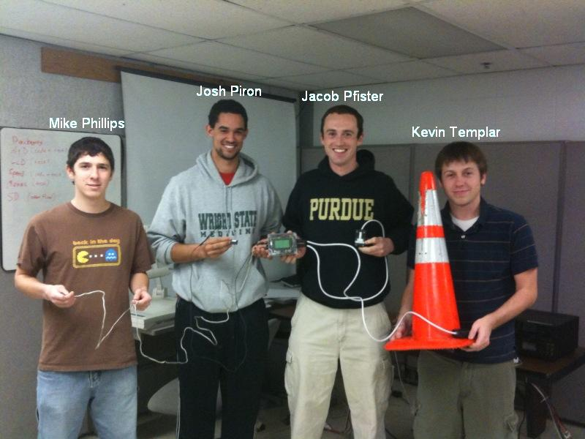
Team Members:

#1: ___Mike Phillips________ Signature: ____________________ Date: __12/14/09___

#2: ___Josh Piron__________ Signature: ____________________ Date: _12/14/09___

#3: ___Jacob Pfister________ Signature: ____________________ Date: __12/14/09___

#4: ___Kevin Templar______ Signature: ____________________ Date: __12/14/09___

CRITERION | SCORE | MPY | PTS
Technical content | 0 1 2 3 4 5 6 7 8 9 10 | 3
Design documentation | 0 1 2 3 4 5 6 7 8 9 10 | 3
Technical writing style | 0 1 2 3 4 5 6 7 8 9 10 | 2
Contributions | 0 1 2 3 4 5 6 7 8 9 10 | 1
Editing | 0 1 2 3 4 5 6 7 8 9 10 | 1
Comments: |  | TOTAL

TABLE OF CONTENTS

Abstract | 1
1.0 Project Overview and Block Diagram | 1
2.0 Team Success Criteria and Fulfillment | 3
3.0 Constraint Analysis and Component Selection | 4
4.0 Patent Liability Analysis | 8
5.0 Reliability and Safety Analysis | 11
6.0 Ethical and Environmental Impact Analysis | 15
7.0 Packaging Design Considerations | 20
8.0 Schematic Design Considerations | 23
9.0 PCB Layout Design Considerations | 26
10.0 Software Design Considerations | 30
11.0 Version 2 Changes | 34
12.0 Summary and Conclusions | 35
13.0 References | 36
Appendix A: Individual Contributions | A-1
Appendix B: Packaging | B-1
Appendix C: Schematic | C-1
Appendix D: PCB Layout Top and Bottom Copper | D-1
Appendix E: Parts List Spreadsheet | E-1
Appendix F: FMECA Worksheet | F-1

Abstract

The Driver’s Assistant Recorder and Tracker (DART) is a speedometer, a stop watch, an accelerometer, a temperature sensor, and a lap counter. The DART was built for the go kart enthusiast who is looking to improve their race performance by logging race data that they can analyze later to help them reach an optimal level of performance. The DART features a fully customizable screen that allows the user to choose which information is put on the screen, and also gives the user the choice of whether to log the data or not. If data is logged it will be stored on a SD card in a format that can be easily imported into a spreadsheet program for further analysis. All of the features of the DART are available for use during practice laps or solo go kart racing. The DART will be implemented with a variety of sensors installed on a go kart, each monitored and logged by a central microcontroller.

- Project Overview and Block Diagram

The DART features four external sensors that are used to gather data about the go kart. A thermocouple is used to report exhaust temperature and uses a ATD converter chip to send a usable value to the microcontroller. A magnetic switch and actuator are mounted near the axle of the go kart and the microcontroller uses the switch to determine the number of rotations that the go kart wheel has made during a time period. This allows the microcontroller to calculate an approximate speed value. The accelerometer has an x-axis and y-axis output which are sent to the ATD module of the microcontroller so that a value for g-force in the x and y directions may be calculated. The final sensor is an infrared detector that is a digital input to the microcontroller and signals when to increment the lap count. The DART also interfaces with a SD/MMC card through the use of a uALFAT-SD breakout board. This board is used because it handles the proper formatting of files so that they can be opened up on a computer in a text file (.txt). The microcontroller used in the DART is a pic33FJ128MC804, and it was chosen because of its multiple reprogrammable pins that allow for versatility during the PCB design when deciding what peripherals to output on what pins. The DART is run off of a rechargeable 3.7 V Li-ion battery and also has the ability to be run off of wall wart power while the battery is being charged.
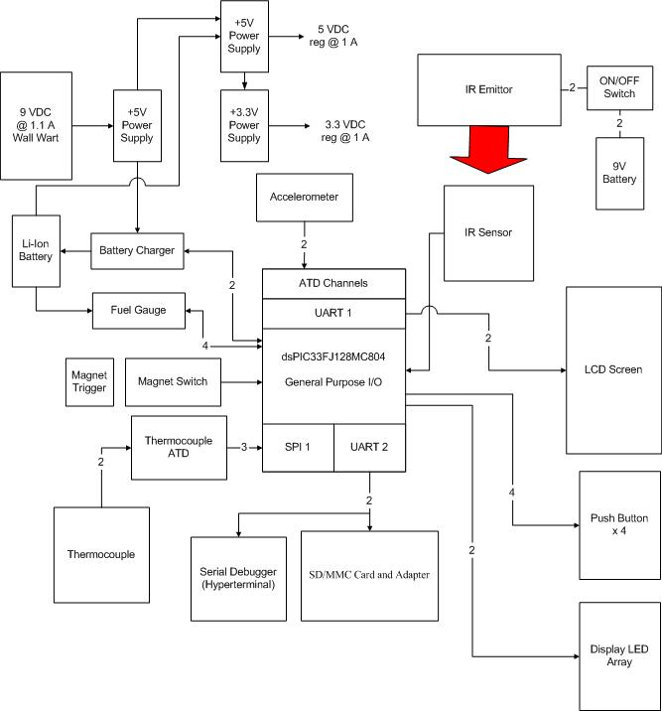
Figure 1-1. Block Diagram.
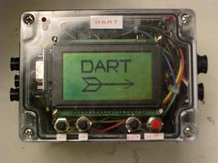
Figure 1-2. DART Module.

- Team Success Criteria and Fulfillment

1. An ability to log data from various sensors.
- PSSC 1 was successfully demonstrated.
- The various sensors included a speed sensor, lap sensor, temperature sensor, x accelerometer and y accelerometer.
2. An ability to time and count laps.
- PSSC 2 was successfully demonstrated.
- Using the lap sensor and a stopwatch generated using the external oscillator, laps were successfully timed and counted.
3. An ability to monitor battery life.
- PSSC 3 was successfully demonstrated.
- Using the microcontroller interfaced with a pair of battery monitoring chips and saving battery values to the SD card, battery life was successfully monitored.
4. An ability to store data on external memory.
- PSSC 4 was successfully demonstrated.
- Using a uALFAT board interfaced to the microcontroller with the UART module, data was written successfully to an SD/MMC Card.
5. An ability to customize race display.
- PSSC 5 was successfully demonstrated.
- Using a set of menus, the user is able to customize the graphs and text to be displayed during a race.

Constraint Analysis and Component Selection

  - Introduction
The DART is a speedometer, a stop watch, an accelerometer, and a lap counter. All of the features of the DART are used during practice laps for go kart racing. The speedometer and accelerometer are also usable during live races. The DART will be implemented with a variety of sensors installed on a go kart, each monitored and logged by a central microcontroller.

  - Design Constraint Analysis
The primary design constraints for the DART are similar to any mobile device to be used in the field. Durability, battery life, and of course function are the greatest concerns for any field device and the DART is no different.
Durability is a concern due to the high speeds and large forces acting on a go kart and therefore acting on the DART. The device must be able to sustain similar forces that the driver experiences. These include vibration, g-force, and the possibility of a crash. For this reason, strong mountings and strong packaging are a must for the DART. Like all mobile devices, the DART must have a practical battery life. For this reason power consumption is a large concern. The device will operate on a lithium-ion battery. The separate beacon will run on a single nine volt battery. This can be achieved with careful device selection. On top of battery life and durability, the DART must function well in the field. The display and user interface of the DART must be easily readable for use during fast paced racing. This is achievable with smart design and device selection.

    - Computation Requirements
The microcontroller will be expected to do a variety of calculations. Virtually all of the sensors will send an analog signal to the microprocessor. Because of this, multiple ATD converters are required and the conversion will be a bulk of the work done by the microprocessor. The calculations for the statistic and data displayed are varied. Some will be relayed after the ATD conversion, other calculations will require waiting for inputs and comparing them to the internal clock of the processor.
The magnetic sensor will be attached to the fixed back axle and will rotate with the axle in order to measure speed. A 10” tire has a circumference of about 2.62 feet and in a solo race can be anticipated to not get any faster than about 80 mph (about 117.3 feet per second). This would mean that the axle will be spinning at 44.8 Hz. This is very easy to be able to sample at this low rate putting no strain on the microcontroller.
Since we are storing all the logged data to an SD card or similar, we need to make sure the microcontroller can handle the amount of data and that the SD card is sufficiently large to hold it. If we have 5 inputs and each gives us a 16 bit value then that is 10 bytes of data. The device is currently planned to sample at a minimum of 10 Hz so this is 20 bytes per second, a very low data rate. A solo race does not last longer than 5 minutes and is usually more on the order or 1 or 2 minutes. If the race was 5 minutes (300 seconds) then at 20 bytes/second the average race would consume 6000 bytes which means that at minimum thousands of races should be able to be stored on any SD card.

    - Interface Requirements

There are a few basic functions that the general purpose I/O of the microcontroller will need to perform. The first is to sample several input sensors such as accelerometers and IR sensors. Some of these inputs will be digital and require no conversion, however, several will be analog, and the microcontroller will interface directly to these sensors using an ATD module. These input sensors will require at least six input pins, with four of those interfacing through the ATD pins. This will interface to the microcontroller through two timer input capture pins. The largest number of output pins will be needed to drive a LCD display, which will require 12 pins to control. However, if necessary to reduce the number of pins it is possible to make use of a SPI interface on the microcontroller in combination will an external shift register to reduce the number of I/O pins used by the LCD to two or three.

The DART will also need to interface with a smart card external memory adapter. This function will also make use of a SPI interface and an additional two pins to accomplish data transfer. The remaining I/O pins will be used for input push buttons used to customize the user display and status LEDs to report things such as high engine temperature or low battery. At least 10 I/O pins will be required in order fulfill this requirement. None of the components chosen place any additional voltage/current constraints on the microcontroller. It has also been determined that there is no reason to plan on optically isolating any of the inputs to DART.

    - On-Chip Peripheral Requirements
A select set of peripherals are necessary for the DART’s microprocessor. A minimum of four ATD channels were necessary for monitoring battery life and the multiple analog sensors; for this reason, a conservative decision of at least 8 ATD channels was made. To interface with external memory, a direct method already in hardware would have been desirable to interface directly to SD/MMC, but many of these chips did not meet other criteria and were impractical. Instead, interfacing with external memory will be done with software and SPI. Information is available on how to interface with either SD/MMC or USB with SPI. Other peripherals such as I2C, Ethernet, PWM, or RS-232 series I/O were not specifically needed so these features were not sought after in our chip selection but were not specifically avoided either.

    - Off-Chip Peripheral Requirements
The off-chip peripheral requirements for this project are numerous since this is mainly what the project is about: getting data from the surrounding environment. A magnetic detector switch with accompanying magnetic trigger will be used to measure the speed of the vehicle, this will be debounced in software. A thermocouple and thermocouple probe will be used for gathering the engine temperature. Somewhere along the center of the kart an accelerometer will be mounted to give feedback on the G forces experienced. Lastly, an IR emitter/receiver pair will be used to monitor laps and help time them.

    - Power Constraints
Since the DART is a mobile device, intended for use in a go kart, it will be battery-powered. A single or pair of standard nine volt batteries will need to power the device for a practical amount of time. With this constraint in mind, power consumption will be an extremely important factor for all components and must be limited wherever possible. A microcontroller with a low operating voltage is a must, and the LCD is sized exactly to the application, no larger than necessary, with low power features. Finally, a switch mode power supply (SMPS) is required for high efficiency in drawing power from the battery.
The external IR transmitter required for lap timing will also operate on a nine volt battery, but the power requirements in this case are much more lenient. The power supply and the transmitter are the only components in the device, and the transmitter should draw less than 100 mW. An SMPS will still be utilized to extend battery life as long as possible.

    - Packaging Constraints
The rugged nature of the go kart necessitates a fairly robust packaging design. As the various sensors are distributed throughout the vehicle, each component is in a slightly different environment. Of major concern for all components is the vibration generated from the vehicle racing around the track, so secure mounting between the components and the packaging, as well as between the packaging and the go kart, is required. Some amount of shock absorption may also prove necessary. A heavily insulated, high-temperature thermocouple is required in the high-temperature (~1200°F) environment of the exhaust pipe. Some amount of insulation may also be necessary for the accelerometers. The accelerometers would ideally be mounted in the center of the vehicle, relatively close to the engine. Highly insulated wire will be necessary in these environments. The central packaging, which houses the microcontroller, PCB, and LCD, has been selected for mounting to the steering wheel so that the driver can see it easily. Fortunately, this configuration also provides for what should be the least heat-intensive environment on the go kart, but the packaging will still need to be able to withstand the significant vibration channeled by the steering column and the motion of the steering wheel itself. Protection from a light drizzle of rain is important, but since go karts do not generally race in a downpour, the packaging need not be “waterproof”.
The environment for the IR transmitter is much more forgiving. The current configuration is to mount it inside or on top of a standard traffic cone for practical as well as aesthetic reasons. While the packaging should be robust enough to protect the circuitry from a simple fall due to the cone getting knocked over, it may not be feasible to ensure the integrity of the circuitry against an outright collision with a go kart. The packaging should protect the transmitter from a modest amount of rain.

    - Cost Constraints

The direct competitor for this product would definitely be the MyChron series of go kart data acquisition gauges and displays. This series of data loggers and displays operates in a similar manner to how the DART is envisioned to operate. Both systems look to combine a lap timer and various sensors into a small, lightweight display that can be mounted to the steering wheel of a go kart. The basic model of the MyChron4 includes the display unit, an infrared receiver, a RPM pickup, and a temperature sensor. The suggested retail price of this basic model is $389. However, if you wish to add more sensors to the data logger you will need to buy the expansion box which comes with a wheel speed sensor and has a suggested retail price of $419. In order to remain competitive in this market the DART looks to offer more at a lower price. The goal is to keep the cost of the DART to be within +/- 10% of the basic MyChron4 package. However, the DART will require no extra expansion box to also track data on speed and acceleration. Also, all needed sensors will be supplied as part of the package. It is this all inclusive concept that will help the DART dominate the market place.

  - Component Selection Rationale

The choice of suitable components for DART is paramount. As previously stated, a wide variety of design components for this mobile device necessitated thorough and well thought selections.

A major selection in this process was the LCD screen. Displaying lap time, speed, and acceleration in a way that increases the driver’s awareness without hindering his driving ability is crucial. For this reason a device of adequate size and detail was necessary. But this LCD must not be so powerful that it greatly impedes battery life. After much research, a few different LCDs were researched. Considerations for Size, Color, Power usage, Documentation, and transflective (best for use in sunlight) properties were made.

LCD | CFAG12864A-YYH-VN | CFAX12864U1-WFH | NHD-12864WG-BTFH-V#N
Dimensions | 93 mm x 70 mm | 56 mm x 83 mm | 75 mm x 52.7 mm
Resolution | 128 x 64 | 128 x 64 | 128 x 64
Color | Green | Grey | White
Transflective? | No | Yes | Yes
Volt/Amps | ~18mA / 5.0 V | ~0.18mA / 8.5 V | ~4.0mA / 8.0
Docs | Adequate | Adequate | Excellent
Interface | 8bit Parallel | 8bit Parallel / SPI | 12 bit Parallel

Figure 3.3-1. LCD Selection

The NHD-12864WG-BTFH-V#N was eventually selected due to its excellent data sheets and comparable power, resolution, and size to the best of the other LCDs.

Another major selection was the microprocessor. As stated before, the main constraints were the number of ATD converters, more than one SPI, and a higher operating frequency. Considerations about power and documentation were also made. The chips also of course had to be in production.

Chip | dsPIC33FJ128MC804 | PIC18F4450 | MC56F800x
CPU Speed (MIPS) | 40 | 12 | 32
Internal Flash (kByte) | 128 | 16 | 16
Internal RAM (byte) | 16,384 | 768 | ~200
ATD | 9 x 10 bit | 13 x 10 bit | 2 x 12 bit
Digital Communication Peripherals | 2-UART, 2-SPI, 1-I2C | USB | LIN, I2C, SCI, SPI
USB | No | USB 2.0 | No
I/O Pins | 35 | 30 | 26
Pin Count | 40 | 40 | 40
Operating Voltage | 3 to 3.6 | 2 to 5.5 | 1.8 to 3.6

Figure 3.3-2. Microcontroller Selection

The dsPIC33FJ128MC804 was eventually selected doe to its overall performance. It has massive ram and flash, an excellent MIPS, two SPIs, 35 I/O pins, and a fairly low operating voltage.

  - Summary
Throughout device selection, one theme was constant. The group selected each device, to the best of our ability, focusing on flexibility. The idea was that as the project would likely change over the following weeks and that the ability of the hardware to adapt to adjust to possible improvements and problems would be necessary. For this reason, a microcontroller with extra ATD converters and two SPI units was selected. A similar theme was followed with the selection of thoroughly researched sensor pieces and an LCD with plentiful documentation.

- Patent Liability Analysis

  - Introduction
The PSSCs are the main functions of the DART system and it is these functions that could possibly infringe upon existing patents. The rest of this report will compare the main functions of DART to two existing patents and one commercial product. After a investigation of existing patents and products it was determined that the potential for infringement exists and a course of action to remove the infringement must be taken before the product can be sent to the market. The possible solutions will be discussed at the end of the report.

  - Results of Patent and Product Search
The first patent that will be investigated is US patent number 5173856, Vehicle Data Recording System. This patent was filed on October 5, 1990 and patented on December 22, 1992. This patent describes a system in which one or more analog sensors send information to a main unit where the values are converted into digital values and then stored into memory. All of these processes occur while a vehicle is taking laps around a track. This invention was intended for an on-board computer which was designed to be put in racing cars. This patent has seven claims, the first of which presents the most potential for infringement. This first claim states, “A vehicle data recording system for connecting to at least one analog sensor on the vehicle, and for storing sets of data there from during a plurality of chosen periods of operation on a course” [12].
The second patent that will be discussed is US patent number 5189305, Timing Apparatus Particularly for Racing Vehicles. This patent was filed on November 13, 1991 and patented on February 23, 1993. In the patent a system is described to have the capabilities to "provide timing information to a moving person moving past a datum line" [13]. This is done by having an electromagnetic radiation source located at the datum line and a radiation sensor located on the moving person. This way when the person passes the line a sensor signal will be generated indicating that the line has been crossed. The system also describes a user display that would show various timing information such as the time of crossing the datum line. This patent has a list of six claims, the fifth of which possesses the most potential for patent infringement. This fifth claim describes in more detail what is meant by timing information and lists as one example, "the time elapsed between the latest two successive crossings of the datum line so as to represent a lap time."[13] The background information for the patent also states that the timing apparatus described was intended for use in "racing vehicles such as motor cars, go karts, speed boats."[13]
There is a commercial product that is made by AiM Sports that shares many functions with the DART. This product is called the MyChron4 and is advertised as a digital gauge and data logger for go kart racing. The MyChron4 looks to combine a "temperature gauge, tachometer, lap timer, and data logger into a compact, powerful unit that easily mounts" [21] to the steering wheel of a go kart. The product uses a graphic LCD to display all of the gathered information to the driver and uses 1 MB of memory to store over three hours of race data. There is also an optional data key that interfaces to the unit using USB which allows the user to transfer the race data to a PC. According to AiM Sports there are no patents pending or that have been issued to date that deal with the MyChron4 technology. This makes sense since there are some other products on the market that perform similar functions to the MyChron4, however, it is possible the AiM Sports is paying royalty fees to patent holders that the MyChron4 potentially infringes upon. The company did not mention anything of this nature, but it is certainly a possibility.

  - Analysis of Patent Liability
The main functions performed by the DART system share several similarities with the patents and commercial products described in the previous section. DART could be infringing upon US patent 5173856, Vehicle Data Recording System under the doctrine of equivalents. The main function described in this patent is substantially the same as the main function of DART, displaying vehicle information to a user. The manner in which this function is achieved is also substantially the same way. Both systems take data from analog sensors around a vehicle, convert those signals using an ATD, and then store that data in memory as well as display the information to the user. The differences between the two are very minimal. For example the DART collects data on speed, exhaust temperature, and acceleration, but, this patented system collects data on oil temperature, rpm, oil pressure, water temperature, and wheel movement. However, it is the collection of analog signals coming from sensors around a vehicle that is patented, so DART would most likely be found to infringe this patent.
DART most likely is not infringing upon US patent 5189305, Timing apparatus particularly for racing vehicles, under the doctrine of equivalents. Both systems perform substantially the same function of detecting when a moving body has crossed a certain line. It even goes so far as laying claim to using this device to calculate a lap time or a best lap time, both of which DART performs. It could be argued, however, that DART achieves this function in a substantially different way by using an infrared light instead of electromagnetic radiation. The patent describes using electromagnetic radiation to create a radiation zone and then uses a calculator circuit to find the time that the vehicle crosses a line. However, the DART uses infrared and simply increments to the next lap upon detection with no calculator circuit. It may be possible to make a case based on this difference, but if this failed then DART would be found to infringe upon this patent under the doctrine of equivalents.
If the MyChron4 were a patented piece of technology then DART would also be
literally infringing the patent for this product. DART could even be viewed as providing a
subset of the properties that the MyChron4 offers. Both systems have the main function of taking sensor data from throughout a go kart and storing/displaying that data to the user. Both systems also keep track of timing information such as lap time and best lap time. The packaging is also very similar in that both systems are designed to mount to the steering wheel of the vehicle. The main difference between the two systems is that DART uses an SD/MMC protocol to store all data to an external memory source, whereas MyChron4 uses a USB protocol. The MyChron4 also takes measurements from some extra sensors such as RPM that DART does not support. However, when looking only at the functions performed, DART and MyChron4 do the same thing and therefore the potential for infringement exists.

  - Action Recommended
The main concern for patent infringement comes from the first patent described over the Vehicle Data Recording System. The second patent has little to no potential for infringement and since the MyChron4 has no patents it is not illegal to create a similar product. The best way to alter the current design of DART would be to change all of the analog sensors to digital sensors. This way a case could be made that although the two devices perform substantially the same function of collecting and displaying vehicle data, they perform the function in a substantially different way. The claim language of US patent 5173856 is very specific to describe an analog system that requires analog to digital conversion before being displayed to the user. If digital sensors were used then the method of sensing would be different and therefore legal. If this was found to be insufficient then it would also be an option to wait a few years as the patent is set to expire shortly. The best solution would be to look into paying licensing/royalty fees to the patent holders in order to make manufacturing and selling of the DART legal.

  - Summary
The DART has several very close similarities to both existing patents and commercial products. The Vehicle Data Recording System poses the biggest threat for patent infringement. For these reasons a change of the design would be necessary before DART could be produced and sold to the public. Another option would be to pay the royalty fees necessary to use the patented ideas the DART was found to be infringing upon. Therefore the DART system as it is designed right now is not a viable product because of patent infringement problems.

- Reliability and Safety Analysis

  - Introduction
DART is a device that logs and displays pertinent data to the operation and tuning of a go kart participating in solo type racing. The system consists of a custom circuit board, LCD, battery, and SD card board mounted inside a small plastic box that sits atop the steering wheel of a go kart. The system interfaces with various sensors mounted throughout the body of the go kart as well as the LCD and SD card board internal to the enclosure.
The system must be physically rugged to withstand the environment of a moving, racing go kart out in the hot sun pulling upwards of 3 G's. The connectors chosen are rugged and water resistant, and likewise the case. The thermocouple is designed to withstand and accurately read up to 1024 degrees Celsius so no go kart motor should be able to thermally harm this aspect of the device while operating properly. The external sensors which contain bare circuitry (accelerometer, infrared lap timer) will be housed in their own sturdy, water resistant box to help protect them. These measures should help ensure the reliability and longevity of the device.
The safety of the consumer of this device is of significant importance to the designers of DART. Care must be taken to design around the failure states of the device so that if it does fail, it fails in a safe manner. DART, fortunately, should not be much of a safety concern to the end user since it has no moving parts and controls nothing which could cause physical harm to the user. The main safety consideration in designing the system, therefore, is the prevention of overheating and fire hazards by the device. This, of course, primarily concerns the power and battery regulation circuitry, but all subsystems should be analyzed for safety. As such, the system will be broken down into the battery regulation circuitry, wall wart power circuitry, the 3.3V and 5V boost power circuitry, the thermocouple circuitry, the serial level translator circuitry, and the microprocessor circuitry and the failure modes of each of these discussed.

  - Reliability Analysis
Three components were chosen for reliability analysis since the failure of any of these components was deemed critical. The dsPIC33FJ128MC802 was chosen for analysis since it is the most complex component and without it the device does not do anything meaningful. The LTC4054-4.2 standalone linear li-ion battery charger was chosen for its high power consumption and because it directly controls the charging of the battery. The TPS61031PWP 3.3V synchronous boost converter was chosen for its high power consumption and for its critical role in powering most of the components of the DART system. The Military Reliability Prediction of Electronic Equipment Handbook [30] will be used to determine the failure model of each of these components.
The model that best fits the microcontroller is that of section 5.1 [30]. The failure rate is here defined by the equation $λ_{P}=(C_{1}π_{T}+C_{2}π_{E})π_{Q}π_{L}$ failures per 10⁶ hours of operation. The die complexity failure rate, C₁, was determined to be because the microprocessor is a 16 bit device. The junction temperature, T_{j}, can be found from the equation $T_{J}=θ_{\text{JA}}P+T_{A}$ in section 5.8 [30] where the maximum power draws was assumed at 825 mW as per the microcontroller datasheet [7]. The value of $θ_{\text{JA}}$ was found in the datasheet as well to be 30°C/W and the case temperature was assumed at 35°C. This leads to a T_{J} of 58 and using the table in 5.8 it is found that π_{T} corresponds to 0.42. Assuming the microcontroller is in a 44 pin, nonhermetric package, C₂ then corresponds to 0.03 according to the chart in 5.9 [30]. The environment factor, π_{E}, is 4 since the device will be ground based but obviously mobile since it is mounted to a go kart. The quality factor, π_{Q}, is 10 since the microcontroller is a commercial, not a military, product. Finally, the learning factor, π_{L}, is 1.0 because the microcontroller has been in production more than 2 years.

Parameter | Value | Justification
C₁ | 0.28 | 16 bit microprocessor
π_{T} | 0.42 | $$T_{J}=θ_{\text{JA}}P+T_{A}$$
C₂ | 0.03 | C₂ = 3.6e-4 * (44)^{1.06}
π_{E} | 4 | Mobile ground device
π_{Q} | 10 | Commercial component
π_{L} | 1.0 | In production for > 2 years
λ_{P} | 2.34 | λ_{P} = (C₁π_{T} + C₂π_{E}) π_{Q}π_{L} Failures/10⁶ Hours
MTTF | 4.281e5 hrs  48.87 years | MTTF = 1/λ_{P}
Figure 5.2-1. Microcontroller Analysis

The second component to be analyzed is the standalone li-ion battery charger which can best be modeled by section 5.1 [30] using the digital MOS device model. The failure rate is here defined by the equation $λ_{P}=(C_{1}π_{T}+C_{2}π_{E})π_{Q}π_{L}$ failures per 10⁶ hours of operation. The die complexity failure rate, C1, was assumed to be 0.01 which corresponds to 1 to 100 transistors. This was assumed since, from looking at the block diagram in the corresponding datasheet [31], the block diagram looks extremely simple. The junction temperature, T_{J}, can be found from the equation $T_{J}=θ_{\text{JA}}P+T_{A}$ in section 5.8 [30] where the maximum power draw was assumed at 0.8 W, as per its datasheet [31]. The value of $θ_{\text{JA}}$ was found in the datasheet as well to be 125°C/W This leads to a T_{J} of 125 and using the table in 5.8 it is found that π_{T} corresponds to 58. Assuming the component is in a 5 pin, nonhermetric package, C₂ then corresponds to 0.002 according to the equation 5 in section 5.9 [30]. The environment factor, π_{E}, is 4 since the device will be ground based but obviously mobile since it is mounted to a go kart. The quality factor, π_{Q}, is 10 since the battery charger is a commercial, not a military, product. Finally, the learning factor, π_{L}, is 1.0 because the component has been in production more than 2 years.

Parameter | Value | Justification
C₁ | 0.01 | 1 to 100 transistors, block diagram seems very simple
π_{T} | 58 | $$T_{J}=θ_{\text{JA}}P+T_{A}$$
C₂ | 0 | C₂ = 3.6e-4 * (5)^{1.06}
π_{E} | 4 | Mobile ground device
π_{Q} | 10 | Commercial component
π_{L} | 1.0 | In production for > 2 years
λ_{P} | 5.88 | λ_{P} = (C₁π_{T} + C₂π_{E}) π_{Q}π_{L} Failures/10⁶ Hours
MTTF | 1.701e5 hrs  19.41 years | MTTF = 1/λ_{P}
Figure 5.2-2. Standalone Li-Ion Battery Charger Analysis

The final component to be analyzed is the 3.3V synchronous boost converter which can best be modeled by section 6.4 [30] using the low frequency SI FET model. The failure rate is here defined by the equation $λ_{P}{\text{=λ}}_{b}π_{T}π_{A}π_{Q}π_{E}$ failures per 10⁶ hours of operation. The component was modeled as a linear MOS device which resulted in a $λ_{P}$of 0.01. The junction temperature, T_{J}, according to the datasheet [27] is 125. Using the table in section 6.4 [30] it is found that π_{T} corresponds to 5.1. The application factor, π_{Α}, was assumed at 4 since the device should be drawing between 5W and 50W. The quality factor, π_{Q}, was assumed at 8 since the packaging is plastic. The environment factor, π_{E}, is 9 since the device will be ground based but obviously mobile since it is mounted to a go kart.

Parameter | Value | Justification
λ_{Β} | 0.01 | MOSFET
π_{T} | 5.1 | T_{J} = 125
π_{Α} | 4 | 5W <= Pf <= 50W
π_{Q} | 8 | Plastic
π_{Ε} | 9 | Mobile ground device
λ_{P} | 17.63 | $λ_{P}{\text{=λ}}_{b}π_{T}π_{A}π_{Q}π_{E}$ Failures/10⁶ Hours
MTTF | 5.674e4 hrs  6.48 years | MTTF = 1/λ_{P}
Figure 5.2-3. 3.3V Synchronous Boost Converter Analysis

  - Failure Mode, Effects, and Criticality Analysis (FMECA)
As it was discussed earlier, the DART device was divided up into five different subsections for failure mode analysis. Once again, these are the battery regulation circuitry, wall wart power circuitry, the 3.3V and 5V boost power circuitry, the thermocouple circuitry, the serial level translator circuitry, and the microprocessor circuitry. The schematic blocks for these subsystems can be found in Appendix A. Three different criticality levels will be used to describe the failure modes of these subsystems:
- Low Criticality: Loss of non-core functionality of the device.
- Medium Criticality – Loss of core functionality of the device (microcontroller, LCD, SD card system.
- High Criticality – Possible injury to the user or noticeable physical damage to the device.
The failure rate λ  for low criticality failures should be less than 10⁻⁹, medium criticality should be between 10⁻⁶ and 10⁻⁹, and low criticality should be between 10⁻⁴ and 10⁻⁶. By looking at the failure rates modeled for the device, it can be seen that the DART system is not within these goals. For commercial production, the device would need to be reworked such that its failure is within desired specifications. It should be noted though that these failure models are generally conservative estimates. Better failure performance should be attained in a real world situation than is modeled here. These models do not, however, take in to account the off-board sensors and devices such as accelerometers, thermocouples, LCD screens, SD card boards, and others. This would add to the failure rate of the device, thereby warranting a redesign were this to go into commercial production.
Some of the things that could be reworked to achieve this would mainly focus on changes to the power supply and battery design. Circuitry could be added to protect against an over-volt or over-current on either the battery or wall wart inputs. There should also be protection against plugging either of these devices in with the wrong polarity. The microcontroller could also have a few analog to digital lines sensing the voltages on the battery and wall wart circuitry and have a way to shut off either of these circuits should they fall out of the normal operating range. There probably also should be protection on the power and ground outputs to the external sensors such that shorts do not occur or any of the other problems mentioned that could happen with the power supply.

  - Summary
The safety and reliability of the design of the DART system was examined. The microcontroller, the battery charger, and the 3.3V boost regulator were the primary components that were focused on for this analysis. Since the DART device does not have any movable parts and it merely samples data, the power systems are the most critical in ensuring that the device operates in a safe manner. These systems must be designed carefully to fail in a safe manner in order to minimize the threat of injury to the user.

- Ethical and Environmental Impact Analysis

  - Introduction
Although DART (Driver’s Assistant Recorder Tracker) certainly does not have to deal with the level of ethical and environmental concerns facing more advanced system-critical designs, there are still many issues that would need to be addressed if the product were to go into production. The simplicity of the design does make the task less daunting as the DART is little more than a sensor network. Data from the speed sensor, exhaust thermocouple, lap counter, and accelerometers is simply logged, not analyzed, and the only outputs are an LCD, a few LEDs, and an SD card. With no moving parts and no control over any other systems, the potential for catastrophic failure is greatly reduced. However, the difference between creating a working prototype and signing off on a product that will be mass-produced and shipped to customers all over the world cannot be overstated. From an ethical perspective, a great deal of testing would have to be completed to make sure that the device not only operates as designed but also causes no harm to the customer under a variety of operating conditions. For the DART, these considerations center around the somewhat harsh environment of the driver’s seat of a go kart, a vehicle designed to run at high speed outdoors. From an environmental perspective, several key questions regarding the impact of the device on the environment need to be answered. Is the device sustainable? Are there harmful byproducts of the manufacturing process? Does the device damage the environment during normal use? What happens when the device reaches the end of its life? Will it harm the environment if it is simply discarded in a landfill? All electronic devices contain some environmentally harmful material, and the DART is no different. Its packaging, PCB, and rechargeable battery are harmful to the environment if disposed of incorrectly. Design and process changes would be necessary to minimize these negative effects.

  - Ethical Impact Analysis
Ethics may not be the first thing that comes to mind when thinking about engineering, but it is essential to the production of any good design. The Merriam Webster Dictionary defines ethics as “the discipline dealing with what is good and bad and with moral duty and obligation [32].” What are the “duties” and “moral obligations” of an engineering team bringing a product to market? First, the team must guarantee that the product will do what they say it does. Part of this process is finding out the exact operational limits of the devices through a variety of tests so that accurate statements can be made in the first place. Second, the safety of the consumer must be guaranteed. Safety mechanisms are incorporated into the design to ensure that the product will not harm the user. Third, the team must adequately inform the user of the intended methods and risks associated with the operation of the device. DART is only a prototype. If it were to be brought to market, ethics demands sufficient testing, the inclusion of safety mechanisms, and adequate documentation.
Perhaps the most glaring ethical issue that prevents DART from being ready for production is the lack of testing conducted. As a device intended for use in an outdoor environment, it must perform under these conditions. Unfortunately, due to the lack of time and equipment available, the operational limits of the DART are simply not known. The individual chips may be rated to certain temperatures, but what about the system as a whole? The packaging indicates that it is protected to IP66 [23], meaning that it protects its contents from even “temporary flooding of water [33],” but this claim has not been verified. Obviously, a great deal of testing would need to be completed to both define the normal operating conditions of the DART and make ethically sound claims about the performance of the system under these conditions. The results of these tests would probably necessitate design changes in certain areas. Vibration is a major concern as the device will undergo vibration constantly as it sits on the steering wheel of a moving go kart. Temperature is not a major concern as the steering wheel of the go kart is not especially hot, but the exact temperature range of the device still needs to be determined. Hopefully, most go kart drivers are intelligent enough not to race while it is raining, but protection from moisture, including humidity, is still important. There is currently a gasket that seals the transparent lid to the body of the packaging. There are also gaskets on each external connector; however, the seals around the on/off switch and SD card slot are not as robust. While, the LCD should be somewhat protected from fog, it is unknown whether or not it is possible for it to develop on the lid and obscure the LCD. At any rate, the device should not be ruined if it is accidentally left sitting in the rain. Testing that not only evaluates each of these conditions individually but also combinations of these conditions would be necessary. Possible changes to the design to expand the operational limits of the DART could include but are not limited to potting the PCB to prevent the components from becoming loose under vibration, vacuum-sealing the LCD inside its own sub package so that condensation does not develop under rapid temperature changes or extreme humidity, and replacing certain components with equivalents rated to higher temperatures.
Another performance-related issue that has not been tested is the calibration of the various sensors. Both the thermocouple and the accelerometers are analog devices, and it is expected that these devices would experience “creep” over time, resulting in inaccurate values. Although the current software design does allow the user to zero the accelerometers, if the development of this creep over time were determined explicitly through extensive testing, the addition of a stand-alone timer would allow the software to anticipate and compensate for these changes automatically. At least basic knowledge of the accuracy of the accelerometer and thermocouple over time would be necessary before bringing DART to full production.
The inclusion of safety mechanisms is paramount to all engineering design. It is essential that the device not harm the user. As discussed in previous analysis, the only real safety concern inherent in the device itself is the Ultralife UBBP01 battery and its charging circuitry. The potential hazards associated with the malfunction of this system are well known, but little or no safety features have been included to ensure that the chances of a battery fire or explosion are extremely remote. The LTC4054-4.2 charging IC shuts off once it charges the battery to its maximum voltage of 4.2 V [25,34], but there is currently no redundancy in the design to prevent this from happening if the charging circuit should fail. A simple voltage monitor that would cut off current to the battery once this voltage has been reached would be a necessary addition to a market-ready design. Under-voltage of Li-ion batteries due to over-discharge can also lead to unsafe conditions [35]. There is currently no circuitry to shut down the device once the minimum voltage of approximately 2 V to 3 V is reached. This condition is completely unacceptable in a marketable device. A more sophisticated power on/off circuit would be necessary to allow the microcontroller (and a separate monitor for redundancy) to shut the whole system down once the battery reaches this minimum voltage and power up again only after the battery has been recharged.
A more mechanical safety issue involves the mounting of the DART to the steering wheel of the go kart. It is imperative that it not come loose during operation. In this case, the wheels of the go kart could become entangled in the cables running to the various sensors, resulting in a crash. Also, during a crash it is important that the impact of the driver’s head with the device is not more severe than that of the driver’s head hitting the steering wheel. The driver should, of course, be wearing a harness, making this situation a non-factor, but it would still be a good idea to cover this possibility. Obviously, testing and safety are often related. Testing would need to be conducted to ensure that the mounting of the DART to the steering wheel is secure even under extreme stress and that the collision of the driver’s helmet with the device is no more dangerous than a collision with the steering wheel itself.
A final safety issue is that of the IR emitter used to detect the completion of each lap. Interestingly enough, human absorption of IR radiation, or IR therapy, has been known to benefit the body [36]. However, IR radiation can also cause eye damage after prolonged exposure [37]. The risks and exact limits of such exposure would need to be thoroughly tested so that the user could be warned of any potential harm.
Adequately informing and warning the user is the final aspect of this ethical analysis. Although a basic user manual will be completed as a part of this project, further documentation would be necessary in bringing the DART to market. Very specific instructions for mounting the device to the steering wheel would be important as an inadequate mount represents a safety risk. Warning labels about improper mounting and other safety issues such as possible eye damage from IR radiation, the risk of battery fire, the dangers of disassembling the device, and the importance of wearing a helmet while racing would need to be added to both the manual and the device itself. Even with a superb design, not all risks can be completed eliminated. Engineering ethics demands that the user be informed of these risks.

  - Environmental Impact Analysis
It is no secret that concern for the environment has become an extremely important issue in today’s world. Pollution and energy concerns often dominate the headlines. It is absolutely necessary, therefore, that all engineering designs evaluate and design around the environmental impact of the final product. It is unfortunate that “much of environmental engineering education, meaning environmental topics and considerations, are to be found mostly in civil, environmental, and/or chemical engineering programs [38].” Electrical engineering is no different. The environmental impact of the DART would need to be evaluated and several design changes made in order to make it more eco-friendly before bringing it to production. This analysis would need to take into account both the entire life cycle of the device—manufacture, normal use, and disposal—as well as all of its components—the packaging, PCB, and battery.
Even the manufacture of the DART results in some environmental harm. The PCB etching process, for example, results in harmful byproducts as the etchant must eventually be thrown out. It is worth noting that the current design does use a copper pour, so the amount of etchant consumed in manufacturing the PCB for the dart is minimized; however, further design modifications could further reduce the amount of byproduct. Shrinking the PCB to a minimum size would help a great deal and make the product more marketable. This process would be supported by a switch to smaller ICs that take advantage of more advanced designs and machine-soldering techniques not currently available in lab. The plastic packaging, made from petroleum, is another consideration as it contributes to the depletion of oil reserves, but its light weight does make it a convenient choice. At a minimum, a trade study investigating the possibility of replacing the plastic with alternative materials should be conducted, although it is likely that these materials would have their own environmental issues as well.
Damage to the environment during the normal use of the DART is minimal, but there is still room for improvement. The only non-renewable energy necessary to run the device is that required to recharge the battery. Efficiency, then, is the key consideration. The original design of the DART specified the use of a buck-boost chip for the 3.3 V logic supply because the battery voltage declines from 4.2 V to 3.0 V over its normal discharge cycle—both above and below the desired output voltage. Unfortunately, a mistake was made during the design that resulted in a boost-only IC, the TPS61031PWP, being misinterpreted as a buck-boost IC [27]. Therefore, the design had to be modified to produce the necessary 3.3 V supply. The current design eliminates the 3.3 V boost chip and instead incorporates a 5 V boost chip followed by a 3.3 V step-down chip, the MAX 1651 [28]. The 5 V boost chip was always part of the design as it is necessary to power the LCD module, which runs on 5 V. Fortunately, since both the boost and the step-down chips are switching regulators, this configuration is not terribly inefficient; however, it is not optimal either. Tests show that the nominal efficiency under battery power is 72%. The efficiency under wall-wart power while charging the battery has not been evaluated. These tests would need to be conducted and the design optimized for efficiency before bringing the DART to market. A key redesign would be to correct the previous error and use an actual buck-boost chip for the 3.3 V supply. Also, replacing some of the power circuitry with a more complex chip capable of switching between wall and battery power without guiding diodes would add even more efficiency.
The most obvious damage to the environment due to the DART occurs at the end of its life cycle during disposal. Disposal of all three major components—the PCB, packaging, and battery—in a landfill is undesirable. Both the components on the PCB and the solder used to connect the two contain lead. In a full-production setting, lead-free solder and lead-free ICs would be used to minimize lead content. As the current design is a prototype, most ICs were chosen based on the availability of free samples, but most ICs come in lead-free versions. Unfortunately, lead-free solder is not practical for prototyping purposes where the soldering is done by hand, but in a full-production setting it could be. The plastic casing also represents a problem as regular plastics are extremely non-biodegradable. There have been recent developments in biodegradable plastic technology, which have resulted in some products being capable of composting in 1-3 months [39], and these new technologies should be investigated as possible replacements; however, these new plastics may not yet be strong enough to handle the stresses of the go kart environment. Finally, the Li-ion battery, likely to need one or more replacements over the life cycle of the entire device, contains environmentally harmful materials and should be recycled per the markings on its cover. The battery cannot be eliminated from the design, but incentives can be put in place to encourage customers to recycle them. If DART were to go to production by a real company, that company could buy replacement batteries in bulk at reduced prices from the manufacturer and implement a reduced-price replacement program for its customers. In this way, the company could ensure that the batteries would be recycled properly. It is not realistic to come up with an equivalent plan for the entire product as the company must make a profit, and people cannot be made to recycle. However, the importance of recycling would be stressed in the user manual along with specific vendors capable of recycling the DART. An agreement for reducing recycling prices for DART customers could possibly be negotiated for the free advertising of being in the user manual. All of these measures would make DART more environmentally friendly.

  - Summary
The ethical and environmental impacts of any product must be thoroughly investigated as a part of any engineering design. Extensive research and many design changes would be necessary to bring the DART to production. Ethically, a producible device would require environmental testing, additional safety measures, and adequate documentation to determine the operational limits of the device, ensure customer safety, and adequately inform the user of all operational modes and the risks associated with the device. With respect to the environment, serious design modifications would be necessary to make the DART more eco-friendly. These modifications would center on increased efficiency and the elimination of harmful materials from the design. In short, DART could never be produced as a marketable product without further analysis of its operational limits, redundant safety mechanisms to prevent device failure, and specific manufacturing and end-of-life processes for minimizing negative effects on the environment. Substantial engineering efforts, time, and money would be necessary to reach such a point.

- Packaging Design Considerations

  - Introduction
The DART is a speedometer, a stop watch, an accelerometer, and a lap counter. The DART operates at high speeds, temperatures, and levels of vibration. A major emphasis for the DART is to package sensors and the central display in a way to withstand each of these extreme operating conditions. While the device must operate in this environment, the usefulness of the display and interface is also paramount.
  - Commercial Product Packaging
    - MyChron4
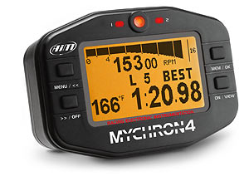
One series of products similar to the DART is the MyChron series. The foremost of this series is the MyChron4. The typical package for a MyChron4 [21] includes three primary sensors: RPM, lap timing, and temperature. The MyChron4 series is on the high end for simple amateurs and hobbyists and as such commands a $350 price.
The MyChron4 has three inputs for a temperature sensor, lap time beacon, and RPM/tachometer. One feature that makes the MyChron4 the standard is its ability to interface with an expansion box and its ability to log data to a device which can later be read by a computer.. With this expansion box come the ports for two additional temperature inputs, a wheel spin input, track mapping with an internal G-sensor, and two extra nine volt battery connections for extended running times. The DART plans to mimic several of these sensors. If necessary we may also add an expansion box for future expandability.
Figure 7.2.1-1. MyChron4.
The MyChron4 does not only lead the industry to its variety of sensors, but also its user interfacing. It has a wide display, warning LEDs, and alarms to help alert the user to extreme conditions during racing. The high-resolution LCD displays large numbers during racing and smaller text for data analysis and setup. This display is ideal and the DART plans to mimic it.
A disadvantage of the MyChron4 system is that many important sensors are not included in the package and the extra sensors are often quite pricey ($50-$80+ each). The DART plans to include all of its sensors in the standard package.
An advantage of the MyChron4 is that is can log up to three hours of racing data. The DART hopes to meet or exceed this specification, actively using the recently cheap and large external memories available to log many orders of magnitude more on a standard SD/MMC or similar format that can easily be carried off and put into a computer. The only way for the MyChron4 to offload data to a computer is with a $80 proprietary USB stick that you must buy from them. Even after purchasing this extra memory you are still limited to three hours of race data on the MyChron4.

    - Race Technology DL-1 Data Logger & Kits
Another series of products similar to DART are the DL-1 data Loggers and kits. The typical DL-1 Data Logger & Kit [22] costs around $850, but comes with a variety of built in and external sensors. GPS and accelerometer sensors are built in and the LD-1 has 8 analog inputs, 2 RPM inputs, 4 wheel/shaft speed inputs, lap beacon inputs, and even a serial port to interface with automobile engines. The DL-1 Data Loggers are more of a low-end professional, compared to the amateurs and hobbyists market of the MyChron4 and the DART.
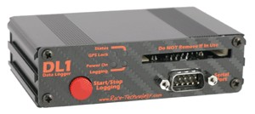
Since the DL-1 data logger is higher end than the DART, many of the features offered by the DL1 exceed the expectations of the DART; but these features are still desired. One such feature is that the DL-1 data logger records data to compact flash much like the DART will do.
Figure 7.2.2-1. DLI Data Logger.
An advantage of the DL-1 is its simple interface. A single button starts and stops data logging. This is something worth mimicking in the DART as the interface should be as simple as possible. The wide variety of sensor inputs in the DL-1 is also a goal of the DART.
A disadvantage of the DL-1 is that is has no active display and that it is well out of the typical market of the DART. More proof of this is that rather than operating on the nine volt battery that the MyChron4 and DART operate on, the DL-1 is tied directly to a twelve volt power supply in the vehicle.

  - Project Packaging Specifications
The DART system must have a small package size in order to fit into a go kart steering wheel but a package large enough to house our large LCD screen with ample room for push buttons and a few LEDs. The DART system is targeting a box that is not much larger than the MyChron4 (5”x3.5”x1.75”) therefore the Hammond Manufacturing 1554F2GYCL [23] was chosen which has dimensions 4.7”x3.5”x2.6” and a reasonable price of $15.25. This project box does have a larger depth than the MyChron4 but this should not impact the placement of the box in the steering wheel. This box was chosen for its small size and for its clear lid. The clear lid should allow us to have a more water resistant design since our LCD and LEDs can be beneath the lid and only the push buttons need to be above the lid. A slot will have to be cut out of the box in order to facilitate the insertion and removal of an SD card into the device but this can be made water resistant by a removable, screw on cover over the slot. The connectors will need to be rugged and water resistant as well so some kind of gasket should be built in or later put on the connectors. The connectors should have some kind of screw on mechanism in order to make sure they do not wiggle out due to the extreme vibration and acceleration encountered in a solo racing environment.
The sensors will have their own packaging which also must be of a rugged nature. For ease of production there will not be a way to disconnect the wire from the sensor box. There should be no need to disconnect the wire from the sensor boxes, only the actual main box itself. The sensor boxes will be constructed from smaller project boxes which should be rather water resistant if not nearly water tight. There will be an external box for the accelerometer and IR beacon receiver. The thermocouple probe already comes in a rugged packaging and the thermocouple chip will be on the main PCB so no external box will be required for this sensor. The speed sensor is also already rugged and will not require an external box nor does it have a specialized chip to read the data off of it that requires an external sensor box.
The IR beacon will simply be housed inside a road cone for both durability and aesthetic purposes. The beacon needs to be reasonably high off of the ground (about 20 inches) and should be somewhat water resistant. The use of a road cone should accomplish both of these goals with ease. To further water proof the IR beacon, though, the top of the cone could be covered so rain cannot get into the cone.

  - PCB Footprint Layout
The most important component in the design was the microcontroller. The Microchip DSPIC33FJ128MC804 [7] was chosen for its abundant I/O as well as its relatively low 44 pin count. This microprocessor comes in both the TQFP and the QFN package. The QFN package is difficult to work with and the two components have essentially the same footprint size so the TQFP package was chosen. From the size of the microcontroller package and the other chips that will need to be on the PCB it was concluded that the PCB size was not a major constraint. Components other than the microcontroller on the PCB are two power regulators, an SD/MMC card slot, a temperature sensor, and battery regulation circuitry. The size of the PCB was set at 4”x3” which was deemed to be amply large to contain all of the components with plenty of extra space to put numerous headers for debugging and future expandability of the device. This size will allow us to fill most of the usable space in the project box and make it so components can be spaced out enough that routing should be easy.

  - Summary
While it will ultimately be a unique device, the DART will include functions and capabilities found in many similar commercial products currently on the market. In short, it will be a hybrid of display devices like the MyChron4 and data logging devices like the DL-1. Due to the fact that the size of the main module packaging is determined mainly by the size of the LCD and the fact that the various sensors are distributed around the go kart on their own PCBs,
fitting all of the components on the main PCB is not foreseen to be especially challenging. Great care, however, must be taken to meet the requirements of the demanding go kart environment such as vibration and moisture. The packaging described should be durable enough to handle the shock and well-made enough to resist moisture. The DART team believes this combination of criteria will lead to a successful product.

- Schematic Design Considerations

  - Introduction
The main circuit design issues deal with keeping the product as small and low power as possible. Careful attention must also be paid to the integration of various sensors, a LCD, and external memory since these devices use different communication protocols and require different operating voltages to operate correctly. The following report will elaborate upon these design issues.

  - Theory of Operation

    - Power Supply
The DART utilizes two converters in converting the 9V battery voltage to 3.3V and 5V power supplies. Both converter chips are from the same high efficiency, low drop-out, step-down DC-DC controller family from MAXIM. The 3.3V supply, which powers the microcontroller and all peripherals except the LCD module—IR receiver, 2-D accelerometer controller, thermocouple controller, and SD card adapter—is controlled by the MAX1651 [28]. This controller also supplies the pull-up resistors for the magnetic speed sensor switch and the six pushbutton switches. The MAX1649 (same datasheet as MAX1651), on the other hand, supplies 5V power to the LCD module, which uses 5V to power its ICs and has an integrated 9V step-up converter to power the LCD itself. There are also two LEDs that can be seen on the front of the main console that are used as indicators of a low battery or high temperature. These LEDs are powered off of the 3.3V rail. A separate MAX1649 is used to supply the separate IR emitter package with 5V. The high-efficiencies of the DC-DC converters were the main driving force behind their selection due to the importance of minimizing power consumption in this battery-powered application. The power circuitry was later revised to include a 3.7 V rechargeable lithium battery in place of the 9V battery. This decision was made because of the strong a lithium battery led to the addition of a wall wart connection that passes through the MAX1649 mentioned previously to bring the voltage down to 5V before it is passed into the rest of the circuit. Also, the LTC4054-4.2 [10] battery charger IC and the LTC4150 [9] coulomb counter were included to help in developing the fuel gauge monitoring system for the lithium battery. The circuitry is set up so that the device will run off of the wall wart when connected or the battery when disconnected. With this setup the user will be able to still operate the device while charging the batteries at the same time.

    - Sensors
The DART system will make use of several sensors to gather data about speed, engine/exhaust temperature, g-forces, and lap time/count. The MP201901 [16] magnetic switch from Cherry Electrical will be utilized to calculate speed. The switch will be mounted to the go kart above the rear axle, which will have a magnetic actuator, the AS201901 (same datasheet), mounted so that every time the axel spins past the switch a signal will be sent to the microcontroller where it will be debounced in software before counting the number of times the axel rotates in a given time frame so that the signal can be used to calculate a speed value. This device claims zero power consumption, so at the worst we expect it to be a very low power drain on the system which is critical to the success of DART.
The temperature sensor that is used in DART is an Omega XCIB-K-3-5-10 [18] thermocouple. Since the output coming from this device is analog and would also require additional conversion to calculate the temperature, DART uses a MAXIM MAX6675 [17] ATD thermocouple conversion IC. This IC requires 3.3V to operate which is also used for several other devices in DART. The microcontroller is able to communicate to the temperature system using an SPI interface and the need for an additional ATD channel on the microcontroller is eliminated by the inclusion of this IC.
DART will perform lap timing and counting by making use of IR sensors and emitters. The idea behind the operation is simple, when the IR sensor on the go kart passes the IR emitter placed at the start/finish line of the track a timer will start. The DART makes us of the ZTT 10.00MT [11] ceramic resonator as an external clock source to the microcontroller in order to create a more accurate timing system than one based off of the internal clock of the microcontroller. The next time the emitter and the sensor cross paths this will trigger the microcontroller to reset the clock, increase the lap count, and store the information about the last lap time in memory. The emitter circuit that is being built makes use of a CMOS 555 Timer IC [1] and an infrared emitting led and will emit at approximately 38 kHz with a supply voltage of 5V. The IR sensor that DART uses is a Vishay TSOP34838 [2] 38 kHz IR receiver which can run off of the same 3.3V supply that many of the other peripherals are using.
The last major sensor that the DART system uses is an ADXL320JCP [3] accelerometer. This IC is also very low power and helps to keep the overall power consumption of DART minimal. The supply voltage for this IC will be 3.3V as well. This IC simply outputs two analog values that are sent to ATD channels of the microcontroller. One output is for the acceleration in the x-axis and the other is for the acceleration in the y-axis. This value can then be used to show the increase/decrease in g-forces on the driver during a race by a corresponding bar graph display on the LCD.

    - LCD
The LCD is a GDM12864HLCM [4] Liquid Crystal Display Module from SparkFun tied to a Dios Universal LCD Carrier [5] power by a DiosPro 40 [6], both of which are from Kronos Robotics. The LCD is a standard, transflective graphic LCD with a 128x64 resolution and a standard 8 bit parallel interface. The Dios Universal LCD Carrier with the DiosPro 40 allows the LCD to be controlled using a UART interface as well as providing a graphic and character library to allow for ease of use when drawing to the LCD. The Carrier provides a complete font library to any standard font column and row position as well as aides in drawing shapes, lines, and dots at any point on the screen. Also, by providing a 5V source to the Carrier, power will be supplied to the rest of the LCD system.

    - Microcontroller
The microcontroller is a 44 pin TQFP dsPIC33FJ32Mc804 [7] running at 10 MIPS and 3.3V. This should provide ample processing power to sample all of our sensors at a very high rate as well as compensate for long write times to flash memory. Four major subsystems will be used on the dsPic33 to communicate with our peripherals. The SCI subsystem is used for communication with the Dios Universal LCD Carrier which powers the graphic LCD. The other SCI link provided by the dsPIC33 will be used for debugging via terminal on a PC. The SPI subsystem is used to read data from the temperature sensor and for writing and reading data with the SD flash card. The A/D subsystem is used to read battery levels and to read the X and Y axis of the accelerometer. The general purpose digital I/O pins are used to drive LEDS, read push buttons, and to read data in from the IR sensor, sampled at 38 kHz. More detail on the use of the microcontroller is provided in the next section.

  - Hardware Design Narrative
The DART’s chosen microcontroller, the dsPIC33FJ32MC804, has a variety of
subsystems. The port assignment of the Serial Peripheral Interface Bus (SPI), Universal Asynchronous Receiver/Transmitter (UART), and any normal I/O can be programmed to any RA, RB, RC, or RP port. The Analog to Digital pins however are not programmable and are on pins 19 through 27. The A/D converter placement takes precedence over other subsystems. They are also a major point for expansion, so it is best to leave them empty to headers rather than use up all of their pins.
The Analog to Digital converters are used to measure the analog signals from the various sensors. There are two different analog signals that must be decoded, but both come from the same device. The two signals are from the accelerometer and they are the x-axis output and y-axis output, both of which are used to determine g force. The ports used for this are AN2 and AN3 which are pins 21 and 22.
The Serial Peripheral Interface Bus (SPI) is used for communication between the thermocouple’s A/D converter chip and the microcontroller. The SPI channel interfaces with an IC that the team has selected to handle the conversion of temperature data and has no direct connection to the thermocouple itself. The ATD converter chip comes with an SPI interface built in, so no additional hardware is needed. The SPI channel is on ports RP9, RP22, and RP23 which corresponds to pins 1, 2, and 3. Only three pins are needed to implement this SPI because the MOSI pin serves no purpose as the microcontroller does not have a need to send any information to the converter chip.
The Universal asynchronous receiver/transmitter (UART) is used to transmit the data we would like to have displayed on our LCD and well as to communicate with the SD/MMC breakout board (uALFAT-SD) [8] .There are two separate UART channels, one to communicate with the LCD and the other to communicate to the SD/MMC interface. The baud rate for the UART that deals with the LCD is set to 115200 baud and the transmit line is set to port RP13 or pin 11, whereas the receive line is set to port RP12 or pin 10. The SD/MMC breakout board allows DART to not only interface with the external memory via a UART interface, but also stores the data in a FAT format and runs on a supply voltage of 3.3 V. The transmit line for the SD/MMC interface can be found on port RP24 or pin 4 and the receive line is on port RP25 or pin 5.

  - Summary
DART is a data logger and display for the hobbyist go kart market. Most of the design decisions were made around keeping DART as small and low power as possible. Most of the devices make use of a 3.3V supply although there are a few that require a 5V supply. DART makes use of several sensors to display and save information on lap time and count, speed, g-forces, and engine/exhaust temperature. This information is then relayed to the microcontroller using the UART, SPI, and ATD channels on the chip. This data is then converted and output to both the screen for display (using UART) and the external memory for storage (using SPI).

- PCB Layout Design Considerations

  - Introduction
The DART PCB design is fairly straightforward as its components can be neatly broken up into three categories. First, five power supply and controller chips regulate the distribution of power. Second, the microcontroller as well as two external logic devices receive, interpret, and transmit a mixture of analog and digital signals. Finally, a variety of surface-mounted connectors channel these signals off-board. The interconnection of these three types of devices should not be especially difficult as long as the general rules of good PCB design are followed.

  - PCB Layout Design Considerations - Overall
The goal of the PCB layout design is to successfully route all the components together in such a way as to minimize the effects of EMI that can degrade or even defeat system function. With this goal in mind, a few key concepts dictate the overall board layout.
It is extremely important to keep analog, digital, and noisy signals separate. The only producers of analog signals on the DART are the thermocouple and the accelerometer. The analog signal on the thermocouple leads is first decoded by the MAX6675 before being transmitted to the microcontroller via SPI, so simply placing the chip and the connector close to the edge of the board should protect the integrity of the analog signal, which is protected off-board by a twisted, shielded cable that runs to the thermocouple itself. The two-dimensional accelerometer input will also be protected externally by a twisted, shielded cable, but it must be routed directly to the microcontroller for analog to digital conversion. It will be routed away from all other signals remaining on the board, which are all digital. If it has to cross a digital line, it will do so at a right angle to minimize interference. The speed sensor, although technically digital, is little more than a magnetic switch that closes to ground each time a magnet on the wheel passes the sensor. It will probably be very noisy, so it will also be routed away from other signals as much as possible and protected externally by a twisted, shielded pair. Its input will be debounced through software. The rest of the circuit is purely digital, so routing these signals together should not be especially troublesome. However, the higher frequency digital signals such as the SPI interface to the thermocouple chip, the RS-232 interface to the LCD, the RS-232 interface for debugging, and the UART interface to the programmer will generally be separated from the lower frequency digital signals such as those from the pushbutton inputs or the LED outputs.
In general, wider traces and decoupling capacitors placed closely to the power and ground pins of each IC will ensure reliable performance. Due to the choice of packaging, the DART board size is not the most crucial design constraint. There should be plenty of room on the PCB for all of the components and traces with some room left over. It is important to make sure that traces do not get too long, but since the physical space is available, it will be utilized by making wider traces wherever possible to reduce impedance along signal lines. With this method followed carefully, there should be no logic ones that are too low or logic zeros that are too high.

  - PCB Layout Design Considerations – Microcontroller
The layout of the microcontroller is perhaps the most challenging. As it is the computational center of the design, it makes sense to place it in the middle of the board where it can be accessed by all of the I/O devices that it services. However, as a large consumer of power that switches at a relatively high frequency, it would also be beneficial to place it near the power supply. These two opposing issues are compounded by the relatively small but still substantial number of 44 pins that need to be routed and the ever-important placement of the bypass capacitors as close to the four sets of power and ground pins as possible. Some compromise between these conflicting goals must be struck. For example, power traces can be a bit longer if they are also wider, and although not ideal, at least some of the capacitors could be placed under the microcontroller.
To ensure the best possible accuracy of the analog to digital converter in interpreting the analog signals sent by the accelerometer, the VREF+ and VREF- pins of the microcontroller will be routed all the way back to the power supply power and ground at a single point without joining another power or ground line. This design measure ensures that microcontroller’s analog reference is not skewed by the voltage drops associated with nearby chips demanding more current during switching. The VREF+ and VREF- pins will also be low-pass filtered with a 1 kΩ resistor and a µF capacitor for increased noise immunity.
No external oscillators are required as the chip has its own internal oscillator, which at 7.37 MHz should provide more than enough processing power to manage all of the system’s I/O. The microcontroller can use this internal oscillator in the same way as an external oscillator, with scaling factors that provide for the use of real-time interrupts of standard values as well as standard baud rates for communication via RS-232. However, the chip does have oscillator pins to provide the option of clocking the core at higher frequencies. If this were the case, the external oscillator would take precedence over the decoupling capacitors in being placed as close to the microcontroller as possible, definitely on the same side of the board.
Finally, the microcontroller plays an important role in keeping the analog, digital, and noisy signals separate. All parallel digital I/O is routed to the top and left sides of the microcontroller, while all serial I/O is routed to the bottom side. The analog accelerometer signals are routed to the top two pins of the right side, and the noisy speed sensor is kept close to one of the corners of the microcontroller away from other signals.
In the final design, an external, 10 MHz oscillator was used to clock the microcontroller. A grounded copper trace that completely encircled the oscillator circuitry was used to protect it from all nearby signals. Also, some I/O pins were eliminated as the number of pushbuttons was reduced from six to four, and the number of LEDs was reduced from four to two.

  - PCB Layout Design Considerations - Power Supply
The layout of the power supply components is perhaps the most crucial to successful system functionality. A step-down switch mode power supply converts the 3.7V output of the rechargeable lithium battery to the 3.3V required by most logic, and a 5V boost switch mode power supply provides the 5V needed by the LCD. A separate 5V supply powers the recharging circuit for the battery and functions only in the presence of an external unregulated 9V DC adapter. Finally, a coulomb counter keeps track of the battery’s remaining power. It is essential that all of these chips are supplied power by very wide and short traces, so that the integrity of the power system, which has a huge impact on the reliability of the rest of the system, is preserved.
All three power supply chips have output capacitors of fairly significant size which must be placed as close to each chip as possible. Care must be taken to ensure that these capacitors are placed near each device first before the rest of the design encroaches upon the available space. A bulk capacitor must also be placed near the output of each power supply to charge up the many decoupling capacitors located throughout the circuit. The power supply chips themselves have such capacitors, which are much smaller than the output capacitors but should, nonetheless, be placed to the as close to the power and ground pins of each device as possible. In short, each of the three power supplies should be surrounded by capacitors upon completion of a good PCB design. Utilization of both layers of the board will be important in minimizing circuit size.
The proper routing of the power and ground traces themselves is of paramount importance. Wherever possible, power and ground traces should be run alongside each other, but the ground system is most important. A “star-pattern” will form a single point where all ground lines from the various supplies come together. Where it may not be possible or completely necessary to have all of the supplies to digital logic converge on a single point, it is essential that the ground lines from the unregulated power supplies—battery and DC adapter—as well as the ground to the analog accelerometer chip come together with the digital logic supplies all at one single point on the board. This configuration will minimize the inductance and resistance in the ground return lines and prevent interference between analog and digital components.
A final aspect of routing the power system is heat dissipation. The two main power supplies have heat pads underneath which must be soldered to a copper plane by way of a via through the board. Also, the charger IC, although it does not have a power pad, relies on thermally beneficial trace layout to dissipate heat. Care must be taken to ensure that the manufacturer’s specifications are met in this regard to prevent the components from overheating.
Several key changes to the PCB layout were implemented in the final design. First, a complete copper pour was used to form a ground plane on both sides of the PCB. Only the analog references voltage VREF- and the oscillator ground were insulated from this pour and allowed to connect to it only at one point. Theoretically, the ground plane results in even better decoupling of separate ICs because it provides an almost infinite number of paths from each IC to ground. Second, a serious mistake was made in that the misinterpretation of a datasheet led to the belief that the 3.3V power supply chip was a buck-boost chip. A buck-boost chip is necessary because the battery voltage declines from 4.2V to 3.0V, both above and below the desired 3.3V, over its discharge cycle. Unfortunately, the IC in question turned out to be a boost chip only. The solution to this problem was to eliminate the 3.3V boost chip from the design and insert a 3.3V step-down chip after the 5V boost chip to bring the voltage back down to the desired 3.3V. This 3.3V step-down circuit was constructed on a separate prototyping board and fly-wired into the main PCB. Nevertheless, these wires were kept as short as possible so as to minimize noise.

  - Summary
Compared to far more complex designs involving high-frequency elements such as RF, the DART PCB layout is notably less challenging. However, this fact does not mean that no care must be taken to avoid the nuisance of EMI. Smart layout techniques will be utilized to ensure a proper power system is provided to all ICs and that digital, analog, and noisy signals are kept separate from one another. With these techniques effectively employed, there should be no EMI-related issues during system integration.

- Software Design Considerations

  - Introduction
The DART is a speedometer, a stop watch, an accelerometer, and a lap counter. With all of these sensors that need to be sampled the main idea behind DART’s software is an interrupt driven approach. This will be done using real time interrupts and the goal is to be able to sample everything every tenth of a second during a race. This would provide the user with ample data to judge their performance.

  - Software Design Considerations

    - Memory Mapping
The dsPIC33FJ128MC804 is the processor chosen for the DART. The processor has a 23 bit Program Counter that is used to form the address for 4M x 24 bits. Program memory begins at 0x000002 with the Reset address followed by an Interrupt Vector table from 0x000004 to 0x0000FE. An Alternate Vector Table is then located from 0x000104 to 0x000200. The User Program Flash Memory is from 0x000200 to 0x0157FE.
The dsPIC33FJ128MC804 has a software defined stack. The 16th register, W15, operates as the Stack pointer. The Stack Pointer always points to the first available free word and grows from lower to higher addresses. Locations of static data, variables, stack, and code are automatically handled by MPLab. A full mapping of Memory can be seen in Appendix C.

    - Peripherals
An issue that has not been tested, that must wait until we have the actual dsPIC33FJ128MC804, is the pin assignment. The dsPIC33FJ128MC804’s peripheral pinouts are programmable. While the datasheets do not make this seem like an obstacle, it is an important feature that has yet to be tested. This feature makes a chip diagram a bit simpler. Instead of explicit names for each of the peripherals pins, the pins are referred to as RPx.
The peripherals of the dsPIC33FJ128MC804 are used to monitor the various sensors, for user interface with the LCD screen, and to read/write data to the SPI/MMC card. The thermocouple’s A/D converter chip interfaces via the external interface SPI1. This interface uses ports RP9, RP22, and RP23. In software, these pins become MISO, SS, and SCK lines. The values read off of the MISO are currently stored temporarily via the DMA. The Accelerometer uses a pair of A/D converters to interface with the microcontroller. The port names are AN2 and AN3. The values are also stored in a pair of DMA controlled registers. The lap counter receiver and speed switch are simple I/Os and use the RP2 and RP19 pins. The AN5 and AN6 pins have been reserved as spare pins incase these need a different input.
Pins 12-15—RA10, RA7, RP14, and RB15, respectively—are used to interface the fuel gauge IC (LTC4150) for the 3.7V lithium-ion battery to the microcontroller. The LTC4150 uses a current-sensing resistor to detect the amount of charge leaving or entering the battery. It keeps track of this charge using an internal counter and sends an interrupt to the microcontroller each time it overruns this internal counter. Pin 14 (RP14) is programmed to act as this interrupt pin, while pin 13 (RA7) provides the corresponding interrupt clear output back to the LTC4150. Pin 15 (RB15) is an input from the LTC4150 indicating the polarity associated with the amount of charge indicated by each interrupt. In this manner, the microcontroller knows if that charge was entering or leaving the battery. Finally, pin 12 (RA10) is an output which allows the microcontroller to shut down the LTC4150 to conserve power, such as after a successful charge has been completed but the unit is still running on wall-wart power.
The battery charger IC (LTC4054) provides a single output for indicating its current state to the microcontroller. This single pin, however, is able to communicate a total of three separate conditions—charging, charge complete, and insufficient input voltage—by taking one of three separate states: low, high, and high impedance. Therefore, two microcontroller pins—one input and one output—are necessary for distinguishing between these three states. A configuration of two pull-up resistors, one to 3.3V and one to the output pin, make this possible.
Both the LCD and the SD/MMC card use UART. The LCD uses pins RP12 and RP13 programmed as UART1Tx and UART1Rx. The SD/MMC card uses pins RP24 and RP25. These pins are programmed as UART2Tx and UART2Rx.

    - Debugging Considerations
There are two major consideration made for debugging. The first is simply bringing every pin to a header. The second is involves UART2.
UART2, along with being brought to a normal header, is brought to a pair of jumpers so that it can be connected to either a serial port for debugging via a terminal or to the SD/MMC card. The jumpers ensure that both cannot be connected at once. MPLab can also interface with our processor via the PGED, PGEC, MCLR pins for debugging and programming.

  - Software Design Narrative
    - Startup/Initialization
When the DART is powered up, there are many operations that must take place. The maximum oscillator source frequency during startup must be in the range of 4MHz to 8 MHz. Since the external oscillator is not in this range, the device must startup in FRC mode. After the device is powered up, the oscillator's source can be changed from internal to the external oscillator.
Initializing the variety of peripherals and pin ins/outs is necessary during this section as well. Since there are multiple configurations of pins and I/O, this section is complicated. Debugging, operation, and testing modes each have different initializations and pins are used differently between them. Some of the sensors must also be zeroed during the initialization.
Startup Status: Pseudo code

    - Menu
The menu section is the true user interface of the DART. In this section the menus are enabled so that the user can do a variety of things. Outside of this section, only a single push button's input is interpreted, but while in this section all are sampled and are used to navigate the menus.
The menus allow the user to customize the race display, edit file names and formatting, turn logging on/off for different sensors, and view past race data in graphs or tables.
Menu Status: Pseudo code

    - Start Timers Interrupts
This section is to detail the enables for the multiple timer interrupts. These timers operate at 100, 10, and 1 millisecond intervals. The 1 ms timer has top priority, and the 10 ms timer has priority over the 100 ms timer. This is because the operations triggered by the 1 ms interrupt have stricter timing requirements. The operations triggered by the 10 ms interrupt also have a stricter timing requirement than those of the 100 ms interrupt.
Timer Status: Pseudo code

    - 100 ms Interrupt : Temp, Accel, Stopwatch, Display, & Data
The interrupt triggered every 100 ms handles the less time sensitive operations. These operations include temperature and accelerometer logging. The stopwatch is also updated with this 100 ms Interrupt. Along with the sensors and stopwatch, the data handling and display updating is within this interrupt. A flowchart of each can be seen in appendix A.
The temperature logging operates via an SPI interface to an A/D converter chip for a thermocouple. This data is received as 16 bits. These 16 bits are a lead 0 bit, 12 temperature value bits, and 3 status bits. The bits are processed and stored into a variable.
Temp Status: Coded and Tested
The accelerometer logging operates via a pair of A/D converters. An X-axis and Y-axis value are inputted as voltages in a 0V to 3.3V scale that is then scaled to +/- 5g and stored.
Accel Status: Coded but not tested
The stopwatch operation is very simple. The stopwatch is simply incremented one tenth of a second each time this interrupt is triggered. Accuracy of this timing is ensure by use of the external oscillator.
Stopwatch Status: Coded but not tested
The display operates via the UART1. A group of variables are used as arguments to a function that checks a set of variables set in the menus to create the race display. These are then sent as commands to the carrier board via UART1.
Display Status: Coded but not tested
The SD/MMC data operations operate via the UART2 and works similar to the display. A group of variables are used as arguments to a function that checks a set of variables set in the menu to create the formatting for the data file. These are then sent as commands to the uALFAT board that handles SD/MMC card writing/reading via UART2.
Data Status: Coded but not tested

    - 10 ms Interrupt : Laps
The interrupt triggered every 10 ms handles the lap sensor and the data involving it. Since the lap counter is achieved via receiving a signal from a beacon on the track, it must be seen in the 'worst case.' This 'worst case' would be a go kart traveling at 80 mph. For this reason, it was deemed necessary to sample for the signal 100 times a second.
Lap Status: pseudo code

    - 1 ms Interrupt : Speed
The interrupt triggered every 1 ms handles the speed sensor. Since the speed sensor is a switch on a spinning tire, it is necessary to have very accurate timing on whether or not the switch is open or closed. The actual work of the interrupt is to increment a counter if the switch is closed. This value is later converted via a simple math.
Speed Status: pseudo code

    - SD/MMC
The SD/MMC operations are divided into three parts. The first part is the SD/MMC initialization and file handling. This is simply a series of commands that are sent over the UART2. The second step of the SD/MMC operation is data writing. This is a series of commands followed by data sent to the uALFAT board over UART2. The third step of the SD/MMC operation is to close the file and flush. Again, this is with a series of commands sent to the uALFAT via UART2.
SD/MMC Status: Coded but not tested

  - Summary
The DART is many different tools, as such many different considerations must be made and a software design must be proposed that merges these tools. An interrupt driven design with multiple interrupts to give a variety of priorities to these different tools is ideal. While several challenges have been foreseen and solutions proposed, the DART's software design hopes to allow the flexibility to adapt to the unforeseen challenges and adjust to better solutions. Much software still remains to be developed and tested, but a plan has been laid to ensure its success.

- Version 2 Changes

The knowledge and experience gained in completing this project naturally led to the desire to redesign the DART system. Hindsight is indeed 20-20 and the phrase, “If only we had known then, what we know now,” was very relevant throughout the assembly and debugging process. Several important changes to the current design would be made in any future iteration.
The most obvious change would be to the power supply design. As previously mentioned, the misinterpretation of a datasheet led to the selection of a boost chip for the 3.3V power supply when a buck-boost chip was required. A buck-boost chip is required because the voltage of the Li-ion battery declines from 4.2V down to 3.0V, both above and below the desired 3.3V output, over its discharge cycle. The current work-around for this problem was to eliminate the 3.3V boost chip and fly-wire a 3.3V step-down chip into the output of a 5V boost chip already existing in the current design. A future design would use a 3.3V buck-boost chip as originally intended. Another option, however, would be to switch to a 2-cell Li-ion battery with a voltage range of 8.4V to 6V, which would always be above both desired voltage supplies of 5V and 3.3V, requiring only step-down components. This redesign would be rather extensive and require a new charging IC as well, however. On that note, the current charging IC is actually somewhat undersized already. The current Li-ion battery can be recharged must faster than the current design allows as the LTC4054 charging IC can only supply 500 mA. The battery can be recharged at twice this current at least. A beefier recharging IC would be included in a future design.
A couple of other adjustments to the hardware design would be necessary to correct earlier mistakes. The pushbutton reset for the microcontroller was incorrectly connected and required fly-wiring to fix the problem. A miscommunication led to the external connector for the IR detector being wired to the 5V supply when it should have been connected to the 3.3V supply. Indeed, the output of the IR detector was connected to a 3.3V microcontroller, so it should probably operate on 3.3V as well! This problem was also corrected using fly-wire. Finally, the indicator LED circuitry was thrown together in the original design in the interest of time. Current-limiting resistors were not included, and the maximum drain current of the microcontroller pins was not taken into consideration. While the current design did overcome these problems by fly-wiring current limiting resistors into place, it would have been convenient if they had been included in the original PCB design. Also, while the current configuration works adequately, the brightness of the LEDs could be improved by using transistors to allow greater current through each LED. This current is limited to 4 mA by the maximum sinking capabilities of the microcontroller’s I/O pins. All of three of these simple but practical issues would be corrected in version 2 of the DART.
Another must-have feature for a production version of DART would be an expansion port that would interface to an expansion box that multiplexes more sensor inputs. This would allow DART to not only generate more revenue through the sale of additional components while still keeping the base price of the system low but also allow expandability to keep up with any future products competitors might release. A simple firmware upgrade could be downloaded to the SD card, and DART could automatically upgrade its firmware in order to use new sensors released after the system.
To make DART more compact in the 2.0 version, the Dios Universal LCD Carrier could be removed from the design and the LCD could be controlled directly from a 100 pin version of our current dsPIC33f microcontroller. This would also save a considerable amount of money since the Dios part is about $70 by itself without a screen.
One final and minor tweak that could be made would be to interface to the SD card board over SPI instead of UART. There seems to be some odd handshaking for the SD board when the baud rate is adjusted which is necessitated by the fact that the board defaults to 9600 baud on start-up every time. This change should allow us to do more robust error handling and much faster data transfer in a future version of DART.

Summary and Conclusions

DART was a huge learning experience and great success for our team. We learned how to select parts and carefully read the data sheets to avoid surprises later on. PCB design was a major hurdle since none of us had ever designed one before. Luckily the data sheets for most of the parts had suggestions on how to design the PCB. Our previous coursework in ECE helped tie together all of these new learning experiences into what ultimately became DART.
Packaging proved to be the biggest unknown in building DART and having all of the design goals working in the final product. It was immensely difficult to optimize the placement of all parts within a project box that is very constrained on size with such a huge number of parts and with some of these parts changing throughout the semester.
Overall, DART was a success. We managed to accomplish all of the major design goals set forth at the beginning of the semester. There are more tweaks and slight bugs that we would work on if time allowed, but as far as functionality is concerned, DART is complete. We believe that DART as it stands is a very good prototype and that it could readily be made into a commercial product with the changes outlined for the next version.

References

[1] National Semiconductor “LMC555 Datasheet” [Online]
http:/www.national.com/ds/LM/LMC555.pdf
[September 21, 2009]

[2] Vishay Semiconductors “TSOP348 Datasheet” [Online]
http://sigma.octopart.com/5333806/datasheet/Vishay-TSOP34838.pdf
[September 21, 2009]

[3] Analog Devices “ADXL320JCP Datasheet” [Online]
http://sigma.octopart.com/133103/datasheet/Analog-Devices-ADXL320JCP.pdf
[September 14, 2009]

[4] SparkFun “GDM12864H Datasheet” [Online]
http://www.sparkfun.com/datasheets/LCD/GDM12864H.pdf
[September 21, 2009]

[5] Kronos Robotics “LCD Carrier Datasheet” [Online]
http://www.kronosrobotics.com/downloads/GraphicLCD.pdf
[September 21, 2009]

[6] Kronos Robotics “DIOS Pro Datasheet” [Online]
http://www.kronosrobotics.com/downloads/Diosoemhookup.pdf
[September 21, 2009]

[7] Microchip “dsPIC33FJ128MC804 detail page” [Online]
http://ww1.microchip.com/downloads/en/DeviceDoc/70291C.pdf
[September 16, 2009]

[8] GHI Electronics “uALFAT-SD Datasheet” [Online]
http://www.ghielectronics.com/downloads/uALFAT/uALFAT-USB%20and%20uALFAT-SD.pdf
[September 23, 2009]

[9] Linear Technology “LTC4150 Datasheet” [Online]
http://cds.linear.com/docs/Datasheet/4150fb.pdf
[December 9, 2009]

[10] Linear Technology “LTC4054-4.2 Datasheet” [Online]
http://cds.linear.com/docs/Datasheet/405442xf.pdf
[December 9, 2009]

[11] ECS INC. “ZTT Series Ceramic Resonator Datasheet” [Online]
http://datasheet.octopart.com/ZTT-10.00MT-ECS-datasheet-3720.pdf
[December 9, 2009]

[12] FreePatentsOnline, “Patent US5173856” [Online]
http://www.freepatentsonline.com/5173856.pdf
[November 2, 2009]

[13] FreePatentsOnline “Patent US5189305” [Online]
http://www.freepatentsonline.com/5189305.pdf
[November 2, 2009]

[14] Microchip “dsPIC33FJ128MC804 detail page” [Online]
http://www.microchip.com/wwwproducts/Devices.aspx?dDocName=en532303
[September 16, 2009]
[15] Freescale “MC56F800X Product Summary Page” [Online]
http://www.freescale.com/webapp/sps/site/prod_summary.jsp?code=MC56F800x
[September 16, 2009]

[16] CHERRY “MP2019 Datasheet” [Online]
http://www.mouser.com/catalog/specsheets/mp2019.pdf
[September 15, 2009]

[17] MAXIM “MAX6675 Datasheet” [Online]
http://datasheets.maxim-ic.com/en/ds/MAX6675.pdf
[September 17, 2009]
[18] OMEGA “XCIB Datasheet” [Online]
http://www.omega.com/Temperature/pdf/XCIB.pdf
[September 17, 2009]

[19] New Haven Display “NHD-12864WG-BTFH-V#N Datasheet” [Online]
http://www.newhavendisplay.com/specs/NHD-12864WG-BTFH-VN.pdf
[September 16, 2009]

[20] Analog Devices “ADXL320JCP-ND Datasheet” [Online]
http://www.analog.com/static/imported-files/data_sheets/ADXL320.pdf
[September 14, 2009]

[21] AIM Sports, “MyChron4 Digital Gauge and Data Logger for Kart Racing” [Online]
http://www.aimsports.com/products/mychron4/index.html
[October 5, 2009]

[22] Solo Performance, “Race Technology DL-1 Data Logger & Kits” [Online]
http://www.soloperformance.com/Race-Technology-DL-1-Data-Logger-
Kits_p_1177.html
[October 6, 2009]

[23] Hammond Manufacturing, “Hammond Mfg. - Watertight - Clear Lid Polycarbonate
Enclosures (1554 Series)” [Online] http://www.hammondmfg.com/1554FCLP.htm
[September 21, 2009]

[24] Motorola, “System Design and Layout Techniques for Noise Reduction in MCU-
Based Systems”. [Online] https://engineering.purdue.edu/ece477/Homework/CommonRefs/AN1259.pdf
[September 25, 2009]

[25] Linear Technology, “Standalone Linear Li-Ion Battery Charger with Thermal
Regulation in ThinSOT”. [Online] http://www.linear.com/pc/downloadDocument.do?navId=H0,C1,C1003,C1037,C1078,C1088,P2294,D2288 [September 26, 2009]

[26] Linear Technology, “Coulomb Counter/Battery Gas Gauge”. [Online]
///////http://www.linear.com/pc/downloadDocument.do?navId=H0,C1,C1003,C1037,C1134,P235 ///////4,D1556 [September 25, 2009]

[27] Texas Instruments, “96% Efficient Boost Converter with 4A Switch”. [Online]
http://focus.ti.com/lit/ds/symlink/tps61032.pdf [September 29, 2009]

[28] MAXIM IC, “5V/3.3V or Adjustable, High-Efficiency, Low-Dropout, Step-Down DC-
DC Controllers”. [Online] http://datasheets.maxim-ic.com/en/ds/MAX1649-MAX1651.pdf

[29] Motorola. “System Design and Layout Techniques for Noise Reduction in MCU-
Based Systems”. [Online]
https://engineering.purdue.edu/ece477/Homework/CommonRefs/AN1259.pdf
[September 30, 2009]

[30] Department of Defense, “Military Handbook, Reliability Prediction of Electronic
Equipment”. [Online] https://engineering.purdue.edu/ece477/Homework/CommonRefs/Mil-Hdbk-217F.pdf
[November 10, 2009]

[31] Linear Technology, “150ma Standalone Linear Li-Ion Battery Charger”.
[Online] http://cache.national.com/ds/LM/LM2679.pdf [November 12, 2009]

[32] Merriam Webster’s Online Dictionary, “Ethic”. [Online] http://www.merriam-
webster.com/dictionary/ethics [November 13, 2009]

[33] The Engineering ToolBox, “IP-Ingress Protection Ratings”. [Online]
http://www.engineeringtoolbox.com/ip-ingress-protection-d_452.html
[November 14, 2009]

[34] Ultralife Batteries, “UBBP01 Technical Datasheet”. [Online]
http://www.ultralifebatteries.com/documents/techsheets/UBI-5154_UBBP01.pdf
[November 14, 2009]

[35] Electropaedia, “Lithium Battery Failures”. Woodbank Communications Ltd.
[Online] http://www.mpoweruk.com/lithium_failures.htm [November 16, 2009]

[36] IR Therapies, “About Light Therapy”. [Online]
http://www.nirtherapy.com/light-therapy.php [November 12, 2009]

[37] Derwent, “Eye Safety with Near Infra-Red Illuminators”. [Online]
http://www.axis.com/products/cam_irillum/files/Eye_Safety_with_Near_Infra-Red_011107.pdf [November 14, 2009]

[38] Splitt, Frank, “Engineering Education Reform: A Trilogy”. [Online]
https://engineering.purdue.edu/ece477/Notes/PDF/Mod15_ref.pdf [November 15, 2009]

[39] World Centric, “Compostable Plastics”. [Online]
http://www.worldcentric.org/biocompostables/bioplastics [November 10, 2009]

Appendix A: Individual Contributions

A.1 Contributions of Jacob Pfister:
As the only EE on the team, my contributions centered on the hardware portion of the design. I am grateful to my teammates that I did not have to write a single line of code because I quickly found out that the hardware component of any ECE design is very time-consuming.
My first major contribution was the PCB design and all of its related activities. While I did not touch the software at all, no one else touched the PADS software because I did all of this work. This involved completing the entire schematic and PCB layout. While this may seem a relatively straightforward task at first, it entails quite a bit of work, not the least of which is part selection. I researched and selected all of the components for the power supply myself, including the 5V wall-wart switch mode supply (MAX1649), the 5V logic switch mode supply (TPS61032), the 3.3V logic switch mode supply (TPS61031), the fuel gauge chip (LTC4150), the charging circuit (LTC4054), and the battery itself (UBBP01). I also researched and selected the necessary components associated with each of these ICs—inductors, capacitors, resistors, transistors, and diodes—including the guiding diodes that allow the power to be switched seamlessly from the battery to a wall-wart supply. Beyond the power supply, I researched and selected the MAX6675 which converts the analog output from the thermocouple to a digital value processed by the microcontroller. While I did not personally research or select the microcontroller, I did do all of the research and selection for the components required by the microprocessor—capacitors, resistors, and an oscillator. I did the same for the MAX3232 RS-232 level translator chip. In this regard, I was involved with every IC on the board. After selecting all components, I entered all of them into PADS, no small task in that any non-standard PCB footprint had to be entered by hand. After entering all of these components into PADS, I “wired up” the entire design to produce the schematic using PADS Logic. I also placed each part on the PCB in PADS Layout. Both the schematic and the PCB layout went through several iterations as different parts were added or subtracted from the design. Finally, although further investigation and knowledge of the PADS software may have rendered it unnecessary, I decided not to trust the Autoroute feature in PADS Router and routed the entire PCB by hand to ensure that all requirements for each IC were met. This was an extremely time-consuming process, but it was worth is because we experienced no issues with EMI or trace width during assembly and debugging.
After completing the PCB and sending it to fabrication, I did have a short period of little contribution; however, when the PCB arrived I was very involved in assembling it. With the exception of the RS-232 and MAX6675, I soldered just about every IC and component to the PCB. This task included all necessary fly-wiring and the construction of a 3.3V step down circuit on a prototyping board to solve the previously discussed flaws in the original power supply design (see Section 11).
While Kevin and Josh did originally do a fair amount of investigation into the IR emitter, I ultimately took over this part of the design as well. This involved breadboarding and experimenting with an oscillator circuit constructed using a 555 timer to produce the necessary 38 kHz square wave. This circuit was necessary because the IR detector uses a bandpass filter around the 38 kHz range to minimize interference from other infrared sources. I had to experiment with adjusting the duty cycle of the square wave to allow a high current to be pulsed through the infrared LEDs for adequate range without overheating them. This high current required the use of robust transistors, which I selected and biased to the appropriate output current. I also investigated the effect of different numbers of IR LEDs in the array, finally settling on six. After completing a working configuration on the breadboard, I also soldered the IR emitter circuitry to a solder breadboard for the final design. I also made the appropriate holes and cuts in its clever road-cone packaging and packaged it accordingly, including an on/off switch and on/off indicator LED.
I also contributed much work of a mechanical nature. I assembled the packaging for the IR detector and accelerometer, including the selection and use of Cat7 cable for EMI reduction. I also researched and selected all of the external connectors which allow the IR detector, accelerometer, thermocouple, speed sensor switch, and wall-wart supply to be connected to the main packaging. With the exception of the speed sensor, I soldered all of the connectors to the cables from these components as well. I determined the placement of all of the interfaces to the main packaging, including the holes for each external connector and the slots for the on/off switch and SD card reader, marking them appropriately for the machine shop to drill and cut. I also helped Mike assemble all of the components into the final packaging and constructed just about every header connector which connects the headers on the PCB to the external connectors, LCD, LEDs, SD card, on/off switch, and pushbuttons.
Finally, my last contribution was the PSSC demo video. I had help from Mike and Josh in filming the necessary scenes, but I did all of the editing myself.

A.2 Contributions of Mike Phillips:
My role in DART has varied greatly as the semester progressed. I was heavily involved with most aspects of the design and development of the device throughout the semester. While I am not the team leader, I still tried to do my best to keep the team on track with where we were in the semester and what we needed to get done by when. I was also a main force in ensuring that the different parts of the design would actually work together in the final product.
At the beginning of the semester the entire team was heavily involved in component selection. I mainly focused on the graphical LCD, the accelerometer, the infrared sensor, and the SD card interfacing. After components were selected and ordered, I set about working on our development environment. I learned to solder surface mount components. I obtained a development kit for the dsPIC33f family from Chuck and set about setting up the laptop with the software needed. Soon after I was able to get some basic “heart beat” code running on the development board as a proof of the ability to correctly program it.
Later on as parts started arriving, I focused on the development and testing of the accelerometer, the IR sensor, the Dios Universal LCD Carrier board, and the SD card board as well as soldering any chips needed for prototyping by other team members. The accelerometer was a simple 5 pin device that output the acceleration data as an analog value. I tested the board and found that the zero G value was very skewed (2.2 V instead of 1.6 V). The board measured +/- 5G and since we only expected values within +/- 3G we did not believe this to be a major problem. I tested the IR sensor with a TV remote control and found to work well but we still had no emitter of our own to test it with. The Dios board was more so a kit of parts that needed to be assembled and a Dios chip that had to be programmed. I soldered the kit and programmed the chip only to find that two of the require pins did not work and the chip had to be sent back. During this time I started work on getting the SD board working over a serial link with a desktop computer in hyperterminal. The correct settings for jumper pins were determined and files were easily created and read from. When the new Dios chip came in my primary task switched to programming all of the menus needed for our device into the Dios chip so that the microcontroller would only need to send the menu number and a few arguments and the Dios would completely draw the menu. This abstraction allowed the microcontroller more time to read sensors and other time sensitive work as well as allow menus to be tested independent of any software bugs that might have been in the microcontroller at the time. The development of the menus for the LCD continued throughout the remainder of the semester.
Around the time the PCB layout was taking shape Jacob and I started prototyping the power supply components. This was very difficult since the power regulator chips chosen had a thermal dissipation pad on the bottom of them that needed to be soldered to ground. Chuck suggested that we could bend all of the leads on the IC down and soldered 30 gauge wire to the bottom of the chip. I undertook this difficult soldering task and managed to eventually get a regulator properly soldered on the protoboard with a 30 gauge wire underneath. Through tested, however, Jacob and I determined that the prototyped that I had made was not functioning correctly. It seemed as though the output was limited but without a good way to test it we had to wait until the PCB came in to see if it would really work.
Throughout the remainder of the semester I continued working on the LCD menu code which eventually weighed in around 1500 lines. I also worked with Kevin and Josh writing and debugging code for our microcontroller. After both of these two tasks were mostly complete Jacob and I worked extensively on packaging. I obtained a go kart steering wheel and designed a bracket to interface the DART to the steering wheel so that it would not take up any internal space within DART and so it was strong enough to handle the stressful environment of go kart racing. I also made some of the external connector cables for external sensors as well as desoldering all of the headers off of the Dios board and either moving them to the inside of the board or getting rid of them completely to make more space. An entire weekend was spent in lab working almost exclusively on packaging to try and get everything to fit inside of the desired package. After many long nights DART was fully packaged and ready to go. Jacob, Kevin, and I headed to my house to use my dad's go kart to make some of our PSSC videos with an actual go kart. The rest of the semester was spent making PSSC videos, documentation, and cleaning up code.
A.3 Contributions of Josh Piron:

I was responsible for various things throughout the semester. I tried to help out in whatever area I could in order to keep things moving at a steady pace. At the beginning of the semester I contributed to the selection and ordering/sampling of various parts. This list of parts includes, but is not limited to, the microcontroller, the LCD screen, and the project box used in the final project.
From a documentation standpoint I was responsible for the patent liability and the hardware narrative reports. I completed the majority of these homeworks and the accompanied presentations on my own. I also helped out in creating the design constraint analysis and safety and reliability homeworks. I teamed up with Kevin to write the majority of the user manual as well. I was the first member on the team to learn PADS and as a result was responsible for the creation of the preliminary schematic, which Jacob then took over from that point on. I also took it upon myself to keep the block diagram as up to date as possible as the design went through its many changes. The bill of materials was an individual effort on my part and this was used in the proof of parts as well as it is posted on our website. Of course I also participated in the creation of the two final reports as well as the design review presentation.
The main focus of my efforts for most of the semester revolved around software development. This includes both development on the PIC Explorer board that was provide by Chuck for use in prototyping as well as the programming of the PIC33FJ128MC804 microcontroller that was used in the final project. I had a hand in every part of the software except for the programming of the DIOS chip used in the LCD module that translated the commands sent from the UART of the microcontroller and drew the correct screens.
I was a big factor in completing the modules for the accelerometer (g-force sensor), speed sensor, timer (stop watch), lap counter, external memory (SD card) interface and the menu interface. I also spent a lot of time setting up the main program as well as the main interrupt service routine. It is in this interrupt routine that most of the program actually happens, such as the sampling/debouncing of pushbuttons and the IR sensor, the updating of all sensor values, and the storing of all sensor values. I was also responsible for adding some of the special features such as the ability to log data or not, and the ability to start on button press or on the first passing of the start line.
I was less of a factor, but still a contributing member, in the creation of the custom SPI interface used for the temperature sensor. This also includes the creation of the temperature system module used in the main program. I also helped out during the debugging of the fuel gauge monitoring system which was the last thing to be added to our final software.
The final thing that I did was to make sure that the final code was fully commented. This includes both in line comments as well as the appropriate headers for each of the files that are zipped up and submitted as our final software.

A.4 Contributions of Kevin Templar:

As lead on embedded software, the majority of my work in the beginning
was understanding the parts and how they would operate in software. This started early in the project by leading in the selection of the microcontroller. In the early steps of the project, I lead by making sure everyone was on task and throughout the project I also made sure that individuals were on task with their homeworks. Once the PCB was designed, I started programming. Being lead on embedded software, it was my job to understand what our chip could do and how to make it work. Over the next month, Josh or Mike would work with me on software bringing in new ideas and perspectives. Once the PCB was assembled, I began programming the real microcontroller with the final program. I then lead in debugging software
issues.
I began selection of the microcontroller with two major ideas. The first, making sure that there was enough memory and ram was a simple task. The second, accounting for future changes in the design was a bit more difficult. I consulted other group members and we determined that extra analog to digital converters were a must and that at least two UART and two SPI modules were necessary. I selected a PIC microcontroller and was able
to soundly convince the group.
Between the selection of the microntroller and the PCB design being finished, I helped other team members get ahead on homeworks and used this time to gain a stronger understanding of our sensors. Understanding the converter chip for the thermocouple was difficult, and I would not fully understand the chip for over a month. The accelerometer and the speed switch were simple in hardware, however the software would be a bit more
complicated.
Once the PCB design was finished, I started programming with the explorer board. After spending a week getting a grasp on the MPLAB software, I starting programing the SPI module. This would quickly become the most troublesome task of the software. In the end, I abandoned the SPI module and achieved an SPI unit with simple inputs and outputs. With some
experienced gained in programming the SPI, I was able to move forward on the UART module. This took some time also, but I eventually would gain a strong understanding of how DMA worked for our chip. Throughout this process, Josh and I would program together with two perspectives so we hit few walls and were able to program efficiently. We also brought in Mike occasionally since he had a strong understanding of the LCD and the uALFAT board. Once
we achieved a single working analog to digital port, I punted the task for a later time.
Once the PCB arrived and was populated, writing the final program and programming the microcontroler began. I took a lead for this as well and the final program was gradually built with the understanding gained from the explorer board and the code we'd already put together. A few small problems were encountered but were quickly overcome.
At the start of December, the team worked especially hard. The team and I were in the lab finishing the project every spare moment striving for the December 6th deadline to go to Mike's house for final testing on the real gokart. This goal was achieved and Jacob, Mike, and I traveled to Michigan City for final testing. Over the following week, I helped the team with the
final reports and presentations.
Appendix B: Packaging

Figure B-1. Top View.

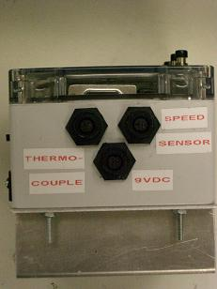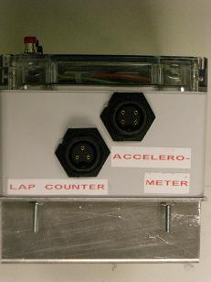
Figure B-2. Left and Right Views.
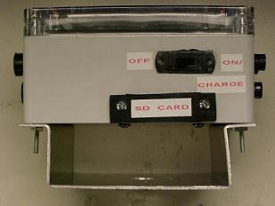
Figure B-3. Back View.

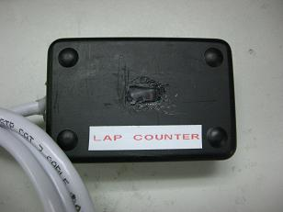
Figure B-4. Lap Counter.
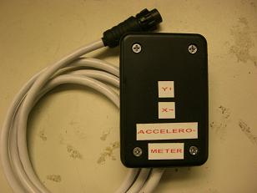
Figure B-5. Accelerometer.

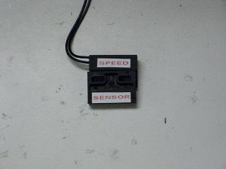
Figure B-6. Speed Sensor.

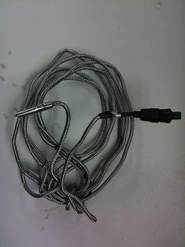
Figure B-7.Thermocouple.
Appendix C: Schematic
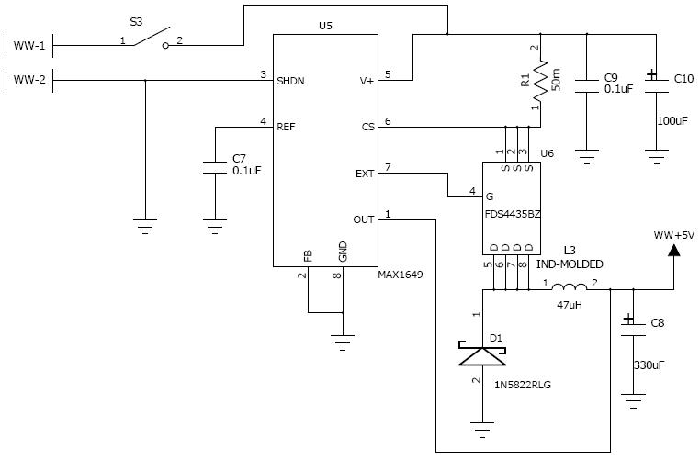
Figure C-1. 5V Wall-Wart Step-Down Power Supply.
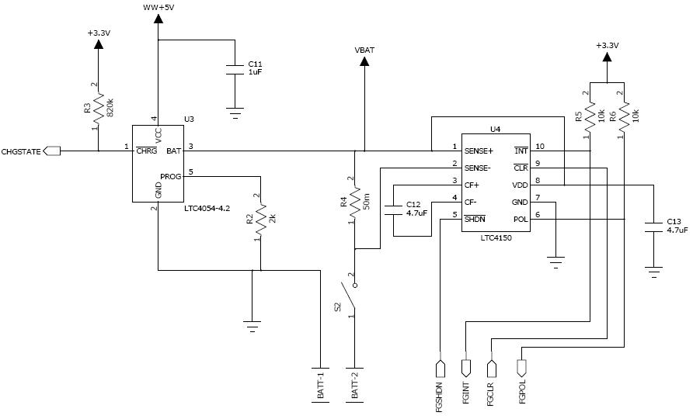
Figure C-2. Battery Charger and Fuel Gauge.
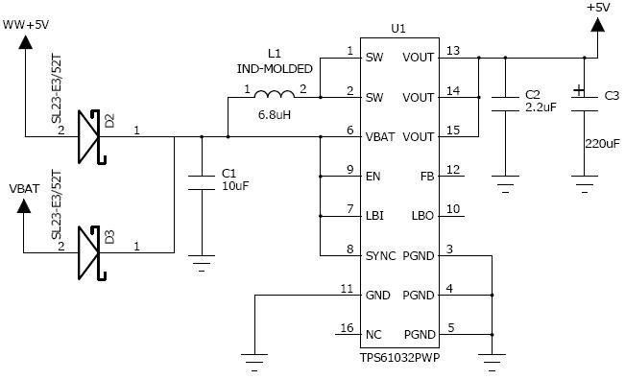
Figure C-3. 5V Logic Step-Up Power Supply.
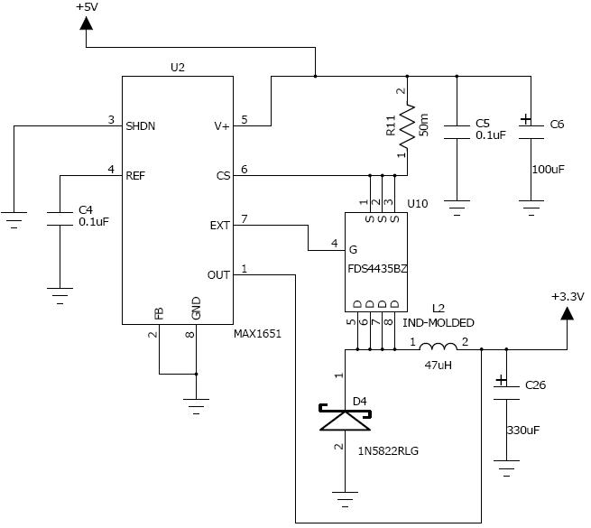
Figure C-4. 3.3 V Logic Step-Down Power Supply.
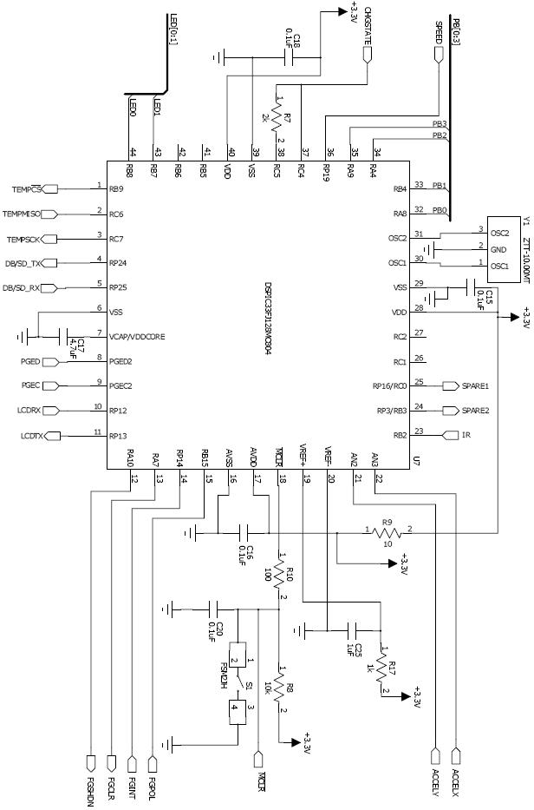
Figure C-5 Microcontroller.
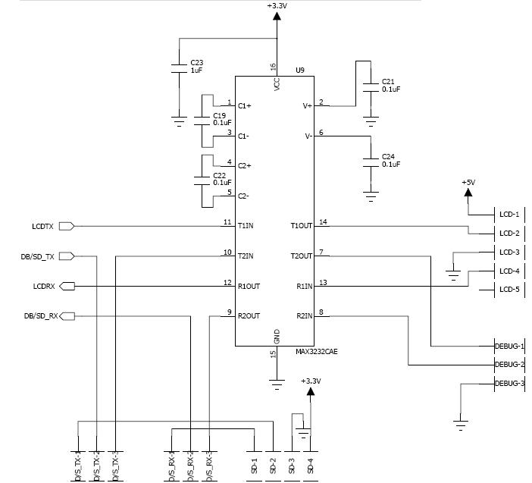
Figure C-6. UART.
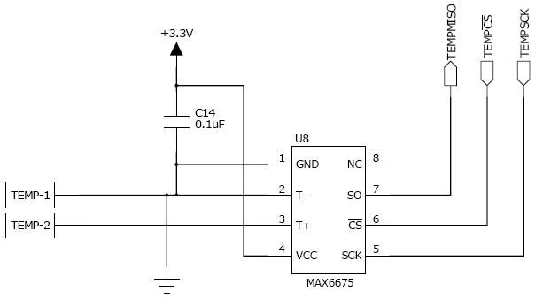
Figure C-7. Thermocouple SPI.
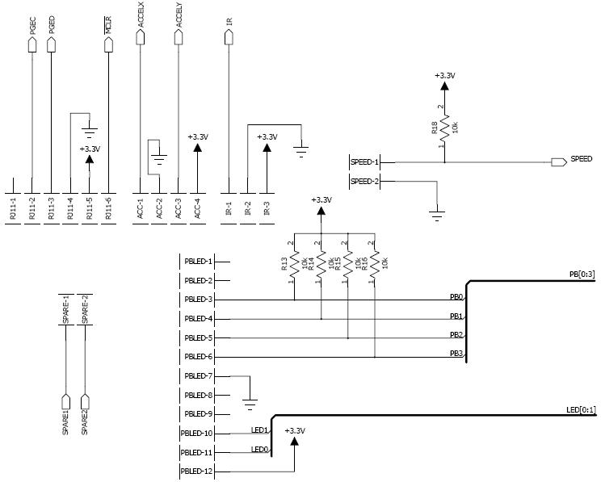
Figure C-8. Off-Board Connectors.

Appendix D: PCB Layout Top and Bottom Copper
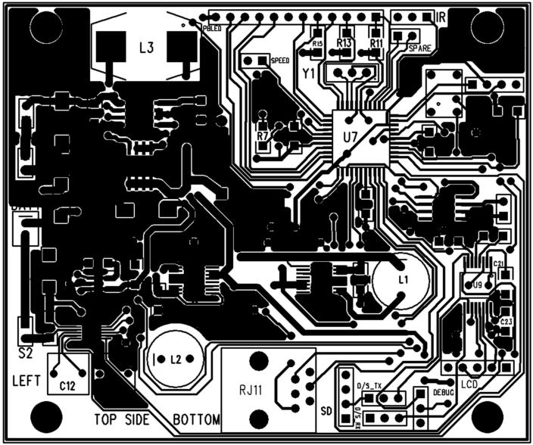
Figure D-1. Top Copper.

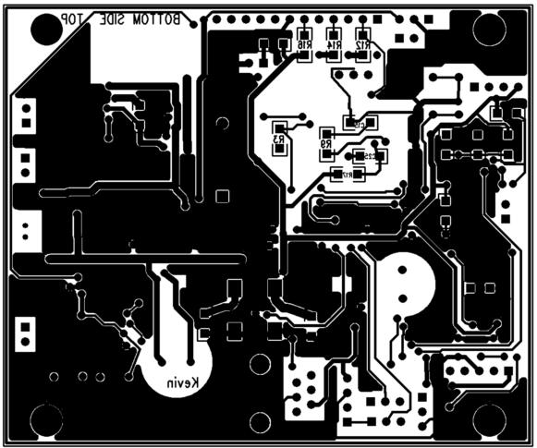
Figure D-2. Bottom Copper.
Appendix E: Parts List Spreadsheet
Appendix F: FMECA Worksheet

Failure No. | Failure Mode | Possible Causes | Failure Effects | Method of Detection | Criticality | Remarks
1A | Battery charger outputs 0V to the battery | Battery charger IC fried | Battery does not charge | Battery stays depleted | Medium | System no longer portable
1B | Battery charger overvolts the battery | Battery charger IC fried | Battery could catch fire or explode | Observable | High | Potential catastrophic destruction and potential harm to the user
1C | Battery charger charges battery past 'full' (overcharge) | Battery charge detection pin is fried | Battery could catch fire or explode | Observable | High | Potential catastrophic destruction and potential harm to the user
2A | Wall wart regulator outputs 0V | Regulator IC fried | No power to the device | Observable | Medium | System loses core functionality (non-operational)
2B | Wall wart regulator outputs >> 5V | Regulator IC fried | Many or most components could be fried, including a cascading effect through the battery circuitry leading in a critical battery failure | Observable | Medium/  High | System could become non-operational and potential catastrophic destruction and potential harm to the user
2C | Device will not turn on/off | Mechanical power switch has broken | The device stays stuck turned on or off | Observable | Medium | The device would be non-functional if stuck off or deplete its battery quickly if stuck on
3A | 5V Boost outputs 0V | Boost IC fried | Device produces no meaningful output | Observable – nothing lights up, nothing on LCD display | Medium | System loses core functionality (non-operational)
3B | 5V Boost outputs >> 3.3V or >> 5V (depending on the IC) | Boost IC fried or wall wart regulator fried and boost input voltage is much higher than expected | All 3.3V peripherals fry or cease to be usable by the microcontroller | Observable – no meaningful output, device may get hot | Medium/  High | System loses core functionality (non-operational micro/peripherals) and system could overheat
4A | Thermocouple pin sticks at  0 or 1 | Pin driver burned out by over voltage on pin | No meaningful temperature data is acquired | Observable – temperature data is constant or random | Low | System loses only this sensor
5A | RS-232 Level Translator pin sticks at  0 or 1 | Pin driver burned out by over voltage on pin | LCD and hyperterminal debugging data corrupted | Observable – LCD and hyperterminal display is garbled | Low/  Medium | System loses one or both of these components (with the LCD being a core component)
5B | Level translator IC outputs 0V | Level translator IC fried | LCD and hyperterminal display nothing | Observable | Medium | System loses both of these components
5C | Level translator IC outputs much greater than rated serial voltage | Level translator IC fried | LCD and hyperterminal display nothing and possible damage to both | Observable | Medium | System loses both of these components
6A | Microcontroller stays in reset mode | Reset circuit or switch is broken | Device produces no meaningful output | Observable – nothing lights up, nothing on LCD display | Medium | System loses core functionality (non-operational)
6B | Microcontroller outputs no data to peripherals | Oscillator for the microcontroller has ceased functioning | Device produces no meaningful output | Observable – nothing lights up, nothing on LCD display | Medium | System loses core functionality (non-operational)
6C | Microcontroller pin sticks at  0 or 1 | Pin driver burned out by over voltage on pin | Peripherals display/record meaningless data or microcontroller reads meaningless data | Observable – LCD display or SD data is not meaningful | Low/  Medium | System loses some functionality which may result in a loss of core functionality of the device

