Homework 6: Printed Circuit Board Layout Design Narrative
Due: Friday, February 22, at NOON

Team Code Name: 2 Wheel Deal SS 4000 Group No. 12
Team Member Completing This Homework: Jeremy Gries
e-mail Address of Team Member: jgries @ purdue.edu
NOTE: This is the third in a series of four “design component” homework assignments, each of which is to be completed by one team member. The completed homework will count for 20% of the individual component of the team member’s grade. The body of the report should be 3-5 pages, not including this cover sheet, references, attachments or appendices.

Evaluation:

SCORE | DESCRIPTION
10 | Excellent – among the best papers submitted for this assignment. Very few corrections needed for version submitted in Final Report.
9 | Very good – all requirements aptly met. Minor additions/corrections needed for version submitted in Final Report.
8 | Good – all requirements considered and addressed. Several noteworthy additions/corrections needed for version submitted in Final Report.
7 | Average – all requirements basically met, but some revisions in content should be made for the version submitted in the Final Report.
6 | Marginal – all requirements met at a nominal level. Significant revisions in content should be made for the version submitted in the Final Report.
* | Below the passing threshold – major revisions required to meet report requirements at a nominal level. Revise and resubmit.
* Resubmissions are due within one week of the date of return, and will be awarded a score of “6” provided all report requirements have been met at a nominal level.

Comments:

- Introduction
The “Two Wheel Deal” is a personal transportation vehicle which balances itself automatically using angle and angular rate sensors. The “Two Wheel Deal” PCB will consist of three individual sections: two high current h-bridge motor controllers and a controller circuit.
The controller circuit will contain the microcontroller and various other inputs to the microcontroller. This circuit will also contain the sensors used to balance the vehicle.
The h-bridge PCB will contain all of the transistors for the voltage switching as well as an IC to time the switching as to not short circuit the voltage supply. These two h-bridges are used to control each motor individually.

- PCB Layout Design Considerations - Overall
The “Two Wheel Deal” PCB has a couple design considerations. The PCB will be split into three physically separate sections which are the left motor controller, right motor controller, and controller circuit. Since the motors are similar, the right and left motor controllers will be similar, and the individual PCBs will be place near the respective motor on the vehicle. The controller PCB will be mounted under the rider platform because it contains sensors that are sensitive to the orientation of the vehicle.
First, the motors that were selected to drive the vehicle require a large amount of current, up to 210 Amps for max torque. This amount of current creates two major considerations which are heat and trace size for the motor controllers.
To deal with the heat of the transistors due to high current and switching, the transistors have been physically arranged in a square-like configuration. The plan is to bend the transistors off of the board and secure them directly to a heat sink. Some of the transistors will have to be insulated as to not ground the wrong transistors. The heat sink would possibly be made of aluminum or some material that has high heat transfer characteristics. There are two purposes that this design serves. This configuration allows a way to secure the PCB to the vehicle, and allows a way to dissipate heat that is generated by the transistors.
To deal with the high current, a large trace size is needed. This trace is confined to the outer areas of the board. This design will isolate the high current from the more sensitive part motor controller that is positioned in the middle of the PCB. It is determined that the trace size needs to be 300 mils to deal with the maximum possible current. 100 mil traces will be tapped off of the 300 mil trace to provide the current to the transistors. The design included three transistors in parallel so that the current could be split between them. Once the board arrives, another conductor will be added to the trace to increase the thickness. This conductor will consist of more copper wire or a solder trace.
The controller had few project specific considerations because the control algorithm is fairly simple. The power and ground traces were placed around the outer part of the PCB. The microcontroller is the central part of the circuit and traces split into many directions, therefore the microcontroller was placed close to the center.

- PCB Layout Design Considerations - Microcontroller
The microcontroller and all of the other components that are on the PCB are all run at 5V, therefore there is a single supply rail. The microcontroller that was chosen for out project was the Atmel ATMega32. This is a 40 pin DIP package as seen in the datasheet. [1] Before considering trace paths, an effort was taken to determine which pins could be grouped together for the controllers I/O. Pins that had a common purpose were grouped together which made the trace routing considerably easier.
First, the microcontroller contained enough pins so that a parallel communication to an LCD is possible. The LCD requires eight data pins and four power and ground pins. One port, of the controller is used for data transmission and the other four pins are routed to the power and ground pins of the controller. The LCD header was placed near the port that it uses. Another input header was added to the same part of the microcontroller because it will use the rest of the input pins on the same said as the LCD. Next, the microcontroller requires an external oscillator circuit. The oscillator was placed close to the microcontroller so that the traces were short and will not pick up much noise before they connect to the microcontroller. Then, the two input sensors were placed in close proximity to each other so that the input data from both sensors would be accurate, and they were wired up according to the datasheets. [2],[3] Unreliable input from these sensors could cause an unstable system. These sensors were also placed close to the microcontroller. A PLD is required to interface the microcontroller to the h-bridge controller signals. The PLD, optical isolators, and motor controller connectors were placed close together to make routing the traces easier. Finally, a header was added so that the microcontroller could be programmed easily. A rough draft the microcontroller PCB can be viewed in Appendix B.

- PCB Layout Design Considerations - Power Supply
The power supply for the “Two Wheel Deal” will consist of two – twelve volt batteries tied in series to provide the 24V dc power for the PCB. The unregulated 24V will be fed into the left and right motor controllers. A 12V regulator on each motor controller PCB will be added because the motor controller driver chip runs at 12V. One of these 12V regulated signals will be sent to the microcontroller board to a 5V regulator. All of the parts on the microcontroller board run at 5V, so only 1 regulator is needed. Also there will be an attenuated unregulated 24V signal sent to the microcontroller straight from the battery. This signal will be used to determine the battery level. This is a low current application, and should not affect any other signals on the microcontroller board. 300 mil traces will be placed on the motor controller board to supply enough current for the motors. Again, once the board is made, an additional conductor will be added to the trace to increase its volume to provide enough current capacity. This trace will be routed around the outside of the board to try to keep it away from the motor driver and power the transistors A rough draft of the PCB layout can be seen in Appendix A.

- Summary
In conclusion, the PCB will have two breakout boards for each motor controller and a PCB for the microcontroller. Each motor controller will have switching transistors that will provide the h-bridge functionality that is needed. These transistors will be switching high current, therefore a 300 mil trace will be used to supply this current. This trace will later be thickened so that it doesn’t overheat and become unusable. The h-bridge transistors will also be a means to secure the PCB to the vehicle.
The controller PCB contains all of the sensitive digital circuitry, and it will be isolated from the motor controllers. The microcontroller will be clocked using an external oscillator to achieve the necessary clocking speed. It will contain the angular inputs, and it will provide outputs to LCD screen as well as the motor controller driver.
Overall parts were placed close to the other parts that they would be interfacing with to reduce trace routing and trace lengths, which in turn reduced the amount of EMI. A careful planning of placement for the parts makes the PCB layout process run much smoother and take considerably less time.
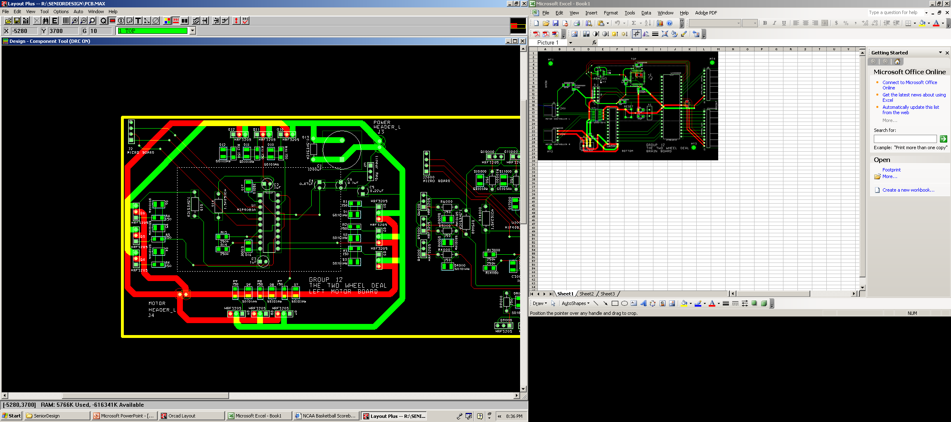
Appendix A: Motor Controller PCB
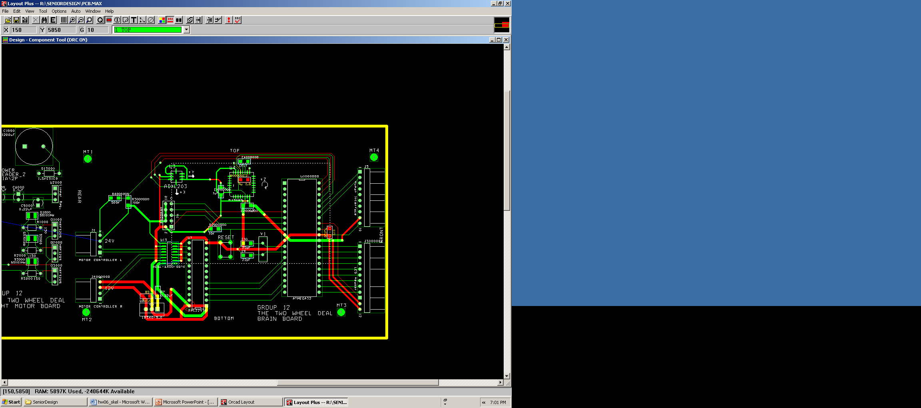
Appendix B: Microcontroller PCB
List of References

- Atmel (2007) ATMega32 datasheet Available: http://www.atmel.com/dyn/resources/prod_documents/2503S.pdf

- Melexis (2008) Angular Rate Sensor datasheet Available: http://www.melexis.com/prodfiles/0005359_MLX90609_standard_datasheet.pdf

- Analog Devices (2008) Precision +- 1.7g Single-/Dual-Axis iMEMS Accelerometer
Available: http://www.analog.com/UploadedFiles/Data_Sheets/ADXL103_203.pdf

IMPORTANT: Use standard IEEE format for references, and CITE ALL REFERENCES listed in the body of your report. Provide “live” links to all data sheets utilized.

