Homework 4: Packaging Specifications and Design
Due: Friday, February 8, at NOON

Team Code Name: ___Two Wheel Deal___________________________ Group No. __12__
Team Member Completing This Homework: ___Pete Dudash_______________________
e-mail Address of Team Member: ____pdudash___ @ purdue.edu
NOTE: This is the first in a series of four “design component” homework assignments, each of which is to be completed by one team member. The completed homework will count for 20% of the individual component of the team member’s grade. The body of the report should be 3-5 pages, not including this cover page, references, attachments or appendices.

Evaluation:

SCORE | DESCRIPTION
10 | Excellent – among the best papers submitted for this assignment. Very few corrections needed for version submitted in Final Report.
9 | Very good – all requirements aptly met. Minor additions/corrections needed for version submitted in Final Report.
8 | Good – all requirements considered and addressed. Several noteworthy additions/corrections needed for version submitted in Final Report.
7 | Average – all requirements basically met, but some revisions in content should be made for the version submitted in the Final Report.
6 | Marginal – all requirements met at a nominal level. Significant revisions in content should be made for the version submitted in the Final Report.
* | Below the passing threshold – major revisions required to meet report requirements at a nominal level. Revise and resubmit.
* Resubmissions are due within one week of the date of return, and will be awarded a score of “6” provided all report requirements have been met at a nominal level.

Comments:
Introduction
The Two Wheel Deal is a self-balancing transporting device similar to the Segway. Both devices gather information from the accelerometers and an angular rate sensor in order to drive the wheels in a way to keep the rider’s center of gravity above the wheels while displaying information on an LCD.
In order to meet our design goal, our project must be packaged in a certain way. Our finished product should weigh no more than 80 pounds to allow for easier turning and so that the user can lift it into a car or up stairs. The motors, batteries, motor controllers, microcontroller, and other circuitry are all secured under the frame which provides more passenger room. The steering post is attached to the base plate and will contain the LCD and turning mechanism.

- Commercial Product Packaging
Because Segway has patented the distinctive method that permits the device to balance itself (dynamic stabilization) on two wheels using a gyroscope and accelerometer, Segway has a monopoly in this particular market. Therefore, no other commercial product is available for comparison [1].

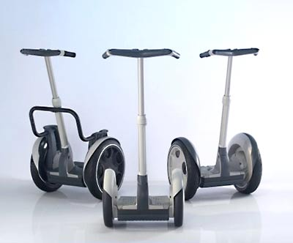
2.1 Product #1
Segway i2
The Segway is a two wheeled personal transportation device that uses the inverted pendulum control problem as its basis of operation. The vehicle has a basic design. It consists of a platform to stand on, a vertical shaft that ends in handlebars, two brushless DC motors, and two wheels. The whole assembly weighs about 105 lbs and leaves a 19 inch by 25 inch footprint. The Segway uses 19 inch tires that allow for 3.5 inch ground clearance. It has adjustable vertical shaft for handle bars that leans to the left and right to allow control of turning [2].
The Segway has some positive and negative aspects of its design. First of all the overall design is very good. It is fairly small, sleek, and efficient. It is basically a platform on wheels with handlebars. It has large wheels which give plenty of ground clearance to prevent any problems that could arise such as grounding the vehicle out while driving through various terrains. It also has easily adjustable handlebars to fit various riders comfortably without much trouble. The Segway has a small display screen that shows important data to the rider but it is rather small. This can become hard to read for riders with vision problems or in dark areas. Also the Segway uses handlebars that tilt side to side to control turning. This uses a lot of movement and can become bothersome to different riders. It also has a width of 25 inches which can be a tight fit through certain smaller than average doors [2]. This can present a problem in different situations.

- Project Packaging Specifications
The Two Wheel Deal will copy the basic design of the Segway. It is simple, concise, and efficient. The Two Wheel Deal will have a simple rectangular platform. We plan to mount our batteries and circuitry underneath the foot plate. This will allow for more foot room on top for comfort and potentially some luggage. It will also have a vertical shaft with handlebars but they will not be adjustable. The steering post will be fastened at the base and angle slightly outward from the rider so that the rider can relax his arms and ride comfortably. One difference from the Segway is that the Two Wheel Deal will not use a leaning handlebar shaft for steering control. Instead it will use a thumb joystick similar to that found on gaming console controllers. This will allow less movement to be necessary in order to control the vehicle. Attached to the handlebars of the Two Wheel Deal will be a 4 line by 20 character LCD display. This is larger than the small pocket display that is found on the Segway. The character LCD display will be able to present more information to the rider than on the Segway. The Two Wheel Deal will also have two independent motors similar to the Segway, but it will use brushed DC motors rather than brushless. The wheels for the Two Wheel Deal will only be 16 inches rather than the 19 inches found on Segways. The Two Wheel Deal will have more ground clearance than the Segway due to the higher placement of the rider’s platform. One final difference in the basic design is that the Two Wheel Deal will have a smaller footprint than the Segway. The larger footprint of the Segway makes it harder to fit through some smaller doors which can be eventually become tedious work for the rider. Because the Two Wheel Deal has a smaller footprint, this allows greater maneuverability.

- PCB Footprint Layout
For our footprint, we put the microcontroller in the center in order to easily route all the inputs and outputs. Our gyroscope and accelerometer are placed in close proximity with the microcontroller. The two motor drivers will be positioned on the outside of the PCB in order to be close to the respective motor. With this arrangement, we can separate the analog and digital portions of the circuit as much as possible. The estimated size of our PCB is approximately 11.5x3.5 inches.

- Summary
Our project mimics the Segway personal transportation device that was released in December 2001 [3]. We are using a gyroscope and accelerometers like the Segway, but our motors can deliver more horsepower. Our device will include safety checks to verify that the rider is present before traveling any further forward. The estimated cost of our Two Wheel Deal will be approximately $1500 and will weigh no more than 80 pounds once completed.
List of References

[1] Segway, “The Science of Segway”, [Online Document], [cited 6 January 2008], http://www.segway.com/about-segway/science-of-segway.php

[2] Segway, “Segway i2 Specifications”,[Online Document],[cited 6 February 2008],
http://www.segway.com/downloads/pdfs/i2-specs.pdf

[3] Wikipedia, “Segway PT”, [Online Article], [cited 6 February 2008],
http://en.wikipedia.org/wiki/Segway

IMPORTANT: Use standard IEEE format for references, and CITE ALL REFERENCES listed in the body of your report.

Appendix A: Project Packaging Illustrations

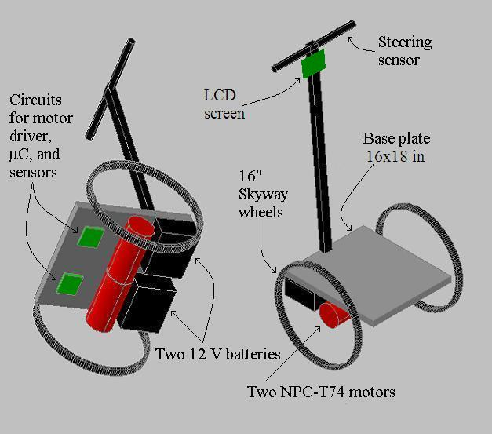

Appendix B: Project Packaging Specifications

Item | Dimensions | Weight | Cost | Tooling Req.
Steel Frame | 16 x 18 in | 14 lbs | $50 | Welding, drilling
Steel Footplate | 15 x 17 in | 9 lbs | $20 | Cut to size
Steering Post | 1 x 1 x 42 in | 5 lbs | $10 | Cut to size
Handle Bar | 1 x 1 x 12 in | 1 lb | $5 | Cut to size
 | Total | 29 lbs | $85

Appendix C: PCB Footprint Layout



