Homework 4: Packaging Specifications and Design
Due: Friday, February 8, at NOON

Team Code Name: _O.M.A.R.___________________________________ Group No. _8____
Team Member Completing This Homework: _____Robert Toepfer_____________________
e-mail Address of Team Member: rtoepfer@ purdue.edu
NOTE: This is the first in a series of four “design component” homework assignments, each of which is to be completed by one team member. The completed homework will count for 20% of the individual component of the team member’s grade. The body of the report should be 3-5 pages, not including this cover page, references, attachments or appendices.

Evaluation:

SCORE | DESCRIPTION
10 | Excellent – among the best papers submitted for this assignment. Very few corrections needed for version submitted in Final Report.
9 | Very good – all requirements aptly met. Minor additions/corrections needed for version submitted in Final Report.
8 | Good – all requirements considered and addressed. Several noteworthy additions/corrections needed for version submitted in Final Report.
7 | Average – all requirements basically met, but some revisions in content should be made for the version submitted in the Final Report.
6 | Marginal – all requirements met at a nominal level. Significant revisions in content should be made for the version submitted in the Final Report.
* | Below the passing threshold – major revisions required to meet report requirements at a nominal level. Revise and resubmit.
* Resubmissions are due within one week of the date of return, and will be awarded a score of “6” provided all report requirements have been met at a nominal level.

Comments:
- Introduction
OMAR is part of an ongoing project conducted by the Purdue IEEE student branch [1]. The goal of the project is to have a helicopter send a sub-vehicle into an unknown building, have the sub-vehicle map the room, and have it send back visual reconnaissance data to a base station. All if this is done autonomously and must be done in less than 15 minutes. The design for the sub-vehicle is an unmanned ground vehicle (UGV) that operates a 4 wheel design much the same as a tank drive system. One of the main concerns for the packing design is that the vehicle will be carried by the helicopter 3 kilometers worth of GPS way points and then be shot into the building. Because of these constraints, the sub-vehicle must be fairly small, as the helicopter that is carrying it is not that large. OMAR must also be very light weight, since the helicopter has a payload of less than 25 pounds. Lastly, OMAR must be very robust, since it must withstand the impact of be shot into the building by the helicopter. Due to that fact that this is an ECE design project, no concern with the operation of insertion into the building will be taken. It will be assumed that the vehicle has landed upright inside the building and proceed from there.

- Commercial Product Packaging
There are a very limited number of commercial products that are designed for the intended use of this project. Most of the work being done in this field is for government use. Autonomous navigation, room mapping, and image recognition are all fields of highly active research. When searching for similar products, the vehicles that were found all fell within two intended categories: research or military use. When it comes to the packaging design used in each category, they seem to have some distinct differences. The vehicles for research tend to be much larger in size, more open and less contained, and some were significantly lighter than those intended for military use. The main reasons for this are due to the fact that military UGV’s are intended for detection, neutralization, breaching minefields, logistics, fire-fighting, and urban warfare to name a few uses. These applications can require the vehicle to be very small, sometimes heavy, have long battery life, and always very powerful. In research implementation the size and weight of the vehicle are not usually of concern. It is the sensors and software running on the vehicle that is the main concern.
Two main commercial products have been chosen that most similarly resemble the project. The first product, which falls under the research category, is the MobileRobotics incorporation’s Pioneer 3-AT [2] with the 2-D/3-D room mapping and stereovision kits. The second product, the iRobot PackBot [3] with mapping kit, is an example of military use. OMAR is planned to incorporate many features from both products and also have some unique features. Shown below are the advantages and disadvantages of each products packaging design, and also the features of each that OMAR will use.

  - MobileRobotics Pioneer 3-AT
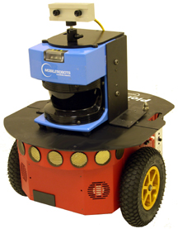
The Pioneer 3-AT [2] is an example of a UGV that is used primarily in classrooms and for research. The Pioneer 3-AT [2] is capable of autonomous navigation, 2-D room mapping using a laser range finder, 3-D room mapping using stereoscopic vision using 2 cameras, and object avoidance using multiple sonar sensors. The included software allows for the Pioneer 3-AT [2] to perform room mapping straight out of the box. It is quite large, fairly heavy, and does not appear to be extremely robust. It stands at 50cm long x 49cm wide x 26cm tall and weights 12 kg. The design seems to be fully contained with no unnecessarily exposed components.
Fig. 2.1: Mobile Robotics Pioneer 3-AT
The first thing to notice when looking at the Pioneer 3-AT [2] is the huge laser range finder with 2 cameras mounted on top. This laser range finder is placed in the middle of the base and is stationary since the range finder is capable of 180˚ scanning. The range finder is large, heavy, and consumes a large amount of power so it would not be well suited for OMAR. The camera mounted on top is very small, but it houses 2 lenses for stereo vision, which OMAR will not need. OMAR will not include 2 cameras, but the placement of the camera will be replicated, since mounting the camera on top seems to give the best angle for image taking.
The next design specification to note is that the Pioneer 3-AT [2] encloses 8 sonar sensors mounted directly to the front bumper of the base. The placement of this design seems optimal, but the amount of sensors seems excessive. After researching sonar sensors, object detection and avoidance can easily be accomplished by mounted only 2 or 3 sensors on the front at 45˚ or 60˚ respectively. The last main design specification on the Pioneer 3-AT [2] is the drive system. This robot uses a 4 wheel design. This system is cheap and light weight and is very easy to use. OMAR will copy the 4 wheel design.

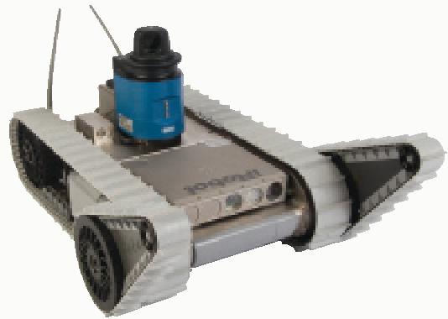
  - iRobot PackBot
IRobot [3] offers many UGV’s on there website. The PackBot [3] is a standard UGV that can come with many different kits that can perform bomb detection, visual reconnaissance, room mapping, and even sniper detection. The kit that most closely meets OMARs intended application is the PackBot [3] with the room mapping kit. This robot is sometimes used in the classroom or for research, but it is mostly used in the military as are the rest of their robots. This PackBot [3] is capable of room mapping, visual reconnaissance, object detection and avoidance, autonomous navigation, and it can even climb stairs. It is very tightly packed sitting at 20 cm wide x 35cm long x 8 cm tall. The problem with this design is that it weighs 42 pounds! It is heavy, but it is smaller and extremely robust, making more suitable than the Pioneer 3-AT [3] for OMARs design.
Fig. 2.2: iRobot PackBot with mapping kit
The first packaging and design specification to consider is the tank drive system. The tank drive system allows it to disperse its weight across a larger surface area, allowing it to traverse just about any kind of terrain. The triangular tracks in the front allow the tank to climb stairs. This tank drive system with the triangular wheels is more expensive and not necessary for OMAR since OMAR is only mapping the inside of a building and the terrain will not vary.
The rest of the packaging specs on the PackBot [3] are the laser range finder, camera, and sonar sensors. The laser range finder is capable of 360˚ scanning and thus can be mounted anywhere on top of the tank as long as it has clear vision. Again, laser ranger scanners are too large and expensive, so OMAR will not be using one. The idea of scanning 360˚ seems to be more efficient, so this will be incorporated into the design. The single camera is on the front of the vehicle close to the bottom. This seems to be inefficient since the camera will only be able to take pictures from a low angle. OMAR will be using the single camera design mounted. Finally, there are 2 or 3 sonar sensors mounted on the very front of the PackBot [3]. OMAR will copy this design and have 2 or 3 sonar sensors on the front.

- Project Packaging Specifications
As mentioned before, OMAR needs to be very light weight and small. Appendix A contains 3 3-D drawings of OMAR. For OMARs drive system, the 4 wheel design will be used. The left and right sides will be controlled independently so that OMAR can rotate 360˚. On the front of OMAR, 2 or 3 Devantech SRF02 [4] sonar sensors will be mounted at either 45˚ or 60˚ apart. The PCB and Gumstix [5] embedded computer will be place in the middle between the sheets of plastic. On top, the R298-1T [6] servo will be mounted. On the front and back face of the servo will sit the Sharp IR [7] range finders. The reason they will be mounted on the servo is so that OMAR can scan an area of 360˚. In order to help eliminate the IR range finders minimum distance the servo will be mounted in the middle of the vehicle. The body will consist of two sheets of lexan [8]. The motors will be packaged between the 2 sheets of plastic with dimensions 10cm wide x 20cm x 10cm. Foam tires, motors, motor mounts, and mounting hubs from Lynxmotion [9] will be used. The camera will also be place on top of the servo so that OMAR can rotate the camera if needed to take pictures in tight situations. The battery will sit on top of the vehicle located in the back. Finally, the wireless card will be placed on top between the sonar sensors and the servo.

- PCB Footprint Layout
The PCB footprint is shown in appendix C. Listed below in table 4.1 is a list of all the major components and the selected packages. There were not many options for the accelerometer and magnetometer so the listed packages were chosen. The estimated dimensions are 95mm x 95mm and the estimated total area is 9025 mm².

Table 4.1: List of major components and packages selected.

- Summary
As you can see, there are some very similar products out on the market used for research and military use. These products seem to be well designed, except they are rather large and heavy. From these products, a few design specifications will be copied, such as the 4 wheel drive system, sonar placement, and camera placement. There were also a few design specifications that not be used. These specifications are the tank drive system, stereoscopic vision, and laser range finding.
Omar project is limited only by a few design constraints. The IR range finders will be mounted in the middle to help eliminate the minimum range distance. OMAR is also limited in size and weight by the helicopters specifications. Because of this, OMAR must be light weight and small. OMARs packaging specifications not only will make it small and light weight, but it will also be very robust.
List of References

- Purdue IEEE, “Purdue IEEE Student Branch,” Purdue IEEE January, 2008. [online]. Available: http://purdueieee.org. [Accessed: February 6, 2008].

- MobileRobots inc., “Pioneer 3-AT with room mapping kit,” MobileRobots inc. January, 2008. [online]. Available: http://www.activrobots.com/ROBOTS/systems.html.
[Accessed: February 6, 2008],

- iRobot, “PackBot with mapping kit,” [online document], unknown publication date, [cited February 6, 2008], http://www.irobot.com/pass.cfm?li=filelibrary/GIspecsheets/MappingKit.pdf

- Acroname Robotics, "Devantech SRF02 Sensor," Acroname Robotics, December, 2007. [Online]. Available: http://www.acroname.com/robotics/parts/R287-SRF02.html. [Accessed: Jan. 31, 2008].

- Gumstix, "Specifications of the Gumstix Verdex Motherboards," DocWiki, December, 2007. [Online]. Available: http://docwiki.gumstix.org/Verdex. [Accessed: Jan. 31, 2008].

- Acroname Robotics, " High Torque Full Turn Servo," Acroname Robotics, January, 2008. [Online]. Available: http://www.acroname.com/robotics/parts/R298-1T-SERVO.html. [Accessed: Jan. 31, 2008].

- Sharp, "GP2Y0A700K0F", [Online Document], 2005 August, [cited January 31, 2008], http://www.acroname.com/robotics/parts/R302-GP2Y0A700K0F.pdf.

- Professional Plastics, “Lexan Sheet,” Professional Plastics. [Online]. Available: http://www.professionalplastics.com/LEXANSHEET9034. [Accessed: Feb. 06, 2008].

- Lynxmotion, “Lynxmotion Robot Kits,” Lynxmotion.[Online]. Available: http://www.lynxmotion.com. [Accessed: Feb. 06, 2008].

IMPORTANT: Use standard IEEE format for references, and CITE ALL REFERENCES listed in the body of your report.

Appendix A: Project Packaging Illustrations
(note: all measurements in inches)

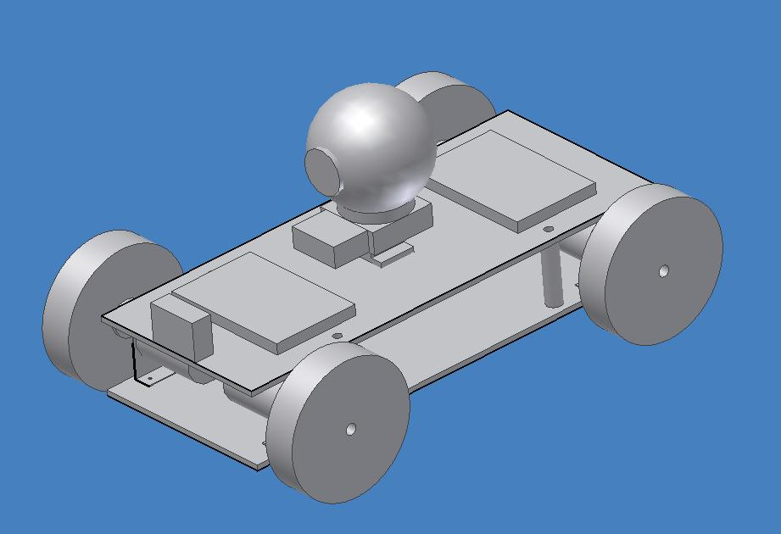Fig A.1: OMAR 3 point perspective
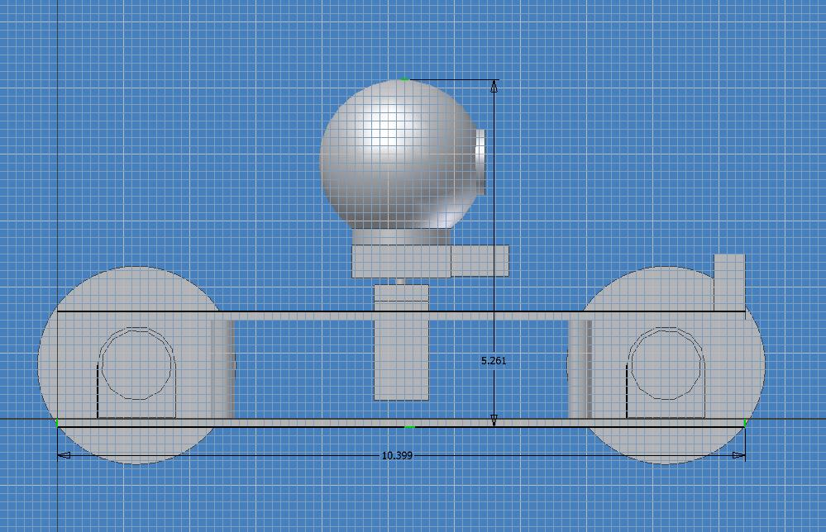
Fig A.2: OMAR side view

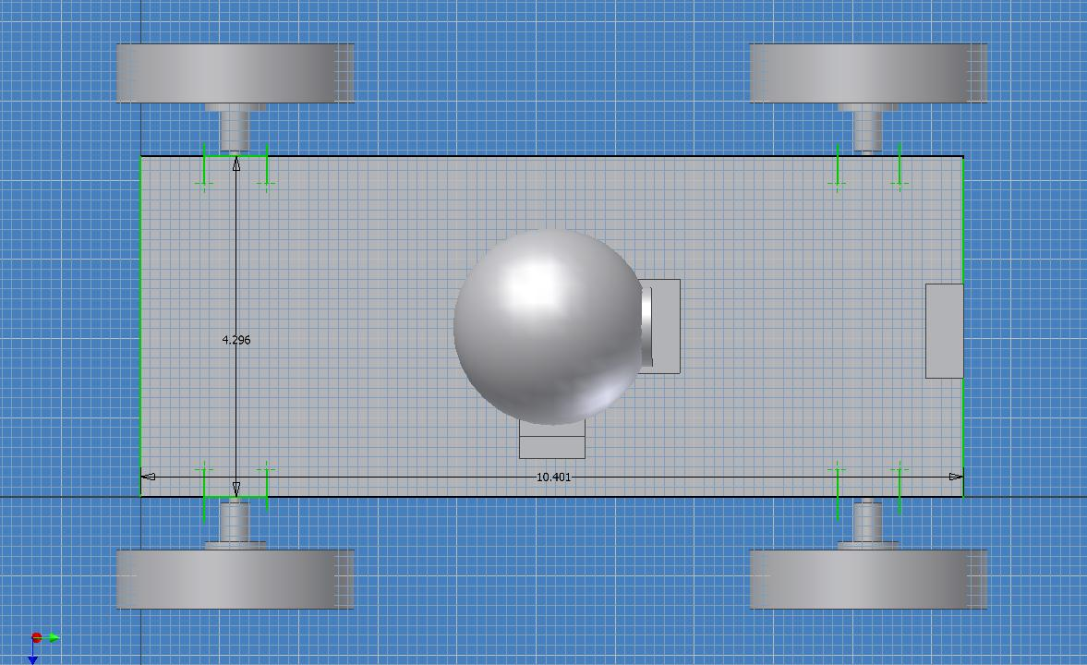
Fig A.3: OMAR top view
Appendix B: Project Packaging Specifications

Item | Description | Quantity | Weight (lb) | Cost ($) | Total Weight (lb) | Total Cost ($)
Neoprene Foam Tire | NFT-07 | 2 | 0.10 | $4.36 | 0.20 | 8.72
Gear Head Motor | GHM-07 | 4 | 0.12 | 16.50 | 0.48 | 33.00
Mounting Hub | HUB-06 | 2 | 0.04 | 8.00 | 0.08 | 16.00
Lexan Sheet | Lexan 9034 36”x36”x0.125” | 1 | ~ | 55.00 | ~ | 55.00
Aluminum Motor Mount | MMT-01 | 2 | 0.03 | 7.95 | 0.06 | 15.90

Appendix C: PCB Footprint Layout
