ECE 477 Final Report − Spring 2008
Team 3 − BEARS
Nikita Solilov
Nicholas
Stephens
Ryan Giltner
Jonathon
Pendlum
B E A R S
B E A R S
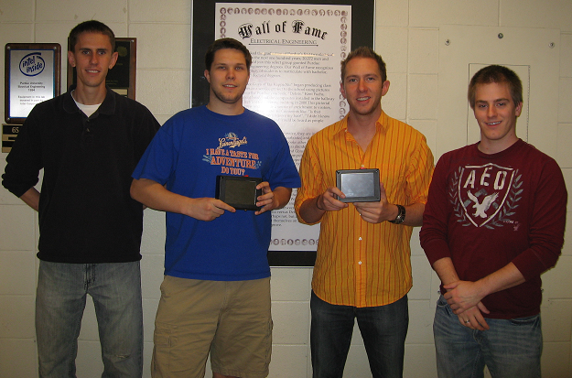

Team Members:

#1: Nikita Solilov Signature: ____________________ Date: _________

#2: Nicholas Stephens Signature: ____________________ Date: _________

#3: Jonathon Pendlum Signature: ____________________ Date: _________

#4: Ryan Giltner Signature: ____________________ Date: _________

CRITERION | SCORE | MPY | PTS
Technical content | 0 1 2 3 4 5 6 7 8 9 10 | 3
Design documentation | 0 1 2 3 4 5 6 7 8 9 10 | 3
Technical writing style | 0 1 2 3 4 5 6 7 8 9 10 | 2
Contributions | 0 1 2 3 4 5 6 7 8 9 10 | 1
Editing | 0 1 2 3 4 5 6 7 8 9 10 | 1
Comments: |  | TOTAL

TABLE OF CONTENTS

Abstract | 1
1.0 Project Overview and Block Diagram | 2
2.0 Team Success Criteria and Fulfillment | 4
3.0 Constraint Analysis and Component Selection | 5
4.0 Patent Liability Analysis | 13
5.0 Reliability and Safety Analysis | 20
6.0 Ethical and Environmental Impact Analysis | 26
7.0 Packaging Design Considerations | 30
8.0 Schematic Design Considerations | 39
9.0 PCB Layout Design Considerations | 45
10.0 Software Design Considerations | 49
11.0 Version 2 Changes | 50
12.0 Summary and Conclusions | 51
13.0 References | 55
Appendix A: Individual Contributions | 60
Appendix B: Packaging | 62
Appendix C: Schematic | 65
Appendix D: PCB Layout Top and Bottom Copper | 67
Appendix E: Parts List Spreadsheet | 70
Appendix F: Software Listing | 71
Appendix G: FMECA Worksheet | 105

Abstract

The Bearing Emergency Alert Road System (BEARS) is a product developed for the Spring 2008 semester of ECE 477 Digital Systems Senior Design. BEARS is a unique GPS-based emergency vehicle detection and alert system designed to aid motorists with a more informative and reliable method for knowing when an emergency vehicle is in their vicinity. Compared to the current system of sirens blaring from active emergency vehicles, BEARS will give the motorist more time to pull safely to the side of the road and allow more reliable passage for emergency vehicles on their critical missions. The system comprises both transmitter and receiver units, uses a radio frequency link with half-mile range for communication, and a touchscreen LCD for user interface. This report will detail the development of BEARS and outline the various facets involved in product design and development.

- Project Overview and Block Diagram

BEARS is a GPS-based emergency vehicle alert system that provides indication to motorists of the presence of an emergency vehicle such as police, fire trucks, and ambulances in their vicinity. The system is activated when the sirens of the emergency vehicle are activated. The emergency vehicle's transmitter unit is equipped with a GPS receiver to mark its location, and an RF transmitter to broadcast the vehicle type (fire, police, or ambulance) and its present GPS location to surrounding vehicles. Individual motorists are equipped with a GPS receiver of their own, and an RF receiver. The RF receiver detects when an emergency vehicle broadcast is taking place, and it is thus known that an emergency vehicle is present. An RF receiver demodulates the transmitted data and sends the broadcast information to the receiver’s microcontroller. The microcontroller calculates the distance and relative location of the emergency vehicle from their present vehicle location by comparing the transmitted and local GPS data. An LCD screen alerts the motorist of an emergency vehicle’s presence and displays useful visual cues for the driver including an arrow pointing in the direction of the emergency vehicle, the distance to the emergency vehicle, and what type of vehicle is broadcasting. When no emergency vehicle is present, BEARS is still useful in its non-emergency active mode for displaying GPS coordinates.
The final delivered project uses a Freescale 9S12XD256 microcontroller, and communicates via SPI to a 5.6” ez-LCD touchscreen display, asynchronously via SCI to a USGlobalSat EM-406a GPS receiver, SCI to the Radiotronix Wi-232 DTS-R RF transceiver, and is capable of using a digital compass on general purpose I/O lines, although the compass functionality was not implemented in our final software approach. The following block diagram demonstrates the outline of BEARS. Note that both the transmitting and receiving units are identical with respect to hardware and software. The user can configure the unit to operate in either mode.

Freescale
9S12XD256
µController

LCD
320x234
ezLCD-004
including
onboard
Controller
& Touchscreen
3.3 V and 5 V LDO Regulators

Transceiver
Wi.232DTS-FCC-RA-R

GPS Module
EM-406a

Speaker
(unused)
3 SPI
4 SCI
Digital Compass
HM55B
(unused)
4 GPIO
PWM
2 SCI

12 VDC Supply

Figure 1.1 – BEARS Block Diagram
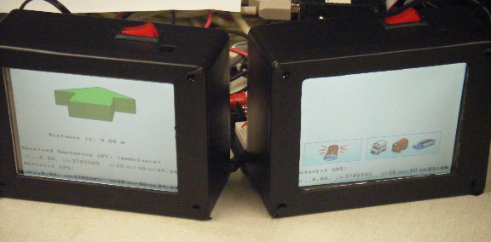

Figure 1.2 – BEARS Transmitter and Receiver Final Product

- Team Success Criteria and Fulfillment

The following five Project Specific Success Criterion (PSSCs) have all been successfully demonstrated to the course staff.

An ability to display GPS information on the transmitter and receiver.

An ability to notify motorists of transmitting emergency vehicle’s presence.

An ability to generate and transmit emergency vehicle information.

An ability to specify emergency vehicle type via touchscreen input.

An ability to determine the relative distance and direction of an emergency vehicle.

Constraint Analysis and Component Selection

Introduction
The Bearing Emergency Alert Road System (B.E.A.R.S.) is an emergency vehicle alert system that provides indication to motorists of the direction and distance of an emergency vehicle. The system is activated when the sirens of the emergency vehicle are turned on. The emergency vehicle is equipped with a GPS receiver to mark its location and a RF transmitter to broadcast the vehicle type (fire, police, medical, other) and its present GPS location. Individual motorists are equipped with a GPS receiver of their own and a RF receiver. The RF receiver will receive the emergency vehicle’s information. A local microcontroller will calculate the distance, relative location, and direction of travel of the emergency vehicle from their present vehicle location by comparing the transmitted and local GPS data. A speaker along with the LCD screen will be used to initially alert the motorists of a transmitting emergency vehicle. Then, using an arrow, the LCD will display the relative direction of the emergency vehicle from the motorist and the distance. As well, along the border of the LCD will be compass headings that correlate to the direction the vehicle is currently facing. As long as the emergency vehicle is transmitting, then the receiver will continue to track and display its relative location. The constraints on the system will arise mainly from these areas: microcontroller computational speed, number of onboard serial interfaces and general purpose I/O, amount of onboard FLASH and RAM, RF transmission distance, packaging size, and cost.

Design Constraint Analysis
To achieve the desired functionality, the project will have several constraints that must be addressed properly by choosing the correct components. First of all, the microcontroller on each unit will have to be robust enough to calculate new telemetry data, update display information on a LCD, control the LCD’s touchscreen, and periodically communicate with the GPS, transceiver, and digital compass peripherals. Secondly, the microcontroller must have enough serial interfaces and general purpose I/O for all the various peripherals. Thirdly, the arrow on the LCD will need individual images for each angle, which will require a substantial amount of memory. Fourth of all, the RF data link will require a substantial range for the system to be effective. Fifth of all, the entire unit must fit inside a vehicle and easily interface with the car’s power supply. Finally, the cost must be competitive enough so the average user can afford to buy a very useful, but non-essential product.

Computation Requirements
The receiver and transmitter units will share most computational tasks except for a few specific peripherals. Both units will need to control a touchscreen LCD display, receive GPS location data, and interface with a transceiver. However, only the receiver will have a digital compass and will have the task of computing the emergency vehicle’s relative location and distance.
Generally, most LCDs have an onboard controller to off load the large amount of work required to drive the display. In this design, the chosen LCD with an onboard controller [9] only requires a SPI port to send display data and commands. The LCD controller’s framebuffer will hold the current display and does not need to be continuously refreshed. The LCD has a SD card interface that will allow the microcontroller to load images directly. The onboard fonts and drawing capabilities of the LCD controller allow the displaying of text and graphics with simple commands. The touch screen uses a simple protocol where buttons are drawn and updates are sent over SPI only after a button status update. Therefore, the LCD will require very little computational time to update the display. However, the images displayed on the screen will require space. The total space required for all images sizes at approximates 8 MBs, which will easily fit on the available 16 and 32 MB SD cards.
The GPS module [2] for our system will be able to detect GPS signals, either with an external or built-in antenna, and calculate location with at least 10 meter accuracy. The module will then convert its calculations to a standard, well-documented, GPS communication protocol such as the National Marine Electronics Association’s (NMEA) 0183 ASCII-based standard, or the SiRF binary protocol. The computation from the microcontroller will be parsing this information from the serial buffer into a useful format.
The transceiver [3] in each unit will have little computational requirements besides start up initialization and controlling the SCI port interfaced with the device.
In the receiver unit, a digital compass [4] is necessary to determine the direction of the motorist. The selected digital compass outputs the angle with respect to two axes in brads (binary radians.) The microcontroller will have to convert the output into a standard form for use with the relative location and distance computation. The conversion will require solving trigonometric equations, which may require many computation cycles to complete. Since the calculation will be performed approximately at a 1Hz interval, this should not pose a major bottleneck in the design.
Finally, the receiver unit needs to display the relative location and distance of the emergency vehicle. The relative location will appear as an arrow while the distance will be simple text. The distance calculation will require the use of a square root algorithm the hypotenuse. One option is Newton’s method, which depending on the accuracy needed, can be cycle intensive. The angle for the arrow will need to use a trigonometric lookup table and interpolation. Depending on the microcontroller used, the required space can range up to 5 kilobytes of memory. In either case, since the GPS data will only update at a 1Hz interval, these calculations should not constrain the system.

Interface Requirements
The microcontroller will interface via general purpose I/O (GPIO) with the LCD controller and the keypad encoder (transmitter only.)
The LCD controller requires a full SPI interface (MOSI, MISO, SCK, and SS) and a GPIO to turn the unit on. The GPIO must have a voltage swing greater than 3.6V, while all the signals must have a voltage swing of 0-3.3V.
The keypad encoder has a four bit bus with an interrupt signal. When a keystroke is detected, the interrupt signal toggles and the keystroke is encoded into a four bit identifier and placed on the bus. All the signals must be standard 0-5V TTL logic.

On-Chip Peripheral Requirements
The following table summarizes the complete I/O requirements, which includes on-chip peripherals:
Receiver (Motorist)
Peripheral | I/O | I/O Voltage Swing | Input Voltage | Peak Input Current
LCD | 1x SPI  1x GPIO | 0-3.3V | 3.3V | 1200mA
GPS | 1x SCI | 0-2.85V | 5V | 100mA
Transceiver | 1x SCI | 0-5V | 3.3V | 57mA
Digital Compass | 1x SPI | 0-5V | 5V | 45mA
Speaker | 1x PWM
Transmitter (Emergency Vehicle)
Peripheral | I/O | I/O Voltage Swing | Input Voltage | Peak Input Current
LCD | 1x SPI  1x GPIO | 0-3.3V | 3.3V | 1200mA
GPS | 1x SCI | 0-2.85V | 5V | 100mA
Transceiver | 1x SCI | 0-5V | 3.3V | 57mA
Table 3.1 – Required I/O Specifications

Off-Chip Peripheral Requirements
The off-chip peripherals include a LCD controller (included with the LCD), GPS module, transceiver unit, antennas for transceiver/GPS modules, digital compass, keypad, keypad encoder, and a speaker. Their specifications in terms of input voltage and I/O voltage swing are specified in the above table 3.1.

Power Constraints
Both the receiver and transmitter units will be interfaced with the car’s electrical system, providing 12.6V to 12.8V with a fully charged battery. Most car batteries provide around 75 Amp-hours and with continuous recharging from the alternator, the units can safely draw up to 2A without affecting car performance. In Table 3.1, the maximum current draw from the major components is approximately 1402 mA in the receiver and 1357 mA in the transmitter. Adding approximately 250 mA from the microcontroller, the total peak current draw becomes approximately 1700 mA. Even though several components were not included, this calculation shows that there should be enough power available for the devices.
Since the peripherals operate at two different voltage levels, a voltage regulator will be used to supply 5V power and a DC-DC converter to support the 3.3 voltage level.

Packaging Constraints
Both the transmitter and receiver units must fit within the car, preferably the dashboard area, without taking up too much space. The transceiver unit and GPS module will need a clear line of sight outside of the car, so their antennas will need to be outside the packaging. Due to the small size of the screen, the LCD will have to be mountable no further than arm lengths away.

Cost Constraints
This kind of product does not currently exist in the market, and therefore has no competition. However, the price point of the devices will still be very important, for both motorists and emergency response teams.
Typical traffic preemption devices used in ambulances to “change the traffic lights” cost approximately $500 [5.] Therefore, emergency response and law enforcement teams have a high price range.
The current trend for motorists is to buy a GPS based navigation system. One popular choice, TomTom, sells for approximately $240 [6.] This device will have reduced functionally compared to the TomTom, a price range of $50-100 per unit (receiver or transmitter) appears reasonable.

Component Selection Rationale
For the LCD, the table below outlines the various parameters considered when deciding which to use.
 | Sparkfun [1] | Newhaven [7] | Display3000 [8] | ezLCD-004 [9]
Resolution | 128 x 128 | 320 x 240 | 176 x 132 | 320 x 240
Size (Inches) | 1.2 x 1.2 | 4.5 x 3.5 | 2.2 x 1.5 | 4.8 x 3.6
Price | $40 | $127 | $71.40 | $300.00
Type | TFT | STN | TFT | TFT
Onboard Controller | Yes | Yes | Yes | Yes
Sample Code | Yes (lots) | No | Yes | Yes
Ease of Integration | High | Low | High | Very High
Table 3.2 – Candidate LCD Parameters
Sample code availability and LCD size were the two most important factors in this decision. The ezLCD-004 came ahead in both areas. Sparkfun’s [1] LCD had a large code and support base, but a very small LCD. The ezLCD-004’s larger screen allows for a more eye catching product. As well, the ezLCD has an integrated touch screen, which removes the need for a separate keypad. Display3000’s [8] LCD could have worked very well in this application as well, except for the price. The other LCDs did not meet the application’s specifications. Therefore, with all factors considered, the ezLCD-004 was the best choice.
The transceiver had a similar matrix to help decide which to use. Table 3.5 shows four of the possible choices for the receiver. The most important areas to consider were the units range, transmission (output) power, and price. Our project specifically needs a range of half a mile while keeping the transmission power low to not possibly interfere with the GPS signal. A low cost unit is also important to fulfill the cost constraints. The Xtend [10] device immediately could not be used due to its cost. Out of the remaining three, we decided to use the Radiotronix device, because that unit had a satisfactory range with the least amount of output power. As well, the company was very receptive with providing samples, which will greatly facilitate development work.
 | Radiotronix  Wi.232DTS [3] | Digi  Xtend [10] | AeroComm  AC4790-1000[11] | AeroComm  AC4790-200[11]
Price (a piece) | $45 | $179 | $77.50 | $63.85
Frequency | 902 - 928 MHz | 902 - 928 MHz | 902 - 928 MHz | 902 - 928 MHz
Range | >1500 ft | Up to 40 miles | Up to 20 miles | Up to 4 miles
Output Power | 25 mW | Up to 1 W | Up to 1 W | Up to 250 mW
Needs Antenna | Yes | Yes | Yes | No
Interface | SCI | SCI | SCI | SCI
Throughput | Up to 152.32 kbps | Up to 115 kbps | 76.8 kpbs | 76.8 kbps
Encryption | No | Yes, 256-bit AES | Yes, 56-bit DES | Yes, 56-bit DES
Table 3.3 – Candidate Transceiver Parameters
Given the constraints for our GPS module, the EM-406(a) [2] engine from USGlobalSat seems to be the best option. A comparison of our modules of interest is shown below. Ultimately, all three modules described fit many of our constraints, as all were within several dollars of each other, supported NMEA serial output protocol, and had reasonable accuracy better than or equal to 10 meters. However, the EM-406(a) was seen as the component of choice because it was the only option with a header pin connection, rather than surface mount packaging. This will be beneficial for the final design and allow for easy development. Also, it is built with an integrated patch antenna so there is no need for purchasing and interfacing with an external GPS antenna. The chip is also relatively high-performance with the latest available SiRF III chipset, with 20 satellite channels for quick times to first fix and maintaining good accuracy.
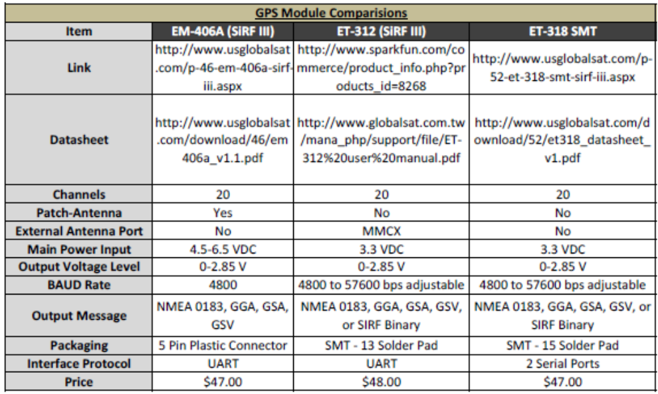
Table 3.4 – Candidate GPS Parameters
Two digital compasses were compared for the project. The HM55B digital compass [4] was chosen over Honeywell digital compass [12] for cost reasons ($29 for HM55B vs. $699 for HMR3000.) While the HMR3000 provides better degree of accuracy (3 axis vs. 2 axis) its price does not justify the unnecessary accuracy that our project is not likely to notice.
Since the peripherals would determine the microcontroller constraints, it was the last component picked. The requirements are: 2 SPI interfaces, 2 SCI, 1 PWM, large amount of FLASH storage (more than 180 KB,) moderate core speed (~25 MHz,) moderate amount of RAM (~16 KB,) and excellent support material. After some initial research, Freescale’s 9S12 line of microcontrollers was chosen due to availability of development boards, support materials, and the group’s previous class experience with the architecture. Two potential microcontrollers were found and compared, the MC9S12XDP512MAG [14] and MC9S12NE64VTUE [13]. Table 3.5 outlines their specifications in project related areas. The 9S12XD variant has a generous amount of onboard FLASH and RAM and a higher core speed, while the 9S12NE has a lower price, smaller footprint, and readily available development boards.
We originally considered interfacing the 9S12NE with external flash, however the limited onboard RAM and slower clock speed could cause problems when trying to transfer the large amount of data needed for the LCD display. As well, the limited number of serial interfaces would force us to either multiplex out the SPI interface or write a software version. The 9S12XD has plenty of internal flash that would easily meet our display image needs and allow space for the font tables, trigonometric tables, and program code. When sending the data to the LCD via SPI, the 9S12XD has a co-processor XGATE that can handle the RAM to SPI buffer transfers.
Weighting the features and limitations, we decided to implement the 9S12XD over the 9S12NE.
 | MC9S12XDP512MAG [14] | MC9S12NE64VTUE [13]
Vendor | Freescale | Freescale
Price | $12.32 | $6.64
Core Frequency (MHz) | 80 | 25
Flash (Bytes) | 512000 | 64000
RAM (Bytes) | 32000 | 8000
Supply Voltage (Volts) | 3.3 & 5 | 3.3 & 5
GPIO | 119 | 38
SCI | 6 | 2
SPI | 3 | 1
PWM | Yes | Yes
Timer | 4 Channel | 8 Channel
Package | 144-PIN LQFP | 80-PIN TQFP
Table 3.5 – Candidate Microcontroller Parameters
Summary
To meet all the specifications of the system, the following components were selected: Freescale’s MC9S12XDP512MAG microcontroller, Radiotronix’s Wi.232DTS-FCC-RA-R transceiver, Hitachi’s HM55B digital compass, EarthLCD’s ezLCD-004 320x240 TFT LCD, and USGlobalSat’s EM-406a GPS module. The microcontroller required a large amount of quickly accessible flash memory, RAM, and serial interfaces, which made the 9S12XD the best choice. Ease of integration and price were among the most important areas in selecting the other peripherals. With the current design, it is expected for the system to work with these selections.

- Patent Liability Analysis

Introduction
The Bearing Emergency Alert Road System (BEARS) is a notification system for motorists of an active emergency vehicle in their vicinity. The BEARS system is a GPS application comprising both a transmitter and receiver module. The transmitter is located within an emergency vehicle. Individual motorists with a receiver module pick-up the emergency broadcast, and are warned via an LCD screen that an emergency vehicle is in their proximity. A local GPS receiver in the motorist's unit is used to compare the position of the motorist and the emergency vehicle and determine its relative location, which is displayed graphically on the LCD.
While the project is certainly useful and non-obvious, a search of US patents has shown that it is not novel. The risk of infringement of several issued patents in relation to the primary functions performed by the BEARS system is present, both literally and by the doctrine of equivalents. The following report will examine several patents and a commercial product whose primary functions are similar to BEARS.

Results of Patent and Product Search
1. US Patent 6 339 382, “Emergency Vehicle Alert System,” filed December 7, 2000
The “Emergency Vehicle Alert System” is a GPS-based system for alerting motorists of a surrounding emergency vehicle. The system consists of an emergency vehicle unit as transmitter and a motor vehicle unit as receiver. Both units include a microcontroller and a GPS receiver. The transmitter unit receives at least three GPS signals and converts its information into an emergency location signal string, which is then broadcast to surrounding vehicles via an RF device. The motor vehicle unit receives the RF broadcast, compares its local GPS signal to the emergency location string, and is able to generally indicate the location of the vehicle by enabling an indicator lamp.
Claim 1 of the patent describes the high-level embodiment of the invention: an emergency vehicle unit and a motor vehicle unit, each with GPS receivers, the former equipped with an RF transmitter, and the latter with an RF receiver. It claims the operation of the system, whereby the emergency vehicle unit receives a GPS signal, converts it to a string of information, transmits this string, and the motorist's receiver end picks up the transmission and determines the relative positions of the two vehicles. At least four warning lamps are claimed which provide indication to the motorist of the location of the emergency vehicle. Claims 2, 3, and 4 describe the necessary components that are used in this implementation of the system. These include a GPS antenna, GPS receiver, RF antenna, and GPS signals on both the emergency and motorist vehicle units. Claim 5 claims that a microcontroller will be used for enabling appropriate indication lamps to the motorist based on both emergency and motor vehicle GPS strings. [34].
- US Patent 6 895 332, “GPS-Based Vehicle Warning and Location System and Method,” filed April 24, 2003
The “GPS-Based Vehicle Warning and Location System and Method” invention describes a very similar product to both the “Emergency Vehicle Alert System” described above, and the BEARS design project. This system is also a GPS-based application. It comprises a transmitter unit on the emergency vehicle and a receiver unit for all other motorists. The transmitter unit has a GPS receiver that determines the position and other heading information, which is broadcast via an RF transmitter. The receiver unit similarly has a GPS receiver, but also has an RF receiver to detect the signal from the emergency vehicle. A microcontroller on the GPS unit uses the two sets of GPS data to display icons of the vehicles on a map, thereby alerting the motorist of an emergency vehicle’s presence.
Claims 1 and 5 claim the high level description of the system, generally as described in the abstract. One particular distinction in this claim is that of “a map display, provided on the motor vehicle, that is configured to display, on a map, a current location of the motor vehicle… and a current location of the emergency vehicle,” [35.] Claim 2 specifies that the emergency vehicles at issue in this invention may be a police vehicle, fire station vehicle, or a school bus. Claim 3 declares the system also comprises an audible warning unit that outputs an alarm when the emergency vehicle signal is received by the receiver unit. Claim 20 claims an emergency vehicle alert system “wherein the map display displays text,” [35.]
- US Patent 6 417 782, “Driver's Emergency Alert System,” filed June 22, 2000
The “Driver’s Emergency Alert System” patent is unique in that it does not patent a physical system, but rather a method for alerting motorists of the presence of an emergency vehicle. The method involves transmitting an emergency signal from the emergency vehicle, receiving the emergency signal in other vehicles, and alerting the driver of the personal vehicle that the emergency vehicle is approaching.
The underlying processes for such an alert system are the claims at issue in this patent. Claim 1 describes the method, wherein a first emergency signal is transmitted from the emergency vehicle, and this signal is received by a relay station. The relay station then broadcasts a second emergency signal which is in turn received by motor vehicle units that can alert the driver. The second claim claims this method wherein the emergency signals are transmitted and received using GPS technology. The third claim describes the relay station as a satellite. Finally, claim 4 describes the alert system means, by which it may be an integrated visual display in the vehicle, or it may be a combination of auditory and visual indicators on an isolated unit mounted within the vehicle [36.]
- EVA – The Emergency Vehicle Alert System (Commercial Product)
EVA, LLC company produces a commercial product in the same market as BEARS. Their emergency vehicle alert system is also used to warn drivers of motor vehicles that an active emergency vehicle is in their proximity. The company has been issued a patent for their product, called “Emergency Vehicle Detection System,” filed on November 27, 2002. The system comprises a transmitter unit on an emergency vehicle and a receiving unit for motorist’s vehicles. When the transmitting unit is activated, it emanates two distinct electromagnetic waves. When the receiving unit is within the range of the transmitter, it will detect the EM waves. A DC voltage is produced in proportion to the strength of the detected signals, and this voltage is used to drive a voltage-controlled oscillator which in turn drives a speaker. Thus, as the emergency vehicle becomes closer, the signal strength detected will be greater and the pitch of the warning signal will vary accordingly. [37] and [38.]
Claim 1 is the primary claim of interest in the “Emergency Vehicle Detection System” patent. It claims the high-level method and system arrangement for their detection system. An emergency vehicle transmitter is claimed that broadcasts two distinct unmodulated detection signals. The claimed receiver unit detects the signals, produces the DC voltage signal in proportion to signal strength, and uses logic to determine when and how to drive the auditory alert system. For redundancy, both signals must be detected for a predetermined amount of time before the alert sounds, whose pith is proportional to the signal strength, and thus the proximity of the emergency vehicle. [38.]

Analysis of Patent Liability
The results of the patent and product research have shown that BEARS is not the first system to attempt a solution to the emergency vehicle detection and alert problem. Quite a few patents have been issued proposing systems and methods for implementing such a solution in several variants. Some of these have even been produced commercially. Therefore, it is important to conduct an analysis of patent liability on BEARS to determine if the system infringes on inventions that have been issued patents.
The BEARS implementation risks patent infringement both literally and by the doctrine of equivalents. In U.S. Patent 6 339 382, “Emergency Vehicle Alert System” [34], it appears there is literal infringement of the first claim, which describes a nearly identical GPS-based transmitter and receiver system. One significant difference is in their alert system, which is described as consisting of at least four indicator lamps that light based on the relative location of the emergency vehicle in the receiver unit. BEARS will use an LCD display with finer resolution and a different arrow-based method of showing the position of the emergency vehicle. Claims 2, 3, and 4 which describe the necessary components for such an implementation such as an RF transmitter, a GPS antenna, etc. could also be literal infringement as BEARS also contains all the listed components. Finally, claim 5 may be an infringement by equivalents, as it describes their system as using a microcontroller to activate the appropriate indicator lamps based on emergency vehicle location. Functionally, the BEARS microcontroller is also the mechanism used to activate an appropriate alert system. However, the alert system is a speaker and LCD display combination rather than lamps.
Next, there are several areas of possible infringement of U.S. Patent 6 895 332, “GPS-Based Vehicle Warning and Location System and Method.” [35]. The system described in this patent is strikingly similar to that of the first patent discussed, U.S. Patent 6 339 382. The major functions performed by the two patents are nearly identical. The major difference between the two inventions is the method of alerting the driver. While the previous patent simply used four directionally-oriented indicator lamps, the alert system in this patent is a map that displays an icon of where the local motorist’s vehicle presently is, and an icon for where the emergency vehicle is on the map. These functions are described in claims 1, 2, and 5. Elements of the implementation of the BEARS system may be at risk of literal infringement of these claims. However, as BEARS will use a visual arrow in the alert system drawing a vector between the relative location of the motorist and the emergency vehicle, whereas this invention displays a map with vehicle icons, the functions performed are essentially equivalent, although they are done in essentially different ways. Therefore, in this aspect, BEARS may be free of infringement from these claims. However, claim 3 uses an auditory alert in conjunction with the visual display, as does BEARS, and so this is a case of literal infringement.
Next, U.S. Patent 6 417 782, “Driver’s Emergency Alert System” [36] describes a high-level method for implementation of an emergency vehicle detection system. This patent does not describe any technical details, but seems rather to patent the high-level method of a particular detection system. Although the first claim describes a system in which there are separate transmitter and receiver units on the emergency and civilian vehicles, respectively, and even may be GPS based by claim 2, the method is substantially different than BEARS. This patent describes a first emergency signal sent from the vehicle’s transmitter to a relay station, which then rebroadcasts the signal to be detected by motor vehicles in a second emergency signal. By contrast, BEARS has no intermediate relay station. The signal transmitted by the emergency vehicle is the signal that is directly detected by the motorist’s receiving unit. Also, although claim 4 describes an alert system of either an integrated or stand-alone combination of auditory and visual indicators, it is based on the system described in claim 1 with a relay station. Thus, BEARS is not at risk of any infringement because the functions performed by the system are done in a significantly different way than described by the claims protected in this patent.
Finally, the commercial product from U.S. Patent 6 778 101, “Emergency Vehicle Detection System” [38] claims a very different system implementation than described in the other patents. The product, as mostly described in claim 1, consists of transmitter and receiver units that are based on analog circuitry and no GPS device. The emergency vehicle broadcasts two distinct signals when activated, and the receiver detects these. A speaker is driven to alert the driver, and its pitch varies based on the signal strength, and thus the proximity of the emergency vehicle. Thus, without the GPS, only general distance, but not direction, can be determined of where the vehicles are in relation to each other. This implementation contrasts completely with the BEARS system, where the major functions performed by BEARS are an ability to alert the motorist of an emergency vehicle, and show what type of vehicle, its distance, and direction from the motorist. The method of doing this are through use of a microcontroller based system with GPS receivers, RF transmitters that modulate a signal for transmission, and an LCD screen for visual display. None of these features are found in the “Emergency Vehicle Detection System,” and BEARS does not infringe on any aspects of this product.

Action Recommended
As the discussion in the previous section indicated, BEARS has the potential for infringement of U.S. Patent 6 339 382, “Emergency Vehicle Alert System” [34] and U.S. Patent 6 895 332, “GPS-Based Vehicle Warning and Location System and Method” [35.] The other two patents (including one commercial product) appear to perform functions that are similar, but done in almost a completely different method. The cases of infringement of [34] and [35] are mostly literal. Both patents describe transmitters and receivers with GPS receivers which are used, in conjunction with a microcontroller, to determine the relative positions, both distance and direction, of the emergency vehicle and the motor vehicle. This is exactly the same function performed by BEARS, in almost exactly the same way.
Several possibilities exist to avoid infringement. First, a completely different method of determining the positions of the emergency vehicle and the motorist would need to be implemented. A GPS-based application is the most obvious and feasible solution, although it may be possible to change this by development of complex communication techniques that are capable of determining distance and direction. However, some of the great features of GPS would not be available, such as the ability to present speed, absolute position, etc. from GPS to the motorist. The reliability and cost effectiveness of such a solution would also be suspect. Second, these patents could be purchased from the inventors so that BEARS would own the rights to the invention. Finally, licensing negotiations could be discussed with the inventors so that rights are granted to BEARS for the ability to use the claims specified in their inventions for a fee.
Summary
While the idea of an emergency vehicle warning and detection system as being designed and constructed by BEARS is certainly useful and non-obvious, patent and product research have shown that it is clearly not novel. Many inventions have been issued patents that attempt to address the problem of a safer and more reliable emergency vehicle warning system. Since the turn of the millennium, with the advent of widely available GPS receivers, a popular method described in several patents is to use these receivers in several variants with an emergency vehicle RF transmitter and a motorist receiver unit, allowing the ability to present GPS information to the motorist, and determine the distance and direction of a nearby emergency vehicle. The BEARS function does precisely the same thing, although the biggest difference between BEARS and the other inventions in their several forms are in the driver alert mechanism. Because of these similarities, the potential for patent infringement exists, and if BEARS were to be taken beyond an educational proof-of-concept project, action would need to be taken either in redesign, patent transfer, or the negotiation of licensing contracts.

- Reliability and Safety Analysis

Introduction
The Bearing Emergency Alert Road System (BEARS) is a two-part, GPS-based system designed to better alert motorists of emergency vehicle presence. The design is based on a transmitter unit (located in an emergency vehicle) that broadcasts an emergency signal to be picked up by receiver units (in motorist vehicles). The units interface with a GPS module, a RF transceiver, a digital compass, and an LCD touch screen.
Given user proximity in intended use of our product it is critical to have high reliability and safety. On a system level our project interfaces with the user via LCD touch screen and car battery (for power supply). The project casing has to provide enough insulation between the user and PCB board to provide the safest handling even of the most hazardous fault modes. To provide a more thorough S&R analysis, the board will be broken down into functional pieces and key components identified for analysis. Military Handbook for Reliability Prediction of Electronic Equipment [25] will be used to model critical components to help to come up with approximate S&R metric. The scope of this paper is to provide an initial analysis; this is by no means a comprehensive analysis and thus should only be treated as an approximate guide to the overall safety and reliability of the BEARS system.

Reliability Analysis
Safety and Reliability is an important part of the engineering in today’s world. We are designing ever more complicated appliances that touch our lives closer and deeper and thus merit an extensive analysis prior to releasing the product to the public. The general approach to the reliability analysis is objectively selecting components based on their stress levels and modeling them with appropriate parameters. The selection was made based on the approximated temperature of the device in normal operation and their models are simulated with help of The Military Handbook for Probability Prediction of Electronic Equipment (MIL-HDBK).
In analysis of our design for safety and reliability we considered the following main components: microcontroller (MC9S12XD256MAA), 5V LDO (KA378R05), 3.3V LDO (KA78R33C), Reverse Voltage Protection Diode (MURS320T3G). In the following sections we will present calculations performed to determine the number of failures expected, mean time to failure (MTTF), for each of the devices.
The microcontroller plays a key role in our design. The dynamic interaction and nature of the microcontroller exposes it to stressed conditions that elevate its core temperature making it an important part with significant contribution to the reliability of our design. Microcontroller will operate at 40MHz and will have cycle intensive polling, calculations and memory accesses. Given these parameters we have modeled the operation of the microcontroller accordingly. We used a general microcircuit model: λ_{p} = (C₁π_{T} + C₂π_{E})π_{Q}π_{L} to obtain the reliability approximations in Failures/Million hours [25]. C₁ is based on the addressability and technology of the microcontroller. C₂ is used to qualify physical layout of the micro, pins, packaging and gate complexity. π_{T} takes into accounts of temperature operation of the device. π_{E} is based on the environment in which the product is placed. π_{Q} is the quality expectation of the product based on the length and extensibility of the verification and validation tests. Finally π_{L} quantifies the learning factor of the product, based on its experience in the field. The main assumptions made were the number of gates (50,000) of the microcontroller, quality of testing (visual and electrical inspections) and operating environment (ground mobile – car application).. The reliability calculations for the microcontroller can be summarized in the Table 5.0 below.

Parameter | Value | Assumptions
C₁ | 0.28 | 16 Bit Microprocessor, MOS ([5], Section 5.1)
C₂ | 0.032 | 80 Pin, Nonhermetic SMT Packaging, Number of gates approximated ([5], Section 5.9)
π_{T} | 0.29 | Digital MOS Device  Assumptions: T_{J}=50°C. ([5], Section 5.11)
π_{E} | 4.0 | Ground Mobile Environment ([5], Section 5.10)
π_{Q} | 5.5 | Visual test, electrical test ([5], Section 5.10)
π_{L} | 1.0 | Years in Production >= 2 ([5], Section 5.10)

λ_{p} | 1.15 Failures/Million hours
MTTF | 896k hours ~ 100 years
Table 5.0: MC9S12XD Failure Rate Parameters

As part of the power supply circuitry we are regulating our power on multiple voltage levels. In our design we have 2 main levels: 3.3V and 5V. The input power supply will be approximately 6V and regulated using the 5V LDO (KA378R05) and 3.3V LDO (KA78R33C). Given the nature of a regulator it is easy to see that there will be an associated temperature rise due to the power dissipation of the device. The LDOs are rated up to 80°C and will under normal conditions operate around 70°C [23] A typical equation for modeling of a regulator circuitry can be approximated using associated equation as follows: λ_{p} = λ_{b}π_{Q}π_{T}π_{S}π_{C}π_{E} [25]. In this model, λ_{p} is based on the application of the diode. π_{T} takes into accounts of temperature operation of the device. π_{E} is based on the environment in which the product is placed. π_{Q} is the quality expectation of the product based on the length and extensibility of the verification and validation tests. π_{S} is based on the stress factor the part will experience.. π_{C} is contact construction factor based on the manufacturing of the part. [25]. The reliability calculations for the regulators can be summarized in the Table 5.1 below.

Parameter | Value | Assumptions
λ_{b} | 0.002 | Voltage regulator application ([5], Section 6.1)
π_{C} | 1.0 | Metallurgically Bonded ([5], Section 6.1)
π_{T} | 3.9 | T_{J}=70°C. ([5], Section 6.1)
π_{E} | 9.0 | Ground Mobile Environment ([5], Section 6.1)
π_{Q} | 2.4 | JAN (discrete semiconductor component) ([5], Section 6.1)
π_{S} | 0.29 | Voltage stress ratio is ~0.55 ([5], Section 6.1)

λ_{p} | 0.0488 Failures/Million hours
MTTF | 2046k hours ~ 2368 years
Table 5.1: KA378R05/KA78R33C Failure Rate Parameters

To prevent negative voltage spikes (transients) we have incorporated a reverse polarization protection diode in series with our main power line. We are anticipating a current draw of about 2A @ 6V and given that our diode has about 0.71V forward voltage drop @ 3A and Tj of 150°C it is evident that this component is critical to the overall reliability of our design [22]. The model used to simulate reliability of this component is similar to the LDO regulators with minor adjustments in the values given slightly different characteristics. The reliability calculations for the protection diode can be summarized in the Table 5.2 below.

Parameter | Value | Assumptions
λ_{b} | 0.069 | Voltage regulator application ([5], Section 6.1)
π_{C} | 1.0 | Metallurgically Bonded ([5], Section 6.1)
π_{T} | 6.7 | T_{J}=70°C. ([5], Section 6.1)
π_{E} | 9.0 | Ground Mobile Environment ([5], Section 6.1)
π_{Q} | 2.4 | JAN (discrete semiconductor component) ([5], Section 6.1)
π_{S} | 0.11 | Voltage stress ratio is ~0.16 ([5], Section 6.1)

λ_{p} | 5.79 Failures/Million hours
MTTF | 172k hours ~ 20 years
Table 5.2: MURS320T3 Failure Rate Parameters
In summary, the reliability of the project is acceptable. Given that the few serious conditions with major (L3) criticality faults have low associated probabilities, the safety of our project is fair. While the reliability of the power supply circuitry is not near the ideal 10^9 hours / failure, we have included a weak link (fuse) to mitigate potential dangerous fault conditions. To further increase the reliability of the power supply circuitry, “beefier” components can be used resulting in lower stress on the part yielding higher MTTF. For the microcontroller, a smaller, more known microcontroller would increase the π_{L} and thus improving its reliability. Also, microcontroller π_{Q} factor can be improved with more extensive testing prior to shipping the product out. Given unbound funds it would be extremely beneficial to add a redundancy microcontroller that would monitor and oversee system operation. It provides additional protection and gives an opportunity for better serviceability and real-time debugging.

Failure Mode, Effects, and Criticality Analysis (FMECA)

The FMECA worksheet is used to organize reliability and safety critical fault modes. For the convenience of the presentation we have broken down the design into functional blocks as follows: Appendix A1 – Power Supply, A2 - Microcontroller, A3 – Peripherals. Refer to the Table 5.3 for descriptions of each of the blocks.

Block Name | Description | Main Component
A1 | 5V / 3.3V Regulators with filtering/bulk capacitors, fuse and protection diode | KA378R05
A2 | PLL / Oscillator and Microcontroller Circuitry | MC9S12XD256MAA
A3 | BDM, Speaker and Compass w/ signal level translator | TXB1014, BAT54
Table 5.3: FEMCA Schematic Blocks

In preparation of the analysis we had agreed on the criticality of each of the failures based on their effects on the user. After looking at all of the found fault modes we have decided to classify each failure according to the Table 5.4. Please see appendix B for FEMCA worksheet with detailed information about each of the faults. The remarks column will specify any assumptions/conditions that are necessary for the fault to occur. While all faults have been classified according to their respective criticality, due to incomplete safety analysis it is important to note that respective probabilities associated with each fault are mere approximations.
Criticality | Failure Effect | Max Probability
L3 | Safety Hazard (Fire/Shock) | λ < 10⁻⁹
L2 | Complete loss of functionality | λ < 10⁻⁶
L1 | Partial loss of functionality | λ < 10⁻⁵
Table 5.4: Summary of Criticality Levels

While analyzing the fault modes several critical (L3) conditions have been found. All of these faults assume a continuous current flow and a short of power to ground. It is important to note that to rectify these faults a fast blowing fuse was added in series with the power supply circuitry to take the board offline in the event of a catastrophic fault.

Summary
Considerations for the reliability and safety in today’s world are of up most importance. As the products become increasingly complex it is the responsibility of the engineering department to understand and take pre-cautions of the nuisances of the product. In the course of this report we have considered the overall safety and reliability of the BEARS system. The stressed components have been subjectively chosen and evaluated with use of the MIL-HDBK. Mean time to failure for each of the components was found to be as follows: 100 years for the microcontroller, 2368 years for the voltage regulators and 20 years for the reverse polarity protection diode. These figures represent a conservative estimate to the lifetime of each of the parts, while the actual times to failure will need to be collected in the field. After analyzing fault modes for the product, some serious L3 (Safety Hazard) risks were found. These risks were lessened by a careful examination of their likelihood and additional safety measures have been proposed to completely mitigate them. In the course of completing this report an interesting insight into engineering was discovered. It seems that to achieve basic functionality of the product it only takes a modest effort, while designing the same functionality with reliability, safety and adequate serviceability is a much more exhaustive task. Given this insight, for future products it is imperative to design with these components in mind paying closer attention to: component selection, added redundancy and testing.

- Ethical and Environmental Impact Analysis

Introduction
The Bearing Emergency Alert Road System (BEARS) is a two-part, GPS-based system designed to better alert motorists of emergency vehicle presence. The design is based on a transmitter unit (located in an emergency vehicle) that broadcasts an emergency signal to be picked up by receiver units (in motorist vehicles). The units interface with a GPS module, a RF transceiver, a digital compass, and an LCD touch screen. As with all electronic products, there are several ethical and environmental issues that need to be addressed. Most of the ethical concerns to follow pertain to impairing the driver’s ability in some form or another. The following environmental issues relate mainly to the printed circuit board and maximizing the car’s battery life.

Ethical Impact Analysis
The nature of our product being used by emergency and motorist vehicles raises several ethical concerns, some of which could result in user injury. Among the most serious are the issues of the device itself shifting around in the car, software causing the user to look the wrong direction, false positives due to the hacking of our RF transmissions, and the device focusing attention away from the road. Other ethical problems could arise from the draining of the car battery and the RF we use interfering with other frequency bands.
In order to ensure that would-be hackers cannot operate on the same frequency as our transceivers and declare themselves as false positives, we will need to encrypt our RF transmissions. As the Radiotronix RF module [3] that we have selected does not innately support encryption of its broadcasts, we will need to encrypt and decrypt the messages ourselves in software with our Freescale microcontroller [19]. We will most likely use a simple shifter/flipper cipher or key-based encryption implemented in C and compiled into assembly for use on the microcontroller. As we will make this a product standard, a key-based encryption [30] would be most secure to prevent hackers from creating false positives.
Another ethical concern is that the device itself may become unattached from the dash and disrupt the driver. The device could also become loose upon a collision and cause injury to a passenger. To best avoid this, extensive research and testing will be done on the packaging of the device – especially the part that attaches to the dash. With best results, there will still be some chance for injury. Thus, we will also place a clear warning in the user documentation to bring this risk to the motorist’s attention.
Another risk of the device that could cause an accident is that the user could spend too much time looking at the LCD screen while it is alerting them of an emergency vehicles presence. This could focus their attention away from the road and cause a collision resulting in injury. In order to make the motorist aware of this danger, we will place a warning label stating such risks in the user documentation. Upon testing, if this is a major issue, we will place timers such that the LCD is only on for a certain amount of time when an emergency vehicle is present, e.g. five seconds on and fifteen seconds off.
If the software that displayed the direction and distance of the emergency vehicle were buggy, this could provide false positives or make the motorist believe the emergency vehicle is coming from the wrong direction. This would inconvenience the user and could potentially cause a collision. Because of this, we will undergo extensive testing of our software when an emergency vehicle is active in the area.
A major ethical issue that could inconvenience the user greatly would be the device draining their cars battery. Many users could fall victim to this common issue. To resolve this, a warning sticker will be placed on the adapter that is placed into the cigarette outlet. In addition to this, we could add software that detects shutdown and sends a short audio signal to our speaker. This would remind the user to unplug the device.
The last ethical issue that we will address is that of the RF interfering with other radio frequencies. The RF band we use is set by the Radiotronix modules [3] we chose. Radiotronix states that the modules are guaranteed to be within legal operating ranges. As such, minor testing to ensure that this statement is true will be performed.

Environmental Impact Analysis
As stated by Frank G. Splitt, “Sustainable development has become the dominant economic, environmental, and social issue of the 21st century…” [31]. Environmental concerns are growing in society more and more each day, and engineers are some of the main contributors to push in the right direction. The following discusses environmental concerns in manufacturing, normal use, and disposal. Most of these stages involve either the printed circuit board or the car battery life.
The most eco-friendly way to manufacture a printed circuit board is to use the smallest amount of lead and chemicals possible for your design. One way to do minimize chemicals used is to utilize copper pours. Our design already implements one copper pour to reduce noise from our RF module, but there are many more empty places that we could set copper pours. This would reduce the chemicals needed to strip away the copper and thus reduce chemical waste.
Another way to minimize lead, chemicals, and all substance in general, is to shrink our PCB to a smaller size. As of now, our PCB is the size of our LCD screen and fits directly behind it (4.5” x 6”). Because the board has a substantial amount of un-utilized space, we may be able to reduce the size by 50%. This could cut our eco-waste by almost that much.
One thing that we will need to make sure of is that most, if not all, of our devices adhere to the Restriction of Hazardous Substances (RoHS) standards. As most of the devices we use now aren’t, we will need to work with or the suppliers. A major concern is that our LCD supplied by ez-LCD [9] matches all of our concerns. It is a large device with its own PCB and microcontroller, which could be manufactured in a harmful way to the environment. We will need to work with ez-LCD to ensure they up their standards.
Under normal use operations, our main environmental goal is to minimize current draw from the car battery. This means longer life for the car battery and less eco-waste. In order to do this, one major thing to implement is a smart backlight for the LCD. Of all the components, the ez-LCD draws the most (~1 amp) [9] and would save the most current. The backlight would remain off when there is no emergency vehicle presence or the user has not touched the screen within the past fifteen seconds. An additional way to reduce current draw would be to put certain peripherals in sleep cycles, such as the GPS module [2] when it is not needed (e.g. no active emergency vehicle present).
During the disposal or recycling phase of our product, we have several main goals. The primary of which is to maximize the lifetime of the product. The longer the product lasts, the better chance the motorist can make use of it and keep it from becoming eco-waste. A key ingredient to this would be standardizing the products so that they could accommodate software updates if needed. This would reduce the need of buying a similar replacement product on a regular basis.
While an eternal product is ideal, it is not achievable. As such, in our documentation we will clearly place suggestions to sell or donate their old device if it is still working. If it is not working, they should seek a local recycling center that accepts electronic devices. If that fails, they may contact outside sources such as sharetechnology.org [32] or freecycle.org [33]. Hopefully this will help users contribute to recycling their electronics after they become of no further use.
Summary
As the design of the transmitter and receiver units are very similar, they have all the same ethical and environmental concerns. As our product is intended to be helpful and ethical in nature, these issues are very important to our success. By keeping the user from harms way, minimizing waste on our printed circuit boards, and maximizing the life of the car battery and our product, we will ensure an ethical and eco-friendly device.

- Packaging Design Considerations

Introduction
The primary function of our device is to warn a motorist of an emergency vehicle in the local area. To do this effectively, a LCD screen will give the relative direction and distance of the vehicle. Since the motorist will want to mount our device on their dashboard, a few constraints arise. The unit must be small so as to not obstruct the driver’s view and securely affixed to the dashboard so as to not cause a hazard in a crash. To determine the best way to package this unit, two GPS navigation units were analyzed.

Commercial Product Packaging
The Magellan Maestro and Garmin Quest 2 are both currently available in-car GPS navigation systems. These products relate closely to our device in several areas. Both products use a LCD screen, a GPS receiver, a microcontroller, and the car’s DC power supply. By analyzing their strengths and weaknesses, we can better design our device’s packaging.

Product #1: Magellan Maestro 3100 Portable GPS System
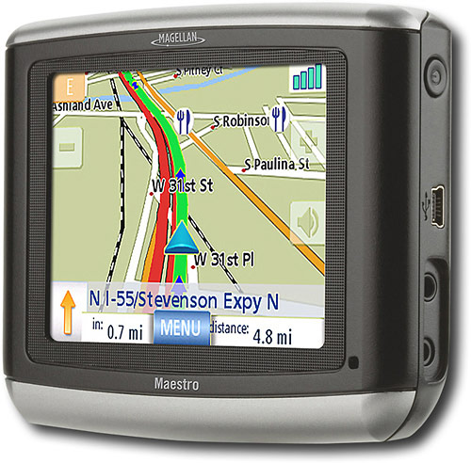
Figure 7.0 – Picture of Maestro 3100
The Maestro 3100 portable GPS [16] device from Magellan utilizes a compact design featuring a 3.5” (89mm) touch-screen LCD display. The LCD is prominently featured on the front of the GPS unit, spanning most of the surface area on the front side. It is mounted to the plastic casing from the underside, and is bordered by about ½” of casing on all sides, with some bevels, shaping, and various colors in the plastic design for aesthetics. The casing is 1.14” (29mm) deep, and along the right side are a power button, USB port, power supply port, and earphone jack.
The Maestro packaging is well designed for its intended use. First, the touch-screen LCD eliminates the need for any buttons (excluding power), enabling the LCD to cover almost the entire available surface area with a sleek and clean look. The user’s attention is then almost completely drawn to the LCD screen where software provides all necessary user interfaces and menus. It is also light at just 3.5 ounces, and small with 3.5 inch screen, and not a lot of overhead in the packaging design as the microcontroller, GPS chip, and PCB lay directly and efficiently behind the LCD. Thus, the unit does not need to be very deep, creating a portable device that can easily be placed in a pocket or attached in a motor vehicle without too much obtrusion. The interfaces on the side are easy to access.
Some disadvantages of this design could be less than optimal LCD size. For some drivers, they may require a larger LCD to see from arm’s length while driving. The 3.5” display is among the smallest on the market among manufacturers of portable GPS navigation systems. Also, a suction cup device can be attached to the back of the unit to attach the device in a vehicle. However, some state laws, such as in California, prohibit the use of suction cup mountings on a car’s windshield.
In our product design, we will also be featuring an LCD screen. However, it will not be as large since we will not need to present as much information as the GPS maps display. Also, we will not be using a touch-screen LCD, and are instead opting for several buttons for user interfacing. Finally, our packaging will allow for the attachment of an external antenna through an SMA type coaxial connector for the transceiver.
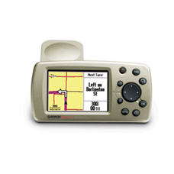
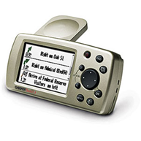
Product #2

Figure 7.1 – Pictures of Quest 2
The Quest 2 [17] produced by Garmin is a typical (cheap) GPS navigation unit that does not feature a touch screen. It uses push buttons to navigate through the software driven menu. It is battery powered which makes it weight slightly more. It uses slightly bigger screen then the one we are planning to use, which should allow us to be packaged slightly smaller than this dash unit. The overall project box is basically a plastic shell that is wrapped around the LCD and the navigation push buttons. As with most GPS units, Quest 2 is equipped with an external antenna to amplify the satellite signal reception.
The positives of this design are: compactness, easy navigation (for quick access while driving), mounts to the car dash with suction cups, adjustable base (to improve viewing angle). The negatives of the design are: small LCD screen (hard to see), external antenna and suction cup mounting (might obstruct the drivers view).
Our product just like this one will be encased in plastic and have navigation buttons to guide user selections. We are planning on using an external antenna for the RF Link and use the suction cups to attach it to the dashboard. We are investigating touch screen pushbuttons to make our UI similar to the high end GPS units.
Unit dimensions, WxHxD: | 4.5"W x 2.2"H x 0.9"D (114.3 x 55.9 x 22.9 mm)
Display size, WxH: | 2.2"W x 1.5"H (38.1 x 55.9 mm)
Display resolution, WxH: | 240 x 160 pixels
Display type: | 256-color, high resolution reflective TFT with backlighting
Weight: | 5.5 ounces (155.92 g)

Project Packaging Specifications
The major constraint on our device’s packaging is size and compass orientation. Since the device will be placed on the dashboard, a large surface area could obstruct the drivers view. As well, a large surface area with a small LCD does not look aesthetically appealing. To compensate, we will use a rectangular box and mount the LCD on the top, thereby reducing viewable non-display packaging area. To ensure that the compass will take correct readings, the unit must remain as horizontal as possible. Therefore, the unit will be affixed to the dashboard of the vehicle, which should be acceptably flat and level.
The box we will use is a 7.620” x 4.620” x 2.225” (194mm x 117mm x 57mm) black polycarbonate box with screw on top from polycases.com [15]. Inside, the PCB will be screwed into the bottom via the provided PCB mounting posts. On the outside, one side (hereby referred to as the top side) will have a 5.6” diagonal hole drilled for the LCD display. Four screws will also be visible from mounting the LCD to the top side. The back will have a hole drilled out for the RF antenna connector. The right side (when looking at the top, LCD side) will have a small hole drilled out for the DC power connector. The upper left corner of the lid will have four screws visible from mounting the GPS unit on the inner side of the lid. This is an attempt to keep the RF and GPS modules as far away from each other as possible. Lastly, the bottom side will have two strips of industrial Velcro tape to affix our device to the dashboard.

PCB Footprint Layout
Each of our PCB designs (receiver and transmitter units) will have generally the same major components that take up the majority of the PCB footprint. Several of the major components will be connected via headers rather than placed directly on the PCB. Because of this, we should be able to have a relatively small footprint.
The GlobalSat GPS [2] units we are utilizing 30mm x 30mm x 10.5mm, but will be connected via a header to the PCB. The headers for the device are 5mm x 8mm and use 6-pin connector cables.
The Radiotronix RF [3] modules will be connected via pins and must have room on the PCB. The RF boards are roughly 20mm x 23mm x 2mm. The RF modules will be place as far from the GPS units as possible so as to minimize interference.
The ezLCDs [9] (5.6” diagonal screens) will be mounted on the top of our devices and will therefore be connected to the PCB with headers. It interfaces via SPI and one additional GPIO, which will take up space on each PCB of around 5mm x 8mm.
The Parallax compass [4] is roughly 13mm x 13mm and will be placed directly into the PCB. We must be sure to place the compass in the same direction that the LCDs are mounted to ensure correct calculations. As well, the compass must lay level to the ground, which will require it to be mounted as horizontally as possible.
The MC9S12XD [19] microcontrollers will be placed directly on the PCBs and will require 22mm x 22mm. We plan on using two general purpose headers that will require 25mm x 15mm (x2) and also need to reserve area for power management, requiring roughly 15mm x 15mm.
Altogether, each PCB design (receiver and transmitter) will require a footprint of around 100mm x 150mm (15,000 mm²). This is equivalently 3.93in x 5.91in (23.23in²).

Summary
By analyzing the Magellan Maestro 6100 and Garmin Quest 2, we determined that our device should attempt to have the LCD cover as much surface area as possible, be as small as possible, and lightweight. When designing our device’s packaging, we had to consider the size of the PCB and the orientation of the compass relative to the ground. The PCB would strictly limit the size of our device and the compass must remain horizontal with the ground for correct measurements. Considering those constraints, our packaging will consist of a rectangular, polycarbonate case that will lay flat on the motorist’s dashboard. While this is the current design, it is in no way final. Depending on the size of the PCB and any component changes, the box size could be reduced. However, the general layout will remain the same.

- Schematic Design Considerations

Introduction
The Bearing Emergency Alert Road System (BEARS) is a GPS based system for more effectively notifying motorists of the presence of an emergency vehicle in their vicinity. The system comprises both a transmitter and receiver, which will be built identically with the same hardware, but programmed with different software. The system will have a power supply circuit that will lead to the Freescale 9S12XD256 microcontroller, which in turn will interface with an RF transceiver, GPS module, and LCD touch-screen.

Theory of Operation
The first stage of the circuit is the power supply that will generate regulated 3.3 VDC and 5.0 VDC output. Since the intended application of BEARS is for use in a motor vehicle, the system will be powered by a +12 V car battery through a cigarette-type adapter. Therefore, there is no need for a rectification circuit. Rather, the two main components in the power supply are 3.3 V and 5 V low drop-out regulators. The 5 V regulator is rated to source 3 A continuously, which will be important as the LCD screen draws significant current, up to 2 A. The 3.3 V regulator is capable of sourcing 1 A, which should be more than sufficient to power many of our CMOS logic devices.
Next, the microcontroller chosen was the Freescale 9S12XD256. The microcontroller will be the “brains” behind coordinating and processing all the peripheral and interfacing device signals used in the system. The microcontroller will be run with an external 4 MHz oscillator at 3.3 V. The microcontroller’s onboard PLL circuitry will be used to frequency multiply the operation to its maximum speed of 40 MHz. The clock speed of 40 MHz will provide ample speed for any processing that will need to be done by the microcontroller. The GPS module updates at a rate of just about 1 Hz, and the LCD screen will have the images that will be displayed stored in its own memory, so there is no need to dissipate more power than is necessary with a higher operating frequency. The MC9S12XD chips are capable of being powered at any supply voltage from just below 3.3 V to just above 5 V. It was chosen to power the microcontroller at the lower end of these specifications primarily because most of our interfacing devices use 3.3 V CMOS logic levels. At 3.3 V, the number of level-shifting buffers needed in the circuit is minimized to 2.
As the schematic shows in Appendix C, the microcontroller requires external circuitry for the analog input reference voltages, PLL loop filter, and oscillator circuit.
Next are the major peripheral devices used in the BEARS system. The first of these is the EM-406(a) GPS module. The interface for the GPS is quite simple, just a 6-pin header that will plug into the mating part on the GPS. It is powered by the 5 V line, but outputs 3.3 V UART logic signals at 4800 baud. The output string is configurable to various NMEA 0183 standard sentence types. The GPS GGA string will be used as it contains all the pertinent information needed: longitude, latitude, UTC time, and horizontal dilution of precision. The output of the GPS is an ASCII serial string of this message type.
The LCD touch-screen, eZ-LCD-004, will be the major interface component between the system and the user. Similar to the GPS module, it will be connected through mating connector/header pieces. It is also powered off the 5 V line, and typically draws above 1 A of continuous current. Communication with the microcontroller will be done through SPI at 3.3 V logic level. The LCD screen module contains its own memory storage, as previously discussed, where the images will be accessed. Thus, commands and memory locations will be the signal types sent over the SPI connection between the microcontroller and LCD controller.
The RF transceiver, Radiotronix Wi-232 DTS-R module, is used to communicate between the two BEARS subsystems – the transmitter side in the emergency vehicles and the receiver side in general civilian motor vehicles. The RF module is used as a seamless wireless solution for communication purposes where the microcontroller is able to communicate with it as if it were actually hard-wired to the device it is intended to communicate with. The module uses a 5 V power supply and has its own voltage regulator on board to step down to 3.3 VDC, the level at which the actual communication IC is powered and communicates at. Thus, its communication with the microcontroller is at 3.3 V, communicating asynchronously through SCI.
Finally, the Hitachi HM55B digital compass is used to determine the orientation of the vehicle as it drives by detecting the magnetic field of the earth and digitizing its direction based on the these readings. The compass requires a 5 V power supply and also communicates with 5 V logic signals. Since the microcontroller operates at 3.3 V, a level-shifting buffer is placed between the compass and microcontroller to step between the two voltages. Note the PCB was designed for and populated with the compass circuitry and components, but in the final design, it was opted not to use the compass and instead use a software solution where the arrow is always referenced pointing up for North.

Hardware Design Narrative
The subsystems of the 9S12XD microcontroller that will be used are the serial communications interface (SCI), serial peripheral interface (SPI), pulse width modulator (PWM), and the background debug module. Output compare timer interrupts will also be used to generate periodic interrupts approximately each second to update the peripherals by gathering new information from the GPS, RF transceiver, and updating the LCD screen if necessary.
The GPS receiver module will use asynchronous SCI at 4800 baud in communicating with the microcontroller. There are two SCI ports available on the 9S12XD256 80-pin package that will be used. The GPS has been connected to the first of these ports, through pins TXD0 and RXD0. Communication will be unidirectional via the RXD0 pin from the GPS receiver to the microcontroller as the GPS continually relays its data. However, the TXD0 pin may be used to send instructions to the GPS in order to configure its output message. Depending on what information is desired to receive from the GPS, and the level of detail needed, the message may be configured to various NMEA standards via communication on this pin. No other configuration options are available, as the baud rate and communication protocol is fixed.
The second SCI port will be utilized by the RF transceiver, on pins RXD1 and TXD1. Two command signals will be used on general purpose I/O pins available, PJ6 and PJ7, which were chosen because they will be unused and due to their close proximity to the SCI pins. The combination of these four pins will allow for bidirectional communication between the microcontroller and RF module. The two I/O pins are clear to send (CTS) and a programmability pin, CMD, that when pulled low allows configuration of the RF unit. With this hardware setup, complete configuration of the transceiver may be accomplished through software, including setting of baud rate, communication protocols, operating modes, and more though various register settings.
The digital compass will use general purpose I/O pins on the microcontroller. The communication protocol is a simulated SPI port. It was chosen to use GPIO because of those pins much better accessibility on the PCB layout and it was proven that the compass does work with SPI simulated software. The simulated lines are MISO, MOSI, and SCK. An enable line will also run between the compass and microcontroller . Any configuration necessary will be done through software, but these four lines allow all configuration and calibration to be done.
The LCD touch-screen will also use an SPI port, this time on pins MOSI2, MISO2, and SCK2. No other general purpose I/O pins are necessary. The LCD screen has onboard drivers and controllers, so there is not a lot of hardware setup needed to configure the device. The SPI communication suffices to send it all the commands and data needed to be fully operable. Choices were available as to the means of communication. The LCD connector is also padded out to accept asynchronous SCI, USB, or I²C lines. However, the simplicity and experience in using SPI led to this choice of interfacing.
The other modules to be used for non-major components include the background debug module and the pulse width modulator. The BDM will be used in development and for loading programs from the BDM module to the microcontroller through the MODC/BKGD and RESET_L pins. The PWM module (pin PWM3) can be used for simple tone generation to a speaker circuit to alert the driver audibly of the presence of a nearby emergency vehicle. The PWM would drive the base of a saturated-switch BJT at audible frequencies, and the BJT would then power a small 8-ohm speaker. However, due to packaging constraints in the final design, the speaker was never implemented. Nevertheless, the PCB contains the necessary traces and is populated with the correct circuitry to be able to use this peripheral with a small speaker quite easily.

Summary
The BEARS system consists of two hardware-identical modules in the receiver and transmitter. A power supply will regulate 5 V and 3.3 V outputs with two LDO regulators, powered from a car battery. The heart of the system is the Freescale 9S12XD256 microcontroller which will have a 4 MHz oscillator and run at 3.3 V. The microcontroller will interface via general purpose input/output pins to a digital compass, through SPI to an LCD touch-screen, and through SCI to an RF transceiver and a GPS receiver.

- PCB Layout Design Considerations

Introduction
The Bearing Emergency Alert Road System (BEARS) is a GPS based system for more effectively notifying motorists of the presence of an emergency vehicle in their vicinity. The system comprises both a transmitter and receiver, which will be built identically with the same hardware, but programmed with different software. The major components in our design include: microcontroller, LCD, GPS, RF link, digital compass and power supply. All of these components inflict specific layout constraints and merit extensive iterative design. The interactions of our main components and their respective operating characteristics impose interference and noise that have the potential to cause our project to yield undesirable results. In the following sections we will describe these considerations and show how they have been addressed in our preliminary PCB layout.

PCB Layout Design Considerations – Overall
PCB layout is a daunting task and as such it must be approached as an iterative process. At the time of writing this document, our team has completed the preliminary PCB layout version 4.2 which can be found in Appendix C. In the course of preparing our preliminary PCB layout we have kept in mind the following design considerations: component placement, trace sizing, signal routing, noise, grounding, component interference, manufacturability, PCB mounting, circuit debugging and programming.
Physical dimensions of the proposed PCB layout are tightly governed by the packaging constraints. The proposed packaging can be described as a PDA form factor in which the main circuitry will be mounted behind the main LCD touch screen. Given this constraint we were restricted to an area of 22.4 in² (L: 5.57, W: 4.0) [9]. This allows us to stay under the 60 in² requirement (maximum area allowed per board) even after merging both the receiver and transmitter to a single board and thus reducing the manufacturing costs [28].
Once the board outline was specified and all of the manufacturer specific tolerances were entered we placed the components on the board. The placement of the components was largely effected by the placement of the LCD connector due to its high typical current draw (approximately 1.3A) [9]. According to the System Design and Layout Considerations from Motorola application note, it is generally a good practice to group the high current (noisy) components and place them away from high frequency digital circuitry [27]. To expand on that suggestion we grouped 5V circuitry and gave it separate power and ground branches. In particular, the 5V power and ground branch feeding the LCD connector was placed as close to the LDO and power jack as possible to keep the high current carrying traces to a minimum. The RF link and GPS units have special requirements on their placement on the board as well. According to the datasheet, RF link requires a LOS (line of sight) for proper operation at the project specified distances (1/2 mile) [3]. Similar to the RF link, the GPS unit required LOS for optimal operation given that we are not using the external antenna to amplify the incoming satellite information. In our final project packaging, the optimal placing for both GPS and RF link components was at the top of the PCB. Despite both units being FCC approved, numerous engineers provide encounters with the interference between the GPS and RF link. So to be safe we have separated the two components, gave them separate power/ground branches and oriented RF link so that its antenna faces away from the GPS unit. Finally, the microcontroller had requirements for placement. In particular, suggested PCB layout has requirements for placement of the PLL and oscillator circuitry as close to the microcontroller as possible and away from sources of electrical noise [19]. To accommodate these requirements we placed the microcontroller circuitry in the bottom left corner (away from all other components), provided separate power and ground branches and placed the PLL and oscillator as close to the respective microcontroller pins as possible. The microcontroller was also rotated clock-wise from its nominal position to better isolate the critical pins from the noisy environment.
After placing all of the components, a special consideration was directed to grounding of the PCB. The application note from Motorola explains the importance of designing the best grounding system for the PCB before laying out any other signals [27]. A single point grounding arrangement was chosen due to its lowering affects on common impedance coupling between subsystems [27]. To decrease the inductance even further, short and thick traces were used due to the inverse relationship between inductance and the conductor diameter and direct proportionality to its length. While ground traces are an adequate solution, the application note clearly indicates the benefits of a ground plane (4 layer boards) or at least a copper pour to enhance the grounding for active elements [27]. Given that our project incorporates RF link we are planning on placing a ground copper pour directly underneath it.
Trace size was another important topic of research. Given our project is going to be drawing up to 2.5A of current we had to ensure that all series traces and components had adequate width. The needed calculations were carried out with the online trace width calculator and reported width for internal traces for power and ground were approximated at 70 mils [26]. To be on the safe side we have designed our PCB layout’s critical traces with 80 mils while keeping the smaller signal traces at 12 mils to allow flexibility in routing. For consistency we have also modified the standard via types to accommodate different trace widths while still maintaining the minimum manufacturability requirement of 15 mils drill layer [28].
Given that our project contains sources of RF noise and high current circuitry, EMI was near the top of our considerations for the PCB layout. To decouple the noise generated by the logic gate switches (especially in high frequency circuitry) the decoupling 0.1 uF surface mount capacitors were used. This value of capacitor provides adequate protection from transient noise for circuits up to 15 MHz which is close to the clocking frequency of our project (16 MHz) [28]. In more critical circuits such as PLL and oscillator we used LC filters on microcontroller inputs to ensure clean signal generation and propagation. To further reduce any produced noise, we used the recommended lower radiation 45˚ trace angles instead of 90˚, given that our PCB layout is not tightly constrained by area.
Signal routing proved to be a simpler constraint to hold. Most signals were routed in parallel with each other, while maintaining the needed clearance set by the manufacturer. Despite somewhat close proximity to the noisy circuitry, RF link signals were routed to avoid being parallel to the high current LCD circuitry. This combined with signal filtering and appropriate component placement ensures reduced probability for fatal interference.
Finally we considered the programming, debugging and mounting of the PCB. We decided to use the BDM (2 wire interface) for the programming and placed it on the left side of the PCB for easy access even after the final project will be packaged. To aid our efforts in debugging we have placed the critical signals (power supply, GPS and RF signals) onto headers and padded out additional 16 general I/O pins to auxiliary header in case a fix to a potential problem will require microcontroller involvement. The mounting of the PCB will be done using 4 screws placed at each corner. The 4 screws were lined up with the matching 4 holes on the LCD circuitry to allow for a solid fit and simpler packaging.

PCB Layout Design Considerations – Microcontroller
The microcontroller is an integral part of our project that has to work flawlessly. To ensure proper operation there were special considerations that had to be addressed such as oscillator placement, PLL circuit arrangement, bypass capacitors and bulk caps. In our layout we tried to follow the manufacturer suggested microcontroller layout as much as possible. To isolate the microcontroller from the rest of the PCB we routed separate main power and ground traces.
Oscillator circuit is at the core of correct operation of the microcontroller. Unfortunately, clean clock generation is harder to maintain in the presence of noisy and high current drawing components, especially at the relatively high frequencies (~15 MHz). As part of the oscillator requirement the traces connecting the crystal to its resonance capacitors need to be as short as possible while minimizing the area taken up by the circuit [19]. The optimal organization that we found is achieved by running one of the leads directly under the oscillator itself and is shown in the Figure 9.0 below.
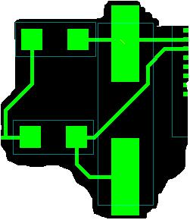
Figure 9.0 - Oscillator Circuit
PLL circuitry, like oscillator needed an electrically quiet area with small traces connecting it to the microcontroller. The left middle side of the microcontroller was used to place all the sensitive circuitry as it is away from all adjacent noisy components. To further reduce the noise in the circuit the suggested component packages were used for the PLL filtering capacitors (ceramic and tantalum) and placed on independent power and ground lines [19].
To allow for the microcontroller to draw instantaneous current in switching intensive operations, every supply pair is decoupled by a ceramic capacitor connected as near as possible to the corresponding pins. The decoupling capacitors were placed on the bottom layer directly underneath the microcontroller to provide the shortest path. In the event of multiple decoupling capacitors emptying their banks simultaneously, a tantalum bulk capacitor is placed on the bottom side of the microcontroller and another one near the filtering circuit at the power supply to quickly replenish the banks.

PCB Layout Design Considerations - Power Supply
Power supply is yet another integral part of our project. The main goal of the power supply is to provide clean constant voltage signal despite dynamic demands of our PCB. While the circuitry and components to make this power supply have been clearly outlined by the schematic, the layout of these components is a pre-requisite to its quality and life cycle.
The trace widths for the power and ground connecting the power supply components have been calculated to be 70 mils [26]. The optimal routing described by the application note was implemented placing the power and ground traces parallel to each other [27]. Our application calls for 2 voltage levels: 3.3V and 5V. The wall wart provides an input voltage of 5V and will be regulated by the LDOs down to their respective levels. Since both LDOs have common circuitry they were placed nearby each other to minimize the area taken up by the routing supply traces. The filtering circuits and the bulk capacitor specified by the manufacturer (Fairchild) were implemented and placed as close to the LDOs as possible [29]. Since primary function of an LDO is to maintain the specified voltage level, it is expected to produce heat that needs to be dissipated. The footprints for these devices were modified from the standard package to include room for the heat sinks. According to the initial calculations, the LDOs will not require heat sinks, however to be safe we placed them ½ inch apart to prevent excessive heat areas.
In our project the critical traces include the supply traces feeding the LCD. In an effort to reduce the inductance and impedance of those traces that produce electrical noise on the board, we routed power and ground traces as short as possible to the LCD connector. If routing will allow, we would prefer to use copper pours for grounding to reduce EMI even more.
Finally, the power button placement was set by the packaging constraints. We are using a rocker switch that nominally has a large footprint. Since our goal in designing the power supply components was to reduce the occupied area and trace lengths, we decided to mount the switch onto the final project box and route short jumpers plugging into the right edge of our PCB.

Summary
PCB layout proved to be a slow and iterative process. We found that with each iteration of our design we gained deeper insight into more optimal organizations of our traces and components. To allow for the greatest probability of successful fabrication of our PCB we have considered the suggested constraints including component placement, trace sizing, signal routing, noise, grounding, component interference, manufacturability and cost, mounting, circuit debugging and programming. Among the most challenging considerations was the placement of the GPS and RF link as they both have similar requirements for placement and have been known to cause interference. Special notice was taken to the layout of the microcontroller and power supply as they are vital to the success of our project. Despite long hours spent coming up with the preliminary PCB, creative thinking and the challenge to foresee the interactions of all variables involved, have made this into an exciting and worthwhile task.

- Software Design Considerations

Introduction
The Bearing Emergency Alert Road System (BEARS) is a two-part, GPS-based system designed to better alert motorists of emergency vehicle presence. The design is based on a transmitter unit (located in an emergency vehicle) that broadcasts an emergency signal to be picked up by receiver units (in motorist vehicles). The units interface with a GPS module, a RF transceiver, a digital compass, and an LCD touch screen. Due to consistent interrupts by these peripherals and a need for constant updates to the LCD, this system requires a hybrid hierarchy for our software design. The following has detailed information on peripherals, software design considerations, and a full run-through of the code’s organization.

Software Design Considerations
As we use the Freescale MC9S12XDT512MAL for both receiver and transmitter units, we will place all memory within 512K of flash save for our multiple static arrow images which will be located on a SD card directly on our LCD board. The flash for our model is located from 0x78_0000 to 0x7F_0000 as stated by Freescale [19]. As we are programming in C, remaining static data, variables, the stack, the heap, and code are all placed by CodeWarrior’s compiler at appropriate locations within this flash block.
Although the receiver and transmitter do not use all the same peripherals, combined we use four different main devices. Peripherals used include a GPS module [2], RF transceiver [3], digital compass [4], and an LCD touch screen [9]. Also included in our design is an audio speaker for the receiver operated by PWM, which makes use of a simple BJT circuit to operate upon a signal from the microcontroller. The GPS, RF, and LCD touch screen will be monitored via a run-time interrupt. The compass will actually utilize a timer as it will not provide data without a request from the microcontroller. This timer will be around half a second, as the GPS unit provides new data only every one second. This should also provide ample time to update the motorist on his new heading. Register initializations will be set in CodeWarrior for each RTI (two in the receiver, two in the transmitter) and timer module (two in the receiver, zero in the transmitter). Details of these integrated peripherals can be found in Table 1 on the next page. Ports and addresses are labeled as according to Freescale documentation [19].

 | Operating Mode | Ports Used | Addresses
GPS Module | SCI, 4800 baud | TXD0  RXD0 | 0x00C8  0x00CF
RF Transceiver | SCI, 9800 baud  2x GPIO | TXD1  RXD1  PJ6  PJ7 | 0x00D0  0x00D7  0x0140  0x0148
Digital Compass | 4x GPIO | PT0  PP0  PP1  PP2 | 0x00EE  0x00F0  0x00F2  0x00F4
LCD Touch Screen | SPI, Master | MISO2  MOSI2  SCK2 | 0x00F8  0x00FA  0x00FC
Table 10.0 - Peripherals
The application code we have designed is an interrupt-driven, hybrid hierarchy. This approach will work best for our design due to the main algorithms requiring new information from our multiple peripherals before acting. As we account for lapses in transmissions from the GPS, compass, and RF modules, each interrupt flag is tested separately to ensure the LCD data can be updated as frequently as possible. Further, this makes sense to keep data updated due to the LCD also displaying general compass heading and GPS location for the motorist. The broadcast variable is used in conjunction with a timer module to ensure we are broadcasting only when receiving an emergency signal and to ignore short lapses in transmissions. Save for perhaps code found to provide a square root or arctangent look-up table (and CodeWarrior), all software will be written by the team. In order to better debug and update our system, we have included a BDM [20] and a reset connected to our microcontroller as well as several output headers.
Software Design Narrative
UpdateStatus(): UpdateStatus() simply sends the LCD the current unit’s GPS status and is used during both emergency and non-emergency status. It displays a picture indicating headers (lat, long, etc) and overlays new text onto the picture, displaying current data.
UpdateEmerStatus(): Providing most of our project’s substance, UpdateEmerStatus() is our most complex function. This module is used for both the transmitter and receiver units. It will provide updated calculations and subsequently send them to be displayed on the LCD screen. It will update the user on emergency vehicle status in the area (indicated by an arrow on the screen and a distance), compass heading, and the motorist’s current GPS location and. The majority of the calculations of this function will be needed when deciding which arrow to command the LCD to display. One major consideration is that it will require an arctangent. To accommodate this, we had additional room so we simply added the math.h header. In order to decide which arrow to use, we will use the GPS values of the emergency vehicle and the motorist’s vehicle in conjunction with the compass data. First, we will find the angle between the GPS vector and the north direction. Next, after adding the compass angle, we will modulate by 360 degrees and choose the appropriate arrow image. The arrow images will either be every 10 degrees (36 images) or every 20 degrees (18 images), depending upon how consistent and accurate our test runs return. This function in all actuality makes use of the calc_dist() and display_dist() routines.
parse_gps(): The parse_gps() function will be used to do just that – parse the information that the GPS sends to the microcontroller. The GPS module sends data delimited by commas as according to NMEA standards [21]. After parsing the GPS coordinates, it will store them for later use by UpdateStatus() and UpdateEmerStatus().
receive_gps_data(), receive_rf_data(), receive_lcd_data(): These modules all simply accept incoming data from their respective devices with an interrupt service routine. The RF and GPS modules utilize SCI, while the LCD uses SPI to communicate.

Summary
Both the receiver and transmitter units use hybrid software architecture. The code in each round-robin loop is driven by flags set by interrupts and timer modules. The majority of our code will be performed in the receiver unit, calculating direction and distance of the emergency vehicle. All of this C coding will be written by the BEARS team members except for possibly math look-up tables. This setup will provide ample awareness time for the motorist to be alerted to emergency vehicle presence.

- Version 2 Changes

Throughout the course of this project many lessons have been learned. If we were to make version 2 of the BEARS we would make some cost out decisions as well as additional features. The cost out options include: make GUI changes to include servicing mode, compass, on-start check routine. Merge PCB with the LCD circuitry to make the unit smaller and less expensive. Cheaper RF link (original one had too many unused features) would serve better and reduce the cost of the overall system. Purchase new GPS unit that updates 5Hz vs. 1Hz to include averaging, smoothing and map snapping to make the GPS feature more appealing. Could use different micro with less memory and interfaces; also reduce the code density appropriately to match the new micro.
As part of the new version we would include some additional features. We would include auditory alerts; implement Google Maps (Wi-Fi connectivity) to update the maps real time. Integrate the unit into the dash of the car and use external GPS / RF in emergency vehicles. Develop interfaces to most common cell phones / PDAs to increase overall connectivity options of the BEARS. Add GPS Real Time Traffic information and ability to transfer information between motorist’s vehicles (such as chats, logs, useful info). Satellite radio / video interface would also appeal to the new generation of the car “mod” crowd. Display information about other surrounding motorists (network) which would enable motorists to share their road knowledge and communicate more efficiently. Version 2 would also involve less time, we have throughout the project learned how to code in CodeWarrior IDE and practiced Layout Plus software.

Summary and Conclusions

In the work and development of BEARS through the course of the Spring 2008 semester, we accomplished a lot in bringing a product from the conception of an idea to a fully functional proof-of-concept prototype. The stages of development from start to beginning were multifaceted and taught us many skills and experiences that we would not have had otherwise. At the start of the semester, while designing the hardware schematic, we enhanced our experience in component selection rationale, the ability to spec what is needed for a desired component, and then searching the market to find the best available option through oral and written communication with vendors, and analyzing datasheets. Tradeoffs and compromises had to be made in terms of performance, availability, and cost for each component in order to build the best and most practical design. During the schematic design phase, we also learned basics of GPS receivers and RF transceivers, how to design efficient power supplies for digital circuits, and the elements of microcontroller circuitry design. In this last aspect, we learned about the various options of oscillator circuitry design, in our case a full-swing Pierce oscillator with an external quartz crystal.
The next phase of the project was the printed circuit board design. This was the first experience anyone on our team had with PCB design and so it was quite a challenge. However, we learned a lot starting with learning new software, Orcad Layout. We learned about making footprints, microcontroller circuitry layout, making sensible decisions for component placement, placing vias, and we learned the importance of including a ground pore for the RF transceiver. In populating the board, our soldering skills were also greatly improved.
We also learned a great deal about the challenges and capabilities of programming an embedded system. Our software development was done in C using CodeWarrior. We learned about how to use C in its traditional context, but also learned about debugging and troubleshooting on a unit that has finite and definite limits of memory space.
Finally, we learned other skills through homework assignments such as the basics of patent liability and analysis, and safety and reliability analyses of our product. We also learned about the importance of documentation, the design process, technical writing skills, giving succinct and clear technical presentations, referencing with the IEEE format, and thinking of product development in terms of clear system integration goals.

References

- Sparkfun Electronics, “Color LCD 128x128 Nokia Knock-Off,” sparkfun.com, [Online], Available: http://www.sparkfun.com/commerce/product_info.php?products_id=569, [Accessed: Jan. 18, 2008].

- USGlobalSat Incorporated, “EM-406a (SiRF III),” usglobalsat.com, [Online], Available: http://www.usglobalsat.com/p-46-em-406a-sirf-iii.aspx, [Accessed: Jan. 18, 2008].

- Radiotronix, “Wi.232DTS-FCC-RA-R,” radiotronix.com, [Online], Available: http://www.radiotronix.com/products/proddb.asp?ProdID=197, [Accessed: Jan. 18, 2008].

- Hobby Engineering, “HM55B Compass Module,” hobbyengineering.com, [Online], Available: http://www.hobbyengineering.com/H2112.html, [Accessed: Jan. 18, 2008].

- eCrater, “The "STEALTH EVP" Traffic Signal Pre-Emption device,” ecrater.com, [Online], Available: http://www.ecrater.com/product.php?pid=545131, [Accessed: Jan. 18, 2008].

- Amazon, “TomTom ONE Portable GPS Vehicle Navigator,” amazon.com, [Online], Available: http://www.amazon.com/TomTom-ONE-Portable-Vehicle-Navigator/dp/B000H866BM, [Accessed: Jan. 18, 2008].

- Newhaven Display, “LCD Graphic Module COLOR 320 x 240 : NHD-320240WC-AFCI-NU,” newhavendisplay.com, [Online], Available: http://www.newhavendisplay.com/ index.cfm/page/ptype=product/product_id=125/category_id=96/home_id=60/mode=prod/prd125.htm, [Accessed: Jan. 18, 2008].

- Display3000, “2,1" color TFT Display, with complete driving board,” www.display3000.com, [Online], Available: http://www.shop-en.display3000.com/ pi19/pi18/pd17.html, [Accessed: Jan. 18, 2008].

- Earth LCD, “ezLCD-004,” ezLCD.com, Available: http://www.ezlcd.com/, [Accessed: April 25, 2008].

- Digi, “XTend OEM RF modules,” digi.com, [Online], Available: http://www.digi.com/products/wireless/long-range-multipoint/xtend-module.jsp, [Accessed: Jan. 18, 2008].

- AeroComm, “Product details: AC4790 900MHz peer-to-peer transceiver modules,” aerocomm.com, [Online], Available: http://www.aerocomm.com/rf_transceiver_modules /ac4790_mesh-ready_transceiver.htm, [Accessed: Jan. 18, 2008].

- Honeywell, “Honeywell SSEC - Magnetic Sensor Products,” honeywell.com, [Online], Available: http://www.ssec.honeywell.com/magnetic/products.html#HMR3000, [Accessed: Jan. 18, 2008].

- Freescale Semiconductor, “S12NE Product Summary Page,” freescale.com, [Online], Available: http://www.freescale.com/webapp/sps/site/prod_summary.jsp?code =S12NE&nodeId=0162468636K100, [Accessed: Jan. 31, 2008].

- Freescale Semiconductor, “S12XD Product Summary Page,” freescale.com, [Online], Available: http://www.freescale.com/webapp/sps/site/prod_summary.jsp?code =S12XD&nodeId=0162468636bJwn, [Accessed: Jan. 31, 2008].

- PolyCase, “DC-47P DC Series Heavy Duty Electronics Enclosure,” polycase.com, Available: http://www.polycase.com/item/dc-47p.html, [Accessed: Feb. 7, 2008].

- Magellan Navigation, Inc. “Maestro Series,” magellangps.com, Available: http://www.magellangps.com/products/product.asp?segID=408, [Accessed: Feb 8, 2008].

- Garmin Ltd., “Quest 2,” garmin.com, Available: https://buy.garmin.com/shop/shop.do? pID=338&tab=quest2, [Accessed: Feb. 7, 2008].

- Amazon, “Velcro(R) Industrial Strength Tape, 2in. x 4ft., Black,” amazon.com, Available: http://www.amazon.com/Velcro-Industrial-Strength-Tape-Black/dp/B00006IC2T, [Accessed: Feb. 8, 2008].

- Freescale Semiconductor, “Motorola MC9S12XDP512 Microcontroller Datasheet”, freescale.com, [Online], Available:
http://www.freescale.com/files/microcontrollers/doc/data_sheet/MC9S12XDP512V2.pdf, [Accessed: March 18, 2008].

- Freescale Semiconductor, “Enhanced 16-bit BDM Stand Alone Programmer”, freescale.com, [Online], Available: http://www.freescale.com/webapp/sps/site/prod_summary.jsp?code=SCBDMPGMRS12&fsrch=1, [Accessed: March 18, 2008].

- GlobalSat, “NMEA Command Reference Manual”, usglobalsat.com, [Online], Available: http://www.usglobalsat.com/downloads/NMEA_commands.pdf, [Accessed: March 18, 2008].

- ON Semiconductor, “MURS320T3 Ultrafast Power Rectifiers”, onsemi.com [Online], Available: http://www.onsemi.com/pub_link/Collateral/MURS320T3-D.PDF, [Accessed: Apr 1, 2008].

- Fairchild Semiconductor, “KA378R05 Low Dropout Voltage Regulator”, fairchild.com [Online], Available: http://www.fairchildsemi.com/ds/KA%2FKA378R05.pdf, [Accessed: Apr 1, 2008].

- Fairchild Semiconductor, “KA378R33C Low Dropout Voltage Regulator”, fairchild.com [Online], Available: http://www.fairchildsemi.com/ds/KA%2FKA78R33C.pdf, [Accessed: Apr 1, 2008].

- Department of Defense, “Military Handbook, Reliability Prediction of Electronic Equipment” [Online], Available: http://cobweb.ecn.purdue.edu/~dsml/ece477/Homework/CommonRefs/Mil-Hdbk-217F.pdf, [Accessed: Apr 1, 2008].

- CircuitCalculator, “PCB Trace Width Calculator,” circuitcalculator.com [Online], Available: http://circuitcalculator.com/wordpress/2006/01/31/pcb-trace-width-calculator/, [Accessed: Feb 20, 2008].

- Motorola, “System Design and Layout Considerations for MCU-Based Systems”, motorola.com, [Online], Available: http://cobweb.ecn.purdue.edu/~dsml/ece477/Homework/CommonRefs/AN1259.pdf, [Accessed: Feb 20, 2008].

- Advanced Circuits, “4PCB Specifications”, 4pcb.com, [Online], Available http://www.4pcb.com/index.php?load=content&page_id=130, [Accessed: Feb 20, 2008].

- Fairchild Semiconductor, “KAFKA278R33C Datasheet”, fairchildsemi.com, [Online], Available: http://www.fairchildsemi.com/ds/KA%2FKA278R33C.pdf, [Accessed: Feb 21, 2008].

- Free Patents Online, “Key-Based Encryption”, freepatentsonline.com, [Online], Available: http://www.freepatentsonline.com/EP1726144.html, [Accessed: April 9, 2008].

- Purdue ECE477, “Engineering Education Reform”, cobweb.ecn.purdue.edu/~dsml/ece477/, [Online], Available: http://cobweb.ecn.purdue.edu/~dsml/ece477/Homework/CommonRefs/enviro_refs.pdf, [Accessed: April 9, 2008].

- Share the Technology, “Computer Reuse & Recycling Project”, sharetechnology.org, [Online], Available: http://sharetechnology.org/, [Accessed: April 9, 2008].

- Freecycle, “The Freecycle Network”, freecycle.org, [Online], Available: http://www.freecycle.org/, [Accessed: April 9, 2008].

- D.A. Arbinger, D.R. Bergin, S.M. Pieper, and S.T. Sander. “Emergency Vehicle Alert System.” U.S. Patent 6 339 382 B1, Dec. 7, 2000.

- B. King and D.A. Yancey. “GPS-Based Vehicle Warning and Location System and Method.” U.S. Patent 6 895 332 B2, Apr. 24, 2003.

- L.D. Darnall. “Driver's Emergency Alert System.” U.S. Patent 6 417 782 B1, Jun. 22, 2000.

- “Emergency Vehicle Alert, Collision Avoidance System.” Internet: www.evallc.com, 2004 [24 March 2008].

- T.A. Turbeville and J.R. Majka. “Emergency Vehicle Detection System.” U.S. Patent 6 778 101 B2, Nov. 27, 2002.

Appendix A: Individual Contributions

A.1 Contributions of Nikita Solilov:
- Setup website
- Lead team meetings and made key design and implementation decisions
- Obtained all development resources through donations and sponsorships
- Setup development environments to facilitate code development
- Prototyped all major components and wrote initial development code specifically for GPS, Compass and Microcontroller
- Aided schematic design, assisted on component selection and fixed errors in netslist
- Designed multiple iterations of PCB
- Populated, soldered and verified both PCBs
- Made numerous adapters and mounting hardware
- Prepared and packaged both units
- Designed GUI for both firmware versions
- Setup framework for all PSSC and demonstrated them to the TAs
- Debugged and assisted in resolution of all project problems
- Planned and delegated team assignments to meet aggressive schedules
- Supported other team members in debugging and peripheral interfacing
- Performed multiple outdoors field tests
- Took active role in team presentations
- Worked many weekends and late nights to ensure timely completion of the project

A.2 Contributions of Jonathon Pendlum:
- Researched transceiver and LCD candidate components
- Completed design analysis and packaging design homeworks
- Contributed to various homeworks and presentations
- Obtained ezLCD-004 LCD and Radiotronix RF transceivers
- Completed initial testing of RF transceiver link
- Aided schematic and PCB layout
- Owned user interface and touch screen LCD development
  - Built PCB to LCD connectors
  - Created touch screen interface (buttons, images)
  - Produced direction indication arrows, compass, and local maps
  - Interfaced LCD through SPI
  - Wrote LCD and touch screen code library
  - Debugged all LCD issues
  - Implemented motorist notification of emergency vehicle (PSSC #2)
  - Implemented ability to specific emergency vehicle type through touch screen (PSSC #3)
- Supported other team members in debugging and peripheral interfacing
- Filmed PSSC demonstration

A.3 Contributions of Nick Stephens:

- Developed the idea for this project with my mother. It was her idea to do something along these lines, as she is hearing impaired and in her experience it has always been difficult to know when an emergency vehicle is coming up on her when she is driving
- Organized website with pages for homework and TCSP presentations
- Developed initial proposal to analyze whether to pursue this project
- Researched GPS solutions during major component selection phase and decided to go with the EM-406a asynchronous communication device with patch antenna
- Obtained samples of some major components including the microcontroller and several GPS units
- Owned hardware schematic design:
  - Designed power supply circuit
  - Developed first draft of schematic in Orcad Capture
  - Determined necessary component values for microcontroller circuitry
  - Ordered most discrete components needed from online electronic distributors
  - Worked with team in developing interface circuitry between microcontroller and peripherals
- Contributed to software development and peripheral interfacing:
  - Wrote GPS C code for communicating with GPS receivers, developed GPS data structure, and wrote code for parsing GPS strings into the GPS structure.
  - Developed first drafts of distance calculation functions from GPS data
  - Owned RF transceiver interfacing: setup SCI port for communication with the RF modules, debugged transmission issues, and setup C code for transmission and reception of parsed GPS data
- Worked on debugging issues in final weeks of software development through field testing and integration of all peripherals into single project
- Developed patent liability and hardware theory of operation reports. Also presented summaries of these in TCSP sessions
- Contributed to end-of-semester documentation including senior design report, final report, and user manual
A.4 Contributions of Ryan Giltner:

Towards the beginning of the semester, I met regularly with the team to pan out our exact plans for our project. With Nikita, we originally set up the initial website and decided on our well known team name B.E.A.R.S.
As a team, after deciding on our PSSCs and major components, I wrote the RF section for homework three. After compilation of that homework, Nick and I decided it was best for us to switch responsibility for peripherals and I took over the GPS modules.
For homework four, I created the footprint that would be for our printed circuit board. Moving on to homework five, I helped with the schematic and created the block diagram v2.0 for our receiver and transmitter units.
Then the time for the PCB layout came and Nikita and I headed up the design. I spent many hours in the lab designing versions one point zero through four point seven of the PCB along with several part footprints. Nikita was there most of the time helping decide on design considerations. This process included major design, routing and placement of parts, modifying and creating part footprints, and fixing the “showstoppers”.
Next, I designed our main software algorithms for the design review. This entailed the involved algorithm for selecting an arrow as well as the distance calculation. After presenting for the review, we reviewed team twelve, The Two Wheel Deal.
It was then that I wrote the initial basic code for our project and began attempting to interface with the GPS modules. The GPS modules were a constant battle with sending too many unneeded strings of data and not being able to capture the information correctly. Eventually towards the end of the semester we got the modules working near perfectly.
When homework nine came around, it was my turn to lead the paper. I single handedly wrote the paper on our software strategy and described every code module we were planning on. Following this, I worked on different interfacing with team members including mostly the GPS functions, parse_gps, calc_dist, and others.
After much coding and debugging, I switched to solely writing homework twelve, ethics and environment. Many of the ideas for the report were presented to me when I brainstormed with Jon.
Finally, attempting to wrap up the project, much debugging and different attempts were used to get the GPS working outside consistently and continuously. One major issue we finally pinpointed was having too many nested function calls placed on the stack that caused consistent performance issues.
Finally, after getting the units to work consistently, Jon, Nikita, and I took video of the units for our PSSCs. I then created the PSSC video for the next day’s presentation and for the ECE362 presentation.
Towards the end, I did a few sections of the Senior Design Report and completed the Poster.

Appendix B: Packaging

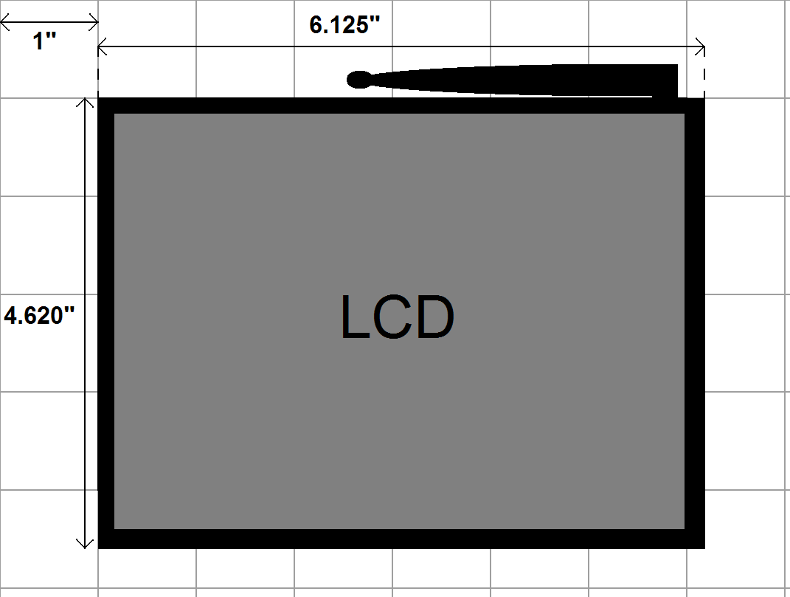
Figure A-1 Top view of Packaging

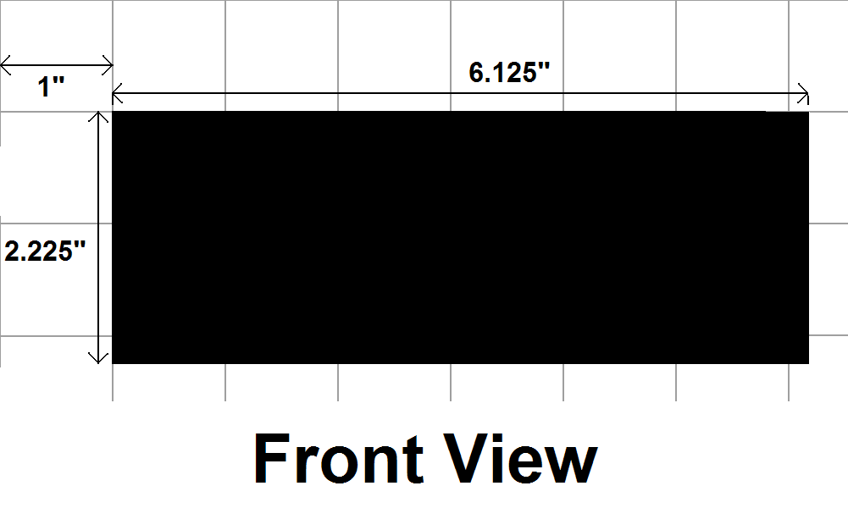
Figure A-2. Front view of packaging

Table B-1. Packaging Material Size, Weight, and Cost
Item | Quantity | Size W x L x H (mm) | Weight (oz) | Cost ($)
PCB | 2 | 150mm x 100mm x 20mm | 4 | 0
DC-47P DC Box | 2 | 194mm x 117 x 57mm | 2 | 17.38
Misc Screws/Washers/Nuts | 12 | ~ | 1 | 3.00
Push buttons | 6 | 6 mm x 6mm x 4mm | ~ | 0
LCD with carrier board | 2 | 36mm x 62mm x 14mm | 1 | 77.80
9S12XD512 MCU | 2 | 22mm x 22mm x 1mm | ~ | 24.64
Radiotronix Transceiver | 2 | 23mm x 20mm x 10mm | 1 | 90.00
GlobalSatUSA GPS Unit | 2 | 40mm x 40mm x 10mm | 1.5 | 93.98
Hitachi Digital Compass | 1 | 13mm x 12mm x 12mm | 0.5 | 29.00
General Headers | 4 | 25mm x 15mm x 8mm | 0.2 | 0
GPS and LCD Headers | 4 | 8mm x 5mm x 8mm | 0.1 | 0
RS232 Connection | 2 | 25mm x 18mm x 10mm | 1 | 4.00
Velcro Tape Strip | 8 | 51mm x 193mm x 2mm | 1 | 7.75
Totals (overall for cost, per unit for weight): |  |  | 12.8 | 347.55
Required Tooling:
- Screw driver
- Small socket wrenches
- Rotozip or other cutting tool to modify casing
- Soldering iron

Appendix C: Schematic

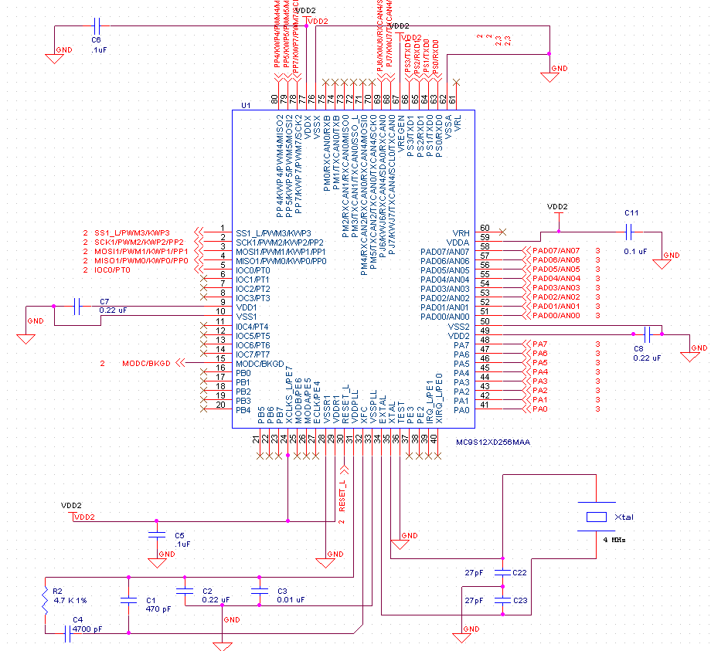

Figure C-1. Schematic of Freescale MC9S12XD256 Microcontroller Circuitry
Appendix C: Schematic
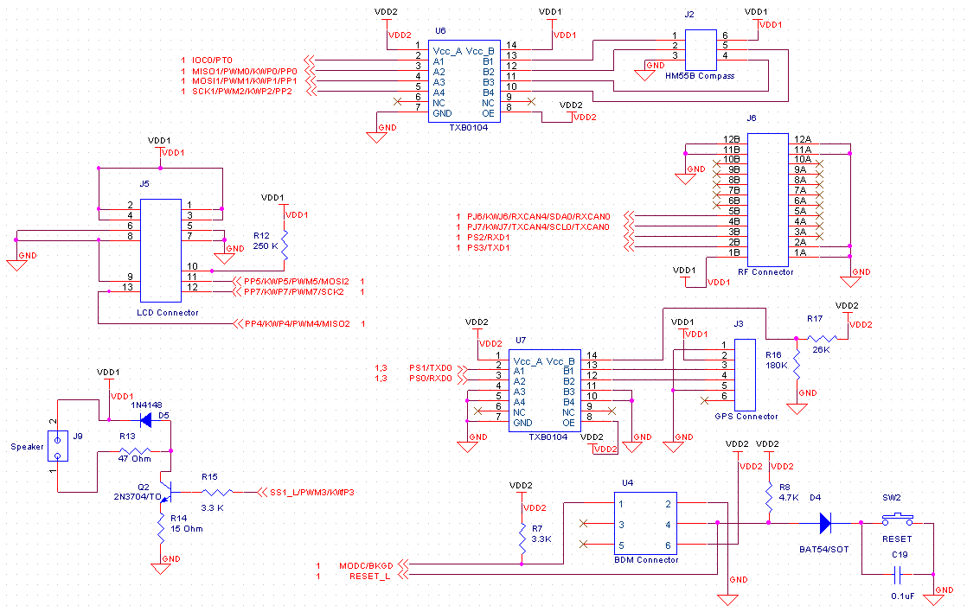
Figure C-2. Schematic of Microcontroller Peripherals Interfacing

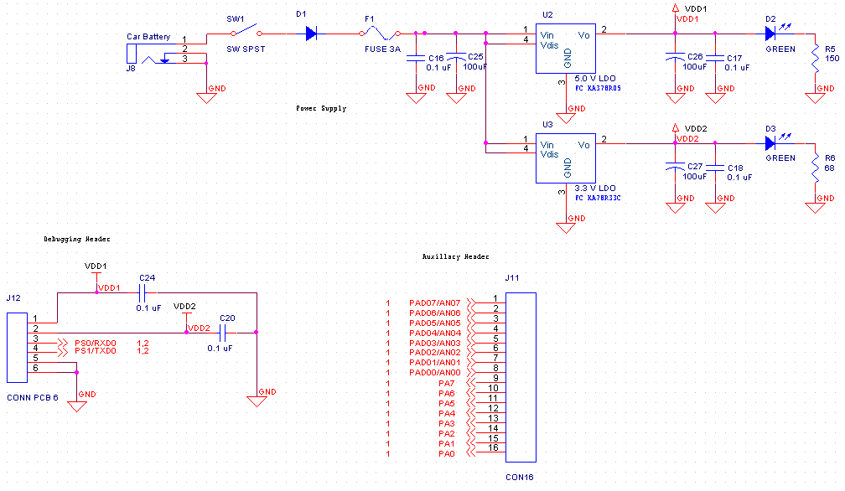
Figure C-3. Schematic of Power Supply Circuitry and Padded Out Headers
Appendix D: PCB Layout Top and Bottom Copper

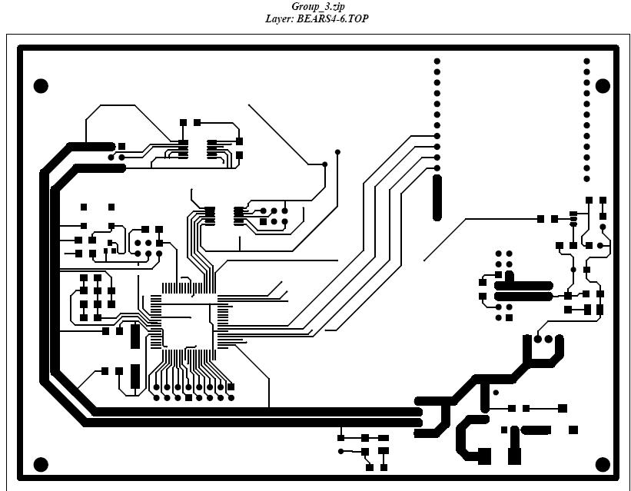
Figure D-1. Image of PCB layout (top side)
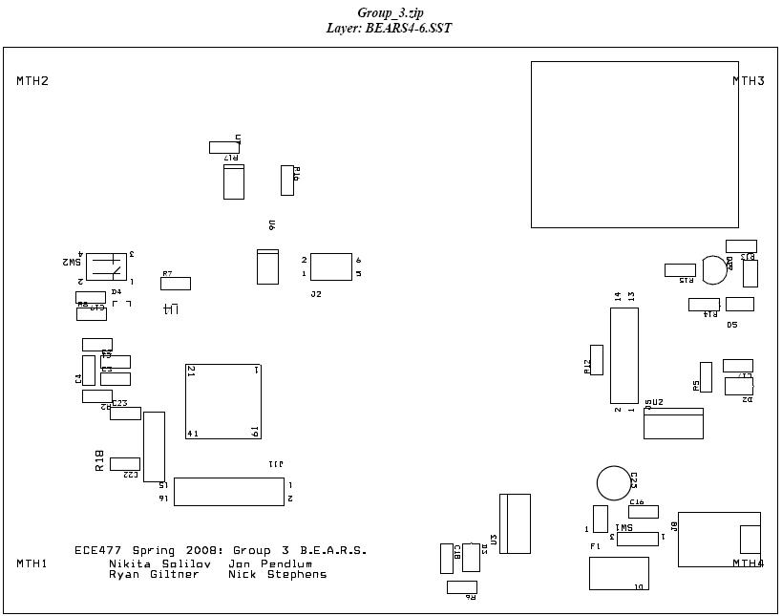
Figure D-2. – Image of PCB layout (silk screen)

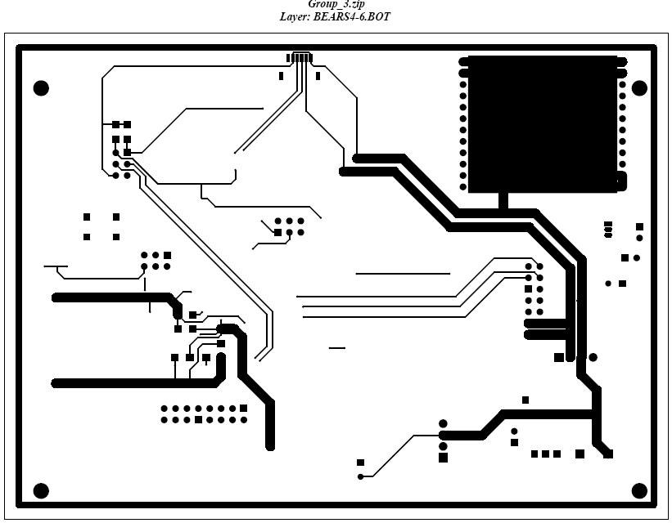
Figure D-3. Image of PCB layout (bottom side)

Appendix E: Parts List Spreadsheet – (list is for one unit, transmitter or receiver)
Vendor | Manufacturer | Schematic ID | Value | Part Number | Description | Unit Cost | Qty | Total Cost
Digikey | Freescale | U1 | -- | MC9S12XDT256 | 16-bit Microcontroller | 12.32 | 1 | 12.32
Parallax | Hitachi | J2 | -- | HM55B | Digital Compass | 29 | 1 | 29
All Electronics | Hosiden | LS1 | -- | HDR960 | Speaker | 1 | 1 | 1
Earth LCD | N/A | J5 | -- | ezLCD-004 | Color 5.6" LCD Touchscreen 320x240 | 300 | 1 | 300
USGlobalSat | USGlobalSat | J1 | -- | EM-406(a) | SiRF III GPS Receiver | 46.99 | 1 | 46.99
Mouser | Radiotronix | J6 | -- | Wi.232DTS-FCC-RA-R | Long Range RF Transciever | 45 | 1 | 45
Fairchild | Fairchild Semiconductor | U3 | 3.3 V | KA78R33CTU | Low Drop Out Regulator, 3.3 V, 1 A | 0.82 | 1 | 0.82
Fairchild | Fairchild Semiconductor | U2 | 5 V | KA378R05TU | Low Drop Out Regulator, 5 V, 3 A | 1.56 | 1 | 1.56
Mouser | Kemet | C22 | 27 pF | 80-C1206C270F5G | Ceramic Crystal Load Capacitor | 2.65 | 1 | 2.65
Mouser | Kemet | C23 | 27 pF | 80-C1206C270F5G | Ceramic Crystal Load Capacitor | 2.65 | 1 | 2.65
Mouser | Kemet | C2 | 0.22 uF | 80-C1206C224J5R | Ceramic X7R VddPll Filter Capacitor | 1.25 | 1 | 1.25
Mouser | Kemet | C7 | 0.22 uF | 80-C1206C224J5R | Ceramic X7R Vdd1 Filter Capacitor | 1.25 | 1 | 1.25
Mouser | Kemet | C8 | 0.22 uF | 80-C1206C224J5R | Ceramic X7R Vdd2 Filter Capacitor | 1.25 | 1 | 1.25
Mouser | Kemet | C11 | 0.1 uF | 80-C1206F104K1R | Ceramic X7R Vdda Filter Capacitor | 0.63 | 1 | 0.63
Mouser | Kemet | C5 | 0.1 uF | 80-C1206F104K1R | Ceramic X7R Vddr Filter Capacitor | 0.63 | 1 | 0.63
Mouser | Kemet | C6 | 0.1 uF | 80-C1206F104K1R | Ceramix X7R Vddx Filter Capacitor | 0.63 | 1 | 0.63
Mouser | Kemet | C3 | 0.01 uF | 80-C1206S103J1R | Ceramic X7R VddPll Filter Capacitor | 0.37 | 1 | 0.37
Mouser | Vishay/Vitramon | C4 | 4700 pF | 77-VJ12Y50V472J | Ceramic PLL Loop Filter Capacitor | 0.33 | 1 | 0.33
Mouser | Murata | C11 | 470 pF | 81-GRM31R71H471JD01D | Ceramic PLL Loop Filter Capacitor | 0.55 | 1 | 0.55
Mouser | Xicon | R2 | 4.7 kOhms | 271-4.7K-RC | PLL Loop Filter Resistor, 1% Tolerance | 0.09 | 1 | 0.09
Mouser | ON Semiconductor | D1 | -- | 863-MURS320T3G | Power Supply Back-Voltage Diode Guard | 0.45 | 1 | 0.45
Mouser | Kemet | C16, C17, C18 | 0.1 uF | 80-C1206F104K1R | Ceramic X7R Power Supply Filter Capacitors | 0.63 | 3 | 1.89
Mouser | Nichicon | C9, C14, C15 | 100 uF | 647-UKL1E101KPDANA | Aluminum Electrolytic LDO Capacitors | 0.23 | 3 | 0.69
Mouser | IRC | R5 | 150 Ohms | 66-W1206LF031500F-R1 | Thin Film LED Current Limiting Resistor | 0.68 | 1 | 0.68
Mouser | IRC | R6 | 68.1 Ohms | 66-W1206LF0368R1F-R1 | Thin Film LED Current Limiting Resistor | 0.68 | 1 | 0.68
Mouser | Lumex | D2, D3 | -- | 696-SML-LX1206GC | Surface Mt. Green LED - Power Indicator | 0.16 | 2 | 0.32
PolyCase.com | PolyCase | -- | -- | DC-46P | Heavy Duty Electronics Enclosure Box | 7.25 | 1 | 7.25
Mouser | Tyco Electronics | SW1 | -- | 506-PRASA1-16F-BB0BW | SPST Power Switch | 0.92 | 1 | 0.92
TI.com | Texas Instruments | U6, U7 | -- | TXB0104 | 3.3/5V Level Shifting Buffer | 0.58 | 2 | 1.16
 |  |  |  |  |  |  | Total Cost: | $463.01

Appendix F: Software Listing

/*MAIN.h*/
/*
B.E.A.R.S. – Team 3

Ryan Gilter
Jonathon Pendlum
Nikita Solilov
Nick Stephens

The BEARS operational program is broken into four modules:
  - LCD_cmds.c
  - GPS.c
  - events.c
  - main.c

LCD_cmds.c contains all the functions responsible for LCD and touch screen control. The file contains all initialization, information displaying, and event procedure handling routines.

GPS.c contains all the functions related to receiving and parsing GPS data.

Events.c contains all code related to controlling the on chip interrupts.

Main.c contains the main routine.

Each module has a header file and function description labels which are the primary source for explaining functionality.
*/

/*CMDCODES.h*/

// EZLCD COMMAND CODES

#define CLS 0x21
#define LIGHT_ON 0x22
#define LIGHT_OFF 0x23
#define SET_COLOR 0x24
#define SET_XY 0x25
#define PLOT 0x26
#define PLOT_XY 0x27
#define LINE_TO_XY 0x28
#define CIRCLE_R 0x29
#define SCR_BMP 0x2A
#define SELECT_FONT 0x2B
#define PRINT_CHAR 0x2C
#define PRINT_STRING 0x2D
#define PUT_BITMAP 0x2E
#define ARC 0x2F

#define PIE 0x30
#define SET_BG_COLOR 0x34
#define SAVE_POSITION 0x35
#define RESTORE_POSITION 0x36
#define PONG 0x38
#define CIRCLE_R_FILL 0x39
#define PRINT_CHAR_BG 0x3C
#define PRINT_STRING_BG 0x3D

#define H_LINE 0x40
#define V_LINE 0x41
#define BOX 0x42
#define BOX_FILL 0x43

#define PICTURE_ROM 0x50
#define PUT_ICON 0x57
#define PUT_SF_ICON 0x58

#define FONT_NORTH 0x60
#define FONT_EAST 0x61
#define FONT_SOUTH 0x62
#define FONT_WEST 0x63

#define SD_PUT_ICON 0x70
#define SD_FILE_OPEN 0x71
#define SD_FILE_CLOSE 0x72
#define SD_FILE_CLOSE_ALL 0x73
#define SD_FILE_GET_SIZE 0x74
#define SD_FILE_READ 0x75
#define SD_FILE_CREATE 0x76
#define SD_FILE_WRITE 0x77
#define SD_SIZE 0x78
#define SD_FILE_LIST 0x79
#define SD_FILE_REWIND 0x7A
#define SD_FILE_TELL 0x7B
#define SD_FILE_SEEK 0x7C
#define SD_FILE_DELETE 0x7D
#define SD_RAW_READ 0x7E
#define SD_RAW_WRITE 0x7F

#define LIGHT_BRIGHT 0x80
#define PING 0x83
#define SET_COLORH 0x84
#define SET_XHY 0x85
#define PLOT_XHY 0x87
#define LINE_TO_XHY 0x88
#define CIRCLE_RH 0x89
#define PUT_COMPR_BMPH 0x8D
#define ARCH 0x8F

#define SET_BG_COLORH 0x94
#define CIRCLE_RH_FILL 0x99
#define PUT_BITMAPH 0x9E

#define H_LINEH 0xA0
#define BOXH 0xA2
#define BOXH_FILL 0xA3

#define BUTTON_DEF 0xB0
#define BUTTON_STATE 0xB1
#define TOUCH_PROTOCOL 0xB2
#define ALL_BUTTONS_UP 0xB3
#define ERASE_ALL_BUTTONS 0xB4

#define EZNOW_BUZZER_OFF 0xD0
#define EZNOW_BUZZER_ON 0xD1
#define EZNOW_BUZZER_BEEP 0xD2

// EZLCD OUTPUT CODES

// Touch Screen Output
#define ID_TOUCH_X 0x81
#define ID_TOUCH_Y 0x82
#define ID_TOUCH_PEN_UP 0x83
#define ID_BUTTON_DN 0x86
#define ID_BUTTON_LEAVE 0x87
#define EZLCD_READY 0xEA

// ezButton Output
#define BUTTON_UP 0x80
#define BUTTON_DOWN 0x40

// OTHER DEFINITIONS

#define MAX_X 320 // Maximum x coord
#define MAX_Y 234 // Maximum y coord
#define MAX_BUTTONS 63 // Maximum number of buttons

#define SD_SEEK_SET 0 // File beginning (SD_FILE_SEEK argument)
#define SD_SEEK_CUR 1 // Current file pointer position (SD_FILE_SEEK argument)
#define SD_SEEK_END 2 // End-of-file (SD_FILE_SEEK argument)

/*LCD_cmds.h*/

/* Including used modules for compiling procedure */
#include "Cpu.h"
#include "Events.h"
#include "LCD_SPI.h"
/* Include shared modules, which are used for whole project */
#ifndef __LCD_CMDS__
#define __LCD_CMDS__

#include "PE_Types.h"
#include "PE_Error.h"
#include "PE_Const.h"
#include "IO_Map.h"
#include "Cmd_Codes.h"

#include <float.h>
#include <stdio.h>

#define LCD_ON PORTA_PA0
#define SF_BEARS_LOGO 0
#define SF_STATUS 1
#define NUM_BUTTONS 7

// Button IDs
#define TRANSMITTER_BUTTON 0
#define RECEIVER_BUTTON 1
#define AMBULANCE_BUTTON 2
#define FIRETRUCK_BUTTON 3
#define POLICE_BUTTON 4
#define SEND_RF_BUTTON 5
#define SELECT_VEHICLE_BUTTON 6

// Vehicle types
#define AMBULANCE 0
#define FIRETRUCK 1
#define POLICE 2
#define NOT_SELECTED 9

#define RECEIVER 1
#define TRANSMITTER 0

//LCD RELATED FUNCTION PROTOTYPES

//Initializes LCD
void InitLCD(void);

//Initialized Touchscreen
void InitTouchScreen(void);

//Updates the touchscreen after a button press
void TouchScreenUpdate(byte status, int button_num);

//Executes the action of a specified button
void ExecButtonAction(byte status, int button_num);

//Deletes a button
void DeleteButton(int button_num);

//Hides a button
void DeleteButton(int button_num);

//Shows a button
void DeleteButton(int button_num);

//Default communication interface
//Receives the reply for each command sent
void LCD_SPI_SendRecvChar(byte msg);

//Printf at x, y coords
void PrintLCD_xy(char *buf, long int color, int x, int y);

//Printf
void PrintLCD(char *buf, long int color);

//Printf
void PrintLCDNum(char *buf, long int color,int num);

//Display a picture from SD card at x, y coords
void DisplayPic_xy(char *file, int x, int y);

//Display a picture from serial flash at x, y coords
void DisplayPicID_xy(int ID, long int x, int y);

//Draws a box
void DrawBox_xy(long int color, long int x, int y,
long int width, int height);

//Set x y coordinates
void SetXY(int x, int y);

//Clears the screen with color of choice
void ClearScreen(long int color);

//Set color
void SetColor(long int color);

//NON-LCD LOW LEVEL FUNCTIONS
//Initialize for transmitter mode
void InitTransmitter(void);

//Allows user to select a vehicle type (transmitter only)
void SelectVehicle(void);

//Initialize for receiver mode
void InitReceiver(void);

//Initialize LCD for emergency mode (receiver only)
void InitEmergencyMode(void);

//Initialize LCD for normal mode (receiver only)
void InitNormalMode(void);

//Update LCD with the new status bar given new motorist GPS data
void UpdateStatus(void);

//Update LCD with the new status bar given new RF received emergency GPS data
void UpdateEmerStatus(void);

//Setup button to send RF data
void InitSendRF(void);

//Draw an (emergency mode only)
void DrawArrow(int angle);

//Draw the compass (normal mode only)
void DrawCompass(int direction);

//MISC FUNCTION PROTOTYPES
void HexToASCII(unsigned char*, unsigned char*, unsigned char*);

#endif

/*GPS.H*/
#ifndef __GPS_H
#define __GPS_H

#include "PE_Types.h"

#define GPS_BUF_SIZE 75
#define GPSData_BYTES 61

// Vehicle Types
#define UNDEFINED_VEHICLE 0
#define GPS_SCI_TComData byte

// GPSdata structure
typedef struct {
char start_chars[2]; // Values should both always be 11 = Vertical Tab in ASCII
char time_string[9]; // ASCII time string HH:MM am or HH:MM pm
char lat_string[13]; // Latitude ASCII string ddmm.mmmm N or ddmm.mmmm S
char long_string[13]; // Longitude ASCII string dddmm.mmmm E or dddmm.mmmm W
byte satellites; // Number of sattelites communicating
char sat_string[3];
float lat_coordinates; // Latitude coordinates converted to actual radians
float long_coordinates; // Longitude coordinates converted to actual radians
char NMEA_string_type[4]; // EX. GPGGA ASCII string = 'GGA'
char HDOP[4]; // Horizontal Dilution of Precision String
byte GPS_error; // 0 if no error, 1 if no data was received
byte vehicle_type[2]; // Vehicle type that produced this packet
char end_char; // Value should always be 26 = Substitute in ASCII
} GPSdata;

// Function prototypes

//which_string parameter selects which string to parse. 1 is raw_gps (normal operation), 2 is raw_gps2, 3 is raw_gps3
GPSdata parse_gps(byte which_string);
int ASCII_2_DecInt(char *, int, int);
float lat_long_convert(char[13]);
float calc_dist(float, float, float, float);
void print_parsedGPS(GPSdata);
void print_rawGPS(void);
//void GPS_shutoff(void);
void print_rawGPS(void);
void receive_gps_data(void);
void calc_angle(void);

#endif

/*LCD_CMDS.C*/
#include "LCD_cmds.h"
#include "GPS.h"

byte LCD_Recv_buf; // LCD receive buffer
byte RxTx_mode = NOT_SELECTED; // Rx mode -- 1, Tx mode -- 0,
// 9 -- Not Selected
byte Vehicle_Type = NOT_SELECTED; // 0 -- Ambulance, 1 -- Firetruck
// 2 -- Police, 9 -- Not Selected

//GPS Data Externs
extern char dispgps_coord_lat[8];
extern char dispgps_coord_lon[8];
extern char disptim[6];
extern char disphdop[3];
extern char dispsat[3];
extern GPSdata motorist_gps;
extern GPSdata emergency_gps;

//RF Externs
extern byte send_rf_flag;
extern int trans_flag;

//FUCNTION DEFINITIONS

/****************************************************
* Function: InitLCD *
* *
* Ensures the LCD is initialized by continuously *
* pinging and waiting for the correct reply byte. *
* *
* Inputs: None *
* Outputs: None *
* *
****************************************************/
void InitLCD(){
float i;
unsigned char Rcv;

// Turn on LCD
for(i=0; i<20000; i++){
asm("nop");
} //Short wait

LCD_ON = 0; // Turn on LCD, 0 because of inverting circuit used.

for(i=0; i<20000; i++){
asm("nop");
} //Short wait

while ((Rcv != EZLCD_READY) && (Rcv != PONG)) {
while(LCD_SPI_SendChar(PING) != ERR_OK);
while(LCD_SPI_RecvChar(&Rcv) != ERR_OK);

for(i=0; i<10000; i++){
asm("nop");
} //Short wait
}

return;
}

/****************************************************
* Function: InitTouchScreen *
* *
* Intialized the ezLCD-004's touchscreen *
* *
* Inputs: None *
* Outputs: None *
* *
****************************************************/
void InitTouchScreen() {

while(LCD_SPI_SendChar(TOUCH_PROTOCOL) != ERR_OK);
while(LCD_SPI_SendChar(0x01) != ERR_OK); // ezButton protocol

/***************************************************
****************************************************
* REMEMBER, UPDATE NUM_BUTTONS IN LCD_cmds.h FILE! *
****************************************************
***************************************************/

//Setup Button 0
// Transmitter -- Pictures: UP: 2, DOWN: 3
while(LCD_SPI_SendChar(BUTTON_DEF) != ERR_OK);
while(LCD_SPI_SendChar(TRANSMITTER_BUTTON) != ERR_OK); // Button 0 - 63
while(LCD_SPI_SendChar(0x01) != ERR_OK);
// Button state (1: Up, 2: Down, 3: Disabled, 4: Non-visible)
while(LCD_SPI_SendChar(2) != ERR_OK); // Up button icon (255 = none)
while(LCD_SPI_SendChar(3) != ERR_OK); // Down button icon (255 = none)
while(LCD_SPI_SendChar(0xFF) != ERR_OK); // Disabled button icon (255 = none)
while(LCD_SPI_SendChar(0) != ERR_OK); // Upper-left corner X-coord MSB
while(LCD_SPI_SendChar(40) != ERR_OK); // Upper-left corner X-coord LSB
while(LCD_SPI_SendChar((byte)(MAX_Y - 50)) != ERR_OK);
// Upper-left corner Y-coord
while(LCD_SPI_SendChar(117) != ERR_OK); // Touch zone width
while(LCD_SPI_SendChar(50) != ERR_OK); // Touch zone height

//Setup Button 1
// Receiver -- Pictures: UP: 4, DOWN: 5
while(LCD_SPI_SendChar(BUTTON_DEF) != ERR_OK);
while(LCD_SPI_SendChar(RECEIVER_BUTTON) != ERR_OK); // Button 0 - 63
while(LCD_SPI_SendChar(0x01) != ERR_OK);
// Button state (1: Up, 2: Down,
// 3: Disabled, 4: Non-visible)
while(LCD_SPI_SendChar(4) != ERR_OK); // Up button icon (255 = none)
while(LCD_SPI_SendChar(5) != ERR_OK); // Down button icon (255 = none)
while(LCD_SPI_SendChar(0xFF) != ERR_OK); // Disabled button icon (255 = none)
while(LCD_SPI_SendChar(0) != ERR_OK); // Upper-left corner X-coord MSB
while(LCD_SPI_SendChar(170) != ERR_OK); // Upper-left corner X-coord LSB
while(LCD_SPI_SendChar((byte)(MAX_Y - 50)) != ERR_OK); // Upper-left corner Y-coord
while(LCD_SPI_SendChar(117) != ERR_OK); // Touch zone width
while(LCD_SPI_SendChar(50) != ERR_OK); // Touch zone height

// Ambulance -- Pictures: UP: 6, DOWN: 7
while(LCD_SPI_SendChar(BUTTON_DEF) != ERR_OK);
while(LCD_SPI_SendChar(AMBULANCE_BUTTON) != ERR_OK); // Button 0 - 63
while(LCD_SPI_SendChar(0x04) != ERR_OK);
// Button state (1: Up, 2: Down, 3: Disabled, 4: Non-visible)
while(LCD_SPI_SendChar(6) != ERR_OK); // Up button icon (255 = none)
while(LCD_SPI_SendChar(7) != ERR_OK); // Down button icon (255 = none)
while(LCD_SPI_SendChar(0xFF) != ERR_OK); // Disabled button icon (255 = none)
while(LCD_SPI_SendChar(0) != ERR_OK); // Upper-left corner X-coord MSB
while(LCD_SPI_SendChar(90) != ERR_OK); // Upper-left corner X-coord LSB
while(LCD_SPI_SendChar(20) != ERR_OK); // Upper-left corner Y-coord
while(LCD_SPI_SendChar(151) != ERR_OK); // Touch zone width
while(LCD_SPI_SendChar(50) != ERR_OK); // Touch zone height

// Firetruck -- Pictures: UP: 8, DOWN: 9
while(LCD_SPI_SendChar(BUTTON_DEF) != ERR_OK);
while(LCD_SPI_SendChar(FIRETRUCK_BUTTON) != ERR_OK); // Button 0 - 63
while(LCD_SPI_SendChar(0x04) != ERR_OK);
// Button state (1: Up, 2: Down, 3: Disabled, 4: Non-visible)
while(LCD_SPI_SendChar(8) != ERR_OK); // Up button icon (255 = none)
while(LCD_SPI_SendChar(9) != ERR_OK); // Down button icon (255 = none)
while(LCD_SPI_SendChar(0xFF) != ERR_OK); // Disabled button icon (255 = none)
while(LCD_SPI_SendChar(0) != ERR_OK); // Upper-left corner X-coord MSB
while(LCD_SPI_SendChar(90) != ERR_OK); // Upper-left corner X-coord LSB
while(LCD_SPI_SendChar(80) != ERR_OK); // Upper-left corner Y-coord
while(LCD_SPI_SendChar(151) != ERR_OK); // Touch zone width
while(LCD_SPI_SendChar(50) != ERR_OK); // Touch zone height

// Police -- Pictures: UP: 10, DOWN: 11
while(LCD_SPI_SendChar(BUTTON_DEF) != ERR_OK);
while(LCD_SPI_SendChar(POLICE_BUTTON) != ERR_OK); // Button 0 - 63
while(LCD_SPI_SendChar(0x04) != ERR_OK);
// Button state (1: Up, 2: Down, 3: Disabled, 4: Non-visible)
while(LCD_SPI_SendChar(10) != ERR_OK); // Up button icon (255 = none)
while(LCD_SPI_SendChar(11) != ERR_OK); // Down button icon (255 = none)
while(LCD_SPI_SendChar(0xFF) != ERR_OK); // Disabled button icon (255 = none)
while(LCD_SPI_SendChar(0) != ERR_OK); // Upper-left corner X-coord MSB
while(LCD_SPI_SendChar(90) != ERR_OK); // Upper-left corner X-coord LSB
while(LCD_SPI_SendChar(140) != ERR_OK); // Upper-left corner Y-coord
while(LCD_SPI_SendChar(151) != ERR_OK); // Touch zone width
while(LCD_SPI_SendChar(50) != ERR_OK); // Touch zone height

// Send_RF -- Pictures: UP: 14, DOWN: 15
while(LCD_SPI_SendChar(BUTTON_DEF) != ERR_OK);
while(LCD_SPI_SendChar(SEND_RF_BUTTON) != ERR_OK); // Button 0 - 63
while(LCD_SPI_SendChar(0x04) != ERR_OK);
// Button state (1: Up, 2: Down, 3: Disabled, 4: Non-visible)
while(LCD_SPI_SendChar(14) != ERR_OK); // Up button icon (255 = none)
while(LCD_SPI_SendChar(15) != ERR_OK); // Down button icon (255 = none)
while(LCD_SPI_SendChar(0xFF) != ERR_OK); // Disabled button icon (255 = none)
while(LCD_SPI_SendChar(0) != ERR_OK); // Upper-left corner X-coord MSB
while(LCD_SPI_SendChar(15) != ERR_OK); // Upper-left corner X-coord LSB
while(LCD_SPI_SendChar(140) != ERR_OK); // Upper-left corner Y-coord
while(LCD_SPI_SendChar(117) != ERR_OK); // Touch zone width
while(LCD_SPI_SendChar(50) != ERR_OK); // Touch zone height

// Select Vehicle Type -- Pictures: UP: 12, DOWN: 13
while(LCD_SPI_SendChar(BUTTON_DEF) != ERR_OK);
while(LCD_SPI_SendChar(SELECT_VEHICLE_BUTTON) != ERR_OK); // Button 0 - 63
while(LCD_SPI_SendChar(0x04) != ERR_OK); // Button state (1: Up, 2: Down,
// 3: Disabled, 4: Non-visible)
while(LCD_SPI_SendChar(12) != ERR_OK); // Up button icon (255 = none)
while(LCD_SPI_SendChar(13) != ERR_OK); // Down button icon (255 = none)
while(LCD_SPI_SendChar(0xFF) != ERR_OK); // Disabled button icon (255 = none)
while(LCD_SPI_SendChar(0) != ERR_OK); // Upper-left corner X-coord MSB
while(LCD_SPI_SendChar(140) != ERR_OK); // Upper-left corner X-coord LSB
while(LCD_SPI_SendChar(140) != ERR_OK); // Upper-left corner Y-coord
while(LCD_SPI_SendChar(151) != ERR_OK); // Touch zone width
while(LCD_SPI_SendChar(50) != ERR_OK); // Touch zone height

return;
}

/****************************************************
* Function: LCD_SPI_SendRecvChar *
* *
* Intialized the ezLCD-004's touchscreen *
* *
* Inputs: None *
* Outputs: None *
****************************************************/
void LCD_SPI_SendRecvChar(byte msg) {

byte Reply;
int i;

while(LCD_SPI_SendChar(msg) != ERR_OK);
while(LCD_SPI_RecvChar(&Reply) != ERR_OK);

if (((Reply >= BUTTON_UP) && (Reply <= (BUTTON_UP + NUM_BUTTONS)))
|| ((Reply >= BUTTON_DOWN) && (Reply <= (BUTTON_DOWN + NUM_BUTTONS)))) {
// If the reply could be a button press, cycle through the current buttons
// then call the touchscreen update function.
for (i = 0; i <= NUM_BUTTONS; i++) {
if (Reply == BUTTON_UP + i) {
TouchScreenUpdate(BUTTON_UP,i);
ExecButtonAction(BUTTON_UP,i);
}
else if (Reply == BUTTON_DOWN + i) {
TouchScreenUpdate(BUTTON_DOWN,i);
ExecButtonAction(BUTTON_DOWN,i);
}
}
}

LCD_Recv_buf = Reply; // Stores the reply
return;
}

/****************************************************
* Function: TouchScreenUpdate *
* *
* Updates a button's status after a button press. *
* *
* Inputs: *
* status -- The button press status *
* button_num -- The button pressed *
* Outputs: None *
* *
****************************************************/
void TouchScreenUpdate(byte status, int button_num) {

if (status == BUTTON_DOWN) {
// The button was pressed down. Update the touch screen
// so the button state is down.
LCD_SPI_SendRecvChar(BUTTON_STATE);
LCD_SPI_SendRecvChar((byte)button_num);
// Button state: 0 - Delete, 1 - Up, 2 - Down
// 3 - Disabled, 4 - Non-Visble
LCD_SPI_SendRecvChar((byte)2);
}
else if (status == BUTTON_UP) {
// The button was pressed down. Update the touch screen
// so the button state is down.
LCD_SPI_SendRecvChar(BUTTON_STATE);
LCD_SPI_SendRecvChar((byte)button_num);
// Button state: 0 - Delete, 1 - Up, 2 - Down
// 3 - Disabled, 4 - Non-Visble
LCD_SPI_SendRecvChar((byte)1);
}

return;
}

/****************************************************
* Function: ExecButtonAction *
* *
* Upon button press, execute the specified action *
* for a particular button. *
* *
* Inputs: *
* status -- The button press status *
* button_num -- The button pressed *
* Outputs: None *
* *
****************************************************/
void ExecButtonAction(byte status, int button_num) {

// Button was pressed down
if (status == BUTTON_UP) {
switch(button_num) {
case TRANSMITTER_BUTTON: // Transmitter button
SelectVehicle();
break;
case RECEIVER_BUTTON: // Receiver button
InitReceiver();
break;
case AMBULANCE_BUTTON: // Receiver button
Vehicle_Type = AMBULANCE;
InitTransmitter();
break;
case FIRETRUCK_BUTTON: // Receiver button
Vehicle_Type = FIRETRUCK;
InitTransmitter();
break;
case POLICE_BUTTON: // Receiver button
Vehicle_Type = POLICE;
InitTransmitter();
break;
case SEND_RF_BUTTON: // Send parsed GPS packet to RF
if(!trans_flag) {
trans_flag = 1;
} else{
trans_flag=0;
}
break;
case SELECT_VEHICLE_BUTTON: // Returns user to vehicle selection screen
SelectVehicle();
break;

default:
break;
}
}
// Button was pressed up
else if (status == BUTTON_DOWN) {
switch(button_num) {
// Button 0, button 1, etc...
default:
break;
}
}

return;
}

/****************************************************
* Function: DeleteButton *
* *
* Deletes a specified button. DOES NOT REMOVE THE *
* IMAGE OF THE BUTTON. This must be done manually. *
* *
* Inputs: *
* button_num -- The button pressed *
* Outputs: None *
****************************************************/
void DeleteButton(int button_num) {

LCD_SPI_SendRecvChar(BUTTON_STATE);
LCD_SPI_SendRecvChar((byte)button_num);
// Button state: 0 - Delete, 1 - Up, 2 - Down
// 3 - Disabled, 4 - Non-Visble
LCD_SPI_SendRecvChar((byte)0);

return;
}

/****************************************************
* Function: ShowButton *
* *
* Brings back a hidden button. *
* *
* Inputs: *
* button_num -- The button pressed *
* Outputs: None *
* *
****************************************************/
void ShowButton(int button_num) {

LCD_SPI_SendRecvChar(BUTTON_STATE);
LCD_SPI_SendRecvChar((byte)button_num);
// Button state: 0 - Delete, 1 - Up, 2 - Down
// 3 - Disabled, 4 - Non-Visble
LCD_SPI_SendRecvChar((byte)1);

return;
}

/****************************************************
* Function: HideButton *
* *
* Removes (but does not delete) a specified button.*
* DOES NOT REMOVE THE IMAGE OF THE BUTTON. This *
* must be done manually. *
* *
* Inputs: *
* button_num -- The button pressed *
* Outputs: None *
* *
****************************************************/
void HideButton(int button_num) {

LCD_SPI_SendRecvChar(BUTTON_STATE);
LCD_SPI_SendRecvChar((byte)button_num);
// Button state: 0 - Delete, 1 - Up, 2 - Down
// 3 - Disabled, 4 - Non-Visble
LCD_SPI_SendRecvChar((byte)4);

return;
}

/****************************************************
* Function: PrintLCD_xy *
* *
* Prints text to the LCD at coordinate xy *
* *
* Inputs: *
* buf -- String to display on LCD *
* color -- 8-bit per channel RGB color *
* x -- X coord (0 to 320) *
* y -- Y coord (0 to 234) *
* Outputs: None *
* *
****************************************************/
void PrintLCD_xy(char *buf, long int color, int x, int y) {

// Send X,Y coords
SetXY(x, y);

// Print a string normally
PrintLCD(buf, color);

return;
}

/****************************************************
* Function: PrintLCD *
* Prints text to the LCD *
* Inputs: *
* buf -- String to display on LCD *
* color -- 8-bit per channel RGB color *
* Outputs: None *
****************************************************/
void PrintLCD(char *buf, long int color) {
int i = 0;

// Send color
SetColor(color);

// Send print string command
LCD_SPI_SendRecvChar(PRINT_STRING);

// Send string to print
while(buf[i] != '\0') {
LCD_SPI_SendRecvChar(buf[i]);
i++;
}

// Send terminating null char
LCD_SPI_SendRecvChar(0);

return;
}

/****************************************************
* Function: PrintLCDNum *
* *
* Prints text to the LCD *
* *
* Inputs: *
* buf -- String to display on LCD *
* color -- 8-bit per channel RGB color *
* num - number of characters to print *
* Outputs: None *
* *
****************************************************/
void PrintLCDNum(char *buf, long int color,int num) {
int i = 0;

// Send color
SetColor(color);

// Send print string command
LCD_SPI_SendRecvChar(PRINT_STRING);

// Send string to print
for(i=0; i<num; i++){
LCD_SPI_SendRecvChar(buf[i]);
i++;
}

// Send terminating null char
LCD_SPI_SendRecvChar(0);

return;
}

/****************************************************
* Function: DisplayPic_xy *
* *
* Displays a picture from the SD card onto the LCD *
* *
* Inputs: *
* file -- String containing the filename *
* x -- X coord (0 to 320) *
* y -- Y coord (0 to 234) *
* Outputs: None *
* *
****************************************************/
void DisplayPic_xy(char *file, int x, int y) {
int i;

// Set x and y coordinates
SetXY(x, y);

// Send picture display command
LCD_SPI_SendRecvChar(SD_PUT_ICON);

// Send string to print
for(i=0; i<64; i++){
if (file[i] == 0) {
break; // If null terminating char is reached, exit the loop
}
LCD_SPI_SendRecvChar(file[i]);
}

// Send terminating null char
LCD_SPI_SendRecvChar(0);

return;
}

/****************************************************
* Function: DisplayPicID_xy *
* *
* Displays a picture from the serial flash on the *
* LCD *
* *
* Inputs: *
* ID -- ID number of the picture (0 to 254) *
* x -- X coord (0 to 320) *
* y -- Y coord (0 to 234) *
* Outputs: None *
* *
****************************************************/
void DisplayPicID_xy(int ID, long int x, int y) {

if ((ID > 254) || (ID < 0)) {
return;
}

// Set x and y coordinates
SetXY(x, y);

// Send picture display command
LCD_SPI_SendRecvChar(PUT_SF_ICON);
LCD_SPI_SendRecvChar(ID);

return;
}

/****************************************************
* Function: DrawBox_xy *
* *
* Draws a colored box at the specified coordinates *
* with the provided dimensions. *
* *
* Inputs: *
* color -- 8-bits per channel RGB color *
* x -- X coord (0 to 320) *
* y -- Y coord (0 to 234) *
* width -- Width of the box *
* height -- Height of the box *
* Outputs: None *
* *
****************************************************/
void DrawBox_xy(long int color, long int x, int y,
long int width, int height) {

SetColor(color);
SetXY(x,y);

LCD_SPI_SendRecvChar(BOXH_FILL);
LCD_SPI_SendRecvChar((byte)(width >> 8));
LCD_SPI_SendRecvChar((byte)width);
LCD_SPI_SendRecvChar((byte)height);

return;
}

/****************************************************
* Function: SetXY *
* *
* Sets the current X,Y coordinate. The coord is *
* relative to the origin (0,0), which is the upper *
* left corner of the LCD screen. *
* *
* Inputs: *
* x -- X coord (0 to 320) *
* y -- Y coord (0 to 234) *
* Outputs: None *
* *
****************************************************/
void SetXY(int x, int y) {

LCD_SPI_SendRecvChar(SET_XHY);
LCD_SPI_SendRecvChar((byte)(x >> 8));
LCD_SPI_SendRecvChar((byte)x);
LCD_SPI_SendRecvChar((byte)y);

return;
}

/****************************************************
* Function: SetColor *
* *
* Converts a 24-bit (8 bits per channel) RGB color *
* to ezLCD-004 standard (5 bits R & B, 6 bit G) *
* and sets that color as the current color. *
* *
* Inputs: *
* color -- 24-bit color (Ex. 0xFF1155) to be *
* converted. *
* Outputs: None *
* *
****************************************************/
void SetColor(long int color) {
unsigned char LSB = 0;
unsigned char MSB = 0;

LSB = LSB | ((color >> 8) & 0xE0); // Lower 3 bits of the upper
// 6 bits of Green
LSB = LSB | ((color >> 3) & 0x1F); // Upper 5 bits of Blue

MSB = MSB | ((color >> 16) & 0xF8); // Upper 5 bits of Red
MSB = MSB | ((color >> 8) & 0x07); // Upper 3 bits of the upper
// 6 bits of Green

LCD_SPI_SendRecvChar(SET_COLORH);
LCD_SPI_SendRecvChar(LSB);
LCD_SPI_SendRecvChar(MSB);

return;
}

/****************************************************
* Function: ClearScreen() *
* *
* Clears the screen with the specified color *
* *
* Inputs: *
* color -- 24-bit color (Ex. 0xFF1155) *
* Outputs: None *
* *
****************************************************/
void ClearScreen(long int color) {

SetColor(color);
LCD_SPI_SendRecvChar(CLS); // Clear the screen

return;
}

// LCD, NON LOW LEVEL FUNCTIONS

/****************************************************
* Function: InitTransmitter() *
* *
* Sets the unit to be in transmitter mode. *
* *
* Inputs: None *
* Outputs: None *
* *
****************************************************/
void InitTransmitter() {

RxTx_mode = TRANSMITTER; // Set transmitter mode
// Delete the startup buttons
HideButton(AMBULANCE_BUTTON);
HideButton(FIRETRUCK_BUTTON);
HideButton(POLICE_BUTTON);
// Set the background white
// Also removes button images
ClearScreen(0xFFFFFF);
DisplayPicID_xy(SF_STATUS, 1, 210); // Show status bar
ShowButton(SEND_RF_BUTTON);
ShowButton(SELECT_VEHICLE_BUTTON);

return;
}

/****************************************************
* Function: SelectVehicle() *
* *
* Allows the user to select a vehicle type *
* (Transmitter only) *
* *
* Inputs: None *
* Outputs: None *
* *
****************************************************/
void SelectVehicle() {

DeleteButton(TRANSMITTER_BUTTON);
DeleteButton(RECEIVER_BUTTON);
// Redraw BEARS logo
// Needed to remove button images
DisplayPicID_xy(0, 0, 0);
ShowButton(AMBULANCE_BUTTON);
ShowButton(FIRETRUCK_BUTTON);
ShowButton(POLICE_BUTTON);

return;
}

/****************************************************
* Function: InitReceiver() *
* *
* Sets the unit to be in transmitter mode. *
* *
* Inputs: None *
* Outputs: None *
* *
****************************************************/
void InitReceiver() {

RxTx_mode = RECEIVER; // Set receiver mode
// Delete the startup buttons
DeleteButton(TRANSMITTER_BUTTON);
DeleteButton(RECEIVER_BUTTON);
// Set the background white
// Also removes button images
ClearScreen(0xFFFFFF);
DisplayPicID_xy(SF_STATUS, 1, 210); // Show status bar

//InitEmergencyMode();

return;
}

/****************************************************
* Function: InitEmergencyMode() *
* *
* Format the LCD for emergency mode. *
* (Receiver only.) *
* *
* Inputs: None *
* Outputs: None *
* *
****************************************************/
void InitEmergencyMode() {
unsigned long int i = 0;
int j = 0;

if (RxTx_mode == TRANSMITTER) {
// Only execute in receiver mode
return;
}

for (j = 0; j < 6; j++) {

DrawBox_xy(0xFF0000,0,0,MAX_X/2,MAX_Y);
DrawBox_xy(0x0000FF,MAX_X/2,0,MAX_X,MAX_Y);

for(i=0; i<100000; i++){
asm("nop");
} //Short wait

DrawBox_xy(0x0000FF,0,0,MAX_X/2,MAX_Y);
DrawBox_xy(0xFF0000,MAX_X/2,0,MAX_X,MAX_Y);

for(i=0; i<100000; i++){
asm("nop");
} //Short wait
}

InitNormalMode();

return;
}

/****************************************************
* Function: InitNormalMode() *
* *
* Format the LCD for normal mode. *
* (Receiver only.) *
* *
* Inputs: None *
* Outputs: None *
* *
****************************************************/
void InitNormalMode() {

if (RxTx_mode == TRANSMITTER) {
// Only execute in receiver mode
return;
}

ClearScreen(0xFFFFFF); // Set the background white
DisplayPicID_xy(SF_STATUS, 1, 210); // Show status bar

return;
}

/****************************************************
* Function: UpdateStatus() *
* *
* Updates the status bar with GPS information *
* *
* *
* Inputs: None *
* Outputs: None *
* *
****************************************************/

void UpdateStatus(){
dispgps_coord_lat[0]=motorist_gps.lat_string[1];
dispgps_coord_lat[1]=motorist_gps.lat_string[2];
dispgps_coord_lat[2]=motorist_gps.lat_string[5];
dispgps_coord_lat[3]=motorist_gps.lat_string[6];
dispgps_coord_lat[4]=motorist_gps.lat_string[7];
dispgps_coord_lat[5]=motorist_gps.lat_string[8];
dispgps_coord_lat[6]=motorist_gps.lat_string[9];
dispgps_coord_lat[7]=0;

dispgps_coord_lon[0]=motorist_gps.long_string[1];
dispgps_coord_lon[1]=motorist_gps.long_string[2];
dispgps_coord_lon[2]=motorist_gps.long_string[5];
dispgps_coord_lon[3]=motorist_gps.long_string[6];
dispgps_coord_lon[4]=motorist_gps.long_string[7];
dispgps_coord_lon[5]=motorist_gps.long_string[8];
dispgps_coord_lon[6]=motorist_gps.long_string[9];
dispgps_coord_lon[7]=0;

disphdop[0]=motorist_gps.HDOP[0];
disphdop[1]=motorist_gps.HDOP[1];
disphdop[2]=0;
disptim[0]=motorist_gps.time_string[0];
disptim[1]=motorist_gps.time_string[1];
disptim[2]=motorist_gps.time_string[2];
disptim[3]=motorist_gps.time_string[3];
disptim[4]=motorist_gps.time_string[4];
disptim[5]=0;

SetXY(2,200);
PrintLCD("Motorist GPS:",0x000000);

//Clear screen
//SelectFont(0);
DisplayPicID_xy(SF_STATUS, 1, 210);

//Write data
SetXY(20,218);
//PrintLCDNum("44.6678", 0x000000,7);
PrintLCD(&dispgps_coord_lat[0],0x000000);

SetXY(102,218);
//PrintLCDNum("86.1029", 0x000000,7);
PrintLCD(&dispgps_coord_lon[0],0x000000);

SetXY(191,218);
//PrintLCDNum("06", 0x000000,2);
PrintLCD(&motorist_gps.sat_string[0],0x000000);

SetXY(235,218);
//PrintLCDNum("01", 0x000000,2);
PrintLCD(disphdop,0x000000);

SetXY(273,218);
//PrintLCDNum("17:05", 0x000000,5);
PrintLCD(disptim,0x000000);

}

/****************************************************
* Function: UpdateEmerStatus() *
* *
* Updates the status bar in emergency mode *
* *
* Inputs: None *
* Outputs: None *
* *
****************************************************/

void UpdateEmerStatus(){

int y_offset = -35;

dispgps_coord_lat[0]=emergency_gps.lat_string[1];
dispgps_coord_lat[1]=emergency_gps.lat_string[2];
dispgps_coord_lat[2]=emergency_gps.lat_string[5];
dispgps_coord_lat[3]=emergency_gps.lat_string[6];
dispgps_coord_lat[4]=emergency_gps.lat_string[7];
dispgps_coord_lat[5]=emergency_gps.lat_string[8];
dispgps_coord_lat[6]=emergency_gps.lat_string[9];
dispgps_coord_lat[7]=0;

dispgps_coord_lon[0]=emergency_gps.long_string[1];
dispgps_coord_lon[1]=emergency_gps.long_string[2];
dispgps_coord_lon[2]=emergency_gps.long_string[5];
dispgps_coord_lon[3]=emergency_gps.long_string[6];
dispgps_coord_lon[4]=emergency_gps.long_string[7];
dispgps_coord_lon[5]=emergency_gps.long_string[8];
dispgps_coord_lon[6]=emergency_gps.long_string[9];
dispgps_coord_lon[7]=0;

disphdop[0]=emergency_gps.HDOP[0];
disphdop[1]=emergency_gps.HDOP[1];
disphdop[2]=0;
disptim[0]=emergency_gps.time_string[0];
disptim[1]=emergency_gps.time_string[1];
disptim[2]=emergency_gps.time_string[2];
disptim[3]=emergency_gps.time_string[3];
disptim[4]=emergency_gps.time_string[4];
disptim[5]=0;

dispsat[0]=emergency_gps.sat_string[0];
dispsat[1]=emergency_gps.sat_string[1];
dispsat[2]=0;

DrawBox_xy(0xFFFFFF,0,200+y_offset,320,220+y_offset);
SetXY(2,200+y_offset);
PrintLCD("Received Emergency GPS: (",0x000000);
if(emergency_gps.vehicle_type[0] == AMBULANCE) {
PrintLCD("Ambulance)",0x000000);
} else if(emergency_gps.vehicle_type[0] == FIRETRUCK) {
PrintLCD("Firetruck)",0x000000);
} else if(emergency_gps.vehicle_type[0] == POLICE) {
PrintLCD("Police)",0x000000);
} else {
PrintLCD("Unknown EV)",0x000000);
}

//Clear screen
//SelectFont(0);
DisplayPicID_xy(SF_STATUS, 1, 210+y_offset);

//Write data
SetXY(20,218+y_offset);
//PrintLCDNum("44.6678", 0x000000,7);
PrintLCD(&dispgps_coord_lat[0],0x000000);

SetXY(102,218+y_offset);
//PrintLCDNum("86.1029", 0x000000,7);
PrintLCD(&dispgps_coord_lon[0],0x000000);

SetXY(191,218+y_offset);
//PrintLCDNum("06", 0x000000,2);
//PrintLCD(&emergency_gps.sat_string[0],0x000000);
PrintLCD(dispsat,0x000000);

SetXY(235,218+y_offset);
//PrintLCDNum("01", 0x000000,2);
PrintLCD(disphdop,0x000000);

SetXY(273,218+y_offset);
//PrintLCDNum("17:05", 0x000000,5);
PrintLCD(disptim,0x000000);

}

/****************************************************
* Function: InitSendRF() *
* *
* Allows the user to use a transmit button *
* to transmit parsed GPS on RF *
* *
* Inputs: None *
* Outputs: None *
* *
****************************************************/
void InitSendRF() {

RxTx_mode = TRANSMITTER;
// Delete the startup buttons
HideButton(AMBULANCE_BUTTON);
HideButton(FIRETRUCK_BUTTON);
HideButton(POLICE_BUTTON);
// Redraw BEARS logo
// Needed to remove button images
DisplayPicID_xy(0, 0, 0);
ShowButton(SEND_RF_BUTTON);

return;
}

/****************************************************
* Function: DrawArrow() *
* *
* Draws an arrow with resolution between 0 and *
* 355 degrees at 5 degree intervals. *
* *
* Inputs: *
* angle -- Angle of the arrow, clockwise *
* Outputs: None *
* *
****************************************************/
void DrawArrow(int angle) {
int i = 0;
char pic[8];

pic[7] = '\0';

for(i = 0; i < 360; i += 5) {

if (angle < i) {
sprintf(&pic[0],"%d.ezp", i);
DisplayPic_xy(&pic[0],20,0);
break;
}
}

return;
}

/****************************************************
* Function: DrawCompass() *
* *
* Draws a compass with 45 degress resolution *
* *
* Inputs: *
* direction -- Current direction *
* Outputs: None *
* *
****************************************************/
void DrawCompass(int direction) {

switch(direction) {
case 0:
DisplayPic_xy("N.ezp",0,0);
break;
case 45:
DisplayPic_xy("NE.ezp",0,0);
break;
case 90:
DisplayPic_xy("E.ezp",0,0);
break;
case 135:
DisplayPic_xy("SE.ezp",0,0);
break;
case 180:
DisplayPic_xy("S.ezp",0,0);
break;
case 225:
DisplayPic_xy("SW.ezp",0,0);
break;
case 270:
DisplayPic_xy("W.ezp",0,0);
break;
case 315:
DisplayPic_xy("NW.ezp",0,0);
break;
default:
break;
}

return;
}

// MISC. FUNCTIONS

/****************************************************
* Function: HexToASCII *
* *
* Converts an input byte to two ASCII characters. *
* Useful for printing hex values to the screen. *
* *
* Inputs: *
* input_byte -- The input byte to be converted *
* upper_nibble -- The ASCII character of the *
* upper nibble of input_byte *
* lower_nibble -- The ASCII character of the *
* lower nibble of input_byte *
* Outputs: upper_nibble, lower_nibble *
* *
****************************************************/
void HexToASCII(unsigned char *input_byte, unsigned char *upper_nibble, unsigned char *lower_nibble) {

unsigned char upper;
unsigned char lower;

upper = (*input_byte >> 4) & 0x0F;
lower = *input_byte & 0x0F;

if (upper > 9) {
upper = upper + 55;
}
else {
upper = upper + 48;
}

if (lower > 9) {
lower = lower + 55;
}
else {
lower = lower + 48;
}

*upper_nibble = upper;
*lower_nibble = lower;

return;
}

/*GPS.C*/

#include "GPS.h"
#include "PE_Types.h"
#include "Events.h"
#include <math.h>
#include <stdlib.h>
#include "LCD_cmds.h"

// GPS Globals
extern char raw_gps[GPS_BUF_SIZE];
char raw_gps1[GPS_BUF_SIZE];
//char raw_gps2[GPS_BUF_SIZE] = {"$GPGGA,161229.487,3723.2475,N,12158.3416,W,1,07,1.0,9.0,M,,,,0000*18\r\n\0"};
//char raw_gps3[GPS_BUF_SIZE] = {"$GPGGA,075436.274,3723.3821,N,12158.3564,W,1,09,2.0,8.0,M,,,,0000*19\r\n\0"};

extern byte Vehicle_Type;

GPSdata motorist_gps;
GPSdata emergency_gps;
GPSdata emergency_gps_in;

/* Function: parseGPS
Return type: Returns a filled GPSdata type structure
Parameters: GPS_string - pointer to first element of received GPS ASCII string
Description: parseGPS parses a GGA NMEA 0183 ASCII character string
For information on NMEA strings, visit
http://cobweb.ecn.purdue.edu/~477grp3/nb/datasheets/GPS/NMEA_Commands.pdf
Author: Nick Stephens
Date: 3/31/2008
Rev: 0.1
Changes since last rev: First edition here
*/
GPSdata parse_gps(byte which_string) {
GPSdata data;
int hour = 0;
int k = 0;
int k1 = 0;
int string_index = 0;
byte GPS_error = 0;
char *GPS_sat_ptr;
int i = 0;
char test;
int offset;
char *raw_string = &raw_gps;

//Find the $ sign offset
for(i = 0; i<GPS_BUF_SIZE; i++) {
test = raw_string[i];
if(test == 36) {
break;
}
}

offset=i;

if(raw_string[0+offset]==36 && raw_string[1+offset]=='G') {

data.time_string[0] = raw_string[7+offset];
data.time_string[1] = raw_string[8+offset];
data.time_string[2] = 58; // ASCII ':'
data.time_string[3] = raw_string[9+offset];
data.time_string[4] = raw_string[10+offset];
data.time_string[5] = 32; // ASCII space
data.time_string[6] = 97; // ASCII 'a'
data.time_string[7] = 109; // ASCII 'm'
data.time_string[8] = '\0';

data.lat_string[0] = 48;
for(k = 0; k < 12; k++) {
k1 = k + 1;
if (k != 11) {
data.lat_string[k1] = raw_string[k+18 + offset];
}
data.long_string[k] = raw_string[k+30+offset];
}

data.lat_string[10] = 32; // ASCII space
data.long_string[10] = 32; // ASCII space
data.lat_string[12] = '\0';
data.long_string[12] = '\0';
data.NMEA_string_type[0] = raw_string[3+offset];
data.NMEA_string_type[1] = raw_string[4+offset];
data.NMEA_string_type[2] = raw_string[5+offset];
data.NMEA_string_type[3] = '\0';

data.sat_string[0] = raw_string[45+offset];
data.sat_string[1] = raw_string[46+offset];
data.sat_string[2] = '\0';

data.HDOP[0] = raw_string[48+offset];
data.HDOP[1] = raw_string[49+offset];
data.HDOP[2] = raw_string[50+offset];
data.HDOP[3] = '\0';

data.lat_coordinates = ((data.lat_string[9]-48)+(data.lat_string[8]-48)*10+(data.lat_string[7]-48)*100+(data.lat_string[6]-48)*1000)/10000.0; //lat_long_convert(data.lat_string);
data.long_coordinates = ((data.long_string[9]-48)+(data.long_string[8]-48)*10+(data.long_string[7]-48)*100+(data.long_string[6]-48)*1000)/10000.0; //lat_long_convert(data.long_string);

GPS_error = 0;
} else {
GPS_error = 1;
for(k = 0; k<9; k++) {
data.time_string[k] = '$';
}

for(k = 0; k<13; k++) {
data.long_string[k] = '$';
data.lat_string[k] = '$';
}

data.satellites = '$';

for(k = 0; k<3; k++) {
data.sat_string[k] = '$';
}

for(k = 0; k<4; k++) {
data.NMEA_string_type[k] = '$';
}

data.lat_coordinates = '$';
data.long_coordinates = '$';

for(k = 0; k<4; k++) {
data.HDOP[k] = '$';
}

}

data.GPS_error = GPS_error;
data.vehicle_type[0] = Vehicle_Type;
data.vehicle_type[1] = 0;
data.start_chars[0] = 11;
data.start_chars[1] = 11;
data.end_char = 26;

return data;
}

/* Function: ASCII_2_DecInt
Return type: int
Parameters: char *MSB_start - Address of an ASCII character representing a digit 0-9. This is the MSB of a decimal number.
int num_chars - How many characters (digits) are in the number sequence? Characters must be sequenced from MSB to LSB
MSB_place - Digit place value of MSB. For example, if sending characters 432, the MSB_start digit is 4, and MSB_place = 100
Description: Converts a sequence of ASCII character digits to its equivalent decimal value and returns an int.
NOTE: Requires use of C math.h library
Author: Nick Stephens
Date: 3/31/2008
Rev: 0.1
Changes since last rev: First edition here
*/
int ASCII_2_DecInt(char *MSB_start, int num_chars, int MSB_place) {
int decimal_data = 0;
int k = 0;
int data_integer = 0;
int bit_signif = 0;

data_integer=((MSB_start[3]-48)+(MSB_start[2]-48)*10+(MSB_start[1]-48)*100+(MSB_start[0]-48)*1000);

return(data_integer); //decimal_data;
}

/* Function: lat_long_convert
Return type: float
Parameters: char input_string[13] is the ASCII character string of latitude or longitude coordinates as parsed by parseGPS function.
Description: Converts the ASCII latitude or longitude coordinate string to real-numbered decimal radians.
Author: Nick Stephens
Date: 3/31/2008
Rev: 0.1
Changes since last rev: First edition here
*/
float lat_long_convert(char input_string[13]) {
float result = 0;
float degrees = 0;
float minutes = 0;

result=ASCII_2_DecInt(&input_string[5],4,10);

return(result/1000);

switch(input_string[11]) {
case 78: // ASCII 'N'
return(result/1000);
break;
case 83: // ASCII 'S'
return(result/-1000);
break;
case 69: // ASCII 'E'
return(result/1000);
break;
case 87: // ASCII 'W'
return(result/-1000);
break;
default:
break;
}

}

/* Function: calc_dist
Return type: float
Parameters: float lat1 - Latitude coordinate of first GPS location in radians
float long1 - Longitude coordinate of first GPS location in radians
float lat2 - Latitude coordinate of first GPS location in radians
float long2 - Longitude coordinate of first GPS location in radians
Description: Uses Haversine's formula/method to calculate the distance between two coordinates on Earth.
Returns distance in miles.
*NOTE: Requires use of math functions from ANSI C's math.h library
Reference: http://www.movable-type.co.uk/scripts/latlong.html
Author: Nick Stephens
Date: 3/31/2008
Rev: 0.1
Changes since last rev: First edition here
*/
float calc_dist(float lat1, float long1, float lat2, float long2) {
float R = 1740.8; //111000;//6371008.7714; // Mean radius of the Earth in meters
float d_lat = 0;
float d_long = 0;
float a;
float c;
float dist;

d_lat = (lat2 - lat1);
d_long = (long2 - long1);

dist=sqrt(d_lat*d_lat+d_long*d_long)*R;

return dist;
}

/* Function: print_parsedGPS
Return type: void
Parameters: n/a (void)
Description: Using PrintLCD function, prints out the parsed GPS packet information to LCD.
Date: 4/08/2008
Rev: 0.1
Changes since last rev: First edition here
*/
void print_parsedGPS(GPSdata printGPS) {
PrintLCD("Time: \0", 0x000000);
PrintLCD(printGPS.time_string, 0x000000);
PrintLCD("\n\r\0", 0x000000);
PrintLCD("Latitude: \0", 0x000000);
PrintLCD(printGPS.lat_string, 0x000000);
PrintLCD("\n\r\0", 0x000000);
PrintLCD("Longitude: \0", 0x000000);
PrintLCD(printGPS.long_string, 0x000000);
PrintLCD("\n\r\0", 0x000000);
PrintLCD("Satellites: \0", 0x000000);
PrintLCD(printGPS.sat_string, 0x000000);
PrintLCD("\n\r\0", 0x000000);
PrintLCD("String Type: \0", 0x000000);
PrintLCD(printGPS.NMEA_string_type, 0x000000);
PrintLCD("\n\r\0", 0x000000);
PrintLCD("HDOP: \0", 0x000000);
PrintLCD(printGPS.HDOP, 0x000000);
PrintLCD("\n\r\0", 0x000000);
PrintLCD("\n\r\0", 0x000000);
}

void print_rawGPS(void) {
PrintLCD("R",0x0000000);
raw_gps[GPS_BUF_SIZE - 1] = 0;
PrintLCD(raw_gps, 0x000000);
PrintLCD("\n\r\0", 0x000000);
PrintLCD("\n\r\0", 0x000000);
}

void receive_gps_data() {
int break_check;
int i=0;
int k = 0;
int found = 0;
static byte junk=0;
GPS_SCI_TComData t;
int string_test = 0;
GPS_SCI_TComData txmsg1[25] = {"$PSRF103,00,01,00,01*25\r\n"};

// Send Query Command
for(i=0; i<25; i++) {
junk = ERR_TXFULL;
while (junk != ERR_OK) {
junk = GPS_SCI_SendChar(txmsg1[i]);
}
}

// Receive Data
for(i=0;i<GPS_BUF_SIZE;i++)
{
for(;;)
{
junk=GPS_SCI_RecvChar(&t);
if(junk==ERR_RXEMPTY)
{
break;
} else
{
raw_gps1[i]=t;
break;
}
}

if (t == 10) {
break;
}
}

for (i = 0; i < GPS_BUF_SIZE; i++) {
raw_gps[i] = raw_gps1[i];
}

}

void calc_angle(void) { // Only for receiver
float distance, x, y;
float angle;
char distance_char[30];
int junk;

// Calculate Angle
x = emergency_gps.lat_coordinates - motorist_gps.lat_coordinates;
y = emergency_gps.long_coordinates - motorist_gps.long_coordinates;

angle = atan(x/y);
angle = (angle * 180) / 3.14159265358979323846; // Convert to degrees
if (x > 0 && y < 0) { // Add 90 if quadrant III
angle = angle + 90;
} else if (x < 0 && y < 0) { // Add 180 if quadrant IV
angle = angle + 180;
} else if (x < 0 && y > 0) { // Add 270 if quadrant I
angle = angle + 270;
}

if (angle > 360) {
angle = angle - 360;
}

DrawArrow(angle);

}

/*EVENTS.C*/
#include "Cpu.h"
#include "Events.h"
#include "LCD_cmds.h"
#include "GPS.h"

#pragma CODE_SEG DEFAULT
extern byte recv_char_flag;
extern byte recv_emer_flag;
extern GPSdata emergency_gps;
extern GPSdata emergency_gps_in;
extern unsigned char in_buffer[100];

extern int periph_flag;
extern int trans_flag;
extern byte send_rf_flag;

extern int emer_present;

int recv_lately;

/*==============================================================
** Event : RF_SCI_OnRxChar (module Events)
**
** From bean : RF_SCI [AsynchroSerial]
** Description :
** This event is called after a correct character is
** received.
** The event is available only when the <Interrupt
** service/event> property is enabled and either the
** <Receiver> property is enabled or the <SCI output mode>
** property (if supported) is set to Single-wire mode.
** Parameters : None
** Returns : Nothing
** ===============================================================
*/
void RF_SCI_OnRxChar(void)
{
byte ret_val = ERR_TXFULL;
static byte start_char_flag = 0;
static int count = 0;
static byte copy_flag = 0;
static char *emergency_ptr = &emergency_gps_in.start_chars[0];
static byte copy_count = 0;
//char dumb_buf = 0;

while(ret_val != ERR_OK) {
ret_val = RF_SCI_RecvChar(&in_buffer[count]);
}

if(in_buffer[count] == 11) {
start_char_flag++;
}

if(start_char_flag == 2) {
start_char_flag = 0;
copy_flag = 1;
}

if(copy_flag == 1) {
emergency_gps.start_chars[0] = 11;
emergency_gps.start_chars[1] = 11;
copy_flag++;
emergency_ptr += 1;
copy_count += 2;
}

if(copy_flag == 2) {
*emergency_ptr = in_buffer[count];
emergency_ptr++;
copy_count++;
if(copy_count == GPSData_BYTES) {
emergency_gps = emergency_gps_in;
recv_emer_flag = 1;
copy_count = 0;
emergency_ptr = &emergency_gps_in.start_chars[0];
//emergency_ptr = emergency_ptr -1;
copy_flag = 0;
}
}

count++;
if(count >= 100) {
count = 0;
if(!recv_char_flag) {
recv_char_flag = 1;
}
}

recv_lately=1;
emer_present=0;
}

/*
===============================================================
** Event : Peripheral_Timer_OnInterrupt (module Events)
**
** From bean : Peripheral_Timer [TimerInt]
** Description :
** When a timer interrupt occurs this event is called (only
** when the bean is enabled - "Enable" and the events are
** enabled - "EnableEvent").
** Parameters : None
** Returns : Nothing
===============================================================
*/
void Peripheral_Timer_OnInterrupt(void)
{
periph_flag=1;
if(trans_flag){
send_rf_flag = 1;
}

if(recv_lately)
emer_present++;

if(emer_present>10){ //Emergency Vehicle left
recv_lately = 0;
ClearScreen(0xFFFFFF);
}
}

/*MAIN.C*/

/* Including used modules for compiling procedure */
#include "Cpu.h"
#include "Events.h"
#include "LCD_SPI.h"
#include "GPIO1.h"
#include "RF_SCI.h"
#include "GPS_SCI.h"
#include "Peripheral_Timer.h"
/* Include shared modules, which are used for whole project */
#include "PE_Types.h"
#include "PE_Error.h"
#include "PE_Const.h"
#include "IO_Map.h"
#include "LCD_cmds.h"
#include "GPS.h"

#include <float.h>
#include <stdio.h>

#define printdebugGPS 0

extern byte RxTx_mode;
unsigned char in_buffer[100];
int buf_ptr = 0;
byte recv_char_flag = 0;
byte recv_emer_flag = 0;
byte send_rf_flag = 0;
extern GPSdata motorist_gps;
char raw_gps[75];
extern GPSdata emergency_gps;

char dispgps_coord_lat[8];
char dispgps_coord_lon[8];
char disptim[6];
char disphdop[3];
char dispsat[3];

// LCD Pictures
#define STATUS 2
#define GOOGLE 3
#define COMPASS 4
#define BEARS_LOGO 5

//Control Flags
int periph_flag=0;
int trans_flag=0;
int firstemer=0;
int emer_present=0;

char distance_char[20];

void DisplayDist(float num){

DrawBox_xy(0xFFFFFF, 55, 125, 250, 140);
sprintf(distance_char, "Distance is: %.2f m", num);
SetXY(60,130);
PrintLCD(distance_char, 0x000000);

}

void main(void)
{
byte ret_val = 1;
char sendchar;
int count = 1;
byte RxTx = 1; // 1 is Receiver, 0 is transmitter
int i = 0;
long int c = 0;
int y = 5;
int printCount = 0;
char *motorist_ptr = &motorist_gps.start_chars[0];
byte RetVal;
float d=0;

/***/
/***/
/***/
/*** Processor Expert internal initialization. DON'T REMOVE THIS CODE!!! ***/
PE_low_level_init();
/*** End of Processor Expert internal initialization. ***/
/***/
/***/
/***/

InitLCD();

InitTouchScreen();

// Query LCD for touchscreen updates
while(RxTx_mode==NOT_SELECTED){
LCD_SPI_SendRecvChar(0x00);
for(i=0; i<2000; i++){
asm("nop");
}
}

for(i = 0; i < 100; i++) {
in_buffer[i] = 0;
}

ret_val = RF_SCI_Enable();
ret_val = RF_SCI_EnableEvent();
ret_val = Peripheral_Timer_Enable();

//RxTx_mode = 1;
if(!RxTx_mode) { // Transmitter
while(1) {

if(periph_flag) {
receive_gps_data();
motorist_gps = parse_gps(1);
UpdateStatus();
periph_flag = 0;
}

if(send_rf_flag) {
ret_val = Peripheral_Timer_Disable();
motorist_gps = parse_gps(1);
for(i = 0; i < GPSData_BYTES; i++) {
sendchar = *motorist_ptr;
motorist_ptr++;
ret_val = ERR_TXFULL;
while(ret_val != ERR_OK) {
ret_val = RF_SCI_SendChar(sendchar);
}
}

motorist_ptr = &motorist_gps.start_chars[0];

send_rf_flag = 0;
ret_val = Peripheral_Timer_Enable();
}

LCD_SPI_SendRecvChar(0x00);
for(i=0; i<2000; i++){
asm("nop");
}

}
} else { // Receiver
// count = 0;

while(1) {

//If RTI interrupt for peripherals happened
if(periph_flag){
RetVal = Peripheral_Timer_Disable();
receive_gps_data();
motorist_gps = parse_gps(1);
UpdateStatus();
if(recv_emer_flag) {
if(firstemer==0){

InitEmergencyMode();
}
firstemer=1;
UpdateEmerStatus();
d=calc_dist(motorist_gps.lat_coordinates,motorist_gps.long_coordinates,emergency_gps.lat_coordinates,emergency_gps.long_coordinates);
DisplayDist(d);
calc_angle();
recv_emer_flag = 0;
}

if(printdebugGPS){
SetXY(5,y);
y+=45;
if(y>=200){
y = 5;
ClearScreen(0xFFFFFF);
}
print_rawGPS();
}
periph_flag=0;
RetVal = Peripheral_Timer_Enable();
}

}
}

/***/
/*** Processor Expert end of main routine. DON'T MODIFY THIS CODE!!! ***/
for(;;){}
/*** Processor Expert end of main routine. DON'T WRITE CODE BELOW!!! ***/
/***/

} /*** End of main routine. DO NOT MODIFY THIS TEXT!!! ***/

Appendix G: FMECA Worksheet - B1: Microcontroller

Failure No. | Failure Mode | Possible Causes | Failure Effects | Method of Detection | Criticality | Remarks
B1.1 | Inability to program the microcontroller | -Oscillator failure  -PLL dysfunction  -Reset button “stuck”  -Bad Flash sectors  -Static Discharge | -No firmware updates  -Can’t debug “other” failure modes | -Attempt to program (BDM Debugger) | L1 | If nature of the cause for this fault is failed oscillator circuitry, there will be partial to complete loss of functionality
B1.2 | Over-voltage on power line | -Bad LDO | -Failure to communicate (bad clock / baud )  -LCD damage | -Measure w/ DMM  -”Finger” test | L2 | Over-voltage of 3.3 -> 5v will produce ill-effects since microcontroller is tolerant of that voltage, however 5v+ will fry the micro.
B1.3 | Under-voltage (brownout) on power line | -Bad LDO  -Loss of power  -Fuse partially blown  -Short circuit in the system (sagging line) | -Failure to communicate (bad clock / baud )  -”Weird” operation (glitches, hangs) | -Measure w/ DMM  -Dim LDO LED | L2,L3 | If fuse is partially blown and a short circuit exists in the system, there is a potential for a fire hazard
B1.4 | Peripheral / Communication Failure | -Oscillator failure  -PLL dysfunction  -Reset button “stuck”  -Bad solder joint/cable  -Static Discharge | Peripheral specific  -Wrong GPS coordinates  -Blank LCD screen  -Incorrect compass orientation | -LCD not responding  -Perform self-test | L1 | Self-test software routine can be used to diagnose interfaces to the peripherals. In particular GPS timing info can be used to diagnose timing issues
B1.5 | GPIO pin sources too much current (short circuit on output pins) | -Connected devices short to ground  -Mechanical failure due to vibration | -Permanent damage to the pin  -Loss of communication w/ device | -Observation of the effects | L1 | An example is speaker enable pin connected to BJT shorts to ground while outputting logic 1

Appendix G: FMECA Worksheet – B2: Power Supply

Failure No. | Failure Mode | Possible Causes | Failure Effects | Method of Detection | Criticality | Remarks
B2.1 | Unregulated 3.3v or 5v lines | -LDOs failed  -OE on power supply lost connection  -Input voltage dropped below 6V (short circuit or weak battery)  -Fuse partially blown | -Dim power LEDs  -LCD is off  -GPS LED is off  -“Weird” operation due to metastability | -Check LEDs  -Measure w/ DMM | L1 / L2 | Fluctuating voltage lines would result in unpredictable behavior and potential micro damage
B2.2 | Filtering / Bulk Caps short out | -Repeated stress condition  -”Welding” transient spike  -Mechanical failure due to vibration in the car | -Blown fuse  -Fire hazard  -Permanent component damage  -Complete loss of functionality | -Loud popping sound  -Smoke / Excessive heat  -Burning plastic smell | L2 / L3 | Given a short circuit situation and un-yielding fuse, car battery will overstressed and can lead to fire/explosion or car damage
B2.3 | D1 Reverse Polarization diode shorting out | -Repeated stress condition  -Car engine turn-on (current spikes) | -Blown Bulk Caps  -Noisy circuitry  -“Weird” operation due to metastability | -Loud popping sound | L1 | Assuming negative transients in combination with D1 failure
B2.4 | Over-voltage on input power line | -Wrong car battery  -Faulty adapter  -Voltage spikes (hybrid cars) | -Damage to the LDOs  -Blown fuse | -Measure /w DMM or scope | L1,L2 | Assuming overvoltage is over the LDO specified limit of 35V
B2.5 | Main power switch contacts bounce / not closed | -Mechanical failure of the contacts | -Micro continuously resets  -LCD blinks and resets  -Added stress to the power supply circuitry  -Damage to the peripherals from constant cycling | -Observation of the effects  -Measure voltage /w DMM or scope | L2
B3.1 | Level Translator Failure | -OE pin lost contact  -Damaged by out of spec voltage spikes (>6V) | -Microcontroller pin damage  -Unable to communicate with compass | -Unable to display compass data  -LCD displays error code | L1
B3.2 | Q2 (Speaker BJT) shorts to ground | -Transistor failure | -Constant noise out of the speaker | -Observation of the effects | L1
B3.3 | BAT54 diode on BDM opens up | -Reset button “stuck”  -Diode failure | -Inability to reset micro manually | -Observation of the effects | L1 | Under this condition we are still able to program and reset the micro with BDM interface
B3.4 | LCD power shorts out | -Connector wires touch (vibration)  -LCD damaged / shorted by the user | -Blown fuse  -Fire hazard  -Permanent component damage  -Complete loss of functionality | -Observation of the effects | L2 / L3 | Aside from being a fire hazard, this condition is unlikely to damage any other peripherals because LCD is the closest to the power supply and is likely to fail first
B3.5 | RF receives unanticipated data | -Transmitter RF failure  -Software bug  -RF interference condition  -Another appliance communicating over the same frequency  -RF receiver is out of range of the transmitter | -Potential false positive on EV presence  -Inability to receive EV data | -Monitoring spectrum  -Monitoring signal strength | L1 | False positives while being an annoyance do not cause major risk to the user. Security / Protocol enhancements can be made in software.

