ECE 477 Final Report − Spring 2008
Team 2 − Robert Johnson Project
Ryan Weaver
Scott Pillow
Yucel Parsak
Yuri Kubo
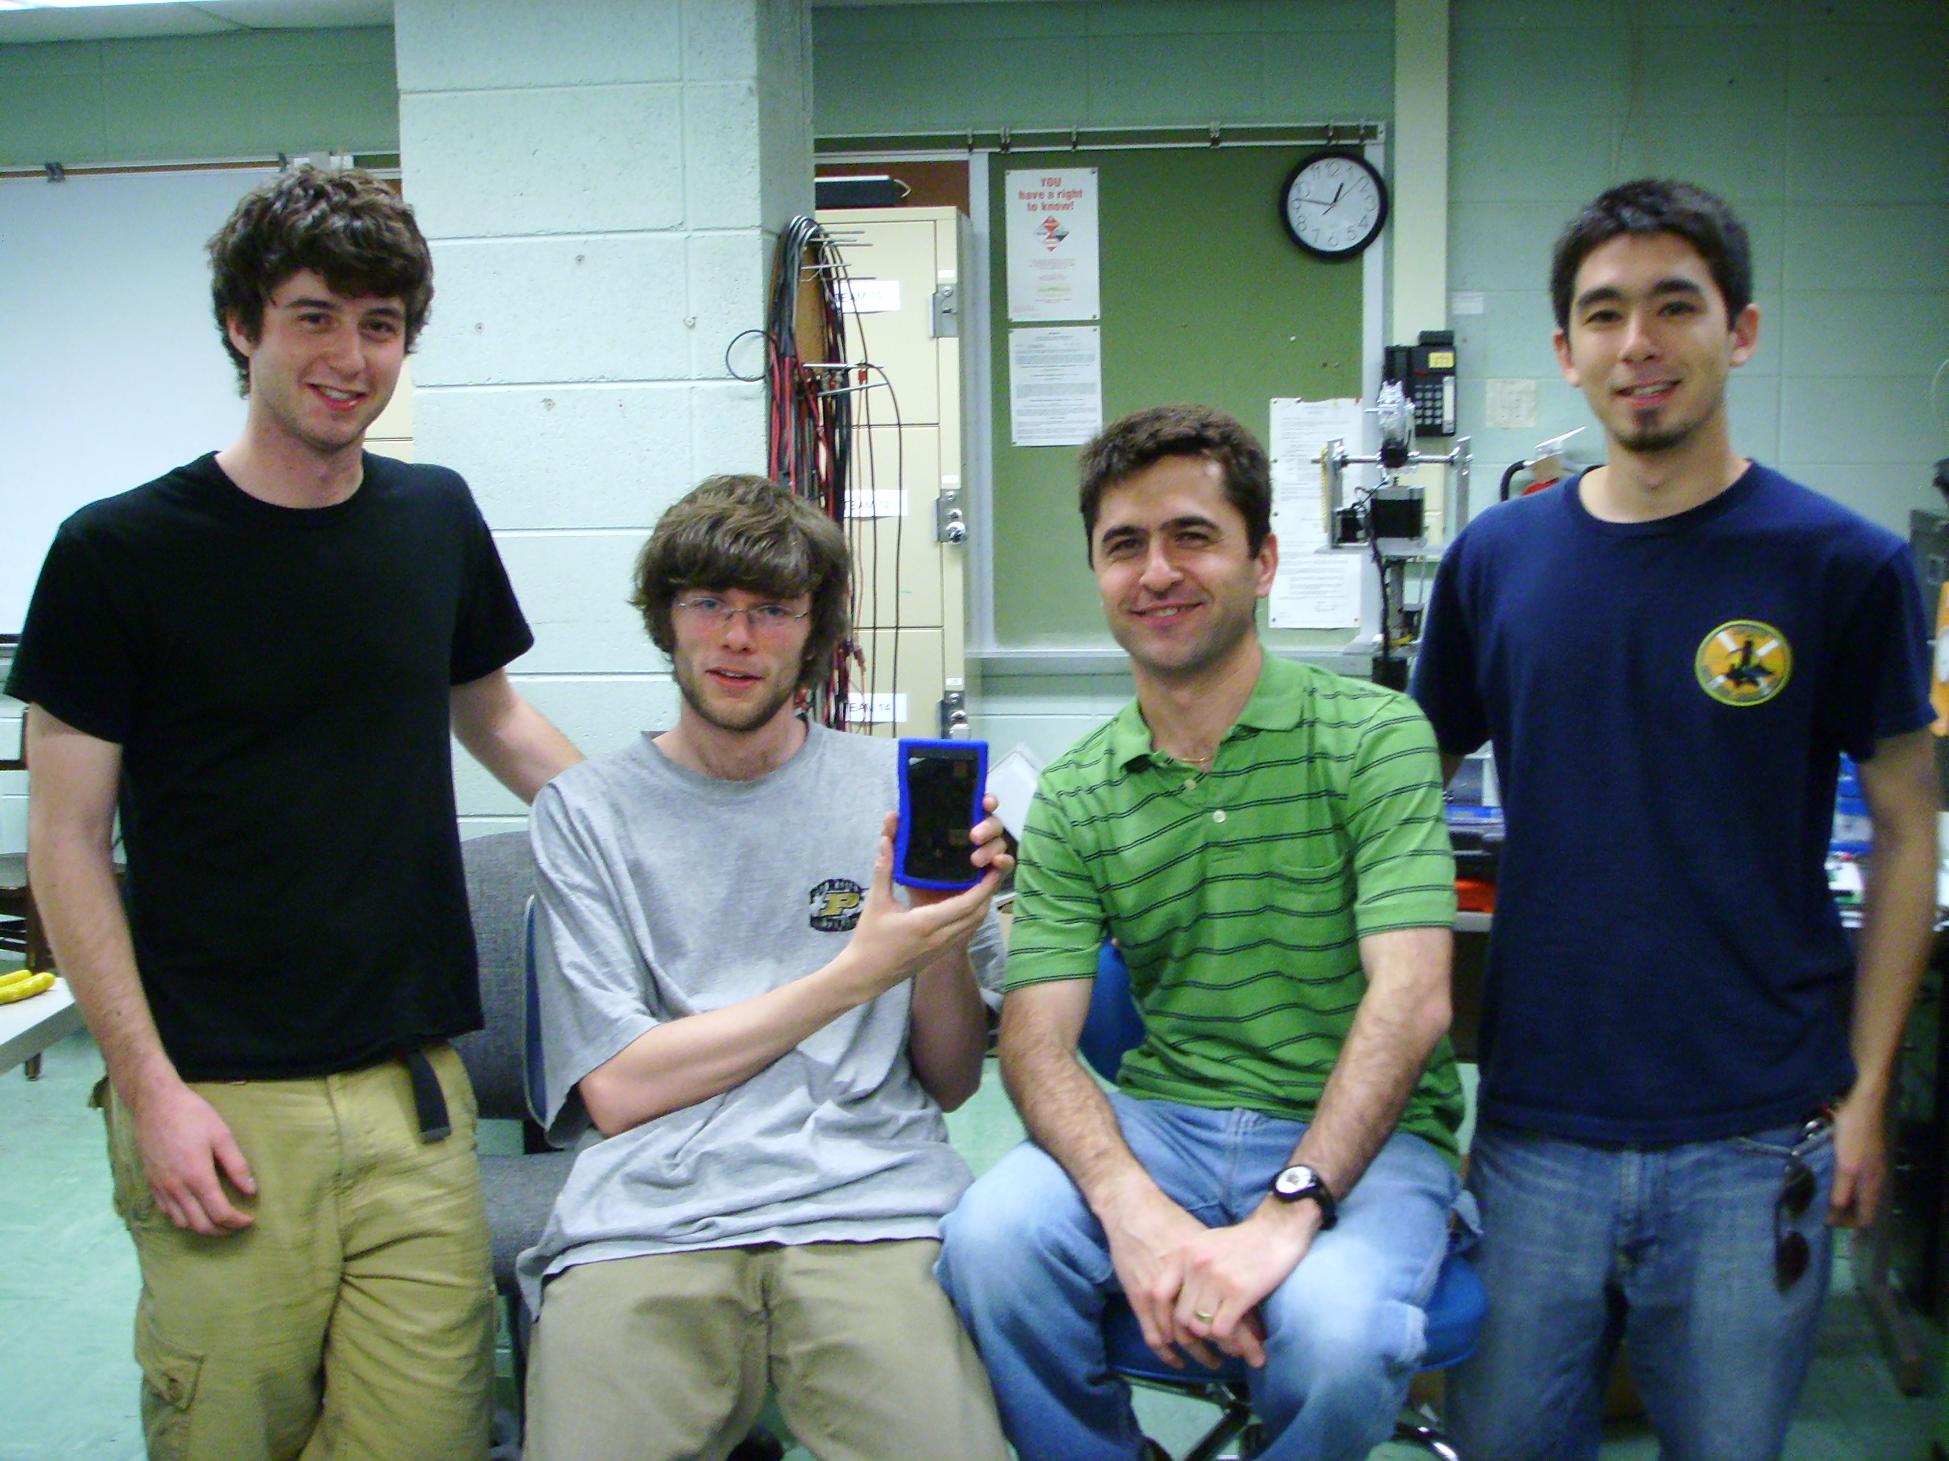

Team Members:

#1: ___Yuri Kubo ______________ Signature: ____________________ Date: _________

#2: ___Ryan Weaver_____________ Signature: ____________________ Date: _________

#3: ___Scott Pillow ______________ Signature: ____________________ Date: _________

#4: ___Yucel Parsak _____________ Signature: ____________________ Date: _________

CRITERION | SCORE | MPY | PTS
Technical content | 0 1 2 3 4 5 6 7 8 9 10 | 3
Design documentation | 0 1 2 3 4 5 6 7 8 9 10 | 3
Technical writing style | 0 1 2 3 4 5 6 7 8 9 10 | 2
Contributions | 0 1 2 3 4 5 6 7 8 9 10 | 1
Editing | 0 1 2 3 4 5 6 7 8 9 10 | 1
Comments: |  | TOTAL

TABLE OF CONTENTS

Abstract | 1
1.0 Project Overview and Block Diagram | 1
2.0 Team Success Criteria and Fulfillment | 3
3.0 Constraint Analysis and Component Selection | 4
4.0 Patent Liability Analysis | 10
5.0 Reliability and Safety Analysis | 15
6.0 Ethical and Environmental Impact Analysis | 19
7.0 Packaging Design Considerations | 24
8.0 Schematic Design Considerations | 28
9.0 PCB Layout Design Considerations | 35
10.0 Software Design Considerations | 40
11.0 Version 2 Changes | 48
12.0 Summary and Conclusions | 48
13.0 References | 50
Appendix A: Individual Contributions | A-1
Appendix B: Packaging | B-1
Appendix C: Schematic | C-1
Appendix D: PCB Layout Top and Bottom Copper | D-1
Appendix E: Parts List Spreadsheet | E-1
Appendix F: Software Listing | F-1
Appendix G: FMECA Worksheet | G-1

Abstract

This document contains the details of the design and fabrication of the Bluetooth Mass Storage device. The Bluetooth mass storage device is a personal portable storage device that can transmit and receive files from a host device wirelessly and a USB connection. Design and professional considerations that were made over the design period are discussed for hardware, software, and packaging. Changes that would be made if a second iteration were possible are also discussed.
- Project Overview and Block Diagram

The Bluetooth mass storage device transfers data both wirelessly using the OBEX (OBject EXchange) serial data transfer protocol over Bluetooth as well as eventually using a wired USB (Universal Serial Bus) connection. The user is able to initiate the data transfer over Bluetooth after ‘pairing’ to a host device, most likely a personal computer. ‘Pairing’ means our device can connect to and remember host devices. When the term ‘remember’ is used, it connotes that the wireless mass storage device, once paired, immediately establishes a connection with all previous host computers once within range. A user configurable passkey is used for security purposes. Wireless data transfer is done utilizing a graphical user interface (GUI) that is unique to our device. This interface allows the user to browse the host PC, select files for transfer to and from the Bluetooth Mass Storage device, delete files from the Bluetooth Mass Storage device, and automatically display the updated file listing on the Bluetooth Mass Storage device. A low battery indicator light emitting diode (LED) lets the user know the status of the battery and will give the user 15 minutes to recharge the device. The USB connection facilitates the recharging of the battery while giving the user continued access to their files. The motivation behind this project is based entirely on ease of use, convenience, and exponential growth of wireless connectivity.
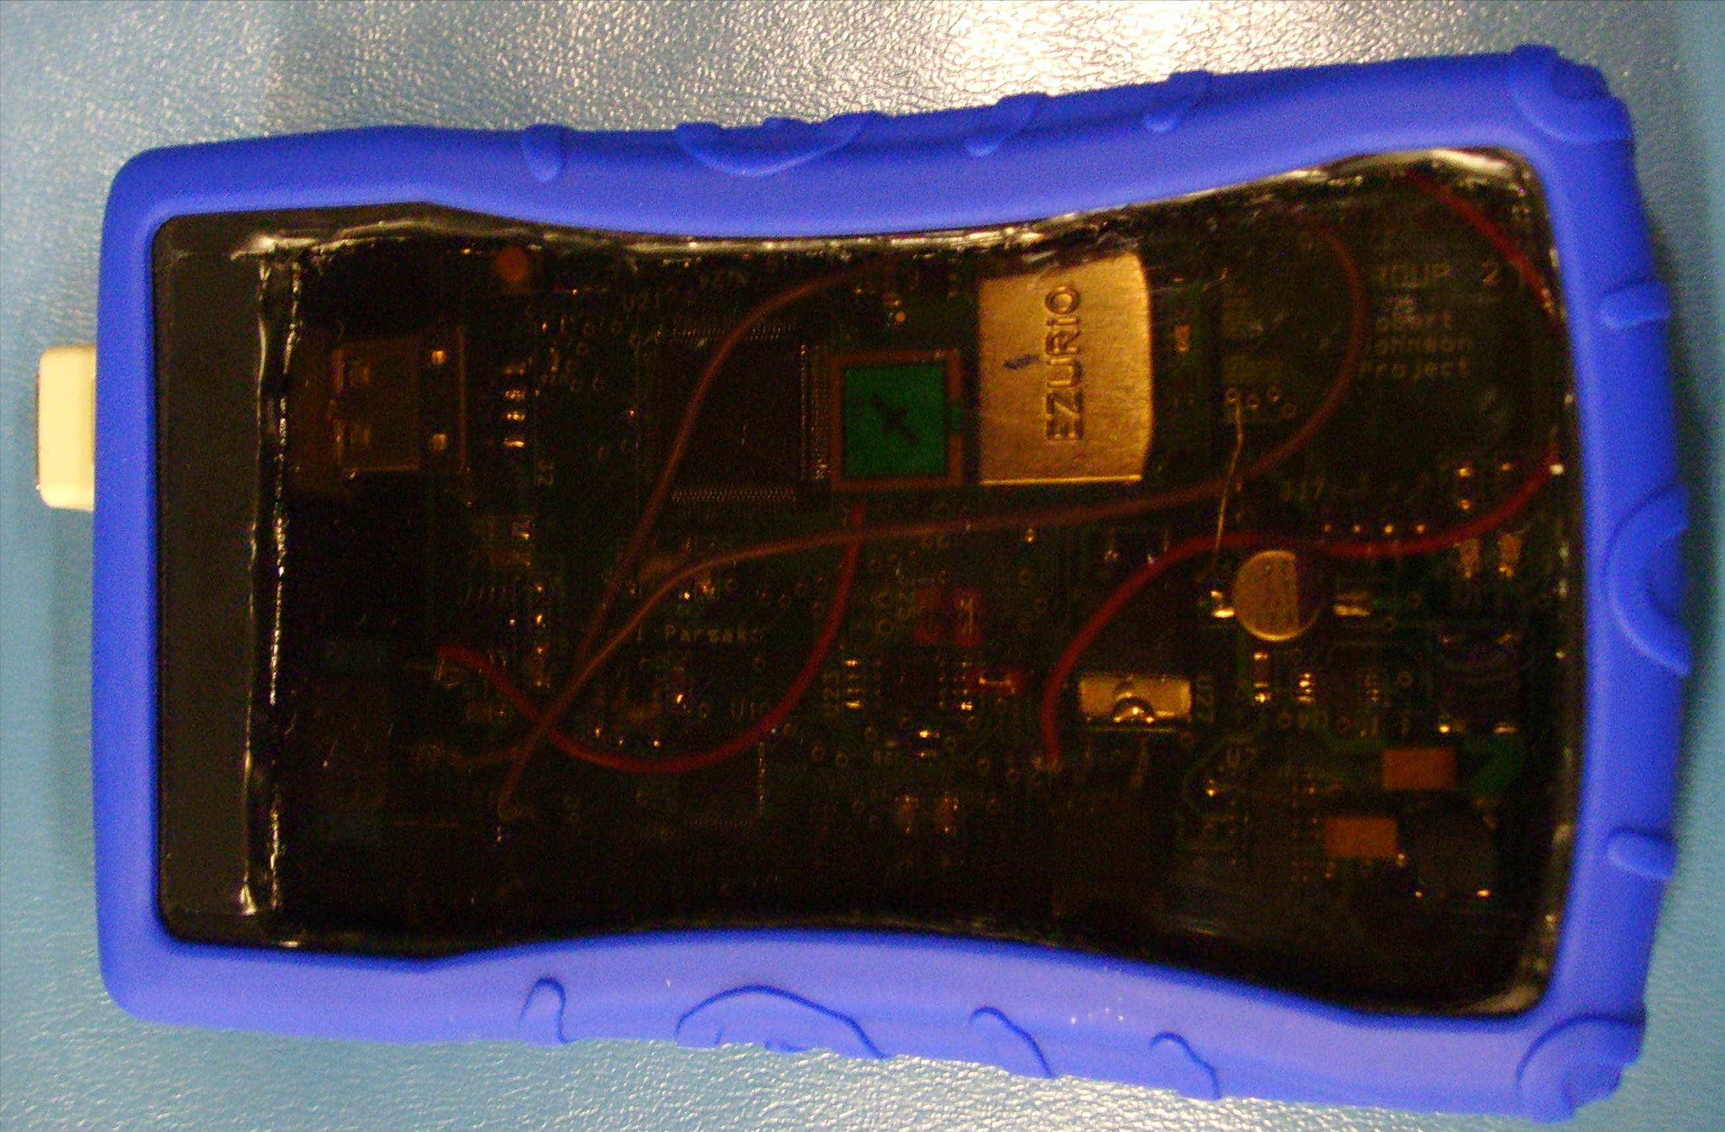
Figure 1.1 Top View of Packaging

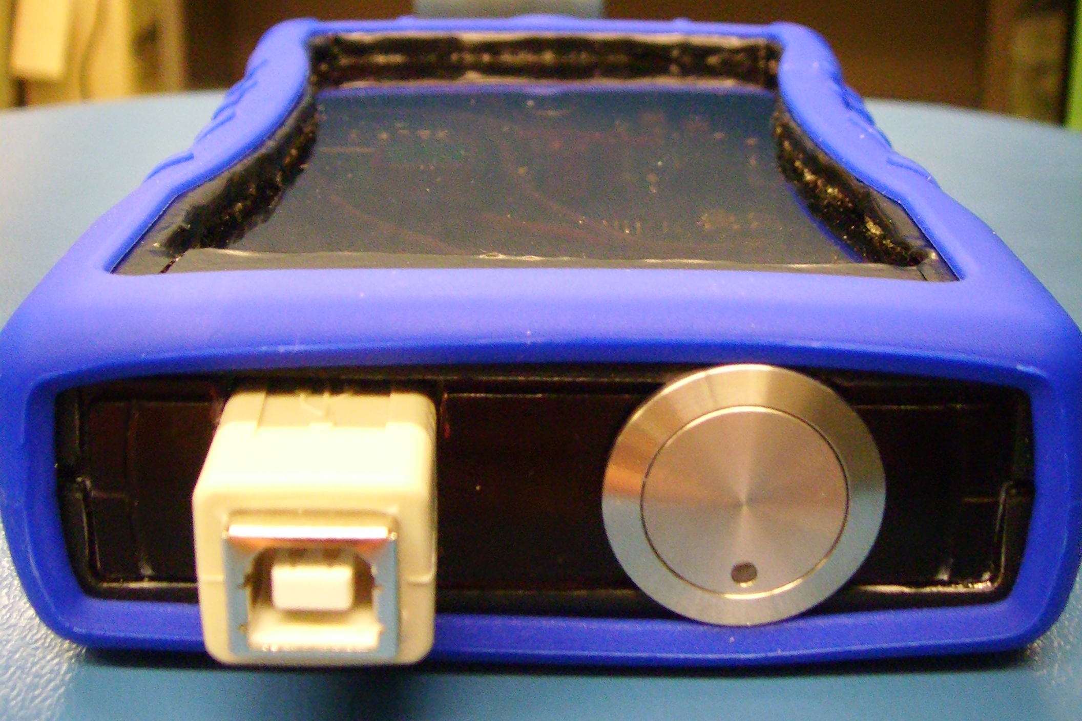
Figure 1.2 Front View of Packaging

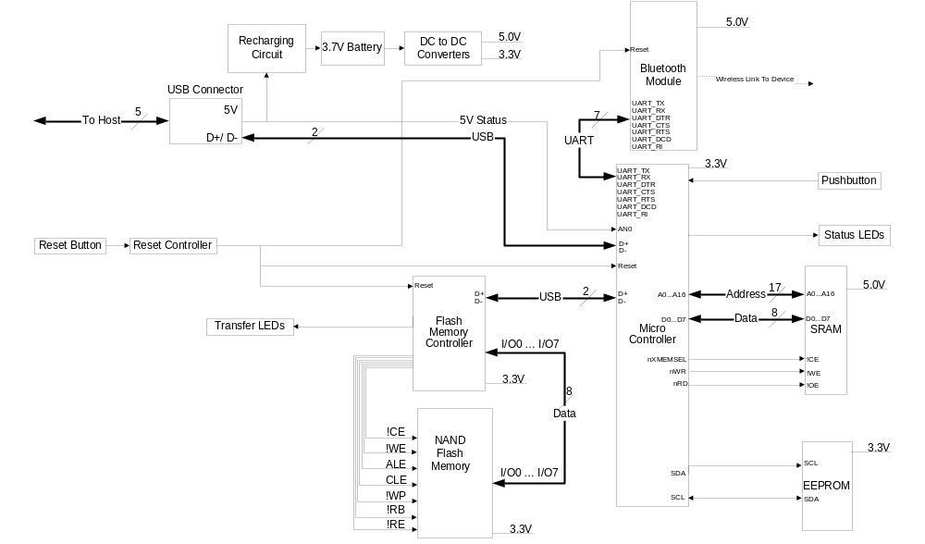
Figure 1.3 System Block Diagram

- Team Success Criteria and Fulfillment

1. An ability to connect to a host device via Bluetooth.
2. An ability to connect to a host device via USB.
3. An ability to transfer data to/from a host device (via Bluetooth or USB).
4. An ability to automatically charge the onboard battery via the USB connector (including indication of battery charge status).
5. An ability to manage the onboard file system (browse, select, delete).
All success criteria were fulfilled April 23rd by the entire team to Karl Herb. The ability to connect to a host device via Bluetooth was demonstrated by connecting to a Bluetooth enabled laptop, entering a passkey, and having the host PC recognize the device. The ability to connect to a host device via USB was demonstrated by a host computer recognizing and installing our device after connecting it to an available USB port. The ability to transfer data to and from a host device and an ability to manage a file system was demonstrated using a Bluetooth serial connection and over HyperTerminal as the user successfully put files on the Bluetooth Mass Storage device, browsed them on the device, sent the files back to the host PC, and deleted them off of the device. The ability to automatically charge the onboard battery via the USB connector was demonstrated by connecting the device to a host PC and the charging indicator LED automatically illuminates and the voltage on the battery increased.

Constraint Analysis and Component Selection

3.1 Introduction
The culmination of our efforts has resulted in a Bluetooth Storage device which is capable of connecting over USB and a wireless connection. Bluetooth communication occurs over the serial port at the standard 9600 baud and, upon plugging the device into a USB port on a host, the PC recognizes the device (although it does not transfer data) and will start to recharge the battery.

3.2 Design Constraint Analysis
Although there are currently few products that incorporate Bluetooth and USB transfers such as ours, analyzing them reveals some crucial constraints that would be necessary for our product to compete with existing solutions. Size is one of the most important constraints with the growing demand for more portable devices. Our device does actually fit in a large pocket as previously hoped, but is still larger than current USB flash drives due to the increased components necessary for Bluetooth and the need for a larger board to facilitate debugging. Power consumption is equally as important as dimensions for a portable device to have use. Although not implemented, techniques such as microcontroller frequency scaling, control of the peripherals and varying the range of Bluetooth all have a significant impact on power consumption. Although we originally hoped for roughly eight hours of quiescent operation, we ended up with about one and half hours. Cost is always a concern in pricing a product in the consumer market, but our design decisions were also motivated by the cost to us. Our microcontroller, the EZ-Host USB embedded host, has a development board which would have greatly sped up development but cost $3000. Our costs were greatly reduced by our sampling of multiple copies of the microcontroller, EEPROM, flash controller and SRAM which would have cost roughly $200 otherwise. Since we were dealing completely with the complex communication protocols of USB and Bluetooth, it was important that we find components that dealt with low level details. Our flash controller interfaces directly with the 1GB of flash memory and implements the USB mass storage device class. Connected directly to our USB host microcontroller, the two would automatically send the correct handshaking information to enumerate the flash memory and make it available for storage and retrieval if we had that functionality working. The data transfer speed differential between USB and Bluetooth is extremely important if the device is to be viable. A much faster USB would largely negate the advantage of wireless communication as a transfer would be faster even with the added time cost of plugging the device into the computer. Since we could not get OBEX FTP transfer to work, our device communicates over the Bluetooth serial profile and makes it appear as if it is connected to a serial port of the device it is paired to. The transfer rate of 9.6 Kb/s is much slower than the Bluetooth EDR+ (enhanced data rate) of roughly 300KB/s but serves as the only means of communication since our device can only enumerate over USB and not transfer data. Support was also something to keep in mind when researching components. Cypress was relatively helpful in quickly responding to our inquiries and shipped our microcontrollers overnight.

3.2.1 Computation Requirements
The microcontroller performs timing to poll pushbuttons, communicates over UART with our Bluetooth module, and has the ability to act as a USB host/slave. Third-party libraries from Cypress contain high level APIs that allow easy use of USB functionality and FAT file format access. Unfortunately, we could not get these to work correctly so were not part of our final design. The microcontroller’s main job is to monitor the incoming UART data. We implemented a simple flat file system that supports dir (show current files), put <file> (send a file to the micro), get <file> (retrieve a file from the micro) and delete <file> (remove file) commands. The files are stored as a linked list in memory and will continue through the internal memory and extend to address 0x7FFF of external SRAM.

3.2.2 Interface Requirements
Four GPIO pins are used to control power to the device and to provide status information to the user. One of the outputs is hooked to a status LED that will tell the user whether the device is powered and the user can release the pushbutton, if the device is paired, if the device is connected over serial and if the device is ready for file transfer.

3.2.3 On-Chip Peripheral Requirements
We used a timer to poll GPIO pins that were connected to the pushbutton and to the output of our low battery indicator. Holding the pushbutton down for two seconds turns the device on or off. If the output of the battery falls below the threshold of ~2.6V it will trigger an LED to come on and give the user 20 seconds to wrap up data transfer before it turns itself off to prevent the battery from draining to the point where it cannot be recharged. UART communication is also needed to communicate with the Bluetooth device. Incoming data to the Bluetooth module is immediately sent out over UART to the microcontroller which can then be stored in SRAM using our own implemented file system.

3.2.4 Off-Chip Peripheral Requirements
The use of the EZ-Host controller and the size of the third-party Cypress libraries necessitated the use of external EEPROM and SRAM. The 16K of internal SRAM on the microcontroller was insufficient to contain all of the libraries that implemented a USB Host to a mass storage device (~53K). We decided on a 128K chip of SRAM from Cypress to easily allow storage of the code and give us room to buffer data coming in from Bluetooth. The external EEPROM was also necessary because the microcontroller cannot be directly written to. A Dataman was used to burn the code onto the EEPROM which the microcontroller calls at boot time over I²C and loads the program code into SRAM.

3.2.5 Power Constraints
The device is powered by a lithium-ion battery [6] that is rechargeable via USB. Heat dissipation is fairly low despite the fact that the Bluetooth module is class 1 (~250 m. range). We utilized a 3.3V rail for the microcontroller and its external chips and a 5V rail for USB. To aid in lowering the power consumption, the Bluetooth mode can be changed (sniff, hold, park) when not active, the peripherals of the microcontroller are configurable and the frequency can be scaled according to the intended application. We had hoped for at least five hours of continuous use from the battery but initial testing indicates that we are getting roughly 1.5 hours of battery life. Here's a more thorough breakdown of power consumption:

Component | Typical Operating Current (mA) | Maximum Operating Current (mA)
Bluetooth Module | 30 | 50
Microcontroller | 1.3 | 3
Flash Controller | 25 | 35
NAND Flash | 10 | 20
Total | 66.3 | 108
Table 3.2.5-1: Power Consumption
DC-to-DC Converter Efficiency | 90%
Needed Current | 73.7 | 120
Table 3.2.5-2: Power Needs

3.2.6 Packaging Constraints
The device was designed with the intention of being transported. It can be fit into larger pockets and can easily go in a bag. We quickly realized that we could not use an aluminum case because it would shield the Bluetooth signal or at least have excessive noise. Our final combination of a plastic case and Lexan cover provides a durable and lightweight solution that should weather daily wear and tear. The dimensions of our packaging turned out to be relatively svelte 14cm. x 9cm. x 2.5 cm.

3.2.7 Cost Constraints
Our device will be competing with standard USB flash drives and partly with Bluetooth dongles. Both are usually sold somewhere in the $20-$30 range. Due to having the functionality of both devices and our lack of mass production the cost of our device is roughly an order of magnitude higher.

3.3 Component Selection Rationale
Microcontroller:
The choice of microcontroller was particularly important because it would determine how much work we had to do to get USB communication up and running. Our choices boiled down to the PIC18F2455 [1] and the EZ-Host CY7C67300 [2]. Both have standard timer and UART ports that are common to most microcontrollers. Both have the necessary USB ports to connect to our flash controller. Both also have controls that can be used to lower power consumption during quiescent periods. Before finding the EZ-Host we began prototyping the PIC controller. One early problem was how we were going to multiplex the data coming in from the host PC over USB and the data coming in from Bluetooth onto the same USB lines of the flash controller. Since the USB lines are extremely sensitive and fast, they could not actually be multiplexed and sent to the controller. This ruled out the use of the PIC. The EZ-Host has four USB ports and a pass-through mechanism so that, when the device is connected to a computer, data can flow from one port directly to another. In addition, the EZ-Host has the capability to act as a host and enumerate peripheral devices that are attached. Since the PIC doesn’t have hosting capabilities, we would have had to implement them ourselves.

Bluetooth module:
After researching various Bluetooth devices, we narrowed our choices down to the WT12 [3] and BISM2 [4]. Both modules have everything prebuilt on the board so we don’t have to worry about setting up our own antenna. Both are slightly larger because of this. Communication occurs over UART for BISM and USB for WT12 (this makes it easier to get the BISM running and the slower speed isn’t a problem as the speed of USB is not necessary for Bluetooth speeds) lines and both can use the OBEX protocol and serial profile for file transfer. The BISM2 was chosen because there is better documentation and the company was willing to help us with technical issues (versus nonexistent support for the WT12). The BISM2 also has a collection of commands such as DIR, PUT and GET that can be used to easily operate the device to receive and transmit files. The BISM2, using Class 1, has a range of 250 m. The biggest downsides are that the company doesn't give out samples and the evaluation board is $180.

Battery:
Our battery choice was critical in having good power-to-weight ratio and in keeping the device light while still providing enough amp-hours to keep the device running with continual recharging. We ultimately had to choose between the EaglePicher PT-2150 [5] and the Ultralife UBP103450 [6] rechargeable battery. The Ultralife battery (with nominal capacity of 740 mAh) was the clear winner because the EaglePicher had an unsavory form factor (cylindrical) and the mAh value was not as high.

Li-ion charger:
Our choices for the battery charger were the MAX1811 USB-Powered Li+ Charger [7] and the Microchip MCP73831 [8]. There isn't a lot to separate chargers so we ended up choosing the Maxim charger over the Microchip charger due to Microchip's lack of thermal management and sparse data sheet.

Regulator:
Our choices for the regulator were the Maxim MAX1797 [9], the Texas Instruments TPS62202 [10] and the Maxim MAX710 [13]. We chose the MAX710 regulator because it had better efficiency at low current and LBO.

Flash memory:
The basic constraints on our flash memory were that it had to be NAND due to the flash controller and at least 512 MB. With many to chose from, we decided on the ST’s NAND01GW3B2BN6E [11] over the Samsung K9F1208R0C NAND flash. ST's gave us 1GB of storage and is compatible with a flash controller from ST that implements the USB mass storage class.
3.4 Summary
We started by giving a brief introduction and recap of what our device does. We then gave a list of the key constraints that guided our choice of components. We found that, due to the specific tasks that our microcontroller needed to perform, the microcontroller would need built-in USB host and peripheral support to make implementing USB communication tractable. The device can connect via serial over Bluetooth and transfer data from and to our own implemented flat file system. We found that the EZ-Host was easily capable of providing UART and timer peripherals. The device utilizes a plastic case with a Lexan cover to provide rugged enough packaging to withstand everyday transport. Our particular device doesn’t have many peers but would come into competition with Bluetooth dongles and standard USB flash drives which will be substantially cheaper than our device due to mass production and the added functionality of our device. We then ultimately outlined what parts we chose by comparing multiple versions of each major component and deciding what to choose based on which component met our design criteria the best.

- Patent Liability Analysis

  - Introduction
With the growth of wireless technology comes an increased risk of patent infringement. As discussed below, there are several patents that describe technologies and methods similar to those being used by the Bluetooth mass storage device being designed. The patents to be discussed lead to the debate of patent infringement on the following design functions of the device: (1) transferring data to and from a host device wirelessly via Bluetooth, (2) transferring data to and from a host device via a wired connection (USB protocol), and (3) having a storage medium in a portable device. These functions may potentially be literally infringing functions as well as commit infringement under the doctrine of equivalents. The following discussion will cover both the possible infringements mentioned as well as recommendations to eliminate these cases of infringement.

  - Results of Patent and Product Search
Patent: 6795327 – “Semiconductor storage method and device supporting multi-interface” (Inventors: Deng, Guoshun, Cheng; Xiaohua, Xiang; Feng. Date Filed: September 30, 2002.) [13]
This patent describes a portable storage method and device supporting multiple interfaces that include a semiconductor storage module, a controller module, and an interface module which supports at least two separate interfaces of different protocols. These different interfaces may be serial or parallel communication as well as wireless communication and include any of the following interfaces: CF (Compact Flash), USB (Universal Serial Bus), IEEE 1394, PCMCIA, True IDE, Bluetooth or wireless LAN. These interfaces will connect the storage device to a data processing system and establish information exchange between the storage device and processing system. The specific semiconductor storage method may include Flash Memory, DRAM, EEPROM, SRAM, FRAM, or MRAM. The descried method is to provide a mobile storage device with multiple interfaces to allow for convenient data and file exchange.
Possible Infringing Functions: (1) transferring data to and from a host device wirelessly via Bluetooth, (2) transferring data to and from a host device via a wired connection (USB protocol), and (3) having a storage medium in a portable device.

Patent: 20070005837 – “Personal portable storage device” (Inventors: Chen, Martin Yu-Wen; Huang; Fu-Ying. Date Filed: January 4, 2007.) [14]
This patent describes a portable storage device comprising of a storage medium, a wireless module that is coupled to the storage medium that is a solid-state storage device of hard disk drive, a transfer management system that allows for a host device to access the personal portable storage device, and for this device to be portable in nature including a self-contained energy source. The wireless component may be a Bluetooth or Ultra-Wideband (UMB) transmitter and receiver. The self-contained energy source may be a rechargeable battery or a hydrogen fuel cell. The hosing is designed to be carried in a pocket or on a belt, and it is designed to protect the storage medium from damage from shock. This device is
Possible Infringing Functions: (1) transferring data to and from a host device wirelessly via Bluetooth, (2) transferring data to and from a host device via a wired connection (USB protocol), and (3) having a storage medium in a portable device.

Patent: 20030216954 – “Apparatus and method for exchanging and storing personal information” (Inventor: Buzzelli, David B. Date Filed: February 27, 2003) [15]
This patent describes a method and system of handheld communicators containing signature marketing information specific to an individual user. The handheld devices communicate with data hosts that are configured to perform information exchange with the handheld devices. The information is stored locally on the handheld devices and can communicate with other handheld devices as well as a central host device wirelessly by Infa-red or RF (Radio Frequency) signals. The author of the patent also claims the communicator device is configured to store information that is loaded from a personal computer through a standard USB port, in addition to the wireless link. The device will share this information on file-by-file basis.
Possible Infringing Functions: (1) transferring data to and from a host device wirelessly via Bluetooth, (2) transferring data to and from a host device via a wired connection (USB protocol), and (3) having a storage medium in a portable device.

  - Analysis of Patent Liability
Patent: 6795327 – “Semiconductor storage method and device supporting multi-interface” [13]
The Bluetooth mass storage device would likely be subject to both literal patent infringement and infringement under the doctrine of equivalents with this patent. The patent is very general in the specifications of interfaces and storage methods. The patent specifies using multiple interfaces, and this is very similar to the Bluetooth mass storage device under design. Both Bluetooth and USB interfaces are specifically stated in the patent as well as using flash memory as the storage semiconductor. Therefore, all three of the major functions (1) transferring data to and from a host device wirelessly via Bluetooth, (2) transferring data to and from a host device via a wired connection USB protocol, and (3) retaining data on nonvolatile memory would be subject to patent infringement.

Patent: 20070005837 – “Personal portable storage device” (Inventors: Chen, Martin Yu-Wen; Huang; Fu-Ying. Date Filed: January 4, 2007.) [14]
The Bluetooth Mass Storage would be subject to both literal patent infringement and infringement under the doctrine of equivalents with this patent. The patent describes exactly the purpose of the Bluetooth Mass Storage. The Bluetooth Mass Storage is a personal portable storage device is a wireless storage device designed for portability. The Bluetooth Mass Storage device uses a solid state storage device (NAND flash), a rechargeable battery as the energy source, a Bluetooth module coupled to the storage medium for transmitting and receiving data to and from a host device, and is designed for portability. Therefore, all three of the major functions (1) transferring data to and from a host device wirelessly via Bluetooth, (2) transferring data to and from a host device via a wired connection USB protocol, and (3) retaining data on nonvolatile memory would be subject to patent infringement.

Patent: 20030216954 – “Apparatus and method for exchanging and storing personal information” [15]
The Bluetooth mass storage device avoids literal infringement may be subject to patent infringement under the doctrine of equivalents. The device described in the patent is describing a means to exchange and store personal information for marketing purposes. Therefore, the Bluetooth mass storage device avoids literal infringement as the major functions are different. However, under the doctrine of equivalents the Bluetooth mass storage device would be considered ‘substantially the same.’ The patent clearly describes using the device for transferring files via a wired serial connection and a wireless RF connection and storing these files on internal RAM. An example of a wired serial connection is USB, and an example of a wireless RF connection is Bluetooth. Both connections are used by the Bluetooth mass storage device. These are the same three major functions as the Bluetooth mass storage device.

  - Action Recommended
Patent: 6795327 – “Semiconductor storage method and device supporting multi-interface” [13]
Few methods are available to avoid patent infringement in this case. The easiest way to avoid infringement is to pay the patent holder royalties. Because the patent is incredibly general and covers a wide range interfaces and storage methods redesigning the device’s major functions would prove useless in avoiding possible patent infringement. One would have to intensely study all of the claims made and then maybe a method could be found to avoid patent infringement.

Patent: 20070005837 – “Personal portable storage device” (Inventors: Chen, Martin Yu-Wen; Huang; Fu-Ying. Date Filed: January 4, 2007.) [14]
The potential for infringement in this case is substantially difficult to overcome. Because the patent describes in general details the purpose and premise of the Bluetooth Mass Storage redesigning the functionality of our device to avoid patent infringement would prove to be non-productive in avoiding this infringement if the same purpose of a portable storage device would want to be kept. The best way to avoid infringement would be to pay the patent holder royalties to use their patent, since all technologies in the Bluetooth Mass Storage are described in this patent.

Patent: 20030216954 – “Apparatus and method for exchanging and storing personal information” [15]
There are not many feasible options in avoiding patent infringement with this patent because it describes all of the Bluetooth mass storage device’s major functions. As stated previously, paying the patent holder royalties may be the only possibility as redesigning our device would not be beneficial in avoiding patent infringement. All of the major functions of our device are described in this patent, so redesigning the device with the same functionality would not avoid patent infringement. If the patent specified which wireless communication would be used, instead of a RF connection in general, and the Bluetooth interface was not stated then avoiding patent infringement could be made possible.

  - Summary
The Bluetooth mass storage device has similar functionality to the patents described even though a product in the consumer market could not be found. This is attributed to the growth of wireless connectivity and the need for personal storage devices. In all of the cases the three major functions of the device infringed on other patents. The patents described are in general terms, so the only feasible corrective action would be to pay royalties to the patent holder. Redesigning the device while keeping the same functionally would not be useful in avoiding patent infringement.

- Reliability and Safety Analysis

  - Introduction
Because the main function of this device is based on the wireless transfer of data, this device is battery powered by a lithium ion battery. The use of a lithium ion battery as its primary source of power will add safety concerns on the part of the user because of the risk of explosion or leakage of the battery if the power supply section of the board becomes unstable and fails unexpectedly creating the possibility of a large current draw from the battery such as a short in one of the power supply integrated circuits (ICs). Also, because of the sensitive nature of the data that this device could be handling, the reliability of the microprocessor, which will be handling all of the data at some point during the transfer process, needs to be examined as well. These are the most critical safety and reliability issues, and they could arise from the failure of four different components. Three of the components are in the power supply section and are all critical to the safety of the user and the reliability of the device to maintain its “mobile” status, and one of the components is the microprocessor and is critical in data retention, data transmission integrity, and device reliability from a functional stand point.

  - Reliability Analysis
There are four components that are most likely to fail in this design due to both operating temperature and complexity of the part itself. These components are also the most critical to the safety and reliability of this device. The four components are the MAX1811 USB lithium ion battery charging IC, the MAX1796 step-up DC-to-DC converter, the MAX710 step-up step-down DC-to-DC converter, and the CY7C67300 microcontroller. The first three components listed are most likely to fail due to heat concerns and the last is due to complexity. There are six parameters that are common to all of our parts and are defined in the following manner: C₁ is the die complexity failure rate, π_{T} is the temperature factor, C₂ is the package failure rate, π_{E} is the environmental factor, π_{Q} is the quality factor, and π_{L} is the learning factor [16]. Any assumptions that had to be made to find these values are discussed later.

The MAX1811 will be modeled as a gate array. The equation for the failure rate measured in failures/10^6 hours for such a device is defined as the following:
λ_{p}=(C₁ * π_{T} + C₂ * π_{E}) * π_{Q} * π_{L}. [16]
Parameter | Value | Rationale
C₁ | .06 | MOS linear device with 1907gates [18]
π_{T} | 1.467 | BiCMOS with assumed operating temperature of 70°C [18]
C₂ | .0026 | hermetic surface mount device with eight pins
π_{E} | 4 | a ground, mobile environment
π_{Q} | 10 | unknown screening level
π_{L} | 1 | manufactured for over two years [18]

Plugging these values back into the initial equation shows that λ_{p} = .9842 failures/10^6 hours. From this value, it can be shown that the MTTF, which is the inverse of the failure rate (MTTF= 1/ λ_{p)} [17], for this part is 1.016 * 10^6 hours.

The MAX1796 will also be modeled as a gate array. The equation for the failure rate is the same as for the previous device.
Parameter | Value | Rationale
C₁ | .06 | MOS linear device with 1100 gates [19]
π_{T} | 1.467 | BiCMOS with assumed operating temperature of 70°C [19]
C₂ | .0026 | hermetic surface mount device with eight pins
Parameter | Value | Rationale
π_{E} | 4 | a ground, mobile environment
π_{Q} | 10 | unknown screening level
π_{L} | 1 | manufactured for over two years [19]

Plugging these values back into the initial equation shows that λ_{p} = .9842 failures/10^6 hours. This gives a MTTF of 1.016 * 10^6 hours.

The MAX710 will also be modeled as a gate array. The equation for the failure rate is the same as for the previous device.
Parameter | Value | Rationale
C₁ | .04 | MOS linear device with 661 gates [20]
π_{T} | 1.467 | BiCMOS with assumed operating temperature of 70°C [20]
C₂ | .0056 | hermetic surface mount device with 16 pins
π_{E} | 4 | a ground, mobile environment
π_{Q} | 10 | unknown screening level
π_{L} | 1 | manufactured for over two years [20]

Plugging these values back into the initial equation shows that λ_{p} = .8108 failures/10^6 hours. This gives a MTTF of 1.233 * 10^6 hours.

The CY7C67300 is modeled as a microprocessor and thus has the following equation for failure rate:
λ_{p}=(C₁ * π_{T} + C₂ * π_{E}) * π_{Q} * π_{L}.
Parameter | Value | Rationale
C₁ | .28 | 16 bit microprocessor [21]
π_{T} | .655 | BiCMOS with assumed operating temperature of 70°C [21]
C₂ | .0405 | hermetic surface mount device with 100 pins
π_{E} | 4 | a ground, mobile environment
π_{Q} | 10 | unknown screening level
π_{L} | 1 | manufactured for over two years [21]

Plugging these values back into the initial equation shows that λ_{p} = 2.634 failures/10^6 hours. This gives a MTTF of 3.797 * 10^5 hours.

For all of the components, an operating temperature of 70°C has been assumed because of an inability to measure the temperature accurately and instead has been qualitatively described as generally warm to the touch but not necessarily hot or near any temperature that would lead one to be concerned about their safety in touching the component. This equates to an obviously higher than ambient temperature but lower temperature than the maximum rating of the device of 85°C. The MAX1811 was significantly higher in temperature than the other components under review here, so this was used as a baseline and all of the other parts were calculated using what was assumed to be the MAX1811’s operating temperature. There is no apparent insight into the screening level, so all of the components had to have an assumed quality level of 10. The components are all assumed to be hermetic because there is also no apparent insight into this property of the device but it seems reasonable that they would be hermetic. The Robert Johnson Project is assumed to be classified as handheld communications equipment, and thus all of the components are a part of the “Ground, Mobile” [16] category.

In general, our components all appear to be fairly robust because their MTTFs are all fairly high. However, because of the possibility that some of these parts may cause personal injury to the user, a λ of less than 10^-9 needs to be attained. This means that there should be redundancy built into the circuits. The microcontroller is by far the most complex so it makes sense that it is also the component with the lowest MTTF. The MTTF could be made longer by adding a heat sink and thus lowering the operating temperature. This is true of all of the components and is the easiest fix to increase the MTTF for all of them. Also, if parts with military ratings, specifications, and superior screening processes were used, the quality coefficient would decrease dramatically and thus increase the MTTF for each component. As for possible design fixes, the major concern for the possible injury to the user comes from the battery shorting and discharging at an unsafe rate. This can be detected earlier by having a low voltage detection circuit implemented across the battery terminals. This would detect a short circuit and could potentially stop the battery from discharging across the shorted device using discreet transistors on the battery lines to the inputs of the devices or having some electrically controlled switch on the battery line itself, such as a relay. This would improve the overall reliability and safety of our design by adding redundancy and could save the user from possible injury or the device from component failure from high currents.

  - Failure Mode, Effects, and Criticality Analysis (FMECA)
This device has two levels of criticality. The first of which has been designated as “low” and will include such effects as loss of communication, static data loss, loss of data transmission integrity, loss of all functionality of device, component damage or failure, loss of user insight into status of device, loss of user control over the device, and a general loss of any portion of nominal functionality. The second criticality has been designated as “high” and is defined as any failure that will adversely affect the health and safety of the user. The acceptable failure rate for a low critically failure is defined here as λ_{p} < 1 failures/10^6 hours. The acceptable failure rate for a high critically failure is defined here as λ_{p} < 1 failures/10^9 hours as this number is generally accepted as a standard for failure rates that could affect the safety of the user.
For all of the failure modes and effects of the schematic shown in Appendix C, please refer to the FMECA table in Appendix G.

  - Summary
The Robert Johnson Project has several reliability and safety risks associated with it. Reliable data transfer is the biggest concern for the reliability of the device and the battery becoming unstable and possibly exploding or leaking and injuring the user is the biggest concern for the safety of the device. With the components used currently, the reliability of the data transfer in the microprocessor would not meet the reliability requirements of a low criticality failure as they have been defined in this paper. Also, the components used in the power supply as they are now would not meet the requirements put forth for the necessary high criticality failure rate. However, with the use of redundancy and failure detection on the power supply as well as heat sinks on all of the major devices, it is reasonable to assume that the failure rates could be brought well below the required limits.

- Ethical and Environmental Impact Analysis
  - Introduction

The “Robert Johnson Project” Bluetooth Mass Storage Device is a hand-held device that communicates with a PC using either Bluetooth or USB communication to store/retrieve data into/from a Flash Memory. Once the communication is established by PC, the design project either loads/stores data or sends directory information to the PC. It is a hand-held device which is powered by a lithium battery that can be recharged through USB port 5V line. Ethically there are three main concerns that need to be addressed concerning the ethical and environmental impact issues:

First of all, the design project must be safe to the user, and should not pose any danger to the nature. The project design uses a lithium-ion battery which may cause harm to the user under certain conditions. These batteries may ignite or explode when they are shorted or exposed to high temperatures [22]. When the battery needs to be replaced, the old battery must be recycled appropriately. Otherwise the chemicals inside the battery may leak into the water supplies in nature, and contaminate the water. If they are exposed to the direct sunlight, they may explode and cause fire. Other components of the design project must also be recycled. They also contain chemicals that may harm the user or the nature. In order to minimize the danger, instructions and labels must be provided to guide the users.

Secondly, the design project must ensure the integrity of the data stored/retrieved from the memory unit. During the load and store procedures the data must never be corrupted by our device. Intensive testing must be applied to assure that load and store functionalities provide the correct data in both Bluetooth and USB communication.

Finally, the design project must ensure the security of the user data from malicious activities. Other users must be blocked from accessing the data by providing password and encryption in hardware and software.

  - Ethical Impact Analysis
There are several challenges that must be addressed during the manufacturing stage. Above all, the most important challenge is that the product must be reliable and safe. The product should not pose any danger to the user and nature at any stage of its life cycle. The product will go under many tests that will ensure the safety of the user. The product will also be tested so that even in failure, it will not pose any danger. There will be warning labels on device packaging and instructions on user manual. There will be sealing on the packaging so that the user will be discouraged to open it. One example is that if seal is broken, the device will be out of warranty.

    - Operational Environment Test
Prior to release, the product will be tested thoroughly to ensure the safety of the device to the user and nature. The design project uses a lithium ion battery that may ignite or explode if it is short-circuited or exposed to high temperature environments, such as direct sunlight [22]. Our product should not be kept in direct sunlight, since it uses a transparent plastic packaging, it will absorb the sun rays without any resistance. This situation only may pose problem if the device is used along with a laptop computer in outdoor activities. If user is using the device in Bluetooth module, then the device must be kept away from direct sunlight such as in a backpack. Secondly, these batteries should only be changed by trained technicians to prevent damaging the battery which may result in fire or explosion. Finally, special precautions must be taken while traveling by plane. The FAA requires that the battery powered devices must be kept in carry-on baggage [23]. They claim that if they catch fire or explode, the plane crew will be able to extinguish the fire where they can easily access the device. The fire and explosion may occur at any stage of the product. The only way to prevent this danger is to provide information and labeling. The instructions and labels must be easily seen on device packing and user manual. In order to minimize the potentially hazardous batteries, they must be tested thoroughly during manufacturing stage. The website “mpoweruk.com” [24] gives a list of battery testing. Some of these tests are “Crush, shock, vibration, impact, drop, heating, temperature cycling, altitude, humidity, fire exposure” etc. These tests will be necessary reduce the possibility of faulty products passing the release stage. When the product is no longer usable, the lithium battery and other components of the products must be recycled appropriately.

Secondly, our focus should be the integrity of our device’s functionality. The product is used to store or load data from a memory unit. During the data transfer in Bluetooth and USB protocols, data loss should not happen. In both USB and Bluetooth RF communication modes, data integrity must be tested thoroughly. In USB communication, the USB goes through the micro-controller and goes directly to the flash controller and flash memory units. The micro-controller should not alter the signal and provide a flawless communication in between the PC and the flash controller. In Bluetooth RF communication, the RF signal is received by Bluetooth module and it is sent to the micro controller via UART. The micro controller passes this signal to the flash controller via USB pins. A 128K SRAM is used to provide a buffer that will fill the gap of data rate difference in between these two communication protocols. A data flow control must be implemented so that the buffer will never exceed its limit. This can be tested by storing and loading large sized files during manufacturing stage.

Finally, the data security must be established. The Bluetooth RF communication uses encryption and a passkey up to 16 digits is required for any pairing between devices. There are 112 printable keys in ASCII, which makes the key block size 112^16 (6.13039E32). This is not very easy to break. Unfortunately most people do not use 16 digits passkey. And many of them use very simple passkey, such as “PIN1234” or “12345”. Another concern is that, the hacker might use other techniques to gain access to the memory unit. Bluetooth RF data packet sniffing is another one. In order to increase the security a secondary encryption can be introduced. Since we are implementing both PC software and the microcontroller software, data packets can be encrypted during data transfer. We will not implement a secondary encryption, but it is an option for later versions.

    - Warnings to the User
The user must be aware of the possible danger that the product might pose. The labels and warnings must be placed during manufacturing stage in order to ensure reliable and safe usage of the product later in its normal use stage. These warnings should include “the battery should not be kept in direct sun light”, and “please recycle the device when it is no longer usable”. Some other labels must be added to inform the user that they should not open the case to try to change the battery. When the battery is being used, it must be changed by a trained technician. In order to ensure that the user will not open the packaging, it can be sealed. If a user opens the box, the seal will be broken, and the device will be out of warranty. Since our device is small in size, there is not enough space on the packing for many warning labels. Therefore more detailed information must be given in the user manual to provide a safe environment to the user and the nature. The warning labels will be placed on the bottom of the packaging (where the battery is placed inside). The top side will be transparent so the user can see inside the circuitry.

  - Environmental Impact Analysis

Digital devices may have large impact on the nature. Electrical parts of the product contain chemicals, and its battery may explode or cause fire. Therefore, during every stage of its life time, precautions must be taken. When the device is no longer usable, it needs to be recycled. The environmental impact will be studied in three stages of its life cycle.

    - Manufacturing Process

Every component of the product contains some chemicals that might cause harm to the environment and the nature. During manufacturing stage, precautions must be taken to prevent possible harm to the employees and environment. Employees must be trained to handle waste materials at this stage. Once the components are not usable, they must be segregated and handled separately. These components may include lead, platinum, mercury, silver and gold connections [25]. The chemical leak must be prevented. Because of its chemical components, the PCBs are classified as “special” waste streams [25]. At manufacturing stage, the batteries also must be handled very carefully. They need to be disposed separately and care must be given to prevent fire or explosion. Another important option is to introduce the lead free components (Green PCB).

    - Normal Use

During normal use of the product, the user must be discouraged to open the packaging for any reason. The battery is no longer usable; it must be changed by trained technicians. If the battery is changed by the user, it may ignite and cause fire, or explode under certain conditions. Proper labeling and user manual must provide information regarding this hazard. The packaging is transparent plastic, so it will absorb the sun light directly which may cause to circuit elements to heat up if it is used in direct sun light. The user will be warned using labels not to use the device in direct sun light for a long time. At this stage, it is also possible that the battery may leak.

    - Disposal

After the normal use time of the device, it must be recycled appropriately. It must be segregated from other waste. All PCBs contain hazardous materials such as lead, platinum, mercury, silver and gold connections [25]. Some PCBs also contain silver and gold connections. These metals will contaminate the drinking water supplies in nature if special care is not given. The old batteries also must be segregated from normal waste, and recycled. One company that provides disposal for electrical appliances is “TCI Incorporated” [26]. They have two facilities in New York and Alabama. More information about the company can be found at http://www.tci-pcb.com .

  - Summary

The ethical and environmental impact analysis of Bluetooth Mass Storage Device has been studied closely. The design project must follow all of the ethical and environmental rules and guidelines. The major constraint is to ensure the safety of the user and the environment. These constraints must be examined in all stages of product’s life cycle, including manufacturing, normal use, and disposal stages. Because of its chemical contents in PCB, and hazardous battery unit, special care must be given. All of these goals can be achieved by instructing producers and users by providing them training, and guideline materials and warning labels that are placed on the packaging. Secondly, the data integrity must be guaranteed. During file transfer, no data loss should occur. The data rate with large size files must be tested to guarantee that buffer overflow will not occur. Finally, cryptography must be used to increase the security of the device, so that the malicious neighbors should not hack into the memory unit.

- Packaging Design Considerations

7.1 Introduction

The device is a Bluetooth enabled USB flash drive. Size is a critical as it to be used as a transportable device that is carried in a pocket or bag. Its final dimensions of 14cm. x 9cm. x 2.5cm. came in larger than USB flash drives and of similar dimensions as portable hard drives. Because of its transportability, our plastic package and Lexan cover will be able to withstand the daily abuse of its user.

7.2 Commercial Product Packaging
7.2.1 Product #1

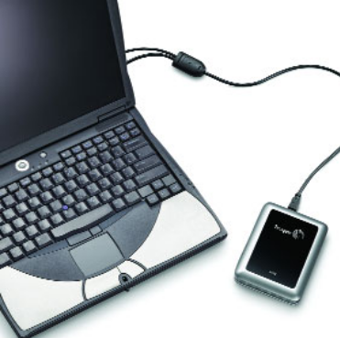
Figure 2.1: Seagate 100GB External Hard Drive

This product is a standard Seagate 100 GB hard drive [1]. In terms of size, our device ended up being roughly equivalent to this Seagate drive (Ours: 14cm. x 9cm. x 2.5cm. vs. 1”x3.7”x5”). It is similar in that it is a storage device and uses USB. The packaging for the Seagate has a silvery appearance with a blacktop with its logo on the top. It is rectangular with smooth, curving edges to prevent injury. The drive has stylized openings on the sides to allow venting of heat. There is a connection to USB going out the side. The positive aspects of its design are its easily holdable size and its silvery appearance. Negatively, the packaging is too deep. In comparison, our device has a nice rubber jacket with slots in the back to hook onto a belt and nice, black plastic casing with a Lexan cover for solid durability. In addition, our device was built with ergonomics in mind and also has an easily removable panel that allowed for the addition of our pushbutton and USB header. The venting of the Seagate made us consider whether we might need a heat sink; this proved unnecessary as none of our parts heats up appreciably. We also couldn’t use aluminum like the Seagate because it would greatly inhibit our RF signal. Using the Lexan cover, our device is transparent so the innards are visible.

7.2.2 Product #2

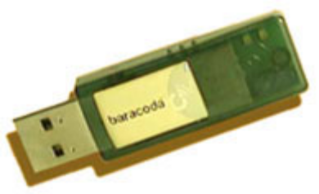
Figure 2.2: USB Bluetooth Dongle

Our initial image of the packaging, before we found that something of this size was not feasible for us, was very similar to this USB Bluetooth dongle [2]. This device has a green, transparent package with dimensions of 2.23” L x .65” W x 0.27” H. There is also an opening for the USB header. Having a material like this that we could easily cut into was essential to allow room to access USB and provide room for the pushbutton. The packaging is good for its small size although we couldn’t create something of this size (especially since we also have Bluetooth functionality). Its transparency gives it a cool look and its plastic-like package looks to be durable enough to withstand constant transportation. In terms of negatives, the data sheet doesn’t specify whether it comes with a cap to protect the header. The edges look a bit sharper than we would like. It is not a matter of injury, just aesthetics. The main ideas we took from this packaging were its see-through appearance and use of a durable plastic. In difference, since we used a pre-made package, it isn’t designed to fit perfectly to the specs of our device (although it fits remarkably well).

7.2.3 Product #3
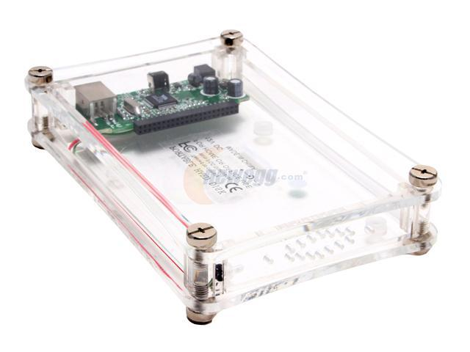
Figure 2.3: Koutech External Enclosure

This Koutech IO-EEU223 [3] has the transparent look that we were originally going for. Its dimensions of 6"L x 4"W x 1 1/4"H are too small in height (our battery will be placed under the PCB) and too large in length and width but are close. We also didn’t want the screws on the corners so we opted to glue the board to the package. The transparency is important because we simply want to show off our design. Positively, the enclosure is only 8 oz. which wouldn’t be too bad for a handheld. The top and bottom plastic plates also look to be thick enough to withstand cracking (screws should also provide relief to plastic from coming directly into contact with the floor when dropped). Being made of plastic is necessary as it will allow the passage of our Bluetooth RF signal. Negatively, the narrow height (which might be the outer dimensions rather than the inner) won’t be close to what we need. A lot of this is caused by the fact that our Bluetooth module is thick (7.6 mm) and rises above the board connected to a 40-pin hirose connector. We ultimately went with a Lexan cover to provide a view of the board like this device but enclosed the rest in black plastic.

7.3 Project Packaging Specifications
In terms of weight, the two most significant components are the Bluetooth Module (8 grams) and the Li-ion battery (41 grams). Our packaging weight of 7 oz., similar to the Koutech hard drive enclosure which is 8 oz., shouldn’t add too much to the weight. Our ideal dimensions of 4” x 3” x 2.5” will take it a bit outside of the “handheld” or “pocket” device category. We will need an opening on one of the sides to attach either a USB header or, more likely, an extension coming out that can be unwound and plugged in with the device on the table (too heavy to plug directly in).

7.4 PCB Footprint Layout

The list of parts package types are as follows:

BISMII – Connects to board by 40 way Hirose connector.
EZ-Host – TQFP package
DC-DC converter – SOIC package
Li-ion charger – SOIC package
Flash controller – QFN package

Estimated Dimensions / Area: 55 mm. x 100 mm. => 5500 mm²

The relative positions of the components on the board were carefully chosen based on the following considerations. The Bluetooth module is placed as far from the microcontroller as possible to reduce any possible RF interference that it could cause. The microcontroller and the flash memory controller are situated closely together to minimize the length of the USB traces which are notoriously sensitive. By the same token, the USB header is placed by the microcontroller because it will be hooked up to one of its USB ports.

7.5 Summary
In this report we took a look at products with similar functions to see what kind of packaging they used and what ideas we could take from theirs and use in ours. We examined a 100 GB hard drive [1] and a small USB Bluetooth dongle [2] that swept the range of the functionality and size of our device. The hard drive has similar dimensions to our product but the casing is of a different material and appearance than what we were looking for. The flash drive has transparency but we ultimately went with the black plastic casing with the transparent Lexan face which should also be more resistant to wear and tear. The plastic enclosure [3] was still influential and has traits like RF friendliness but was not deep enough due to our protruding Bluetooth module.
.

- Schematic Design Considerations

  - Introduction
The Robert Johnson Project is a portable, wireless, battery powered device, which creates many circuit design issues. Because a battery’s voltage will degrade over time, a special circuit for power needed to be considered. Also, because of this same constraint, there needed to be a focus on power consumption in our circuit design. The microcontroller needed to be USB compatible in order to facilitate transfer to and from a host computer and the built in flash drive. The Bluetooth module and the flash controller also had their own associated issues to be overcome that included antenna interference for Bluetooth and USB connectivity for the flash controller.

  - Theory of Operation
There are four major subsections of the design: the power supply, microcontroller, Bluetooth module, and flash memory and its associated controller.

8.2.1 Power Supply Subsection
The power supply section gets its input voltage from an onboard battery. The battery can be charged by passing the 5V USB output voltage through a lithium ion battery charging IC (MAX 1811) in order to provide the correct voltage and current for proper battery charging conditions [30]. The output of this IC will be put into the plus terminal of the battery and will also run into the battery input of one step up/step down DC to DC converter (MAX 710) and one step up DC to DC converter (MAX 1796). The step up/ step down converter for the 3.3V rail is necessary because of the nature of a battery to lose voltage as it drains. The nominal output of the lithium ion battery is 3.7V, but after some time, it will be reduce to under 3.3V. The 5V rail only needs to have the step up ability because even when the battery is charging, it will only achieve 4.2V as its peak output charging voltage. Both of the converters are designated as 3.3V or 5V based on a feedback pin connecting to ground or the output of the chip [36] [32], respectively. Because the battery could be permanently damaged if it drops below 2.3V [33], there is low battery protection on both of the converters that will be utilized to help notify the user of a low battery and to completely shut off the device when the voltage gets too close to the damage point. The MAX 710 has a low battery indication line that will go high when the voltage on the LBI+ pin goes below that of the LBI- pin [36]. The LBI- pin is connected to the steady voltage of the 5V rail through a voltage divider. The low battery output line runs to the microcontroller for use in internal code that will strobe the low battery LED to conserve power, as opposed to merely turning on an LED and having a constant power drain. The MAX 1796 has its shutdown pin connected to its low battery output (LBO) pin and is then connected to the battery output via a 1M resistor. The LBO pin is an open drain pin when it is not active, so it will drive this net low. When the low battery protection is initiated through another voltage divider circuit from the battery voltage, the LBO pin will go into high impedance and drive the net high, thus initiating the shutdown mode of the MAX 1796 [32]. This will, in turn, shut down the 5V rail, which is also connected to the active low shutdown pin of the MAX 710. So, once the MAX 1796 goes into shutdown due to a low battery, the 5V rail goes low, sending the MAX 710 into shutdown and thus also shuts down the 3.3V rail, completely turning off the device. The 3.3V rail will provide power to the microcontroller and flash memory/controller subsections. The 5V rail will provide power to the Bluetooth module subsection.

When the USB is plugged in, there will be a 5V source on the MAX 1811 input pin. There is another pin on the MAX 1811 that will go low whenever it senses that the output voltage is under 4.2V, the voltage for a fully charged battery [30]. If this pin goes low, there becomes a voltage differential across an LED that will indicate if the device is charging. Also, the 5V from the USB is routed into the gate of an N-channel MOSFET [34] whose source is connected to ground and drain is connected to an input pin of the microcontroller, a resistor, and the 3.3V rail, in that order. This will allow for a level translation down to the microcontroller’s operating voltage of 3.3V [35] as an indicator of when the USB is plugged in. This is necessary for the microcontroller to know to allow for it to initiate handshaking with the host computer if the computer does not immediately do so. A charging voltage of 4.2V is given by the datasheet of the battery and is controlled through a pin on the MAX 1811.

The last portion of the power subsection is the on/off control circuit. This is made up of a transistor network leading to two low on resistance P-channel MOSFETs. One of these PFETs is for the 5V rail and the other is for the 3.3V rail and the gates of which are tired to the same node, henceforth referred to as node X. The sources of the PFETs are connected to the power supply output directly (3.3VS and 5VS) and the drains of the PFETs are connected to the voltage rails for all of the downstream components (3.3VR and 5VR). This allows for isolation between the supply side that will constantly be powered and the rail side that can now be controlled. The low on resistance (.05 ohms) [37] of the PFETs is necessary because of the high current (up to 400mA) running through them and the necessity for there to be as small a voltage drop across them as possible. Node X is connected to a transistor network that has the following components in it from 5VS to ground: a PMOS whose gate is connected to a microcontroller GPIO pin, a large resistor, node X, and two NMOS transistors in parallel whose gate inputs are the same microcontroller GPIO pin as the afore mentioned PMOS and a pushbutton that is tied to 3.3V on one side and a resistor to ground on the other side. The pushbutton’s resistor to ground side is connected to the NMOS and also the microcontroller between the resistance and the pushbutton, creating an active high configuration. An NMOS or a PMOS transistor can be seen as a switch with the switch being on when ~Vdd or 0V is applied, respectively, or off when 0V or ~Vdd is applied, respectively. Vdd is used here as a simplification of the actual specifications of the device and to avoid a discussion of threshold voltages. Vdd will be considered any voltage at or above 3.3V for this discussion. Please refer to Figure 8.1 for a visual representation of the circuit that has been described. Starting the discussion when the device is off, it is presumed that the voltage from the microcontroller will be 0V because the device is turned off. When the pushbutton is pressed, one of the two NMOS transistors will pull node X low, thus turning on the two low resistance PMOS transistors and applying power to both the 3.3V rail and the 5V rail. The microcontroller has a counter in its startup code that will wait for two seconds to pass and if this time has elapsed and the pushbutton has been applied this whole time, the microcontroller will turn its port pin high that is connected to the PMOS and NMOS transistors. This way, there will be no conducting path from the 5V supply to ground and node X will be constantly grounded even if the pushbutton is no longer depressed, allowing the board to stay on. If the pushbutton does not hold for the full 2 seconds, the microcontroller will never send the control signal, and thus the device will turn back off. This is good if the button is accidently pressed while in a pocket or if its bumps against something. Once the board is on and the microcontroller sends its control signal, the power supply will continue to operate independent of the button pressed. This way, the microcontroller can still accept commands from the pushbutton while not interfering with power. However, if the user wants to turn the device off, there is a counter in the microcontroller that will check to see if any button press lasts another two seconds, if it does not, the microcontroller will accept the input and handle the instruction, but if the user does hold it for two seconds while the board is on, the microcontroller will output 0V on the control signal and turn on the PMOS and turn off the NMOS. The microcontroller also kills any processes it is working on so that when the user stops pressing the button, the other NMOS turns off and node X is pulled high, which turns the both of the PMOS transistors off and turns off both of the power supply rails.

The 5V rail will draw up to 250mA during a device search and the 3.3V rail will draw up around 200mA when all of the LEDs are on from experimental observation. With a battery life of approximately 740mAh [31], this device can run at full capacity for around 2 hours.

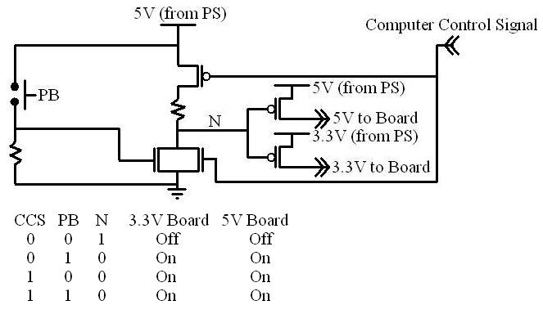
Figure 8-1: Visual Representation of On/Off Circuitry

*NOTES: Computer means microcontroller, N is referred to as node X in the above discussion, the node underneath of the PB shown above is also connected to the microcontroller, PS means power supply, and the voltage on the top of the PB is actually 3.3V and is not connected to the 5V supply in order to avoid damaging a port pin on the microcontroller.

8.2.2 Bluetooth Subsection
The Bluetooth subsection will facilitate the wireless transfer of data between the device and a host device and is entirely made up of the EZURiO Bluetooth module with onboard RF antenna. This subsection will have two operating modes the purposes of which are to transfer data and to wait for a pairing request. The first mode discussed will be the connected mode. In this mode data can be transferred from the device to the host and vice versa. This mode will interface with the microcontroller bi-directionally using the UART serial interface for both commands and data. The commands will be used to set the Bluetooth mode and the data will be taken from the microcontroller or put into the microcontroller for transfer to the SRAM or to the external host, respectively. The second mode allows the device to wait for a new computer to try to pair to it. This mode will use more power than the connected mode and will interface with the microcontroller subsection for control of the mode through the UART serial interface. There is no user/designer configurable operating frequency and the module has a voltage input requirement of needing to be greater than 3.6V [34] and we will be providing 5V. 5V was chosen because the SRAM also operates at 5V [41] and it was necessary to try to minimize the number of voltage supply rails that were on the board. This Bluetooth module is on its own PCB and is mounted on the Robert Johnson Project via a 40-pin Hirose connector. There is also a status LED on the Bluetooth module that will indicate if it is actively connected to a host computer.

8.2.3 Microcontroller Subsection
The microcontroller subsection is made up of the microcontroller, EEPROM, and SRAM and controls the Bluetooth module’s operating mode and interfaces with the flash controller as an intermediary between both the Bluetooth module’s serial input/output and the host computer and the flash controller’s USB output/input. The operating frequency will have to be fast enough to packetize and format the data for transfer over USB from the serial connection and vice versa while buffering the data for manipulation and calculations, but because the USB functionality is not currently utilized, the internal clocking has been stepped down to 3MHz. The microcontroller will also take in commands from the host device via the Bluetooth module and will need to decode these and poll either the flash controller or the Bluetooth module for each subsections respective status. The commands will have a header section telling what type of command it is (status, data transfer, or connection request) followed by a data field. We will dictate the format of these packets and will decode and encode appropriately both on the microcontroller and the host device. As operating frequency increases, however, power consumption increases and ultimately decreases battery life, and if the USB function is ever utilized, 48 MHz will need to be chosen due to written requirements to handle USB data transfer [35]. The microcontroller will handle any switch debouncing that needs to be done using the timer module. The microcontroller will provide a volatile data storage method until such time as the flash controller can be implemented and will use the bus expansion capabilities to immediately address the SRAM for storage of the various files transferred to it via Bluetooth. The timer will also be used to blink the status LEDs at different rates depending on the operating mode of the Bluetooth module. Once the flash controller and memory is implemented, the USB serial interface engines that are on chip will be used to act as a pass through for USB data and handshaking from the host computer to the flash controller.

8.2.4 Flash Controller and Memory Subsection
The flash controller and memory are not currently implemented and currently have no bearing on how the device operates. However, once this functionality is achieved, the following discussion will pertain to the device. The flash memory and associated controller subsection will take care of all of the data retention and will actually put the data onto the flash memory. This subsection will interface with the host indirectly over USB and will also interface with the microcontroller over the same USB bus. The flash memory controller will take the USB packets and data from both the host device and the microcontroller and either store the data into the flash memory or take them from the flash memory by sending a command and address on a bus and then waiting for the data on the same bus [38]. This helps to save pins between the flash controller and memory. The flash memory controller provides a level of abstraction for the microcontroller so that it will not have to handle the load of figuring out how to deal with the instructions and polling the flash memory, error correction codes, and wear leveling [39]. There will be only one mode of operation for this and it will be active for transfer over both USB and Bluetooth. The flash memory itself is a fairly standard product. So much so that an end user can generally swap out one NAND flash memory chip for another even if it has a different storage capacity [40]. It will take the address and command from the flash controller and then either accept data or output the requested data. The flash controller is its own separate chip and has several data/address pins to facilitate transfer to and from the memory. The flash controller is not programmable by the user in any way as is implemented on the Robert Johnson Project. The functionality of the device is as hardcoded during manufacture and will not be changed.

  - Hardware Design Narrative
When choosing the microcontroller, the most pertinent parts were a timing module, direct USB IO lines, built in UART, and having extra GPIO pins. The timing subsystem will be used to distinguish between user button presses of different lengths to be interpreted as different commands. For example, a button press of 2 seconds when it is currently off would turn it on. A short button press while the device is on could initiate a connection with a paired device while a 2 second hold will turn it off. The direct USB IO lines will eventually facilitate a direct transfer of data to the flash controller without the need of a level translator or CMOS to differential USB converter. This is more for ease of implementation and integration of the subsections. This will allow for writing of the code to send the correctly formatted commands directly to the flash controller. The UART will allow the microcontroller to communicate with the Bluetooth module that will take both data and commands through this. There will also be several GPIO pins for use in interfacing with status LEDs for user insight, interfacing with pushbuttons, checking the 5V USB power line for connectivity, and turning the board on and off. The data and address pins of the microcontroller will be connected to an external SRAM chip. Most of these ports have device defined pins so these are not user configurable. However, when deciding what GPIO pins to use, the least densely used area of the chip was used. All other major subsections have one choice when it comes to connectivity to other subsections and are be used in this manner.
  - Summary
The Bluetooth mass storage device that has been outlined in this report will have four major subsections that will work together to facilitate transfer of data over a Bluetooth wireless link. The four major subsections are a Bluetooth module, a Cypress microcontroller, a flash controller with associated flash memory, and a power supply section that will provide the correct voltage rails for all of the subsections among other functions. The Bluetooth module will act as a medium for transfer of commands and data from the microcontroller. The microcontroller will decode these commands and facilitate transfer of data to and from the SRAM, which will, in turn, store or retrieve data. Through this device, the ease and convenience of a wireless world will come to the realm of small scale, portable, personal data storage.

- PCB Layout Design Considerations

  - PCB Layout Design Introduction
EMI reduction, signal routing, component placement, physical size of our PCB and mechanical durability are all considerations for our printed circuit board layout design. By isolating the major components of the board into the USB, the specific Bluetooth module, and the power supply shows one can see they all have special considerations as well.

  - PCB Layout Design Considerations – Overall
There were several special considerations that had to be taken into account when designing the PCB. The differential pair used for the USB protocol is very sensitive to EMI and requires numerous design requirements. Also, the oscillators for the microcontroller and flash controller are sensitive to other high speed switching circuits. The Bluetooth module is going to be mounted above the board, so some mechanical requirements have to be considered. Also, the antenna on the Bluetooth module requires special consideration when in proximity to other components and metal. The power supply’s DC to DC converters requires attention as well to minimize ground bounce and noise. The dimensions of the PCB are also important in order to maintain our device’s portable nature.

There are several general constraints on the layout given by our manufacturer 4PCB.com [42]. The constraints that are of major concern to the design of the PCB are having no acute angles when routing traces and trace width. Acute angles in the traces results increases the amount of radiation released into the surrounding circuit [43]. From the Module 9 PCB Fabrication and Layout Basics Lecture [44], it is suggested that the minimum trace width be 12 mil, and with consideration of power traces to be much larger: 40 to 60 mil with a goal of 100 mil if possible. A trace-width calculator can be used to determine if these values are within specifications of our design [45]. As the component draws more current the trace width also needs to increase, but since the device will only be capable of pulling 500 mA, 40 mil is generous for the design. The power connection’s trace width will be maximized given the size of available space to optimize the power supply circuitry.

Component placement is also very critical in the design of the PCB layout. The most pressing issue is physically routing all of the components together, while minimizing vias and eradicating any crossing of lines on the same layer, as that would cause shorts in the design. Since the data transfer rate of USB is 12 Mbit/s, there are several design requirements to maintain the integrity of the data that is being transferred on the differential pair. As a consequence of the differential pair needed a ground plane beneath it, there can be no signals that cross this section of the board with the limitations of 2 layers in the board. The microcontroller and flash controller need to be physically close to the USB header because of the length and parallel requirements imposed by the differential pair, D+ and D- [46]. The USB developer’s guidelines also state that the traces for the differential pair should be parallel to one another, within 2mm of each other in length, spaced at least 10mm from other traces, and also have a ground plane under the differential pair. In result to the parallelism and ground plane the design has to have no traces crossing the differential pair on either side of the board. Therefore, the USB header and components that use the signal are placed close together in the bottom corner of the board. The flash memory needs to be close to the flash controller since all of the data lines entering the flash memory come from the flash controller. This is going to be accomplished by placing the flash memory on the bottom layer and using vias to run the signal traces between the two components.

Another component placement issue is the Bluetooth module. The module is physically mounted above the PCB on its own PCB. The antenna needs a 2 mm proximity clearance from other major components and metals it to ensure signal quality [45]. Also, to add some mechanical security to the device, mounting pillars have to be added. To ease the problem of having the drill hole for the mounting pillars close to other components, the space underneath the board was kept mostly non-populated except for a few resistors and bypass capacitors. The components on the Bluetooth Module have a grounded RF shield around them to reduce EMI. The circuitry on the PCB that is being designed will not be affected by the Bluetooth antenna due to both the output power being turned down to reduce the range of the module and all of the PCB design requirements being implemented.

  - PCB Layout Design Considerations – Microcontroller
There are several PCB layout considerations specific to the microcontroller. These include the oscillator circuit layout, bypass capacitor location and power trace routing. The oscillator circuits are low power in nature so they are very sensitive to high-speed switching circuits. To prevent some the noise that could be induced into the oscillator circuit, it should be placed as close as possible to the microcontroller and have no traces entering the boundaries of the circuit except for the ground line and the power line. The datasheet also recommends using a ground ring to isolate the oscillator circuit if the design requires it to be placed next to a high speed signal [46]. The design for the Bluetooth mass storage device will use this ground ring as added EMI protections because of the desired density of our PCB. Having more components in closer proximity of the oscillator circuit results in more noise and the PCB design must take this into account. The oscillator circuit also needs filter capacitors that are specified by the crystal. The load capacitance of the crystal determines the filter capacitor values.

Bypass capacitors are also needed by the microcontroller. The datasheet states that the decoupling capacitor should be 0.1 uF and be placed as physically close to the microcontroller as possible [46]. The decoupling capacitor will be placed underneath the PIC to minimize the length of the traces.

The routing of power and ground to the micro is also important. The microcontroller draws a maximum of 250 mA and sinks a maximum of 300 mA. A 40 mil wide trace has the minimum width recommended from the lecture notes, while our calculations show that a much smaller trace width is possible. Traces of at least 40 mil will be used and will be made larger if space allows the trace width will be larger.

  - PCB Layout Design Considerations - Power Supply
The power supply has several PCB layout considerations. These include critical trace routing, bypass and bulk capacitor location, ground planes, and the power supply trace routing. Creating loops with the power supply traces will induce a severe amount of noise and should be eliminated if possible. There are abundant amounts of switching occurring in the power supply circuitry from the two DC to DC converters and the lithium ion battery charger, so this circuitry is going to be kept separate from the critical digital signals of the design.

The critical signal trace routing to and from the power supply circuitry is going to be minimal. Besides the 4.2 V and 3.3 V power rails, only the voltage rail from the USB bus to charge the battery and a low voltage indicator will be entering the circuitry. The positive 5 V rail from the USB header will be operating at 500 mA, so trace width is not critical if the design uses the recommended minimum trace width of 40 mil. This trace will be run along the edge of the PCB since the power circuitry will located at the opposite end of the PCB. Again, this is to keep the power circuitry away from the crucial USB differential pair.

Power trace routing is more critical. A branch method needs to be used to avoid loops in the circuit that are highly susceptible to EMI. The 4.2 V power rail needs to go to the microcontroller and the Bluetooth module. The 3.3 V power rail needs to go to the flash circuitry. Ground lines are run in parallel to these voltage rails so power system noise can be decoupled with decoupling capacitors [47]. The decoupling and filtering capacitors for the flash controller are going to be needed due to its 6 digital Vcc and 2 analog Vcc inputs [7]. The datasheet does not specify certain values for these decoupling or filter capacitors. Decoupling capacitors will be placed on the digital Vcc inputs, while filtering capacitors will be placed on the analog Vcc inputs. Pads are going be place on the bottom of the PCB in close distance to the flash controller, so we can easily debug the values of the capacitors if are initial estimate is wrong.

Recommended bypass and bulk capacitors for the power supply are from the DC to DC converter and lithium ion battery charger datasheets. The DC to DC converter (MAX1796) recommends a 47 uF bulk capacitor and .1 uF decoupling capacitor [44]. The MAX710 high frequency operation makes the layout important for minimizing ground bounce and noise. The datasheet recommends keeping the IC’s ground pin and the ground leads the bypass capacitors less than 5mm apart. Also the connections to the FB and LX pins need to be kept as short as possible. To maximize output power and efficiency while minimizing output ripple voltage, a ground plane will be used and the IC’s GND pin will be directly soldered to the ground plane [49]. The lithium ion battery charger specifies a 4.7 uF decoupling capacitor for the input voltage and a 2.2 uF decoupling capacitor for the voltage going to the battery [42]. Also, the physical size of the battery had to be taken in consideration since we are mounting the battery onto the board. A space of 31 mm by 52 mm is going to be kept clear of major components for this physical space [43]. Ground planes are going to be run parallel to power rails and placed underneath the MAX1796, MAX710 and the MAX 1811 to minimize ground bounce from the power supply circuitry.

  - PCB Layout Design Summary
Designing the PCB layout for reduction in EMI and the special needs of the specific components will result in a better design for the device. Thinking about all of the considerations should lead to fewer challenges as the design begins its prototype phase. The trace routing depends on the major components, and the USB differential pair has very specific recommendations for the data transfer in order for it to behave ideally. Trace widths and angles are also very important to a successful design. Decoupling and bulk capacitors for the power components will result in fewer issues related to EMI. These considerations are being directly implemented to our PCB design and should result in a successful design.

- Software Design Considerations

  - Introduction
The “Robert Johnson Bluetooth Mass Storage” design project uses software to communicate with a PC through either a Bluetooth RF connection or a USB wired connection to provide file transfer and storage capabilities on external flash memory. The project consists of two main software implementations: the PC software written in python and CYPRESS EZ-HOST microcontroller software written in C. In order to facilitate our embedded development, Cypress has provided third-party software under an NDA that provides us higher level access to USB communication as well as access to FAT formatted memory. The Bluetooth driver that comes with the Bluetooth dongle assigns the Bluetooth RF module to a serial COM port. The PC software uses this port to communicate with the Bluetooth Mass Storage Device. The PC software is OS independent and it uses Tkinter [54] and Pyserial [55] libraries. Once the pairing is established, the Bluetooth Mass Storage Device responds to requests made by the PC over its assigned COM port via Bluetooth RF.

The commands and data are sent serially over a serial COM port (specifically 42 currently), and the data is transmitted over a Bluetooth RF signal. The Bluetooth module on the Bluetooth Mass Storage Device receives this signal and sends it to the microcontroller via the UART interface. The microcontroller evaluates each command and makes the necessary action. The user can browse the file system, delete files, and establish file transfer between a local PC and a remote Bluetooth Mass Storage Device.

  - Software Design Considerations
The Bluetooth Mass Storage Device communicates with a PC through either USB or Bluetooth RF signal. The PC software enables the user to view and change the Bluetooth Mass Storage Device file system. In terms of implementation, there are two main applications: “The PC software” and “EZ-HOST Microcontroller Software”. Both of these implementations will be explained in the following sections. The PC is referred to as “Local System” and the Bluetooth Mass Storage Device is referred to as “Remote System”.

10.2.1 PC Software massblue_v_2_3.py
The PC is an external interface being used to access the Bluetooth Mass Storage Device via Bluetooth RF signal. The software is written in Python which uses Tkinter [54] and Pyserial [55] libraries. This code was executed in both UBUNTU (Linux) and Windows using the Python interpreter. Before the program is executed, we used Bluetooth software that is available in the Windows XP operating system or other software that comes with the Bluetooth dongle. Once the Bluetooth hardware is installed into the system, this software establishes pairing with the remote system. The Bluetooth Mass Storage Device may have a passkey up to 16 digits. The user must provide this passkey in order to communicate with the device. If the pairing is successful, this software assigns a serial COM port to the Bluetooth module. In our testing we used serial PORT COM 42 for communication. Since it is open source, this part may be changed by the user.
When the program is executed, the user is able to browse the “Remote System Directory”, delete files, and transfer files between the PC and the Bluetooth Mass Storage Device. The flowchart is given in Appendix A1. It should be noted that the first block on top of the diagram describes Bluetooth Software that is available in the Windows OS. As mentioned earlier, it assigns a serial COM port to the Bluetooth communication protocol.

10.2.2 Cypress Ez-Host Software uart.c app.c
The Cypress CY7C6700 EZ-Host Programmable Embedded USB Host/Peripheral Controller communicates with the PC software through the Bluetooth module via asynchronous UART pins, and converts this signal into the FAT file system. This signal is passed onto the Flash Controller through the microcontroller’s USB pins. The microcontroller contains 8K x 16 internal SRAM and 8 K on-chip EEPROM. However the EEPROM is reserved for BIOS; therefore, 128K SRAM and 32K EEPROM external memory have been used. The program code will be stored into 32K EEPROM, and 128K SRAM will be used as a buffer if needed. A large 128K SRAM was chosen to hold large USB chunks in memory because of the data rate difference between the Bluetooth module and the Flash Controller; 3Mbits/sec and 12Mbits/sec respectively.

The Bluetooth module is connected to the microcontroller via asynchronous UART pins. The microcontroller sends AT commands to program the Bluetooth module to change its settings, and the data transfer will be done on the same UART pins as well after handshaking is established. In terms of the peripherals, an interrupt-driven timer module is used. In order to use the TIMER module, the interrupt enable register will be used. Depending on the time that the push button is pressed different functionalities will be implemented. For example, if the button is pressed for a long time, then the device will turn off. In USB mode, the microcontroller becomes a transparent layer between the USB header and the Flash Controller. The microcontroller’s OTG (USB On-the-go) pins are connected to the USB pins of the Flash controller. The microcontroller will be polling this line, and if activity is detected, necessary changes will be made. This block diagram is given in Appendix B “Hierarchical Block Diagram of Code Organization”
The microcontroller’s internal mapping [56] is given in Figure 2.2.1.
Figure 2.2.1 Memory Map (Internal Memory)
0x0000 – 0x00FF | HW INT’s
0x0000 – 0x00FF | SW INT’s
0x0100 - 0x011F | Primary Registers
0x0120 - 0x013F | Swap Registers
0x0140 - 0x0148 | HPI Int / Mailbox
0x014A - 0x01FF | LCP Variables
0x0200 - 0x02FF | USB Registers
0x0300 - 0x030F | Slave Setup Packet
0x0310 - 0x03FF | BIOS stack
0x0400 - 0x04A2 | USB Slave & OTG
0x04A4 - 0x3FFF | USER SPACE  ~15K
0xC000 - 0xC0FF | Control Registers
0xE000 - 0xFFFF | BIOS

In terms of initial debugging we used the Bluetooth Dev Kit. Initially the PIC microcontroller was used, and some testing had been done before the design change. This test and debugging includes blinking of an LED for timer the module, and communicating with the Bluetooth module via UART pins in order to change its settings.

  - Software Design Narrative
The Cypress microcontroller software provides a high level API to carry out common USB tasks and makes access of a FAT file system transparent. In order to user their software a nondisclosure agreement had to be agreed upon. The company also provided some GNU tools that have been ported over to our microcontroller’s architecture. The second implementation includes PC software written in Python along with Tkinter [54] (GUI), and Pyserial [55] libraries.

    - PC Software massblue_v_2_3.py
The PC software is written in Python, and uses mainly Tkinter [54] GUI and Pyserial [55] API. The block diagram of the software is given in Appendix A2. Once the program is called on the command prompt, it opens the serial COM port 42 which needs to be assigned by Bluetooth Software once the pairing is initialized. This needs to happen before our PC software is executed. The PC software then uses serial COM port 42 to communicate with the Bluetooth Mass Storage Device. The software provides “Local System Directory” and “Remote System Directory” listings. The “Local System Directory” displays the file system on the PC and the “Remote System Directory” displays the file system on the Bluetooth Mass Storage Device. The PC software communicates with the Bluetooth Mass Storage Device using the following commands. These commands are written on the serial COM port 42.

The main function calls the function file_transfer() which creates a GUI window. In this window there are two main window objects. “Local File System” listbox, “Remote File System” listbox, transfer buttons, and a delete button. They are executed in object oriented programming fashion. Their event handler functions call several different functions. These functions write commands and data to the assigned serial port. “A.1 PC - Software Flowchart” explains this procedure in detail. If the user wants to transfer a file from the “Local File System” to the “Remote File System”, first the program sends “put <filename>” command, and then it opens the file and sends the file contents over the serial port. Next, it sends “dir” command and starts reading the serial port. The Bluetooth Mass Storage Device sends the directory information to the Local PC, and it updates the Remote File System listbox. If the user wants to delete a file in the “Remote File System”, the program writes “delete <filename>” command on the serial COM port. The Bluetooth Mass Storage device deletes the file, and when PC sends the “dir” command, new directory listing is sent over and the PC updates its “Remote File System” listbox.

    - Cypress Ez-Host Software uart.c app.c
The block diagram of this implementation is given in Appendix B “Hierarchical Block Diagram of Code Organization”. The Software code polls the USB pins, and if some activity is detected, it checks if the Bluetooth mode is active as well. Since it gives higher priority to the USB protocol, it tries to terminate the Bluetooth communication smoothly. If Bluetooth communication is in the idle state, it disconnects the communication, so that the PC side will not initiate another file transfer. If the USB connection is idle, then the microcontroller sends the passkey to the Bluetooth module and makes the device visible to other devices. This is done via UART pins, and the microcontroller sends AT commands to the Bluetooth Module in order to change its status. Once the Bluetooth communication is established, it again checks for USB connection. In the Bluetooth mode, it converts the data on UART pins into the USB protocol and sends it to the Flash Controller.

The Bluetooth module receives the Bluetooth RF signal and sends it over to the microcontroller over UART. The microcontroller polls these UART lines, and changes the file system according to the commands it receives over UART. The commands include “dir”, “delete”, “put”, and “get”. “Dir” command sends the directory listing, “delete” deletes the given file, “put” saves the file into the memory, “get” reads the file in memory and sends it back to the PC via UART. This is also explained in “Appendix A.2 Ez-Host Software” Flowchart.

The above mentioned pass through method to create a transparent link between the peripheral USB port connected to the PC and the host USB port connected to the flash controller was not successful.

Flowchart/Pseudo-code for Main Program

Figure 10.1 PC - Software Flowchart
Bluetooth Software assigns Serial COM Port (42) for Bluetooth communication
Enter Passkey

Start

Assign serial COM port 42 for communication

Display Local and Remote file system

File System
File Transfer

Delete
Receive File
Send File
Dir

Serial port write
“get <filename>”
Serial port write
“put <filename>”
Serial port write
“delete <filename>”

Serial port read
Serial port write
<file contents>

Serial port write
“dir”
Save File

Update Local File System Listing

Serial port read

Update Remote File System Listing

Note: Dashed box is not part of the PC software implementation. This is done via Bluetooth driver software.

Figure 10.2 Ez-Host Software Flowchart

Bluetooth Mode
Poll UART
Start
Delete
Read File
Write file
Receive File
Send File
Dir
File System commands
File Transfer command
Read file
Send file
Delete file

Detect command and data;
Read Dir
Send Dir

Figure 10.3: Hierarchical Block Diagram of Code Organization

START
USB Signal
Detected
YES
Is Bluetooth
Active
YES
Wait
NO
Disable
Bluetooth
USB Connection
NO
Enable
Bluetooth
Bluetooth Connection
GO TO START

  - Summary
The Bluetooth Mass Storage Device communicates with the PC software and serves the requests made by the PC software user. Using this software one may connect to the design project and do file transfer. The USB connection provides much faster connection and is also used to recharge the battery. In order to demonstrate this design project, the PC software is also being implemented, using Python along with Tkinter [54] GUI, and Pyserial [55] libraries that use serial port communication. The microcontroller in this design orchestrates each communication and allows smooth data transfer, giving higher priority to the USB. Parts of the software implementation have been done successfully, and the remaining part is mainly on file system.

- Version 2 Changes

Version 2 of the Bluetooth Mass Storage would be an attempt to add more user functionality and compatibility to the device while making the package smaller. The device did connect to a host device over USB, but it could not act as a mounted drive as we originally desired. Also, transferring data to the NAND flash could not be implemented. Instead the SRAM holds the files until the device is turned off. Given some more time this could be completed. Having the microcontroller control the entire functionality of the device including handling the entire file structure and Bluetooth protocol would also be a goal of a second iteration. Also having the device mount as a drive when connected over Bluetooth would be desired instead of creating our own user interface. The modular approach to a prototype design saved time in software design, but added unnecessary complexity to the hardware design and PCB layout.

The original goal for portability was to maintain similar size to a standard sized flash drive. This was not possible due to using a two layer board and the size of the components chosen. Upon a second iteration having the microcontroller handle the majority of the functionality would eliminate the majority of the space taken by major components including the flash controller and Bluetooth module. Also, using a 4 layer board the PCB design constraints for the USB connection could be closely followed and data transfer over a USB connection would likely be possible.

Summary and Conclusions

Throughout the course of this project, the team gained a wealth of knowledge while accomplishing many of our major goals. Even at the beginning, there was much to be learned about how to find the right parts that would work together without any problems. Reading datasheets and siphoning out the correct information while still maintaining a global view of the project and where the part would fit in was huge learning process and a constant challenge that we were able to accomplish with great success. This was followed immediately by another great accomplishment of being able to make up a schematic that actually fit all of the parts together and left no pins forgotten or unconnected. The team learned a great deal about the layout tool, which facilitated another accomplishment of physically laying out an entire PCB and having the end result of a fabricated board in hand. During this process, much was learned about the subtle nuances of the layout of different types of data traces, USB differential signaling, and clocking circuits that could have ultimately made or broken the entire project. The board population was yet another learning experience leading to a large accomplishment. New soldering techniques such as using solder paste and hot air pencils facilitated the population of three very component dense boards in a very short time span. New debugging skills and knowledge were learned as well as the fact that troubleshooting is an art that takes much practice and a wealth of knowledge about how to use several types of lab equipment in order to make the process feasible. The team accomplished the successful debugging of all three boards and also the successful demonstration of all five PSSCs. The last piece of knowledge learned by this team is the following: to try to condense all of the knowledge gained or all of the accomplished goals down into one paragraph would be an exercise in futility due to the sheer magnitude of growth that the team has gone through thanks to this class.

References

- Microchip, “PIC18F2455/2550/4455/4550 Data Sheet” [Online Document], Dec 2006, http://ww1.microchip.com/downloads/en/DeviceDoc/39632D.pdf
- Cypress, “EZ-HOST Programmable Embedded USB Host/Peripheral Controller”, [Online Document], Dec 2007, http://download.cypress.com.edgesuite.net/design_resources/datasheets/contents/cy7c67300_8.pdf

[3] Bluegiga, “WT12 Data Sheet”, [Online Document], Nov 2007
http://www.bluegiga.com/files/bluegiga/Pub%20files/WT12_Datasheet.pdf

[4] EZURiO, “BISM2 Data Sheet”, [Online Document],
http://www.ezurio.com/dl/open/?id=88
[5] EaglePicher, "PT-2150 Data Sheet", [Online Document], 2006,
http://www.epcompower.com/CPS/documents/specsheets/pt2150.pdf
[6] ULTRALIFE, "UBP103450 Data Sheet", [Online Document], Sep. 2006,
http://www.ulbi.com/documents/techsheets/UBI-1014_UBP103450.pdf

[7] Maxim, "USB-Powered Li+ Charger Data Sheet", [Online Document], Jun. 2003,
http://www.datasheetcatalog.com/datasheets_pdf/M/A/X/1/MAX1811.shtml

[8] Microchip, "MCP73831 Data Sheet", [Online Document], Oct. 2007,
http://ww1.microchip.com/downloads/en/DeviceDoc/21984c.pdf

[9] Maxim, "MAX1797 Data Sheet", [Online Document], Dec. 2000,
http://www.datasheetcatalog.com/datasheets_pdf/M/A/X/1/MAX1797.shtml
[10] Texas Instruments, "TPS62202 Data Sheet", [Online Document], May 2006,
http://focus.ti.com/lit/ds/symlink/tps62202.pdf
[11] ST, "NAND0*G-B Data Sheet", [Online Document], Oct. 2004,
http://www.st.com/stonline/products/literature/ds/12407/nand01gw3b2b.pdf
[12] Samsung, "K9F1208R0C Data Sheet", [Online Document], Jun. 2007,
http://www.samsung.com/global/business/semiconductor/productInfo.do? fmly_id=158&partnum=K9F1208R0C

[13] United States Patent: 6795327. Inventors: Deng, Guoshun, Cheng; Xiaohua, Xiang; Feng. Date Filed: September 30, 2002. Available: http://patft.uspto.gov/netacgi/nph-Parser?Sect2=PTO1&Sect2=HITOFF&p=1&u=%2Fnetahtml%2FPTO%2Fsearch-bool.html&r=1&f=G&l=50&d=PALL&RefSrch=yes&Query=PN%2F6795327 [Accessed March 25, 2008]

[14] United States Patent: 20070005837. Inventors: Chen, Martin Yu-Wen; Huang; Fu-Ying. Date Filed: January 4, 2007. Available: http://appft1.uspto.gov/netacgi/nph-Parser?Sect1=PTO2&Sect2=HITOFF&p=1&u=%2Fnetahtml%2FPTO%2Fsearch-bool.html&r=1&f=G&l=50&co1=AND&d=PG01&s1=%22Personal+portable+storage+device%22.TTL.&OS=TTL/"Personal+portable+storage+device"&RS=TTL/"Personal+portable+storage+device[Accessed April 22, 2008]

[15] United States Patent: 20030216954. Inventor: Buzzelli, David B. Date Filed: February 27, 2003. Available: http://appft1.uspto.gov/netacgi/nph- Parser?Sect1=PTO2&Sect2=HITOFF&p=1&u=%2Fnetahtml%2FPTO%2Fsearch-bool.html&r=3&f=G&l=50&co1=AND&d=PG01&s1=buzzelli&s2=information&OS=buzzelli+AND+information&RS=buzzelli+AND+information [Accessed March 25, 2007]

[16] Department of Defense, “Military Handbook: Reliability Prediction of Electronic Equipment”, MIL-HDBK-217F, Dec. 2, 1991. Available: http://cobweb.ecn.purdue.edu/~dsml/ece477/Homework/CommonRefs/Mil-Hdbk-217F.pdf

[17] D.G. Meyer, “Module 14: Designing for Reliability, Maintainability, and Safety”, Digital Systems Design Project, 2008. Available: http://cobweb.ecn.purdue.edu/~dsml/ece477/Notes/PDF/Mod14.pdf

[18] MAXIM Integrated Products, “USB-Powered Li+ Charger”, [Online Document], 2003, [Accessed April 2, 2008],
http://www.ortodoxism.ro/datasheets/maxim/MAX1811.pdf

[19] MAXIM Integrated Products, “Low Supply Current, Step-Up DC-DC Converters with True-Shutdown”, [Online Document], 2000, [Accessed April 2, 2008],
http://www.ortodoxism.ro/datasheets/maxim/MAX1795-MAX1797.pdf

[20] MAXIM Integrated Products, “3.3V/5V or Adjustable, Step-Up/Down DC-DC”, [Online Document], 1997, [Accessed April 2, 2008],
http://datasheets.maxim-ic.com/en/ds/MAX710-MAX711.pdf

[21] Cypress Semiconductor, “EZ-Host™ Programmable Embedded USB Host/Peripheral Controller with Automotive AEC Grade Support”, [Online Document], 2006, [Accessed April 2, 2008], http://download.cypress.com.edgesuite.net/design_resources/datasheets/contents/cy7c67300_8.pdf

[22] Wikipedia Org, “Lithium ion battery”, [Online Document], accessed on April 7, 2008,
http://en.wikipedia.org/wiki/Lithium_ion_battery#Safety

[23] Safe Travel, “Batteries”, [Online Document], accessed on April 7, 2008,
http://safetravel.dot.gov/index_batteries.html

[24] M Power UK, “Testing”, [Online Document], accessed April 7, 2008,
http://www.mpoweruk.com/testing.htm

[25] P2 Navy Library, [Online Document], Handbook, accessed April 7, 2008, http://p2library.nfesc.navy.mil/P2_Opportunity_Handbook/2_II_8.html

[26] “PCB Waste Disposal”, TCI Incorporated [Online Document], accessed on April 10, 2008, http://www.tci-pcb.com

[27] Seagate, “USB 2.0 Portable External Hard Drives Data Sheet”, [Online Document], 2006, http://www.seagate.com/content/pdf/datasheet/disc/ds_portable.pdf

[28] InPath Devices, “Bluetooth USB Dongle Data Sheet”, [Online Document],
http://www.inpathhosting.com/inpath_datasheets/BluetoothUSBdongle.pdf

[29] Koutech, “Koutech IO-EEU223 Plastic 2.5" USB 2.0 Durable See-Through Clear external HDD case”, [Online Document], http://www.x-tremegeek.com/templates/SearchDetailPrint.asp?productID=10254&core_cross=

[30] MAXIM Integrated Products, “USB-Powered Li+ Charger”, pp. 1, [Online Document], 2003, [Accessed February 15, 2008],
http://www.ortodoxism.ro/datasheets/maxim/MAX1811.pdf

[31] ULTRALIFE Batteries, “UBP053048/PCM Technical Datasheet”, pp.1, [Online Document], 2005, [Accessed February 15, 2008],
http://www.ulbi.com/documents/techsheets/UBI-5092_UBP053048.pdf

[32] MAXIM Integrated Products, “Low Supply Current, Step-Up DC-DC Converters with True-Shutdown”, pp. 10, [Online Document], 2000, [Accessed February 15, 2008],
http://www.ortodoxism.ro/datasheets/maxim/MAX1795-MAX1797.pdf

[33] ON Semiconductor, “MMBF170LT1”, pp 2, [Online Document], 2007, [Accessed February 15, 2008], http://www.onsemi.com/pub/Collateral/MMBF170LT1-D.PDF

[34] EZURiO, “BISM2 Bluetooth™ Version 2.0 Serial Module”, pp. 4, [Online Document], [Accessed February 15, 2008], http://www.ezurio.com/files/00547.pdf

[35] Cypress Semiconductor, “EZ-Host™ Programmable Embedded USB Host/PeripheralController with Automotive AEC Grade Support”, All pages, [Online Document], 20006, [Accessed April 27, 2008], http://download.cypress.com.edgesuite.net/design_resources/datasheets/contents/cy7c67300_8.pdf

[36] MAXIM Integrated Products, “3.3V/5V or Adjustable Step-Up/Down DC-DC Converters”, [Online Document], 1997, [Accessed April 25, 2008], http://datasheets.maxim-ic.com/en/ds/MAX710-MAX711.pdf

[37] Fairchild Semiconductor, “P-Channel Logic Level Enhancement Mode Field Effect Transistor”, [Online Document], 1997, [Accessed April 25, 2008], http://www.fairchildsemi.com/ds/ND/NDP6020P.pdf

[38] Cypress Semiconductor, “EZ-USB NX2LP™ USB 2.0 NAND Flash Controller”, pp. 4, [Online Document], 2005, [Accessed February 15, 2008],
http://download.cypress.com.edgesuite.net/design_resources/datasheets/contents/cy7c68024_8.pdf

[39] Cypress Semiconductor, “EZ-USB NX2LP™ USB 2.0 NAND Flash Controller”, pp. 1, [Online Document], 2005, [Accessed February 15, 2008],

[40] Micron Technology, Inc., “NAND 101: An Introduction to NAND Flash and how to Design it into your Next Product”, [Online Video], 2007, [Accessed February 15, 2008], http://extmedia.micron.com/webmedia/NAND101/NAND101.html

[41] Cypress Semiconductor, “128K x 8 Static RAM”, [Online Document], 2006, [Accessed April 25, 2008], http://cobweb.ecn.purdue.edu/~477grp2/nb/Files/sram_fast.pdf

[42] Advanced Circuits, “Tolerances and Design Requirements”, [Online Document], 2007, [Accessed February 16, 2008], http://www.4pcb.com/index.php?load=content&page_id=15

[43] Motorola, “AN1259,” [Online Document], 1995, [Accessed February 16, 2008], http://cobweb.ecn.purdue.edu/~dsml/ece477/Homework/CommonRefs/AN1259.pdf

[44] Meyer, David G. , “Module 9: PCB Fabrication and Layout Basics”, [Online Document], 2007, [Accessed February 16, 2008], http://cobweb.ecn.purdue.edu/~dsml/ece477/Notes/PDF/Mod9.pdf

[45] 4 “PCB Trace Width Calculator”. [Online Webpage], 2007, [Accessed February 16, 2008], http://circuitcalculator.com/wordpress/2006/01/31/pcb-trace-width-calculator/

[46] Intel Corportation, “High Speed USB Platform Design Guidelines”, [Online Document], 2001, [Accessed February 15, 2008],
http://www.usb.org/developers/docs/hs_usb_pdg_r1_0.pdf

[47] EZURiO, “BISM2 Bluetooth™ Version 2.0 Serial Module”, pp. 23-26, [Online Document], [Accessed February 15, 2008],
http://www.ezurio.com/files/00547.pdf
[48] Microchip Technology Inc., “PIC18F2455/2550/4455/4550 Data Sheet”, pp. 134, [Online Document], 2007, [Accessed February 15, 2008],
http://ww1.microchip.com/downloads/en/DeviceDoc/39632D.pdf

[49] MAXIM Integrated Products, “3.3V/5V or Adjustable Step-Up/Down DC-DC Converters”, pp. 10-11, [Online Document], 2000, [Accessed March 15, 2008],
http://datasheets.maxim-ic.com/en/ds/MAX710-MAX711.pdf

[50] MAXIM Integrated Products, “Low Supply Current, Step-Up DC-DC Converters with True-Shutdown”, pp. 11-13, [Online Document], 2000, [Accessed February 15, 2008],
http://www.ortodoxism.ro/datasheets/maxim/MAX1795-MAX1797.pdf

[51] Cypress Semiconductor, “EZ-USB NX2LP™ USB 2.0 NAND Flash Controller”, pp. 6, [Online Document], 2005, [Accessed February 15, 2008],
http://download.cypress.com.edgesuite.net/design_resources/datasheets/contents/cy7c68024_8.pdf

[52] MAXIM Integrated Products, “USB-Powered Li+ Charger”, pp. 6,9, [Online Document], 2003, [Accessed February 15, 2008],
http://www.ortodoxism.ro/datasheets/maxim/MAX1811.pdf

[53] ULTRALIFE Batteries, “UBP053048/PCM Technical Datasheet”, pp.2, [Online Document], 2005, [Accessed February 15, 2008],
http://www.ulbi.com/documents/techsheets/UBI-5092_UBP053048.pdf

[54] Tkinter Widget Toolkit; Online Documentation [INTERNET]
http://wiki.python.org/moin/Tkinter [1]

[55] Pyserial Serial COM Port Communication Library; Online Documentation [INTERNET] http://Pyserial [2].sourceforge.net/

[56] Cypress Semiconductor Corporation; Cypress CY7C67300 Datasheet; [INTERNET]
http://cobweb.ecn.purdue.edu/~477grp2/datasheets/uc/datasheet.pdf
Appendix A: Individual Contributions

A.1 Contributions of Yuri Kubo:

As both team leader and one of the two electrical engineers in the group, I contributed in many different ways throughout the course of the project. In the beginning of the project, I delegated tasks across all the group members and synthesized the information in order to complete the preliminary project designs and feasibility studies. As far as leadership goes, I also broke the group down into two groups, the hardware team and the software team, which was implemented nicely due to our 2:2 ratio of electrical engineers to computer engineers. I told the computer engineers what was expected of them and what we needed to get done on the software side as Ryan and I worked on the hardware side. In working on the hardware, I made many contributions to the success of the Robert Johnson Project. I worked on finding the discrete components for our boards. I was solely responsible for the printed circuit board routing and part placement of four different boards because I had a very global view of how everything needed to interconnect. We initially had one board for a specific microcontroller, but when our software team informed me that our current microcontroller was unable to do the job, I revised the schematic and routed the entire board over again. The two other boards were functional variants of the first board with our new microcontroller, which I worked with Chuck on to have them tiled. I was responsible for the schematic homework and because of this, synthesized all of the information that I had requested from my teammates into our first working schematic. I designed our first power supply from various datasheets on my own and included other various circuits to it in order to provide extra functionality such as an on/off circuit from discrete transistors that was designed from scratch, a low battery indication and power supply shutdown circuit, and a level translating USB connected indication circuit. Once we had the physical hardware on hand, I was responsible for populating three separate boards. I learned how to use solder paste and hot air from the electrical engineering technology department to populate our boards and this method was used extensively in getting our first board done. The other two were populated mainly by hand soldering. Besides designing the boards and populating them, I also helped in the debugging process for the hardware errors. I setup our logic analyzer to verify the address and data lines from the microcontroller to the SRAM and recognized several hardware faults that caused single bit errors on both the address bus and the data bus. I was responsible for spot soldering the faults and repopulating broken parts. I was responsible for creating a test bed for the onboard flash drive so that it could be tested independently from the rest of the circuit board. I also did all of the necessary modifications to our packaging in order to make it work for our project such as cutting out the top of the box and adding a smoked Plexiglas window, cutting out the battery holder to make the board fit, and putting two holes in the front of the package to allow the push button and the USB type B female connector through. I also wrote the safety and reliability analysis homework. Finally, I worked on multiple occasions with Scott to try to help debug code problems and to verify that his code provided the functionality that our device required for any specific task. While doing this, I informed the software team about which headers were for which specific nets and how to connect the device to a power supply and to the Dataman so that they could work independently of the hardware team.

A.2 Contributions of Ryan Weaver:

As one of the two electrical engineers on the team, I mainly concentrated on the hardware design, evaluation, and testing. I also made sure everyone was on task and stayed focus on fulfilling the PSSCs. I focused a majority of my time at the beginning of this project on research of major components needed for the design. Since our device is novel a significant amount of preliminary research had to be done to find the desired parameters of each component. Once the parameter of each major component was found I attempted to find a readily available part that met our needs. I contacted vendors for samples of such components or searched distributors for the part if sampling was not available. Then I determined if the major components were compatible with one another. I was able to find a Bluetooth module with desired data transfer rates with and a built in antenna. Also, a NAND Flash IC that was compatible with our flash controller was particularly hard to find in low quantities. I also searched for a package suitable for our design constraints. I was able to sample a desired package that closely fit our PCB, kept the portable nature of our device, and was aesthetically pleasing. Because of a design mistake in choosing the USB header we could not find a male to male type A USB cable that we needed for our device. I searched for a possible solution and found a male type A to a female type B header. Without this connector fulfilling one of our PSSCs would not have been possible.

I also evaluated and tested the schematic and PCB layout throughout the design process of the semester. Because of the pressing time constraints prototyping our design was not possible, so thoroughly reading datasheets and brainstorming with Yuri to design the schematic and PCB layout was necessary. Almost all of the parts chosen did not have footprints in the layout tool, so I had to create all of the footprints from scratch. While Yuri was primarily responsible for the hardware design we worked together throughout the semester on the hardware and PCB design, which led to minimal fly-wiring on our final PCB. Because of the fine pitch components chosen hand soldering the parts would not have been easy, thus I found a surface mount professor and lab on campus that allowed very quick population of the board. During the population of the PCB, I would test all of the pins of every part to make sure they were connected and no bridging occurred between adjacent pins. This let us populate our final board and have it fully functional in less than 12 hours after receiving it from the PCB manufacturer.

I also evaluated and tested the functionality of our device by working closely with Scott towards the end of the project. While they were primarily responsible for the development of the software, I was able to quickly troubleshoot through numerous design issues that were both software and hardware related. I was able to establish the Bluetooth connection between two computers using our Bluetooth development board and consequently established the Bluetooth connection with the portable storage device. Once this connection method was determined software for the microcontroller could be written. Being able to work with them on the software proved useful in hurdling the software issues that arose through the course of the design process. I also created the video that demonstrated our PSSCs and compiled the final report and other final documentation.

A.3 Contributions of Scott Pillow:
Worked with the group early on to bounce around and research ideas of what we may want to do for the project. Once we decided on the Bluetooth mass storage device, I began doing some research into protocols and possible components that might meet the needs of our device. I wrote the Design constraints homework with the help of the others to help us come up with a preliminary list of parts that we thought would be needed to implement the device. With the software needs in mind, I tried to choose a microcontroller (initially the PIC) that would suit our needs and try to make implementation as simple as possible. I then went to work on the packaging report to find some candidate materials and shapes that would give our design a nice look while also keeping in mind what kinds of dimensions we would ultimately have. We started testing the Bluetooth dev kit once it arrived to give us an idea of how our micro would need to communicate with it. When the PIC came in, Yucel and I started to get it setup to prototype on a breadboard so we could get some initial functionality running by getting communication going between the microcontroller and Bluetooth module over UART. We researched some possible open source applications that we could use to communicate with our device over the OBEX FTP protocol. I worked with the whole team to get things ready for our initial design review presentation. After some more research into the needs of our device and the microcontroller capabilities, I decided that it would be a tedious task to try and implement USB communication and FAT file system access from the ground up. My research turned up the EZ-Host microcontroller which had easy USB access capabilities and Cypress had some libraries that would implement a Host to a USB mass storage device. It was a rather late decision which necessitated a furious push to get the PCB done but was necessary. After the boards came in I started doing research into how to program the microcontroller’s external EEPROM and get a feel for all the things that we would need to do to get USB working. We ran into some quick problems with SRAM as it did not seem to be working when we tried loading programs into it. I did a lot of software testing to try and determine the problem. We ultimately found that one of the address pins and one of the data pins weren’t quite on right and were messing up the data. There were also some software problems that corrected problems. Despite these breakthroughs, we could never completely get the Cypress code to work on the microcontroller. I wrote a flat file system so we could check off our PSSC related to managing a file system since we couldn’t get USB going. I wrote UART code to handle the communication over UART so commands could be typed in and sent over Bluetooth to manipulate the data in the file system. I then helped Yucel interface the microcontroller code with a simple python UI that would make file transfer simpler. I then finished up coding by writing code to take care of the pushbutton for supplying power to the device and connecting to the LBO to automatically power down the device once the battery fell below the threshold of ~2.6V. I then went back and made modifications to the earlier homeworks for the final report because of the large design change we made midway through the course.

A.4 Contributions of Yucel Parsak:
My role in team was “Software and Data Acquisition”. I mainly worked with Scott Pillow who is also graduating from Computer Engineering. Our main focus was the software implementation of the design project. However, we also worked with Yuri and Ryan many times in order to discuss the design project and solve problems. Many times, our roles passed beyond our regular role assignment. We wrote software in C, Python, and Bluetooth AT commands. We also used some other tools to debug the problem.

Having experience in web development, I have designed and maintained the website. I provided help if team members had any questions. Sometimes I took backups for notebook html files. And I tried to make sure that our website looked professional.

I also purchased the Bluetooth Development kit, and used it to increase our knowledge in Bluetooth communication. Using terminal window, I have tested the Bluetooth communication, and helped the group to determine the type of the communication to implement (such as AT-serial or OBEX_FTP etc).

PCB design and layout was Yuri and Ryan’s area of expertise. However, Scott and I helped them as much as we could. We helped them in components selection and component libraries, and once the design is finished we helped them to check errors. I gave feedback to them in terms of hardware and software implementations. In our first design, we had some issues in USB protocol, and a possible BUSFIGHT of signals, and also the microcontroller we picked was not suitable for our design, so Scott and I provided a feedback to change these issues.

Once the design was finished, we worked on testing and debugging. Scott and I built some test circuitry to test our design. Having experience in soldering, I soldered the fragile components in our test board, and made sure that our design would work when it is populated. We tested the Bluetooth and microcontroller communication over UART lines, and worked on the microcontroller programming in C. We did this twice for both PIC and Cypress microcontrollers.

Having experience in Serial COM Port communication, I wrote the PC software that is used for file transfer and directory listing. In this process, I tested and debugged the code. I also worked on the project documentation and designed the group poster that will encourage and inspire many young generations and their hopeful parents.
Appendix B: Packaging

Figure B-1 Top View of Packaging

Figure B-2 Front View of Packaging
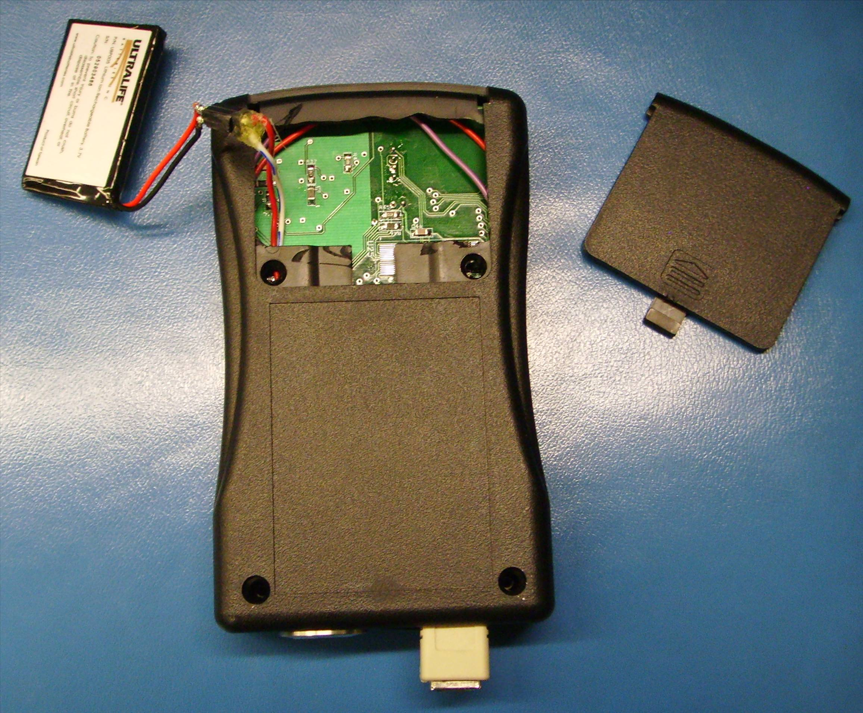
Figure B-3 Back View of Packaging

Appendix C: Schematic

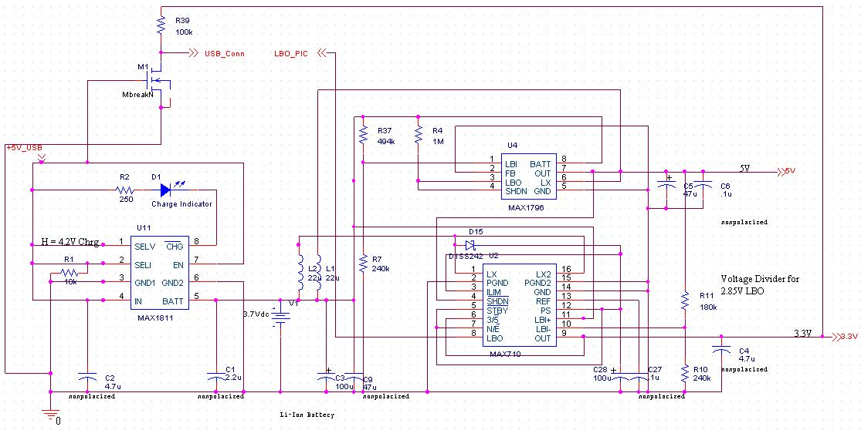

Figure C-1: Functional Block A: Power Block

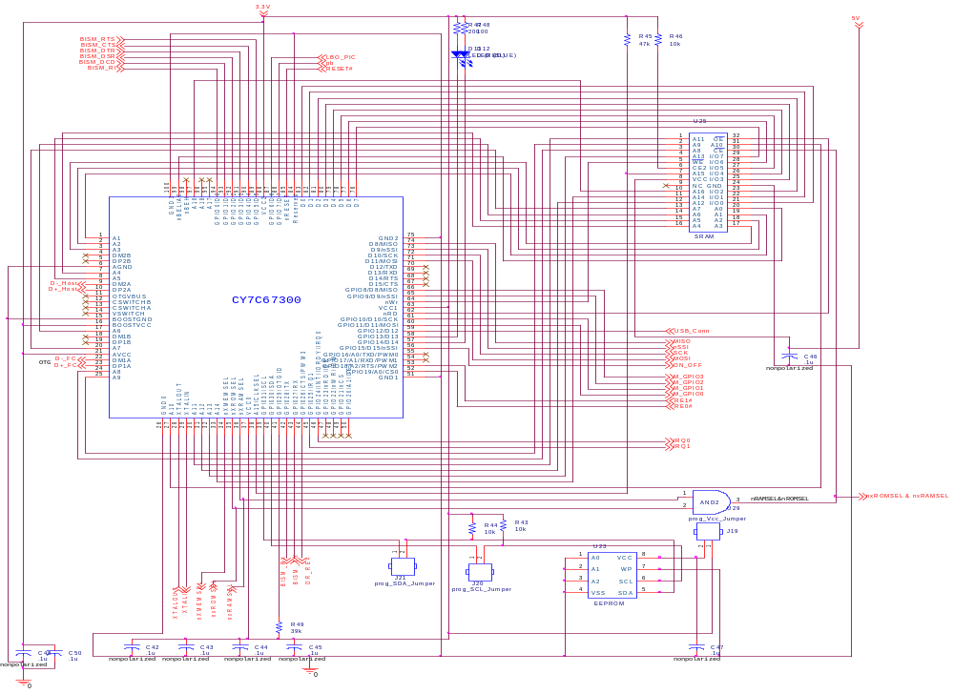
Figure C-2: Microcontroller Block
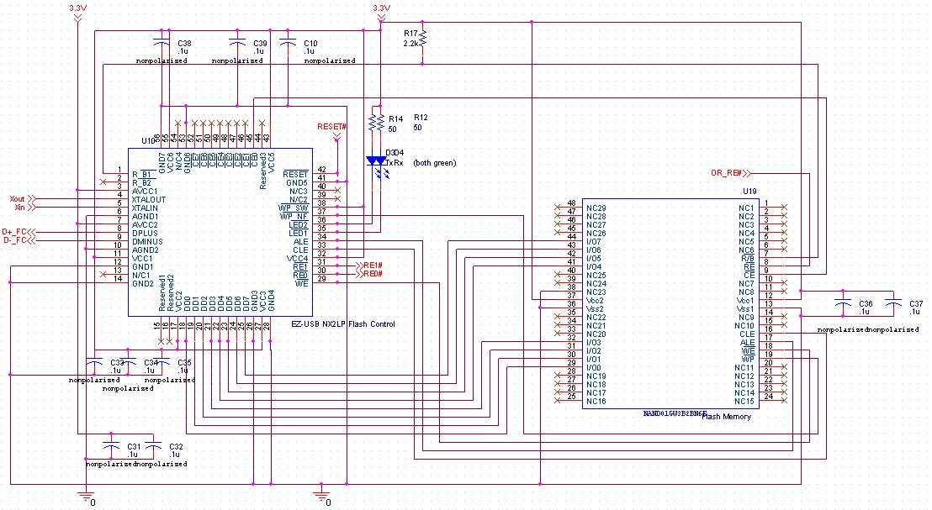
Figure C-3: Flash Memory Block
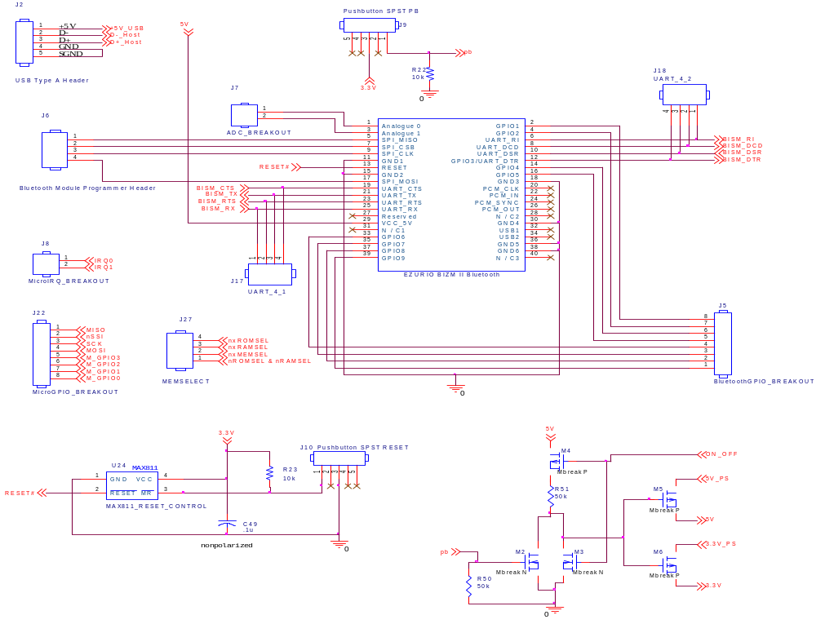
Figure C-4: Header and Push Button Block

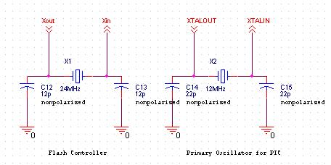
Figure C-5: Clock Source Block

Appendix D: PCB Layout Top and Bottom Copper
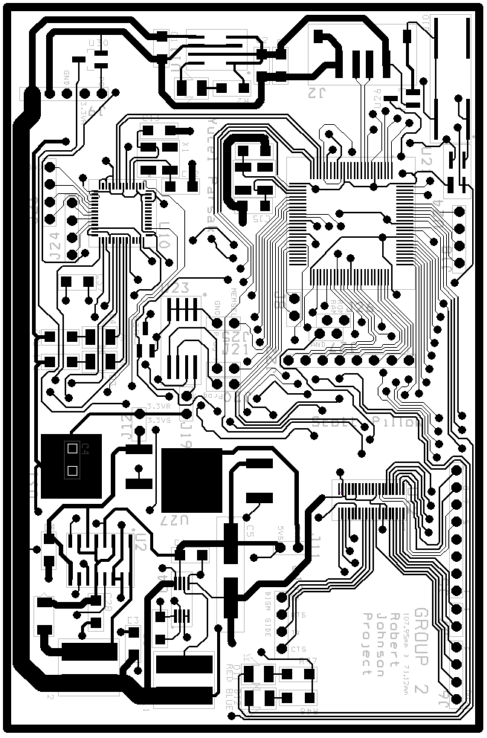

Figure D-1: Top Layer of PCB Layout with Silkscreen
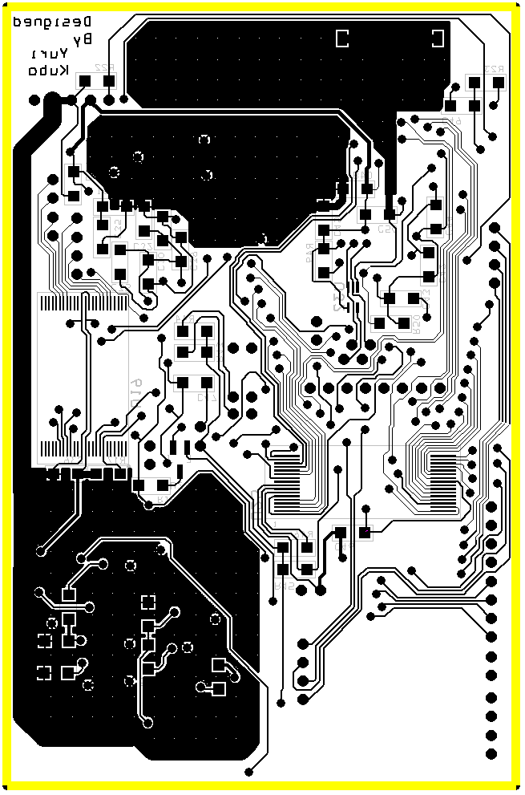

Figure D-2: Bottom Layer PCB Layout with Silkscreen
Appendix E: Parts List Spreadsheet

Vendor | Manufacturer | Part No. | Description | Unit Cost | Qty | Total Cost
Cypress | Cypress | CY7C68024 | EZ-Host USB Host/Peripheral | 11.90 | 1 | $11.90
Mouser | EZURiO | TRBLU23-00200-03 | BISM2 Bluetooth Module | 67.00 | 1 | $67.00
Digikey | Maxim | MAX1797EUA-ND | DC-DC Converter w/ Shutdown | 4.40 | 1 | $4.40
Digikey | Maxim | MAX1811ESA-ND | Li+ Battery Charger via USB | 2.04 | 1 | $2.04
Mouser | ST | NAND04GW3B2BN6E | 1 Gigabit NAND flash memory | 12.79 | 1 | $12.79
Mouser | Ultralife | UBP103450 | 1.7 Ah Li-ion battery | 12.20 | 1 | $12.20
Mouser | Cypress | 24AA512 | 512K EEPROM | 3.05 | 1 | $3.05
Mouser | Cypress | CY7C68023 | Flash Controller | 4.66 | 1 | $4.66
Digikey | Cypress | CY7C109BN | 128Kx8 SRAM | Unknown | 1 | Unknown
Digikey | Maxim | MAX811 | Reset Controller | 0.99 | 1 | 0.99
 |  |  |  | TOTAL |  | $119.03

Appendix F: Software Listing

/* app.c
* This file contains our initialization code and and timer code. The timer polls the
* pushbutton to see how long it is pressed to determine whether power needs to be *turned on our turned off. It also polls the output from the LBO to see whether the *battery is getting to a crucially low level and needs to be turned off before it gets *to the point where it cannot be recharged.
*/

#include "fwx.h"
#include "app.h"
#include "uart.h"

#define BLUE_LED 0xBFFF

uint16 count = 0;
uint16 blue_blink = BLUE_LED;
uint16 speed = 3000;
uint16 pb_count = 0;
uint16 device_on = 0;
uint16 let_go = 1;
uint16 low_batt = 0;
uint16 time_to_shutdown = 0;
uint16 blue_blink_count = 0;
uint16 solid_blue = 0;
uint16 flip = 0;
uint16 temp = 0x0000;
uint16 low_batt_count = 0;

uint16 uart_trans = 0;

void timer1_notify_5(void)
{
if ( (READ_REGISTER(GPIO0_IN_DATA_REG) & 0x0080) && let_go )
{
if ( device_on )
{
//INPLACE_AND(GPIO0_OUT_DATA_REG, 0xBFFF); //BLUE LED ON
}

solid_blue = 1;

pb_count++;
}
else
{
solid_blue = 0;
if ( !let_go && !(READ_REGISTER(GPIO0_IN_DATA_REG) & 0x0080) )
let_go = 1;

pb_count = 0;
}

if ( low_batt )
{
time_to_shutdown++;

if ( time_to_shutdown == 20000 )
device_on = 0;
}

if ( !(READ_REGISTER(GPIO0_IN_DATA_REG) & 0x0040) )
{
low_batt_count++;
if ( low_batt_count >= 2000 )
low_batt = 1;
}
else
low_batt_count = 0;

if ( pb_count >= 2000 )
{
if ( device_on )
{
device_on = 0;
pb_count = 0;
let_go = 0;
}
else
{
device_on = 1;
pb_count = 0;
let_go = 0;
}
}

if ( device_on )
{
if ( !solid_blue )
{
//blink when device is on and the button is not pushed
//INPLACE_OR(GPIO0_OUT_DATA_REG, 0x8000); //15
}
INPLACE_OR(GPIO0_OUT_DATA_REG, 0x8000); //15
}
else
INPLACE_AND(GPIO0_OUT_DATA_REG, 0x7FFF); //15

if ( low_batt )
INPLACE_AND(GPIO0_OUT_DATA_REG, 0xDFFF); //13
else
INPLACE_OR(GPIO0_OUT_DATA_REG, 0x2000); //13
}

char myuart_getchar()
{
uint16 tries = 0;
while ( !(READ_REGISTER(UART_STAT_REG) & UART_RX_FULL) && tries++ < 5 );
return READ_REGISTER(UART_DATA_REG);
}

void myuart_putchar(char c)
{
while ( (READ_REGISTER(UART_STAT_REG) & UART_TX_EMPTY) );
WRITE_REGISTER(UART_DATA_REG, c);
}

void app_task(FWX_SYSTEM_MODE mode[2])
{
//uart_putchar('c');
}

void app_init(void)
{
WRITE_REGISTER(GPIO0_DIR_REG, 0xFFFF);
WRITE_REGISTER(GPIO1_DIR_REG, 0xFFFF); //TX, RX unchanged

INPLACE_AND(GPIO0_DIR_REG, 0xFF7F); //GPIO7 input
INPLACE_AND(GPIO0_DIR_REG, 0xFFBF); //GPIO6 input

WRITE_REGISTER(GPIO0_OUT_DATA_REG, 0xFFFF);
}

/* uart.c
* This implements all of our file system. Characters are read in over UART
* and monitored to see if commands put, get, delete and dir are sent. The appropriate
* actions are taken to modify the file system by placing the data in a linked list
* of files.
*/

extern uint16 uart_trans;
extern uint16 speed;

#define FILE_START_PLACEMENT 0x2500
#define DIRECTORY_START 0x2400

extern char myuart_getchar();
extern char myuart_putchar();

typedef struct file {
char* filename;
char* start;
uint16 size;
uint16 allocated;
}file;

uint16 newFileLocation = FILE_START_PLACEMENT;
uint16 newDirLocation = DIRECTORY_START;

file* newFile = (file*)FILE_START_PLACEMENT;
file** directory = (file**)DIRECTORY_START;

void fileMenuLoop(char currChar)
{
static char command[50]; //holds the command name
char filename[32];
static char sentinel[6];
static uint16 pos = 0;
static uint16 file_transfer = 0;
static uint16 sentinel_count = 0;
uint16 filename_find = 0;
int i;

command[pos] = currChar;

if ( file_transfer )
{
//while transferring, keep moving data into memory
speed = 500;

*(newFile->start) = currChar;
newFile->start++;
newFile->size++;

if ( currChar == '1' )
sentinel_count = 0;

sentinel[sentinel_count++] = currChar;

if ( !strncmp(sentinel, "15269A", 6) )
{
//strip the sentinel off of the file
newFile->start -= 6;
newFile->size -= 6;

//reset sentinel
sentinel[0] = '0'; sentinel[1] = '0'; sentinel[2] = '0';
sentinel[3] = '0'; sentinel[4] = '0'; sentinel[5] = '0';
sentinel_count = 0;
file_transfer = 0;
//move pointer back to beginning of string
newFile->start = (char*)newFileLocation;
//move location beyond file
newFileLocation += newFile->size;
myuart_putchar('\r');
myuart_putchar('\n');
return;
}

if ( sentinel_count >= 6 )
sentinel_count = 0;
}

if ( (currChar == '\r') && !file_transfer )
{
//grab the filename
while ( command[filename_find++] != ' ' );
//now filename is stored from command[filename_find] to command[pos-1]

if ( !strncmp(command,"delete",6) )
{
speed = 500;
//delete file
myuart_putchar('\r');
myuart_putchar('\n');
uint16 j = 0;
for (i=filename_find; i < pos; i++)
{
filename[j++] = command[i];
}

filename[j] = '\0';

directory = (file**)DIRECTORY_START;
while ( directory > (file**)newDirLocation )
{
if ( !strcmp((*directory)->filename,filename) )
{
(*directory)->allocated = 0;
break;
}
directory--;
}
}
else if ( !strncmp(command,"dir",3) )
{
speed = 500;
myuart_putchar('\r');
myuart_putchar('\n');
//scroll through all the files and send their names over the UART
directory = (file**)DIRECTORY_START;
while ( directory > (file**)newDirLocation )
{
i=0;
while ( (*directory)->filename[i] != '\0' && (*directory)->allocated )
{
myuart_putchar((*directory)->filename[i]);
i++;
}
if ( (*directory)->allocated )
{
myuart_putchar('\r');
myuart_putchar('\n');
}
directory--;
}
}
else if ( !strncmp(command,"get",3) )
{
myuart_putchar('\r');
myuart_putchar('\n');
speed = 500;
//scroll through each of the files and see if the names match
//directory = DIRECTORY_START;
//get the current filename
uint16 j = 0;
for (i=filename_find; i < pos; i++)
{
filename[j++] = command[i];
}

filename[j] = '\0';

directory = (file**)DIRECTORY_START;
while ( directory > (file**)newDirLocation )
{
if ( !strcmp((*directory)->filename,filename) && (*directory)->allocated )
{
for (i=0; i < (*directory)->size; i++)
myuart_putchar((*directory)->start[i]);

break;
}
directory--;
}

myuart_putchar('\r');
myuart_putchar('\n');
}
else if ( !strncmp(command,"put",3) )
{
newFile = (file*)newFileLocation;
directory = (file**)newDirLocation;
*directory = newFile;

speed = 500;

//init file size
newFile->size = 0;
//make it allocated
newFile->allocated = 1;

//make room for the file structure
newFileLocation += sizeof(file);
newDirLocation -= sizeof(file*);

newFile->filename = (char*)newFileLocation;

for (i=filename_find; i < pos; i++)
{
*(newFile->filename) = command[i];
newFile->filename++;
}
*(newFile->filename) = '\0';
newFile->filename = (char*)newFileLocation;
//make room for the string
newFileLocation += pos - filename_find + 1;

//init file location
newFile->start = (char*)newFileLocation;

//when putting a file, keep reading until sentinel 15269A found
file_transfer = 1;
myuart_putchar('\r');
myuart_putchar('\n');
}
}

if ( ++pos >= 50 )
pos = 0;

if ( (currChar == '\r' || currChar == '\n') || file_transfer )
pos = 0;
}

void uart_rx_isr(void)
{
/* Fill in your ISR functionality here. */
static char buffer[30];
static uint16 pos = 0;
static uint16 ring_find = 0;
static uint16 start_flag = 0;
static uint16 connected = 0;
static uint16 file_menu = 0;
static char ringme[4];
uint16 i;

uint16 sleep1;
uint16 sleep2;
uint16 sleep3;

buffer[pos] = myuart_getchar();

if ( buffer[pos] == 'R' )
ring_find = 0;

ringme[ring_find] = buffer[pos];
if ( !strncmp(ringme, "RING", 4) )
{
pos = 3;
buffer[0] = 'R'; buffer[1] = 'I';
buffer[2] = 'N'; buffer[3] = 'G';
start_flag = 1;
}

ring_find++;
if ( ring_find == 4 )
ring_find = 0;

if ( start_flag == 1 )
{
pos++;
buffer[pos] = '\0';
}

if ( file_menu )
{
fileMenuLoop(buffer[pos]);
}

if ( connected )
{
if ( pos >= 17 && start_flag == 1 )
{
//if the device is ringing
speed = 50;
//accept call
myuart_putchar('A');
myuart_putchar('T');
myuart_putchar('A');
myuart_putchar('\r');
myuart_putchar('\n');
start_flag = 0;
connected = 0;
file_menu = 1;
}
}

if ( !connected )
{
if ( pos >= 17 && start_flag == 1 )
{
//if the device is ringing
speed = 250;
//hang up
myuart_putchar('A');
myuart_putchar('T');
myuart_putchar('H');
myuart_putchar('\r');
myuart_putchar('\n');

//wait for the user to hangup
for (sleep1=0; sleep1 < 65; sleep1++)
{
speed = 100;
for (sleep2=0; sleep2 < 650; sleep2++)
{
for (sleep3=0; sleep3 < 650; sleep3++);
}
}

speed = 100;
//grab the address
//reconnect using the address
myuart_putchar('A');
myuart_putchar('T');
myuart_putchar('D');
for ( i=5; i < 17; i++)
{
myuart_putchar(buffer[i]);
}
myuart_putchar('\r');
myuart_putchar('\n');

connected = 1;
start_flag = 0;
}
}
}

Appendix G: FMECA Worksheet

Failure No. | Failure Mode | Possible Causes | Failure Effects | Method of Detection | Criticality | Remarks
A1 | No current output from MAX1811 when plugged into USB | MAX1811 failure | Loss of battery charging capability | Even when plugged in for extended periods of time, if disconnected the device dies | Low | Minor annoyance, loss of wireless functionality
A2 | No voltage output from MAX1811 when plugged into USB | MAX1811 failure | Loss of battery charging capability, no ability to power device other than from the battery | No battery charge LED indication, no response when plugged in after battery dies | Low | Complete loss of functionality
A3 | No voltage across battery terminals | Internal battery short, MAX1811, MAX1796, or MAX710 failures, C1, C3, C9, R37, R7, or R4 shorted | Battery completely discharges and cannot be fixed, possibility of catastrophic failure (battery explosion or leak) | Battery leaks or explodes, device gets physically hot, device does not respond | High | Could cause injury to user and will probably cause damage to parts and suffer loss of functionality
A4 | No voltage on USB 5V rail when plugged in | C2 or R1 shorted, M1 failure | Pull too much current from computer, no voltage into MAX1811 | Host computer malfunctions, battery charge LED does not indicate charging on dead battery | High | If device is used in a medical application and causes malfunctions of other life saving devices attached to the host computer

Failure No. | Failure Mode | Possible Causes | Failure Effects | Method of Detection | Criticality | Remarks
A5 | Charge indicator LED does not turn on | R2 open, MAX1811 failure | No user insight into battery status | LED not on when dead battery plugged into host computer | Low | No loss of functionality of device
A6 | No/low voltage on 3.3V rail | MAX710 failure, C4 short, D15 failure | No downstream devices on 3.3V rail are powered | No response from device, status LED fails to light | Low | Possible damage to MAX710, no downstream damage
A7 | No/low voltage on 5V rail | MAX1796 failure, C5, C6, R11, or R10 shorted | No downstream devices on5V rail are powered | No response from device, status LED fails to light | Low | Possible damage to MAX1796, no downstream damage
A8 | Large voltage fluctuations on 5V rail | MAX1796 failure, L1 failure | Could swing output voltage out of range of downstream parts | Unpredictable behavior from device | Low | Possible damage to components on 5V rail
A9 | Low battery line fails to change voltage when battery voltage drops below threshold | MAX710 failure, MAX1796 failure, R11, or R10 shorted | User will have no insight into battery charge being low | Low battery LED does not go on before battery dies | Low | No loss of general functionality, minor inconvenience
A10 | Large voltage fluctuations on 3.3V rail | MAX710 failure, L2 failure | Could swing output voltage out of range of downstream parts | Unpredictable behavior from device | Low | Possible damage to components on 3.3V rail
Failure No. | Failure Mode | Possible Causes | Failure Effects | Method of Detection | Criticality | Remarks
A11 | USB connected signal fails to change voltage when USB 5V is connected | MAX710 internal failure, M1 failure,R39 shorted | No ability to transfer data over USB to and from host computer | Device is not discoverable by host computer when connected via USB | Low | Loss of one data path is not critical. Will still charge battery
A12 | USB connected signal always on | M1 shorted | No ability to transfer data over Bluetooth | Device will not accept any Bluetooth file transfer | Low | Loss of one data path
A13 | Low battery line always on | MAX710 internal failure | Low battery LED always on | Low battery LED on after charging for substantial amount of time | Low | Minor inconvenience. No loss of general functionality
B1 | No data transfer from EEPROM upon startup | CY7C67300 internal failure, EEPROM internal failure, J19, J20, or J21 broken, R44, or R43 shorted | Will not be able to load program onto microprocessor | Total loss of functionality of device. Status LED always off | Low | No damage to other parts or data loss
B2 | No data transfer to or from SRAM | CY7C67300 internal hardware failure, internal software failure, SRAM failure | Microprocessor unable to use SRAM as extended memory and cannot load full program | Total loss of functionality of device. Status LED always off. | Low | No damage to other parts or data loss
B3 | Status LEDs always on | CY7C67300 internal hardware failure, internal software failure | User no longer has insight into device operation | Visually inspect status LEDs | Low | No damage to other parts or data loss
Failure No. | Failure Mode | Possible Causes | Failure Effects | Method of Detection | Criticality | Remarks
B4 | Status LEDs never turn on | CY7C67300 internal hardware failure, internal software failure, R47, R48, D11, or D12 shorted | User no longer has insight into device operation | Visually inspect status LEDs | Low | No damage to other parts or data loss
B5 | Pushbutton does not respond | CY7C67300 internal hardware failure, internal software failure | User can no longer control the device mode or turn the device off | No response or changes in status of device in response to button presses | Low | Complete loss of control over device. No damage to other parts sutained
B6 | UART data lines toggle unexpectedly | CY7C67300 internal hardware failure, internal software failure | Data from microcontroller to Bluetooth module is no longer reliable | File transfer over Bluetooth results in a corrupt or incorrect file | Low | No damage to other parts but possible data loss
B7 | USB buses toggle unexpectedly | CY7C67300 internal hardware failure, internal software failure | Data from microcontroller to flash controller or host is no longer reliable | File transfer over USB results in corrupt or incorrect file | Low | No damage to other parts but possible data loss
B8 | GPIO pins toggle unexpectedly | CY7C67300 internal hardware failure, internal software failure | No impact to user but could effect testing process | GPIO pins are unpredictable while being monitored | Low | No damage to other parts or data loss
Failure No. | Failure Mode | Possible Causes | Failure Effects | Method of Detection | Criticality | Remarks
B9 | Read enable for flash memory toggles unexpectedly | CY7C67300 internal hardware failure, internal software failure | Could cause file write process to fail and lose data | File transfer aborted or when retrieving file it is incomplete or corrupt | Low | No damage to other parts but possible data loss
B10 | Read enable for flash memory never on | CY7C67300 internal hardware failure, internal software failure | Never able to read files from the flash memory | Not able to access any of the data on the device | Low | No damage to other parts and no data loss. Minor inconvenience of not being able to access data
B11 | Read enable for flash memory always on | CY7C67300 internal hardware failure, internal software failure | Never able to write files to flash memory | Not able to copy any files to the device | Low | No damage to other parts or data loss
B12 | No/low voltage on 3.3V line | C42, C43, C44, C45, C46, C47, C48, C49, or C50 shorted, CY7C67300 internal hardware failure | All 3.3V devices and associated functions fail, possible damage to MAX710 | Complete loss of functionality, status LEDs never turn on | Low | No data loss expected
C1 | USB bus toggles unexpectedly | Flash controller internal hardware or software failure | Data from flash controller to microcontroller is no longer reliable | Data received from file transfer is corrupt or incorrect | Low | No damage to other parts, possible data loss
Failure No. | Failure Mode | Possible Causes | Failure Effects | Method of Detection | Criticality | Remarks
C2 | Read enable lines toggle unexpectedly | Flash controller internal hardware or software failure | Could cause file write process to fail and lose data | File transfer aborted or when retrieving file it is incomplete or corrupt | Low | No damage to other parts but possible data loss
C3 | Read enable lines never on | Flash controller internal hardware or software failure | Never able to read files from the flash memory | Not able to access any of the data on the device | Low | No damage to other parts and no data loss. Minor inconvenience of not being able to access data
C4 | Read enable lines always low (on) | Flash controller internal hardware or software failure | Never able to write files to flash memory, file transfer to device fails | Not able to copy any files to the device | Low | No damage to other parts or data loss
C5 | Transfer LEDs always on | Flash controller internal hardware or software failure | No user insight into activity of file transfers | Visually inspect LEDs when no file transfer occuring | Low | No damage to other parts or data loss
C6 | Transfer LEDs never on | Flash controller internal hardware or software failure, R14 open, R12 open | No user insight into activity of file transfers | Visually inspect LEDs when file transfer occurring | Low | No damage to other parts or data loss
C7 | Transfer LEDs toggle unexpectedly | Flash controller internal hardware or software failure | No user insight into activity of file transfers | Visually inspect LEDs when no file transfer occuring | Low | No damage to other parts or data loss
Failure No. | Failure Mode | Possible Causes | Failure Effects | Method of Detection | Criticality | Remarks
C8 | No/low voltage on 3.3V line | C10, C38, C39, C33, C34, C35, C31, C32, C36, C37, or R17 shorted | All 3.3V devices and associated functions fail, possible damage to MAX710 | Complete loss of functionality, status LEDs never turn on, view via probe | Low | No data loss expected
C9 | Address, data, and control lines to flash memory toggle unexpectedly | Flash controller internal hardware or software failure | Possible data loss or corruption of present data | File transfer results in corrupted or incomplete file, view via probe | Low | No damage to other parts but data loss expected
D1 | Reset line always low | MAX811 failure, reset pushbutton mechanical failure resulting in short, C49 short | Microcontroller, Flash controller, Bluetooth module are all always in reset. No data transfer possible | Complete loss of functionality, status LEDs always off | Low | No damage to other parts or loss of data
D2 | Reset line always high | MAX811 fault, reset pushbutton mechanical failure resulting in always open | Microcontroller, Flash controller, Bluetooth module are all never able to be reset | System does not reset when button is pressed | Low | No damage to other parts or loss of data or functionality to user, only debugger is inconvenienced
D3 | Pushbutton line always high | Pushbutton mechanical failure resulting in short | Microcontroller will turn itself off if already on, or turn itself on if off and not respond to any subsequent button presses | Microcontroller does not respond to pushbutton commands, status LEDs on when supposed to be off, or vice versa | Low | No damage to other parts or loss of data. Will continue to function if the device is stuck on
Failure No. | Failure Mode | Possible Causes | Failure Effects | Method of Detection | Criticality | Remarks
D4 | Pushbutton line always low | Pushbutton mechanical failure resulting in always open | All pushbutton commands will be ignored, user unable to initiate pairing, change modes | System is unresponsive to pushbutton commands | Low | No damage to other parts or loss of data
D5 | UART data lines toggle unexpectedly | Bluetooth module software fault | Data from Bluetooth module to microcontroller is no longer correct or reliable | File transfer over Bluetooth results in a corrupt or incorrect file | Low | No damage to other parts but possible data loss
E1 | 24MHz crystal has does not oscillate | X1 (clock) failure, C12 shorted, C13 shorted | Flash controller loss of functionality, no data transfer | Data transfer fails, not able to access any data on the device via host | Low | No damage to other parts but possible loss of data
E2 | 12MHz crystal has does not oscillate | X2 (clock) failure, C14 shorted, C15 shorted | Microcontroller loss of functionality, no status LEDs, no data transfer | No possible data transfer, not able to access any data on device via host, cannot connect to host | Low | No damage to other parts but possible loss of data

