ECE 477 Final Report − Spring 2008
Team 1 − Sentinel Mark I

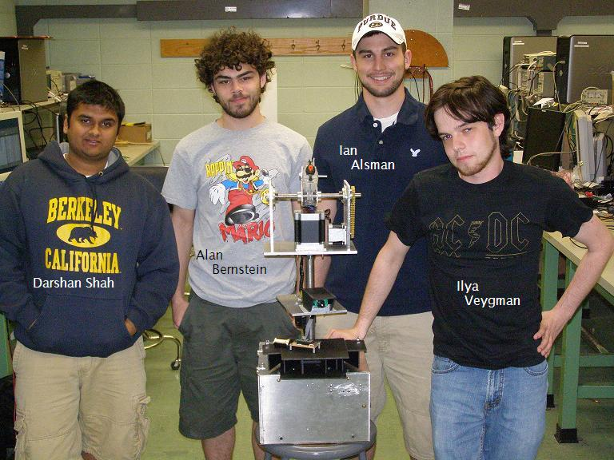

Team Members:

#1: Ilya Veygman Signature: ____________________ Date: _________

#2: Alan Bernstein Signature: ____________________ Date: _________

#3: Ian Alsman Signature: ____________________ Date: _________

#4: Darshan Shah Signature: ____________________ Date: _________

CRITERION | SCORE | MPY | PTS
Technical content | 0 1 2 3 4 5 6 7 8 9 10 | 3
Design documentation | 0 1 2 3 4 5 6 7 8 9 10 | 3
Technical writing style | 0 1 2 3 4 5 6 7 8 9 10 | 2
Contributions | 0 1 2 3 4 5 6 7 8 9 10 | 1
Editing | 0 1 2 3 4 5 6 7 8 9 10 | 1
Comments: |  | TOTAL

TABLE OF CONTENTS

Abstract | 1
1.0 Project Overview and Block Diagram | 2
2.0 Team Success Criteria and Fulfillment | 4
3.0 Constraint Analysis and Component Selection | 5
4.0 Patent Liability Analysis | 11
5.0 Reliability and Safety Analysis | 15
6.0 Ethical and Environmental Impact Analysis | 21
7.0 Packaging Design Considerations | 24
8.0 Schematic Design Considerations | 28
9.0 PCB Layout Design Considerations | 34
10.0 Software Design Considerations | 37
11.0 Version 2 Changes | 42
12.0 Summary and Conclusions | 43
13.0 References | 44
Appendix A: Individual Contributions | A-1
Appendix B: Packaging | B-1
Appendix C: Schematic | C-1
Appendix D: PCB Layout Top and Bottom Copper | D-1
Appendix E: Parts List Spreadsheet | E-1
Appendix F: Software Listing | F-1
Appendix G: FMECA Worksheet | G-1

Abstract

This report demonstrates the thorough analysis of the development of digital system that implements an embedded microcontroller. Both hardware and software were integrated together to make a complete project with the use of all the knowledge that has been attained through previous coursework. This project was aimed towards designing an automated sentry turret, named Sentinel Mark I. This device has the ability to run in manual mode with complete control of the motion of a camera and gun via a user interface, and, while in auto-mode, has the ability to sense enemies with the use of ancillary sensors. Friendlies are given the ability to disable the gun using a remote control. The motivation behind this project is that it not only has military applications such as bunker defense, but also commercial ones such as adding a new twist to recreational shooting sports like paintball. This project was unique in that it required everyone’s electrical engineering background in one form or another: whether it deals with image processing, logic design, control, or software. The design process is demonstrated from beginning to end in this report.

- Project Overview and Block Diagram

The Sentinel Mark I is an automated sentry turret capable of autonomous motion and detection/neutralization of targets. There are two manual override features: a graphical user interface from which the device may be controlled and an infrared remote control receiver that may be used to remotely disable targeting. The purpose of the latter is to allow friendly personnel to avoid being targeted and possibly injured by the turret. This device may be operated as an autonomous defense system, or it may be remotely controlled for customized defense solutions.
The electronic aspect of the device is centralized around a Freescale MC9S12X family chip, with peripherals such as motor control PLDs; breakout circuitry for motion sensors and IR sensors; RS-232 and other level translators for communication with the user interface and video camera; and simplex expanded RAM. See Figure 1-2 for a block diagram of this system.

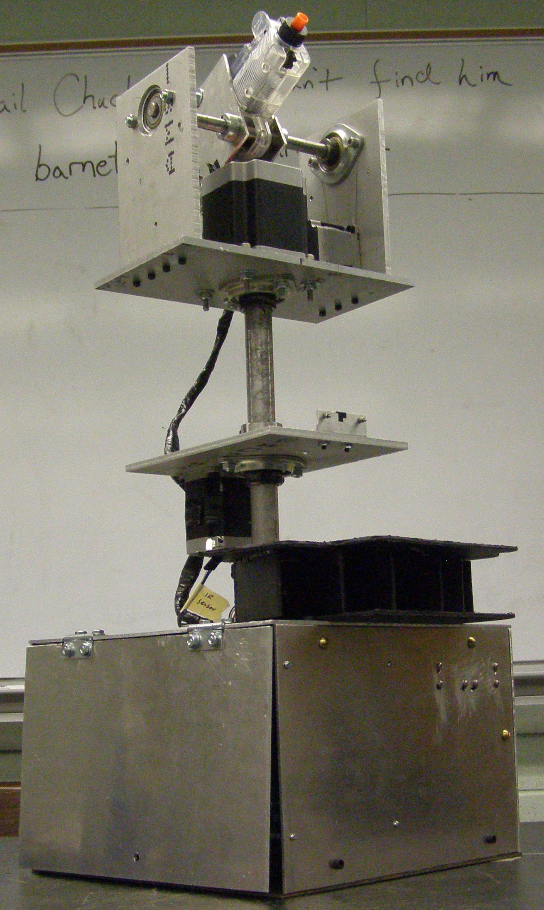
Figure 1-1: Final Assembly Photo

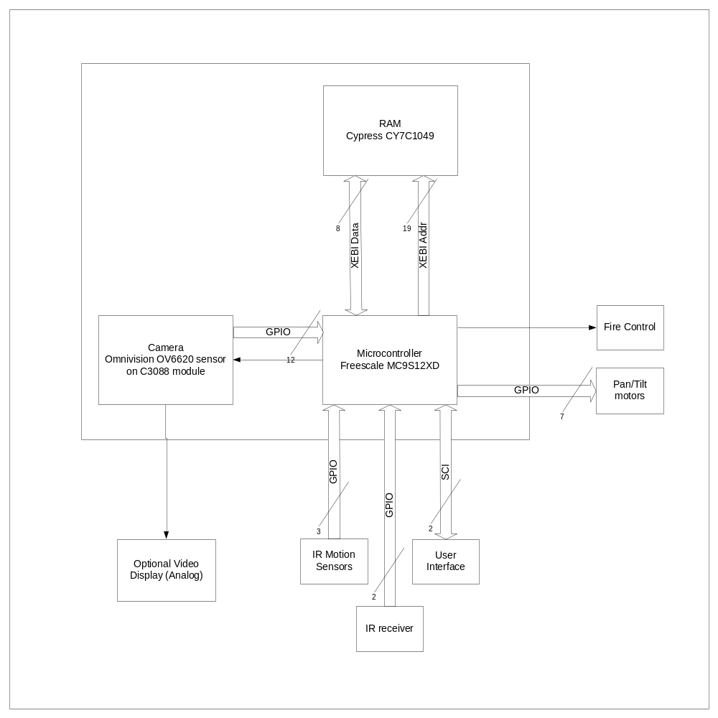
Figure 1-2: System Block Diagram

The packaging consists of ancillary sensors (IR and motion), three motors, a video camera and an Airsoft automatic weapon integrated onto an aluminum chassis. There are two moving platforms. One has two motors that may pan and tilt the integrated weapon. The other, which holds the camera, may only pan side to side. Both platforms rotate about a fixed steel shaft which attaches at the bottom of the base: a 12” by 12” by 8” high aluminum box. The box contains all of the circuitry and motor drivers for the device.

- Team Success Criteria and Fulfillment

 | Full Text | Status
1 | An ability to electronically fire an Airsoft pistol (either autonomously or manually). | Demonstrated successfully on 4/16/2008, fired via manual override. See video on website for demonstration
2 | An ability to detect off-camera motion via ancillary sensors. | Demonstrated successfully on 4/16/2008, tripped sensors caused the main turret to move to a corresponding location. See video on website
3 | An ability to remotely disable device to prevent “friendly fire”. | Demonstrated successfully on 4/18/2008. See video on website for demonstration
4 | An ability to automatically detect a (hostile) target within the camera’s field of vision. | Video targeting was not completed
5 | An ability to pan and tilt the firearm assembly (a minimum of) ±45° in the longitudinal direction and ±30° in the latitudinal direction. | Demonstrated successfully on 4/16/2008. See video on website for demonstration

Constraint Analysis and Component Selection

  - Introduction
The Sentry Gun project consists of an Airsoft pellet gun mounted on a pan/tilt assembly controlled by two stepper motors, which are driven by Vexta stepper motor drivers, and a small camera module mounted on a separate pan assembly, controlled by a single stepper motor. Video data from the camera is processed by the microcontroller to determine how to position the weapon. Additional data (at low baud rates) from infrared motion sensors is used to detect the presence of hostile targets, and from infrared receivers to detect the presence of friendly targets. The user interface may include a video display as well as a PC-based application for manual control. Additional RAM is necessary for temporary storage of video processing data.

  - Design Constraint Analysis
The most important design constraint for the project is the choice of microcontroller. The video processing requires some minimum clock speed, available memory, and data transfer rate. Video data transfer may be accomplished independently of other data transfers, such as control and diagnostic data. Given the amount of external interfaces, a reasonable number of microcontroller peripheral pins and GPIO pins are required. Physical size and power usage are secondary concerns.
Regarding physical construction, the main constraint is the sensitivity and speed of the pan/tilt assembly. Thus, motors with the appropriate torque and speed characteristics should be selected.

    - Computation Requirements
The primary computational task is the video processing algorithm. The computational complexity of this algorithm will almost definitely scale directly with camera resolution and frame rate. At the resolution of 356x292 pixels and frame rate of 12 frames per second, a conservative estimate of processing speed required for the video algorithm alone is about 25MHz [1]. This clock speed was found as the product of the resolution, the frame rate, and the estimated number of cycles per pixel required by the algorithm (20 cycles). The cycles per pixel estimate was found assuming the use of a basic subtract-and-threshold algorithm; with appropriate memory access techniques, each pixel should require only a read of the video data, a subtraction, two comparisons, and a write to the RAM. This algorithm uses five instructions per pixel, and at approximately three cycles each, 20 cycles is a conservative estimate leaving some room for error or expansion.
Since other interfaces will generate interrupts, the clock speed must exceed this minimum requirement by a small amount. While processing long interrupt service routines, a small number of pixel reads may be skipped, but this should not have a significant effect on the targeting algorithm. Aside from startup and initialization code, the only software that needs to be active during targeting mode are the sensor interrupts and the user interface receive data interrupts, none of which require significant processing time. Based on this, the video algorithm should be able to run at least 80-90% of operating time.
Using three targeting regions, three full frames must be stored in memory at all times. Given access to a constant background frame, the targeting location can be computed on the fly at any time without significant additional storage space, since the result of the subtract-and-threshold can be stored as the maximum and minimum row and column, instead of storing a full bitmap. Using full resolution of 356x292, each frame requires approximately 104KB of memory, for a total of about 312KB. Clearly 256KB is too small for this, so 512KB is necessary.

    - Interface Requirements
The microcontroller will primarily interface with two external devices: the camera and the RAM. The microcontroller will communicate with the RAM using the 16-bit simplexed external bus on microcontroller ports A/B/K (address), D (data) and E (control) [2]. With 512KB of memory, 19 address pins, eight data pins and two control pins will be necessary, for a total of 29 pins. The digital camera interface consists of a 16-bit data bus, eight bits of which can be ignored since they can be configured to contain only color data. Three clock signals are available for the data bus, as well as an I²C bus and two other controls which will simply be tied high. Discarding the eight data signals and two control signals, a total of 11 pins are necessary.
The camera will additionally interface to the remote user interface (UI) via a 75Ω analog PAL video feed, using a USB television tuner capable of decoding PAL video if the UI is PC-based [1]. The analog and digital outputs can be used simultaneously.
The microcontroller will interface with all other devices. The microcontroller will use seven bits to control the three stepper motors; a step and direction for each, and a single clock pin used to trigger a step on all three motors simultaneously, by sending all six control signals through a PLD. A single GPIO pin will be used for weapon fire control. The three motion sensors will interface to the chip via GPIO [4]. Up to three infrared sensors will be used for friendly detection, which will interface via GPIO as well. If more than one IR sensor is used, the signals will be combined in a logical AND sense [5, 6]. Since the purpose of the IR sensors is to prevent fire in the presence of a friendly, knowledge of which sensor is tripped is irrelevant. Both the motion detection and the IR receiver sensors will trigger interrupts. The user control interface will communicate with the chip using an SCI channel.

    - On-Chip Peripheral Requirements
The microcontroller has several peripheral requirements. It will need an I²C channel which will communicate with the camera, and an SCI channel which will communicate with the remote UI. An RTI module or timer will also be needed to turn off the gun after it has been fired, and to control the motion of the motors. An external memory bus will be needed to interface directly with the memory at high speed. A small number of additional GPIO pins will be needed for fire control, motor control and sensor interfaces.

    - Off-Chip Peripheral Requirements
Users will transmit a signal to IR receivers via remote to prevent the gun from firing. The IR receivers will work at a carrier frequency of 56.9 kHz [5]. The remote control will transmit a simple binary signal which will trigger an interrupt when active.
The PCB will have a number of additional, off-chip peripherals. The most important is the RAM. A 512KB chip will suffice for the resolution used in this project, for the reasons discussed in section 2.1. A multiplexer will be needed if more than one IR sensor is used. A logical AND gate can be used for this purpose [6].
Vexta motor drivers will be used to convert step/direction signals at logic levels to high-power stepper coil signals [7]. Two of these drivers are available, but three drivers are necessary so a third simple driver will be constructed, and used for the camera pan platform, since high precision is not necessary on that axis.

    - Power Constraints
Since the Vexta drivers run on 120VAC, the entire device will as well. A standard consumer PC power supply will supply the different logic levels (3.3V and 5.0V) required voltages for the various logic components. Fans will be used to increase airflow within the packaging to dissipate the heat from the power supply and motor drivers.
From the power constraint analysis summarized in table 3.2.16, the power supply is more than capable of supplying the necessary power.

Part | Voltage (V) | Max Current (mA) | Power (W) | Quantity | Total Power (W)
MC9S12XD  Microcontroller | 3.3 | 1500 | 5 | 1 | 5
CY7C1049  RAM | 3.3 | 90 | .297 | 1 | .297
TXS0108EPWR  Level Translator | 3.3, 5.0 | 50 | .25 | 2 | .5
OV6620  Camera | 5.0 | 16 | .08 | 1 | .08
MAX3232  Level Translator | 5.0 | 152 | .76 | 1 | .76
GAL26CV12B  PLD | 5.0 | 133 | .665 |  | .665
 |  | Total Power Usage on 3.3V rail |  |  | 5.8
 |  | Total Power Usage on 5.0V rail |  |  | 2.0
 |  | Total Power Usage |  |  | 7.8
Table 3.2.16: Onboard Power Constraints

    - Packaging Constraints
The project will be housed in an assembly that contains a horizontal rotating axis for the camera and a horizontal and vertical rotating axis for the turret, all of which are placed on a stand. Though this mechanical design seems overly complicated, the use of an additional rotating axis will simplify the video processing algorithm greatly; using a moving background would require significantly more processing power. The lower motor moves the camera assembly, while the upper motors will move just the turret. The pan (horizontal) motors will need a significant amount of holding torque as well. Additionally, both of these motors will need the ability to move over the range of fire that has been set for the turret and motion sensors (approximately 180 degrees horizontally). Finally, another motor, that does not need to be as powerful as the other two, will control the tilt (vertical) action for the turret. This motor needs to have enough torque so the gun can tilt throughout the full field of view of the camera, about 15 degrees above and below the horizontal.
The final assembly is made from a material that is light but strong enough: aluminum. The base attaches to a center shaft via bearings, which allow the entire assembly to rotate with little friction and also allow for the required response time we need from the assembly.
The final PCB should be similar in size to the gun assembly. This is not a strict constraint; a 6”x6” board could easily contain all of our components and would be small enough to attach to the assembly.

    - Cost Constraints
With no known similar commercial products, cost comparison is extremely difficult. Several websites detail the construction of similar devices by hobbyists, but again cost information is unavailable. [9]. As an upper limit, the overall project cost should be kept below $500.

  - Component Selection Rationale
For the microcontroller, the choices were quickly narrowed to Freescale parts due to familiarity and the availability of development kits. Three of the parts researched were the MCF5213, MC9S12XDP512 80-pin and MC9S12XDP512 144-pin chips. The MC9S12XDP512 144-pin was chosen because it has 3 SPI ports, 2 SCI ports, an I²C interface, a simplexed bus expansion and enough GPIO pins to support all the other necessary interfaces. The comparison of important features is summarized in table 3.3.0-1

Feature | MCF5213 _{[13]} | MC9S12XDP512 112-pin _{[5]} | MC9S12XDP512 144-pin _{[14]}
I²C | Yes | Yes | Yes
SCI | Yes | Yes | Yes
Bus Expansion | Multiplexed | Multiplexed | Simplexed
GPIO pins | 60 | 91 | 119
Table 3.3.0-1: Microcontroller Design Constraints

Two choices for the video camera were to use a digital camera or an analog camera with a video decoder. The camera chosen, a C3088 32-pin module with an Omnivision OV6620 sensor, provides digital output, but includes an analog television signal as well. This allows for both options without the disadvantage of extra components.
The choice of RAM was not difficult; several 512KB 8-bit chips with adequate timing performance are available, so a chip available through free online samples was chosen for simplicity [3].

  - Summary
The components selected for this project meet all requirements. The selection of a microcontroller, DSP, and camera module were all heavily constrained in order to fulfill the basic functions of the project. The selection of motors, power supplies, and other minor peripherals were chosen in order to meet the basic requirements of the main devices.

- Patent Liability Analysis

  - Introduction
It is probable that products similar to the Sentinel Mark I exist in patent form, specifically robots and camera-tracking platforms that may use similar approaches to those utilized by Sentinel Mark I.
  - Results of Patent and Product Search
The first patent which performs substantially the same function as this project is titled “Camera tracking movable transmitter apparatus,” US patent number 4905315, filed 30 June 1988 and published 27 February 1990. The abstract states that it is an “apparatus for mounting and positioning an associated device” such as a camera with a platform and a control apparatus including a number of sensors at angular intervals around some axis. Each of these sensors is designed to accept a control signal from a transmitter, which will then be discriminated amongst to determine where the “target” is and where to therefore position the platform. The invention claims that it may smoothly accelerate and decelerate to allow for “high quality pictures,” which is similar to the motor control algorithms used in the sentry gun project. This particular invention, however, tracks its targets using the (infrared) transmitter worn by the target. This effectively tags them, and the device uses an array of sensors to determine “angular displacement” to facilitate tracking. The claims are claim 1 and claim 5 which, summarized, specifies using the infrared sensors which are at angular displacements to position the assembly [10].
A second patent is US patent number 20070208459, filed on 27 February 2007, titled “Sentry robot.” According to the abstract, this is a device which can perform long-range and short-range monitoring and automatically shoot at a target. It has a base with a main body installed upon it which can rotate, as well as two cameras: one that rotates with the main body and a second which can rotate independently of the main body. There are several claims which potentially contain infringement. Claim 1 speaks of a main body that can pivot around the base as well as a camera that may move independently of the main body. Claim 4 speaks of a gun installed on the main body that can follow where the camera looks. Claims 7 and 8 essentially speak of optically tracking a target and following the target with said gun [11]. This is actually a patent application, but it is very similar to the Sentinel Mark I project. It is safe to say that this is not a commercial product because, having done some research the $200,000 price tag places this solely in the military application category [12].
The third patent where similarity occurs is US patent number 5434617, filed 7 December 1994, titled “Automatic tracking camera control system.” This covers methods and circuits to control camera movement to track and display the location of a moving object. Two cameras are utilized, one covering a general field of view and a second to specifically track the object, zoom in on it, etc. Information to drive the controlling motors is derived from the pixel difference between two images: a current image and a previous image of the background. A further tracking algorithm tells the camera where to move based on those coordinates. This is where the most conflict may exist in the form of software. Both claims essentially summarize the general method utilized by the Sentinel Mark I project to perform its target acquisition, although the method of tracking may not specifically be infringed upon by the Mark I method. Specific parts of the claim include but may not be limited to: generating and storing a previous and current image for the purposes of acquisition during a scan interval; determining threshold to reduce the effects of background noise; and determining pixel differences between the two said images [13]. The patent was issued to Bell Communications, so it is presumable that some military, industrial, commercial or consumer application exists, although no such product was found by using a simple Google-based search.

4.3 Analysis of Patent Liability
Patent number 4,905,315 has two potentially infringing claims, both of which have to do with position the platform based upon signals received by the infrared sensors. This may be infringement under the doctrine of equivalents. The difference between Sentinel Mark I and this product is that Sentinel only uses sensors to position the platform in a general area where the target MAY be, whereas the patent in question seems to use a large array of these sensors to read an infrared signal with the purpose of extrapolating angular displacement, and therefore target position, without the use of video [10]. Furthermore, the sensors used by Sentinel Mark I are infrared in the sense that its motion sensors have passive infrared (PIR) components within them, which are a key principle in what makes the modules work. The two products are therefore most likely not in conflict, unless the opposition has a particularly clever lawyer. It can also be argued that the use of an infrared remote control to signal a friendly target in the area is infringing upon these claims. This is not the case, as the Sentinel’s use of true infrared receivers is meant to indicate such a target in the general area, not where it is specifically. In fact, the outputs of the IR receivers on the Sentinel are tied together because it is not important where the friendly is so long as he is in the area.
The second patent has a claim which contains a main body that may rotate atop a base. This is similar to the pan/tilt assembly which will sit atop the base of the sentry gun. This may or may not be infringing under the doctrine of equivalents because the patent has not yet been granted, although it is conceivable that this claim will not be upheld because of its similarity to a prior art: a turret. The claim regarding a gun pointing in the direction of the camera is possibly an infringement under the doctrine of equivalents, as the gun on the Sentinel assembly is designed to point where the camera points [11]. A point of difference, however, may be that the Sentinel’s camera does not move up and down, but only side to side. The claim of optically tracking a target is possibly an infringement under the doctrine of equivalents, however unlikely as there is no indicator of how this is done [11]. It will only be infringement if optically tracking a target with such a camera, in general, is granted to this patent. Overall this is clearly performing the same function as the Sentinel Mark I, although it is debatable as to whether or not they perform the actions in the same way.
The final patent has to do with an automatic camera tracking system. The functionality in this thing overall is somewhat different, as the sensors aside from the main camera on the Sentinel are motion sensors instead of a second camera. Thus, it could be argued that although they perform substantially the same function, it is not done in substantially the same way. There is the possibility of literal infringement when it comes to the algorithm. A similarity seems to exist in the first two steps of the video algorithm, in the fact that a previous and current image exist. When the thresholding is taken into consideration as well, it could very well be argued that the Sentinel Mark I performs its functions in substantially the same way, which would mean that even if there is not literal infringement, a doctrine of equivalents would probably apply. It seems, however, that the algorithm used in this device is different from the one in the Sentinel [13]. The sentry gun uses a stationary background, with the camera being able to rotate independently of the assembly which is to be aimed. One place where this argument does not apply, however, is the step of the claiming regarding “determining pixel differences…” This is essentially how the sentry gun project determines where a target exists, so it is likely that this is a part of the function that is indeed performed in substantially the same way [13].
  - Action Recommended
Any infringement upon the first patent is most likely of no concern because the issue date is around 20 years prior to this product being designed and no reason for allowing an extension on the term [14, 15]. This is one case where a lawyer would need to determine the specific course of action because it is unclear to someone not versed in patent law if filing just after the expiration date of the patent would still imply that infringement may exist (assuming the patent is still granted).
A potential for infringement exists on the second patent involving a sentry robot. Obviously the two devices perform the same function and have some general similarities such as optical tracking of the target and a gun pointing in the same direction as the camera. When it comes to optical tracking, a conflict may exist in the specific algorithm that is used to do this. If there is indeed infringement, the solution would either be to switch to very similar GPL-type software or just license it from Samsung. The same may have to be done with the claim regarding a gun pointing in the direction of the camera, although this seems unlikely.
The same may likely be said about patent three. The conflict seems to reside in four specific parts of claim one having to do with current image, previous image, thresholding and pixel difference. The Sentinel Mark I project derives its algorithm from examples of hobbyists and other university projects found online. It is possible that the changes made to the algorithm used here will be enough that it is infringing upon the patent and no longer similar to these free algorithms found online. The safest course of action to take would be to buy a license or pay royalties if it is indeed infringing (according to the lawyer). A more desirable, but risky maneuver, is to argue that this software already exists in open-source format and therefore not an infringement under the idea that it is free for everyone to use.

- Reliability and Safety Analysis

  - Introduction
The Sentinel Mark I is an autonomous sentry turret with manual override capabilities that can be utilized for both commercial and military applications. While in auto-mode, the sentry turret uses ancillary sensors (i.e. motion sensors) that trip when an enemy is approaching to position the gun in one of three fields of view. Within this field of view the microcontroller will run a threshold and detection video algorithm that will accurately position the gun to its target. Friendlies will be able to hinder the gun from firing with an IR remote, but it may also be used as a safety mechanism. The Sentinel Mark I is clearly a device that is meant to be used for defense because its ultimate goal is to harm enemies. Given these circumstances it is even more important that the Sentinel Mark I is reliable and safe for friendlies. The following components are potentially threatening to the Sentinel Mark I’s reliability should failure occur: MC9S12XDP512 microcontroller, GAL26CV12 PLD, TIP122 transistor, and MAX3232 Level Translator. The microcontroller and TIP122 transistor are most critical for the design because they both have a hand in the fire control. The user can be harmed drastically should the fire control fail or behave differently than expected. The failure rate and mean time to failure are going to be evaluated for each of these components. Possible refinements for the design and analysis parameters to increase the reliability will also be mentioned.
Further analysis for safety will be performed on the design based on a functional block basis. The following is a list of the functional blocks that are a blend of both the on board and off board components that are being considered for FMECA analysis: microcontroller, sensors, fire control, motor control/motor driver, user interface, video, RAM, and power.
  - Reliability Analysis
The reliability of the design is a very significant element and should be considered as part of the design process. Analysis for reliability is done by choosing components within the design which are the most susceptible to failure (generally it is those components that operate above room temperature and heat up). The Military Handbook for Probability Prediction of Electronic Equipment provided the necessary parameters to compute failure rates (λ_{p}) and the mean time to failures (MTTF) for each component, which are values to base the reliability analysis off of [16].
The equation that is used as a microcircuit model for failure rates is λ_{p} = (C₁π_{T} + C₂π_{E})π_{Q}π_{L} in units failures/10⁶ hours. These individual parameters account for the following: C₁ is the die complexity rate, C₂ is the package failure rate, π_{T} is the temperature factor, π_{E} is the environmental factor, π_{Q} is the quality factor, and π_{L} is the learning factor.
The equation that is used as a transistor model for failure rates is λ_{p} = λ_{b}π_{T}π_{A}π_{Q}π_{E} in units failures/10⁶ hours. These individual parameters account for the following: λ_{b} is the base failure rate, π_{T} is the temperature factor, π_{A} is the application factor, π_{Q} is the quality factor, and π_{E} is the quality factor.
Four components were chosen to be analyzed for reliability: MC9S12XD microcontroller, GAL26CV12 PLD, TIP122 transistor, and MAX3232 Level Translator. These were chosen primarily because they are components that heat up when the design is powered and are operating above room temperature. Below are the tabulated parameters and justifications for the parameter values based of the handbook:

  - MC9S12XD Microcontroller Reliability Analysis
λ_{p} = (C₁π_{T} + C₂π_{E})π_{Q}π_{L} (Microcircuit Model)
Parameter | Value | Justification / Assumptions
C₁ | 0.280 | 16 Bit Microprocessor, MOS ([16], Section 5.1)
C₂ | 0.077 | 144 Pin, Nonhermetic SMT Packaging, Value determined by interpolation ([16], Section 5.9)
π_{T} | 3.1 | Digital MOS Device  Assumptions: T_{J}=125°C. ([16], Section 5.8)
π_{E} | 2.0 | Ground Fixed Environment ([16], Section 5.10)
π_{Q} | 10.0 | Commercial Component ([16], Section 5.10)
π_{L} | 1.0 | Years in Production >= 2 ([16], Section 5.10)

λ_{p} | 10.22 Failures/Million hours
MTTF | 9.78E4 hours ~ 11.2 years
Table 16: MC9S12XD Failure Rate Parameters [2]

The MC9S12XD has a fairly decent MTTF; since technology is drastically improving this chip will easily get outdated in the next 10 years or so. However, the failure rate and MTTF were found after making some drastic assumptions to be on the conservative side. The most drastic assumption was the junction temperature of 125°C. The microcontroller won’t be running at 125°C constantly so the temperature factor could be reduced to help improve the device’s reliability. Also, to even further improve the design a heat sink can be used to reduce the junction temperature.

  - GAL26CV12 PLD Reliability Analysis
λ_{p} = (C₁π_{T} + C₂π_{E})π_{Q}π_{L} (Microcircuit Model)
Parameter | Value | Justification / Assumptions
C₁ | .0017 | PLA, 1000 Gates, MOS ([16], Section 5.1)
C₂ | .013 | 28 Pin, Nonhermetic DIP Packaging ([16], Section 5.9)
π_{T} | 3.1 | Digital MOS Device  Assumptions: T_{J}=125°C. ([16], Section 5.8)
π_{E} | 2.0 | Ground Fixed Environment ([16], Section 5.10)
π_{Q} | 10.0 | Commercial Component ([16], Section 5.10)
π_{L} | 1.0 | Years in Production >= 2 ([16], Section 5.10)

λ_{p} | .3127 Failures/ Million hours
MTTF | 3.20E6 hours ~ 365.1 years
Table 2: GAL26CV12 PLD Failure Rate Parameters [17]

The GAL26CV12 PLD is clearly very reliable based off its failure rate and MTTF. This is great because the device is providing the logic that is controlling the motors in positioning the camera and gun. There is no need for any necessary design refinements to improve its reliability further because once again conservative assumptions were made to produce the failure rates and MTTF.

  - TIP122 (Darlington NPN Expitaxial Transistor) Reliability Analysis
λ_{p} = λ_{b}π_{T}π_{A}π_{Q}π_{E} (Transistor Model)
Parameter | Value | Justification / Assumptions
λ_{b} | .012 | NPN, Si MOSFET ([16], Section 6.4)
π_{T} | 5.1 | Assumptions: T_{J}=125°C. ([16], Section 6.4)
π_{A} | 4.0 | Power MOSFET,  Assumption: P_{R} = 6 V * 6 A = 30 W ([16], Section 6.4)
π_{Q} | 8.0 | Assumption: Plastic (worst case scenario) ([16], Section 6.4)
π_{E} | 6.0 | Ground Fixed Environment ([16], Section 6.4)

λ_{p} | 11.75 Failures/Million hours
MTTF | 8.51E4 hours ~ 9.7 years
Table 17: TIP122 (Darlington Expitaxial NPN Transistor) Failure Rate Parameters [18]

The TIP122 is a very significant component because it is an integral part in the firing of the gun. This component heats up considerably when the microcontroller is sending a signal to fire the gun. The reliability of this component is crucial because the failure could pose a threat to the behavior of the firing motor on the gun which could potentially harm the users. Once again, the failure rate and MTTF are not horrific, but it definitely can use improvement since it is probability based figure. The use of conservative assumptions has led these figures to be lower than they could be (i.e. T_{J}=125°C, P_{R} = 30W) because the gun will not be fired constantly and the current going through the gun is variable (6 A is maximum). Heat sinks would be very effective in improving the reliability of the transistor.
  - MAX3232 Level Translator Reliability Analysis
λ_{p} = (C₁π_{T} + C₂π_{E})π_{Q}π_{L} (Microcircuit Model)
Parameter | Value | Justification / Assumptions
C₁ | 0.040 | Linear MOS, 399 Transistor count ([16], Section 5.1)
C₂ | 0.072 | 16 Pin, Nonhermetic SMT Packaging ([16], Section 5.9)
π_{T} | 0.98 | Linear MOS Device  Assumptions: T_{J}= 85°C. ([16], Section 5.8)
π_{E} | 2.0 | Ground Fixed Environment ([16], Section 5.10)
π_{Q} | 10.0 | Commercial Component ([16], Section 5.10)
π_{L} | 1.0 | Years in Production >= 2 ([16], Section 5.10)

λ_{p} | 1.83 Failures/Million hours
MTTF | 5.46E5 hours ~ 62.3 years
Table 18: MAX3232 Level Translator Failure Rate Parameters [19]

The MAX3232 Level Translator is decently reliable based off its failure rate and MTTF just as the PLD, however it is a function that can be used as a safety feature (i.e. manual override over SCI should auto-mode behave unpredictably), so maybe a 10^-9 or better failure rate would be desired. To remedy this, the use of heat sinks and fans to cool the component down and bring the junction temperature down could improve the failure rate.

  - Failure Mode, Effects, and Criticality Analysis (FMECA)

The design can be divided into 8 major functional blocks. Appendix A contains the schematics of each functional block while Appendix B contains the FMECA Worksheet which provides information about the different failure modes, causes, effects, and criticality for each of the functional block. The functional blocks are organized in the following manner:
A. Microcontroller (Figure 1)
B. Sensors (Figure 2)
C. Fire Control (Figure 3.)
D. Motor Control/Motor Driver (Figure 4.)
E. User Interface (Figure 5.)
F. Video (Figure 6.)
G. RAM (Figure 7.)
H. Power (Figure 8.)
Below are the three criticality levels given in the FMECA analysis and their given probabilities and failure effects.

Criticality | Failure Effect | Maximum Probability
Low | Device stops functioning or is damaged, but reparable (User Inconvenience) | λ_{p} ≥ 10⁻⁶
Medium | Device stops functioning or is damaged, but irreparable (User Inconvenience) | 10⁻⁶ < λ_{p} < 10⁻⁹
High | Harm to the user | λ_{p} ≤ 10⁻⁹
Table 5-6: Criticality Classification

High is the worst case scenario when a user gets harmed in the failure process of one or more functional blocks. Medium level is if something gets damaged in the design, and no user is harmed, however the device is damaged permanently. The low level criticality is when damage is done to the design, but it still can be fixed at the cost of user inconvenience.
The sensors functional block was very significant because the idea of the automated sentry turret was to shoot enemies and prevent friendlies from being shot. The IR transmitter and receiver needs to be functioning properly in order for the user to remain unharmed by the turret. Power was also another important functional block because failure in that area can potentially lead to total system failure. Fuses can be used for the AC lines should something short out, and since the power is coming from a standard ATX power supply, reliability should not be much of an issue for the PCB and off board components that require DC voltages.

  - Summary
It is very significant to perform a safety and reliability analysis on any embedded system project. It is supposed to be an integral part of the design to make it robust by making necessary refinements to allow for preventive maintenance. None of the components that were evaluated for reliability stood out as unreliable for the Sentinel Mark I, but those failure rates and mean time to failure values can definitely be improved on by adding on heat sinks to components in order to reduce junction temperatures. It is also important to mention that the rational for many of the assumptions made in the analysis were to maintain a conservative outlook on the final values. A FMECA analysis was also performed on the design to decide what areas of the design would have a safety issues. Sensors and power were the two functional blocks that stood out the most so those two areas will need some protection.

- Ethical and Environmental Impact Analysis

  - Introduction
The Sentinel Mark I is an autonomous sentry turret with manual override capabilities that can be utilized for both commercial and military applications. While in auto-mode, the sentry turret will use ancillary sensors (i.e. motion sensors) that trip when an enemy is approaching to position the gun in one of three fields of view and within this field of view the microcontroller will run a video algorithm that will accurately position the gun to its target. The user will be able to keep the gun from firing with an IR remote.
There are inherent ethical and environmental issues related to this product. This product should fall into the guidelines for ethical standards as documented in the IEEE Code of Ethics [20]. Since this product is a weapon, there are concerns for misuse and failure. If this product falls into the wrong hands, it can be used in a harmful and deadly way. Also, if it is not tested properly and malfunctions, the results will most likely be severe if not fatal. The environmental issues of this product during its life cycle consist of the manufacture, use, and disposal of the product.

  - Ethical Impact Analysis
The main purpose of this device is for defense of a base or strategic location. The goal is for military or recreational use in commercial Airsoft or paintball gun games. This product could be used incorrectly or with malicious intent. This is a real problem, especially with the present terror threat and war in Iraq. A malfunction in any of these situations would result in severe injury or death.
In order to keep this product from being used incorrectly there are several solutions. A user manual will be provided and if this product is used by the military, technicians will train the military on how to correctly use the device. Educating the user is the number one way to keep the product from being operated incorrectly. There will also need to be numerous cautions printed in the user manual relating to the dangers of firearms and their misuse. Furthermore, there will need to be some sort of warning light or indication that the turret is in operational mode, in order to keep anyone from walking in front of it without knowledge of its state.
In order to prevent the misuse of this product for malicious intent, a password or some sort of encrypted operating condition will need to be added in order for the user to use the device. Using a biometric reader would provide a good security option for adding a password to our device [21].Another way prevent the misuse of this product is to provide a user interface that is not connected to a network of any kind. In doing so, it would prevent hacking into the device remotely. By providing this feature we hope to prevent anyone with malicious intent from using the device.
Another possible issue is the malfunction of the device. This provides several ethical concerns as the results of this device failing could be fatal. In order to solve this problem there will need to be very rigorous testing under many operating conditions. A company like Cascade Tek, who is approved for MIL-STD testing, has a A2LA accreditation, and is ISTA certified, could provide the necessary conditions for testing this device to meet the most rigorous standards [22, 23, 24].This product is to be used by the military, so it will be required to meet military specifications. If the device does malfunction, there will need to be safeguards, which will override the faulty component and send the product into a shutdown mode in order to protect the user. This will need to be stated in the user manual.
An issue related to the malfunction of the product is an electrical failure. This product will use 112 VAC, which if shorted to the aluminum and steel case, could seriously injure the user. In order to combat this issue, there will need to be testing, as stated in the previous paragraph, as well as warning labels placed on the product and warnings placed in the user manual.

  - Environmental Impact Analysis
This device is designed for use by the military or commercial, recreational operators. The environmental impacts of this product will stem from the manufacture, operation, and disposal of this product.
The manufacture of the printed circuit board provides several environmental concerns. One of which is the potential of water pollution from the printed circuit board manufacturing process. During this process hazardous waste is generated which includes airborne particulates, spent plating baths, and waste rinse water [25].Also, in a report from the Senior Director of Manufacturing at KTEC Electronics, “If the metal bearing leachate is allowed to contact storm water, groundwater, or to migrate into groundwater, local drinking water supplies are threatened with contamination [26].” However, the effect of all of these pollutants can be minimized with control practices [25]. Another environmental risk of PCB manufacturing is the use of flame retardants, which help ensure fire safety. Some of these flame retardant chemicals, if released into the environment, can be harmful [27]. This can be combated with alternate flame retardant chemicals that are being developed and used that do not use the harmful epoxy resins the current flame retardant chemicals use [27].
The use of this product can effect the environment in a few adverse ways. This device’s main purpose is to track and shoot a moving object. The problem with this is the device cannot distinguish between the target it is supposed to shoot and wildlife it should not. There is a significant problem here because if this product is set up in an area with endangered species or any species for that matter, it could potentially kill an animal. In order to prevent this from happening there will need to be a means for detecting animals versus humans; biometric facial recognition would provide a feasible approach to this problem [28].
This product will also use electricity for its power source. Since this device uses electricity, it will rely upon power plants, which produce greenhouse gasses and contribute to global warming [29]. In order to minimize this issue, this device, if entered into mass production, will need some sort of “standby” mode where minimal systems will be running in order to save electrical energy. Also, the motor drivers will have to be current limited, so there is not wasted energy driving the motors.
A few of the components used on this prototype are not RoHS compliant, due to the cost of materials for this project. If this product were to be manufactured on a large scale all the components used will need to be RoHS compliant.
The disposal of the product also has environmental concerns. The product is made mainly of metal, a non-renewable resource, so the metal should be recycled. There will be a core return policy for our product, which will be outlined in the user manual. The core return policy will be where the user returns the product to the company who produced it and they will recycle it and pay the user for the returned product. The printed circuit board on the product should be recycled as well. There are several companies that provide this service [30]. According to one report, “Recycling can reduce waste by removing and recovering regulated materials from the printed circuit boards [30].”

- Packaging Design Considerations

7.1 Introduction
The Sentry Gun project consists of a weapon mounted on a pan/tilt assembly controlled by three motors, and a small camera module. The project is housed in an assembly that contains a horizontal rotating axis for the camera and a horizontal and vertical rotating axis for the turret, all of which will be placed on a stand. The lower motor moves the camera in the horizontal plane, while the upper motors move the main gun assembly. The pan (horizontal) motors have a significant amount of holding torque as well. Additionally, both of these motors have the ability to move over the range of fire that has been set for the turret and motion sensors (approximately 180 degrees horizontally). Finally, another motor, that is not as powerful as the other two, controls the tilt (vertical) action for the turret. This motor has enough rotation to allow a tilt of at least 30 degrees above and below the horizontal.

7.2 Commercial Product Packaging
7.2.1 Product #1
The most similar product to ours which is on the consumer market is the EZ Track PTZ Dome, a video surveillance system which can automatically track movement. The product has an outward appearance of a normal security dome camera, which is mountable on a wall instead of a ceiling (like what would be seen in a retail security scheme). A positive aspect of this design is that it can pan and tilt fairly easily while providing a wide field of view. It is also weatherproof, which is good for military and security applications [31]. However, this packaging cannot be used directly for this project. Obviously, this does not have a weapon for defense. It also cannot sense targets outside of its field of view, which would be accomplished by the motion sensors on this project. The biggest drawback, however, is that it is designed to be mounted high on a wall, whereas the Sentinel needs to be at 2 to 4 feet above ground level. This device costs at least $1189, which is another major drawback [31].
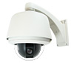
Figure 7.2.1-1

7.2.2 Product #2
Another product similar to this project is known as “The Quintessential Sentry Gun” [32]. While this is not available for consumer purchase since this is a hobby project, it is very similar to the Sentinel Mark I. The packaging is essentially a BB gun mounted on a pan and tilt mechanism with a static camera covering a single field of view. The gun is specifically mounted by compressing it between two blocks of wood that rotate on a dowel rod. The pan and tilt mechanism sits on a platform mounted on a tripod. A lazy susan bearing (Figure 7.2.2-1) is what gives the mechanism its pan ability [32]. Radial bearings connect to the dowel rod which acts as the tilt axis. A linkage is connected to a servo which provides the tilt (Figure 7.2.2-2).
The positive aspects of this design are that it is fairly simple to implement and can be built by hand in one day. It also provides the ability to change weapons with relative ease. The fact that this project was made from wood implies that it is of poor quality. There are several negative aspects. First, there is a great amount of play in the bearings, leading to instability. In addition to this, the tripod is not a very stable base. The linkage system used here is sloppy at best. The camera mount used here can only cover one field of view and is unable to pan to cover other areas.
In our design we incorporated some components from this package. The tilt axis, not the linkage, but the axis itself with the radial bearings will be incorporated in our design in the same way. Also, we incorporate the concept of how to pan the assembly. While we do not use a lazy susan bearing, we use a flange mount bearing, which is used for higher stability applications.
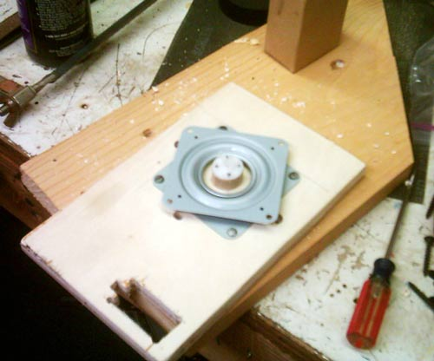
Figure 7.2.2-1

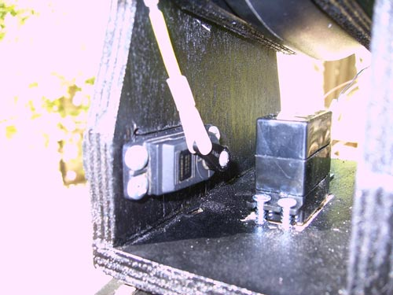
Figure 7.2.2-2

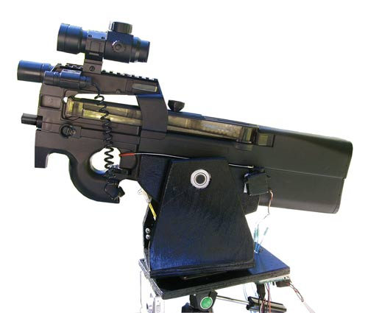
Figure 7.2.2-3

7.3 Project Packaging Specifications
The base of the package will be a box housing the PCB, motor drivers, IR receiver, and the power supply. The dimensions of this are 12” by 12” in area and 8” high. A hole is cut in the center of the top face, where a 1” diameter shaft that is mounted to the bottom metal plate protrudes. The purpose of this shaft is to support the camera and gun platforms and allow for a stationary reference point for the motors to rotate against. The camera platform sits 6” above the base and rotates about the shaft on a bearing which is rotated via a chain and sprocket system connected to the motor. The gun pan and tilt assembly sits 6” above the camera assembly and also rests on a bearing. The pan motor for this platform is directly connected to the center shaft, which allows for pan.
The pan and tilt assembly houses two motors and also the gun. One motor is connected vertically along and directly to the center axis which allows for pan. The other motor will be connected via a chain and sprocket system to the tilt axis shaft. The assembly itself consists of a 6” by 10” platform with two vertical arms 7” in height and 5” in width to support the tilt axis. The tilt axis is a ½” steel shaft, between these two arms and is connected via radial bearings, which are in the vertical arms. The gun sits on the tilt axis and is connected through a simple vice mount. Since the gun used is an Airsoft gun, there is no need to reduce vibration significantly. The choice of the polyurethane chain for the tilt in this assembly will allow for flex in this axis.

7.4 PCB Footprint Layout
The major components to be discussed here are the microcontroller and RAM chips. For the microcontroller, the chip most suited to the project was available only in the 144-LQFP package. Its dimensions are listed on the site as 20 by 20 mm [2]. A RAM chip from Cypress was selected due to its size and price. A chip with 4 megabits comes only in the 44 pin TSOP package, so this one was selected by default. The dimensions of this package are approximately 19 by 11 mm [3]. The entire PCB layout is 5.16” x 5.48”.

8 Schematic Design Considerations

  - Introduction
The Sentry Gun is a security device capable of detecting and tracking movement within its field of view, and aiming and firing an Airsoft pistol based on tracking information determined by a microcontroller. The microcontroller will use 512KB of external memory to run the motion tracking algorithm. The Sentry Gun will include infrared motion sensors to detect rough motion in one of several zones, a digital video camera to track motion more accurately, and infrared receiver diodes to receive friendly detection signals. Positioning of the pan/tilt platform will use a three stepper motors driven by Vexta motor drivers. An SCI user interface will be used in manual control mode.

  - Theory of Operation
8.2.1 Camera
The C3088 camera module is a small PCB with an Omnivision OV6620 CMOS sensor chip, lens, and 0.1” two row male header, providing access to 32 of the 48 pins on the OV6620 chip. This header will connect to a similar header on the main PCB through a 32-conductor female-female ribbon cable. The image sensor chip provides a 16-bit wide parallel bus containing raw video data [3]. Eight of these bits contain luminance data, which will be used as a black-and-white video feed, and the other eight bits contain chrominance data, which can safely be ignored in our system; luminance is sufficient to detect motion except in the case of very specific camouflaged targets. Three clocking signals are supplied to provide timing information regarding frame start and row start times, and an IIC bus is available to configure camera settings, which will be done once, at system startup.
The eight luminance bits of the data bus, along with the three clocking signals and the IIC bus, will connect to the microcontroller through TXS0108E 3.3-5.0V level translators [8]. The image sensor chip requires 5V power, which will be supplied through the header. The camera also provides analog PAL output on a single pin, which will be connected to a monitor display for the user, using a USB TV tuner device capable of decoding PAL video. Analog and digital signals can be used simultaneously.

8.2.2 Microcontroller
The microcontroller, a 144-pin MC9S12XDP512 LQFP, will run in normal mode during tracking and firing operation, at 40 MHz with a supply voltage of 3.3V [2]. The microcontroller will run simple interfacing and control code, as well as the main video processing code, so a high bus speed is desired. The microcontroller will interface with all external peripheral components directly.
In automatic control mode, infrared motion sensors will detect motion in distinct zones, and based on this information the microcontroller will position the pan/tilt platform to keep the camera centered on the relevant zone. The microcontroller will continuously run the motion tracking algorithm, and convert the data from the pixel coordinates into control signals for the pan/tilt motors. Weapon fire will be disabled when a friendly remote control signal is present on infrared diode receivers.
In manual control mode, the user will send information via SCI for pan/tilt motors and fire control directly. In both modes, video will be displayed on a monitor, via the analog video output from the camera.

8.2.3 RAM
The microcontroller requires direct parallel connections to the camera and memory to run the video algorithm. The algorithm will require access to one constant, background image for each region. At 356x292 8-bit pixels, approximately 100kB is required for each image, and the algorithm may be simplified by using multiple images. Only two full-frame images can be stored in 256kB, so the 512KB, 8-bit 44-pin Cypress CY7C1049 SRAM will be used. Addressing for 512kB of memory requires 19 bits, and data requires 8 bits; the microcontroller provides a simplexed expanded memory interface for this. With the additional two control signals required, 29 bits are required to interface with memory [3].

8.2.4 Motors and Fire Control
Three stepper motors will control the pan/tilt axes. Stepper motors require four high-power coil signals each. For two of the motors, these signals will be supplied by 120VAC-powered Vexta stepper motor drivers, and the other motor, the camera pan motor, will be driven by a simpler MOSFET driver. The motor controllers or PLD requires only two input signals (direction and step, at logic levels) from the microcontroller. The PLD converts the direction and step signals to logical coil 1, coil 2, coil 3, coil 4 signals which are then used to switch MOSFETs, in a standard stepper motor driving configuration. The output signals from the PLD will be available on headers, and sent to the drivers. Each stepper motor rotates 1.8º per step in full step mode, which is used for the camera pan, or .9º per step in half step mode, which is used for the gun pan and tilt. This, combined with the approximately 2:1 drive chain ratio on the pan axis, allows the gun to be panned and tilted to an accuracy of less than 1º on both rotational axes.
Weapon fire control will be through an optically isolated GPIO pin used to switch a BJT, which powers a DC motor to control the trigger. This signal will also be available on a header, and sent to the weapon.

8.2.5 Infrared Receivers and Motion Sensors
Infrared receivers [5] will signal the presence of friendly targets. Since these receivers will each trigger an interrupt that disables weapon fire, knowledge of which receiver was activated is unnecessary. When activated, the diodes provide short pulses, and these signals are conditioned to provide pulses at logic levels. The signal conditioning circuitry consists of a simple 2-input 74HC08 device since the receivers are active-low, and is located on a smaller board, connected to the main PCB through headers. The signals provided by the receivers are simple active-low logic signals, so the microcontroller only needs to configure the corresponding pins to trigger software interrupts, which then allow the software to take action when the signal is received. Infrared motion detectors [4] indicate when a moving object is present in one of three regions, and also provide short pulses. For these sensors, knowledge of which sensor has been activated is important, so one bit is required for each sensor. The microcontroller uses this information to position the pan platform to the relevant region. These sensors are connected to the main PCB by headers as well. Again, each signal is a simple active-low logic signal, so the microcontroller can simply configure the corresponding pins to trigger software interrupts, which allow the software to take the appropriate action when a signal is received.

8.2.6 User Interface
The MATLAB-based graphical user interface allows manual control of each motor and the Airsoft gun, displays diagnostic and alert information such as the state of each sensor, and allows the user to switch the device between automatic and manual mode. The MATLAB GUI will use a PC serial port to communicate bidirectionally with the microcontroller’s SCI port, using a simple character encoding to represent commands and events.

8.2.7 Power and Supply Voltages
The onboard power usage is summarized in table 2.31. None of the onboard components are expected to use a significant amount of power; the listed power consumption is the maximum possible under the given electrical connections but typical power consumption is much lower. These low power levels are easily supplied by the included PC power supply.

Part | Voltage (V) | Max Current (mA) | Power (W) | Quantity | Total Power (W)
MC9S12XD  Microcontroller | 3.3 | 1500 | 5 | 1 | 5
CY7C1049  RAM | 3.3 | 90 | .297 | 1 | .297
TXS0108EPWR  Level Translator | 3.3, 5.0 | 50 | .25 | 2 | .5
OV6620  Camera | 5.0 | 16 | .08 | 1 | .08
MAX3232  Level Translator | 5.0 | 152 | .76 | 1 | .76
GAL26CV12B  PLD | 5.0 | 133 | .665 |  | .665
 |  | Total Power Usage on 3.3V rail |  |  | 5.8
 |  | Total Power Usage on 5.0V rail |  |  | 2.0
 |  | Total Power Usage |  |  | 7.8
Table 2.31: Onboard Power Constraints

  - Hardware Design Narrative
8.3.1 Microcontroller Peripherals
The microcontroller must control all other devices, which require approximately 58 output pins in total. Motor control uses seven output pins. Three stepper motors are used, each of which requires two digital signals to control driving circuitry. These signals will be provided on GPIO. A seventh signal is used to control the PLD which isolates the microcontroller from the motor drivers, and all seven of the stepper motor signals use port T. Fire control, infrared receiver, and motion sensors will use five GPIO pins on port AD. The microcontroller will communicate with the user interface using two SCI pins on port J. The camera data interface uses six pins on port M and eight bits on port S all configured as GPIO, as well as one two-pin IIC channel on port J. The memory expansion uses 19 pins on ports A, B and K for address bus, eight pins on port D for the data bus, and one pin on port E for a control signal. The chip will be programmed with a BDM module, using the BKGD pin [2].

8.3.2 Camera Configuration
The camera is capable of sending and receiving control signals using IIC, but does not require an initialization to run. The default running mode of the chip is high frame rate and high resolution, so the camera can be used as a read-only device, with no bidirectional communication necessary. This configuration may be attempted, but it is likely that the camera frame rate and resolution camera settings will be modified at startup to improve performance. This can be accomplished entirely through the I²C bus, and will consist of modifying a small number of registers on the camera chip according to the documentation [1].

  - Summary
The Sentry Gun consists of an Airsoft pistol mounted on a pan/tilt platform controlled by stepper motors. In automatic control mode, the microcontroller receives video data from a video camera, and runs a motion tracking algorithm, which requires the use of external memory. The positioning results of this algorithm are used to position the pan/tilt platform. Motion sensors indicate when rough movement has occurred in a wide region and the microcontroller positions the pan axis accordingly. Infrared receivers indicate the presence of a friendly target, and the microcontroller uses these signals to disable fire control. In manual control mode, the user sends control signals to the microcontroller using a PC-based GUI; motors and weapon fire will be controlled directly. The microcontroller makes use of GPIO, SCI, and I²C ports, as well as RTI, timer, and hardware interrupts.

- PCB Layout Design Considerations

  - Introduction
The Sentinel Mark I’s PCB design is primarily divided into 3 major sections based off power: the power supply headers, components that require 5V supply, and finally components that require 3.3V supply. The MC9S12XDP512 microcontroller, which runs the image processing algorithm, will be the primary component of concern for routing signals because the chip has more pins than all the other components, needs the smallest trace size for routing, and needs many power (3.3V) and ground connections. Other major components that need to be placed around the microcontroller for smooth routing are the GAL26CV12 PLD, RAM chip, and level translators.
  - PCB Layout Design Considerations - Overall
The PCB layout dimensions are 5.16 in. by 5.48 in. (28.28 in.²). The major components in routing the PCB are the microcontroller, GAL26CV12 PLD, the RAM, and level translators. There are two different operating voltages for those components so the PCB layout is subdivided into sections based on operating voltages.
Since the PCB layout is divided based on power; first and the most simplistic of routing are the 5V components: the GAL26CV12 and motor control header, the level translators and the camera header, and the fire control circuitry. The GAL26CV12 and motor control headers along with the fire control circuitry are all placed on the top right of the board, and the video header is placed on the top left of the board. The PLD interfaces with the microcontroller and is oriented so that the signals can be fed from the breakout headers of the microcontroller to the PLD without too much complex routing. The traces for the signals in this subsection are 12 mils from the microcontroller to the PLD and 20 mils from the PLD to the motor control breakout header. The tracing from the microcontroller to level translators and level translators to the video breakout header are predominantly 14 mils. The camera header is the only component requiring an analog ground, thus the PCB is designed so that the analog and digital grounds are separated appropriately. Lastly, the fire control circuitry is put on the edge of the board due to the large amount of heat dissipation from the TIP122 Darlington transistor while the gun is active.
An important thing to mention is that all the motor control circuitry which drives the stepper motors is placed on a separate board; this is primarily because of the heat generated from the IRL530N transistors (which supply 1.2 amps to the motors [33]) used in that circuitry. It would be ill-advised to put this circuitry on the PCB. Also, the IR sensor receiver circuitry for shutting off the sentry gun is placed on a separate board to allow mobility for placement on the packaging.
The microcontroller (operating voltage at 3.3V) is placed in the middle of the layout. The placement of breakout headers around the microcontroller chip allows for direct signal routing on all sides of the chip causing all the more complex routing to be done from all the other components that are interfacing with the microcontroller. The reason for this is twofold. First, the pin spacing is .50 mm and second, there are 144 pins, half of which need to be routed to other components. Using the breakout headers not only allows us to avoid possible signal degradation and noise interference issues rising from convoluted routing of considerably small trace sizes from the microcontroller, but also allows for debugging because the breakout header pins are directly connected to its respected pin on the microcontroller chip. Also, the headers provide an easy way to make every microcontroller signal available on both layers. The trace sizes from the microcontroller to all the breakout headers are set at 12 mils which is the largest possible size to avoid trace overlapping from the pins. The spacing is also approximately 12 mils or more. There is a need for a handful of vias for the bypass capacitors and the oscillator circuit. The via dimensions are chosen to be 25 mils for the drill hole size and 45 mils for the pad size, which are the largest possible given the amount of closely-spaced pins on the smaller chips.
The 3.3V subsection contains not only the microcontroller, but also the RAM. The RAM is placed below the microcontroller. Most of the routing for the RAM is set at 12 mils; a lot of the complicated routing is present here because it greatly simplifies the memory access in software, which can have a significant impact on algorithm speed. The spacing is set also 12 mils or more. There is a need for vias around the RAM because routing for the microcontroller chip was made simpler; these are set at 25 mils for the drill hole size and 45 for the pad size.
All the main power and ground lines are given traces of 100 mils and are placed on the right side of the PCB. Copper pour is placed on the second layer of the right side of the PCB to aid noise reduction of the signals that were routed on layer 2 for the power headers.
  - PCB Layout Design Considerations - Microcontroller
The main component, the MC9S12XD microcontroller, requires a Pierce oscillator circuit that was provided in the documentation [2]. The frequency for the crystal should be 10.00 MHz. There are two 18 pF capacitors in the circuitry. The placement of this circuit will be on the underside of the chip near the EXTAL and XTAL pins on the microcontroller. Another circuit required for the phase locked loop mentioned in the documentation as a filtering circuit which needs 470 pF and 4.7 nF capacitors with a 4.7 kΩ resistor [2]. There are also 7 bypass capacitors at 220 nF recommended for the chip from the documentation placed between the power and ground pins [2]. Ease of routing is essential for this component and so the breakout headers mentioned earlier were used.
  - PCB Layout Design Considerations - RAM
There are 2 bypass capacitors at 220 nF recommended for the chip from the RAM documentation placed between the power and ground pins as close as possible to the chip [3].
  - PCB Layout Design Considerations – Level Translators
There are 2 bypass capacitors at 100 nF recommended for both chips from the TI level Translator documentation placed between the power (on both the 3.3V and 5.0V side) and ground pins as close as possible to the chips [8].
  - PCB Layout Design Considerations - Power Supply
There are two voltage breakout headers (3.3V and 5V) that are all connected to the PC power supply molex connector, which is going to power the entire PCB. They are both given a bypass capacitor of 220 uF protect against current spikes and EMI. The main power lines are set at 100 mils, but are kept to at least 20-60 mils when finer routing becomes an issue. The power traces are kept as large possible and power and ground loops are avoided at all costs.
  - Summary
The PCB layout dimensions are 5.16 in. by 5.48 in. The components are placed based on operating voltages. The component of major concern for routing was the MC9S12XS chip, the solution to keep it simple in that area is with the use of breakout headers. The microcontroller chip has bypass capacitors, an oscillator circuit, and a loop filter placed on the underside. The power supply trace sizes are kept as large as possible, and the use of copper pour will reduce the risk of noise.

- Software Design Considerations

- 10.1 Introduction
The main software considerations for the Sentinel Mark I include the video processing algorithm, motor control, ancillary sensors and the user override interface.
- 10.2 Software Design Considerations
The software was to be written on the Freescale MC9S12XDP512 microcontroller. According to its datasheet, there is a total 32K RAM, 512K Flash and 4K EEPROM available. There is paging available for the Flash (4 pages of 128K), which will be used, if necessary, by this project. The code is primarily stored in Flash, which exists in the local memory between the addresses $4000 and $FFFF and in the global memory map on the addresses 0x400000 to the maximum, with the reset vectors occurring from $FF10 to $FFFF in the local map (0x7FFF10 to 0x7FFFFF globally) [2]. The Flash between $4000 and $8000 and between $C000 and $FFFF is unpaged, while the memory in between those two regions is paged. Code will be stored starting at $8000 in the local memory map. The stack pointer is initialized to $3FFF and will grow down from there as necessary. This should leave a great deal of room for global variables to be stored between $4000 and $8000. Most of this memory will likely go unused. The interface registers are mapped from global address 0x000000 to 0x000367 [2].
There are several peripherals utilized in this program. First, the enhanced capture timer peripheral is used to send control signals to the stepper motors as well as to receive two control signals from the camera: the pixel clock and vertical sync (VSYNC) [1]. The control signals are sent through six pins on Port AD initialized as general purpose outputs via the port integration module (PIM). The timer output compare register, TIOS, is initialized to have at least one channel acting as output compare by setting the corresponding channel’s bit high. The corresponding bits of TIE will need to be set high as well. Two other ports are used as input capture, capturing data on the rising edge, with dedicated interrupt service routines for each signal. To streamline operation, only one of the three timer-related interrupt service routines are active at a time. This means sacrificing the ability to move the motors while also doing video processing. This is counterbalanced by the benefit of very fast video processing. The timer system control registers, TSCR1 and TSCR2, are initialized 0x80 and 0x0C, respectively. This enables the timer, and sets the prescaler to 16, respectively. The value TC7, corresponding to enabled timer channels acting as output capture, is set to achieve a reasonable interrupt rate for clocking the stepper motors [2]. The speed of the individual motors is controlled by changing this register value as needed. The PWM is also utilized to generate a 15MHz, 50% duty cycle signal to send to the camera.
The SCI interface has only one channel activated to accommodate the user override interface. The baud rate registers, SCIBDH and SCIBDL are set according to the fastest possible speed allowed by the terminal on the computer’s end, which is about 115.2 kilobaud. SCICR2 will be set to 0x2C to enable both transmitter and receiver as well as allow interrupts [2]. The fifth bit is cleared in manual control mode and is set in automatic mode. The purpose of interrupt-driven SCI is to allow real-time data reception during automatic operation. This is not needed during manual mode, as program-driven operation is fine. The purpose of bidirectional transmitting is to allow some form of software debugging on the board in terms of sending control and status messages to the user interface upon startup or various errors.
The RTI peripheral, used in reading inputs from the motion sensors and IR receivers, is initialized like it was for the 9S12C32 module in ECE362. CRGINT is set to 0x80 and RTICTL is initialized to 0x70 to allow interrupts approximately every 8 milliseconds, assuming a 10MHz oscillator is still used. The XEBI (external bus for the S12X family) will be used to interface to the external SRAM on the board via ports A, B, D and parts of K as well as PE2 (the R/W signal). EBICTL0 is initialized to 0x16 to give 20 bits of addressing and normal threshold levels [2].
The code is organized as a hybrid model, with both round-robin polling of peripherals and interrupts being utilized. The reason for this is that while most of the operations may be done by polling, some things such as override commands from the friendly detection and user interface will need to be able to stop the device from targeting and/or firing upon command. Peripherals such as motion sensors may be polled because the micro will be running fast enough to catch a change of state before it goes away.
  - Software Design Narrative
The code is organized into four main blocks: video processing, motor control, ancillary sensing and user override interface. The video processing is only called upon a trigger from the ancillary sensors and is responsible for capturing a target image and determining the target coordinates. The motor control block is responsible for moving the pan/tilt assembly and camera platform in either automatic or manual override control modes. Ancillary sensing encompasses the motion sensors and friendly detector and is responsible for notifying the machine that a given sensor was tripped. The user override interface is responsible for toggling between the manual and automatic modes as well as full control over the machine during manual mode operation.
The main program does all of the initializations of global variables and peripherals, which are stored in a separate file. It then enters an infinite loop containing two sub-loops: one for manual mode and one for automatic mode. The default operating mode will be manual, whereupon the user will have to define a “zero” or home position as a reference for the position tracking of the stepper motors. This ought to be done manually so that the machine knows which way is “forward”. An interrupt from the SCI containing a toggle command between manual and automatic modes will switch this. Upon switching from manual to automatic mode, a routine will be run to capture background images.
In automatic mode, the code will poll the motion sensors for a change from low to high and enter the automatic targeting routine. The motor control code will move the camera to the region where the motion sensor was tripped. After this, the video processing software will capture an image of the target area and then run a subtract and threshold algorithm to determine where a target exists. Another algorithm will run to determine the center of the region where greatest difference exists. At certain points in this loop, the code may get commands via interrupt to stop what it is doing and enter manual mode. Specifically, those points are between ancillary detect notification and running the video algorithm, and right before the weapon is fired. If at any point during the automatic detection mode, a friendly detect flag is set, the assembly will return to its center position, the gun will be pointed downward and control will revert to manual mode.
In manual mode, the loop will wait for commands received from the user interface and then execute actions based upon predetermine codes sent to the device. The ancillary sensors and image capture/video processing will not be active during this mode and the motors will rely solely on commands from the user to move. Only a certain “revert to automatic mode” code will cause the program to break out of this sub-loop and enter the other.
Video processing, once again, will only run when the device is in automatic mode and an ancillary detect signal has been sent. Upon entering the CaptureImage() subroutine, the software will disable the output compare interrupt on the timer peripheral and enable the input capture port responsible for sensing VSYNC signals. Once such a signal has been received, that interrupt will be disabled and another input capture interrupt is enabled to read pixel data to RAM for a predetermined number of pixels. This is known from the OV6620 data sheet [1]. Once this has completed, the software will run a pixel-by-pixel subtract and threshold algorithm based on various algorithms found online. The listed algorithm also has the ability to determine the location of the target [34]. This code is developed but is non-functional due to hardware issues with the RAM interface.
Motor control will operate in one of two ways, depending on if the main program is running in manual or automatic mode. If it is in manual mode, then the software will wait until it receives a command relating to moving one or more of the motors. When this happens, it will call the correct motor control routine, which either steps the motor once or moves it to some absolute location. This routine will get the current position of the motor to be moved, check to see if it is at a preset limit, then either move to the new position and store it or do nothing. The position of the motors, in general, will be tracked based on an initial “zero” or “home” position defined at startup. The current position will be tracked by incrementing or decrementing a counter for each motor, once for each step of the stepper. For example, every step panning left adds one to the pan counter and vice-versa for right. One important thing to note is that when panning in manual mode, both the assembly and camera platforms may be moved left or right concurrently to allow the user to keep the targeting reticule lined up with the camera’s viewing angle. This will not necessarily happen in automatic mode. The speed of stepping in manual mode will also be slower than that in automatic mode. This is due to the speed of manually sending step commands being significantly slower than the step signals being sent when automatically moving to an absolute position.
In both cases, the speed of the motors will be controlled by a stepping clock generated by the timer module. The speed of stepping can be simply varied by changing the value of TC7 depending on which motor needs to be moved.
The ancillary sensing block will occur almost entirely within the RTI interrupt and main automatic mode operation polling block. Much like the pushbutton debouncing done in ECE362 labs, the RTI will look for a change of state corresponding to going from low to high for the motion sensors and going from high to low and the friendly detection sensors staying low for a certain amount of polls. This is done by tracking the last eight states of the receivers in an eight-bit register, then setting a flag when all eight bits are zero. The purpose of this, especially for the friendly detection sensors, which are infrared receivers, is to reduce some of the noise due to ambient sources of light radiation. The RTI interrupt will set flags, which will be polled by the main program.
The user override interface encompasses several files already mentioned, and will exist partially in main and a separate file which exists for the purpose of keeping main from getting very long. Further elaborating upon the functionality of main, this block will be activated when an override command is received through SCI to put it into the manual control loop. From there, it will wait for commands from the user to do various actions. For example, the command may be “move left” which will cause the pan/tilt assembly and camera platform to move to the left concurrently per the method described in the motor control block. The commands will be one-character signals which will then be run through a switch statement to find the proper action, located in DoCommand().
All ISR code may be found in isr_vectors.c. There are three service routines for the RTI, SCI and timer modules as well as initialization functions for all utilized parameters within this file.

- Version 2 Changes

Our project suffered from the use of several components, when we were unaware of more appropriate products that were available. The C3088 camera module, with OV6620 image sensor, caused two main problems: we were not able to communicate over the I²C bus, and the analog video output was PAL format, which made debugging the video system difficult. Other than bare image sensor chips, there are not many camera modules available, so the choices were extremely limited. However, a similar module with NTSC analog output was available, which probably would have been a better option.
Another component that caused a lot of trouble was the Analog Devices ADG3300 level translator; we misread the documentation and placed it incorrectly on our PCB, but even after we found this error, the chips did not work well; they are extremely sensitive to power supply connections and we destroyed many of the level translators while testing them, which made debugging extremely difficult. We eventually replaced the level translators with Texas Instruments chips, which worked much better. Unfortunately, we lost a significant amount of time identifying the problems related to the ADG3300s: if we had chosen a better product sooner, we would have had several additional weeks to work on the rest of the project.
Our initial design involved using an Analog Devices DSP, and later a Freescale DSP. Neither of these options seemed to work well, so we eventually switched to a Freescale microcontroller, which was much easier to design with. Our choice of the Analog Devices DSP was motivated by the availability of a development board, but we should have made the decision based on the merits of the chip. We later received a development board for the Freescale microcontroller, but we were nearly done with the design phase by that point. We should have chosen a microcontroller much sooner, and should have asked for a development board donation much earlier in the semester. This would have allowed us to develop code and test electronic interfaces before committing to a PCB design, improving our productivity over the course of the entire semester.
We lost too much time trying to debug components when we should have simply found replacements and moved on. We were hesitant to make moderate design changes on the PCB, but in retrospect we would have probably saved time by switching to the better components sooner.

Summary and Conclusions

Our group faced many rigorous challenges throughout the semester in developing our digital system. The primary challenge was the selection of components and the necessary speeds for the various applications we are using with the peripherals. If there is one very important thing we’ve learned, it is to always select components that have responsive manufacturers when help is needed in interfacing with them. The next most important thing learned was the design of a PCB, OrCad Layout was a program with many glitches, but with the right amount of time invested and patience, it can actually be worked to one’s advantage. Finally, our last challenge was the interfacing with our video and RAM. We got to communicate with the RAM using the external bus interface, but a lot of time was lost in figuring that out. Problems with our design always started with hardware and gradually propagated to software. We also learned about how important a patent, safety/reliability, and environmental/political analysis not only affects the way how our project may have been completed; but raise issues that are important in industry today.

References

[1] Omnivision OV6620 Sensor Data Sheet
http://www.cs.cmu.edu/~cmucam/Downloads/ov6620DSLF.PDF

[2] Freescale Semiconductor, “MC9S12XDP512 Data Sheet,” [Online Document], July 2007, Available: http://www.freescale.com/files/microcontrollers/doc/data_sheet/MC9S12XDP512V2.pdf

[3] Cypress, “cy7c1049dv33 Data Sheet,” [Online Document], July 23 2007, [cited April 22, 2008],
http://download.cypress.com.edgesuite.net/design_resources/datasheets/contents/cy7c1049dv33_8.pdf

[4] Futurlec Motion sensor product page, Item SB0061
http://www.futurlec.com/PIR_Module.shtml

[5] Panasonic PNA4614M00YB IR sensor data sheet
http://beta.octopart.com/Panasonic__PNA4614M00YB__0.pdf

[6] IR multiplexer
www.nxp.com/acrobat_download/datasheets/74F08_2.pdf

[7] Vexta Drivers product page
http://catalog.orientalmotor.com/item/all-categories/stepping-motor-drivers/udk2120a?&plpver=11&origin=keyword&by=prod&filter=0

[8] Texas Instruments, “TXS0108E 8-bit Bidirectional Voltage-level Translator for Open-Drain and Push-Pull Applications,” [Online Document], December 2007, Available: http://focus.ti.com/lit/ds/symlink/txs0108e.pdf

[9] A. Rasmussen, “How we built the quintessential sentry gun” [Online document], 2007 Sep 20, available HTTP:
http://www.TheSentryGun.com

[10] P. Solari, H. Miller, S. Spencer, "Camera tracking moveable transmitter apparatus,” US Patent 4,905,315, Feb. 27, 1990

[11] K. Choi, “Sentry robot,” US Patent 20,070,208,459, Feb. 27, 2007

[12] D. Crane, “Samsung Developing Armed Sentry Robot for Security Missions
(Video!),” defensereview.com, Nov. 13, 2007. [Online]. Available: http://www.defensereview.com/modules.php?name=News&file=article&sid=950
[Accessed : Mar. 23, 2008]

[13] M. Bianchi, “Automatic tracking camera control system,” US Patent 5,434,617, Dec.
12, 1995

[14] US Code: Title 35,154, “Contents and term of patent; provisional rights.” [Online]. Available: http://www.law.cornell.edu/uscode/35/154.html

[15] US Patent Office, “2701 Patent Term [R-2] – 2700 Patent Terms and Extensions.” [Online]. Available HTTP: http://www.uspto.gov/web/offices/pac/mpep/documents/2700_2701.htm

[16] Department of Defense, “Military Handbook, Reliability Prediction of Electronic Equipment,” [Online Document], 1991, Available: http://cobweb.ecn.purdue.edu/~dsml/ece477/Homework/CommonRefs/Mil-Hdbk-217F.pdf

[17] Lattice Semiconductor Corporation, “GAL26CV12 High Performance E²CMOS PLD Generic Array Logic,” [Online Document], 2000, Available: http://www.latticesemi.com/lit/docs/datasheets/pal_gal/26cv12.pdf?jsessionid=ba305f3ee353$7F$0E$3

[18] Fairchild Semiconductor Corporation, “TIP120/121/122,” [Online Document], 2001, Available: http://www.fairchildsemi.com/ds/TI/TIP120.pdf

[19] Maxim Integrated Products. Dallas Semiconductor, “3.0V to 5.5V, Low-Power, up to 1 Mbps, True RS-232 Transceiver Using Four 0.1µF External Capacitors,” [Online Document], January 2007, Available: “http://datasheets.maxim-ic.com/en/ds/MAX3222-MAX3241.pdf

[20] IEEE.org, “IEEE Code of Ethics,” [Online Document] , February 2006, [cited April 5, 2008], http://www.ieee.org/portal/pages/iportals/aboutus/ethics/code.html

[21] PCWorld.com, “Privacy Watch: Protect Your Data, System With a Fingerprint Reader,” [Online Document], March 17, 2006, [cited April 9, 2008], http://www.pcworld.com/article/id,125115/article.html

[22] CascadeTek.com, “A2LA-Accredated-Test-Lab,” [Online Document], May 29,
2007, [cited April 9, 2008],
http://www.cascadetek.com/downloads/A2LA-Accredited-Test-Lab.pdf

[23] CascadeTek.com, “ISTAcert.pdf,” [Online Document], no date stated [cited April
9, 2008], http://www.cascadetek.com/downloads/ISTAcert.pdf

[24] CascadeTek.com, “DSSCapprov.pdf,” [Online Document], Feb 2,
2007, [cited April 9, 2008],
http://www.cascadetek.com/downloads/DSCCapprov.pdf

[25] Printed Circuit Board Manufacturing, International Network for Environmental Compliance and Enforcement, [Online Document], 2002 July, [cited April 5, 2008], http://inece.org/mmcourse/chapt7.pdf

[26] Environmental Impacts and Toxicity of Lead Free Solders, [Online Document], unknown publication date, [cited April 5, 2008], http://leadfree.ipc.org/files/RoHS_16.pdf

[27] EPA.gov, “Flame Retardants in Printed Circuit Boards Partnership,” [Online Document], December 19, 2007, [cited April 5, 2008], http://www.epa.gov/dfe/pubs/projects/pcb/index.htm

[28] rand.org, “Biometrics A Look at Facial Recognition,” [Online Document], 2003, [cited April 9, 2007], http://www.rand.org/pubs/documented_briefings/DB396/DB396.pdf

[29] EPA.gov, “Basic Information Climate Change,” [Online Document], April 1, 2008, [cited April 9, 2007], http://www.epa.gov/climatechange/basicinfo.html

[30] Printed Circuit Board Recycling, [Online Document], May 2003, [cited April 5, 2008], http://p2library.nfesc.navy.mil/P2_Opportunity_Handbook/2_II_8.html

[31] EZWatchSore.com, “EZ Watch Pro- EZ Track PTZ Dome,” [Online Document], 2006, [cited April 22, 2008], http://www.ezwatchstore.com/ptz-cameras.php?s_kwcid=pan%20tilt%20camera|593199256

[32] Thesentrygun.com, “How We Built the Quintessential Sentry Gun,” [Online Document], Oct. 27 2007, [cited April 22, 2008], http://www.thesentrygun.com/

[33] Oriental Motors, “Unipolar Stepper Motor Data Sheet,” [Online Document], Available:
http://www.jameco.com/Jameco/Products/ProdDS/237631.PDF

[34] Wauthier, Fabian. “Motion Tracking.” School of Informatics, University of Edinburgh fourth year honors project, available HTTP: http://www.anc.ed.ac.uk/demos/tracker/
Appendix A: Individual Contributions

A.1 Contributions of Ian Alsman

This member of the project was given the task of designing and building the packaging and assembly, as well as, integration of the motors into the assembly. There were several hurdles this member had to face in this contribution to the product including, the selection of materials, the selection and finding of components, the torque speed characteristics of the motors used along with the weight of materials used, and the integration of motors into the design. In the selection of materials aluminum and steel were chosen over the alternative of plastic or wood due to their structural rigidity, the ability to be precisely manufactured, and their weights. When choosing which motors to use, it was very important to build the assembly with the motors in mind as well as choosing the motors to match the weights and torque induced by the assembly. In integrating the motors into the design, there were many drive systems which were considered: several gearing systems and chain and sprocket methods. In the end the chain and sprocket were chosen due to research and speaking with engineers in the field. The design of the product was done mainly with CAD software. This software was used to design each part of the physical structure and ensure that these parts meshed together once produced. Once the product was designed and the parts were chosen, this member of the team oversaw and worked on the majority of the build. This member used a machine shop as well as personal tools and equipment in building the structure.
This member was also given the task of developing and building the motor drivers. For the main platform’s pan and tilt motors this task was made remarkably simpler since this member spoke with a company and received donations to the product, which included the drivers used for these functions. The only driver this team member needed to build was the driver for the camera pan. After several weeks of looking up drivers and from many failed tests, this driver circuit was finally functional on a breadboard. This driver needed to be put on a breakout board and this was this member’s responsibility as well.
This member also contributed to the PCB layout and design. While the majority of the work, routing, and soldering was done by other members of the team, this member did help in a significant portion of this process.
This member was also given the responsibility of completing the Packaging Specifications and Design and Ethical and Environmental Impact Analysis homeworks. This responsibility was delegated by the team at the beginning of the semester. Along with those assignments, this team member gave the TCSP presentations for both of these subjects.

A.2 Contributions of Alan Bernstein:

In the conception and design phase of the project, I helped make decisions regarding main components, including the switch late in the semester from our DSP/separate microcontroller design to a single, larger and faster microcontroller design. In this phase of the project I also researched choices for camera components, as well as methods of implementing the video-tracking algorithm in our system. As an extension of this responsibility, I also contributed significantly to the circuit design, mainly the digital interfaces between the microcontroller, memory, camera and motor control block, as well as basic microcontroller support circuitry (oscillator, PLL, reset circuit, debug header).
Before we received our first PCB, we tested most of our components on breadboards, which involved the use of small breakout PCBs, and figuring out the interfaces for the components. After I soldered components onto the breakout boards, I did a lot of the electronic testing work with Ilya. Eventually this work was also done on the development board we received from Freescale, and with the help of Ilya’s work learning to use the kit with Codewarrior over spring break, I also worked with Ilya to test components on that board.
I did a significant amount of work on the layout for our PCB, in both iterations. Our second design involved totally different components, so the entire layout and routing had to be redone from scratch. I made many of the decisions regarding the layout and placement of components on the PCB, in addition to completing most of the trace routing and learning the details of working with OrCAD Layout. This includes finding/creating part footprints, controlling physical sizing settings, ensuring the layout followed basic fabrication constraints (DRC issues), and generally working with and learning the software.
When we received our PCB, I did the majority of the soldering; after soldering breakout boards and unrelated chips for practice, I was the most comfortable with soldering the surface mount components, and I got to be pretty fast with soldering so I did the rest of the components as well. I also did the few flywires and trace cuts that we needed. When we received our second PCB I again did most of the soldering.
Ian designed the packaging and mechanical assembly on his own, and then acquired the materials and hardware necessary to construct it. I provided the group with access to a small machine shop (thanks to my roommate), and the physical labor of constructing the assembly was split between me, Ian, Darshan and my roommate fairly evenly. Later on this work also included the construction of a large number of electrical connections; we were fed up with finding faulty connections to be the causes of our problems, so we tried to build cables using more reliable connectors.
While Ilya did the majority of the software work, I helped some with software structure design choices, and I tested a few algorithms and interfaces on the microcontroller. I also created the control GUI using MATLAB.
I completed the first Professional Component Homework assignment, the Design Constraint Analysis and Component Selection Rationale, and the second Design Component Homework assignment, the Hardware Design Narrative and Preliminary Schematic, as well as giving the Technical Communication Skills Practicum presentations associated with both assignments.

A.3 Contributions of Darshan Shah:

During the design phase and prior to the semester’s start, I helped the team in by researching many of the closely related projects out there for the sentry turret. I found many websites and our initial test assembly was based off one of them. We created our initial design off one of these hobby projects and evaluated the pros and cons of it. Many changes were made to our design throughout the beginning of the semester.
Once the hardware phase of the project had begun, I made sure our team had the necessary components to start testing and I also made the initial attempt to get a development board so that we may start implementing some of the software. I put in a lot of time for the PCB because it was primarily what I was delegated. Learning OrCAD layout in itself required a lot of time dedication, and I had when through numerous tutorials that had been passed back and forth in lab. Alan had also had a significant role in the PCB design; he and I had worked together to make sure we made the most robust PCB ensuring we would not have any ground or power loops and that the traces were thick enough so that there is no signal degradation.
I also tried to figure out the best way to get video output so we can see what we are targeting with our camera. Using the analog output, I tried to feed that into a USB TV tuner, but the tuner demodulated a signal at baseband so that didn’t help. The solution was to use a TV that Barrett Robinson had which was capable of handling a PAL signal (but it was not at the best quality).
Once the PCB had arrived our primary goal was to get the motor control working, I had a hand in developing the state machine for one of the motors (which used a homemade driver and not one provided by the vendor) on a GAL device. Once the motor control was up and ready one of our PSSCs were completed.
I helped Ian assemble some of the test assembly and the final assembly, and also built the housing for motion sensors so that not more than one is tripped when Sentinel Mark I is in auto mode.
Also I helped debug the issues we were having with the fire control. For some reason the gun was not firing when the microcontroller was sending it a signal. After talking with many people we had learned that the motor needed a 6A diode as a flyback.
I helped the team in trying to figure out different ways to interface with the camera without using I²C, and helped debug issues that came with our second iteration PCB.
I completed the Printed Circuit Board Layout Narrative plus the Preliminary PCB Drawing and the Reliability and Safety Analysis homework assignments as well as the Technical Communication Skills Practicum Presentations that went with them.

A.4 Contributions of Ilya Veygman:

Prior to the semester beginning, I was responsible for coming up with the original concept of this project, which was far different from the final design that we ended up with in its execution. Early in the semester, I worked on making the choices on the DSP and later microcontroller that was used as the central core of the circuit board of the sentry gun. Also early in the semester, I helped Ian build the wooden, prototype assembly which became the basis for our current one.
While Ian worked on the mechanical components and motor driving circuitry and Alan was working on the camera-related things, I was working on the planning for the motion sensor circuits and the infrared remote control receiver devices that would make up the friendly detection circuit. I bought several components toward both of these ends and toyed with several different approaches until something was finalized toward the end of the semester. I built the infrared remote transmitter that was to be used with the receivers using my ECE 362 microcontroller and other off-the-shelf components.
I designed the first version of the fire control circuit based on a lab from ECE 362, and later worked with Alan and Darshan to debug the noise that the gun was inducing inside the circuit. This was fixed using a high-current flyback diode. While doing this, I also helped the two of them on the schematic and PCB design. I helped to make a few of the component choices for our board: specifically that of RAM, RS-232 level translator, the fire control circuitry, the oscillator, and some of the glue logic.
Once the development kit came in from Freescale, Ian got it from Alan, then dropped it off at my house over spring break so I could learn how to use it. I had mostly mastered its use with CodeWarrior and began working on software when I got back to campus after break was over. I was responsible for the majority of the software work, although Alan helped with some of it, especially the GUI. I developed the majority of the interrupt software, the motor control, the fire control, the video reading software and the ancillary/friendly sensing software. Alan helped me with the SCI software used to send debug messages and debugging the RAM.
I was responsible for the Software Design Considerations and Patent Liability Analysis homeworks in addition to giving the TCSP presentations related to these. I helped to make several of the PowerPoint presentations in these, and the videos for the final presentation.
Appendix B: Packaging
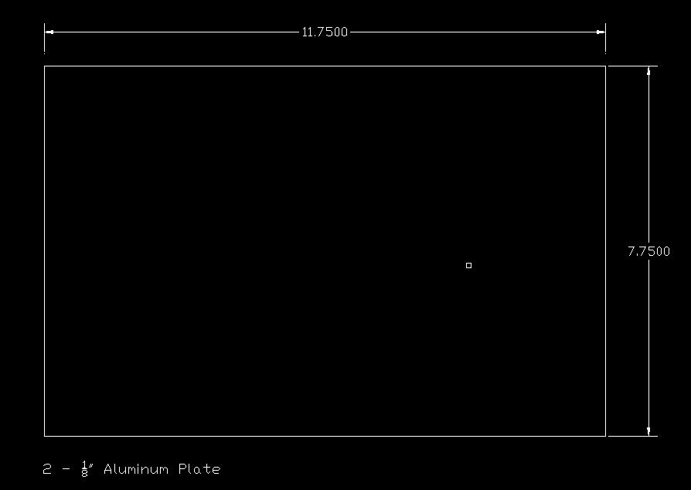
Figure B-1: CAD Drawing - Side View of Base

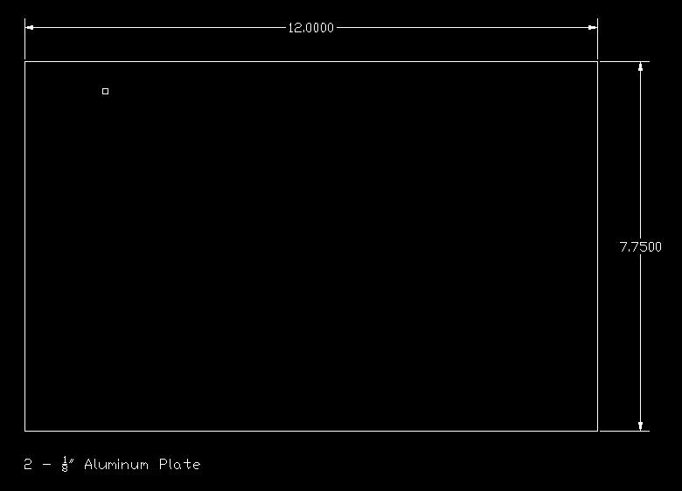
Figure B-2: CAD Drawing - Side View of Base
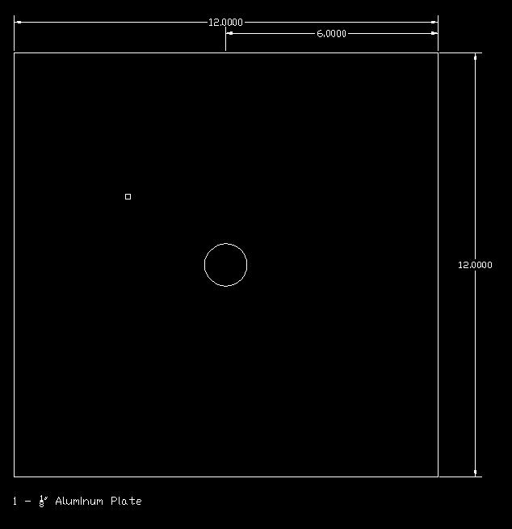
Figure B-3: CAD Drawing – Top View of Base

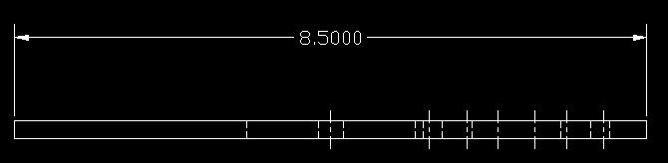
Figure B-4: CAD Drawing – Front View of Camera Platform
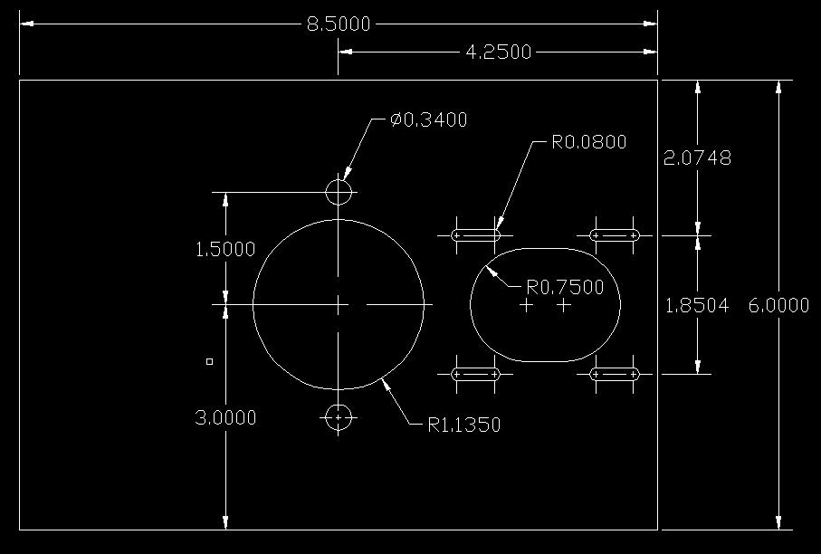
Figure B-5: CAD Drawing – Top View of Camera Platform

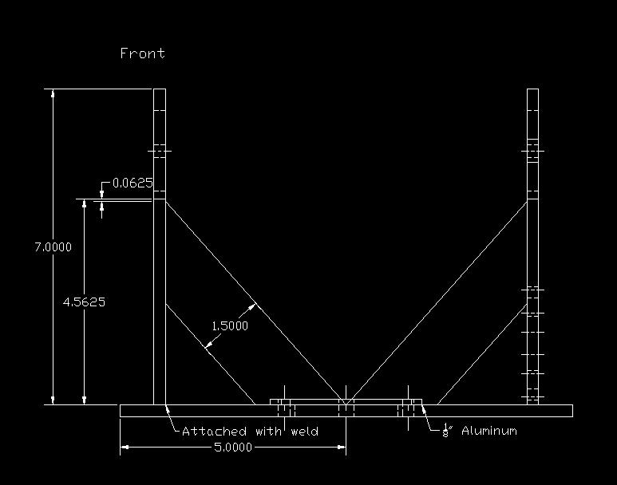
Figure B-6: CAD Drawing – Front View of Main Gun Platform
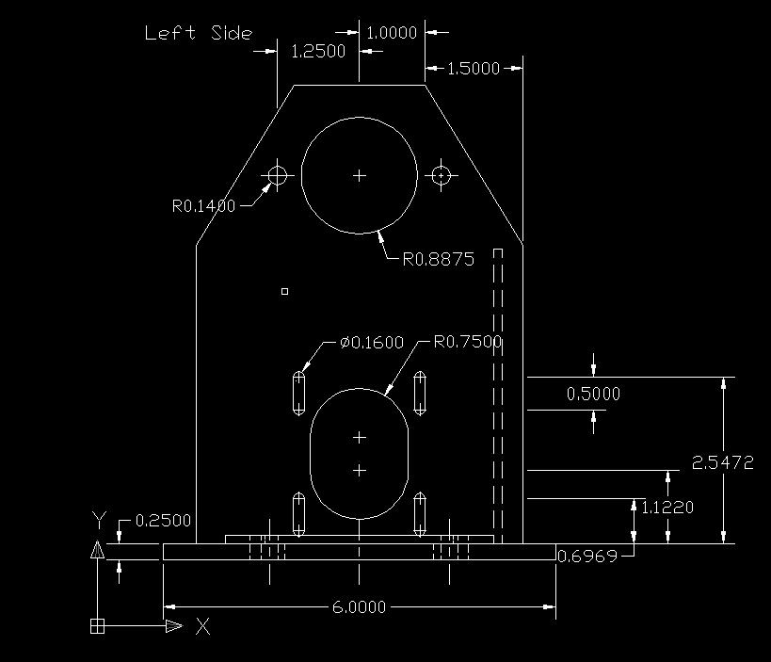
Figure B-7: CAD Drawing – Left Side View of Main Gun Platform

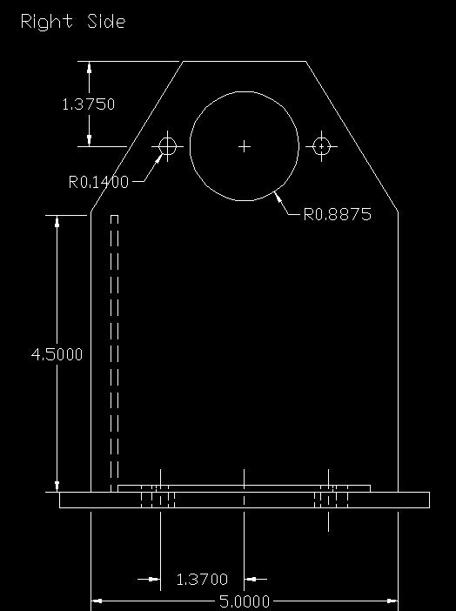
Figure B-8: CAD Drawing – Right Side View of Main Gun Platform
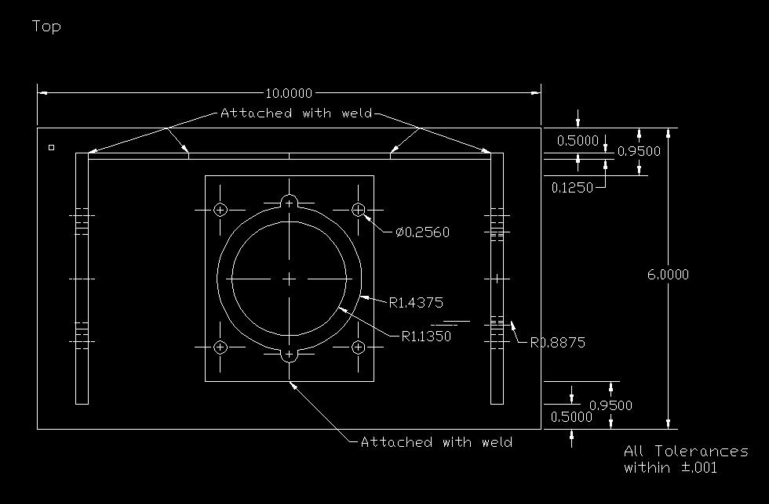
Figure B-9: CAD Drawing – Top View of Main Gun Platform

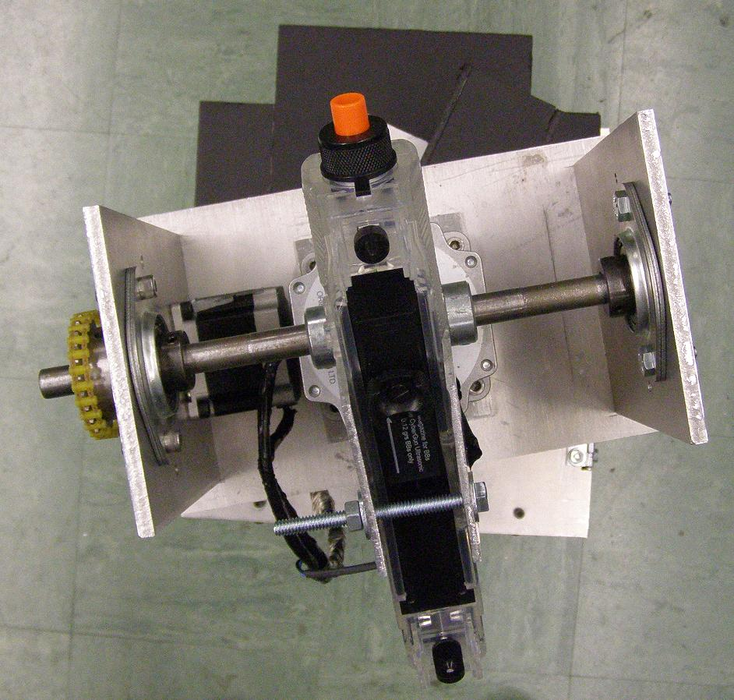
Figure B-10: Top View of Product Packaging.
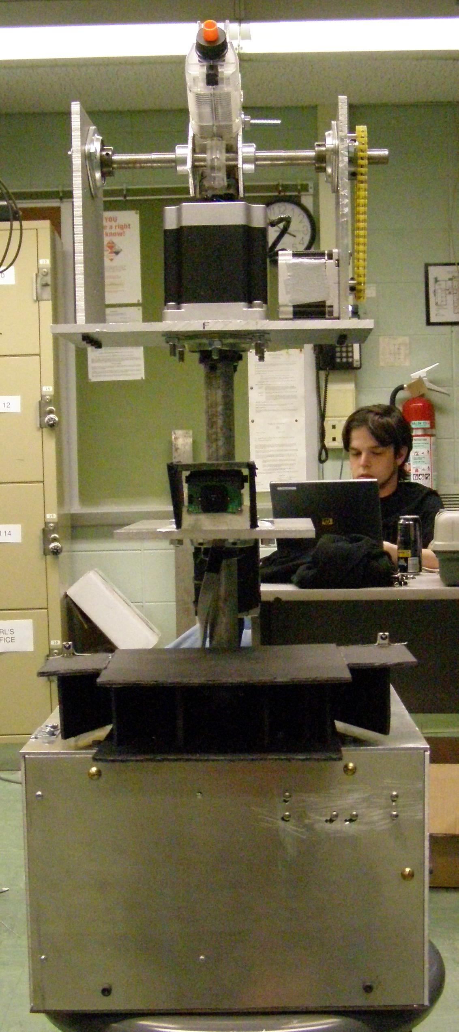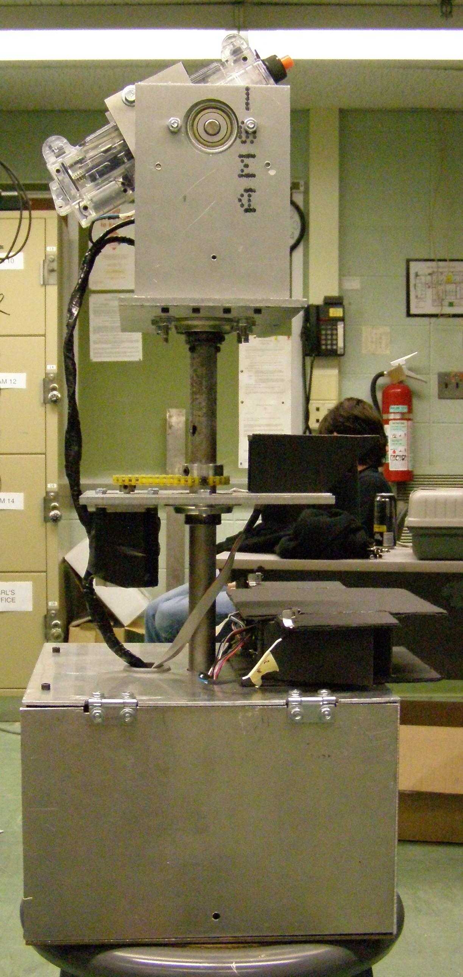
Figure B-11 Front View of Product Packaging. Figure B-12: Side View of Product Packaging.
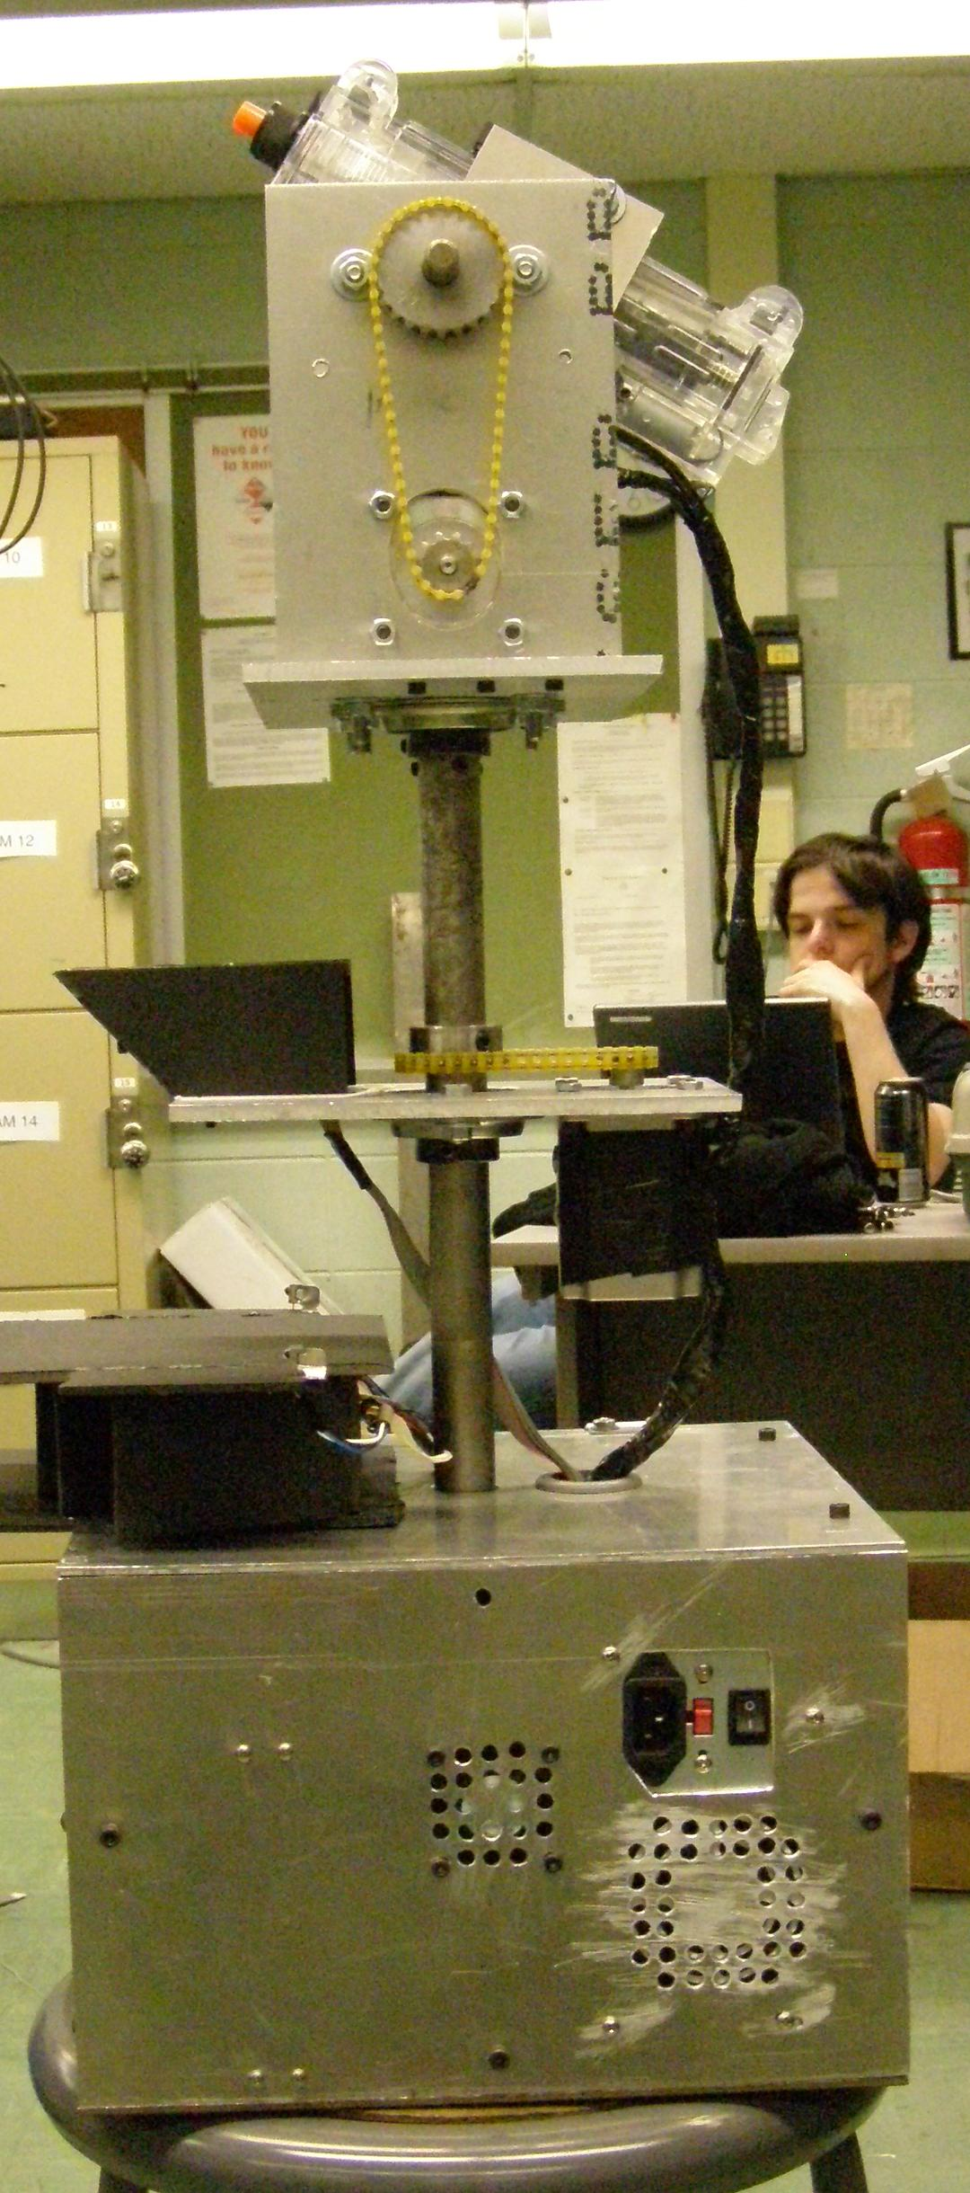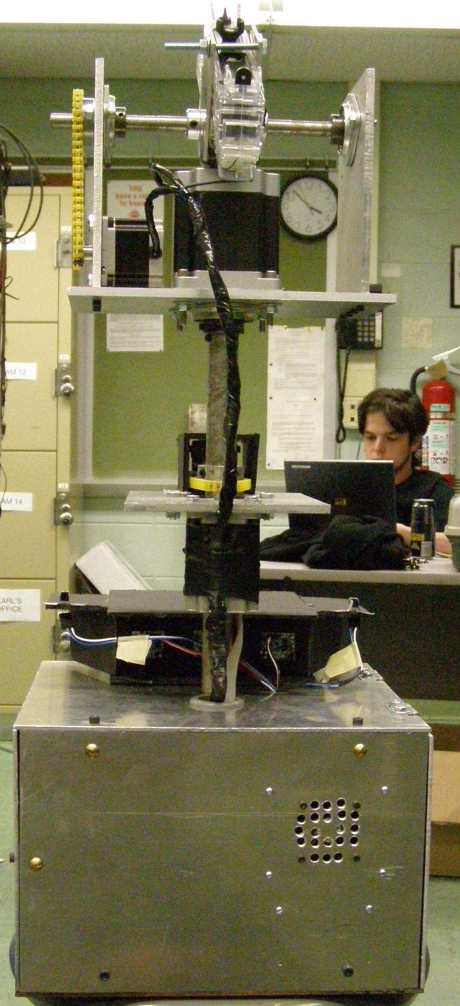
Figure B-13: Rear View of Packaging. Figure B-14: Side View of Packaging.
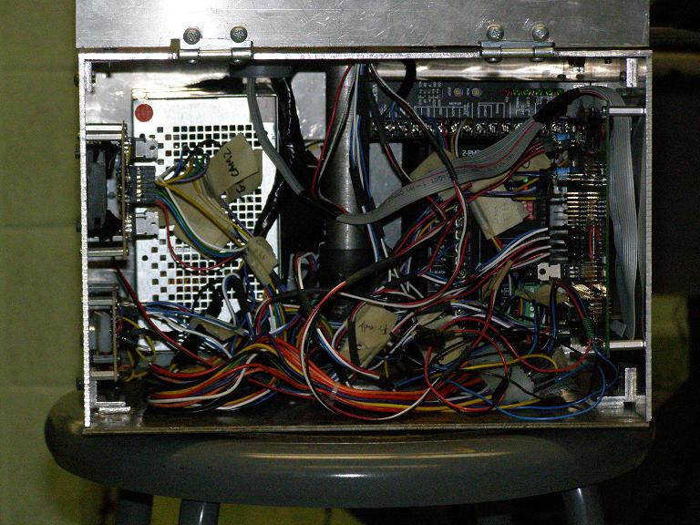
Figure B-15: Inside View of Product Base

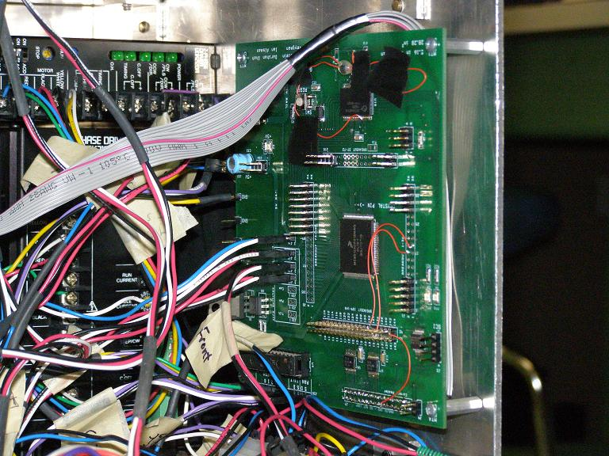
Figure B-16: View of PCB in Base
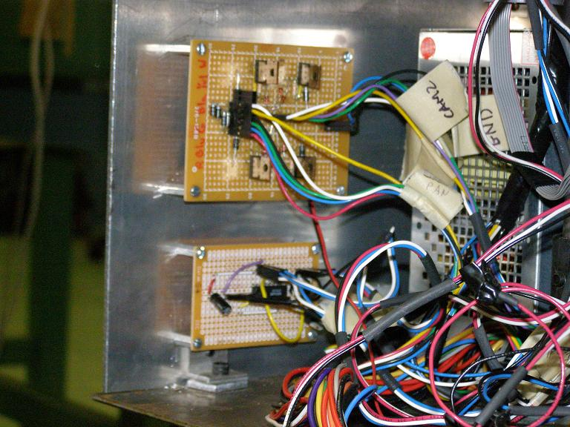
Figure B-17: View of Driver Circuitry and IR Receiver Circuitry in Base

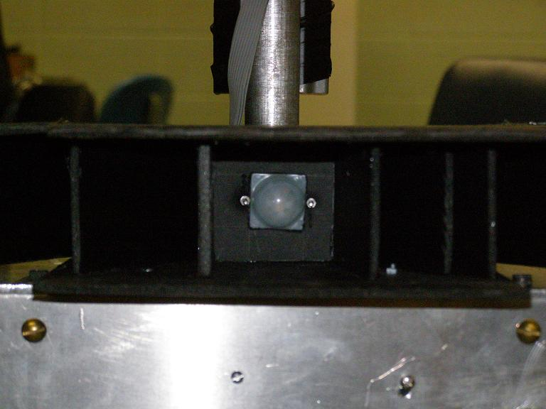
Figure B-18: Front View of Motion Sensor Housing
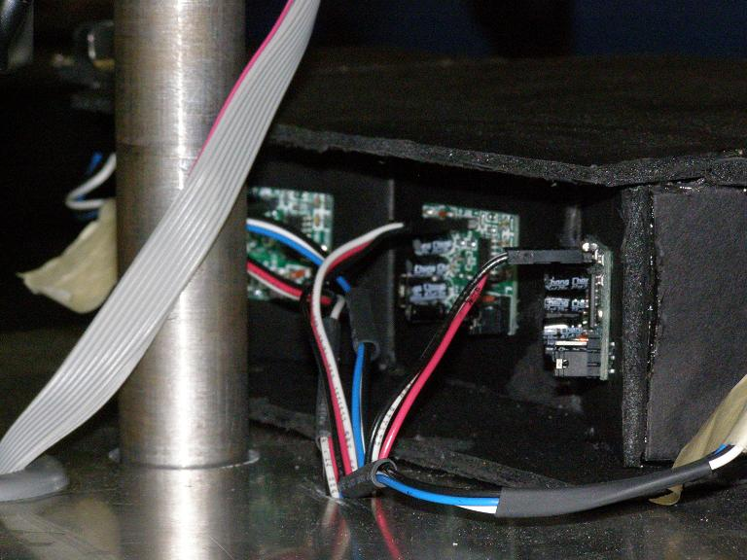
Figure B-19: Rear View of Motion Sensor Housing

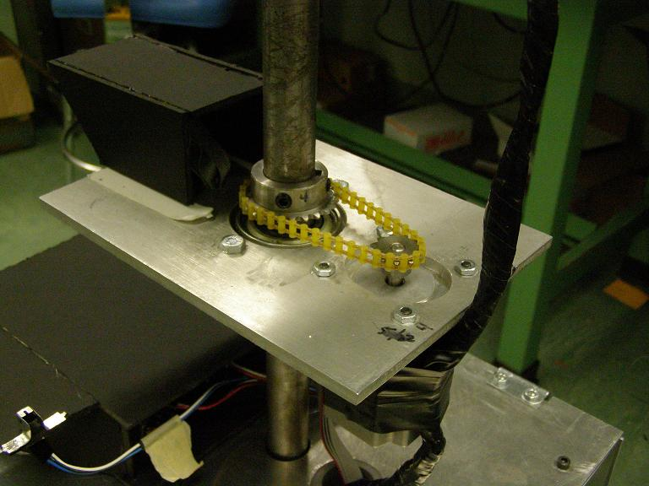
Figure B-20: Rear View of Camera Housing and Camera Platform Chain Drive
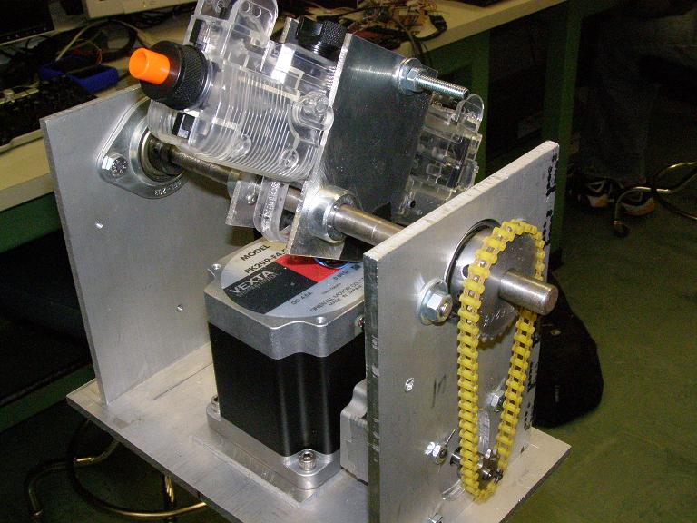
Figure B-21: View of Gun Mount and Tilt Chain Drive

Appendix C: Schematic

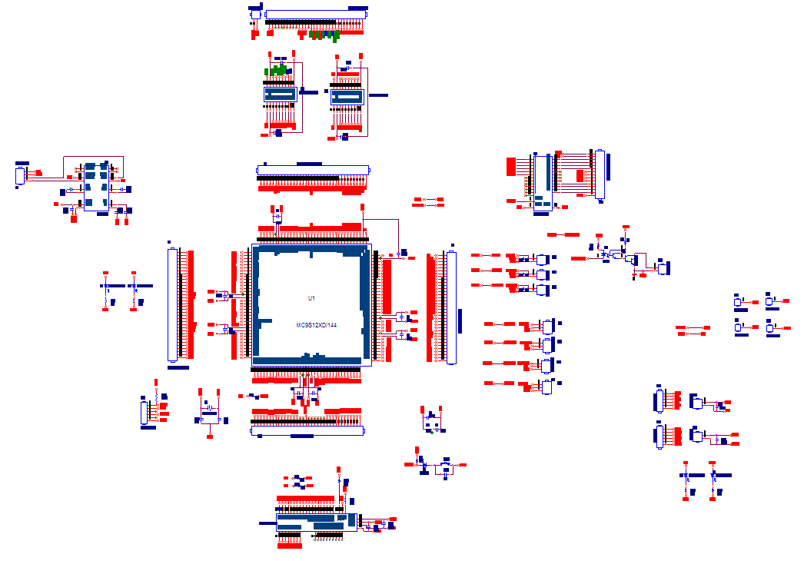
Figure C-1
Overall Schematic
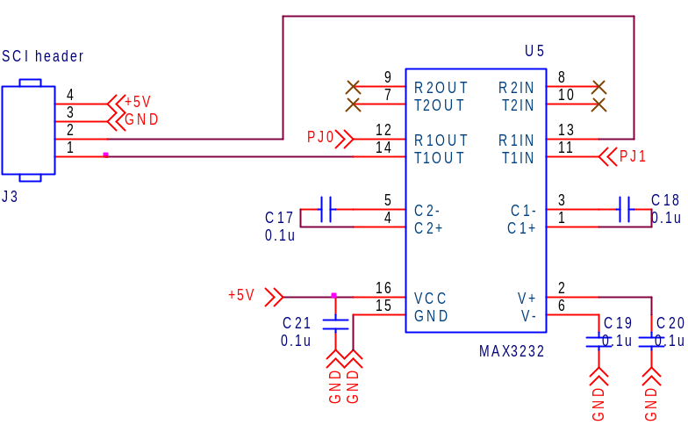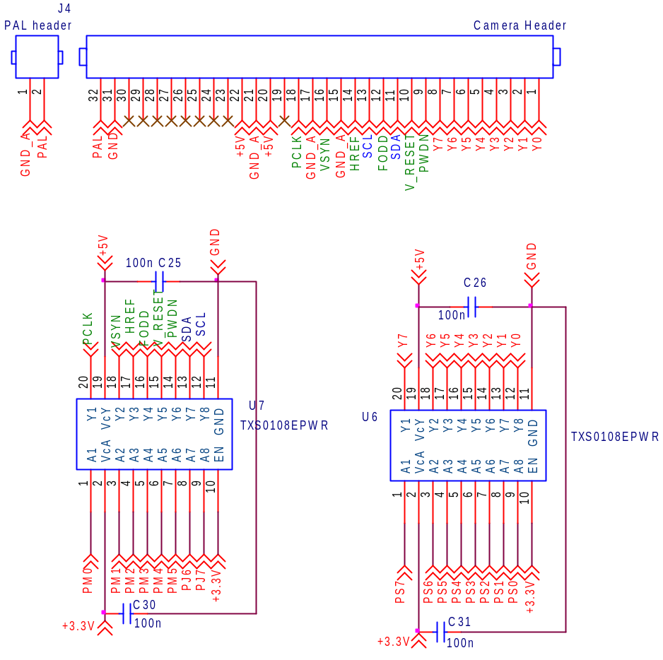
Figure C-2
RS-232 Level Translator
Figure C-4
3.3-5V Video Level Shifters
Figure C-3
Video Header
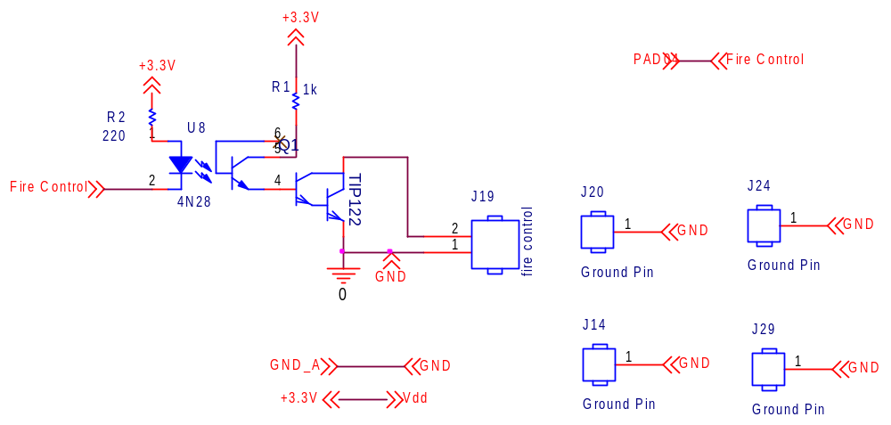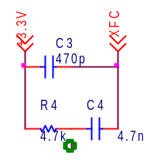
Figure C-6
Loop Filter
Figure C-5
Fire Control Circuitry and Ground
Pins

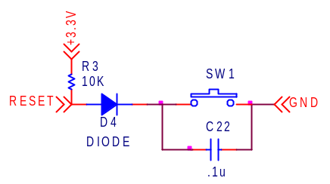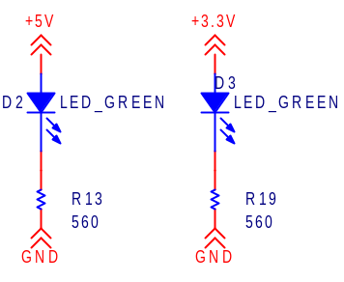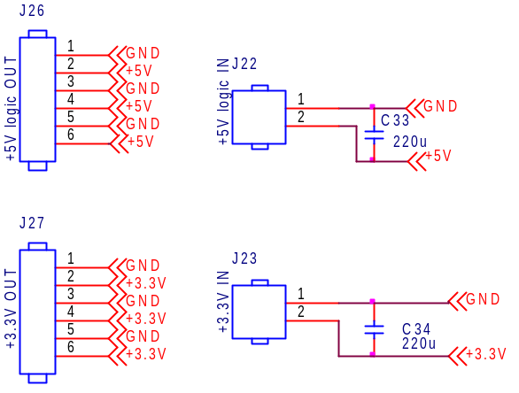
Figure C-7
Reset Circuit

Figure C-8
Power Indicator LEDs
Figure C-9
Power Headers
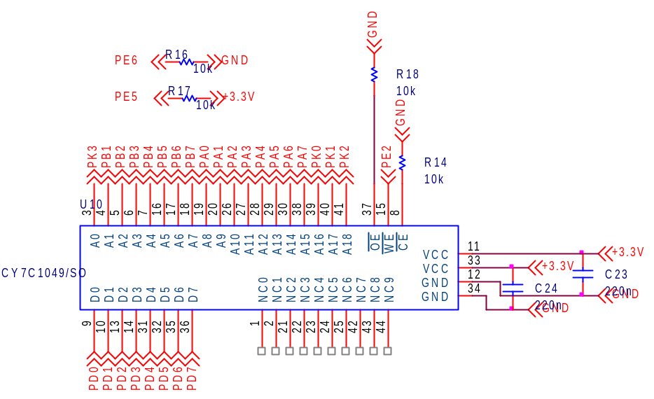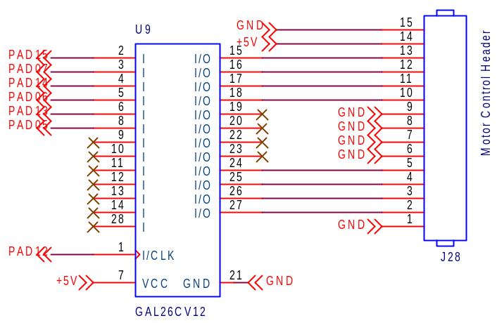

Figure C-10
RAM
Figure C-11
Motor Control Logic

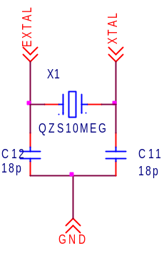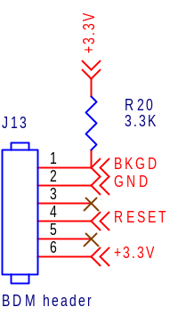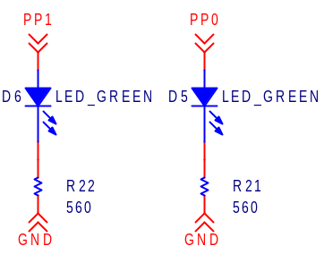
Figure C-12
10MHz Pierce Oscillator
Figure C-13
BDM Header
Figure C-14
Port P Debugging LEDs
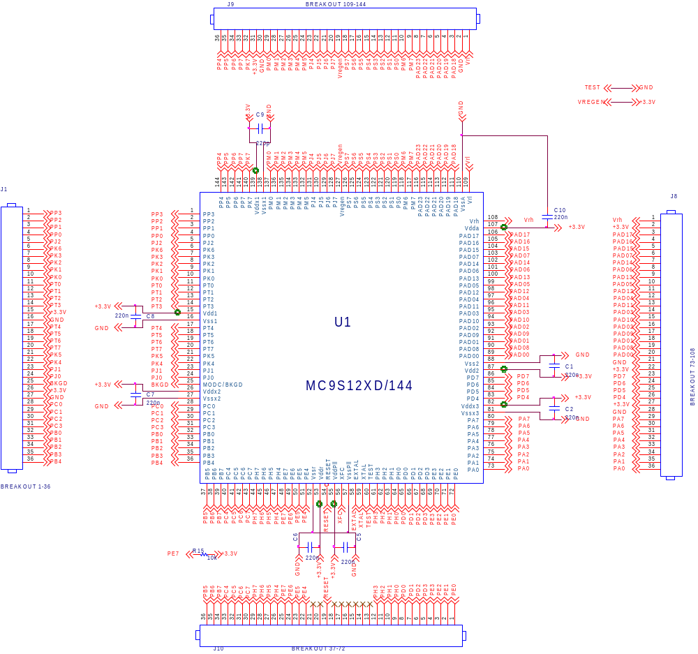
Figure C-15
Microcontroller and Breakout Headers
Appendix D: PCB Layout Top and Bottom Copper
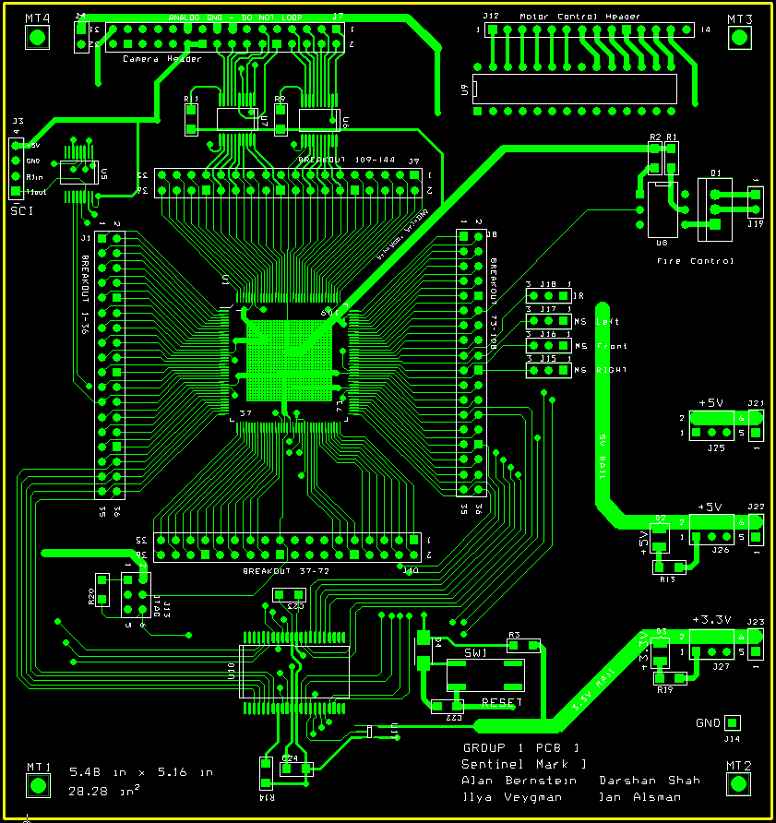
Figure D-1: PCB top copper with silk screen

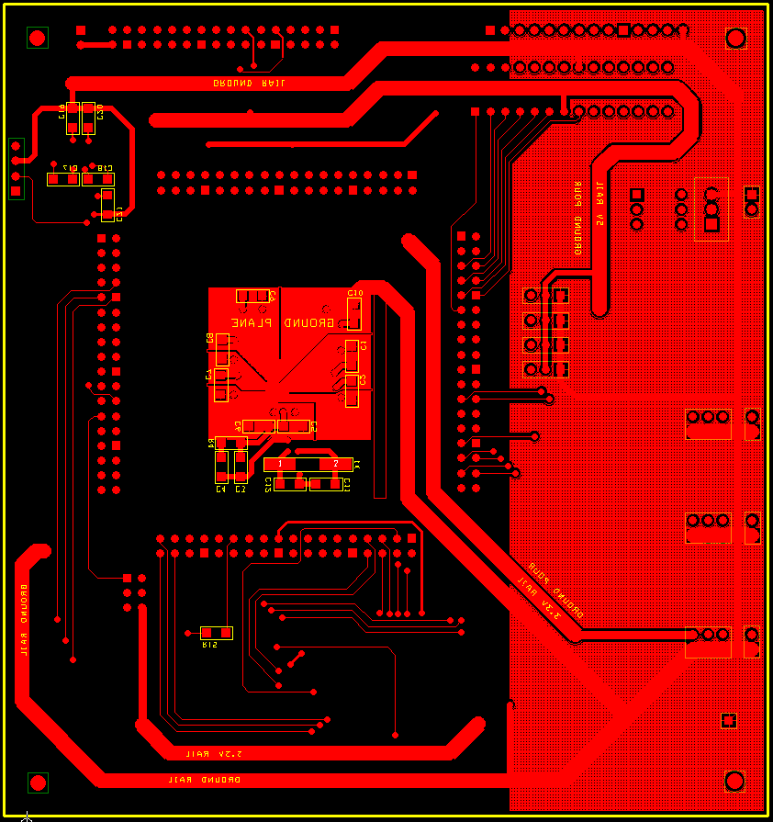
Figure D-2: PCB bottom copper with silk screen
Appendix E: Parts List Spreadsheet
Vendor | Manufacturer | Part No. | Description | Unit Cost | Qty | Total Cost
Electronics123.com | Omnivision | C3088 w/ OV6620 | Digital camera module | $39.95 | 1 | $39.95
Freescale | Freescale | MC9S12XDP512 | Microcontroller 80 MHz, 144-pin | Sample | 1 | $0.00
Cypress Semi. | Cypress Semi. | CY7C1049 | SRAM | Sample | 1 | $0.00
Lattice Semi. | Lattice Semi. | GAL26V12 | PLD used for Motor Logic | $5.00 | 1 | $5.00
Digikey | Fairchild Semi | 4N26-M | General Purpose 6-Pin Optocoupler | $0.25 | 1 | $0.25
TI Instruments | TI Instruments | TXS0108EPWR | Level Translator (3.3V <-> 5V) 8-bit | Sample | 2 | $0.00
MAXIM | MAXIM | MAX3232 | RS-232 Level translator | Sample | 1 | $0.00
Digikey | ECS International | CSM-7X | 10 MHz Quartz crystal clock | $2.50 | 1 | $2.50
Digikey | Fairchild Semi. | TIP122 | Linear Switching Applications | $1.00 | 1 | $1.00
Jameco | Jameco | 57BYGH801 | Stepper Motor Holding Torque: 55 Ncm | $12.00 | 1 | $12.00
Oriental Motor | Vexta PK Series | PK268-E2.0A | Stepper Motor Holding Torque: 1.75 Nm | Donation |  | $0.00
Oriental Motor | Vexta PK Series | PK299-F4.5A | Stepper Motor Holding Torque: 6.2 Nm | Donation |  | $0.00
Oriental Motor | VEXTA | UDK2120A | 2-Phase Driver | Donation |  | $0.00
Oriental Motor | VEXTA | UDK2160A | 2-Phase Driver | Donation |  | $0.00
Futurlec.com | Futurlec | SB0081 | Compact PIR Module | $7.41 | 3 | $22.23
Digikey | Pnasonic | PNA461xM | IR Sensors | $1.43 | 2 | $2.86
Digkey | Failrchild Semi. | RFP3055LA-ND | MOSFET N-CH 60V 11A | $0.50 | 1 | $0.50
Digikey | Fairchild Semi. | IRL530N | Power MOSFETS | $1.50 | 4 | $6.00
Digikey | Fairchild Semi. | 1N4007 | General Purpose Rectifier | $0.10 | 8 | $0.80
Digikey | Philiips | 1N4148 | High Speed Diode- for Driver | $0.05 | 8 | $0.40
Freescale | Freescale | 9S12C32 | IR Remote-362 Microcontroller | $0.00 | 1 | $0.00
Digikey | OSRAM | SFH4500 | High Power Infrared Emitter | $0.75 | 2 | $1.50
Digikey | Fairchild Semi. | DM7408 | AND gate | $0.00 | 1 | $0.00
Walmart |  |  | Airsoft gun | $20.00 | 1 | $20.00
Lowes/Ace/Menards/Mcmaster-Carr | Team KANG | n/a | Packaging Materials | $300.00 | 1 | $300.00
 |  |  |  | TOTAL |  | $424.99

Appendix F: Software Listing

/*
File: main.c

Description: This file contains the main loop as well as global variables, flags and two supporting functions: Fire() and WaitLoop().

Version: 3.3
*/

#include <hidef.h> // common defines and macros
#include <mc9s12xdp512.h> // derivative information
#pragma LINK_INFO DERIVATIVE "mc9s12xdp512"
#include "globals.h" // global flag definitions
#include "initial.h" // initialization routines
#include "video.h" // video and bit-bang RAM routines
#include "motors.h" // motor routines
#include "manual.h" // manual control routines
#include "SCI.h" // SCI message routines

short main_pan_pos; // current position of pan motor
short camera_pos; // current position of camera motor
short tilt_pos; // current position of tilt motor
short CoordX; // X coordinate of target
short CoordY; // Y coordinate of target
unsigned char cmd; // command received from SCI
byte sense_flag; // flag detailing which of the sensors are tripped
byte RAM_data; // data sent to and from RAM
byte manual_delay; // reduces the speed of motors in manual mode
byte tim_oscil;
// an on-off latch for use with a certain part of motor control
byte KANGflag; // general purpose flag
byte gun_timer; // counts how long the gun will remain on
byte dir_flag;
// flag that tells a function which direction to move motors
byte PAD1_prev; // previous state of PAD1
byte PAD0_prev; // previous state of PAD0
byte video_flag; // flag for video-related operations
byte prev_friend_vals; // previous values of friend register
word friend_sense_delay;
// slows down how often the RTI looks at the friendly detect sensors to
// mitigate noise

byte addr_hi, addr_mid, addr_lo, data_out, data_in; //memory interfacing
byte* far img1; // background image 1 (left side)
byte* far img2; // background image 2 (center)
byte* far img3; // background image 3 (right side)
byte* far targ; // target image
byte* far temp; // temporary variable, to streamline isrs for reading images
byte last_region;// previous region where motion was sensed by the motion
// sensors
long int num_pixels; // number of pixels read by the code

/*
Function: Fire()

Description: Activates the gun active flag, sets the RTI's gun duration timer and asserts the logic pin that corresponds to the fire control.

Arguments: none
*/
void Fire(void){

if ((KANGflag&FIRING_MASK) && !(KANGflag&GUN_ACTIVE_MASK)) {
#ifdef DEBUG
SCI_String_Send("Firing...\n\r");
#endif
KANGflag |= GUN_ACTIVE_MASK; // turn on gun firing flag
gun_timer = 200; // start the delay
PT1AD0 &= ~(0x10); // set the gun going
} // if firing is enabled
} // Fire

/*
Function: WaitLoop()

Description: A delay loop based upon burning cycles to prevent signals
from being sent out too fast. Duration is approximately
2*i*j cycles.

Arguments: i and j are delay counters that may have value of 0 to 65535
*/
void WaitLoop(word i, word j) {

for (i; i>0;i--) {
for (j; j>0;j--) asm nop;
} // for

} // WaitLoop

void main(void) {

INT_CFADDR = 0xE0;// set vector offset
INT_CFDATA1 = 7; // highest interrupt priority for vsync_isr

COPCTL = 0x40; // COP off, RTI and COP stopped in BDM mode
PLL_Init(); // initialize PLL
SCI_Init(); // initialize SCI
GPIO_Init(); // set GPIO directions
RTI_Init(); // initialize RTI
TIM_Init(); // initialize timer channels 5,6 and 7 (only 7 is
// activated)
PWM_Init(); // initialize external clock to camera
XEBI_Init(); // initialize external bus interface

// initialize all flags and variables
KANGflag = 0;
dir_flag = 0;
gun_timer = 0;
num_pixels = 0;
cmd = 0;
sense_flag = 0;
main_pan_pos = 0;
camera_pos = 0;
tilt_pos = 0;
manual_delay = 0;
tim_oscil = 0;
PAD1_prev = 0xff;
PAD0_prev = 0xff;
friend_sense_delay = FRIEND_DELAY_VAL;
video_flag = 0;
prev_friend_vals = 0xff;
PORTB = 0xff;

KANGflag |= FIRING_MASK; // allow firing
KANGflag |= TARGETING_MASK; // allow targeting
EnableInterrupts; // allow interrupts

for(;;) {

while (KANGflag&MODE_MASK) {
// if a friendly is detected, automatically go into manual mode
if (sense_flag&FRIENDLY_MASK) {
TiltToPos(-TILT_LIMIT);
MainPanToPos(POS2_PAN);
CamPanToPos(POS2_CAM);
KANGflag &= ~MODE_MASK;
sense_flag &= ~FRIENDLY_MASK;
SCI2DRL = 0;
} // a friendly was detected
else if (KANGflag&SENSOR_TRIPPED) {

if (sense_flag&MS_CENTER_MASK) {
MainPanToPos(POS2_PAN);
CamPanToPos(POS2_CAM);
video_flag |= CAPTURE_TARGET_2;
CaptureImage();
sense_flag &= ~MS_CENTER_MASK;
} // center tripped
else if (sense_flag&MS_LEFT_MASK) {
MainPanToPos(POS1_PAN);
CamPanToPos(POS1_CAM);
video_flag |= CAPTURE_TARGET_1;
CaptureImage();
sense_flag &= ~MS_LEFT_MASK;
} // center tripped
else if (sense_flag&MS_RIGHT_MASK) {
MainPanToPos(POS3_PAN);
CamPanToPos(POS3_CAM);
video_flag |= CAPTURE_TARGET_3;
CaptureImage();
sense_flag &= ~MS_RIGHT_MASK;
} // center tripped
KANGflag &= ~SENSOR_TRIPPED;
} // if
else if (sense_flag&AUTO_TO_MAIN) {
KANGflag &= ~MODE_MASK;
#ifdef DEBUG
SCI_String_Send("Returning turret control to user\n\r");
#endif
SCI2DRL = 0;
cmd = 0;
while (!(SCI2SR1&0x20));
cmd = SCI2DRL;
asm bclr sense_flag,AUTO_TO_MAIN;
} // want to return to auto mode

} // automatic mode
while ((KANGflag&MODE_MASK)==0) {
sense_flag &= ~FRIENDLY_MASK;
while (!(SCI2SR1&0x20));
cmd = SCI2DRL;
DoCommand(); // do it
} // manual mode

} // loop forever

// never leave this function!
} // seriously
// no, i'm super serious
/*
File: globals.h

Description: Contains the flag bit definitions for global variables

*/
#ifndef __GLOBALS__H__
#define __GLOBALS__H__
#include <mc9s12xdp512.h>

// address definitions for the images
extern byte* far img1; // background image 1 (left side)
extern byte* far img2; // background image 2 (center)
extern byte* far img3; // background image 3 (right side)
extern byte* far targ; // target image for difference algorithm
extern byte* far temp; // temporary location for an image
#define IMG1_ADDRESS (byte* far)0x600000 // starting address of first image
#define IMG2_ADDRESS (byte* far)0x640000 //starting address of second image
#define IMG3_ADDRESS (byte* far)0x680000 // starting address of third image
#define TARG_ADDRESS (byte* far)0x6C0000 // target image

//byte dir_flag;
/* direction of motion flags for manual control
bit 7: high to move left, else disabled
bit 6: high to move right, else disabled
bit 5: high to move up, else disabled
bit 4: high to move down, else disabled
bit 3: camera move left
bit 2: camera move right
*/
#define MOVE_LEFT_MASK 0x80
#define MOVE_RIGHT_MASK 0x40
#define MOVE_UP_MASK 0x20
#define MOVE_DOWN_MASK 0x10
#define CAM_LEFT_MASK 0x08
#define CAM_RIGHT_MASK 0x04

//extern byte KANGflag;
/* a generic, multi-purpose flag
bit 7: 1 -> coordinates ready, 0 -> no new coordinates
bit 6: 1 -> gun is firing, 0 -> gun is not firing
bit 5: 1 -> targeting enabled, 0-> targeting disabled
bit 4: 1 -> firing enabled, 0 -> firing disabled
bit 3: 1 -> automatic control mode, 0 -> manual control mode
bit 2: 1 -> a sensor was tripped, 0 -> no sensor was tripped
bit 1: 1 -> command was sent to move a motor in tim_isr, 0-> no command
(cleared once move was done)
bit 0: 1 -> motor control: automatically moving to one of three regions, 0-> not doing that

*/
#define COORDS_READY_MASK 0x80
#define GUN_ACTIVE_MASK 0x40
#define TARGETING_MASK 0x20
#define FIRING_MASK 0x10
#define MODE_MASK 0x08
#define SENSOR_TRIPPED 0x04
#define COMMAND_PENDING 0x02
#define REGION_MOVE 0x01

//extern byte sense_flag;
/* flag for the ancillary sensors
bit 7: 1 -> friendly detected
bit 6: 1 -> motion sensed on MS_left
bit 5: 1 -> motion sensed on MS_center
bit 4: 1 -> motion sensed on MS_right
bit 3: 1 -> want to return to manual mode from auto
*/
#define FRIENDLY_MASK 0x80
#define MS_LEFT_MASK 0x40
#define MS_CENTER_MASK 0x20
#define MS_RIGHT_MASK 0x10
#define AUTO_TO_MAIN 0x08

/* video related bits for video control flag video_flag
bit 7: allow capture (active high)
bit 6: frame began (set to 1 when a new frame has been detected)
bit 5: want to capture background image for region 1
bit 4: same, for region 2
bit 3: same, for region 3
bit 2: capture an image for targeting, in region 1
bit 1: capture an image for targeting, in region 2
bit 0: capture an image for targeting, in region 3
*/
#define CAPTURE_VIDEO 0x80
#define FRAME_BEGIN 0x40
#define CAPTURE_REGION_1 0x20
#define CAPTURE_REGION_2 0x10
#define CAPTURE_REGION_3 0x08
#define CAPTURE_TARGET_1 0x04
#define CAPTURE_TARGET_2 0x02
#define CAPTURE_TARGET_3 0x01

/* motor control bits on Port AD
bit 15: pan motor direction
bit 7: pan motor enable
bit 14: tilt motor direction
bit 6: tilt motor enable
bit 13: camera motor direction
bit 5: camera motor enable
*/
#define PAN_BIT 0x80
#define TILT_BIT 0x40
#define CAMERA_BIT 0x20

#define RTI_DELAY_VALUE 0xff
#define MANUAL_DELAY_VAL 0
#define FRIEND_DELAY_VAL 15

#define POS1_TILT -60 // position difference of position 1 from zero
#define POS2_TILT 0
#define POS3_TILT 60

#define POS1_PAN -40
#define POS2_PAN 0
#define POS3_PAN 40

#define POS1_CAM 45
#define POS2_CAM 0
#define POS3_CAM -45

#define CAM_PAN_LIMIT 50 // number of steps allowed on camera pan
// motor in either direction from zero
#define GUN_PAN_LIMIT 50 // number of steps allowed on gun pan motor
// in either direction from zero
#define TILT_LIMIT 90 // number of steps allowed on tilt motor in
// either direction from zero

#define MASTER_SLAVE_MASK 0b00100000 // for the I2C bus
#define TRANSMIT_MASK 0b00010000

#define BASE_TC7_RATE 2500 // base interrupt rate for timer channel 7 #define CAM_TC7_RATE 50000 // a slower value for the camera
#define VIDEO_THRESH 1 // threshold for video targeting algorithm
#define NDEBUG // debug messages being sent?

#endif
/*
File: initial.c

Contents: Initializations of all peripherals and GPIO pins.

Version: 3.0

*/

#ifndef __INTERRUPT__C__
#define __INTERRUPT__C__
#include "initial.h"
#include "globals.h"

// external stuff
extern void WaitLoop(word,word);
volatile extern word friend_sense_delay;

/*
Function: PWM_Init()

Description: Initializes the PWM module to output an approximately 15MHz square wave on PWM channel 4 w/ 50% duty cycle. This goes to the external clock of the camera.

Arguments: none
*/
void PWM_Init(void) {
PWME |= 0x10;
PWMPOL |= 0x10;
PWMPRCLK = 0;
PWMPER4 = 2;
PWMDTY4 = 1;

} // PWM_Init

// turns other interrupts on or off depending on input argument except for
// timer channel 5
void ToggleOtherInterrupts(byte on) {
if(on){
TIE |= 0xC0;
CRGINT |= 0x7F;
} // turn them on
else {
TIE &= 0b00100000;
CRGINT &= 0x7F;
} // turn them off

} // DisableOtherInterrupts

/*
Function: PLL_Init()

Description: Puts the bus clock to 30MHz

Arguments: none
*/
void PLL_Init(void) {
CLKSEL &= 0x7F; // disengage PLL
PLLCTL |= 0x40; // turn on PLL bit
SYNR = 2; // 30MHz bus clock (60MHz PLL)
REFDV = 0; // keep this zero
asm nop;
asm nop;
while ( !(CRGFLG&0x08) );
CLKSEL |= 0x80; // engage PLL

} // PLL_Init

/*
Function: TIM_Init()

Description: Initializes the timer module to have input capture on channels 5 and 6 and output compare on channel 7. Input capture will capture on the rising edge. Only channel 7 will be enabled, initially.

Arguments: none
*/
void TIM_Init(void){
#ifdef DEBUG
SCI_String_Send("Initializing timer module interrupts...");
#endif
TSCR1 = 0x80; // enable the timer
TIOS = 0x80; // set channels 7,4 as output compare, others as input
TSCR2 = 0x0C; // prescale factor = 16, allow reset from successful output
TC7 = BASE_TC7_RATE;
TCTL3 = 0b00010100; // input capture on rising edge on channels 5 and 6
TIE = 0x80; // enable interrupts only on channels 7,6 initially
#ifdef DEBUG
SCI_String_Send("done\n\r");
#endif

} // TIM_Init

/*
Function: RTI_Init()

Description: Sets the RTI to run at around 6.5536ms interrupt rate.

Arguments: none
*/
void RTI_Init(void){
#ifdef DEBUG
SCI_String_Send("Initializing real-time interrupts...");
#endif
// input clock is 10MHz
RTICTL = 0x70; // decimal divide bus clock by 2^16 (rate about 6.5536ms)
CRGINT |= 0x80; // enable RTI interrupts
friend_sense_delay = FRIEND_DELAY_VAL;
#ifdef DEBUG
SCI_String_Send("done\n\r");
#endif
} // RTI_Init

/*
Function: SCI_Init()

Description: Initializes the SCI on channel 2 to run at about 115.2kbaud. Receiver interrupts are initially disabled.

Arguments: none
*/
void SCI_Init(void){

SCI2BDL = 17;
SCI2CR1 = 0x00; // for some reason, this causes an illegal opcode
// sometimes...I blame the BDM
SCI2CR2 = 0x0C; // disallow interrupts from receiver
// enable Tx/Rx for SCI2
// SCI2CR2 |= 0x20;
} // SCI_Init

/*
Function: XEBI_Init()

Description: Puts the chip into normal expanded mode and sets the address settings for our 512k by 8 RAM.

Arguments: none
*/
void XEBI_Init(void){
#ifdef DEBUG
SCI_String_Send("Initializing XEBI...");
#endif
MMCCTL0 = 0x02; // chip select 1
MMCCTL1 = 0x01; // ROMON = 1, ROMHM = 0
MODE = 0b10100000; // put into normal expanded mode
EBICTL0 = 20; // sets normal threshold with 8-bit data and 19 bits of addr
// EBICTL1 = 132; // enables external wait, with >=8 cycles of stretch
#ifdef DEBUG
SCI_String_Send("done\n\r");
#endif
} // XEBI_Init

/*
Function: GPIO_Init()

Description: Sets the following GPIO pins...
Inputs: PAD9,8,1,0, port S
Outputs: PAD15,14,13,12,7,6,5,4,PT4,PTM5,PTM4
Arguments: none
*/
void GPIO_Init(void){
#ifdef DEBUG
SCI_String_Send("Initializing GPIO pins...");
#endif
ATD1DIEN1 = 0xFF; // enable digital inputs on all PT1ADx channels
ATD0DIEN = 0xFF;
DDR1AD0 = 0xF0; // need ports 7,6,5,4 as output; 0,1 as input
DDR1AD1 = 0xF0; // 15,14,13,12 output; 9,8 input
DDRM = 0b00110000;
DDRA = 0xff;
DDRB = 0xff;
//DDRJ = 0xC0;
DDRS = 0x00; // read stuff as GPIO from camera
DDRT = 0x10;
PT1AD0 |= 0x10; // disable gun output
#ifdef DEBUG
SCI_String_Send("done\n\r");
#endif
} // GPIO_Init

#endif

#ifndef __INTERRUPT__H__
#define __INTERRUPT__H__

#include <mc9s12xdp512.h>

// initialization functions
extern void PLL_Init(void);
extern void TIM_Init(void);
extern void SCI_Init(void);
extern void RTI_Init(void);
extern void IIC_Init(void);
extern void XEBI_Init(void);
extern void GPIO_Init(void);
extern void Camera_Init(void);
extern void PWM_Init(void);

#endif

// if you delete this, I will kill you
#include <mc9s12xdp512.h>
#include "sci.h"
#include "globals.h"

// Interrupt section for this module. Placement will be in NON_BANKED area.
#pragma CODE_SEG __NEAR_SEG NON_BANKED

volatile extern byte KANGflag;
volatile extern byte gun_timer;
volatile extern byte sense_flag;
volatile extern byte manual_delay;
volatile extern far byte tim_oscil;
volatile extern byte PAD1_prev;
volatile extern byte PAD0_prev;
volatile extern byte video_flag;
volatile extern byte prev_friend_vals;
volatile extern unsigned char cmd;
volatile extern word friend_sense_delay;
volatile extern byte* far img1;
volatile extern byte* far img2;
volatile extern byte* far img3;
volatile extern word num_pixels;
volatile extern byte last_region;

/*
Function: Cpu_Interrupt

Description: Illegal isr_vector trap

Arguments: none
*/
__interrupt void Cpu_Interrupt(void) {
// Unimplemented ISRs trap

asm BGND;
} // UnimplementedISR

/*
Function: tim7_isr

Description: Handles interrupts for timer channel 7. Primarily sends step pulses to the motor control PLD and clears the enable bits afterward.

Arguments: none
*/
__interrupt void tim7_isr(void) {

// clear interrupt flag
TFLG1 |= 0x80;
PT1AD1 &= ~(0x10); // clear clock pulse

if(KANGflag&MODE_MASK) {
PT1AD1 |= 0x10; // send clock pulse
PT1AD1 &= 0x1F; // clear all enable bits so only one step occurs
KANGflag &= ~COMMAND_PENDING;
// clear command sent flag to indicate task complete

} // automatic mode
else {
PT1AD1 |= 0x10; // send clock pulse
PT1AD1 &= 0x1F; // clear all enable bits so only one step occurs
KANGflag &= ~COMMAND_PENDING;
// clear command sent flag to indicate task complete
} // manual mode
} // tim_isr

/*
Function: vsync_isr

Description: Handles interrupts for input capture channel 6, the VSYNC signal. An interrupt here means that the frame has begun.

Arguments: none
*/
__interrupt void vsync_isr(void) {

TFLG1 |= 0x40; // clear the flag

// do nothing unless video capture is on
if(video_flag&CAPTURE_VIDEO){
video_flag |= FRAME_BEGIN; // frame has begun
} // if

} // vsync_isr

/*
Function: pclk_isr

Description: Handles interrupts for input capture channel 5, the PCLK
signal. Stores the pixel data in RAM and turns itself off once all the pixels are there.

Arguments: none
*/
__interrupt void pclk_isr(void) {

if(num_pixels){
*temp = PTS;
num_pixels--;
temp+=2;
} else {
TIE = 0x80;
}
TFLG1 |= 0x20; // clear the flag

} //pclk_isr

/*
Function: rti_isr()

Description: Handles RTI interrupts.
* Decrement gun timer counter and turn off gun when it reaches zero
* Check motion sensors
* Check IR receivers for friendly detect

Arguments: none
*/
__interrupt void rti_isr(void) {

CRGFLG |= 0x80; // interrupt flag

--friend_sense_delay;

// don't bother doing this if not firing
if (KANGflag&GUN_ACTIVE_MASK) {
if (gun_timer) // hasn't reached zero
gun_timer--;
else { // time to stop
PT1AD0 |= 0x10; // turn off gun
KANGflag &= ~GUN_ACTIVE_MASK; // clear the flag
} // else
} // if

// don't check motion sensors if in manual mode or targeting disabled or
// there was already

// a sensor tripped
if ((KANGflag&MODE_MASK) && !(KANGflag&SENSOR_TRIPPED)) {
// HIGH = tripped
if(!(PAD0_prev&0x02)){ // last state was low?
if ((PT1AD0&0x02) && (last_region != MS_RIGHT_MASK)){
KANGflag |= SENSOR_TRIPPED;
sense_flag |= MS_RIGHT_MASK;
last_region = MS_RIGHT_MASK;
SCI_String_Send("1");
} // if
} // if

else if(!(PAD1_prev&0x02)){ // last state was low?
if ((PT1AD1&0x02)&&(last_region != MS_LEFT_MASK)){
KANGflag |= SENSOR_TRIPPED;
sense_flag |= MS_LEFT_MASK;
last_region = MS_LEFT_MASK;
SCI_String_Send("3");
} // if
} // if

else if(!(PAD1_prev&0x01)){ // last state was low?
if ((PT1AD1&0x01)&&(last_region != MS_CENTER_MASK)){
KANGflag |= SENSOR_TRIPPED;
sense_flag |= MS_CENTER_MASK;
last_region = MS_CENTER_MASK;
SCI_String_Send("2");
} // if
} // if

} // if - motion sensors

// check if IR sensor was turned low, using the delay counter
if((friend_sense_delay==0)) {
friend_sense_delay = FRIEND_DELAY_VAL;
prev_friend_vals<<=1; // shift previous IR bits left
if(PT1AD0&0x01) // set the lowest but to current value
prev_friend_vals |= 0x01;
else
prev_friend_vals &= ~0x01;
if(prev_friend_vals==0){ // if we got 8 low bits in a row, then trip
// the sensor
KANGflag &= ~(TARGETING_MASK+FIRING_MASK);
KANGflag &= ~GUN_ACTIVE_MASK;
sense_flag |= FRIENDLY_MASK;
SCI_String_Send("f");
} // if last eight friend values were zero

} // if

PAD1_prev = PT1AD1; // store previous states
PAD0_prev = PT1AD0;

} // rti_isr

/*
Function: sci_isr()

Description: Handles SCI channel 2 interrupts
Sets a flag if an m is received, otherwise does nothing.

Arguments: none
*/
__interrupt void sci_isr(void) {
cmd = SCI2DRL;
if ((cmd=='m') || (cmd=='M')){
asm bclr SCI2CR2, 0x20;
SCI2DRL = 0;
#ifdef DEBUG
SCI_String_Send("Ending automatic mode...\n\r");
#endif
sense_flag |= AUTO_TO_MAIN;
} // if

} // sci_isr

typedef void (*near tIsrFunc)(void);
const tIsrFunc _InterruptVectorTable[] @0xFF10 = { /* Interrupt vector table */
/* ISR name No. Address Pri XGATE Name Description */
Cpu_Interrupt, /* 0x08 0xFF10 - - ivVsi unused by PE */
Cpu_Interrupt, /* 0x09 0xFF12 1 no ivReserved119 unused by PE */
Cpu_Interrupt, /* 0x0A 0xFF14 1 no ivReserved118 unused by PE */
Cpu_Interrupt, /* 0x0B 0xFF16 1 no ivReserved117 unused by PE */
Cpu_Interrupt, /* 0x0C 0xFF18 1 no ivReserved116 unused by PE */
Cpu_Interrupt, /* 0x0D 0xFF1A 1 no ivReserved115 unused by PE */
Cpu_Interrupt, /* 0x0E 0xFF1C 1 no ivReserved114 unused by PE */
Cpu_Interrupt, /* 0x0F 0xFF1E 1 no ivReserved113 unused by PE */
Cpu_Interrupt, /* 0x10 0xFF20 1 no ivReserved112 unused by PE */
Cpu_Interrupt, /* 0x11 0xFF22 1 no ivReserved111 unused by PE */
Cpu_Interrupt, /* 0x12 0xFF24 1 no ivReserved110 unused by PE */
Cpu_Interrupt, /* 0x13 0xFF26 1 no ivReserved109 unused by PE */
Cpu_Interrupt, /* 0x14 0xFF28 1 no ivReserved108 unused by PE */
Cpu_Interrupt, /* 0x15 0xFF2A 1 no ivReserved107 unused by PE */
Cpu_Interrupt, /* 0x16 0xFF2C 1 no ivReserved106 unused by PE */
Cpu_Interrupt, /* 0x17 0xFF2E 1 no ivReserved105 unused by PE */
Cpu_Interrupt, /* 0x18 0xFF30 1 no ivReserved104 unused by PE */
Cpu_Interrupt, /* 0x19 0xFF32 1 no ivReserved103 unused by PE */
Cpu_Interrupt, /* 0x1A 0xFF34 1 no ivReserved102 unused by PE */
Cpu_Interrupt, /* 0x1B 0xFF36 1 no ivReserved101 unused by PE */
Cpu_Interrupt, /* 0x1C 0xFF38 1 no ivReserved100 unused by PE */
Cpu_Interrupt, /* 0x1D 0xFF3A 1 no ivReserved99 unused by PE */
Cpu_Interrupt, /* 0x1E 0xFF3C 1 no ivReserved98 unused by PE */
Cpu_Interrupt, /* 0x1F 0xFF3E 1 no ivReserved97 unused by PE */
Cpu_Interrupt, /* 0x20 0xFF40 1 no ivReserved96 unused by PE */
Cpu_Interrupt, /* 0x21 0xFF42 1 no ivReserved95 unused by PE */
Cpu_Interrupt, /* 0x22 0xFF44 1 no ivReserved94 unused by PE */
Cpu_Interrupt, /* 0x23 0xFF46 1 no ivReserved93 unused by PE */
Cpu_Interrupt, /* 0x24 0xFF48 1 no ivReserved92 unused by PE */
Cpu_Interrupt, /* 0x25 0xFF4A 1 no ivReserved91 unused by PE */
Cpu_Interrupt, /* 0x26 0xFF4C 1 no ivReserved90 unused by PE */
Cpu_Interrupt, /* 0x27 0xFF4E 1 no ivReserved89 unused by PE */
Cpu_Interrupt, /* 0x28 0xFF50 1 no ivReserved88 unused by PE */
Cpu_Interrupt, /* 0x29 0xFF52 1 no ivReserved87 unused by PE */
Cpu_Interrupt, /* 0x2A 0xFF54 1 no ivReserved86 unused by PE */
Cpu_Interrupt, /* 0x2B 0xFF56 1 no ivReserved85 unused by PE */
Cpu_Interrupt, /* 0x2C 0xFF58 1 no ivReserved84 unused by PE */
Cpu_Interrupt, /* 0x2D 0xFF5A 1 no ivReserved83 unused by PE */
Cpu_Interrupt, /* 0x2E 0xFF5C 1 no ivReserved82 unused by PE */
Cpu_Interrupt, /* 0x2F 0xFF5E 1 no ivReserved81 unused by PE */
Cpu_Interrupt, /* 0x30 0xFF60 1 - ivVxsramav unused by PE */
Cpu_Interrupt, /* 0x31 0xFF62 1 - ivVxsei unused by PE */
Cpu_Interrupt, /* 0x32 0xFF64 1 no ivVxst7 unused by PE */
Cpu_Interrupt, /* 0x33 0xFF66 1 no ivVxst6 unused by PE */
Cpu_Interrupt, /* 0x34 0xFF68 1 no ivVxst5 unused by PE */
Cpu_Interrupt, /* 0x35 0xFF6A 1 no ivVxst4 unused by PE */
Cpu_Interrupt, /* 0x36 0xFF6C 1 no ivVxst3 unused by PE */
Cpu_Interrupt, /* 0x37 0xFF6E 1 no ivVxst2 unused by PE */
Cpu_Interrupt, /* 0x38 0xFF70 1 no ivVxst1 unused by PE */
Cpu_Interrupt, /* 0x39 0xFF72 1 no ivVxst0 unused by PE */
Cpu_Interrupt, /* 0x3A 0xFF74 1 no ivVpit3 unused by PE */
Cpu_Interrupt, /* 0x3B 0xFF76 1 no ivVpit2 unused by PE */
Cpu_Interrupt, /* 0x3C 0xFF78 1 no ivVpit1 unused by PE */
Cpu_Interrupt, /* 0x3D 0xFF7A 1 no ivVpit0 unused by PE */
Cpu_Interrupt, /* 0x3E 0xFF7C 1 no ivVReserved65 unused by PE */
Cpu_Interrupt, /* 0x3F 0xFF7E 1 no ivVapi unused by PE */
Cpu_Interrupt, /* 0x40 0xFF80 1 no ivVlvi unused by PE */
Cpu_Interrupt, /* 0x41 0xFF82 1 no ivViic1 unused by PE */
Cpu_Interrupt, /* 0x42 0xFF84 1 no ivVsci5 unused by PE */
Cpu_Interrupt, /* 0x43 0xFF86 1 no ivVsci4 unused by PE */
Cpu_Interrupt, /* 0x44 0xFF88 1 no ivVsci3 unused by PE */
sci_isr, /* 0x45 0xFF8A 1 no ivVsci2 unused by PE */
Cpu_Interrupt, /* 0x46 0xFF8C 1 no ivVpwmesdn unused by PE */
Cpu_Interrupt, /* 0x47 0xFF8E 1 no ivVportp unused by PE */
Cpu_Interrupt, /* 0x48 0xFF90 1 no ivVcan4tx unused by PE */
Cpu_Interrupt, /* 0x49 0xFF92 1 no ivVcan4rx unused by PE */
Cpu_Interrupt, /* 0x4A 0xFF94 1 no ivVcan4err unused by PE */
Cpu_Interrupt, /* 0x4B 0xFF96 1 no ivVcan4wkup unused by PE */
Cpu_Interrupt, /* 0x4C 0xFF98 1 no ivVcan3tx unused by PE */
Cpu_Interrupt, /* 0x4D 0xFF9A 1 no ivVcan3rx unused by PE */
Cpu_Interrupt, /* 0x4E 0xFF9C 1 no ivVcan3err unused by PE */
Cpu_Interrupt, /* 0x4F 0xFF9E 1 no ivVcan3wkup unused by PE */
Cpu_Interrupt, /* 0x50 0xFFA0 1 no ivVcan2tx unused by PE */
Cpu_Interrupt, /* 0x51 0xFFA2 1 no ivVcan2rx unused by PE */
Cpu_Interrupt, /* 0x52 0xFFA4 1 no ivVcan2err unused by PE */
Cpu_Interrupt, /* 0x53 0xFFA6 1 no ivVcan2wkup unused by PE */
Cpu_Interrupt, /* 0x54 0xFFA8 1 no ivVcan1tx unused by PE */
Cpu_Interrupt, /* 0x55 0xFFAA 1 no ivVcan1rx unused by PE */
Cpu_Interrupt, /* 0x56 0xFFAC 1 no ivVcan1err unused by PE */
Cpu_Interrupt, /* 0x57 0xFFAE 1 no ivVcan1wkup unused by PE */
Cpu_Interrupt, /* 0x58 0xFFB0 1 no ivVcan0tx unused by PE */
Cpu_Interrupt, /* 0x59 0xFFB2 1 no ivVcan0rx unused by PE */
Cpu_Interrupt, /* 0x5A 0xFFB4 1 no ivVcan0err unused by PE */
Cpu_Interrupt, /* 0x5B 0xFFB6 1 no ivVcan0wkup unused by PE */
Cpu_Interrupt, /* 0x5C 0xFFB8 1 no ivVflash unused by PE */
Cpu_Interrupt, /* 0x5D 0xFFBA 1 no ivVeeprom unused by PE */
Cpu_Interrupt, /* 0x5E 0xFFBC 1 no ivVspi2 unused by PE */
Cpu_Interrupt, /* 0x5F 0xFFBE 1 no ivVspi1 unused by PE */
Cpu_Interrupt, /* 0x60 0xFFC0 1 no ivVIIC0 unused by PE */
Cpu_Interrupt, /* 0x61 0xFFC2 1 no ivVReserved30 unused by PE */
Cpu_Interrupt, /* 0x62 0xFFC4 1 no ivVcrgscm unused by PE */
Cpu_Interrupt, /* 0x63 0xFFC6 1 no ivVcrgplllck unused by PE */
Cpu_Interrupt, /* 0x64 0xFFC8 1 no ivVtimpabovf unused by PE */
Cpu_Interrupt, /* 0x65 0xFFCA 1 no ivVtimmdcu unused by PE */
Cpu_Interrupt, /* 0x66 0xFFCC 1 no ivVporth unused by PE */
Cpu_Interrupt, /* 0x67 0xFFCE 1 no ivVportj unused by PE */
Cpu_Interrupt, /* 0x68 0xFFD0 1 no ivVatd1 unused by PE */
Cpu_Interrupt, /* 0x69 0xFFD2 1 no ivVatd0 unused by PE */
Cpu_Interrupt, /* 0x6A 0xFFD4 1 no ivVsci1 unused by PE */
Cpu_Interrupt, /* 0x6B 0xFFD6 1 no ivVsci0 unused by PE */
Cpu_Interrupt, /* 0x6C 0xFFD8 1 no ivVspi0 unused by PE */
Cpu_Interrupt, /* 0x6D 0xFFDA 1 no ivVtimpaie unused by PE */
Cpu_Interrupt, /* 0x6E 0xFFDC 1 no ivVtimpaaovf unused by PE */
Cpu_Interrupt, /* 0x6F 0xFFDE 1 no ivVtimovf unused by PE */
tim7_isr, /* 0x70 0xFFE0 1 no ivVtimch7 unused by PE */
vsync_isr, /* 0x71 0xFFE2 1 no ivVtimch6 unused by PE */
pclk_isr, /* 0x72 0xFFE4 1 no ivVtimch5 unused by PE */
Cpu_Interrupt, /* 0x73 0xFFE6 1 no ivVtimch4 unused by PE */
Cpu_Interrupt, /* 0x74 0xFFE8 1 no ivVtimch3 unused by PE */
Cpu_Interrupt, /* 0x75 0xFFEA 1 no ivVtimch2 unused by PE */
Cpu_Interrupt, /* 0x76 0xFFEC 1 no ivVtimch1 unused by PE */
Cpu_Interrupt, /* 0x77 0xFFEE 1 no ivVtimch0 unused by PE */
rti_isr, /* 0x78 0xFFF0 1 no ivVrti unused by PE */
Cpu_Interrupt, /* 0x79 0xFFF2 1 no ivVirq unused by PE */
Cpu_Interrupt, /* 0x7A 0xFFF4 - - ivVxirq unused by PE */
Cpu_Interrupt, /* 0x7B 0xFFF6 - - ivVswi unused by PE */
Cpu_Interrupt /* 0x7C 0xFFF8 - - ivVtrap unused by PE */
};

/*
File: manual.c

Contents: Two functions: a manual motor movement function and a command interpreter

Version: 1.1
*/

#ifndef __MANUAL__C__
#define __MANUAL__C__
#include "manual.h"
#include "globals.h"
#include "motors.h"

typedef unsigned char byte; // for convenience

// external functions and global variables
extern void Fire(void);
extern void SCI_Send(unsigned char);
extern void TiltToPos(short);
extern void MainPanToPos(short);
extern void CaptureImage(void);
volatile extern short main_pan_pos;
volatile extern short camera_pos;
volatile extern short tilt_pos;
volatile extern byte KANGflag;
volatile extern byte dir_flag;
volatile extern byte video_flag;
volatile extern unsigned char cmd;

// Gets takes the command that was received from SCI and takes an appropriate // action based upon what it received.
// List of commands:
// spacebar = fire weapon
// A or a = move assembly left
// D or d = move assembly right
// Q or q = move camera left
// E or e = move camera right
// W or w = tilt assembly up
// S or s = tilt assembly down
// Z or z = set current position of motors to be zero (in software)
// M or m = turn on automatic mode
// 1 = pan to center of region 1
// 2 = pan to center of region 2
// 3 = pan to center of region 3
// 4 = tilt to about 45 degrees
// 5 = tilt to about 0 degrees
// 6 = tilt to about -45 degrees
// 7 = camera pan to center of region 1
// 8 = camera pan to center of region 2
// 9 = camera pan to center of region 3
void DoCommand(void) {

SCI_Send(cmd);
switch(cmd) {

case ' ':
Fire(); break;

case 'e':
case 'E':
if(camera_pos > -CAM_PAN_LIMIT){
dir_flag |= CAM_LEFT_MASK; // move left
#ifdef DEBUG
SCI_String_Send("Camera Left\n\r");
#endif
ManMove();
} // if not at limit
break;

case 'q':
case 'Q':
if(camera_pos < CAM_PAN_LIMIT){
dir_flag |= CAM_RIGHT_MASK; // move left
#ifdef DEBUG
SCI_String_Send("Camera Right\n\r");
#endif
ManMove();
} // if not at limit
break;

case 'a':
case 'A':
if (main_pan_pos > -GUN_PAN_LIMIT){
dir_flag |= MOVE_LEFT_MASK; // move left
#ifdef DEBUG
SCI_String_Send("Left\n\r");
#endif
ManMove();
} // if not at limit
break;

case 'd':
case 'D':
if(main_pan_pos < GUN_PAN_LIMIT){
dir_flag |= MOVE_RIGHT_MASK; // move right
#ifdef DEBUG
SCI_String_Send("Right\n\r");
#endif
ManMove();
} // if not at limit
break;

case 'w':
case 'W':
if (tilt_pos < TILT_LIMIT) {
dir_flag |= MOVE_UP_MASK; // move up
#ifdef DEBUG
SCI_String_Send("Up\n\r");
#endif
ManMove();
} // if not at limit
break;

case 's':
case 'S':
if (tilt_pos > -TILT_LIMIT) {
dir_flag |= MOVE_DOWN_MASK; // mode down
#ifdef DEBUG
SCI_String_Send("Down\n\r");
#endif
ManMove();
} // if not at limit
break;

case '1': //dir_flag = REGION1_MASK;
MainPanToPos(POS1_PAN);
#ifdef DEBUG
SCI_String_Send("Went to region 1\n\r");
#endif
break;

case '2': //dir_flag = REGION2_MASK;
MainPanToPos(POS2_PAN);
#ifdef DEBUG
SCI_String_Send("Went to region 2\n\r");
#endif
break;

case '3': //dir_flag = REGION3_MASK;
MainPanToPos(POS3_PAN);
#ifdef DEBUG
SCI_String_Send("Went to region 3\n\r");
#endif
break;

case '4': //dir_flag = REGION1_MASK;
TiltToPos(POS1_TILT);
#ifdef DEBUG
SCI_String_Send("Tilt to region 1\n\r");
#endif
break;

case '5': //dir_flag = REGION2_MASK;
TiltToPos(POS2_TILT);
#ifdef DEBUG
SCI_String_Send("Tilt to region 2\n\r");
#endif
break;

case '6': //dir_flag = REGION3_MASK;
TiltToPos(POS3_TILT);
#ifdef DEBUG
SCI_String_Send("Tilt to region 3\n\r");
#endif
break;

case '7': CamPanToPos(POS1_CAM);
#ifdef DEBUG
SCI_String_Send("Camera to region 1\n\r");
#endif
break;

case '8': CamPanToPos(POS2_CAM);
#ifdef DEBUG
SCI_String_Send("Camera to region 2\n\r");
#endif
break;

case '9': CamPanToPos(POS3_CAM);
#ifdef DEBUG
SCI_String_Send("Camera to region 3\n\r");
#endif
break;

case 'z':
case 'Z': // set zero position for all motors
#ifdef DEBUG
SCI_String_Send("Zeroing all positions\n\r");
#endif
main_pan_pos = 0;
camera_pos = 0;
tilt_pos = 0;
break;

case 'm':
case 'M': KANGflag|=MODE_MASK;
#ifdef DEBUG
SCI_String_Send("Activating automatic mode...\n\r");
#endif
CamPanToPos(POS1_CAM);
video_flag |= CAPTURE_REGION_1;
CaptureImage();
CamPanToPos(POS3_CAM);
video_flag |= CAPTURE_REGION_3;
CaptureImage();
CamPanToPos(POS2_CAM);
video_flag |= CAPTURE_REGION_2;
CaptureImage();
video_flag = 0; // clear it
KANGflag |= (TARGETING_MASK+FIRING_MASK);
SCI2CR2 |= 0x20;
break; // change to automatic mode

case 'c':
case 'C':
while (!(SCI2SR1&0x20));
cmd = SCI2DRL;
#ifdef DEBUG
SCI_String_Send("Capturing image...\n\r");
#endif
if(cmd=='1')
video_flag |= CAPTURE_REGION_1;
else if(cmd=='2')
video_flag |= CAPTURE_REGION_2;
else if(cmd=='3')
video_flag |= CAPTURE_REGION_3;
CaptureImage();
video_flag = 0;
break;

default: break; // do nothing
} // switch

cmd = 0;
} // DoCommand

// Sets up the motors to move in certain directions depending on what
// dir_flag is set to
// For moving left or right, both the camera platform and main assembly move
// For moving up or down, only the main assembly moves
// Each of these cases will move both devices exactly ONE step
// Any bits set here will be cleared in tim_isr
void ManMove(void) {

if (!(KANGflag&COMMAND_PENDING)) {

KANGflag |= COMMAND_PENDING; // a command was sent to tim_isr to move a motor

if(dir_flag&CAM_LEFT_MASK){
TC7 = CAM_TC7_RATE;
PT1AD1 |= CAMERA_BIT; // enable camera movement
PT1AD0 |= CAMERA_BIT; // direction is left
camera_pos--;
} // if

if(dir_flag&CAM_RIGHT_MASK){
TC7 = CAM_TC7_RATE;
PT1AD1 |= CAMERA_BIT; // enable camera movement
PT1AD0 &= ~CAMERA_BIT; // direction is right
camera_pos++;
} // if

if(dir_flag&MOVE_LEFT_MASK){
TC7 = BASE_TC7_RATE;
PT1AD1 |= PAN_BIT; // enable main pan movement
PT1AD0 &= ~PAN_BIT;
main_pan_pos--;
} // pan left

if(dir_flag&MOVE_RIGHT_MASK){
TC7 = BASE_TC7_RATE;
PT1AD1 |= PAN_BIT; // enable main pan movement
PT1AD0 |= PAN_BIT;
main_pan_pos++;
} // pan right

if(dir_flag&MOVE_UP_MASK){
TC7 = BASE_TC7_RATE;
PT1AD1 |= TILT_BIT; // enable tilt movement
PT1AD0 |= TILT_BIT; // direction is up
tilt_pos++;
} // tilt up

if(dir_flag&MOVE_DOWN_MASK){
TC7 = BASE_TC7_RATE;
PT1AD1 |= TILT_BIT; // enable tilt movement
PT1AD0 &= ~TILT_BIT; // direction is down
tilt_pos--;
} // tilt down

} // if command not pending
dir_flag = 0x00; // clear motion flags when done

} // ManMove

#endif

// header file for manual.c
#ifndef __MANUAL__H__
#define __MANUAL__H__

extern void DoCommand(void);
extern void ManMove(void);

#endif

/*
File: motors.c

Contents: Three functions that can move either the pan, tilt or camera stepper motors to some specified step coordinate, relative to a preset "zero"

Version: 2.3
*/

#ifndef __MOTORS__C__
#define __MOTORS__C__
#include "motors.h"
#include "globals.h"
#include "manual.h"

// external variables and functions
volatile extern byte KANGflag;
volatile extern byte dir_flag;
volatile extern short main_pan_pos;
volatile extern short camera_pos;
volatile extern short tilt_pos;
extern void ManMove(void);
extern void WaitLoop(word,word);

/*
Function: TiltToPos()

Description: Moves the tilt motor to some given coordinate, assuming it is within the valid range.

Arguments: coord is the destination coordinate
*/
void TiltToPos(short coord) {

short i; // a counter
short numsteps = 0; // number of steps to take
TC7 = 2500; // set counter to something reasonable
numsteps = (coord-tilt_pos);
if(numsteps<0) i=-numsteps;
else i=numsteps;

KANGflag |= REGION_MOVE;

for (i; i>0; i--) {
while((KANGflag&COMMAND_PENDING));// wait for motor command queue to open
if(numsteps>0){
WaitLoop(20,19);
dir_flag |= MOVE_UP_MASK;
} // if
else if(numsteps<0) {
WaitLoop(20,19);
dir_flag |= MOVE_DOWN_MASK;
} // else
ManMove();
}// for

KANGflag &= ~REGION_MOVE;
TC7 = BASE_TC7_RATE;

} // TiltToPos

/*
Function: MainPanToPos()

Description: Moves the large assembly motor to some given coordinate, assuming it is within the valid range.

Arguments: coord is the destination coordinate
*/
void MainPanToPos(short coord) {

short i;
short numsteps = 0;
TC7 = 7500;
numsteps = (coord-main_pan_pos);
if(numsteps<0) i=-numsteps;
else i=numsteps;

KANGflag |= REGION_MOVE;

for (i; i>0; i--) {
while((KANGflag&COMMAND_PENDING));// wait for motor command queue to open
if(numsteps<0){
WaitLoop(20000,1900);
dir_flag |= MOVE_LEFT_MASK;
}
else if(numsteps>0){
WaitLoop(20000,1900);
dir_flag |= MOVE_RIGHT_MASK;
}
ManMove();
}// for

KANGflag &= ~REGION_MOVE;
TC7 = BASE_TC7_RATE;

} // TiltToPos

/*
Function: CamPanToPos()

Description: Moves the camera motor to some given coordinate, assuming it
is within the valid range.

Arguments: coord is the destination coordinate
*/
void CamPanToPos(short coord){

short i;
short numsteps = 0;
TC7 = 2500;
numsteps = (coord-camera_pos);
if(numsteps<0) i=-numsteps;
else i=numsteps;

KANGflag |= REGION_MOVE;

for (i; i>0; i--) {
while((KANGflag&COMMAND_PENDING));// wait for motor command queue to open
if(numsteps<0){
//WaitLoop(20,19);
dir_flag |= CAM_LEFT_MASK;
}
else if(numsteps>0){
//WaitLoop(20,19);
dir_flag |= CAM_RIGHT_MASK;
}
ManMove();
}// for

KANGflag &= ~REGION_MOVE;
TC7 = BASE_TC7_RATE;

} // CamPanToPos

#endif

// header declaration file for motors.c
#ifndef __MOTORS__H__
#define __MOTORS__H__
#include <mc9s12xdp512.h>

extern void TiltToPos(short);
extern void MainPanToPos(short);
extern void CamPanToPos(short);

#endif

/*
File: SCI.c

Contents: More advanced SCI functions

version History:
1.0: 3/30/2008
* added sci_send, sci_receive, sci_hex_send
sci_binary_send, sci_hex_receive, sci_string_send
* have not tested binary_send

*/

#include "SCI.h"
#include "globals.h"

/****************************************************************************
* Basic SCI send and receive functions
****************************************************************************/

// Send a character on SCI channel 2
void SCI_Send(unsigned char data) {

while (!(SCI2SR1&0x80)); // wait for transmit register to be available
SCI2DRL = data;

} // SCI_Send

// Pause to receive character on SCI channel 2
unsigned char SCI_Receive(void) {

byte data;

while (!(SCI2SR1&0x20)); // wait for receive register to be available
return SCI2DRL;

while (!(SCI2SR1&0x80)); // wait for transmit register to be available
SCI2DRL = data; // echo character to the terminal

} // SCI_Receive

/*******************************************************************************
* Hex SCI send and receive functions
*******************************************************************************/

// Pause to receive two HEX characters on SCI channel 2,
// then return a byte containing the corresponding value in [0 255]
// immediately returns 0 if any characters besides 0123456789ABCDEF are input
byte SCI_Hex_Receive(void) {

unsigned char input;
byte data=0;

// these lines are copied directly into this function
// to avoid using more function calls than necessary

while (!(SCI2SR1&0x20)); // wait for receive register to be available
input = SCI2DRL;

while (!(SCI2SR1&0x80)); // wait for transmit register to be available
SCI2DRL = input; // echo character to the terminal

input=input-0x30; // always subtract 30
if(input>9) // if this nibble is >9,
input=input-7; // subtract 7
if(input>15)
return 0;

data = (input << 4); // high nibble, so shift it left

while (!(SCI2SR1&0x20)); // wait for receive register to be available
input = SCI2DRL;

while (!(SCI2SR1&0x80)); // wait for transmit register to be available
SCI2DRL = input; // echo character to the terminal

input=input-0x30; // always subtract 30
if(input>9) // if this nibble is >9,
input=input-7; // subtract 7
if(input>15)
return 0;

data = data | input; // low nibble, so OR it with the nibble already there

return data;

} // SCI_Receive

// given a single 8-bit byte, outputs 2 ascii characters on SCI channel 2
// corresponding to that value
void SCI_Hex_Send(byte data) {

byte low, high; // low, high

low = (data & 0x0F); // mask off low nibble
low=low+0x30; // add 0x30
if (low > 0x39) // if low>9, add 7 to get alpha character
low=low+7;

high = (data & 0xF0); // mask off high nibble
high = high>>4; // shift right 4 bits
high=high+0x30; // add 0x30
if (high > 0x39) // if high>9, add 7 to get alpha character
high=high+7;

// these lines are copied directly into this function
// to avoid using more function calls than necessary

while (!(SCI2SR1&0x80)); // wait for transmit register to be available
SCI2DRL = high;

while (!(SCI2SR1&0x80)); // wait for transmit register to be available
SCI2DRL = low;

} // SCI_Hex_Send

/*****************************************************************************
* Binary SCI send and receive functions
* (receive unimplemented, send untested)
****************************************************************************/

// Send a character in binary on SCI2
void SCI_Bin_Send(byte data) {

int i;

for(i=0; i<8; i++) {
if(data & 0x01 == 0x01) {
// these lines are copied directly into this function
// to avoid using more function calls than necessary
while (!(SCI2SR1&0x80)); // wait for transmit register to be available
SCI2DRL = '1';
} else {
while (!(SCI2SR1&0x80)); // wait for transmit register to be available
SCI2DRL = '0';
}
}

SCI_Send(' ');

} // SCI_Bin_Send

/****************************************************************************
* String SCI send and receive functions
* (receive unimplemented)
****************************************************************************/

// Send a null-terminated string of arbitrary length out of SCI channel 2
void SCI_String_Send(unsigned char str[]) {

int i=0;

while(str[i] != '\0') {
// these lines are copied directly into this function
// to avoid using more function calls than necessary
while (!(SCI2SR1&0x80)); // wait for transmit register to be available
SCI2DRL = str[i++];
}

}

#ifndef __SCI__H__
#define __SCI__H__

#include <mc9s12xdp512.h>

// initialization functions
extern void SCI_Send(unsigned char);
extern unsigned char SCI_Receive(void);
extern byte SCI_Hex_Receive(void);
extern void SCI_Hex_Send(byte);
extern void SCI_Bin_Send(byte);
extern void SCI_String_Send(unsigned char[]);

#endif

/*
File: video.c

Contents: The video algorithm, including all functions required to read and write to RAM and from the camera

Version: 0.9

*/

#ifndef __VIDEO__C__
#define __VIDEO__C__
#include <mc9s12xdp512.h>
#include "video.h"
#include "globals.h"
#include "sci.h"

// external functions and variables
volatile extern short CoordX;
volatile extern short CoordY;
volatile extern byte RAM_data;
volatile extern byte video_flag;
volatile extern long int num_pixels;
extern void ToggleOtherInterrupts(byte);

/*
Function: CaptureImage()

Description: Can capture and store an image either for background use or for targeting. In the case of targeting, the threshold algorithm exists here.

Arguments: none
*/
void CaptureImage(void) {

byte* far base_img; // image to subtract from target image
byte capturing_target; // logical value to save room later
short diff; // difference between two values

capturing_target = ( (video_flag&CAPTURE_TARGET_1) ||
(video_flag&CAPTURE_TARGET_2) ||
(video_flag&CAPTURE_TARGET_3) );
TIE = 0x40;
CRGINT &= ~0x80; // disable RTI interrupts
video_flag |= CAPTURE_VIDEO; // set this flag high

// set which address to download an image to
if(video_flag&CAPTURE_REGION_1)
temp = IMG1_ADDRESS;
else if(video_flag&CAPTURE_REGION_2)
temp = IMG2_ADDRESS;
else if(video_flag&CAPTURE_REGION_3)
temp = IMG3_ADDRESS;
else if( capturing_target)
temp = TARG_ADDRESS;

num_pixels = 103952;
video_flag &= ~FRAME_BEGIN;
while(!(video_flag&FRAME_BEGIN)); // wait until a frame begins
// at this point, the channel 6 isr should have enabled interrupts on 5
TIE = 0x20; // enables pclk_isr
// let the thiing load

while(!num_pixels); // wait for it to finish loading
TIE = 0x80;
video_flag &= ~CAPTURE_VIDEO;
CRGINT |= 0x80; // enable RTI interrupts

if (capturing_target) {
num_pixels = 103952;
targ = TARG_ADDRESS;
if(video_flag&CAPTURE_TARGET_1)
base_img = IMG1_ADDRESS;
else if(video_flag&CAPTURE_TARGET_2)
base_img = IMG2_ADDRESS;
else if(video_flag&CAPTURE_TARGET_3)
base_img = IMG3_ADDRESS;
// SCI_String_Send("Beginning threshold algorithm...\n\r");
for(num_pixels;num_pixels>0;num_pixels--){ // reload previous image arrays
diff = *base_img - *targ;
if((diff > VIDEO_THRESH) || (diff < -VIDEO_THRESH)){
asm nop;
// SCI_String_Send("Target found?\n\r");
}
targ+=2; base_img+=2;
} // for loop that does pixel-by-pixel subtraction w/ threshold
// SCI_String_Send("Targeting algorithm finished\n\r");

} // if we are trying to find a target
else {
/* num_pixels = 103952;
img1 = IMG1_ADDRESS; // reset all three arrays
for(num_pixels;num_pixels>0;num_pixels--){ // reload previous image arrays
SCI_Hex_Send(*img1);
img1++;
} */
}

img1 = IMG1_ADDRESS; // reset all three arrays
img2 = IMG2_ADDRESS; // so we can start from the beginning address
img3 = IMG3_ADDRESS;
targ = TARG_ADDRESS;

} // CaptureImage

// To write RAM, OE tied to ground and strobe WE low then back to high
void WriteRAM(byte addr_hi, byte addr_mid, byte addr_lo, byte data) {
DDRA = 0xFF;
DDRB = 0xFF;
DDRD = 0xFF;
DDRE |= 0x04;
DDRK = 0xFF;

PORTD = data;
PORTK = addr_hi;
PORTA = addr_mid;
PORTB = addr_lo;

// addr_hi >>= 3;
// addr_hi &= 0x01;
// PORTB &= addr_hi;

PORTE &= ~0x04;
asm nop;
asm nop;
PORTE |= 0x04;
} // WriteRAM

byte ReadRAM(byte addr_hi, byte addr_mid, byte addr_lo) {
DDRA = 0xFF;
DDRB = 0xFF;
DDRK = 0xFF;
DDRD = 0x00;

PORTK = addr_hi;
PORTA = addr_mid;
PORTB = addr_lo;

return PORTD;
} // ReadRAM
#endif

// header declaration file for video.c

#ifndef __VIDEO__H__
#define __VIDEO__H__

extern void CaptureImage(void);
extern void SwitchExternalRAM(byte);

extern void WriteRAM(byte, byte, byte,byte);
extern byte ReadRAM(byte, byte,byte);

#endif

PLD Code

MODULE sentinel

TITLE 'sentinel'

DECLARATIONS
"Inputs
CLOCK pin 1; "istype 'node';
TILT_en, TILT_dir pin 2,3;
PAN_en, PAN_dir pin 4,5;
CAM_en, CAM_dir pin 11,12;

TILT_step_out,TILT_dir_out pin istype 'com';
PAN_step_out,PAN_dir_out pin istype 'com';
CAM0..CAM3 pin 15,16,17,18 istype 'reg';
" four states for custom driver circuits

X=.X.;
TRUTH_TABLE ([CAM0,CAM1,CAM2,CAM3,CAM_en,CAM_dir]:>[CAM0,CAM1,CAM2,CAM3])
[0, 0, 0, 0, X, X] :> [1, 0, 0, 0];
[1, 0, 0, 0, 0, X] :> [1, 0, 0, 0];
[0, 1, 0, 0, 0, X] :> [0, 1, 0, 0];
[0, 0, 1, 0, 0, X] :> [0, 0, 1, 0];
[0, 0, 0, 1, 0, X] :> [0, 0, 0, 1];
[1, 0, 0, 0, 1, 0] :> [0, 0, 0, 1];
[0, 1, 0, 0, 1, 0] :> [1, 0, 0, 0];
[0, 0, 1, 0, 1, 0] :> [0, 1, 0, 0];
[0, 0, 0, 1, 1, 0] :> [0, 0, 1, 0];
[1, 0, 0, 0, 1, 1] :> [0, 1, 0, 0];
[0, 1, 0, 0, 1, 1] :> [0, 0, 1, 0];
[0, 0, 1, 0, 1, 1] :> [0, 0, 0, 1];
[0, 0, 0, 1, 1, 1] :> [1, 0, 0, 0];

EQUATIONS

[CAM0..CAM3].CLK = CLOCK;
PAN_dir_out = PAN_dir;
PAN_step_out = CLOCK&PAN_en;
TILT_dir_out = TILT_dir;
TILT_step_out = CLOCK&TILT_en;

END

MATLAB GUI CODE

function eventHandler(cmd,s1,Fig)

% file: GUIeventHandler.m
% this function runs when a control on the form is used,
% and performs the appropriate action

%!mode com5:115200,n,8,1
fprintf('%c\n',cmd)
playsound=0;

switch cmd

%%%%%%%%%%%%%%
case 'x' %quit
fclose(s1);
delete(s1)
clear s1
close(1);
warning on

%%%%%%%%%%%%%%
case ' ' %fire
fprintf(s1,cmd);
r=floor(rand*3);
switch r
case 0
fname='firing.wav';
case 1
fname='gotcha.wav';
case 2
fname='dispensing.wav';
end
fprintf('FIRING\n');
playsound=1;

%%%%%%%%%%%%%%
case 'm' %mode toggled
fprintf(s1,cmd);
X=findobj('tag','optAuto');
Xval=get(X,'value');
set(X,'value',1-Xval);

X=findobj('tag','optManual');
Xval=get(X,'value');
set(X,'value',1-Xval);

if Xval==1
r=floor(rand*2);
switch r
case 0
fname='canvassing.wav';
case 1
fname='sentrymode.wav';
end
playsound=1;
end

%%%%%%%%%%%%%%%
case 't' %send arbitrary string
X=findobj('tag','txtConsole');
str=get(X,'string');
fprintf('sending arbitrary string to gun... be careful\n');
for i=1:numel(str)
fprintf(s1,str(i));
fprintf('%s',str(i));
pause(.2)
end
fprintf('\n');
end

if playsound
fullname=['sound/' fname];
[Y FS Nbits]=wavread(fullname);
wavplay(.7*Y,FS)
pause(1)

end

if cmd~='x' & cmd~='t'

fprintf(s1,cmd(1));
end

function serialEventHandler(s1,Fig)

% file: serialEventHandler.m
% this function serves as the "interrupt service routine"
% for receiving asynchronous serial data from the device

fprintf('received asynchronous data\n')
N = get(s1,'bytesavailable');

if N>0
str=fscanf(s1,'%c',N);
fprintf('received "%s"\n',str);

RED = [1 0 0];
GRAY=.75*[1 1 1];

switch str(1)
case '1'
X=findobj('tag','lblLeft');
set(X,'foregroundcolor',RED);
X=findobj('tag','lblFront');
set(X,'foregroundcolor',GRAY);
X=findobj('tag','lblRight');
set(X,'foregroundcolor',GRAY);

case '2'
X=findobj('tag','lblLeft');
set(X,'foregroundcolor',GRAY);
X=findobj('tag','lblFront');
set(X,'foregroundcolor',RED);
X=findobj('tag','lblRight');
set(X,'foregroundcolor',GRAY);

case '3'
X=findobj('tag','lblLeft');
set(X,'foregroundcolor',GRAY);
X=findobj('tag','lblFront');
set(X,'foregroundcolor',GRAY);
X=findobj('tag','lblRight');
set(X,'foregroundcolor',RED);

case 'f'
X=findobj('tag','lblFriendly');
set(X,'foregroundcolor',RED);
end

end

% file: startGUI.m
% run this file to open the GUI and the COM port with it.
%

clc, clear
format compact
warning off

%% open com port
s1 = serial('COM5');
set(s1, 'BaudRate', 115200);
set(s1, 'Parity', 'none');
set(s1, 'Databits', 8);
set(s1, 'StopBits', 1);
set(s1, 'Terminator', 'LF');
set(s1, 'BytesAvailableFcnMode','byte');
set(s1, 'BytesAvailableFcnCount',1);
set(s1, 'BytesAvailableFcn', 'serialeventHandler(s1,Fig)')
%fopen(s1);

% open figure
Fig = figure(1); clf
set(Fig,'units','pixels','position',[100 100 640 480],...
'name','sentinel control panel','numbertitle','off','color',[.8 .8 .8])

%A=imread('tower.bmp','bmp');
%image(A); %set(gca,'position',[10,10,100,100])

% define pushbuttons pos: [x y w h ]
btnGunLeft = uicontrol(Fig,'units','pixels','pos',[103 347 41 26],...
'style','pushbutton','string','< (A)','callback','GUIeventHandler(''a'',s1,Fig)');
btnGunRight = uicontrol(Fig,'units','pixels','pos',[203 347 41 26],...
'style','pushbutton','string','> (D)','callback','GUIeventHandler(''d'',s1,Fig)');

btnGunPanPos1 = uicontrol(Fig,'units','pixels','pos',[103 275 41 26],...
'style','pushbutton','string','<<','callback','GUIeventHandler(''1'',s1,Fig)');
btnGunPanPos2 = uicontrol(Fig,'units','pixels','pos',[153 275 41 26],...
'style','pushbutton','string','-','callback','GUIeventHandler(''2'',s1,Fig)');
btnGunPanPos3 = uicontrol(Fig,'units','pixels','pos',[203 275 41 26],...
'style','pushbutton','string','>>','callback','GUIeventHandler(''3'',s1,Fig)');

btnGunUp = uicontrol(Fig,'units','pixels','pos',[153 372 41 26],...
'style','pushbutton','string','^ (W)','callback','GUIeventHandler(''w'',s1,Fig)');
btnGunDown = uicontrol(Fig,'units','pixels','pos',[153 322 41 26],...
'style','pushbutton','string','v (S)','callback','GUIeventHandler(''s'',s1,Fig)');

btnGunTiltPos1 = uicontrol(Fig,'units','pixels','pos',[50 322 41 26],...
'style','pushbutton','string','vv','callback','GUIeventHandler(''4'',s1,Fig)');
btnGunTiltPos2 = uicontrol(Fig,'units','pixels','pos',[50 347 41 26],...
'style','pushbutton','string','-','callback','GUIeventHandler(''5'',s1,Fig)');
btnGunTiltPos3 = uicontrol(Fig,'units','pixels','pos',[50 372 41 26],...
'style','pushbutton','string','^^','callback','GUIeventHandler(''6'',s1,Fig)');

btnCamLeft = uicontrol(Fig,'units','pixels','pos',[103 215 41 26],...
'style','pushbutton','string','< (Q)','callback','GUIeventHandler(''q'',s1,Fig)');
btnCamRight = uicontrol(Fig,'units','pixels','pos',[203 215 41 26],...
'style','pushbutton','string','> (E)','callback','GUIeventHandler(''e'',s1,Fig)');

btnCamPanPos1 = uicontrol(Fig,'units','pixels','pos',[103 175 41 26],...
'style','pushbutton','string','<<','callback','GUIeventHandler(''7'',s1,Fig)');
btnCamPanPos2 = uicontrol(Fig,'units','pixels','pos',[153 175 41 26],...
'style','pushbutton','string','-','callback','GUIeventHandler(''8'',s1,Fig)');
btnCamPanPos3 = uicontrol(Fig,'units','pixels','pos',[203 175 41 26],...
'style','pushbutton','string','>>','callback','GUIeventHandler(''9'',s1,Fig)');

btnFire = uicontrol(Fig,'units','pixels','pos',[103 117 61 26],...
'style','pushbutton','string','FIRE ( )','callback','GUIeventHandler('' '',s1,Fig)',...
'backgroundcolor',[1 0 0],'fontweight','bold');
btnZero = uicontrol(Fig,'units','pixels','pos',[183 117 61 26],...
'style','pushbutton','string','zero (Z)','callback','GUIeventHandler(''z'',s1,Fig)');

btnQuit = uicontrol(Fig,'units','pixels','pos',[420 220 81 26],...
'style','pushbutton','string','quit (X)','callback','GUIeventHandler(''x'',s1,Fig)');
btnMode = uicontrol(Fig,'unit','pixels','pos',[300 220 81 26],...
'style','pushbutton','string','toggle mode (M)','callback','GUIeventHandler(''m'',s1,Fig)');
btnSend = uicontrol(Fig,'unit','pixels','pos',[300 250 81 26],...
'style','pushbutton','string','send string','callback','GUIeventHandler(''t'',s1,Fig)');
btnCapture = uicontrol(Fig,'unit','pixels','pos',[420 250 81 26],...
'style','pushbutton','string','capture image','callback','GUIeventHandler(''c'',s1,Fig)');

%define labels
lblTitle = uicontrol(Fig,'units','pixels','pos',[120 420 400 50],...
'style','text','string','Sentinel Mark I Graphical User Interface',...
'fontsize',12,'fontweight','bold','backgroundcolor',[.8 .8 .8]);
lblGun = uicontrol(Fig,'units','pixels','pos',[146 350 45 16],...
'style','text','string','Gun','backgroundcolor',[.8 .8 .8]);
lblCam = uicontrol(Fig,'units','pixels','pos',[146 215 45 16],...
'style','text','string','Camera','backgroundcolor',[.8 .8 .8]);
lblGunPanPos = uicontrol(Fig,'units','pixels','pos',[100 255 150 16],...
'style','text','string','Gun Pan Positions','backgroundcolor',[.8 .8 .8]);
lblGunTiltPos = uicontrol(Fig,'units','pixels','pos',[10 405 120 16],...
'style','text','string','Gun Tilt Positions','backgroundcolor',[.8 .8 .8]);
lblCamPanPos = uicontrol(Fig,'units','pixels','pos',[100 155 150 16],...
'style','text','string','Camera Pan Positions','backgroundcolor',[.8 .8 .8]);

lblLeft = uicontrol(Fig,'units','pixels','position',[103 87 51 21],...
'style','text','string','LEFT','backgroundcolor',[.8 .8 .8],'fontsize',8,...
'fontweight','bold','foregroundcolor',[.75 .75 .75],'tag','lblLeft');
lblFront = uicontrol(Fig,'units','pixels','position',[203 87 51 21],...
'style','text','string','RIGHT','backgroundcolor',[.8 .8 .8],'fontsize',8,...
'fontweight','bold','foregroundcolor',[.75 .75 .75],'tag','lblFront');
lblRight = uicontrol(Fig,'units','pixels','position',[153 87 51 21],...
'style','text','string','FRONT','backgroundcolor',[.8 .8 .8],'fontsize',8,...
'fontweight','bold','foregroundcolor',[.75 .75 .75],'tag','lblRight');
lblFriendly = uicontrol(Fig,'units','pixels','position',[103 48 151 40],...
'style','text','string','FRIENDLY','backgroundcolor',[.8 .8 .8],'fontsize',12,...
'fontweight','bold','foregroundcolor',[.75 .75 .75],'tag','lblFriendly');
lblConsole = uicontrol(Fig,'units','pixels','position',[300 378 51 20],...
'style','text','string','Console:','backgroundcolor',[.8 .8 .8]);

%define other controls
optAuto = uicontrol(Fig,'units','pixels','position',[300 172 101 17],...
'style','radiobutton','string','Automatic','value',0,'tag','optAuto',...
'backgroundcolor',[.8 .8 .8]);
optManual = uicontrol(Fig,'units','pixels','position',[300 158 101 17],...
'style','radiobutton','string','Manual','value',1,'tag','optManual',...
'backgroundcolor',[.8 .8 .8]);
txtConsole = uicontrol(Fig,'units','pixels','position',[300 297 201 76],...
'style','edit','string','','tag','txtConsole','backgroundcolor',[1 1 1],...
'max',2.0,'horizontalalignment','left');

Appendix G: Functional Blocks & FMECA Worksheet
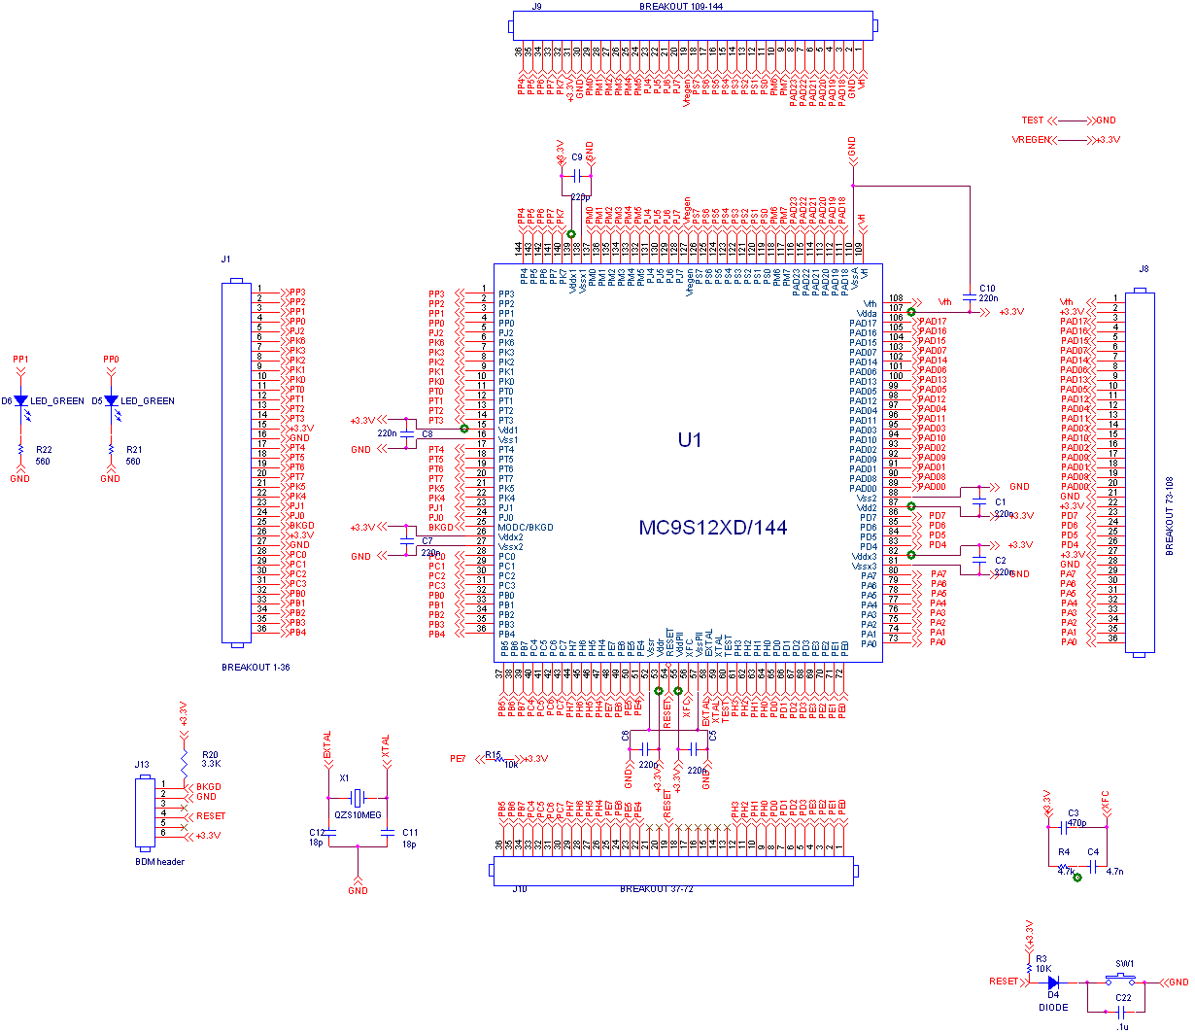
Figure G-1: Microcontroller (Functional Block A)

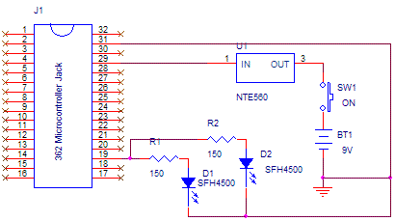

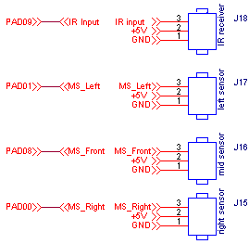
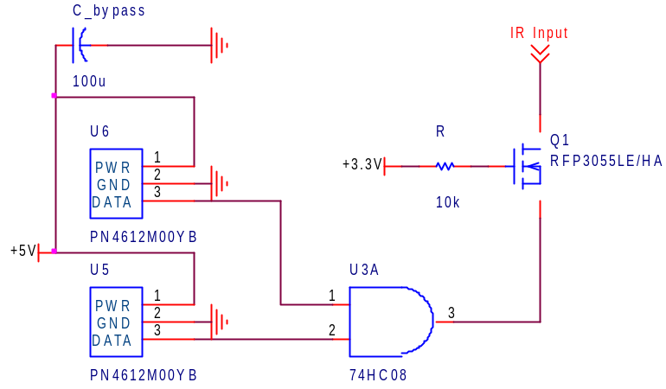

Figure G-2: Sensors (Functional Block B)

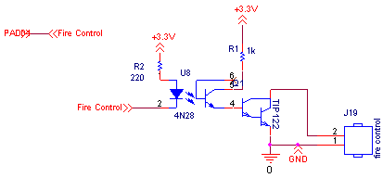

Figure G-3: Fire Control (Functional Block C)

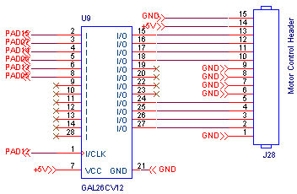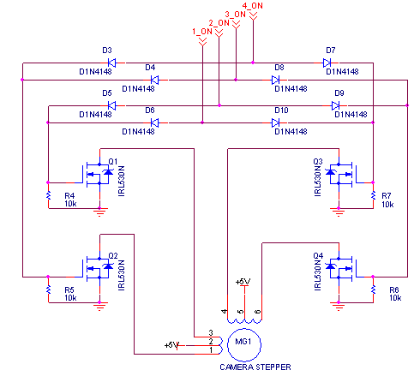

Figure G-4: Motor Control/Motor Driver (Functional Block D)

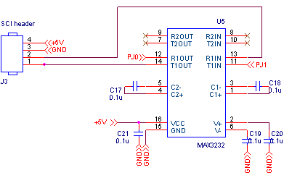

Figure G-5: User Interface (Functional Block E)

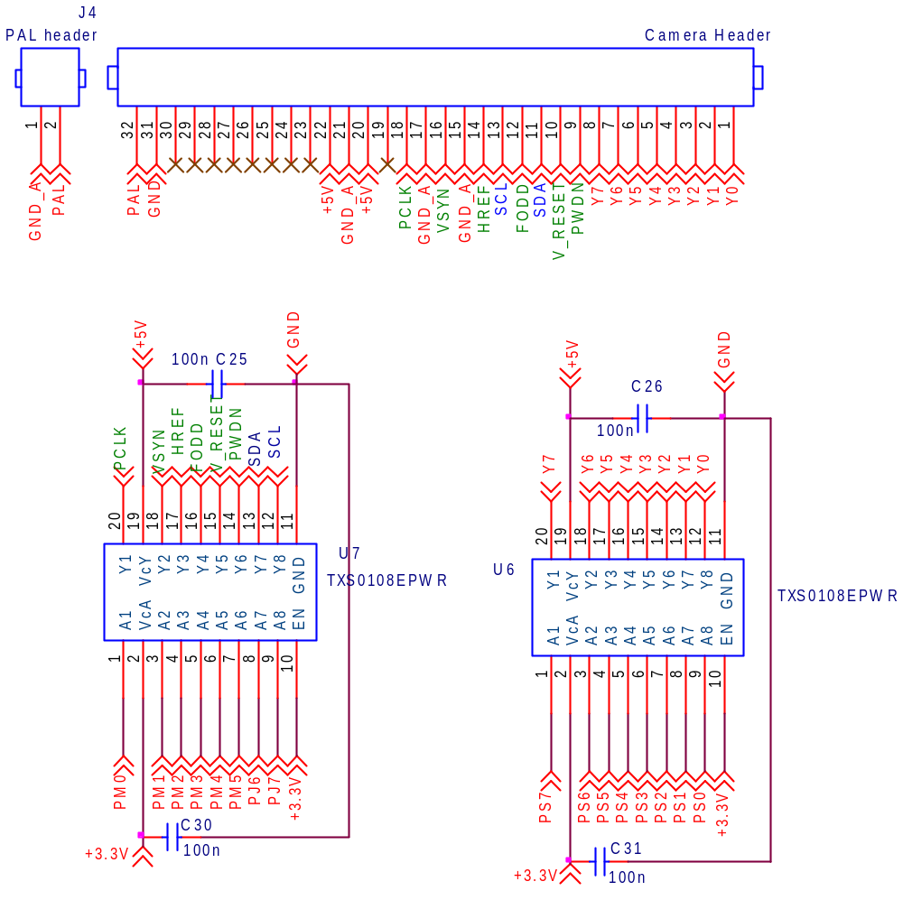
Figure G-6: Video (Functional Block F)

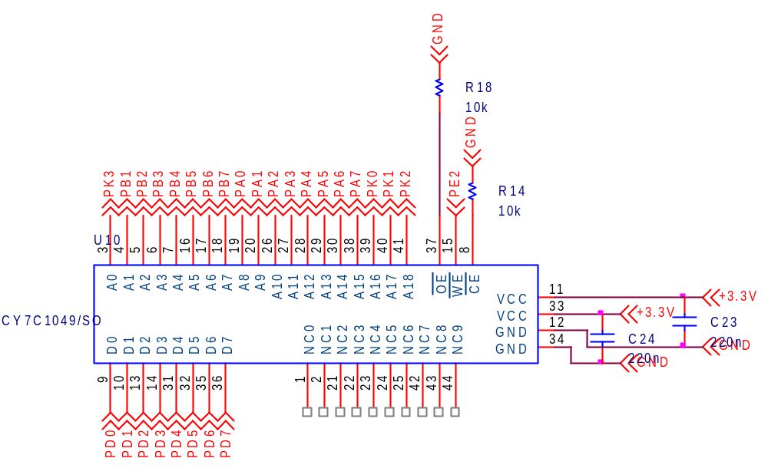

Figure G-7: RAM (Functional Block G)

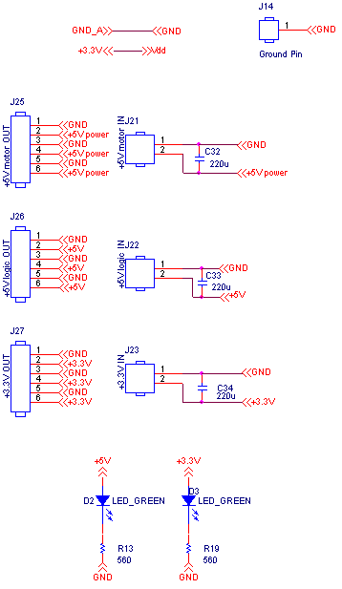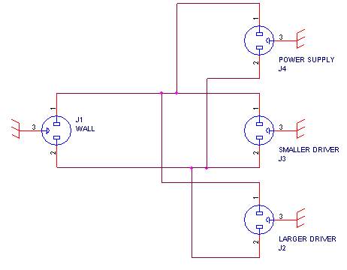

Figure G-8: Power (Functional Block H)

Failure No. | Failure Mode | Possible Causes | Failure Effects | Method of Detection | Criticality | Remarks
A1 | Dead MCU | -Short of bypass caps: C1, C2, C5, C6, C7, C8, C9  -Failure U1 | -Dead MCU | Observation | Low | -If MCU is dead, it can be replaceable
A2 | MCU speed reduction | -PLL loop failure: R4, C3, C4  -Oscillator Failure: X1, C11, C12 | -Inability to read full-speed frame rate  -Motor speed reduced | Observation | Low | -Minimum video frame rate required for reliable motion tracking; speed reduction can cause algorithm to fail
A3 | MCU unpredictable operation | -Short of bypass caps: C1, C2, C5, C6, C7, C8, C9  -Failure U1 | -Unpredictability of MCU’s operation  -Human Damage | Observation | High | -If MCU’s operation is unpredictable effects can be lethal to humans (i.e. firing guns unpredictably)
Table G-1: FMECA of Functional Block A, Microcontroller

Failure No. | Failure Mode | Possible Causes | Failure Effects | Method of Detection | Criticality | Remarks
B1 | Failure of Friendly Detection | -Failure of IR Transmitter  (Components U1, D2)  -Failure of IR Receiver  (Components U3,U5,U6, U2,U3B, U4B, damaged breakout header J18 ) | -Gun functions as if everything is an enemy in auto-mode. | Observation | High | -Friendlies will get shot once a motion sensor is tripped
B2 | Failure of Enemy Detection | -Failure of Motion Sensors (U7, U8, U9)  -Connection Failure (J15, J16, J17) | -Enemy not detected  -Device is not reliable (Friendly gets shot by enemy) | Observation | High | -Gun would never enter tracking algorithm in auto-tracking mode
Table G-2: FMECA of Functional Block B, Sensors

Failure No. | Failure Mode | Possible Causes | Failure Effects | Method of Detection | Criticality | Remarks
C1 | Gun shoots unpredictably | -TIP122 overheating (Q1)  -MCU overheating (U1) | -Human Damage | Observation | High | -Friendly can get shot even though the IR receiver/transmitter system functions correctly
C2 | Gun cannot shoot | -Optoisolator failure (U8) | -No harm to friendly, but none to enemies as well  -Gun can no longer function | Observation | Medium | -Gun won’t shoot so there is no physical damage to anyone  -PCB can be permanently damaged
Table G-3: FMECA of Functional Block C, Fire Control

Failure No. | Failure Mode | Possible Causes | Failure Effects | Method of Detection | Criticality | Remarks
D1 | Immobile gun motors | -Failure of U9 | -Gun will be immobile  -Enemy can flee gun target | Observation | Low | -Enemy only needs to flee the gun’s direction  -Replace GAL device
D2 | Unpredictable motion of gun motors | -Failure of U9 | -Gun can move to friendly and potentially shoot, if IR sensor is not depressed | Observation | High | -Gun can shoot friendly if in field of view
D3 | Immobile camera motor | -Failure of driver (Components D3-D10, Q1-Q4)  -Failure of U9 | -Gun will only have one field of view to target | Observation | Low | -Friendly is safe, but enemy can avert in the two other regions the camera is not facing.  -Can replace
D4 | Unpredictable motion of camera motor | -Failure of Driver (Components D3-D10, Q1-Q4)  -Failure of U9 | -Video algorithm will run on the image the camera moves to  -Enemy can completely avert the turret | Observation | High | -Enemy can potentially shoot friendly because video algorithm not targeting correctly
Table G-4: FMECA of Functional Block D, Motor Control/Motor Driver

Failure No. | Failure Mode | Possible Causes | Failure Effects | Method of Detection | Criticality | Remarks
E1 | User Interface communication failure | -MAX3232 chip failure (U5)  -Shorted C21 | -Manual override failure (potential safety feature removed) | Observation | High | -If auto-mode is on and loses control; manual mode safeguard has vanished
E2 | User Interface slow reaction | -Software bugs  -PLL/oscillator circuitry failure | -Gun not able to target enemies fast enough, but can be repaired | Observation | Low | -Software needs debugging  -Put a new oscillator circuit
Table G-5: FMECA of Functional Block E, User Interface

Failure No. | Failure Mode | Possible Causes | Failure Effects | Method of Detection | Criticality | Remarks
F1 | Video coming too fast for the MCU to handle | -Software | -Video algorithm will no longer work  -Enemy Detection will breakdown | Observation | Low | -The register in the camera can be fixed to slow down video by sending the value from MCU to video
F2 | Video data corruption | -Failure of ADG3300 (U6, U7)  -Software | -Video algorithm will no longer work  -Camera can potentially be permanently damaged | Observation | Low | -Friendly is essentially in the dark, but can be repaired
Table G-6: FMECA of Functional Block F, Video

Failure No. | Failure Mode | Possible Causes | Failure Effects | Method of Detection | Criticality | Remarks
G1 | RAM failure | -Short C23, C24  -Failure U10 | -Video algorithm will not function properly  -Enemy will be able to evade | Observation | Low | -RAM needs to be replaced
Table G-7: FMECA of Functional Block G, RAM

Failure No. | Failure Mode | Possible Causes | Failure Effects | Method of Detection | Criticality | Remarks
H1 | 5V supply failure | -Shorted C33 | -Video will no longer work  -GAL will no longer work  -Fire | Observation | High | -5V components will be destroyed  -Possible fire hazard
H2 | 3.3V supply failure | -Shorted C34 | -Micro and RAM will not function properly  -Fire | Observation | High | -3.3V components are destroyed  -Possible fire hazard
H3 | AC line failure | -Bad Power splitting  -AC line short | -Motors will not be able to move  - Shorted PCB  -Fire | Observation | High | -Gun will still function, friendly will not get harmed.  -Potential Fire hazard
Table G-8: FMECA of Functional Block H, Power

