Homework 13: User Manual

Due: Friday, December 5, at NOON

Team Code Name: PHI-Master Group No. 2

NOTE: This is one of the last sections needed to finish the Final Report. This homework will count toward each team member’s grade, and therefore all team members should participate equally in completing it. The User Manual should be about 5 pages in length (one page per bullet).

User Manual Outline:
Include this sheet as a cover page for your report

Brief (marketing-style) product description

Product illustration annotated with callouts for each control/display

Product setup instructions

Product use instructions

Product troubleshooting instructions

Evaluation:

SCORE | DESCRIPTION
10 | Excellent – among the best papers submitted for this assignment. Very few corrections needed for version submitted in Final Report.
9 | Very good – all requirements aptly met. Minor additions/corrections needed for version submitted in Final Report.
8 | Good – all requirements considered and addressed. Several noteworthy additions/corrections needed for version submitted in Final Report.
7 | Average – all requirements basically met, but some revisions in content should be made for the version submitted in the Final Report.
6 | Marginal – all requirements met at a nominal level. Significant revisions in content should be made for the version submitted in the Final Report.
* | Below the passing threshold – major revisions required to meet report requirements at a nominal level. Revise and resubmit.

* Resubmissions are due within one week of the date of return, and will be awarded a score of “6” provided all report requirements have been met at a nominal level.

A Brief History

In 2008, at Purdue University, a team of students invented and introduced a new concept in football player safety. This concept was simple… measure and record impacts endured by a football player. This simple concept was realized through the integration of an embedded system into a football helmet. This system comprises of an array of sensors, a memory device, and a wireless transreciever. After a few months of hard work and testing, the PHI-Master (Purdue Helmet Impact–Monitoring Arrangement for Safety Tracking and Reporting) was born.

Product Introduction

The PHI-Master is the most advanced Football helmet ever created. It is capable of recording and reporting on a wide variety of impact types. This allows coaches, and sideline personnel to constantly monitor the well being of the player. The most important concern of the PHI-Master Inc. is the protection and comfort of our products and as such, the PHI-Master was designed such that the integrated circuitry does not interfere with the play of the game. No lights or sounds are perceivable to the players. Heat generation is kept to a minimum by strategic placement of the components. This allows the natural airflow generated by the player’s movement to dissipate any generated heat.

Product Warranty

All of PHI-Master’s products come with a 1 year limited Warranty. Should any problems be encountered, the helmet should be returned in whole with all internal components intact to the nearest PHI-Master authorized distributer.

Product Illustration
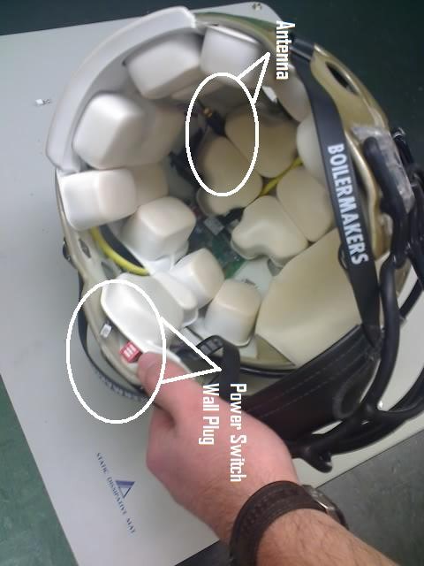
The antenna is placed between the padding to remain out of the way. The power switch and wall plug (for recharging) are located just below the left ear. They are both out of sight as they are tucked under the padding. You may need to pull the padding away slightly to expose them.
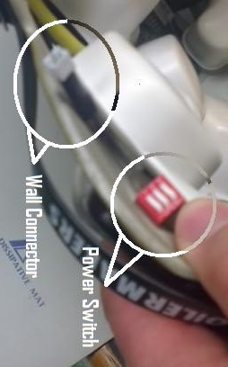

Product Setup Instructions
In order to use the PHI-Master it must be turned on and fully charged. To do this you must plug the wall unit into the main board and wait for the Charge Complete light to turn on. Next you must connect to the Wi-Fi. Scan for Wireless networks with your Laptop and choose the “PHI-Master” Network and connect to it.
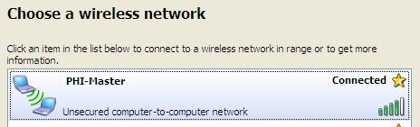
Once Connected, open a web browser (currently only Firefox and Internet Explorer are supported) and type http://169.254.091.039/cob/webserver.html into the URL. The following page should appear:
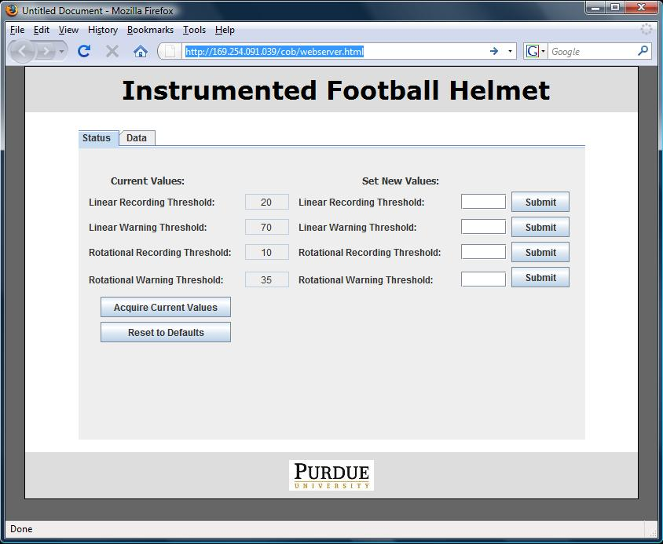

To change the values of the helmet you must place the cursor in the right most set of text boxes and enter the new value then press submit. The new value should appear on the left:
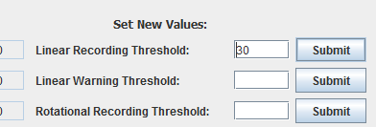
After the desired values are entered and submitted you can begin using the PHI-Master. These values can be changed at any time by following the above steps. To pull up the current thresholds that the PHI-Master is using for recording / reporting, you can press the “Acquire Current Values” button. This will refresh the left column.
The PHI-Master goes on like any other football helmet. It should be placed securely on the head and the chin strap should be adjusted so that the helmet is snug and will not slip.

Product Use Instructions
To use the PHI-Master, connect to the PHI-Master device as described in the previous section. Once you have connected and pulled up the web server, click on the data tab. This is where all the data from the helmet will be stored. To view data on the helmet, click the “Acquire Data” button. This will display battery charge levels as well as impact data. To clear the contents of the PHI-Master, click the “Clear Data” button. WARNING: Once data is erased, it cannot be undone. In order to save data to your PC, simply select all the data in the form with the mouse and copy + paste the data into any text editor of your choice.

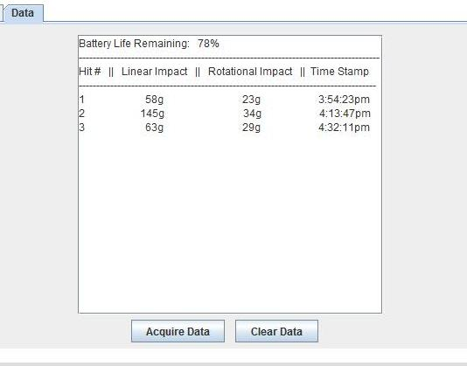
While the webpage is active, any measured impacts above the notification thresholds will result in a pop up window displaying the impact information. Should you wish to reset the PHI-Master’s thresholds to its default values, press the “Reset to Defaults” button.

Product troubleshooting instructions
Problem: Connecting to the Matchport takes a long time
Solution: Try changing your computer’s TCP/IP settings to use a static IP address

Problem: The website for the Matchport is accessible, but nothing besides the title and Purdue University logo can be seen.
Solution: The website for the Matchport makes use of a Java Applet. You must enable Java Applets in your browser and also download the latest version of Java from Sun Microsystems.

Problem: The website no longer appears to be updating.
Solution: Try turning the helmet on and off, and wait 3 minutes before connecting; there may have been a buffer overflow.

Problem: I’ve been hit really hard and there hasn’t been a warning sent to the sidelines and no data has been recorded.
Solution: First, make sure the threshold values are set correctly in the configuration website. If this does not fix the problem, restart the PHI-MASTER to cause it to enter accelerometer diagnostic mode.

Problem: The wireless connection seems to have sporadic service.
Solution: Try plugging in the helmet to a wall using a 5V transformer to recharge the Lithium Ion battery.

Problem: Data is not saved to the SD card
Solution: First, try having the helmet reformat the SD card. If this does not work, it may be that the micro SD card you are using does not support SPI. Any micro SD card used with the PHI-MASTER must support SPI.

