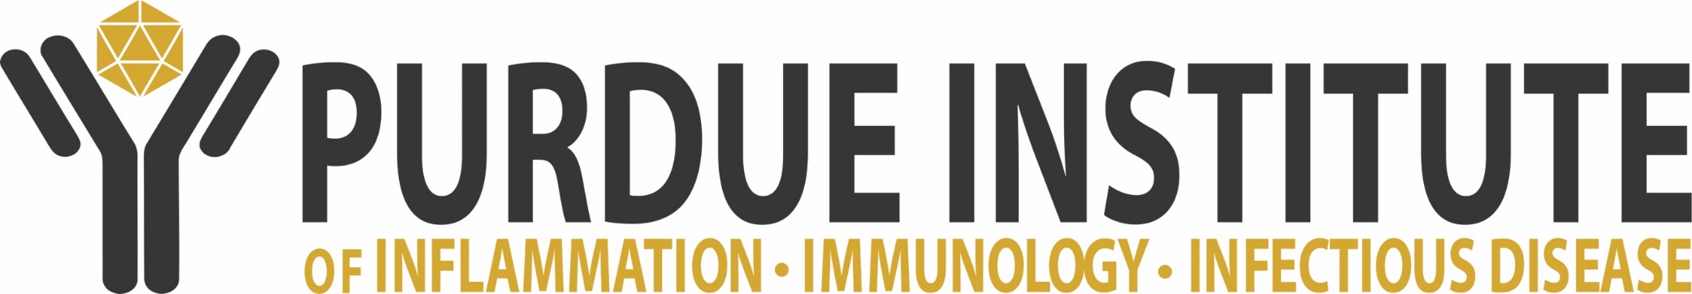

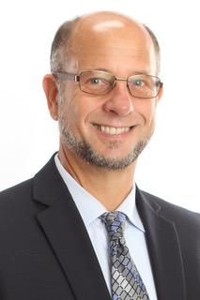**Dr. Scott J. Hultgren, Ph.D.**

Washington University School of Medicine, Department of Molecular Microbiology, Center for Women’s Infectious Disease Research

***“UTI Complexity Results from Diversity at the***

***Bacterial-Host Interface”***

Our studies blend multiple scientific disciplines elucidating bacterial and host mechanisms that determine the onset, course and outcome of interactions between a host mucosal surface and bacterial pathogens. Using genetics, genomics, biochemistry, structural biology, high-resolution imaging, animal models, clinical studies and combinatorial chemistry, we have illuminated how bacterial intracellular lifestyles and community behaviors play critical roles in urinary tract infection (UTI). We uncovered principles of adhesive pili biogenesis in Gram-negative bacteria of the chaperone/usher pathway; delineating molecular details of donor strand complementation and exchange mechanisms by which subunit folding is coupled with translocation and assembly of pili across the outer membrane. We delineated how uropathogenic *E. coli* use type 1 pili to invade and establish biofilm-like intracellular bacterial communities within bladder cells subverting extracellular host defenses and how quiescent intracellular reservoirs can seed recurrent infection. We have shown that risk of UTI depends on the specific pairing between diverse uropathogens and hosts and that the outcome of these interaction depends on both gene carriage and transcriptional responses. We identified complex networks governing mucosal epithelial responses that determine disease outcome. Finally, our work has also revealed fundamental insights into catheter-associated urinary tract infections caused by Enterococcus and *E. coli*. Together, our work is changing the way UTIs are evaluated, re-shaping models of bacterial infections in general and spawning new technologies to design novel vaccines and anti-microbial therapeutics to diagnose, treat and/or prevent UTIs and their sequelae.

Scott Hultgren is the Helen L. Stoever Professor of Molecular Microbiology (since 2000) and was elected to the National Academy of Sciences in 2011. He received his B.S. in Microbiology from Indiana University (1981) and his Ph.D. in Microbiology from Northwestern University (1987). He did post-doctoral work in the laboratory of Staffan Normark at the University of Umea, Sweden (1987-1989).  He became an Assistant Professor of Molecular Microbiology at Washington University School of Medicine in 1989, Associate Professor in 1995 and Professor in 1998. He was named the Director of the Center for Women’s Infectious Disease Research at Washington University School of Medicine in 2007. He has published over 180 peer-reviewed and 80 invited publications. Scott has mentored numerous individuals within and outside of his lab. Twenty-four Ph.D/MSTP students have graduated from his lab and more than 30 postdoctoral and medical fellows have trained with him.

**PI4D Distinguished Speaker Seminar**

**Wednesday, September 13, 2017**

**4:00 – 5:00 PM in**

**MJIS 1001**

